NAME: K.APPALA REDDY
ROLL NO: A24126552089
BRANCH: CSM
SECTION: B
COURSE NAME: FULL STACK WEB DEVELOPMENT
CODE: 23CM4121
TITLE OF THE EXPERIMENT:
To develop a Student Profile Manager using JavaScript classes and DOM manipulation to collect student details and dynamically display a styled student profile.
DESCRIPTION:-
This experiment demonstrates JavaScript classes and objects, DOM selection, dynamic HTML element creation, event handling, content modification, and CSS styling. The user enters student details and clicks the button to generate the student profile dynamically.
PROGRAM:-
<!DOCTYPE html>
<html lang="en">
<head>
<meta charset="UTF-8">
<meta name="viewport" content="width=device-width, initial-scale=1.0">
<title>Dynamic Student Profile Generator</title>
<style>
body {
font-family: 'Segoe UI', Tahoma, Geneva, Verdana, sans-serif;
background-color: #f4f7f6;
display: flex;
flex-direction: column;
align-items: center;
padding: 2rem;
margin: 0;
}
.form-container {
background: #ffffff;
padding: 1.5rem 2rem;
border-radius: 8px;
box-shadow: 0 4px 6px rgba(0,0,0,0.1);
width: 100%;
max-width: 400px;
margin-bottom: 2rem;
}
.form-group {
margin-bottom: 1rem;
}
.form-group label {
display: block;
margin-bottom: 0.3rem;
font-weight: 600;
color: #333;
}
.form-group input {
width: 100%;
padding: 0.5rem;
border: 1px solid #ccc;
border-radius: 4px;
box-sizing: border-box;
}
button {
width: 100%;
padding: 0.75rem;
background-color: #007bff;
color: white;
border: none;
border-radius: 4px;
font-size: 1rem;
font-weight: bold;
cursor: pointer;
transition: background-color 0.2s ease;
}
button:hover {
background-color: #0056b3;
}
/* Target container for dynamic DOM injection */
#profileContainer {
width: 100%;
max-width: 400px;
}
/* CSS Styling applied to the dynamically generated profile card */
.profile-card {
background: #ffffff;
border-left: 5px solid #007bff;
border-radius: 8px;
padding: 1.5rem;
box-shadow: 0 4px 6px rgba(0,0,0,0.1);
}
.profile-card h2 {
margin-top: 0;
color: #007bff;
border-bottom: 2px solid #f4f7f6;
padding-bottom: 0.5rem;
}
.profile-card p {
font-family: 'Courier New', Courier, monospace;
font-size: 1.05rem;
margin: 0.5rem 0;
color: #2c3e50;
white-space: pre; /* Preserves column alignment formatting */
}
</style>
</head>
<body>
<div class="form-container">
<h2>Student Input Form</h2>
<div class="form-group">
<label for="name">Name</label>
<input type="text" id="name" value="Appala Reddy">
</div>
<div class="form-group">
<label for="rollNo">Roll No</label>
<input type="text" id="rollNo" value="A24126552089">
</div>
<div class="form-group">
<label for="department">Department</label>
<input type="text" id="department" value="CSE (AI & ML)">
</div>
<div class="form-group">
<label for="cgpa">CGPA</label>
<input type="number" step="0.01" id="cgpa" value="8.65">
</div>
<button id="generateBtn">Generate Profile</button>
</div>
<div id="profileContainer"></div>
<script>
// 1. JavaScript Class definition
class Student {
constructor(name, rollNo, department, cgpa) {
this.name = name;
this.rollNo = rollNo;
this.department = department;
this.cgpa = parseFloat(cgpa).toFixed(2);
}
// Method returning formatted strings for key details
getFormattedProfile() {
return [
`Name : ${this.name}`,
`Roll No : ${this.rollNo}`,
`Department : ${this.department}`,
`CGPA : ${this.cgpa}`
];
}
}
// 2. DOM Element Selection
const generateBtn = document.getElementById('generateBtn');
const profileContainer = document.getElementById('profileContainer');
// 3. Event Handling
generateBtn.addEventListener('click', function() {
// Fetch user-provided input values
const nameVal = document.getElementById('name').value;
const rollNoVal = document.getElementById('rollNo').value;
const deptVal = document.getElementById('department').value;
const cgpaVal = document.getElementById('cgpa').value;
// Input Validation
if (!nameVal || !rollNoVal || !deptVal || !cgpaVal) {
alert("Please fill in all fields before generating the profile.");
return;
}
// 4. Instantiate Student Object
const student = new Student(nameVal, rollNoVal, deptVal, cgpaVal);
// Clear previous dynamic content
profileContainer.innerHTML = '';
// 5. Creating HTML Elements Dynamically
const cardDiv = document.createElement('div');
cardDiv.className = 'profile-card';
const heading = document.createElement('h2');
heading.textContent = 'Student Profile';
cardDiv.appendChild(heading);
// Generate paragraphs dynamically from class method output
student.getFormattedProfile().forEach(textLine => {
const p = document.createElement('p');
p.textContent = textLine; // Modifying element content
cardDiv.appendChild(p);
});
// 6. Adding dynamic elements to the webpage DOM
profileContainer.appendChild(cardDiv);
});
</script>
</body>
</html>

OUTPUT:-
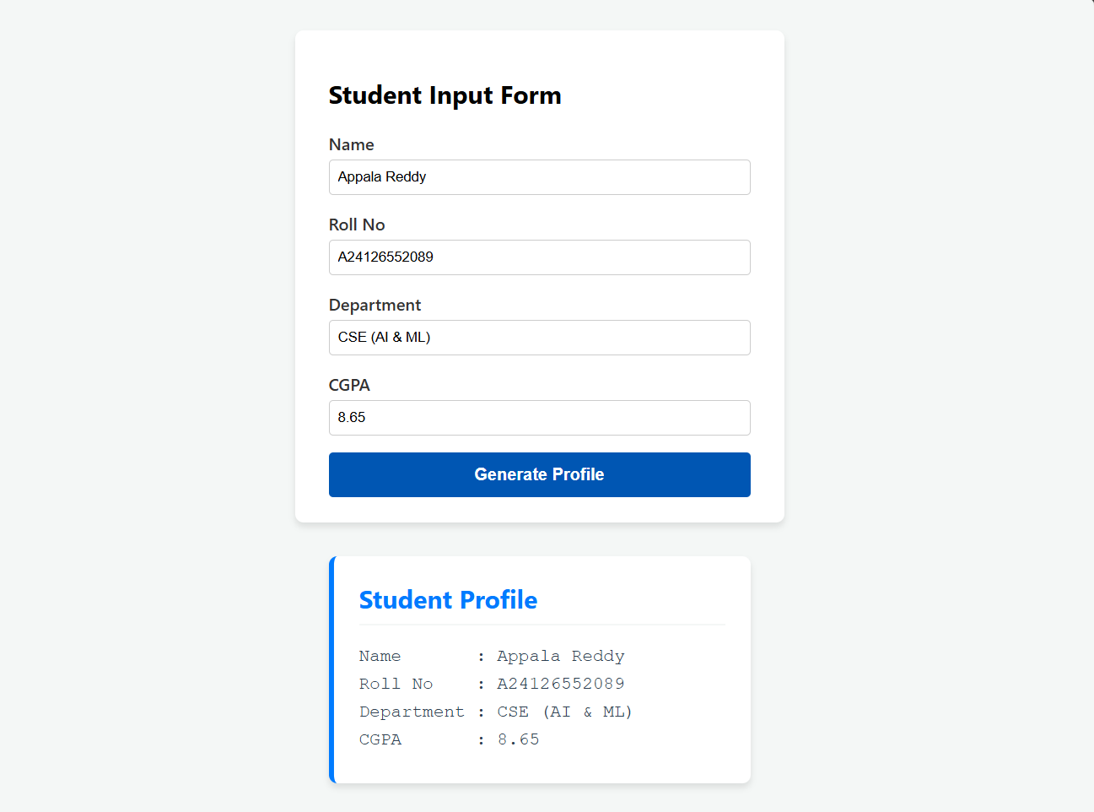
THANK YOU

