NAME: K. APPALA REDDY
ROLL NO: A24126552089
BRANCH: CSM
SECTION: B
COURSE NAME: FULL STACK WEB DEVELOPMENT
CODE: 23CM4121
TITLE OF THE EXPERIMENT:
To develop an interactive To-Do List using JavaScript, DOM manipulation, and event listeners that allows users to add, complete, and delete tasks dynamically.
DESCRIPTION:-
This experiment demonstrates DOM element selection, dynamic element creation, event listeners, click event handling, and adding and removing elements from a webpage. The user can enter a task, add it to the list, mark it as completed, and delete it.
PROGRAM:-
<!DOCTYPE html>
<html>
<head>
<meta charset="UTF-8">
<meta name="viewport" content="width=device-width,initial-scale=1.0">
<title>My To-Do List</title>
<style>
* {
box-sizing: border-box
}
body {
font-family: 'Segoe UI', sans-serif;
background: linear-gradient(135deg, #667eea, #764ba2);
min-height: 100vh;
display: flex;
justify-content: center;
align-items: center;
margin: 0;
padding: 20px
}
.app-card {
background: #fff;
width: 100%;
max-width: 450px;
padding: 30px;
border-radius: 16px;
box-shadow: 0 10px 25px rgba(0, 0, 0, .2)
}
h2 {
color: #333;
margin: 0 0 20px;
text-align: center;
font-size: 1.8rem
}
.input-container {
display: flex;
gap: 10px;
margin-bottom: 20px
}
input[type=text] {
flex: 1;
padding: 12px 16px;
font-size: 15px;
border: 2px solid #e2e8f0;
border-radius: 10px;
outline: 0;
transition: border-color .2s
}
input[type=text]:focus {
border-color: #667eea
}
.btn-add {
background: linear-gradient(135deg, #667eea, #764ba2);
color: #fff;
border: none;
padding: 12px 20px;
font-weight: 600;
border-radius: 10px;
cursor: pointer;
transition: transform .1s, box-shadow .2s
}
.btn-add:hover {
transform: translateY(-1px);
box-shadow: 0 4px 12px rgba(118, 75, 162, .3)
}
ul {
list-style: none;
padding: 0;
margin: 0
}
li {
display: flex;
align-items: center;
justify-content: space-between;
padding: 14px 16px;
margin-bottom: 10px;
background: #f8fafc;
border-left: 5px solid #667eea;
border-radius: 8px;
box-shadow: 0 2px 5px rgba(0, 0, 0, .05);
transition: all .2s
}
li span {
font-size: 15px;
color: #2d3748;
font-weight: 500;
word-break: break-word;
padding-right: 10px
}
li.completed {
background: #f1f5f9;
border-left-color: #10b981;
opacity: .75
}
li.completed span {
text-decoration: line-through;
color: #94a3b8
}
.button-group {
display: flex;
gap: 8px
}
.btn-complete {
background: #10b981;
color: #fff;
border: none;
padding: 8px 12px;
border-radius: 6px;
cursor: pointer;
font-size: 13px;
font-weight: 600
}
.btn-complete:hover {
background: #059669
}
.btn-delete {
background: #ef4444;
color: #fff;
border: none;
padding: 8px 12px;
border-radius: 6px;
cursor: pointer;
font-size: 13px;
font-weight: 600
}
.btn-delete:hover {
background: #dc2626
}
.empty-message {
color: #94a3b8;
text-align: center;
font-style: italic;
padding: 15px 0;
margin: 0
}
</style>
</head>
<body>
<div class="app-card">
<h2>My To-Do List</h2>
<div class="input-container"><input type="text" id="taskInput" placeholder="Enter a task..."><button
id="addTaskBtn" class="btn-add">Add Task</button></div>
<ul id="taskList"></ul>
<p id="emptyMessage" class="empty-message">No tasks available.</p>
</div>
<script>const taskInput = document.getElementById('taskInput'), addTaskBtn = document.getElementById('addTaskBtn'), taskList = document.getElementById('taskList'), emptyMessage = document.getElementById('emptyMessage'); function updateEmptyMessage() { emptyMessage.style.display = taskList.children.length === 0 ? 'block' : 'none' } function addTask() { const e = taskInput.value.trim(); if (!e) return; const t = document.createElement('li'), n = document.createElement('span'); n.textContent = e; const a = document.createElement('div'); a.className = 'button-group'; const s = document.createElement('button'); s.textContent = 'Complete', s.className = 'btn-complete'; const l = document.createElement('button'); l.textContent = 'Delete', l.className = 'btn-delete'; s.addEventListener('click', () => t.classList.toggle('completed')), l.addEventListener('click', () => { t.remove(), updateEmptyMessage() }), a.appendChild(s), a.appendChild(l), t.appendChild(n), t.appendChild(a), taskList.appendChild(t), taskInput.value = '', updateEmptyMessage() } addTaskBtn.addEventListener('click', addTask), taskInput.addEventListener('keypress', e => { 'Enter' === e.key && addTask() }), updateEmptyMessage();</script>
</body>
</html>

OUTPUT:-
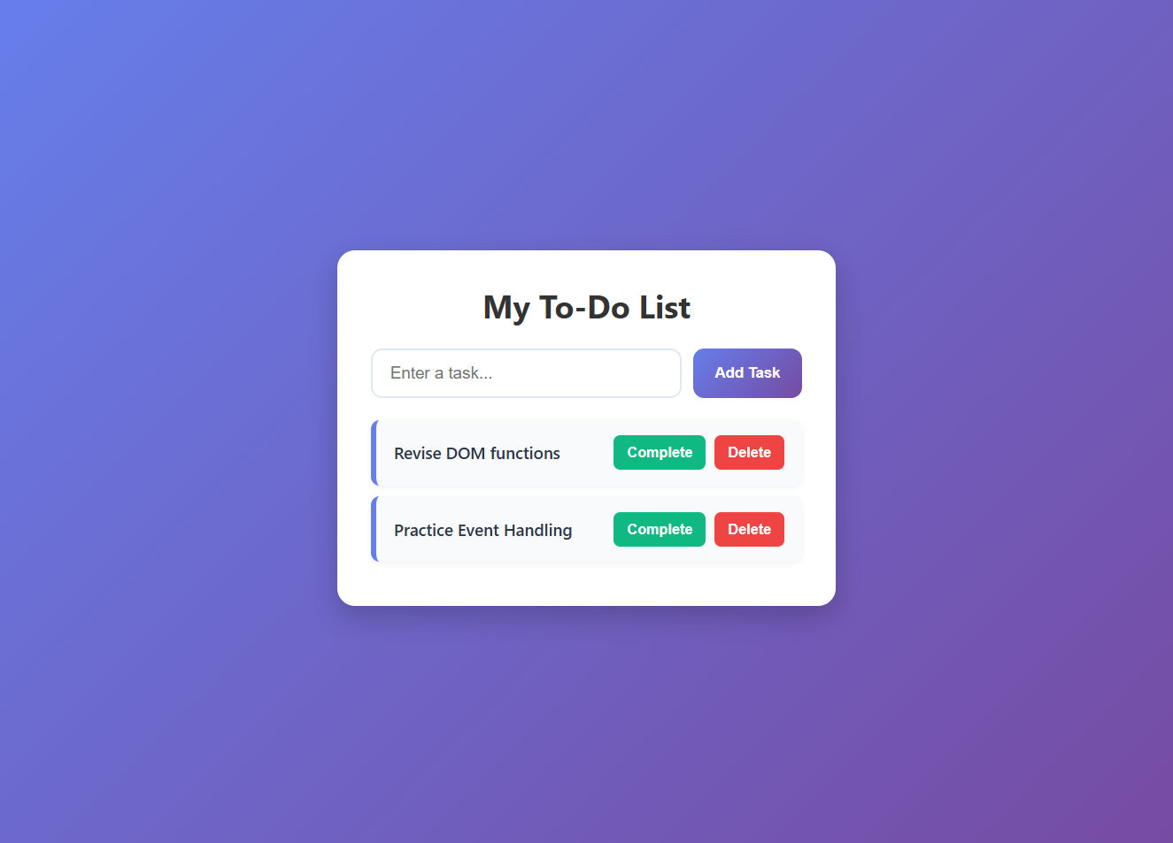
THANK YOU

