1. Download the code base .

2. Eclipse --> File --> import --> Existing maven projects --> select the project code base.

3. Eclipse --> Run --> Run Configuration --> left side window select "Maven Build" --> Name (market service clean package)

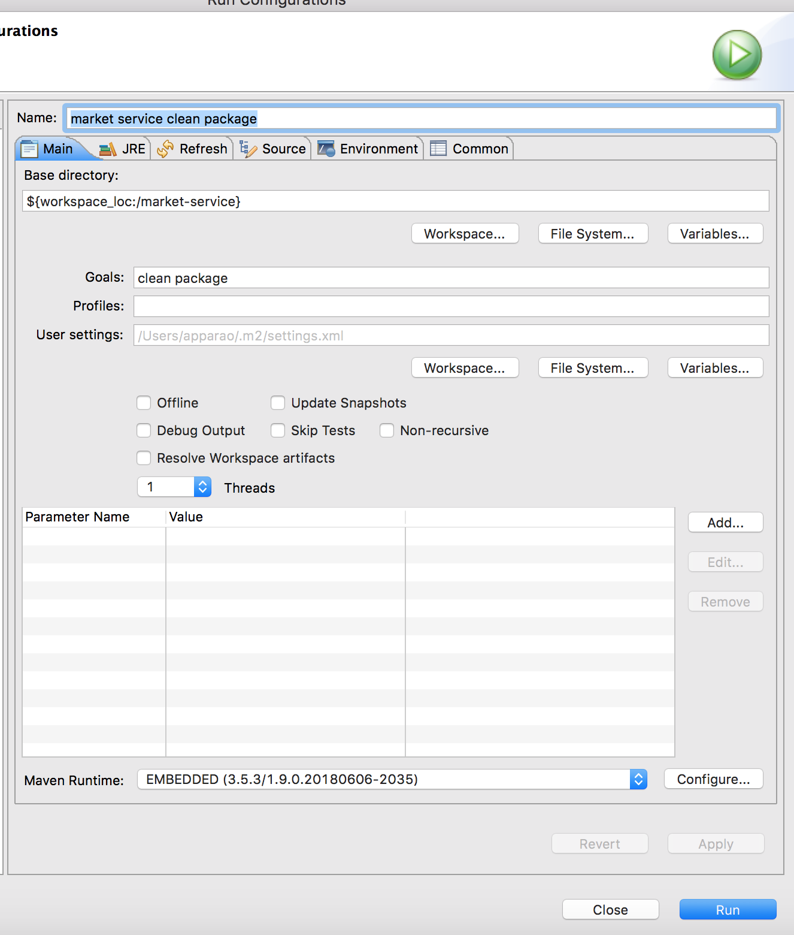

Goals: clean package

Click on “Apply” button

Click on “Run” button.

4. For running the application open MarketServiceApplication.java class and right click 🡪 Run As Spring Boot App

5. Open your favorite browser, paste the below swagger link and hit enter

<http://localhost:8090/marketservice/swagger-ui.html>

6. For opening H2 database console use below link

<http://localhost:8090/marketservice/h2>

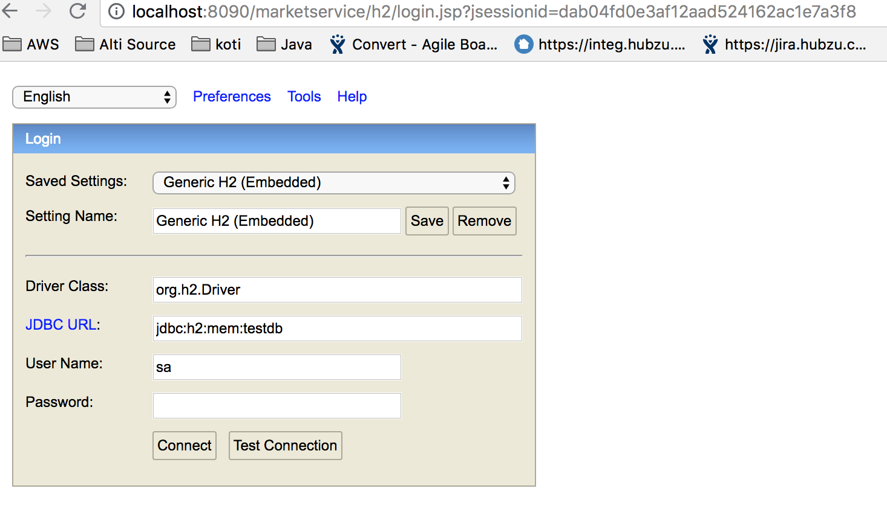

Click on “connect” button.