**EEE5502: FOUNDATION OF DIGITAL SIGNAL PROCESSING**

**PROJECT 3: CONVOLUTION (MATCHED FILTERING)**

**NAME:** APARNA HARIYANI

**UFID:** 69185846

**EMAIL:** [ahariyani@ufl.edu](mailto:ahariyani@ufl.edu)

**Generating required signals:**

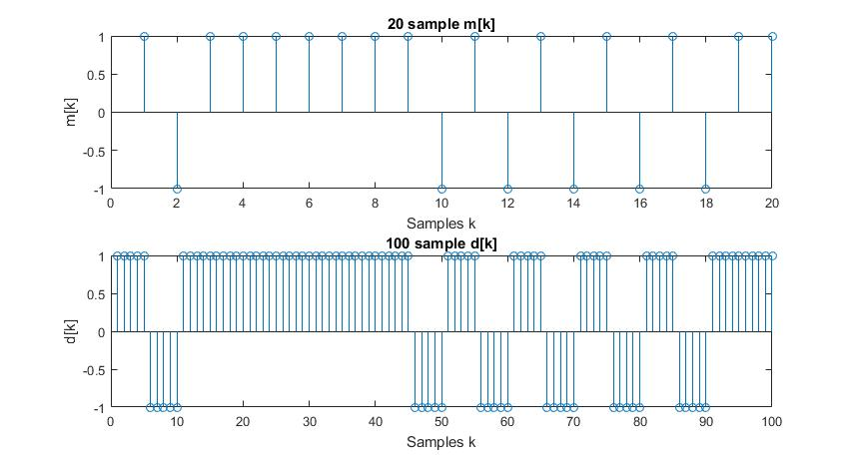Fig. 1. The upper plot shows a 20 sample signal m[k] generated using random function in Matlab. The lower plot is m[k] upsampled by 5 i.e. d[k]

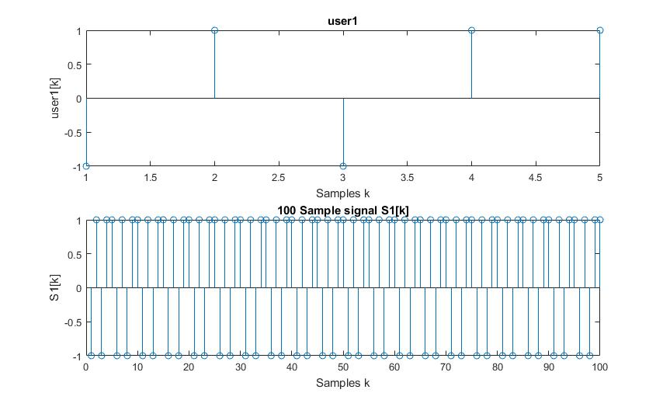

Fig. 2. The upper plot shows the Signal for user1. The lower plot is a 20 repetitions of user1 to make it a 100 sample signal

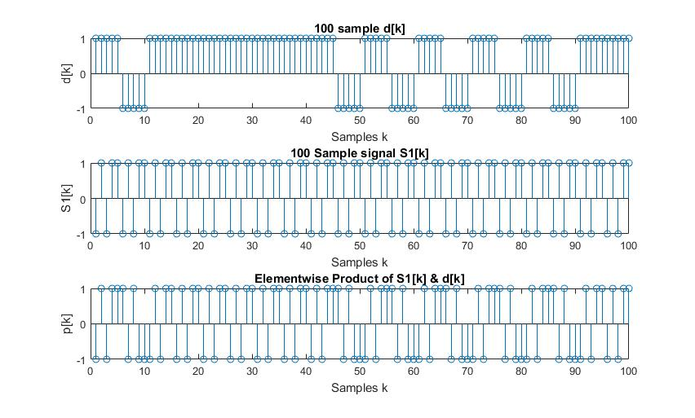

Fig. 3. The first plot is m[k] upsampled by 5 i.e. d[k], the second plot is 100 sample signal S1[k], the third plot is elementwise product p[k] = S1[k] * d[k]

**Report 3.a:**

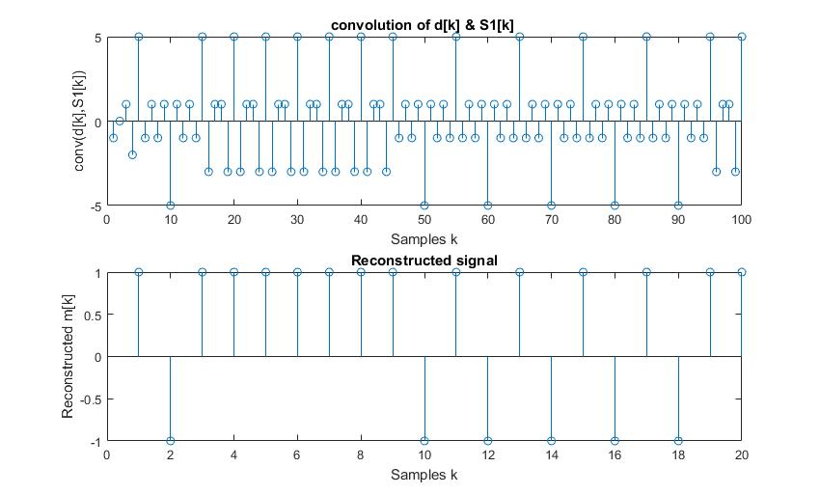

Fig. 4. The upper plot show convolution of d[k] and S1[k] which output at receiver of matched filter. The lower plot shows Reconstructed Original Signal

**Report 3.b:**

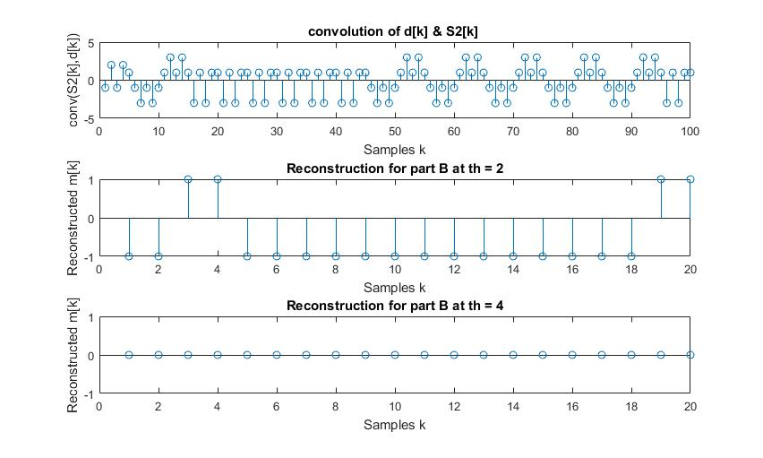Fig. 5. The first plot shows convolution of d[k] with S2[k] which is repetition of user2[k] = [-1 -1 -1 -1 1]. The second plot is reconstructed signal with a threshold of 2. The third plot is reconstructed signal with threshold of 4.

**Report 3.c:**

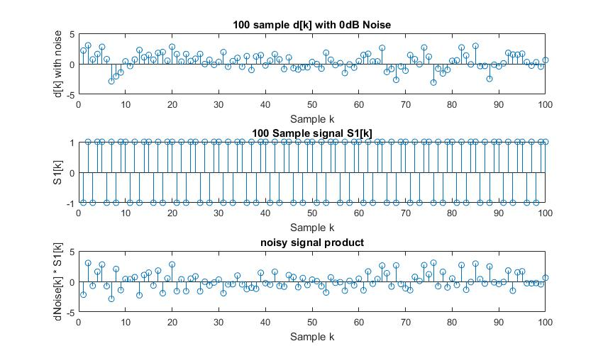Fig. 6. The upper plot shows 100 sample d[k] with SNR 0dB added to it. The second plot shows S1[k]. The lower plot shows elementwise product of noisy d[k] and S1[k]

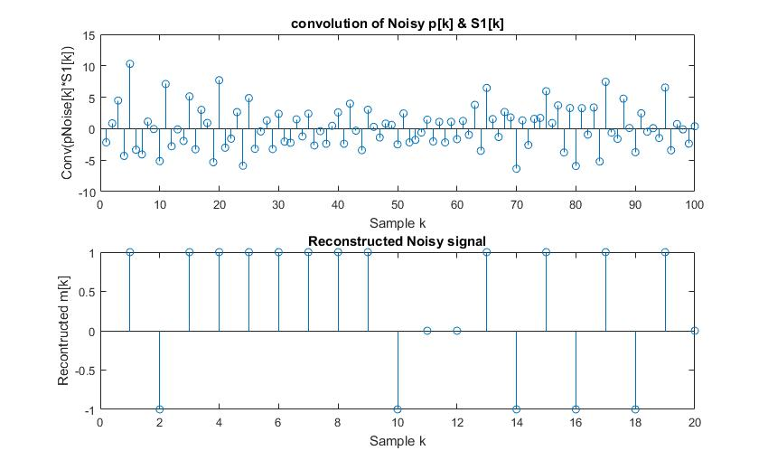

Fig. 7. The upper plot shows convoluted noisy product and h1[k] at the receiver. The lower plot shows the reconstructed m[k] with a threshold of 2

**BER for Part 1, Part 2, Part 3:**

|  |  |  |  |  |
| --- | --- | --- | --- | --- |
|  | **Part 1** | **Part 2** | | **Part 3** |
| **Error rate** | 0 | 0.5 | 1 | 0.15 |
| **#Erroneous bits** | 0 | 10 | 20 | 3 |
| **Total #Samples** | 20 | 20 | 20 | 20 |
| **Threshold** | 4 | 2(Rational Choice) | 4 | 2(Rational Choice) |

We observe that the BER depends on the amount of noise, the threshold and the reverse sequence relative to user. Some noisy signals can be better reconstructed at a lower thresholds as compared to higher thresholds as noise might reduce the amplitudes of the received signals.

**Matlab Code for Project 3**

%%%%%%%%%%%%%%%%%%%%%%%%%%%%%%%%%%%%%%%%%%%%%%%%%%%%%%%%%%%%%%%%%%%%%%%%

%Name: Aparna Hariyani

%UFID: 69185846

%Course: EEE 5502

%Project3 - Convolution (Matched Filtering)

%%%%%%%%%%%%%%%%%%%%%%%%%%%%%%%%%%%%%%%%%%%%%%%%%%%%%%%%%%%%%%%%%%%%%%%%%

close all;

clear all;

clc;

N=5;

rng(1); %To ensure same sequence everytime

x = randi(2,1,20); %generate a random sequence of length 20

x(x==2) = [-1]; %Replace all 2's by -1 to get a random sequence of -1 & 1

d = upsample(x,N);

l1 = length(d);

for len = 1:l1 %removing zeros

if d(len) == 0

d(len) = d(len-1);

end

end

figure(1);

subplot(2,1,1);

stem(x) %plotting m[k]

title('20 sample m[k]');

xlabel('Samples k');

ylabel('m[k]');

subplot(2,1,2);

stem(d) %plotting m[k]

title('100 sample d[k]');

xlabel('Samples k');

ylabel('d[k]');

user1= [-1 1 -1 1 1]; %user 1

h1 = [1 1 -1 1 -1 ]; % reverse image of user 1

user1N = (repmat(user1,1,20)); % user1 for 100 samples

figure(2);

subplot(2,1,1);

stem(user1);

title('user1');

xlabel('Samples k');

ylabel('user1[k]');

subplot(2,1,2);

stem(user1N)

title('100 Sample signal S1[k]');

xlabel('Samples k');

ylabel('S1[k]');

p = (d .* user1N); % pint wise multiplication of d[k] & user 1

figure(3);

subplot(3,1,1);

stem(d) %plotting m[k]

title('100 sample d[k]');

xlabel('Samples k');

ylabel('d[k]');

subplot(3,1,2);

stem(user1N)

title('100 Sample signal S1[k]');

xlabel('Samples k');

ylabel('S1[k]');

subplot(3,1,3);

stem(p)

title('Elementwise Product of S1[k] & d[k]');

xlabel('Samples k');

ylabel('p[k]');

%%%%%%%%%%%%%%%%%%%%%%%%%%%%%%%%%%%%%%%%%%%%%%%%%%%%%%%%%%%%%%%%%%%%%%

% Part A

%%%%%%%%%%%%%%%%%%%%%%%%%%%%%%%%%%%%%%%%%%%%%%%%%%%%%%%%%%%%%%%%%%%%%%

y1 = conv(p,h1);

th = N-1;

j = 1;

for i = 1:length(p)

if (mod(i,N) == 0)

if (abs(y1(i)) > th )

r1(j) = y1(i)/(th+1); % m2k is the message signal obtained at the receiver side, dividining by gain N to get original signal

j = j+1;

else

r1(j) = 0; % for those values which are below the threshold and should be rpresented to have the sample values k

j = j+1;

end

end

end

j=1;

figure(4);

subplot(2,1,1);

stem(y1);

xlim([0 100]);

title('convolution of d[k] & S1[k] ');

xlabel('Samples k');

ylabel('conv(d[k],S1[k])');

subplot(2,1,2);

stem(r1);

title('Reconstructed signal');

xlabel('Samples k');

ylabel('Reconstructed m[k]');

% Finding error rate

hError = comm.ErrorRate; % Using communication toolbox

input = reshape(x,length(x),1);

output = reshape(r1,length(r1),1);

errorRate1 = step(hError,input,output);

display('Part 1');

display(errorRate1(1),'Error rate for Part 1 ');

display(errorRate1(2),'No. of erroneous bits for Part 1 ');

display(errorRate1(3),'Total no. of samples ');

%%%%%%%%%%%%%%%%%%%%%%%%%%%%%%%%%%%%%%%%%%%%%%%%%%%%%%%%%%%%%%%%%%%%%%

% Part B

%%%%%%%%%%%%%%%%%%%%%%%%%%%%%%%%%%%%%%%%%%%%%%%%%%%%%%%%%%%%%%%%%%%%%%

user2= [-1 -1 -1 -1 1]; %user 1

h2 = [1 -1 -1 -1 -1 ]; % reverse image of user 1

y2 = conv(p,h2);

th = N-3;

for i = 1:length(p)

if (abs(y2(i)) > th )

r2(j) = y2(i)/(th+1); % m2k is the message signal obtained at the receiver side, dividining by gain N to get original signal

j = j+1;

end

end

j = 1;

th = N-1;

for i = 1:length(p)

if (mod(i,N) == 0)

if (abs(y2(i)) > th )

r21(j) = y2(i)/(th+1); % m2k is the message signal obtained at the receiver side, dividining by gain N to get original signal

j = j+1;

else

r21(j) = 0; % for those values which are below the threshold and should be rpresented to have the sample values k

j = j+1;

end

end

end

r2 = r2(1:length(x));

figure(5);

subplot(3,1,1);

stem(y2);

xlim([0 100]);

title('convolution of d[k] & S2[k] ');

xlabel('Samples k');

ylabel('conv(S2[k],d[k])');

subplot(3,1,2);

stem(r2);

title('Reconstruction for part B at th = 2');

xlabel('Samples k');

ylabel('Reconstructed m[k]');

subplot(3,1,3);

stem(r21);

title('Reconstruction for part B at th = 4');

xlabel('Samples k');

ylabel('Reconstructed m[k]');

hError = comm.ErrorRate; % Using communication toolbox

input2 = reshape(x,length(x),1);

output2 = reshape(r2,length(r2),1);

errorRate2 = step(hError,input2,output2);

disp('Part 2');

display(errorRate2(1),'Error rate for Part 2 ');

display(errorRate2(2),'No. of erroneous bits for Part 2 ');

display(errorRate2(3),'Total no. of samples ');

%%%%%%%%%%%%%%%%%%%%%%%%%%%%%%%%%%%%%%%%%%%%%%%%%%%%%%%%%%%%%%%%%%%%%%

% Part C

%%%%%%%%%%%%%%%%%%%%%%%%%%%%%%%%%%%%%%%%%%%%%%%%%%%%%%%%%%%%%%%%%%%%%%

dNoise = awgn(d,0,'measured');

pNoise = (dNoise .* user1N); % pint wise multiplication of d[k] & user 1

figure(6);

subplot(3,1,1);

stem(dNoise) %plotting m[k]

title('100 sample d[k] with 0dB Noise');

ylabel('d[k] with noise');

xlabel('Sample k');

subplot(3,1,2);

stem(user1N)

title('100 Sample signal S1[k]');

ylabel('S1[k]');

xlabel('Sample k');

subplot(3,1,3);

stem(pNoise)

title('noisy signal product');

ylabel('dNoise[k] * S1[k]');

xlabel('Sample k');

yNoise = conv(pNoise,h1);

th = N-3;

j = 1;

for i = 1:length(p)

if (mod(i,N) == 0)

if (abs(yNoise(i)) > th )

rNoise(j) = yNoise(i)/(th+1); % m2k is the message signal obtained at the receiver side, dividining by gain N to get original signal

j = j+1;

else

rNoise(j) = 0; % for those values which are below the threshold and should be rpresented to have the sample values k

j = j+1;

end

end

end

j=1;

for i = 1:length(rNoise)

if (rNoise(i) > 0)

rNoise(i) = 1;

else

if (rNoise(i) < 0) % else it will remove the 0s place in previous steps too, so check required

rNoise(i) = -1;

end

end

end

figure(7);

subplot(2,1,1);

stem(yNoise);

xlim([0 100]);

title('convolution of Noisy p[k] & S1[k]');

ylabel('Conv(pNoise[k]*S1[k])');

xlabel('Sample k');

subplot(2,1,2);

stem(rNoise);

title('Reconstructed Noisy signal');

ylabel('Recontructed m[k]');

xlabel('Sample k');

% Finding error rate

hError = comm.ErrorRate; % Using communication toolbox

input3 = reshape(x,length(x),1);

output3 = reshape(rNoise,length(rNoise),1);

errorRate3 = step(hError,input3,output3);

disp('Part 3');

display(errorRate3(1),'Error rate for Part 3 ');

display(errorRate3(2),'No. of erroneous bits for Part 3 ');

display(errorRate3(3),'Total no. of samples ');