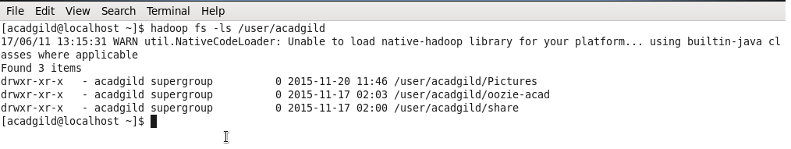

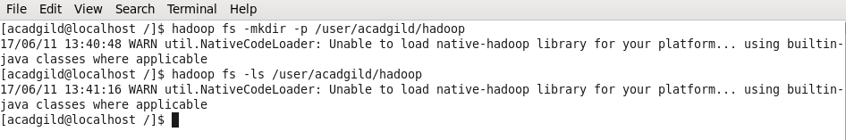





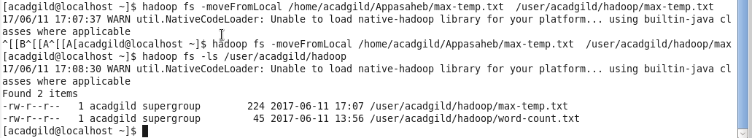

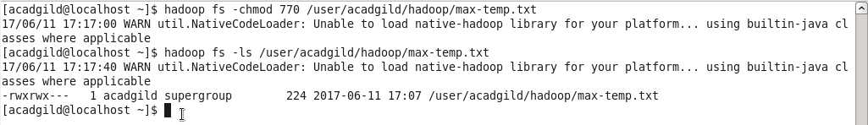

1. pwd

Present Working Directory. Its shows which directory we are currently working under

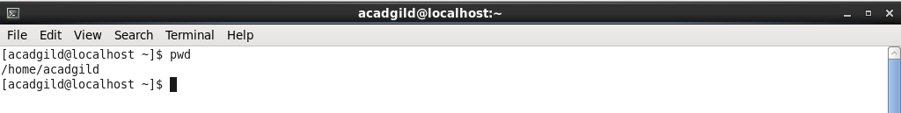

1. vi

vi is editor where we can type the text and save it in particular directory



1. touch : It creates a file with zero bytes.

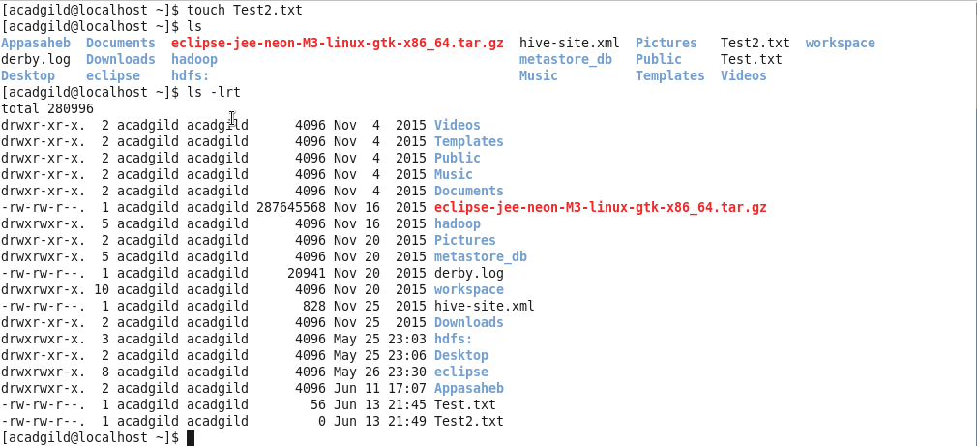

1. mkdir : Creates a directory

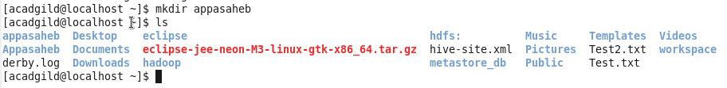

1. rm : Removes files and directory

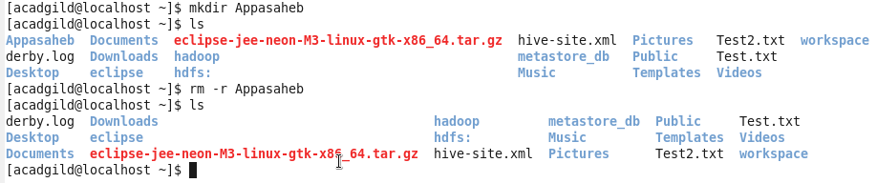

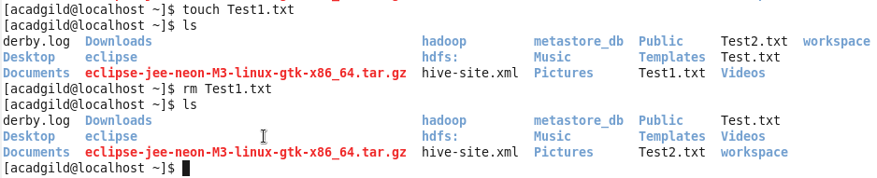

1. ls : command that lists directory contents of files and directories.

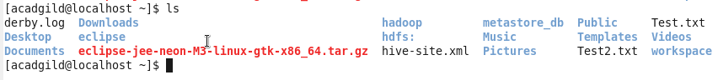

1. echo : Echo the String(s) to the standard out



1. cat : Display the content of the file on the screen



1. who : You need to use who command to display users who are currently logged in your server.



1. cd : Change directory. Takes us to inside the specified directory if it exists.

Cd .. takes us to one level up near the parent directory.

Cd ~ will take to the parent directory

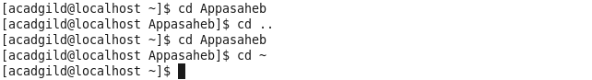

1. date : Display the current server date and time



1. cal : Display a current month Calendar. Highlight with current date

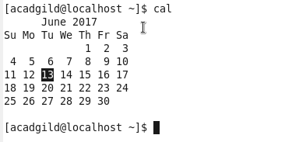

1. mv : Move the file from source to destination

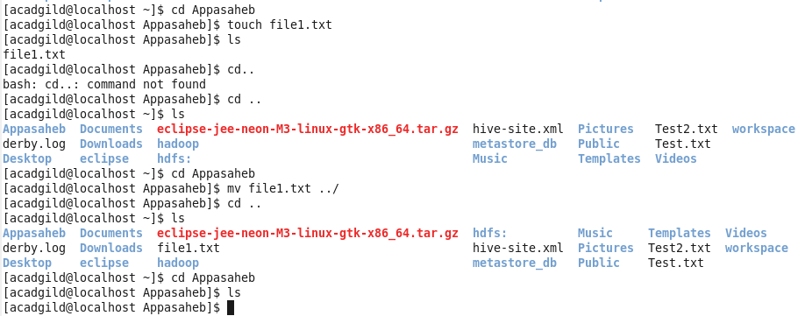

1. cp : cp command is used to copy file from one location to other location.

Copies content of one file to another.

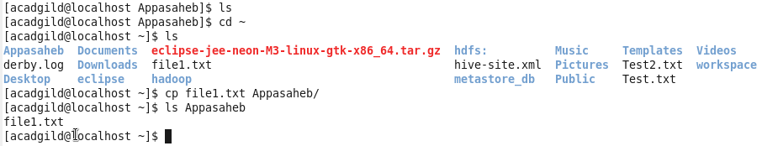

1. which : Locate the executable file associated with a given command.

: