Task 1:

Write a java program, to take an HDFS Path as input displays all the files and sub-directories in that HDFS path

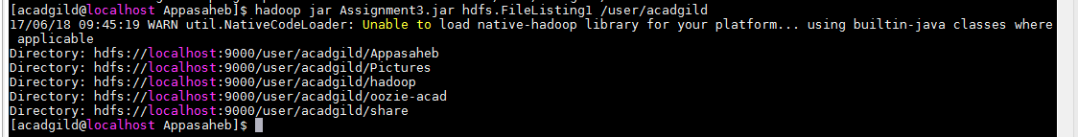

Task 2:

Modify the previous program to list all the files and sub-directories in the HDFS path recursively.

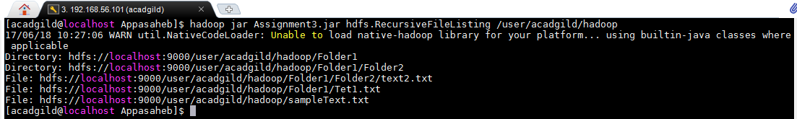

Task 3:

Modify the previous program to take multiple HDFS paths (separated by space) and list all the files and sub-directories in those HDFS paths recursively.

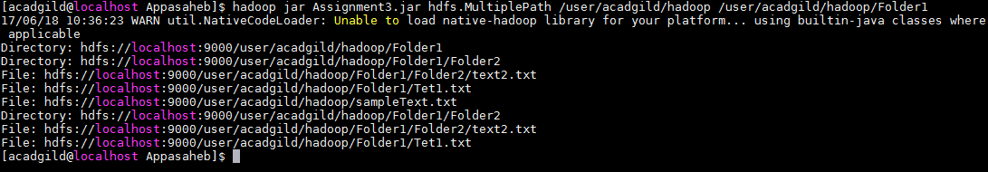

Task 4:

Write a java program to list down all the files inside a directory and its sub-directories who have last modified timestamp between the start_ts and end_ts passed as an argument. The default value of start_ts is 0 and for end_ts is infinite.

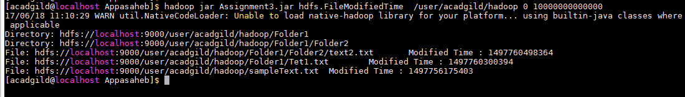

Task 5:

Write a java program to display the content of a file in HDFS on screen.



Task 6:

Write a java program to copy a file from local filesystem to HDFS.

