Project Address: https://github.com/langleyfcu/online-banking-system
After downloading the source code, decompress the zip package to get the following files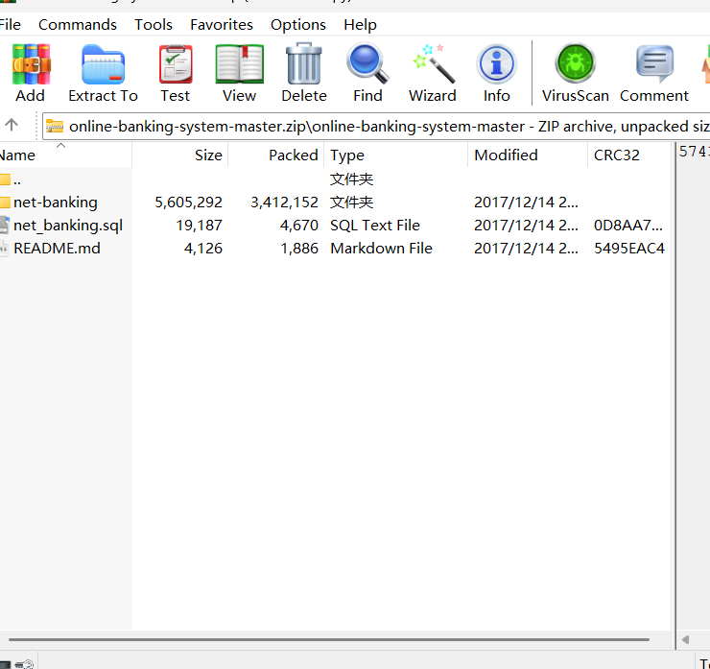
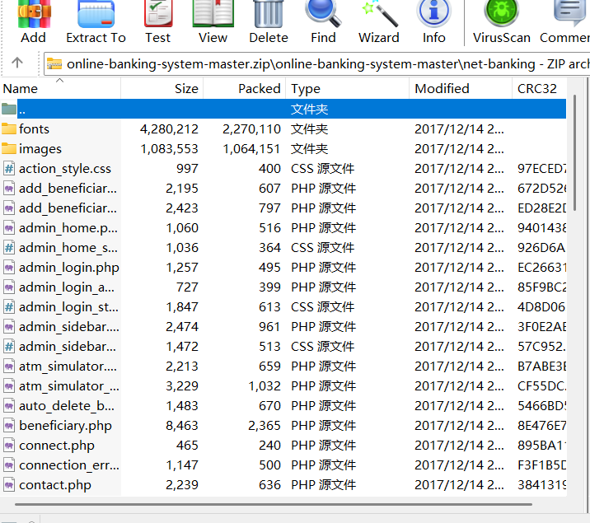
Then, copy all the files in net-banking to the root directory of the small Pi website and import the decompressed SQL database into the small Pi
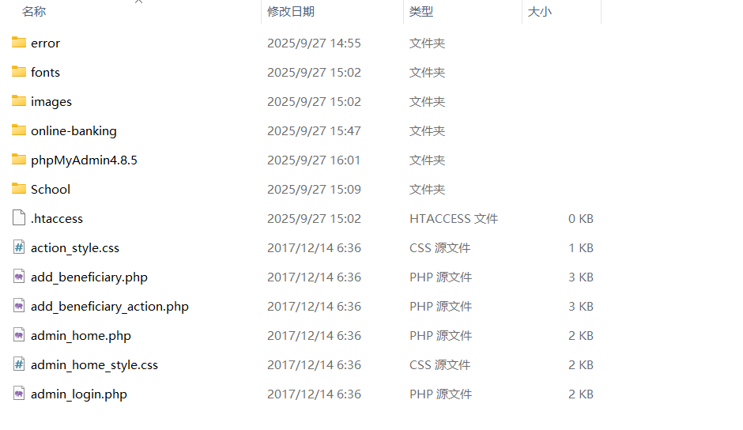
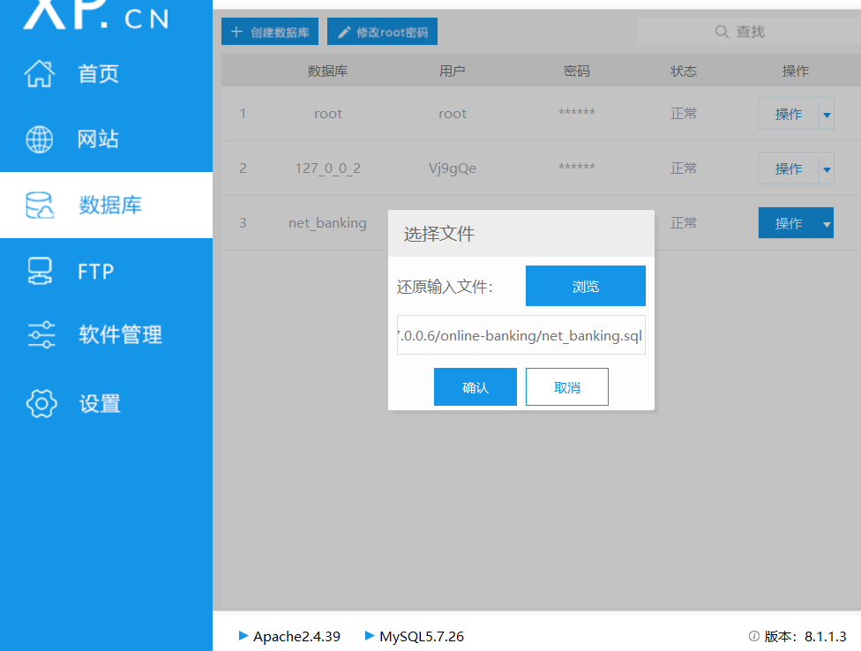
Then install the database management in the small skin and specify the database of the website for management
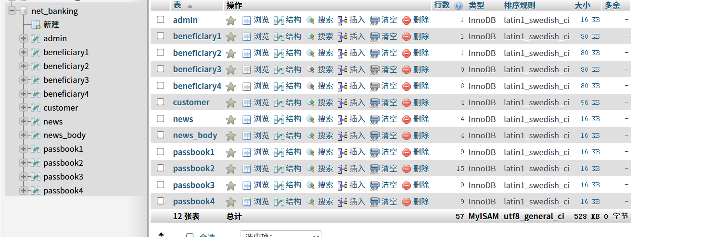
Then open the built target field and get the account from the database to log in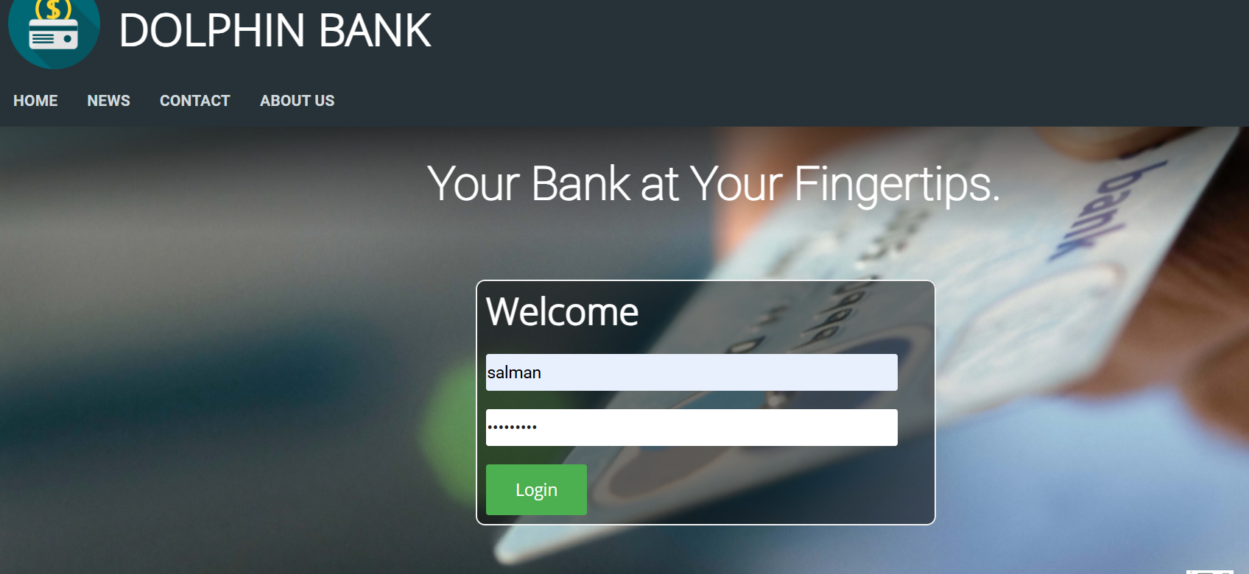
Then you go into this page and you see that there's an ID in this location and you can change the ID to get different responses
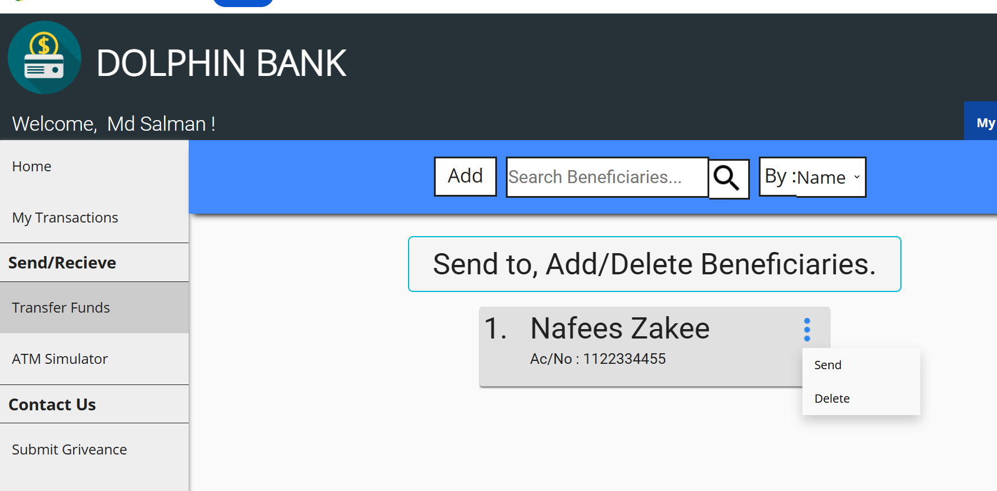
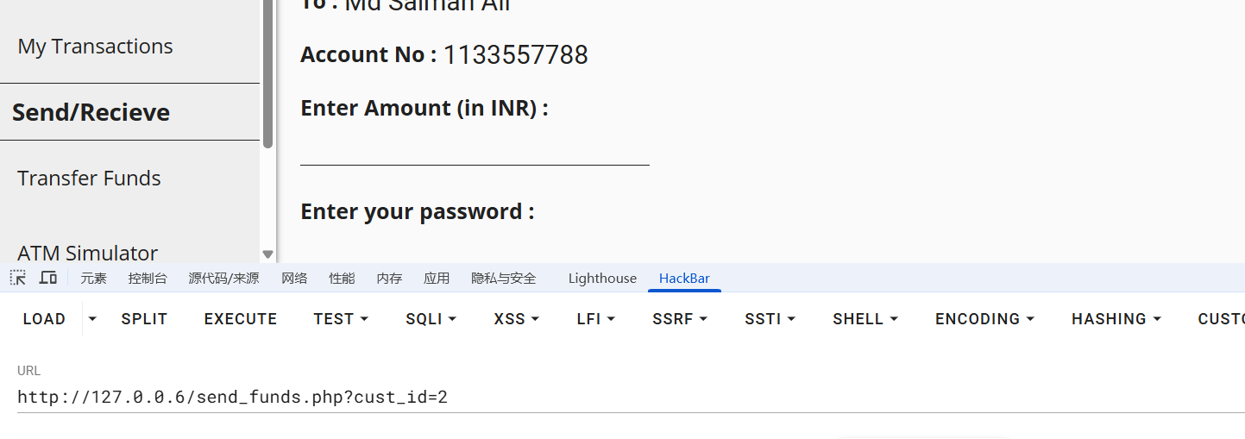
Then the test was carried out first to get that the table has 14 columns, and then the database user name and version number were obtained at the reply position through sql injection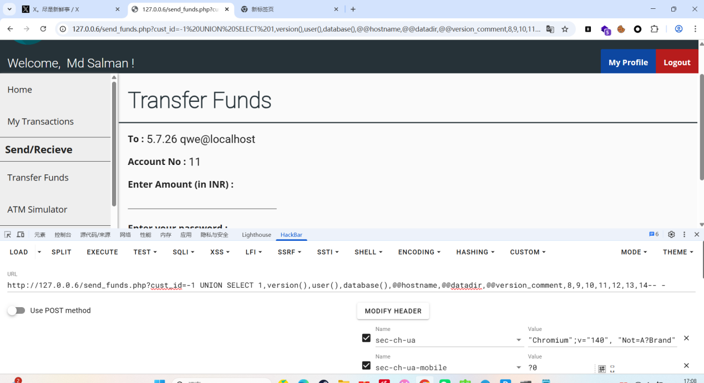
It can be found that the website configuration has a SQL injection vulnerability and information can be obtained

