Project Address: https://github.com/langleyfcu/online-banking-system
After downloading the source code, decompress the zip package to get the following files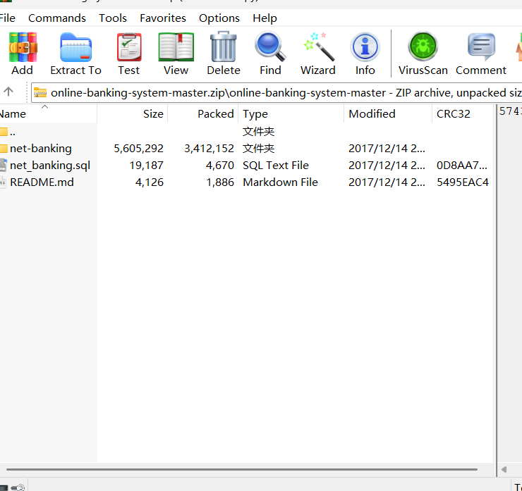
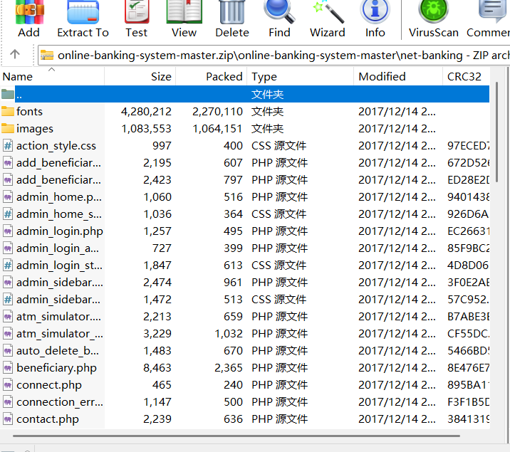
Next, copy all files from the online banking system to the root directory of the phpstudy_pro website. Then, import the decompressed SQL database into phpstudy_pro and open the connect.php file to configure the database connection.
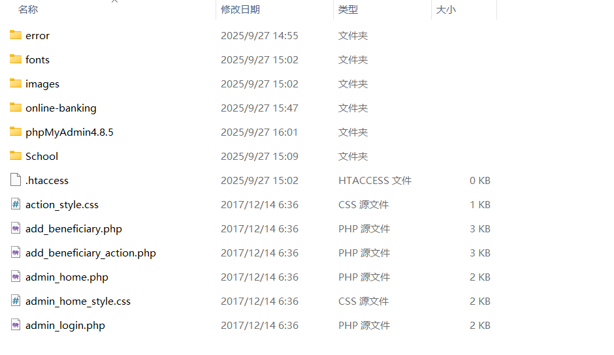
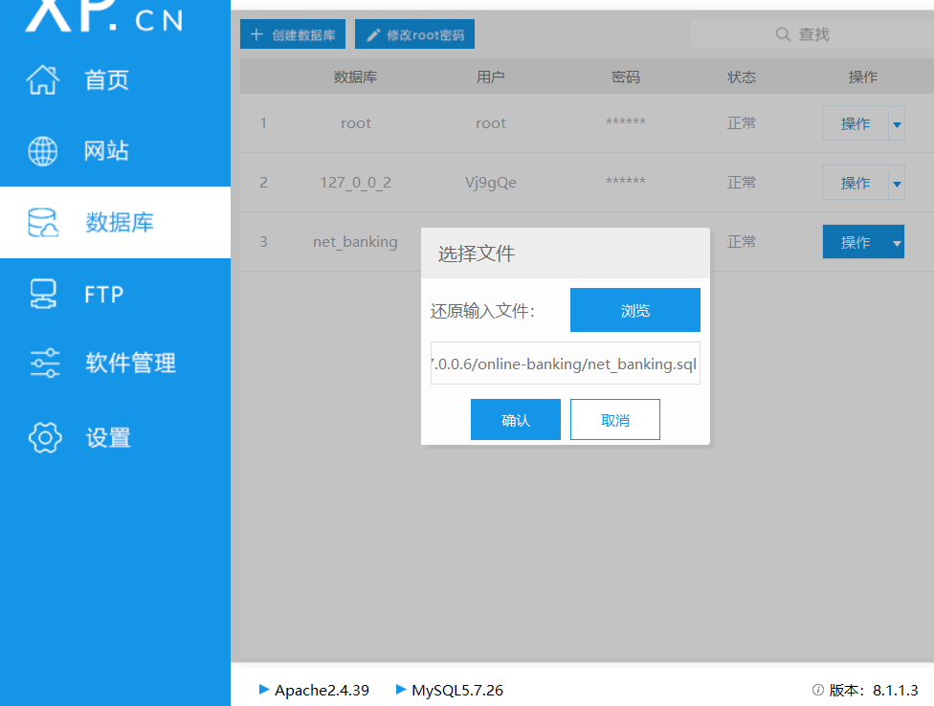
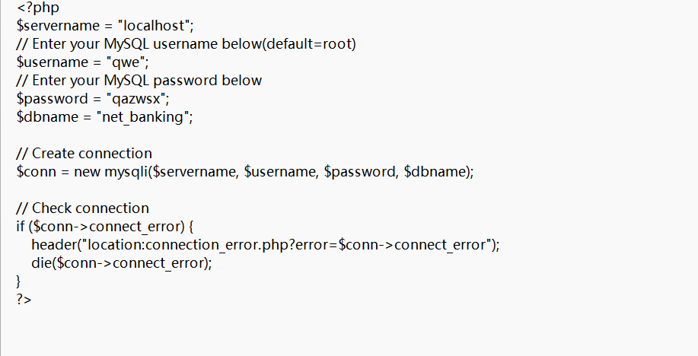
Then install the database management in the small skin and specify the database of the website for management
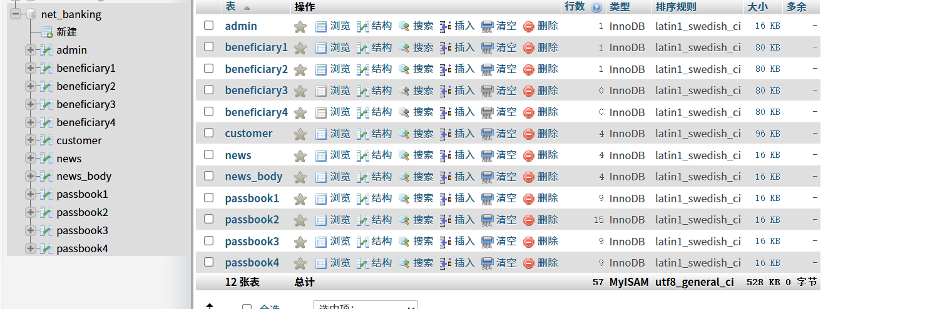
Then open the built database, retrieve account information from it to log in. You can easily obtain a regular user account and log in.
Account：salman
Password：salman123
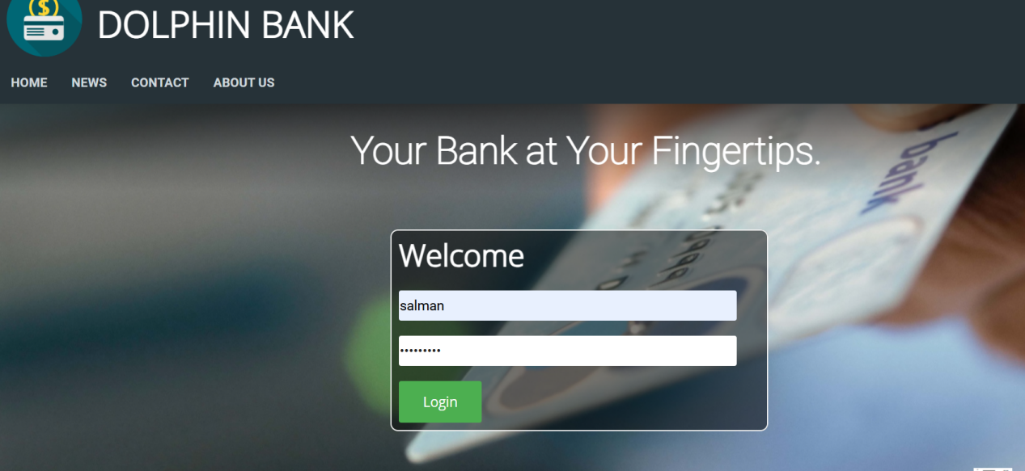
Then open the URL box and navigate to the admin_login.php file to log in to the backend management system.
Account:admin
Password:password123
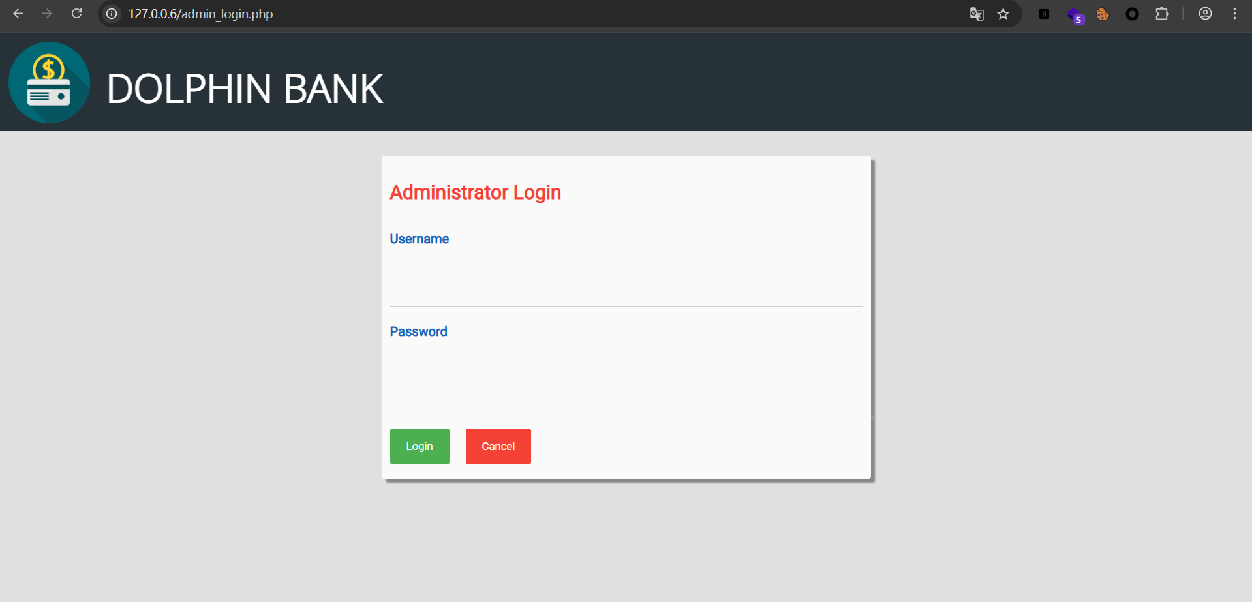
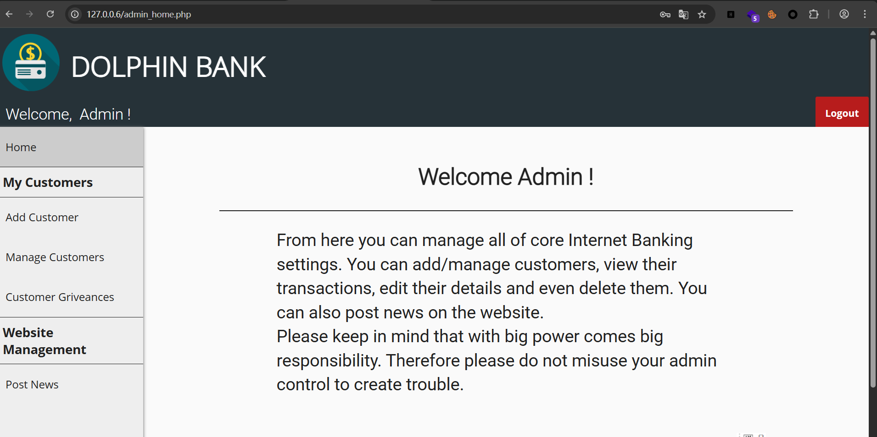
Then open the Mangage Customers section and select one of the users to view/edit.
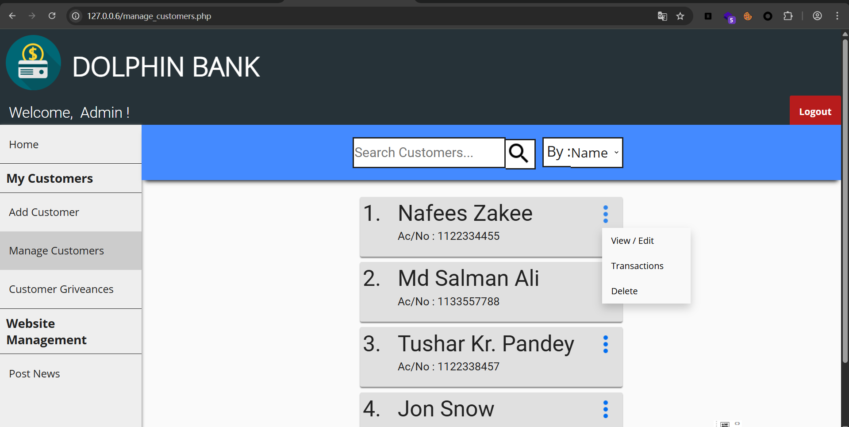
Upon entering, it was discovered that the page contained a GET parameter named cust_id. Hackbar was then opened to attempt to build the payload.
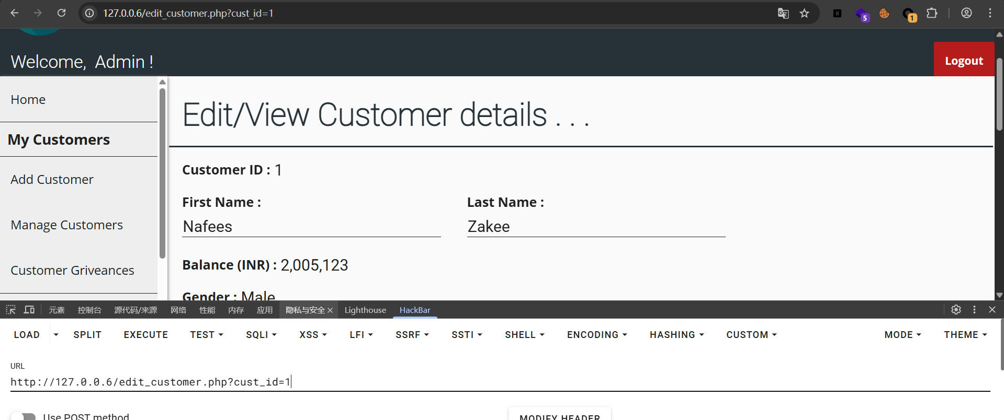
Then, a single quote was entered to determine whether the injection was a character or numeric type. No output was found, but the value of `cust_id` was displayed in the Customer ID field on the page. It was guessed that the database query result was returned to a variable and then displayed in the form's `value` attribute. Therefore, it was initially treated as a numeric injection.
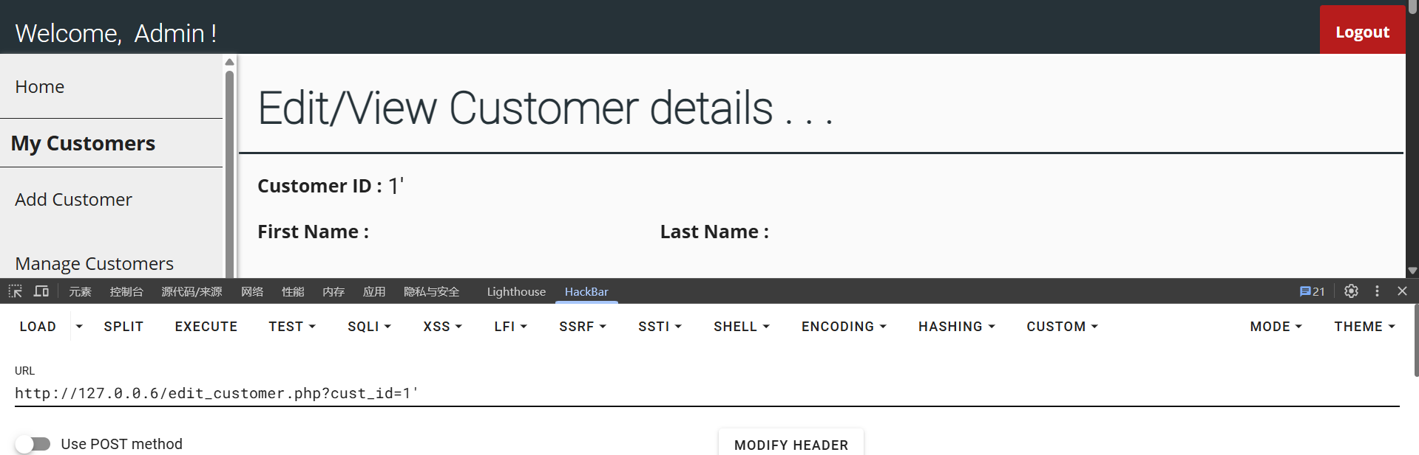
Constructing the payload `?cust_id=-1 union select 1,2,3,4,5,6,7,8,9,10,11,12,13,14` reveals that the form displays data when 14 columns are entered, concluding that the database table has 14 fields.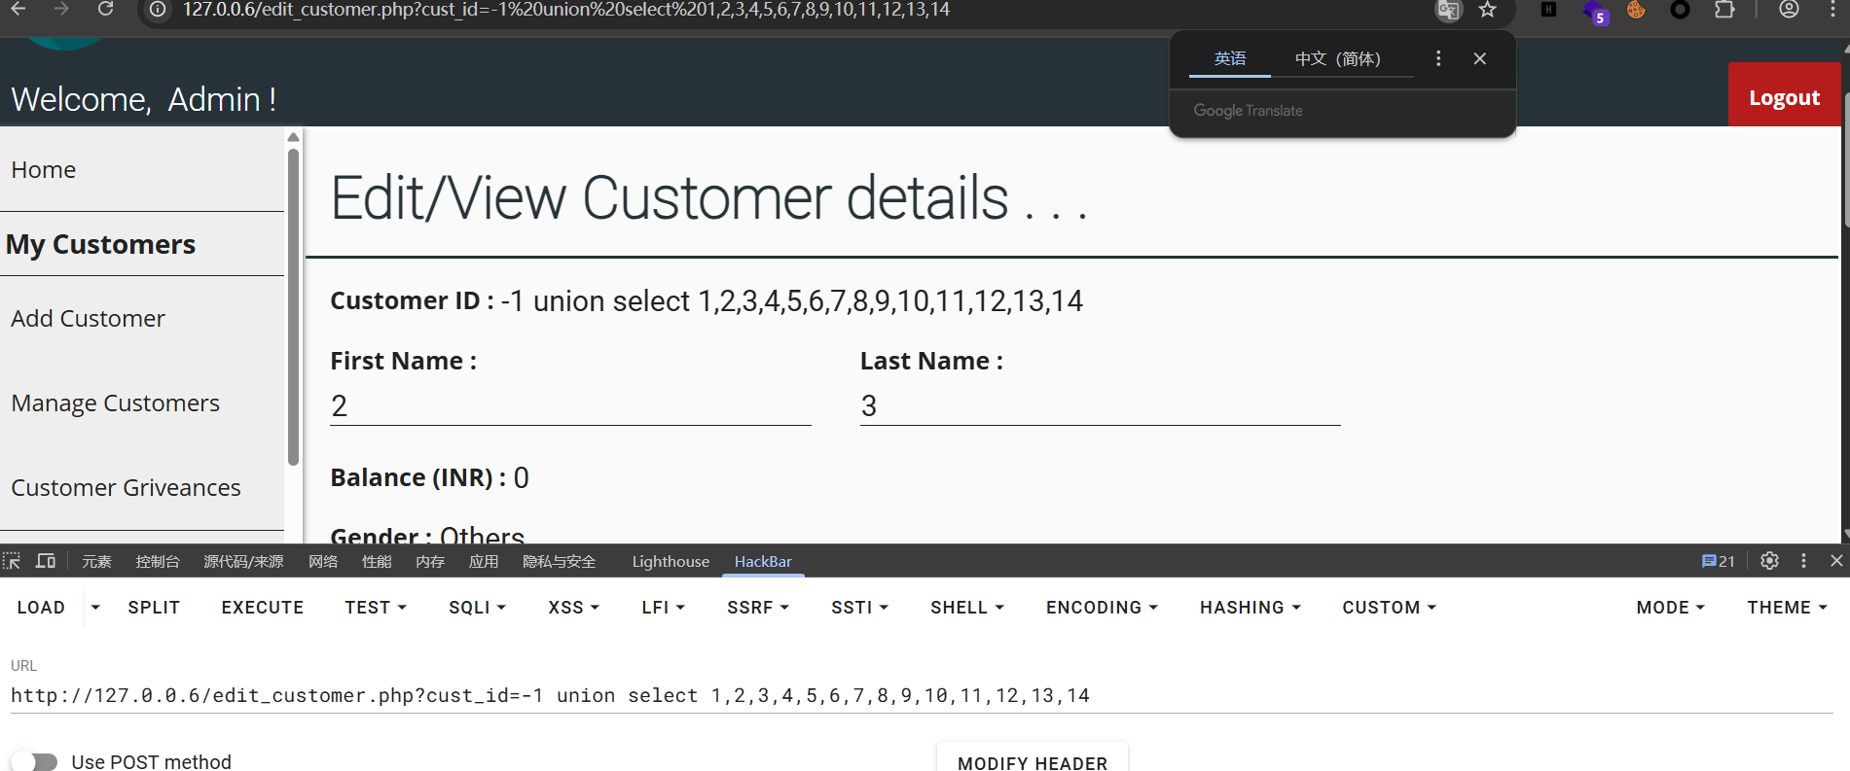
We can also see that all columns except those at positions 1, 4, and 10 have output. Therefore, we changed the payload to `?cust_id=-1 union select 1,database(),version(),4,(SELECT group_concat(column_name) FROM information_schema.columns WHERE table_name='customer'),6,7,8,9,10,11,12,13,14`. Observing the page afterwards, we found that the database name, all fields labeled 'customer', and the MySQL version number appeared.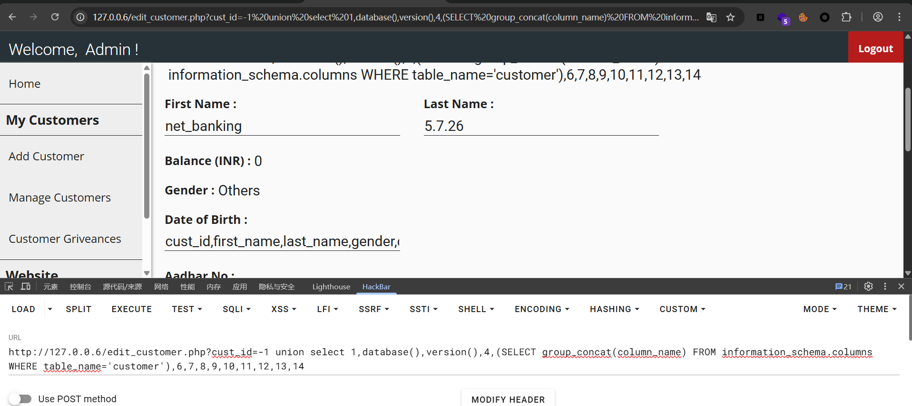
Therefore, there is a SQL vulnerability in the project's backend.

