Cross Platform Mobile Development in Titanium
Lab Exercise

Objectives
- Explore techniques for structuring JavaScript code
- Create component factories that will be easy to adapt cross platform
- Use Titanium’s built-in functions and directory structures to branch code and assets per-platform

Summary

In this lab assignment, we will begin to create a cross-platform mobile application for Android and iPhone devices called TiBountyHunter. TiBountyHunter is derived from an example application developed in the iOS development primer Head First iPhone Development. The purpose of the TiBountyHunter application is enable bounty hunters to track a list of fugitives on their mobile device.

Lab Specification

Create a new Titanium Mobile application called “TiBountyHunter”. This is the application we will progressively enhance over the course of the next several lab modules.

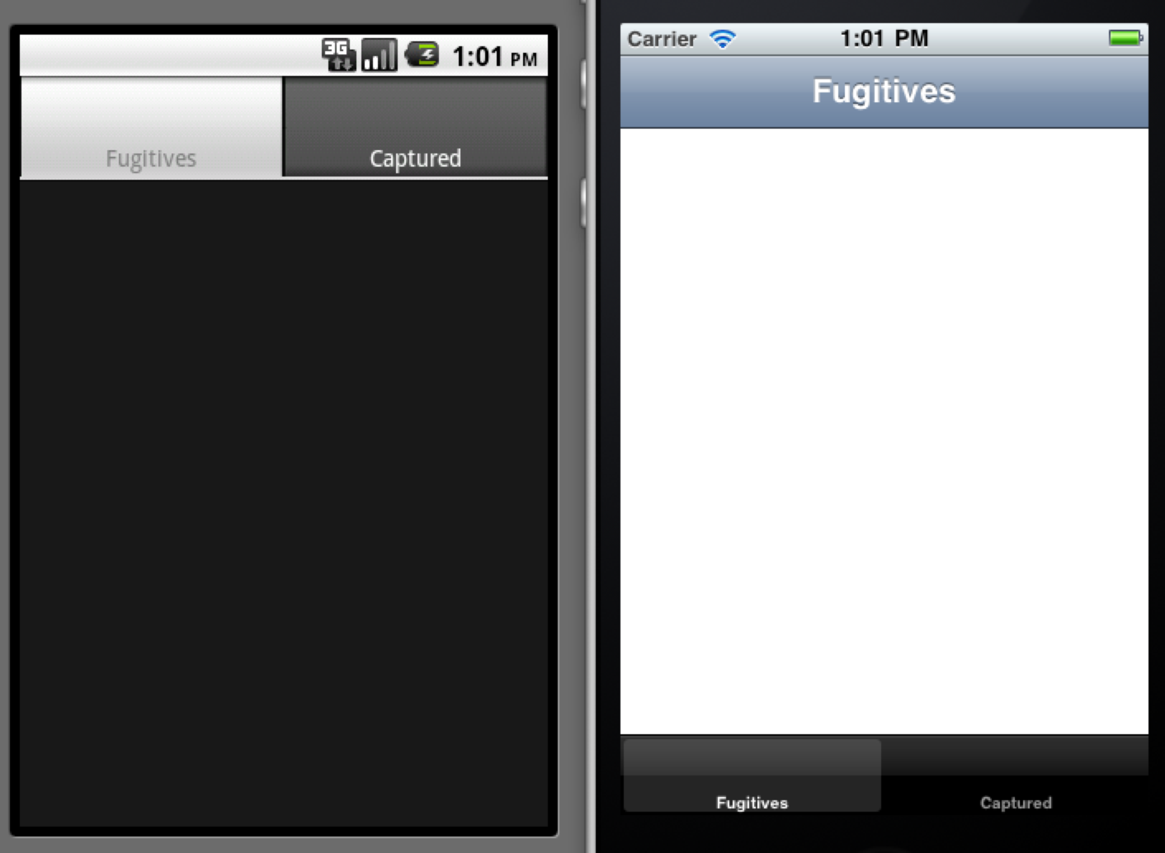

For this iteration, we will simply be setting up our project and structuring our code and resources for cross-platform development.

To successfully complete this lab, you must develop an application that meets the following description:

- Exposes only a single variable to the global scope
- Uses localized strings
- Provides a custom component constructor for a basic tab group (hint: the default application contains this code – you need to repurpose it)
- The tab group should have two windows titled “Fugitives” and “Captured”
- When your application launches, you should print the platform name to the console
- Bonus: Customize the splash screen for the application per-platform
- Bonus: Customize the home screen icon per-platform

