UI Fundamentals
Lab Exercise

Objectives
- Understand the basics of UI composition
- Use absolute positioning and vertical layouts to position controls
- Expand a library of app-specific UI components

Summary

In this lab assignment, we will create the basic user interface for TiBountyHunter using table views and windows, using dummy data. We will also add basic event handling and two new windows to the application, which will be used for viewing fugitive details and adding a new fugitive.

Lab Specification

Opening up the TiBountyHunter project you created for the last assignment, you will now put in place the main components of the application with new custom component constructors. Additionally, you will learn the basics of event handling by opening a new window when a table view row or button is clicked.

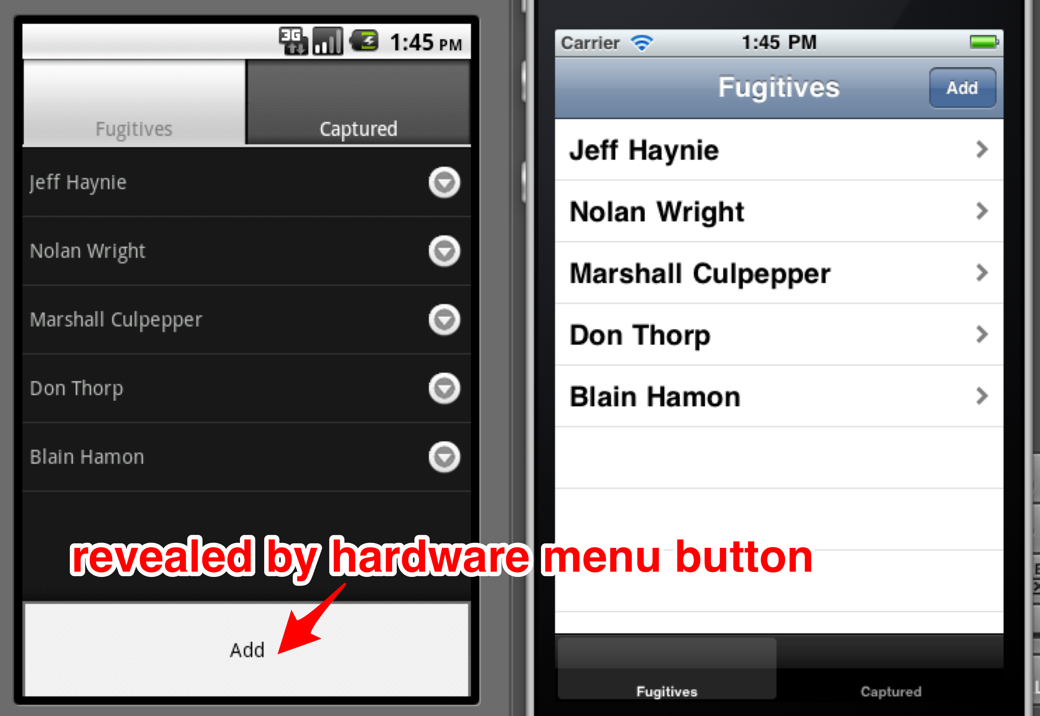

To successfully complete this lab, you must develop an application that meets the following description:

- Creates a table view in each window that shows a list of fugitives and a list of captured suspects. Use dummy data in the tables for now
- Provides a blank window that will (eventually) be used to add a new fugitive. This window will be opened by either clicking a button in the nav bar (customary on iOS) or by pressing a button in the menu (customary on Android), pictured above
- When a table view row is clicked, open a detail window for a fugitive which will contain text and buttons as shown below

