Working With Local Data
Lab Exercise

Objectives
- Understand how to interact with a local database
- Separate data access code from user interface code
- Bind data to user interface controls

Summary

In this lab assignment, we will back our fugitive list with actual data from a local SQL database (SQLite). We will display our data-driven fugitive list, and keep it up to date with every database change.

Lab Specification

Opening up the TiBountyHunter project you created for the last assignment, you will now add event handlers that will actually update a local database.

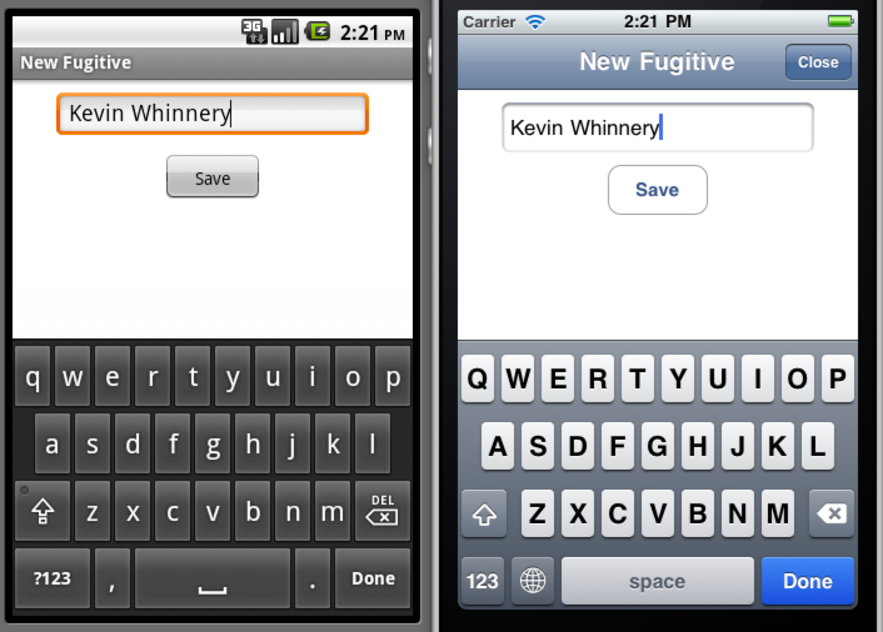

To successfully complete this lab, you must develop an application that meets the following description:

- Populate a table view with results from a SQL database
- Keep the fugitive lists up to date with every database change
- Implement the “Add” screen for the fugitive list, allowing the bounty hunter to add a new fugitive to the database
- Allow the user to delete fugitives
- Implement the “Capture” button, which will update a fugitive’s status in the database to “captured” and display him or her in the proper tab

