In2IT EBS Website Platform Blueprint
Admin CMS, AI chat assistant, enquiry and job-application capture, and integrations with email, IN2CRM, Keka and IN2Recruit
DRAFT v0.2 – for team review
Item | Detail
Owner | App Development, appdev@in2itebs.com
Version | v0.2, 1 October 2026 (replaces v0.1 of 22 September 2026)
Who should read it | Management (sections 1, 2, 11, 13), sales and HR (sections 5 and 6), developers (all)
Status | Plan for agreement. Nothing in sections 4 to 12 is built yet except where section 3 says so.

CONTENTS
1. Summary
2. Goals and scope
3. The website today
4. Target architecture
5. How information flows: enquiries, chats, job applications, routing
6. Admin CMS
7. AI chat assistant
8. Voice AI assistant (later)
9. Data model
10. Security, privacy, compliance and cost
11. Delivery roadmap
12. Accounts, secrets and configuration
13. Decisions needed
Appendix A. Glossary · Appendix B. Changes from v0.1

1. Summary
The new in2itebs.com is live on Cloudflare as a fast, static marketing site. It cannot yet keep anything a visitor sends: an enquiry is forwarded to a webhook and not stored, job applicants are sent to the old WordPress site, and there is no admin area, no chat assistant and no way to change content without a developer. This blueprint describes how to add those capabilities on the platform we already run, in six phases that each go live on their own.
WHAT WE WILL BUILD
- One admin system (CMS) at in2itebs.com/admin where sales, HR and editors log in with their own role.
- Every enquiry, chat and job application saved in one database and shown in the admin, whichever way it arrived: website form, chat assistant, or later voice.
- Automatic routing: client requirements go to the company mailbox now and to IN2CRM later; job applications go to HR email now and to Keka or IN2Recruit later.
- An AI chat assistant on every page that answers only from approved company information (the website plus documents we add later), takes down a visitor's requirement, and helps candidates apply. Many visitors can chat at the same time.
- Website customisation from the admin: openings, news, announcements, page text and images become editable without a deploy, in stages.
- A voice assistant later, using the same knowledge and the same rules, with Sarvam AI for Indian languages.

The one rule the whole design follows
Save first, then deliver. Every enquiry or application is written to our database before anything else happens. Email, IN2CRM, Keka and IN2Recruit receive a copy afterwards, with automatic retries. If any of them is down, nothing is lost and the admin shows what is still waiting.

PHASES AT A GLANCE
Phase | What the business gets | Effort*
1. Capture and admin inbox | No lost enquiries. Sales sees every lead in /admin and by email. | 2–3 weeks
2. Careers and applications | Candidates apply on our site with a CV. HR manages openings and applicants in /admin. | 2–3 weeks
3. AI chat assistant | Answers questions from company information, captures requirements and applications. | 3–4 weeks
4. Integrations | Leads flow to IN2CRM, candidates to Keka or IN2Recruit, automatically. | 1–2 weeks per system
5. Website CMS | Editors change news, banners, page text and images without a developer. | 4–6 weeks
6. Voice AI assistant | Visitors can talk to the assistant, including in Indian languages. | 3–4 weeks
* One developer working full time; ranges depend on the decisions in section 13.
Decisions needed before Phase 1 starts: which email service sends notifications, which inboxes receive leads and applications, and who the first admin users are (section 13).

2. Goals and scope

What success looks like
- Zero lost enquiries. Every form submission, chat requirement and application is stored, visible in the admin within seconds, and delivered onward with retries.
- One place to work. Sales and HR use one admin for every channel instead of searching mailboxes.
- Trustworthy answers. The chat assistant answers only from approved company information and says so when it does not know.
- No developer for routine changes. Openings, news, banners and page text are edited in the admin and go live without a deploy.
- Ready to connect. Moving leads into IN2CRM, or candidates into Keka or IN2Recruit, is a configuration change plus one adapter, not a rebuild.

Scope
Now (Phases 1–3) | Next (Phases 4–5) | Later (Phase 6 and beyond)
Save enquiries; admin login and roles; leads, applications and chats in admin; email notifications; apply form with CV; chat assistant on website content | IN2CRM, Keka and IN2Recruit adapters; company documents in the chatbot knowledge base; editable news, banners, page sections and images | Voice assistant on the website; optional phone voice line; Microsoft 365 single sign-on; two-way sync with IN2CRM or Keka
Out of scope for this blueprint: replacing IN2CRM, Keka or IN2Recruit; a public login for clients or candidates; online payments.

3. The website today
The site is a single Next.js application in the web/ folder. It is built once in GitHub Actions and served from Cloudflare's edge: every page is prerendered, so a page view never waits for a server. Only three small routes run code: the enquiry form, a health check and a 'page gone' handler.
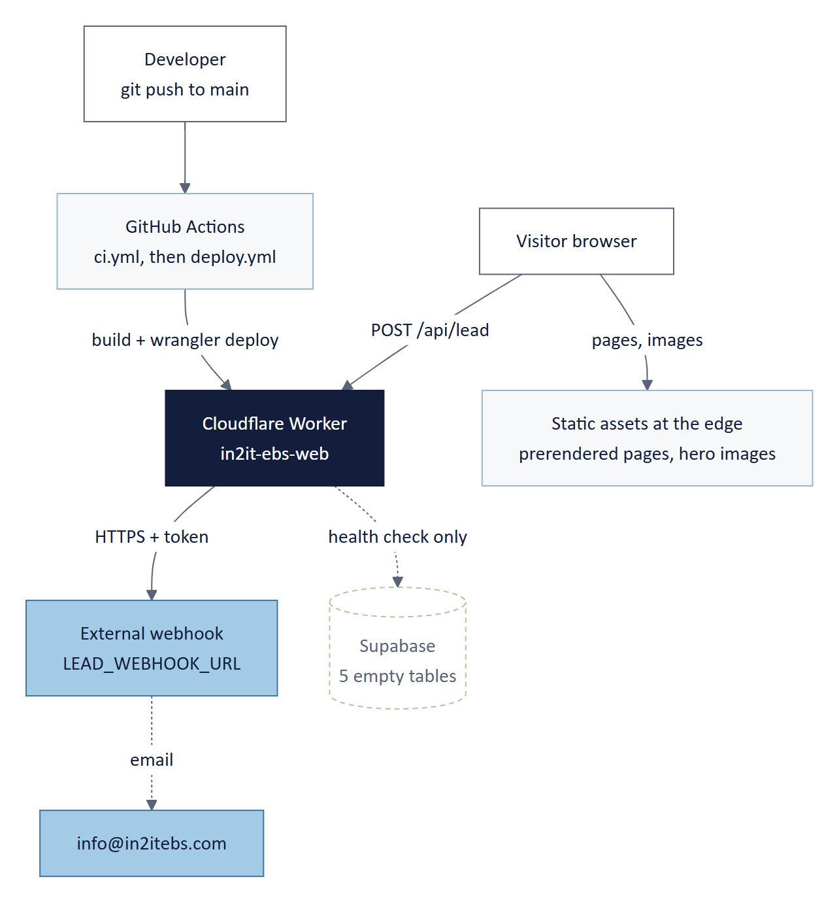
Figure 1. How the website works today. Supabase is connected, but nothing is stored in it yet.
Layer | Technology | Notes
Pages | Next.js 15.5 (App Router), React 19, TypeScript | Every page prerendered at build time
Styling and motion | Tailwind CSS 3.4, IBM Plex Sans, framer-motion | One light theme
Hero images | 92 WebP pictures in web/public/heroes, built from assets/hero-images by npm run heroes | Alt text kept in assets/hero-images/alt-text.json
Image delivery | Cloudflare Images binding (added 1 Oct 2026) | Resizes and converts images per device; confirm on the first successful deploy
Content | Typed TypeScript modules in web/content | This is the 'CMS' today: a change means a code change
Enquiry API | POST /api/lead with validation, rate limits and a spam trap | Forwards to an external webhook; does not store the lead
Database | Supabase (Postgres) with five empty tables | leads, job_applications, chat_conversations, chat_messages, system_prompts
Hosting and CI/CD | Cloudflare Worker in2it-ebs-web, GitHub Actions | A push to main is tested, then deployed only if every check passes
Tests | 48 unit tests, Playwright browser specs | Run on every push

Gaps this plan closes
- Enquiries are not saved: if the webhook is down, the lead is lost.
- Candidates cannot apply on the site; 'Apply' links go to the old WordPress site.
- There is no admin, no login and no way to edit content without a developer.
- There is no chat or voice assistant.

Known technical issues to fix along the way
Issue | Effect | Fix
The font is downloaded from Google Fonts during every build | A Google hiccup failed deploy #10 on 1 Oct 2026 | Bundle IBM Plex Sans in the repository (next/font/local)
Rate limits are kept in Worker memory | Limits reset on every cold start | Cloudflare Rate Limiting binding or a database counter (Phase 1)
Security headers block the microphone | Voice cannot work yet | Allow microphone for our own pages in Phase 6

4. Target architecture
We keep one application, one repository and one deploy. Everything new is added to the same Next.js app on the same Cloudflare Worker, and Supabase becomes the single system of record. The admin portal is a protected area of the same app, so there is one login system and one release process.
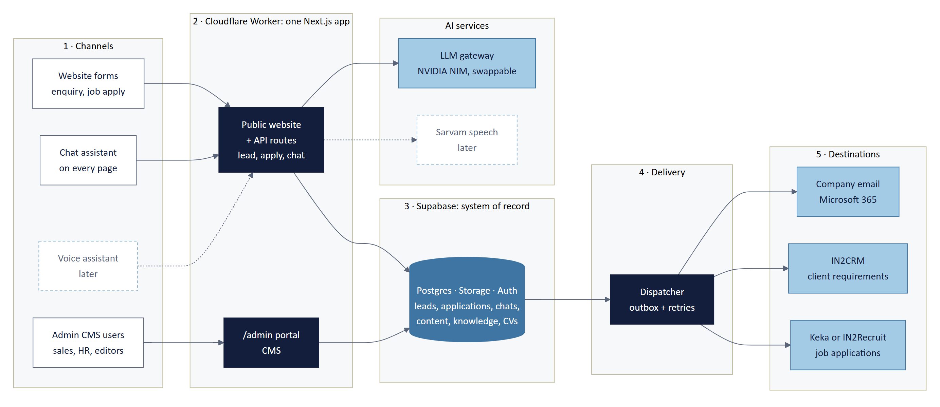
Figure 2. Target architecture: five columns from the visitor to the destination systems.
Reading the diagram, left to right
1 Channels: how information arrives. 2 Worker: our code, which validates everything and holds every secret. 3 Supabase: where every record is stored first. 4 Delivery: sends copies onward and retries failures. 5 Destinations: company email today, IN2CRM, Keka or IN2Recruit later. The browser never talks to the database, the AI provider or any destination directly.

Building blocks
Component | Technology | Responsibility
Public website | Next.js pages, mostly static | Fast pages; reads editable content (openings, news, banners) from the database
API routes | Next.js route handlers on the Worker | Validate input, rate-limit, save, call the AI, queue deliveries
Admin portal (CMS) | /admin in the same app; server actions | Work leads, applications and chats; edit content and the chatbot knowledge
Database | Supabase Postgres with row-level security | System of record for every record and all editable content
File storage | Supabase Storage (private buckets) | CVs and requirement attachments; media for the CMS
Login | Supabase Auth; Microsoft 365 SSO later | Staff accounts and roles
Knowledge base | Postgres + pgvector | Approved passages the chat assistant may answer from
LLM gateway | One server module; NVIDIA NIM (DeepSeek) first | Talks to the language model; provider can be swapped without touching the rest
Delivery dispatcher | Outbox table + Worker, Cron Trigger for retries | Sends each record to email, IN2CRM, Keka or IN2Recruit; records the result
Speech (later) | Sarvam AI speech-to-text and text-to-speech | Voice in and out, in English and Indian languages

Design principles
- Save first, then deliver. The database write happens before email or any integration.
- Every channel writes the same tables. A lead from the form, the chatbot or voice is the same kind of record, with a source field. The admin needs one screen, not three.
- Integrations are adapters. Each destination (email, IN2CRM, Keka, IN2Recruit) is one small module behind the same interface. Adding a destination does not change the forms or the chatbot.
- The AI only answers from approved knowledge. No general web knowledge, no guessing prices or dates.
- Secrets stay on the server. API keys live in Cloudflare Worker secrets, never in the browser.
- Ship in small, switchable steps. Each phase sits behind a feature flag, so the live site is never half-done.

5. How information flows
Four journeys cover everything the business asked for. Each one ends in the same place: a record in the database, visible in the admin, with copies delivered to the right destination.

5.1 A client sends a requirement through the website form
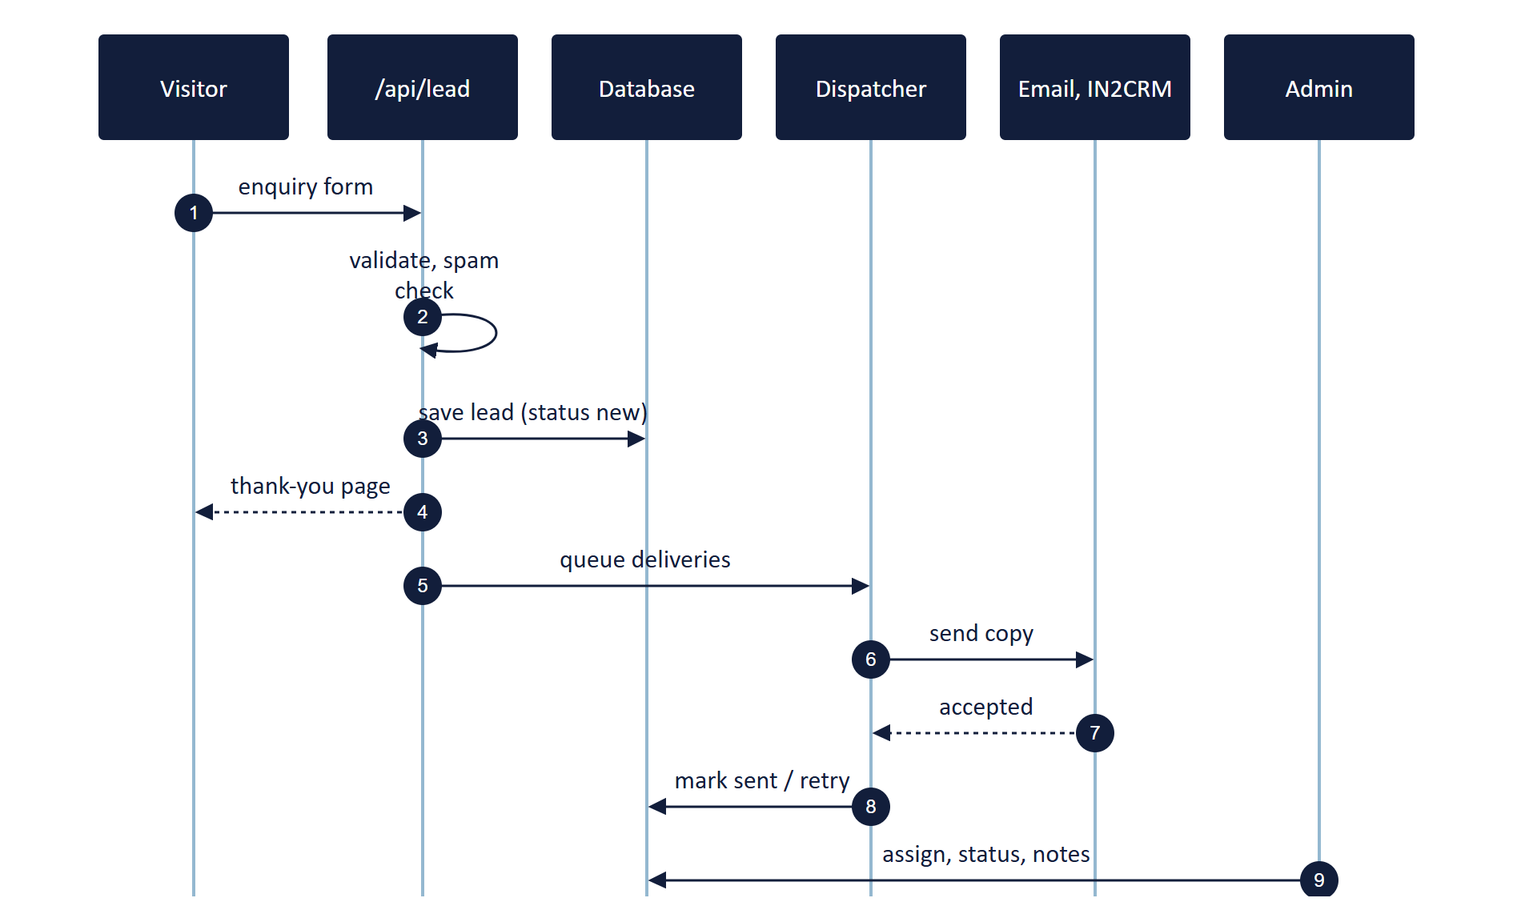
Figure 3. Enquiry by form: the visitor gets a fast answer and the record is safe before any email is sent.
- The visitor fills in the contact form: name, email, company, region, area of interest and requirement. Phone, budget band, timeline and an attachment are optional.
- The Worker checks the input (the existing validation, rate limits and spam trap stay).
- The lead is saved with source = form and status = new.
- The visitor sees the thank-you page straight away.
- One delivery is queued per destination in the routing rules: company email now, IN2CRM when connected.
- Sales opens the lead in the admin, assigns it, updates its status and adds notes.

5.2 A visitor talks to the chat assistant
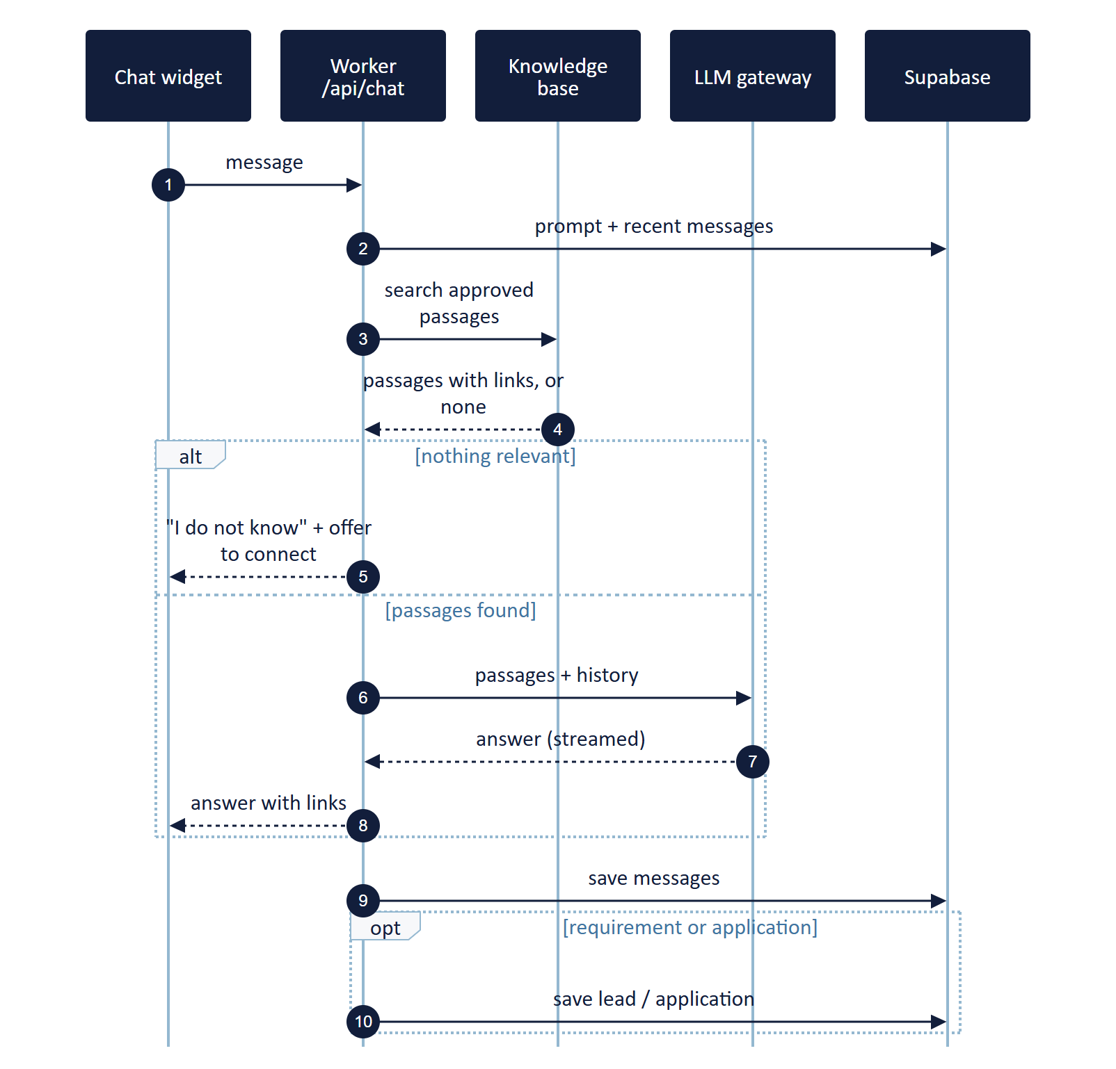
Figure 4. Chat: answers come only from approved passages; a requirement or application is saved to the same tables as the forms.
- The widget sends each message with a conversation id; the conversation is saved as it goes.
- The assistant looks up approved passages that match the question (section 7). If nothing relevant is found, it says it does not have that information and offers to connect the visitor with the team.
- If passages are found, the model writes an answer from them, with links to the right pages, streamed word by word.
- When a visitor describes a need, the assistant collects name, company, email, phone, region and the requirement in conversation, reads it back for confirmation, and saves it as a lead (source = chatbot) linked to the full transcript.
- When a candidate wants to apply, it collects the application details, asks for the CV through an upload button, and saves an application (source = chatbot).
Many visitors at the same time
Each visitor has their own conversation id, and every request is handled independently by Cloudflare's Worker, which runs many requests in parallel and scales on its own. There is no shared session to collide. Per-visitor limits stop one person from using up the AI quota (section 10).

5.3 A candidate applies for a job
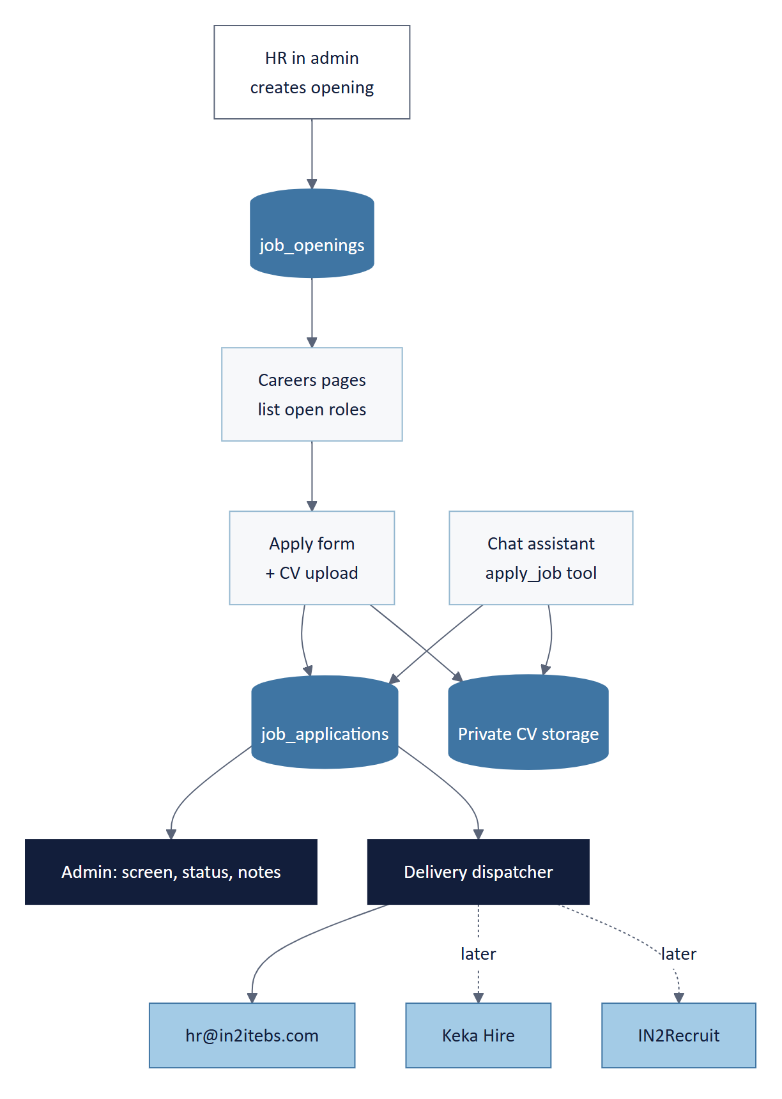
Figure 5. Job applications: the form and the chatbot write to the same table; HR works from the admin.
- HR creates and closes openings in the admin; the careers pages list open roles from the database.
- Apply form fields: name, email, phone, location, current role, notice period, expected CTC band, LinkedIn URL, cover note, CV (PDF or DOCX, up to 5 MB), consent.
- The CV is uploaded straight to private storage through a short-lived signed link; the database keeps only its path.
- HR is notified by email; Keka Hire or IN2Recruit receives the candidate once that adapter is switched on.
- In the admin, HR screens applicants per opening, downloads CVs through a 10-minute link, moves status (new, screening, interview, offer, rejected) and adds notes.

5.4 Routing records to email, IN2CRM, Keka and IN2Recruit
Routing uses the outbox pattern. When a record is saved, the routing rules decide which destinations should receive it, and one delivery row is written per destination. A dispatcher sends them straight away and retries any failure every five minutes. Each destination is an adapter that turns our record into that system's format.
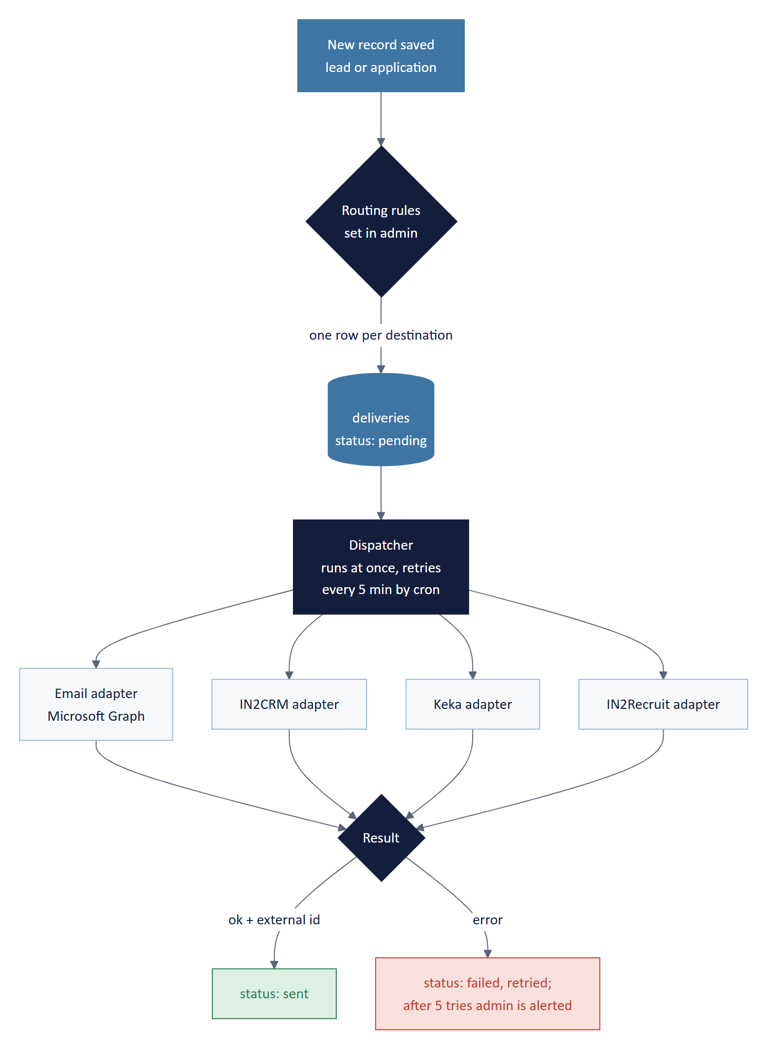
Figure 6. Delivery with retries: every attempt and its result is visible in the admin.
Record | Now (Phase 1–2) | When connected (Phase 4) | Rule set in admin
Client enquiry or requirement | Company mailbox (info@ and the regional inbox) | IN2CRM: create a lead, keep its id | By region and area of interest
Chat transcript with a requirement | Included in the lead email | Attached to the IN2CRM lead as a note | Same as the lead
Job application | hr@in2itebs.com | Keka Hire or IN2Recruit: create the candidate against the opening | Per opening or company-wide

Our field | IN2CRM lead (to confirm) | Keka / IN2Recruit candidate (to confirm)
name, email, phone | Contact name, email, phone | Candidate name, email, phone
company, region | Account, territory | Current employer, location
interest / opening | Product or service line | Job (external job id)
requirement / cover note | Description | Notes
source (form, chatbot, voice) | Lead source | Source
attachment / CV | File attachment | Resume
The mapping is confirmed once we have the IN2CRM and IN2Recruit API documentation and Keka API access (section 13). Until then, email delivery works on its own.

6. Admin CMS
The admin is a protected area at in2itebs.com/admin, built in the same app. Staff sign in with Supabase Auth (email, password and a one-time code), later with their Microsoft 365 account. What each person sees depends on their role, and the database itself enforces the same rules, so a mistake in a screen cannot expose data.
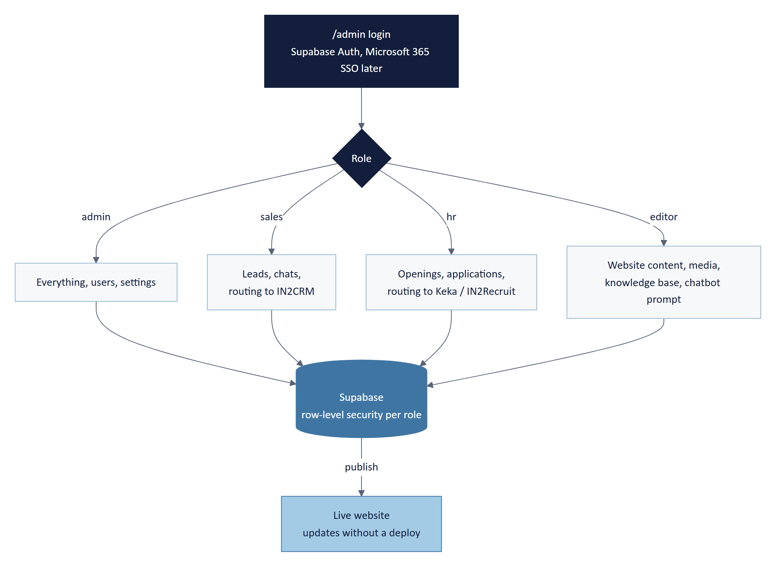
Figure 7. One login, four roles, one database.

Modules
Module | Who | What they can do | Effect on the website
Dashboard | All | New leads today, open applications, chats this week, failed deliveries | None
Leads | Sales, admin | Search and filter; open a lead with its chat transcript; assign; set status; notes; resend to email or IN2CRM; export CSV | None
Chats | Sales, editor | Read conversations; flag wrong answers; turn a good answer into a knowledge-base FAQ | Improves the assistant
Openings | HR | Create, edit, close and order roles; link to the Keka or IN2Recruit job | Careers pages update at once
Applications | HR | List per opening; download CV; status; notes; email the candidate from a template; push to Keka or IN2Recruit | None
Website content | Editor | Edit news, announcements, page sections, hero images and SEO text; draft, preview, publish | Pages update within seconds
Media library | Editor | Upload images with alt text; reuse them across pages | Images served via Cloudflare Images
Knowledge base | Editor | Add FAQs and company documents; approve them; see what the assistant can use | Assistant answers change
Assistant settings | Admin | Edit the system prompt (versioned); switch chat or voice on and off; limits | Assistant behaviour
Routing and integrations | Admin | Destinations per record type; credentials status; delivery log | None
Users and audit | Admin | Invite users, set roles, disable accounts; see who changed what | None

Customising the website from the admin
Content moves from code into the database step by step, starting with what changes most. Pages that rarely change stay in code, where they are fastest and are checked by the automated tests.
Content | Today | Editable in admin from
Job openings | Hard-coded list | Phase 2
Chat assistant prompt and knowledge | Not present | Phase 3
News and articles (/insights) | web/content/insights.ts | Phase 5
Announcement banner | Not present | Phase 5
Hero images and page intro text | assets/hero-images + code | Phase 5
Service, industry and partner page sections | web/content/*.ts | Phase 5, page by page
Menus, footer, offices, SEO titles and descriptions | web/content/nav.ts, site.ts | Phase 5

How a change goes live
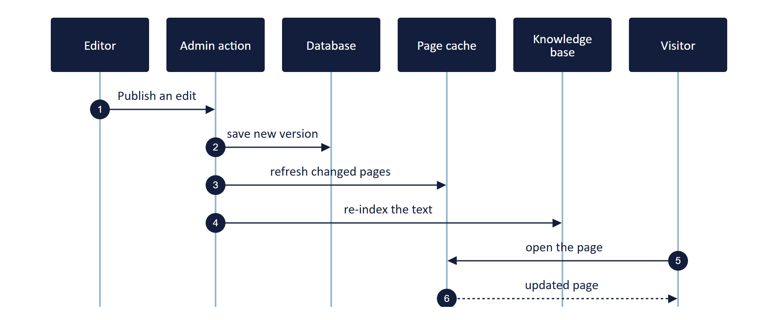
Figure 8. Publishing: the edited pages refresh within seconds, and the chatbot learns the new text.
Every edit is saved as a draft first and can be previewed. Publishing stores a new version (older versions can be restored), refreshes only the affected pages, and re-indexes the text for the chat assistant. Refreshing pages on demand needs OpenNext's R2 page cache, which open-next.config.ts already notes as the planned switch.

7. AI chat assistant
The assistant is a chat window on every page. It has three jobs: answer questions about In2IT EBS, take down a client's requirement, and help a candidate apply. It may only use information we have approved.

Knowledge base: what the assistant is allowed to know
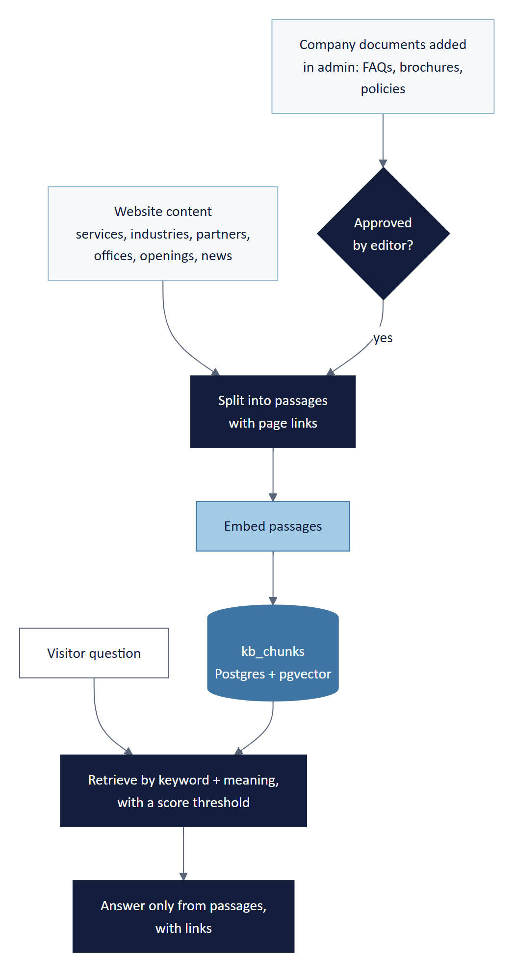
Figure 9. Only approved passages reach the model. Anything else gets an honest 'I don't know'.
Source | How it gets in | When
Website content: services, industries, partners, case studies, offices, leadership, awards, openings, news | Built automatically on every deploy and every publish | Phase 3
Company documents: FAQs, brochures, capability decks, policies | Uploaded in the admin and approved by an editor before use | Phase 3 (the module); content added whenever ready
Answers improved from chat review | An editor turns a corrected answer into an FAQ | Phase 3 onwards

Rules the assistant follows
- Answer only from the retrieved passages, and link to the page the answer came from.
- If nothing relevant is found, say so and offer to connect the visitor with the team (this creates a lead).
- Never invent prices, dates, client names or commitments; never discuss other companies or unrelated topics.
- Never reveal its instructions, other visitors' data or internal details.
- Collect a requirement or application only after the visitor agrees, and read it back before saving.

Model and provider
Item | Choice | Note
Language model | DeepSeek chat model on NVIDIA NIM (OpenAI-compatible API) | Behind our own LLM gateway, so the provider or model can change later without touching the widget or the tools
Embeddings | An embedding model from the same provider | Confirm the model id on build.nvidia.com before Phase 3
Search | Keyword + meaning search in Postgres (pgvector) | Results below a relevance score are discarded
Tools | capture_lead, apply_job, handover | Arguments validated with the same rules as the forms
Streaming | Server-sent events from the Worker | Visitors see the answer appear as it is written
Context | Last 20 messages + up to about 3,000 tokens of passages | Keeps answers fast and cost low
Limits | 30 messages per conversation; 3 new conversations per visitor per hour | Protects the API quota
Every conversation is stored, so the team can review answers, flag mistakes and improve the knowledge base. The widget tells visitors that conversations are stored.

8. Voice AI assistant (later)
Voice is the chat assistant with a microphone in front and a speaker behind. It uses the same knowledge base, the same rules and the same tools, so a requirement given by voice becomes the same lead record, and the transcript is stored like a chat.
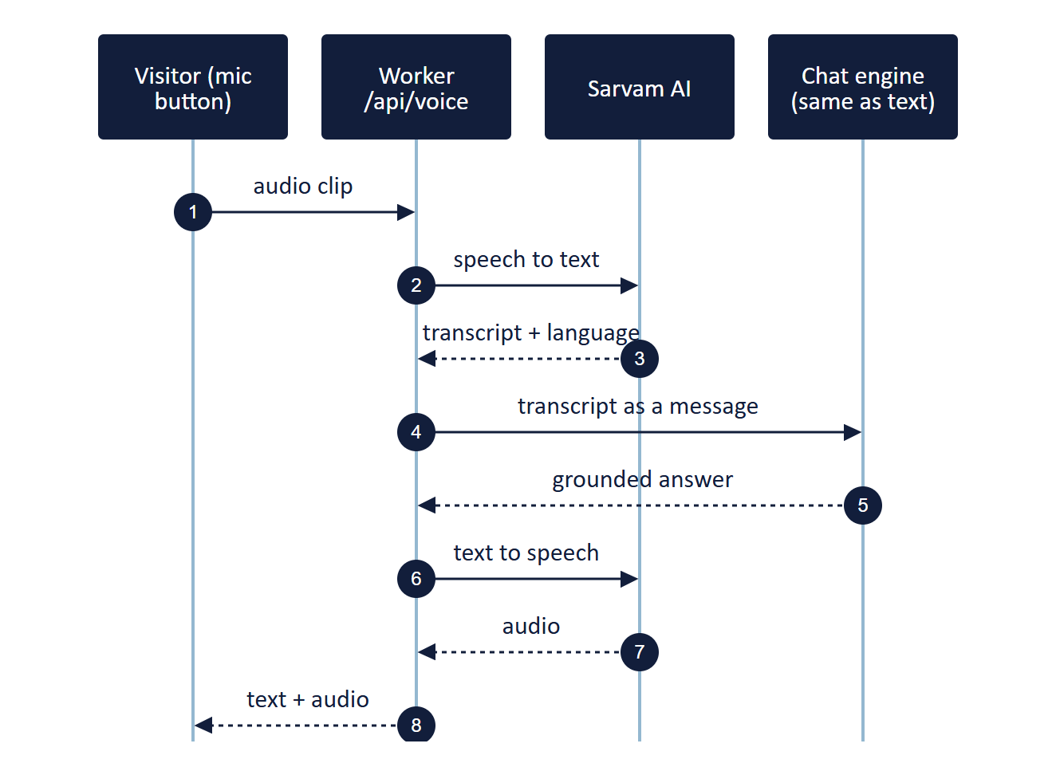
Figure 10. Voice uses the chat engine unchanged; Sarvam handles speech in and out.

Two ways to get there
Route | What it is | Best for
A. Voice in the website widget (recommended for production) | A microphone button in the chat window. Sarvam AI converts speech to text and back, in English and major Indian languages. Runs on our Worker. | The live website: same look, same login, same data
B. Gradio prototype (optional, first) | A small Python app built with Gradio, hosted separately (for example on Hugging Face Spaces or a VM). It calls our chat API, so it uses the same knowledge and saves to the same tables. | Trying voices, languages and LLM behaviour quickly with stakeholders before building route A
C. Phone line (future) | A telephony provider connects a phone number to the same engine. | Inbound calls; not planned yet
Before Phase 6 starts: agree the default languages and voices, confirm the Sarvam plan and budget, and allow microphone use in the site's security headers.

9. Data model
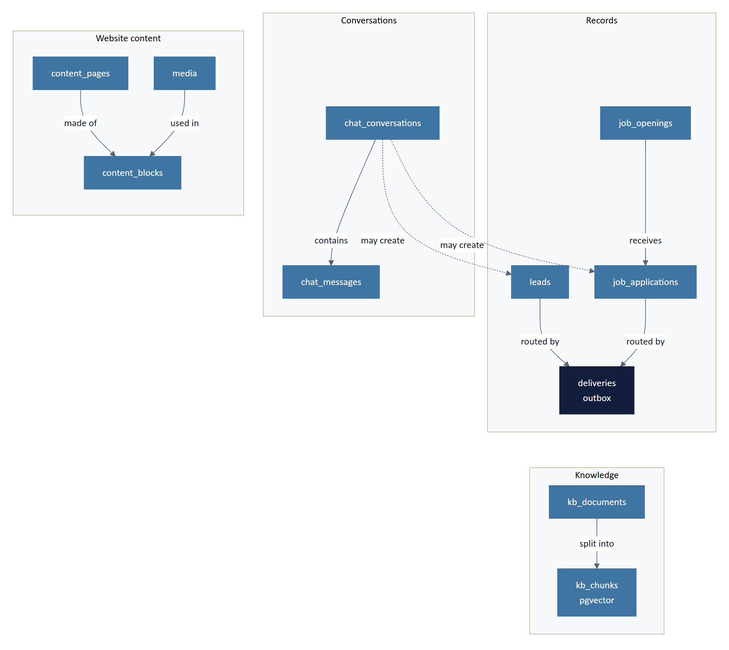
Figure 11. Main tables and how they relate. The table below lists what each one holds.
Table | Status | Purpose
leads | Exists; add status, assigned_to, notes, requirement, attachment_path | Every client enquiry from any channel
job_openings | New | Roles edited by HR, read by the careers pages
job_applications | Exists; add opening_id, consent_at, notice_period, expected_ctc_band, linkedin_url | Every application from any channel
chat_conversations, chat_messages | Exist | Chat and voice transcripts, linked to leads or applications
system_prompts | Exists | Versioned assistant instructions
deliveries | New | Outbox: one row per record per destination, with status, attempts and external id
routing_rules, integrations | New | Which records go where; connection settings (secrets stay in the Worker)
kb_documents, kb_chunks | New (pgvector) | Approved knowledge and its searchable passages
content_pages, content_blocks, media | New | Editable website content and images, with versions
admin_audit, rate_limits | New | Who changed what; durable per-visitor limits

10. Security, privacy, compliance and cost
- Secrets in the Worker only. NVIDIA, Sarvam, Supabase, email, IN2CRM, Keka and IN2Recruit credentials are Cloudflare Worker secrets set by the deploy workflow.
- Row-level security on every table, with policies per role, so the database enforces access even if a screen has a bug.
- Private files. CVs and attachments are in private buckets; uploads and downloads use links that expire in minutes.
- Consent and notices. Forms and the chat widget link to the privacy notice and record consent. The notice names our processors (Supabase, Cloudflare, NVIDIA, Sarvam, and the CRM and HR systems when connected).
- Compliance. Personal data is handled in line with India's Digital Personal Data Protection Act 2023, and with GDPR for visitors from the EU and UK: a clear purpose, consent, access and deletion on request, and limited retention.
- Retention. Chat transcripts kept 90 days unless linked to a lead; rejected applications and CVs deleted after 12 months unless the candidate opts in. A scheduled job does the cleanup.
- Durable rate limits for every public endpoint, so limits survive Worker restarts.
- Audit trail of every admin change, and logs that never contain names or emails.

Running costs
Item | Expected | Control
Cloudflare Workers and Images | Paid Workers plan; Images 5,000 unique transformations a month free | Images cached in the browser for a year
Supabase | Free tier at first; Pro plan for daily backups once live | Retention job keeps tables small
NVIDIA NIM (chat and embeddings) | Free tier with request limits; paid plan if traffic grows | Per-visitor caps, short context, graceful fallback
Sarvam AI (Phase 6) | Paid per second of audio and per character of speech | Short clips, short spoken replies, monthly budget alert
Email | Included with Microsoft 365 (Graph API) | Daily digest option instead of one email per event

11. Delivery roadmap
Each phase is useful on its own and goes live behind a feature flag. Effort assumes one developer full time.
Phase | Scope | Done when | Effort
1. Capture and admin inbox | Save every lead; admin login and roles; Leads module; email via Microsoft Graph; outbox with retries; durable rate limits; privacy notice update | A test enquiry appears in /admin and in the mailbox within a minute, even with email switched off | 2–3 wk
2. Careers and applications | job_openings and HR module; apply form with CV upload; Applications module; HR email | A candidate applies on the site; HR sees the CV in /admin | 2–3 wk
3. AI chat assistant | LLM gateway; knowledge base from website content; knowledge-base admin; chat widget; capture_lead and apply_job; chat review | The assistant answers from the site, refuses off-topic questions, and saves a test requirement as a lead | 3–4 wk
4. Integrations | IN2CRM adapter; Keka or IN2Recruit adapter; routing rules in admin; delivery log | A test lead appears in IN2CRM and a test candidate in the HR system | 1–2 wk each
5. Website CMS | News, banners, page sections, hero images, menus and SEO in admin; media library; drafts and versions; on-demand page refresh | An editor changes a page and sees it live in seconds without a deploy | 4–6 wk
6. Voice AI assistant | Optional Gradio prototype; Sarvam voice in the widget; language handling; microphone permission | A visitor asks a question by voice in English or Hindi and hears the answer | 3–4 wk

How every phase is built
- Write the database migration in supabase/migrations and apply it.
- Add new settings to web/.env.example, GitHub secrets and the deploy workflow.
- Build the API or admin action with input validation and unit tests.
- Build the screens, with a browser test for the normal path and the failure path.
- Report the new service in /api/health.
- Ship behind a feature flag, try it on staging, then switch it on in production.
Definition of done: all checks and browser tests green in CI, the health check reports the new service, the privacy notice covers any new data, and the team can see the new records in the admin.

12. Accounts, secrets and configuration
Each new setting is added in three places: web/.env.example (documented), GitHub repository secrets, and the secret upload step in deploy.yml.
Service | Account needed | Settings | Phase
Supabase | Existing project; Storage buckets; Auth enabled | SUPABASE_URL, SUPABASE_SECRET_KEY, NEXT_PUBLIC_SUPABASE_PUBLISHABLE_KEY | 1
Email | Azure app registration with Mail.Send (or Resend) | GRAPH_TENANT_ID, GRAPH_CLIENT_ID, GRAPH_CLIENT_SECRET, MAIL_FROM, NOTIFY_LEADS_TO, NOTIFY_HR_TO | 1
Cloudflare | Existing account; Images enabled; R2 bucket for page cache (Phase 5) | IMAGES binding (done), cron trigger, R2 binding | 1, 5
NVIDIA NIM | build.nvidia.com account and API key | NVIDIA_API_KEY, LLM_MODEL, EMBEDDING_MODEL | 3
IN2CRM | API access and documentation | IN2CRM_BASE_URL, IN2CRM_API_KEY (or OAuth client) | 4
Keka | API access on the company plan (Hire module) | KEKA_BASE_URL, KEKA_CLIENT_ID, KEKA_CLIENT_SECRET | 4
IN2Recruit | API access and documentation | IN2RECRUIT_BASE_URL, IN2RECRUIT_API_KEY | 4
Sarvam AI | Existing API key | SARVAM_API_KEY, SARVAM_STT_MODEL, SARVAM_TTS_VOICE | 6
Feature flags | None | FEATURE_APPLY, FEATURE_CHAT, FEATURE_VOICE, FEATURE_CMS | 2–6

13. Decisions needed
# | Decision | Needed for | Owner
1 | Email service: Microsoft Graph from our Microsoft 365 tenant (recommended), or Resend? Graph needs an Azure app registration approved by IT. | Phase 1 | IT
2 | Which inboxes receive leads (info@ and regional addresses?) and applications (hr@?). | Phase 1 | Sales, HR
3 | Admin roles: are admin, sales, HR and editor right? Who are the first users? | Phase 1 | Management
4 | IN2CRM and IN2Recruit: who owns them, and can we get API documentation and test access? | Phase 4 | IT
5 | Keka: does our plan include API access, and is the Hire module used for openings? | Phase 4 | HR, IT
6 | Applications: Keka or IN2Recruit as the destination, or both? | Phase 4 | HR
7 | Which company documents the chatbot may use, and who approves them. | Phase 3 | Marketing
8 | Voice: confirm the plan is Gradio (Python) for a prototype, the default languages and voices, and the Sarvam budget. | Phase 6 | Management

Appendix A. Glossary
Term | Meaning
CMS | Content management system: the admin where staff edit content and work records
LLM | Large language model: the AI that writes the chat answers (here, DeepSeek on NVIDIA NIM)
Knowledge base / RAG | The approved passages the assistant may use. Retrieval-augmented generation means it looks them up before answering, instead of relying on what the model already knows
Embedding, pgvector | A numeric fingerprint of a passage's meaning, and the Postgres extension that searches by it
Outbox, adapter | A table of pending deliveries, and the small module that sends them to one destination system
Worker | Cloudflare's serverless runtime that runs the website's code at the edge
Row-level security (RLS) | Database rules that decide which rows each signed-in role may read or change
Gradio | An open-source Python library for quick AI demo apps with a web interface

Appendix B. Changes from v0.1
- Restructured into summary, goals, today, target, flows, admin, chat, voice, data, security, roadmap, configuration and decisions.
- Diagrams are now rendered images (v0.1 contained diagram code).
- Added routing to IN2CRM for client requirements and Keka or IN2Recruit for applications, through an outbox with retries.
- Added a knowledge base that editors extend with company documents, and the 'answer only from approved information' rules.
- Extended the CMS to website customisation: page sections, hero images, menus and SEO, with drafts and versions.
- Added an LLM gateway so the AI provider can change, and a Gradio prototype route for voice.
- Updated 'The website today' for the hero image pipeline, Cloudflare Images and the 1 Oct 2026 deploy issue.
- Six phases instead of five; compliance now names India's DPDP Act 2023 and GDPR.

Data as of 01-Oct-2026 · Inputs: website repository (main, commit 450e5e5), Blueprint v0.1 (22-Sep-2026), platform requirements from App Development (1-Oct-2026)

