**Naïve occupancy**

“FNLC” = four-note location call

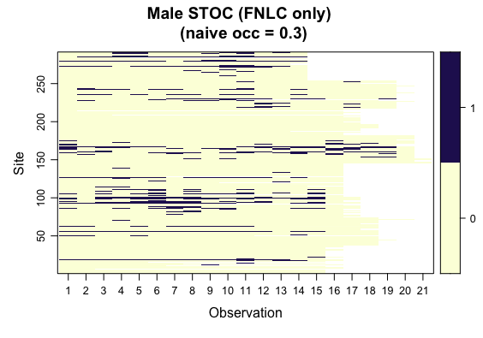

**Constant *p*, constant *psi***

**All STOC**

nPars AIC delta AICwt cumltvWt

p7_any 10 2182.78 0.00 1.0e+00 1.00

p3_any 9 2220.56 37.78 6.3e-09 1.00

p5_any 4 2305.00 122.22 2.9e-27 1.00

p8_any 5 2306.99 124.21 1.1e-27 1.00

p2_any 3 2340.87 158.09 4.7e-35 1.00

p4_any 4 2342.84 160.06 1.8e-35 1.00

p6_any 3 2391.64 208.86 4.4e-46 1.00

p1_any 2 2424.98 242.20 2.6e-53 1.00

p7_any <- occu(~dist + site + effort ~1, data = input_any) #top model

**Female STOC (any calls)**

nPars AIC delta AICwt cumltvWt

p7_fem 10 1275.45 0.00 9.9e-01 0.99

p3_fem 9 1284.33 8.88 1.2e-02 1.00

p8_fem 5 1333.65 58.20 2.3e-13 1.00

p5_fem 4 1336.26 60.80 6.2e-14 1.00

p4_fem 4 1342.10 66.64 3.3e-15 1.00

p2_fem 3 1345.30 69.85 6.7e-16 1.00

p6_fem 3 1345.85 70.39 5.1e-16 1.00

p1_fem 2 1354.75 79.29 6.0e-18 1.00

p7_fem <- occu(~dist + site + effort ~1, data = input_female) #top model

**Female STOC (FNLC/pairs)**

nPars AIC delta AICwt cumltvWt

p7_fem_fnlcp 10 1207.32 0.00 9.6e-01 0.96

p3_fem_fnlcp 9 1213.82 6.50 3.7e-02 1.00

p8_fem_fnlcp 5 1259.03 51.71 5.7e-12 1.00

p5_fem_fnlcp 4 1260.53 53.21 2.7e-12 1.00

p4_fem_fnlcp 4 1265.27 57.95 2.5e-13 1.00

p2_fem_fnlcp 3 1267.35 60.03 8.9e-14 1.00

p6_fem_fnlcp 3 1278.17 70.85 4.0e-16 1.00

p1_fem_fnlcp 2 1284.86 77.54 1.4e-17 1.00

p7_fem_fnlcp <- occu(~dist + site + effort ~1, data = input_female_fnlcp) #top model

**Female STOC (FNLC only)**

nPars AIC delta AICwt cumltvWt

p7_fem_fnlc 10 1201.69 0.00 9.6e-01 0.96

p3_fem_fnlc 9 1207.94 6.25 4.2e-02 1.00

p8_fem_fnlc 5 1253.98 52.29 4.2e-12 1.00

p5_fem_fnlc 4 1256.25 54.56 1.4e-12 1.00

p4_fem_fnlc 4 1259.93 58.24 2.2e-13 1.00

p2_fem_fnlc 3 1262.82 61.12 5.1e-14 1.00

p6_fem_fnlc 3 1274.04 72.35 1.9e-16 1.00

p1_fem_fnlc 2 1280.48 78.79 7.4e-18 1.00

p7_fem_fnlc <- occu(~dist + site + effort ~1, data = input_female_fnlc) #top model

**Male STOC (any calls)**

nPars AIC delta AICwt cumltvWt

p7_mal 10 1883.89 0.00 1.0e+00 1.00

p3_mal 9 1914.76 30.87 2.0e-07 1.00

p8_mal 5 1947.44 63.54 1.6e-14 1.00

p5_mal 4 1950.03 66.14 4.4e-15 1.00

p4_mal 4 1976.21 92.32 9.0e-21 1.00

p2_mal 3 1977.63 93.74 4.4e-21 1.00

p6_mal 3 2047.02 163.13 3.8e-36 1.00

p1_mal 2 2072.89 189.00 9.1e-42 1.00

p7_mal <- occu(~dist + site + effort ~1, data = input_male) #top model

**Male STOC (FNLC/pairs)**

nPars AIC delta AICwt cumltvWt

p7_mal_fnlcp 10 1874.53 0.00 1.0e+00 1.00

p3_mal_fnlcp 9 1904.55 30.02 3.0e-07 1.00

p8_mal_fnlcp 5 1940.24 65.71 5.4e-15 1.00

p5_mal_fnlcp 4 1941.56 67.03 2.8e-15 1.00

p4_mal_fnlcp 4 1968.14 93.61 4.7e-21 1.00

p2_mal_fnlcp 3 1968.49 93.97 3.9e-21 1.00

p6_mal_fnlcp 3 2032.69 158.16 4.5e-35 1.00

p1_mal_fnlcp 2 2058.05 183.53 1.4e-40 1.00

p7_mal_fnlcp <- occu(~dist + site + effort ~1, data = input_male_fnlcp) #top model

**Male STOC (FNLC only)**

nPars AIC delta AICwt cumltvWt

p7_mal_fnlc 10 1870.89 0.00 1.0e+00 1.00

p3_mal_fnlc 9 1900.54 29.65 3.6e-07 1.00

p8_mal_fnlc 5 1937.27 66.38 3.9e-15 1.00

p5_mal_fnlc 4 1938.96 68.07 1.7e-15 1.00

p4_mal_fnlc 4 1964.78 93.89 4.1e-21 1.00

p2_mal_fnlc 3 1965.45 94.56 2.9e-21 1.00

p6_mal_fnlc 3 2028.77 157.88 5.2e-35 1.00

p1_mal_fnlc 2 2053.75 182.86 2.0e-40 1.00

p7_mal_fnlc <- occu(~dist + site + effort ~1, data = input_male_fnlc) #top model

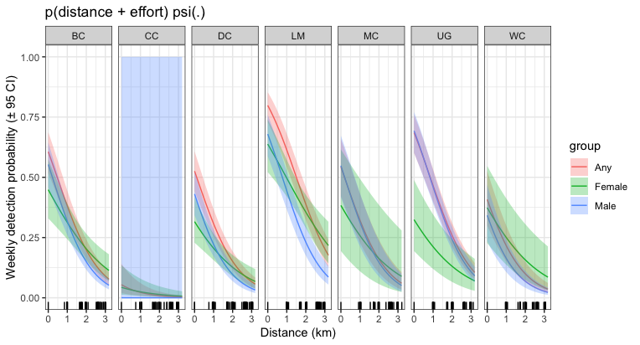

#Ok, there's really just one outlier at Miller Creek with very large effort. Should truncate that

#There shouldn't be *this* strong of a relationship with effort... we didn't actually sample out that much

**Time-varying *p*, constant *psi***

**All STOC**

nPars AIC delta AICwt cumltvWt

p3_any_time 29 2206.35 0.00 1.0e+00 1.00

p2_any_time 23 2322.99 116.64 4.7e-26 1.00

p4_any_time 24 2324.68 118.33 2.0e-26 1.00

p9_any_time 22 2406.17 199.82 4.1e-44 1.00

p1_any_time 2 2424.98 218.63 3.4e-48 1.00

p3_any_time <- occu(~dist + site + time ~1, data = input_any) #top model

**Female STOC (FNLC/pairs)**

nPars AIC delta AICwt cumltvWt

p3_fem_fnlcp_time 29 1207.20 0.00 1.0e+00 1.00

p4_fem_fnlcp_time 24 1251.32 44.13 2.6e-10 1.00

p2_fem_fnlcp_time 23 1254.45 47.25 5.5e-11 1.00

p6_fem_fnlcp_time 23 1268.90 61.70 4.0e-14 1.00

p9_fem_fnlcp_time 22 1270.22 63.03 2.1e-14 1.00

p1_fem_fnlcp_time 2 1284.86 77.66 1.4e-17 1.00

p3_fem_fnlcp_time <- occu(~dist + site + time ~1, data = input_female_fnlcp)

**Male STOC (FNLC/pairs)**

nPars AIC delta AICwt cumltvWt

p3_mal_fnlcp_time 29 1907.13 0.00 1.0e+00 1.00

p2_mal_fnlcp_time 23 1969.73 62.60 2.5e-14 1.00

p4_mal_fnlcp_time 24 1970.08 62.95 2.1e-14 1.00

p9_mal_fnlcp_time 22 2057.69 150.56 2.0e-33 1.00

p1_mal_fnlcp_time 2 2058.05 150.93 1.7e-33 1.00

p3_mal_fnlcp_time <- occu(~dist + site + time ~1, data = input_male_fnlcp)

**Plot using model 2 (no ‘site’ covariate) for simplicity**

**Lines here are different weeks**