

Contract Logix: Version 10 Release Notes
February 2011

What’s New in Version 10 4
1 Getting Started menu 4
2 Dashboard enhancement 4
3 Document Search Screen and Quick Access Link 5
4 Email Enhancements 5
4.1 Email Manager 5
4.2 Email Receive Module (optional) 7
4.3 Email Alert Messages and Logs 7
4.4 Merge fields in email Subject line 8
4.5 Batch email from Search Tab 8
4.6 Add “Blind copy myself by default” option to Email Signature 8
5 Contract Date Alarms Enhancements 8
5.1 Date Alarm icons change 8
5.2 Redesigned Reminder Labels 8
5.3 More flexible Advanced Snooze feature 8
5.4 Set Date Alarm Defaults 9
5.5 Auto update alarms when email template changed 9
6 Contacts Enhancements 9
6.1 Enhancements for adding Contracted Company Contact 9
6.2 Enhancement for adding Our Company Contact 9
6.3 Display Contact Title and Contact Dpt in Our Company and Contracted Company areas 10
6.4 Our Company Contacts Association field is modifiable 10
6.5 Contact Window changes 10
6.6 New Contact Group Access tab 10
7 Contract Folder Enhancements 12
7.1 Select, Retrieve and Auto Retrieve moved to toolbar 12
7.2 Save Contract Folder State 12
7.3 Document fields available for Search Criteria screen 12
7.4 Contract Browse Report moved to toolbar 12
7.5 Delete from Search Tab 12
7.6 Contract Browse List Display Options 12
7.7 Tree View Display 12
7.8 Support for Multi-level parent child relationships 13
7.9 Calendar Display 13
7.10 Added some custom fields in the Custom Data tab 16
7.11 Add Documents from Details tab 16
7.12 Replace *Add Lookup Code* with the actual field label name 16
7.13 Save As feature for creating contract record templates 16
7.14 Location and Fee Schedule (healthcare) changes 17
7.15 Fee Schedule (NM) calculated fields 1-3 can also be displayed in Details Custom Data 17
7.16 Able to duplicate Fee Schedule records 17
7.17 Filter button to toggle on or off Filter Criteria window for Doc Mgr and Action Items 18
7.18 Modified option names when adding documents 18
7.19 Document Property (Add Document) changes 18
7.20 Document Category Filter 18
7.21 Batch Add/Create Documents from the Search tab 18
7.22 New Window and Full Window options in Document Manager 19
7.23 Compared Documents now displayed side-by-side 20
7.24 “Cancel Checkout” added to Options toolbar 20
7.25 New Combine Feature 20
7.26 Modified screen design for Action Items 21
7.27 Action Item Status Tracking Audit screen 21
7.28 Full Text Search enhancements 22
8 To Do List enhancements 22
8.1 Unread emails reported in the To Do gadget 22
8.2 An icon can be associated with a To Do list item 22
9 Contract Requirements Painter 22
9.1 Display Word Icon (Yes/No) column 22
9.2 Default value column 22
9.3 Requirement can have Money format 22
10 Lookup Painter 23
10.1 Lookup Painter UI changes 23
10.2 Allow deleting of Lookup tables 23
10.3 “To Do Enabled” column for Contract Status table 23
11 Screen Painter 23
11.1 Support for custom colors 23
11.2 Add invisible fields 23
11.3 Alignment Grid 24
11.4 Properties added to Field Properties window 25
11.5 Open Lookup Painter from Field Properties window 26
11.6 Change field properties for more than one field simultaneously 26
11.7 Add Tab Page Properties and Screen Property dialogs on right-click in Screen Painter 26
11.8 Batch Update for tab color and DW Style 26
11.9 Auto update field properties on Search tab if Details tab properties are changed 26
11.10 Set one date field date based on another date field date 26
11.11 Setting Lookup Field Dependencies 27
11.12 The Products data window can be hidden 28
12 To Do List Painter 29
12.1 Associate icons with To Do List items 29
13 User Painter 29
13.1 Add contact when creating a user 29
13.2 Run Mode field 30
13.3 Longer passwords allowed 30
14 View Painter 30
14.1 User-definable icons for tabs 30
15 Report Writer Module 30
15.1 Ability to use OR Logic Operator in Static Filter 30
15.2 Auto place field in the sort list when selecting a field to Group by in report 31
15.3 Report Writer Date Range comparison 31
16 Work Flow Module 31
16.1 “On Login” trigger parameter 31
16.2 Able to trigger on Action Items and Fee Schedules screens 31
16.3 “And/Or” Operator for Data Value Comparison triggers 31
16.4 E-sign required option 31
17 Clause /Template Library Enhancements 32
17.1 Adjust width of Tree View 32
17.2 Copy Clause Function 32
17.3 Import Existing Word document as Clause 32
17.4 Export Clause as Word document 32
17.5 Use Word file name as Clause Name 32
17.6 Display Information Message as Word Comment 32
17.7 Clause Library Version Control 33
17.8 Clause update at Contract Document Level 33
17.9 Add Clause Attribute Data Tab 33
17.10 Searching by Attribute 33
17.11 Display Attributes and Dynamic formula directly on Add Clause window 34
17.12 Template Library Map List Modifications 34
17.13 Side by side clause comparison 34
17.14 Clause Status Changes 34
18 Export Module 34
18.1 Export Based on View functionality 34
18.2 Copy Fields enhancements 35
18.3 Automatic Export Mode 36
19 System Utilities and Functions 37
19.1 User ID Batch Update will update Our Company Contacts whether Owner or not 37
19.2 OCR Image Documents and Batch Convert to PDF 37
19.3 Supports "%APPDATA% in the Temporary Directory 37
19.4 Added checks for problems when OCX registration fails during web update 38

What’s New in Version 10
NOTE: The new features and enhancements in this document include both Version 9.5 and Version 10 changes.

Getting Started menu
To assist new users in finding their way around the system, a Getting Started menu is now displayed when a user logs in. The same menu may be selected as a Dashboard gadget or displayed at any time by clicking the Get Started icon in the toolbar. Users can click on any button to perform the associated action. Only functions available to that user’s role will be enabled. Users can access tutorials on these and other subjects by selecting View Tutorials. To prevent this window from launching at login, click the Don’t Show at Startup checkbox.
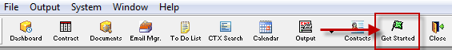
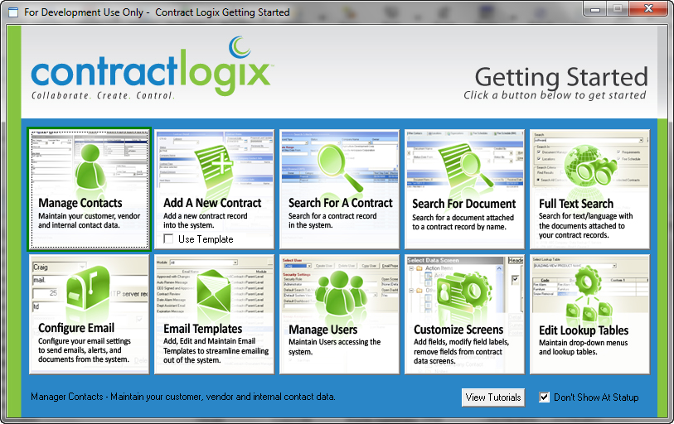

Dashboard enhancement
We have added the ability to set Text Color for Dashboard.

Document Search Screen and Quick Access Link
A new Document Search screen has been added. To open the screen, click the Documents button in the toolbar.
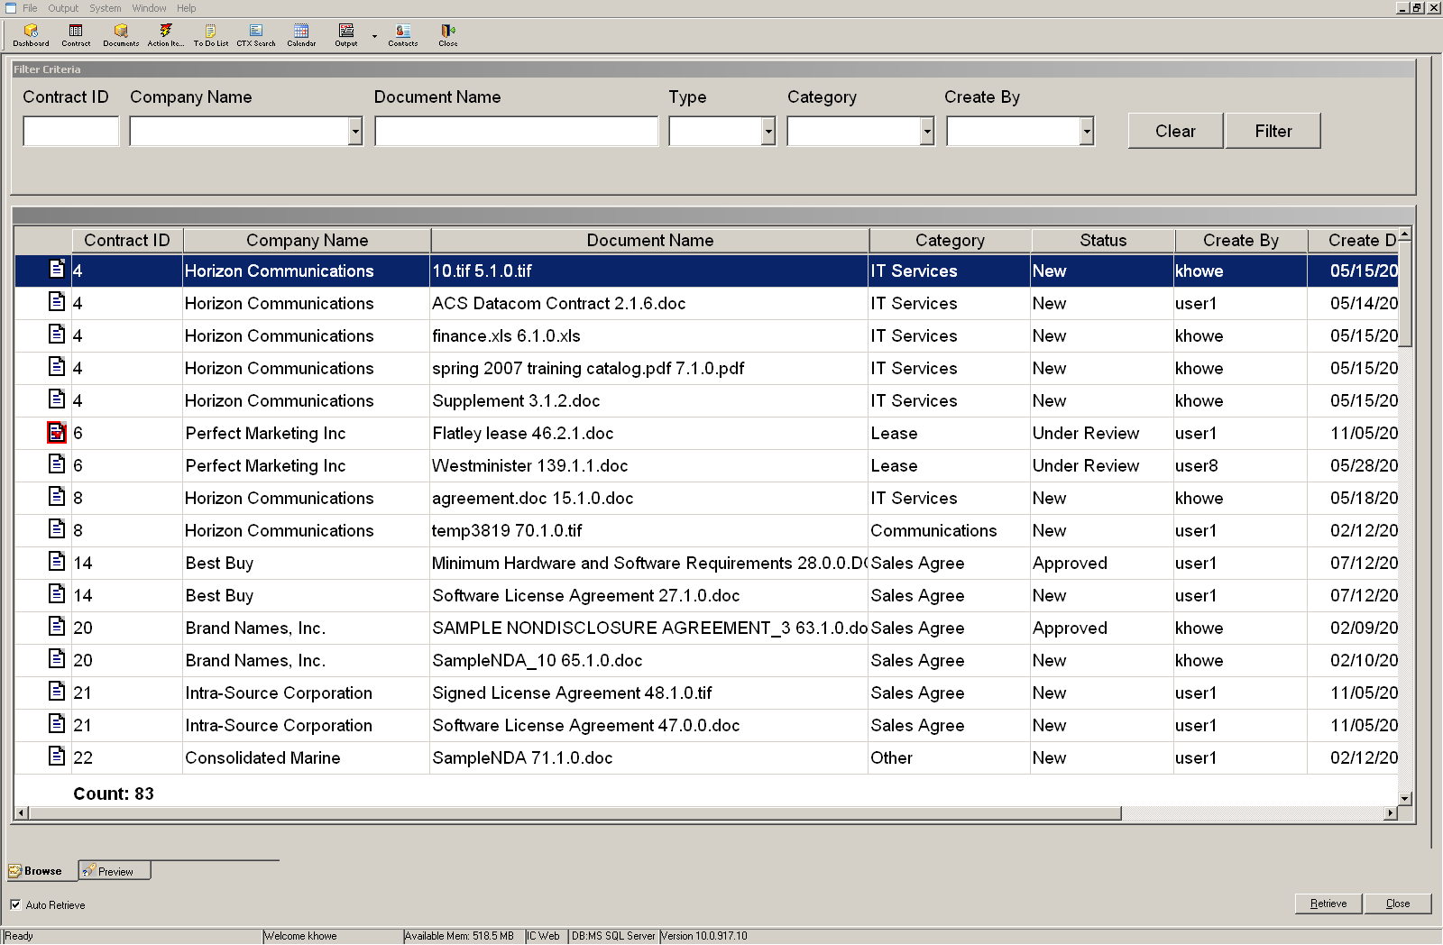
- To search for a document, select one or more filters from the Search Criteria fields at the top and then click the Filter button.
- To open a document, double-click on it.
A new Quick Access Link to the Document Search screen is also available (for sites that use the web version only). Using this link will bring a user directly to the Document Search screen after login (and no other windows are accessible). This feature is good for casual users who only need access to documents. Append %2docquickview to the normal system link to use this feature. Example: http://web.contractlogix.com/prod/?abc1111%2docquickview.

Email Enhancements

Email Manager
A new Email Manager window replaces the Sent folder. To open the Contract Logix Email Manager, click the Email Mgr icon in the toolbar. The Email Manager icon in the toolbar will change dynamically (become red) when you have unread email.

You have unread email | You do not have unread email
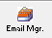 | 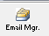
From Email Manager you have access to Email Folders such as Inbox (if the optional Receive Email module is enabled), Sent Items, Deleted Items, etc. You can send, receive, delete, forward, and reply to emails like in Outlook, and can also copy and paste emails from Outlook to Contract Logix. A radio button at the bottom enables you to view All Emails or only emails pertaining to the Selected Contract.
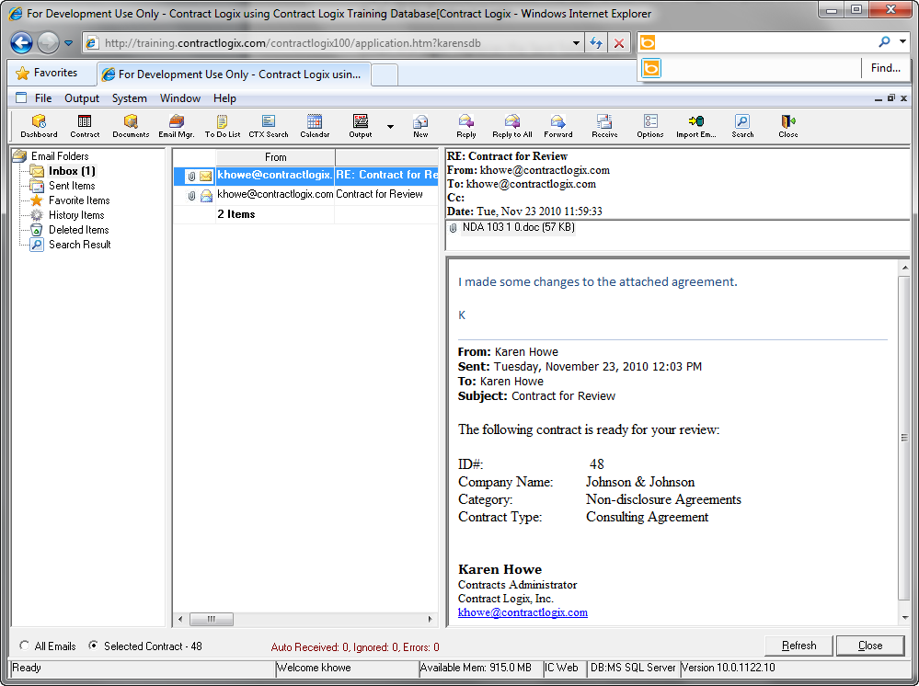
Your site may have the Receive Email Module (see next section). If not, to manually import email from Outlook to the Email Manager:
- First use Save As to save the email in Outlook Message Format (msg).
- (Optional) Copy the .msg file to the Clipboard.
- Return to Email Manager and click the Import Email icon in the toolbar.
- If you pasted the email to the Clipboard in Step 2, click Paste. Otherwise, click Select… and browse to the location of the saved .msg file.
- Select the Folder to import to.
- (Optional) Enter the Contract ID to associate the email with. Note that if the imported email is in reply to an email generated from Contract Logix, you will not need to enter a Contract ID since that information will already be embedded in the email.
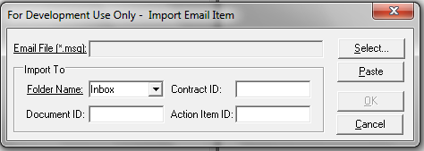

Email Receive Module (optional)
Contract Logix now supports receiving emails via POP. If the optional Receive Email Module is enabled in your system, you can receive and view emails pertaining to contracts in the Inbox of the new Email Manager screen. This is achieved through special tags embedded in the Subject Line or Body of emails sent from Contract Logix. If the Receive Email Module is not enabled, you will still have access to the Email Manager, but no access to the Inbox.
An Email Receive Options screen (accessible from the Email Manager toolbar) enables you to set options controlling the behavior of emails.
To use the Email Receive option, in the Email Account Maintenance screen you will need to add the Incoming Mail Server (POP) and port number.

Email Alert Messages and Logs
Email Notifications and messages now appear at the bottom left-hand side of the screen in red.
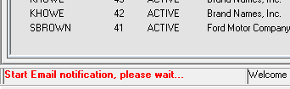
An Email Alert Complete message is displayed in the center of the screen once email sends have completed. From there, you can click the Report… button to browse the Sent Email log.
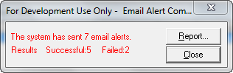
The Sent Email Log contains a list of emails that were sent and the Success or Failure result. The Sent Email log may also be accessed by (1) clicking the Email Log button on the Email Manager Toolbar or (2) clicking the Sent Email Log button in the Contract Logix Utilities screen (System—Utilities).
Another option is the Email Alert to System Administrator. If this feature is turned on then the system sends an email alert to the designated address each time email alerts go out. To turn on this feature, open the Application Settings window (System—Utilities—Application Settings) and locate the “Notify the recipients below…” option. Select “Yes” and then enter the email address(es) to send the notification to.

Merge fields in email Subject line
Add the ability in the Email Painter to use merge fields in the Subject line.

Batch email from Search Tab
In the Search tab, the Email icon has been changed to be a dropdown toolbar icon and Email is set to default. When the down arrow is clicked, a toolbar icon Batch Email is displayed. If a user selects Batch Email without having multiple records selected (2 or more) then the user will be prompted to select two or more contract records on the browse screen.

Add “Blind copy myself by default” option to Email Signature
In the Signature Setup window (System—Personal Settings—Email Signature), a check box has been added: [x] Blind copy myself by default. Whenever a new email is created manually (not through work flow) the system will fill the BC area of the email with the logged in user’s email address.

Contract Date Alarms Enhancements

Date Alarm icons change
The icons that indicate the status of a Date Alarm have changed.

Redesigned Reminder Labels
The Contract Date Alarm screen has been slightly re-designed. At the top, the fields for setting the alarm reminder schedule have been relabeled to make it easier and more user-friendly to set the alarm.
New Label | Was
Send 1st Reminder | Days in advance
Resend Reminder | Reminder Frequency / Times to Remind
Set Date … (Years/Months/Days) in future | Auto Snooze

More flexible Advanced Snooze feature
A […] button is added next to the Set Date field. When clicked, a dialog box opens, in which the user can fill in different intervals, for example, first snooze for one month, after it’s triggered, next snooze for two months, after triggered, for nine months, and after triggered, for a year. The system will put a green checkmark next to the snooze records that have been triggered already. The [x] loop checkbox will reset all the snooze records and start from beginning again once the last snooze happens; otherwise the system will keep the last snooze as the snooze setting for ongoing alarms.
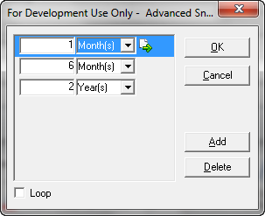

Set Date Alarm Defaults
A [Set As Default] button has been added to the Contract Alarm window which makes the settings of the Contract Alarm for the current date field the default settings for any new alarms that will be set for the same field in the future, This applies to new records or records that have no alarms set for this field.

Auto update alarms when email template changed
After a user changes an email template and clicks Save, the system will check to see if any of the existing alarms use that template. If so, upon saving, the system displays a popup message “You have X active date alarms that have this Email Template associated with it. Would you like to update these alarms to reflect the changes made to this email template?”

Contacts Enhancements

Enhancements for adding Contracted Company Contact
When adding a new contract, if the Company Name selected has only one contact person related to it, then that contact will be automatically selected and the Default To checkbox will be checked. If the Company Name selected that has no contacts, when a user clicks Save, a prompt message will be displayed: “Would you like to add a Contracted Company Contact now?” Yes, No. If the user clicks “Yes”, the Contact Window opens and retrieves the Contracted Company Details tab with focus on the Contact Information window.

Enhancement for adding Our Company Contact
If the Our Company Contact data window is empty and the user clicks Save, a new prompt message appears: “Would you like to add an Our Company Contact now?” Yes, No. If the user clicks “Yes” then the Contact Window opens and retrieves the Our Company record Details tab with focus on the Contact Information window.

Display Contact Title and Contact Dpt in Our Company and Contracted Company areas
Added the ability to display Contact Title and Contact Department in the Our Company and Contracted company areas.

Our Company Contacts Association field is modifiable
On the Details tab, in Our Company Contacts, you can now modify the Association field at the contract level. Previously the value in the Association field was based on the “Contact Type” field in Contact Person data. Now the Association field is a drop down. This field is often used in work flows, where the system can assign a work flow step to the appropriate Assigned By or Assigned To person based on the **Contact Type**.
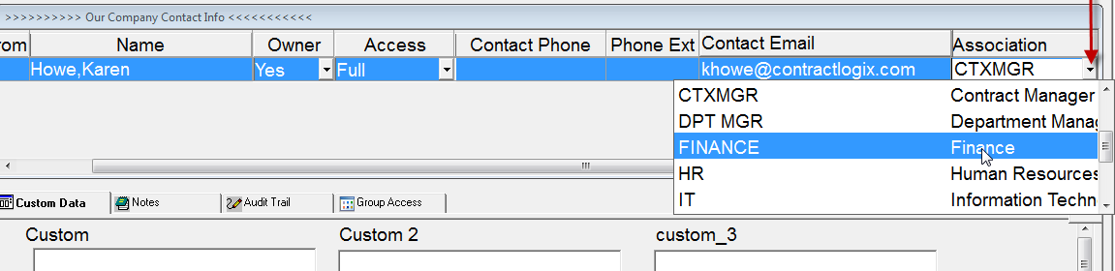

Contact Window changes
Several changes have been made to the Contact data window. The Contact Phone Numbers window label “Phone Numbers” has been changed to “Email / Phone #” and is displayed within a Group Box within the Contact Information Detail data window. The Add and Delete buttons for that section have been removed. If the user clicks ok, the system deletes any via rows that don’t have info filled in.

New Contact Group Access tab
In the Contacts screen, a new tab (Group Access) has been added. It is similar to the Group Access tab in the Contract folder except it is related to Company data. This feature will most commonly be used to filter which companies a user has access to depending on that user’s region or division. For example, the screen shot below shows access to a company named Wind Farms of Europe. Users in the Europe group have Full Access to the contacts data for this company, whereas users in the North America and Asia groups have No Access.
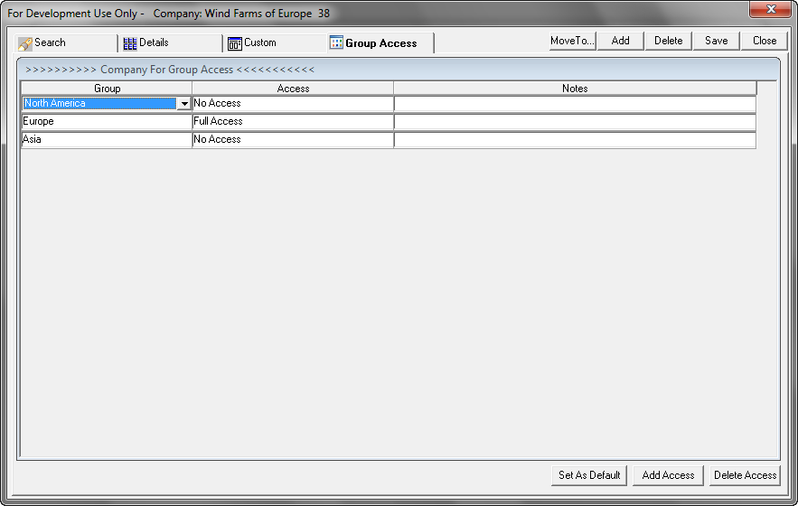
User Groups are created in the User Painter->Group Painter screen. Once a group has been created, you can assign users to that group. Then, depending on the groups that a logged on user belongs to and how the group access tab in the Contact screen is set up the system will:
- Filter the Contact Window-> Company Search results
- Filter the Contract Folder->Detail Company field
If the Contact Window Group Access tab has no records then everyone can view the company.
Click the Set As Default button at the bottom of the Group Access screen to save the current Group Access settings as the default for the logged in user. Whenever that user adds a new company the system will automatically fill in the Group Access Tab with that data. Set As Default is a user-level setting

Contract Folder Enhancements

Select, Retrieve and Auto Retrieve moved to toolbar
In the Contract Folder, the Select and Retrieve buttons which previously appeared at the bottom of the window have been moved to the toolbar. Retrieve is renamed Refresh. Also, the Auto Retrieve Data checkbox is moved to the toolbar and renamed Auto Refresh.
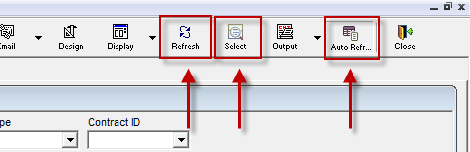

Save Contract Folder State
A new option under the Window menu enables you to save the current state of the contract folder so that when it is closed and reopened, it returns to the previous settings.

Document fields available for Search Criteria screen
Several new document-related fields can now be added to the Search Criteria screen: Document Name, Document Status, Document Category, Document ID (system-assigned number) and Document Content.

Contract Browse Report moved to toolbar
The Report… button previously located at the bottom of the Contract Browse List has been moved to the Output toolbar.

Delete from Search Tab
Authorized users can now select a contract on the Browse list and delete that contract record by using the Delete button in the Search Tab Toolbar.

Contract Browse List Display Options
A new Display button in the Search Tab toolbar enables you to select one of three different displays for the Contract Browse List: Default, Tree View and Calendar View.

Tree View Display
Tree View can be used to show the relationships between contract records. When you select Tree View, contracts are displayed in a tree structure to the left of the Contract Browse screen. Selecting an item in the tree selects the contract in the Browse list. The right-click menu includes functions to collapse or expand groups and a Settings menu item which opens the Tree View Display Settings screen. From here you can modify the way the items are grouped and sorted, and choose which fields to display for each item. For example, the items may be grouped by Category and sorted by Company Name in each group. If you check the Hide Browse check box, the tree view will be extended to the full width of the contract folder window.
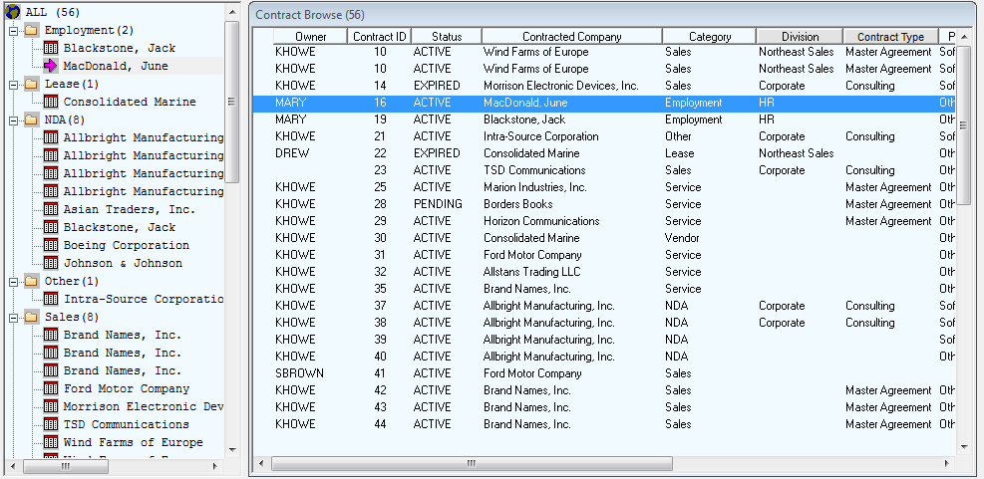

Support for Multi-level parent child relationships
You can now create multi-level relationships (Master Contract – Linked Contract) and view those relationships in Tree View.

Calendar Display
A new Calendar screen displays Action Item and/or Date Alarm information. To display the calendar, select Display→Calendar in the Search tab toolbar (see above) or open the Calendar in a separate window (not part of the Contract Folder) by selecting the Calendar icon in the Contract Logix toolbar.
Various options at the top enable you to control how the calendar looks and what information is displayed.
- Click Day, Week or Month to change the calendar display:
- Use the arrows to display the Previous or Next Day, Week or Month:
- You may also click on the Month to view a menu containing all 12 months; click to jump to a month.
Items on the calendar are preceded by an icon which indicates the type of item (Action Item or Date Alarm), and include the contracted company name and the action type.
Date Alarm
Action Item
The text color of the item on the calendar represents the status of the item:
- Active Alarms and Incomplete Action Items are displayed in Black
- Inactive, Completed or Completed Workflow Action Items are displayed in Dark Grey
- Overdue items that are not completed are displayed in Red
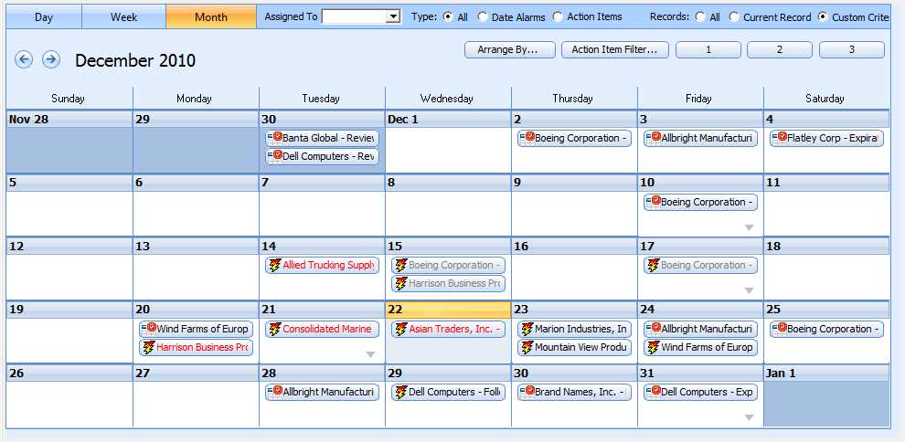Right-click options include:
- Properties - This will do same as double clicking and opens the item properties window.
- Go To Date Field - This will go to the contract record and put focus on the date field that the alarm is for.
- Go To Action Item Tab - This will go to the Acton Item tab of the contract record that the entry is related to and highlight the Action Item record.
- Go to Detail Tab - This will go to the Detail tab of the contract record that the item is related to.
Several filtering options are available for the Calendar:
- Select an Assigned To user from the drop-down to display only those Alarms and/or Action Items assigned to a specific user.
- Select the Type of items to display on the calendar (All, only Date Alarms or only Action Items):
- Select which records to report on (All records, only the currently selected record, or Custom Criteria). If Custom Criteria is selected, only items for those records that meet the Search Criteria which you entered in the Search Criteria fields are displayed.
- Click Arrange By to change how the system will place items on the calendar (by Start Date or by Due Date):
- Click Action Item Filter to set additional filters for Action Items. Select filter criteria individually by clicking the checkbox, or click the Select All checkbox at the bottom of each criteria list and then click the OK button.
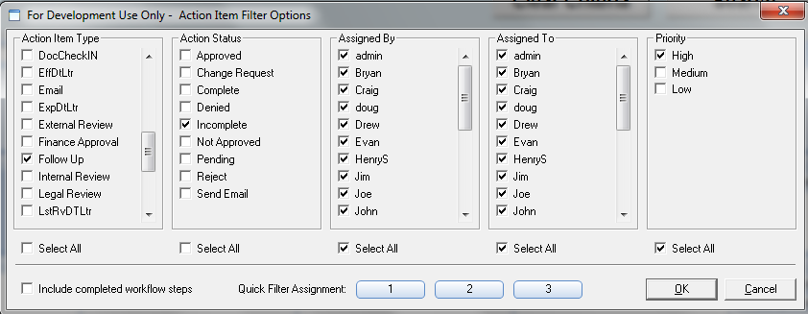
To display completed work flow actions (steps) on the calendar, click the checkbox at the lower left. If unchecked, completed steps are not shown.
Filter criteria can be saved to one of 3 Quick Filter buttons. Click the 1, 2 or 3 button and select from the menu:
- To view the criteria assigned to the button, select View Filter.
- To assign the filter criteria selections to the current button, click Assign Filter.
- To rename the filter from a number to a meaningful name, click Rename Filter… and enter the new name.
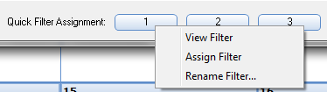
To use a Quick Filter, do the following:
- Display the calendar.
- Select the Type: Action Items radio button.
- Click the filter button you have assigned a Quick Filter to.

Added some custom fields in the Custom Data tab
- Five (5) Custom Notes fields have been added.
- Ten (10) Custom Percent fields have been added.
- Three (3) Fee Schedule Calculated Fields have been added.
- Five (5) Work Flow fields have been added.
The chart below displays all Custom fields now available on the Custom Data Tab:
Field | Field Type | Can be used for/Accepts
Custom 1-20 | Char (255) | Text or Lookups
Custom Date 1-15 | Datetime | Dates
Custom Number 1-25 | Decimal (2) | Numbers or Lookupst
Custom Notes 1-5 | Char (8000) | Text or Lookups
Custom Percent 1-10 | Decimal (4) | Numbers (percentage) or Lookups
Fee Sched Calc Field | Decimal (4) | Displays the value of a Fee Schedule Calculated field

Add Documents from Details tab
You can now add documents to a contract without going to the Document Manager tab. After saving a new contract, click the Add Doc icon in the toolbar and fill out the Add Document screen as you normally would. If your site has the Contract Creation module, you can select Create Doc from the Details tab to create a new document from a template. This new feature is also available from the Search tab.

Replace *Add Lookup Code* with the actual field label name
When entering data in a field, the generic *Add Lookup Code* option has been changed to *Add xxxx* where xxxx=the field label for the specific field, for example *Add Contract Type*

Save As feature for creating contract record templates
In the Details tab there is now a new icon on the toolbar labeled “Save As”. This feature enables you to save a contract record as a template. To create a contract record template:
- Create a new contract record (New CTX) or select an existing contract record to be the model for the template.
- Click the Save As icon in the Details tab toolbar.
- Fill out the Save as a Template window (shown below) to select which data you want included in the template.
- Click OK.
To use a template to create a contract:
- Select Use Template from the New CTX drop down in the toolbar.
- Select the template you want to use to create the new record and click OK. The template you selected is copied and a new record is created.
- Fill out remaining details for the record and save (fields that were not copied from the original).
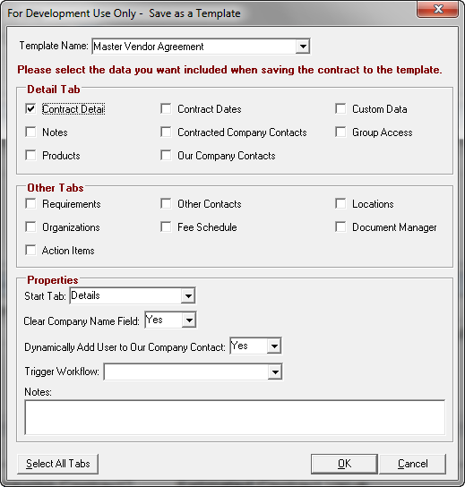

Location and Fee Schedule (healthcare) changes
In the Location tab, the Location ID has been changed to varchar(255) and will default (for new records) to the Group name + Street 1. Also, the Locations drop down in the Fee Schedule tab for healthcare shows the new longer Location ID.

Fee Schedule (NM) calculated fields 1-3 can also be displayed in Details Custom Data
The first three calculated (computed) fields you place on the Fee Schedules (NM) tab may now also be displayed on the Details tab in Custom Data. As the data is updated on the Fee Schedule, the field is also updated on the Details tab. To do this, use the Screen Painter to add the calculated field to the Fee Schedule tab, then place the same field on the Details tab.

Able to duplicate Fee Schedule records
You are now able to duplicate a fee schedule record, which will make creating a set of fee schedule records easier. For example, you can set up the first record of a series of monthly payments and have the system duplicate that record x number of times. To duplicate a fee schedule record, click the Duplicate icon in the toolbar and fill out the Duplicate record window.
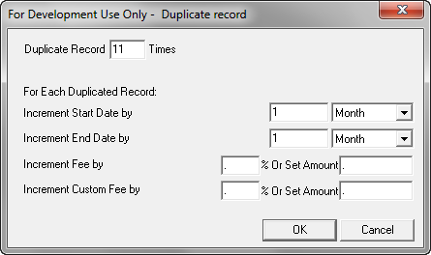

Filter button to toggle on or off Filter Criteria window for Doc Mgr and Action Items
You can now toggle the Filter Criteria fields window on or off by clicking the Filter icon in the Document Manager or Action Items toolbar.
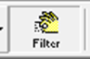

Modified option names when adding documents
Add Buy and Add Other have been combined into a single option named Add. (Add an existing document, from file, scan, paste). Add Sell has been changed to Create (Create New Document using a Template).

Document Property (Add Document) changes
When adding documents, the user can specify the Document Type (no longer restricted to Sell, Buy or Other). New document types may be added via the Lookup Painter→Document Type table. Document From is renamed to Received From and is now editable so it can be typed into. The Description field is included on the Document Manager Browse Screen. The Add Document window may also be modified using the Screen Painter. To do this, click the Design button located above the OK button.

Document Category Filter
When you add a new document into the document manager, the Category drop-down menu will be filtered by the category permissions of the role, just like the Details Tab.

Batch Add/Create Documents from the Search tab
A new batch add or batch create document feature is available on the Search tab. This enables you to select a batch of contract records and either create a new document using a template, or add an existing document to each selected contract. After the documents are added, an additional option asks if you’d like to email the documents to the Default To contact for each contract.
To use Batch Add/Batch Create Document:
- On the Search tab, select the contracts you want to add/create documents for. HINT: Use CTRL-click to multi-select, and SHIFT-click to select a range of contracts.
- Click the Add Doc button in the toolbar if you want to add an existing document OR click Create Doc to create a new document from a template.
- Fill out the Batch Add or Batch Create New Document window as you usually would and then click OK. Documents are added or created for each of the contract records.
- After all documents have been added or created, the following dialog box opens:
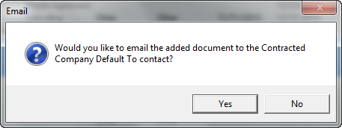
To send the documents to the Default To contact for each contract select Yes and the Email window will open. From here, you can enter the details for the email and send. If you do not wish to email the documents, select No and the batch process is complete.

New Window and Full Window options in Document Manager
Two new options are available when viewing documents: Full Window and New Window.
Full Window maximizes the currently opened document window so that it is easier to read the document. To use Full Window, open a document and click Full Window in the upper right corner of the document header. 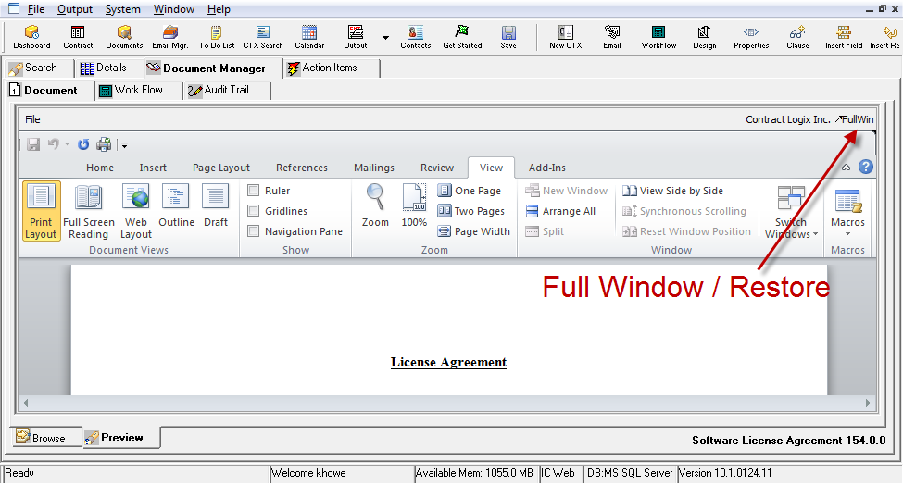
Full Window is a toggle; click Restore to restore the original window size. The Full Window/Restore feature is available in all types of document windows, such as Clauses, Templates, the Email window and the Email Signature window.
New Window opens the selected document in a separate document viewer window instead of the Preview tab. To use New Window, select a document from the Document Browse list and choose Open in New Window from the right-click menu. This way, the user can be in one contract and be able to review another related contract record (parent, child for instance) at the same time.

Compared Documents now displayed side-by-side
When you use the Compare feature to compare two or more documents, the screen is divided in half. The Document to Compare Against is always displayed on the left-hand side of the screen. Select a Compare To document from the drop down list and it is displayed on the right-hand side of the screen.

“Cancel Checkout” added to Options toolbar
A “Cancel Checkout” option has been added to the Options toolbar. This is used to cancel the checkout status of the document so it can be edited. An audit trail “Cancel Checkout” is created, with normal audit information.

New Combine Feature
A new feature called “Combine” will enable you to combine revisions from multiple reviewers or multiple revision cycles into a single document.
To use Combine:
- Add a document to the Document Browse list.
- Click Check Out and check the document out to one or more reviewers.
- When you receive the document back from the first reviewer, check it in as you normally would (click the Check In button, select the file or paste from the Clipboard and click Check In).
- When you receive the document back from the other reviewer(s), click the Combine button in the toolbar.
- Select or paste the file and then click the Combine button at the bottom of the Check In window.
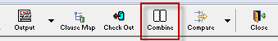
The Combine option will retain the tracked changes of the original checked-in document and add in any new changes from subsequent combine operations.

Modified screen design for Action Items
The Action Items tab has been redesigned (see below). An expanded Detail screen displays one action item at a time. Use the Page Up and Page Down keys to scroll between items. The Browse tab displays the action items in list format.
This change will affect new installations only. If you have an existing installation and would like to switch to the new design in one or more views, please contact your Contract Logix support specialist.
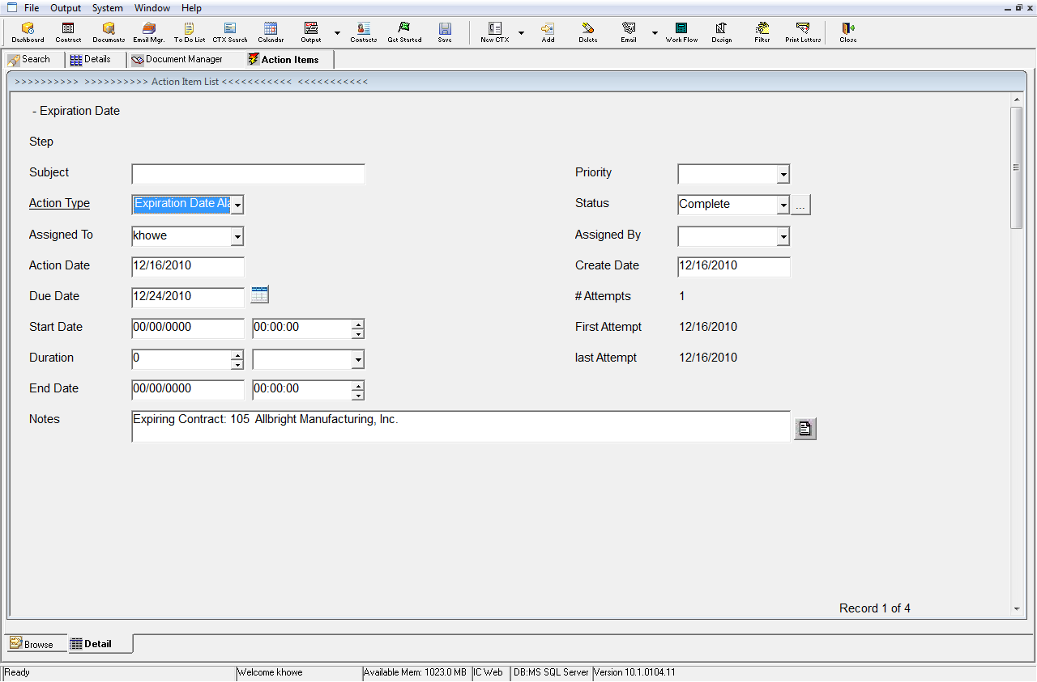

Action Item Status Tracking Audit screen
A new audit screen can now be displayed for Action Items. When a user clicks the […] button next to the Status field in an Action Item the Action Items Status Track window opens.
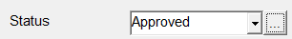
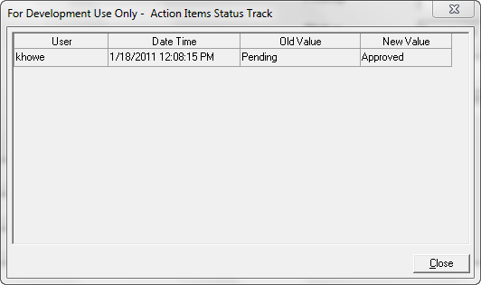

Full Text Search enhancements
Full Text Search now allows for two types of searches that were previously unsupported:
- Full Text Search of lookup values in Custom Fields
- Full text search of Fee Schedules NM data

To Do List enhancements

Unread emails reported in the To Do gadget
A line has been added to the To Do List gadget indicating when there are unread emails and a link to the Inbox is provided. If there are unread emails, the text appears in red.

An icon can be associated with a To Do list item
To define the icon, see To Do List Painter on page 29.

Contract Requirements Painter

Display Word Icon (Yes/No) column
Use this option to turn on or off the Word icon that appears to the right of a requirement when viewed in the Requirements tab. [When you click the Word icon, a Word attachment opens into which you can enter text. This text may be merged into a document clause or template].

Default value column
Enter data in the Default Value column if you want the requirement to contain default data.

Requirement can have Money format
Add the ability to format values as money.

Lookup Painter

Lookup Painter UI changes
When a new lookup record is entered and a user types in the Code and tabs out of the field, the Description field is defaulted to the same as the Code and the Description is highlighted so the user can just start typing if they want to change it.
The Lookup Painter now has 2 tabs, Browse and Detail. By default the Browse tab will be selected (like before) and a user can enter data into the Browse (like before) but they are also able to click on the Detail tab to see all the fields for that record in one view.

Allow deleting of Lookup tables
Added the ability to delete all the rows from a lookup (provided no contracts reference it) and the associated lookup table. When user deletes the last row a warning message will be displayed: “Warning, last row in lookup table. Delete Lookup Table?”

“To Do Enabled” column for Contract Status table
In the Contract Status lookup table, Custom Column 3 has been changed to “To Do Enabled” with two values “Yes” and “No”. If No is selected, the Action Items of the corresponding contracts will not show in a To Do List.

Screen Painter

Support for custom colors
In Screen Painter, if a user selects a custom color and adds it to the custom colors palette, it’s available to use for other screens and text.

Add invisible fields
In screen painter, the Show Invisible button has been replaced with an Add Field button or right-click menu. Instead of showing all the invisible fields and the user having to click on them and bring up properties box and select Visible /Yes, a dialog box will appear and display all of the fields that are invisible and not being used in that screen.
When a user double clicks or clicks the Select button the system will prompt the user to click where they want to place the field and then once field is placed the system will ask where the user would like to place the field label and once that is done the system will show the field and field label in that position and then pop up the properties box for that newly placed field.
- The user can also select multiple fields to add.
- When a field is added, lowered border is the default border style.
- Once the user clicks and positions the Label, Label Text area has focus so that user can start to type label text.
- When a field that is added is removed, the label text is set back to the field name.
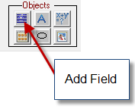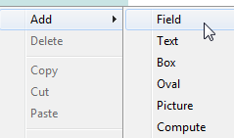
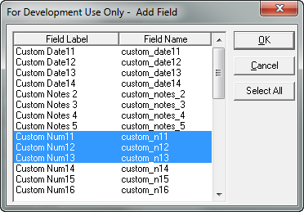
Note that the method of removing fields has not changed; you will continue to display the field properties and set the Visible property = No.

Alignment Grid
You are now able to define a grid for help in aligning objects. When you place or move objects and a grid is defined then the object will snap to the grid. To define the grid size:
- Click the Options button on the toolbar.
- In the Snap to Grid fields, enter an X and Y value (in pixels) for the grid.
- Click OK.
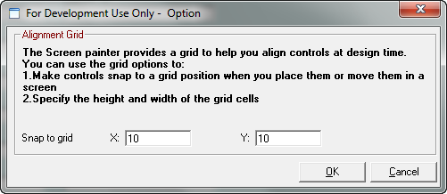

Properties added to Field Properties window
Several new properties have been added to the Field Properties dialog box.
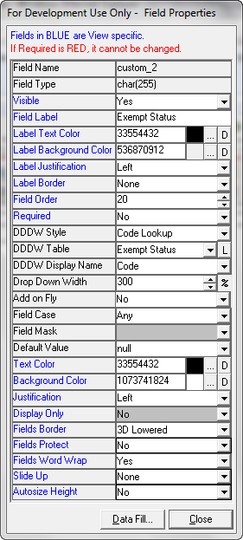

Field Property | Description
DDDW Style  DDDW=Drop Down Data Window | Choices are None, Code Lookup, User, and Company.  Select None if this is not a lookup field.  Select Code Lookup to link a Lookup Table (from Lookup Painter) to the field, then choose the table in DDDW Table.  Select User to link a list of user ids to the field.  Select Company to link a list of companies to the field then choose Our Company, Contracted Company or Other in DDDW Table.
Add on Fly | Yes or No. If Yes, user will be able to add new lookup values from the contract folder. If no, the *Add xxxx * where xxx=field label is not an option on the drop down.
Text Color | Color of text in the field
Background Color | Color of the field background
Slide Up | Whether the field moves up when other fields above it leave empty space available.
Autosize Height | Whether the control's width should be held constant and its height adjusted so that all the data is visible.

Open Lookup Painter from Field Properties window
In the Field Properties window, a button marked [L] adjacent to the DDDW Table field enables you to open the Lookup Painter to add entries to an existing table or create a new table.

Change field properties for more than one field simultaneously
You are now able to change some of the field properties for more than one field simultaneously. When you select multiple fields and click the Properties toolbar item, a Group Properties dialog box displays.

Add Tab Page Properties and Screen Property dialogs on right-click in Screen Painter
A right click menu has been added to the Screen Painter tree view. If you right click on a Tab name, then the Tab Page Properties dialog window from the View painter is displayed and allows you to set tab name and colors from there. If you right click on a Screen name then the Screen property dialog displays (same as double clicking on background area of data window (not field).

Batch Update for tab color and DW Style
In the Screen painter, you are now able to batch update the Tab colors and the border style of fields in the Batch Update properties window.

Auto update field properties on Search tab if Details tab properties are changed
If the property of a field on the Details tab (such as Field Label, Lookup Name, Lookup Field, or Format) is modified, and the field is visible on the Search Criteria or Contract Browse screens, the system will prompt the user with “This field is also visible on the Search Tab, Criteria and Browse screen. Would you like to update these screens with your new property settings?” If yes, then the system automatically updates the field on the Criteria and Browse screens to match the new settings. There is a checkbox [ ] Always Update in the message box which, if checked, the system will not show this message each time and will automatically update. If the field is Invisible on the search tab then the properties will be changed without notice.

Set one date field date based on another date field date
You can now set the date in a date field based on another date field plus some number of days. For example, you could enter a Hire Date and when you tab out of the field or click Save, the system can fill in an Next Review Date that is 120 days away from the Hire Date.
To use this feature, open the Field Properties for the base date field (in our example, Hire Date). Click the Data Fill… button and select the Fill Field (field you want system to fill, in this example Next Review Date) and Relative Days. You can define more than one Fill Field by adding more rows. If there is already data in the field to be filled the user will be asked if they want to overwrite the existing data; otherwise the system will fill it in.
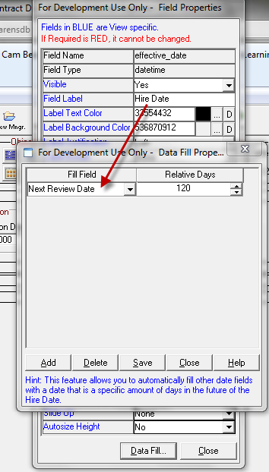

Setting Lookup Field Dependencies
The Depend button in the toolbar enables you to set Lookup value dependencies. This can be used to filter lookup values based on the value of another field. For example, the lookup values for the Contract Type field could be dependent on which Contract Category was selected. If the Base Field (Category) = Vendor, then the Contract Type lookup choices could be Amendment or Master Agreement. But if the Category = Service Agreement, then Contract Type lookup choices will be Amendment, Master Agreement and Statement of work.
- Open Screen Painter and select the View you wish to modify.
- Click the Depend button on the toolbar.
- Select a Base Field (such as Category). This will be the field that drives the dependency. Then select a Depend Screen and Depend Field (such as Contract Detail—Contract Type). This will be the dependent field whose values will be filtered.
- For each Base Lookup Data value, select the Dependent Lookup Data that will be available in the drop down for the Dependent field.
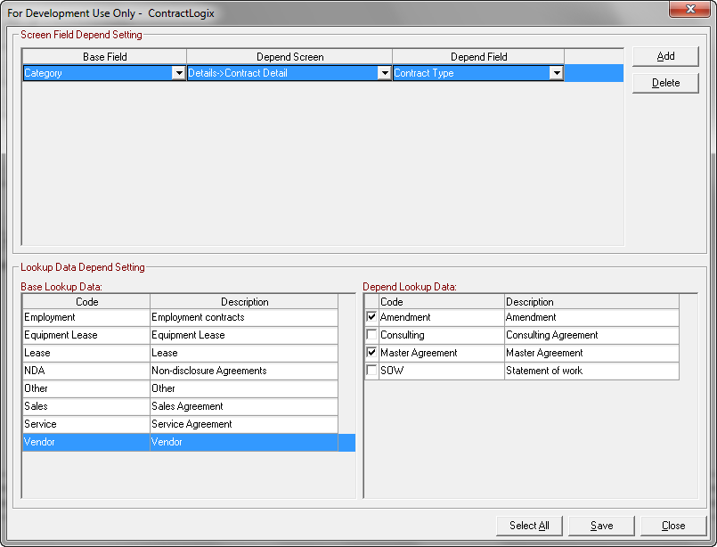

The Products data window can be hidden
In Contract Folder->Details tab, the Products window at the lower left is no longer required and can now be hidden if you would rather not display it. To hide the window:
- In the view you want to modify, select the Products screen.
- Right-click on the background of the screen and select Property from the right-click menu.
- In the property dialog, change the Visible property to No.
- Close the properties window and click Save in the Screen Painter toolbar.
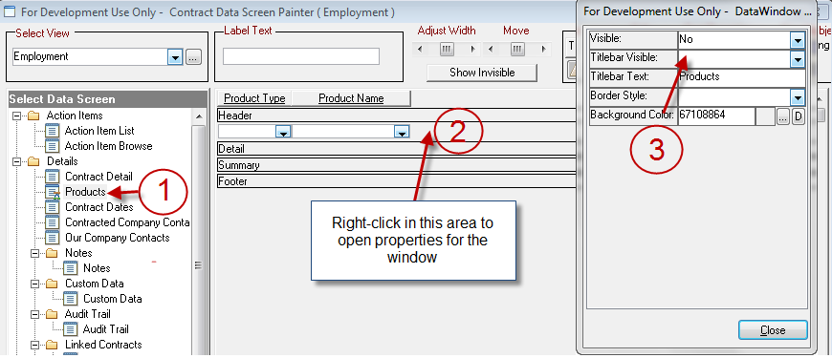

To Do List Painter

Associate icons with To Do List items
- Open the To Do List Painter (System—Painters—To Do List Painter).
- Select the To Do List.
- Select the line item you want to assign an icon to.
- Click the Icon […] button and scroll through the list of available icons. Select the icon you wish to associate with the item and click OK.

User Painter

Add contact when creating a user
You are now able to create a new user and add the contact person at the same time, or, if the contact person already exists, you can associate the new user with an existing contact.
- In User Painter, click the Create User button.
- Enter the User ID for the new user.
- Select the Company from the drop-down.
- Select <<Add New Contact Person>> and then enter details for the contact person in the fields to the right OR select the contact to associate with this new User ID.
- Click OK.
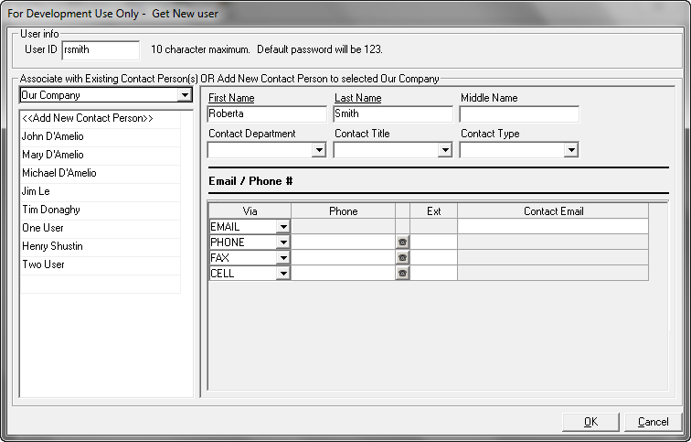

Run Mode field
A new Run Mode field has been added. If the value in that field is set to Normal, the user is a normal user. If that field is set to Automatic Export Mode, the user is associated with an Automatic export. See Export Module Enhancements.

Longer passwords allowed
The maximum character limit on the passwords for Contract Logix has been increased from 12 characters to 20 characters.

View Painter

User-definable icons for tabs
In Tab Properties, users can now choose the Icon for every Tab.

Report Writer Module

Ability to use OR Logic Operator in Static Filter
In the Report Writer a user can now add an OR Logic Operator. Previously the filtering only allowed for AND so all comparisons had to be true in order for a record to be returned. The OR logical statement will expand the filtering capabilities and allow users to filter based on multiple fields and if any of those comparisons are true the data will still be returned.

Auto place field in the sort list when selecting a field to Group by in report
In the report writer, when a user is designing a new report and selects a field to Group by, the system will automatically place that field in the sort list. Each field that is selected for grouping will be automatically selected as a sort field by system. The order of the sort field will be defaulted to the order of the fields in the column tab.

Report Writer Date Range comparison
When the user has a date range comparison, the user can fill in one date and leave the other date blank, the system will get the correct result. For example, the user could enter a start date of 1/1/2010 and leave the end date blank, and the filter would include all dates after 1/1/2010; or the user could enter an end date of 12/31/2011, and it would include all dates before 12/31/2011.

Work Flow Module

“On Login” trigger parameter
There is a new “On Login” trigger parameter for Data Value Comparison triggers. Two check boxes have been added to the Work Flow Properties screen under Triggered Type: [x] On Login and [x] On Save.
The difference is that the [x] On Save will trigger a workflow when the user clicks save and the data matches (like now). The [x] On Login option will check all contract data values during the login process at same time as it checks for Email alarms (first time someone logs in that day) and if matches are found will trigger the workflow.
All current workflows will have a database update that will set them to [x] On Save.

Able to trigger on Action Items and Fee Schedules screens
The Action Items and Fee Schedule screens have been added to the Data Value Comparison (parent and document manager level) Trigger Parameters.

“And/Or” Operator for Data Value Comparison triggers
For writing advanced trigger parameters, there is a new Logical And/Or operator.

E-sign required option
When setting up the parameters for an Action Status, you may now check the new E-Sign Required checkbox. If this option is selected, the user changing the status of a work flow action item must provide his/her password in order to change the status. In the Prompt message area type the message you want the user to see.
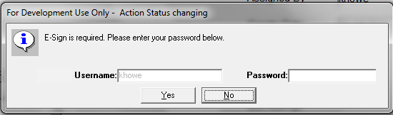

Clause /Template Library Enhancements

Adjust width of Tree View
The vertical divider in the Browse tab of the Document Libraries is adjustable to accommodate long names.

Copy Clause Function
Added the ability to Copy clauses.

Import Existing Word document as Clause
In the Add Clause Properties box, two new buttons [Browse] and [Paste] enable you to either browse to a Word file or if you perform a right click / Copy in Microsoft File Explorer you can click the Paste button and the system will copy the word document contents as the basis for a new clause.

Export Clause as Word document
A function has been added to the Clause Library to enable export of one or more clauses. To export a single clause, select it from the tree view and right-click. From the right-click menu, select Export Clause as Separate File. To export multiple clauses into a combined file (it looks like a table) select a folder and from the right-click menu select Export Clause as Combined File.

Use Word file name as Clause Name
If a file is selected using Browse or Paste, the clause name is defaulted to the Word file name.

Display Information Message as Word Comment
If the [x] Display as Word Comment checkbox is checked then when the Clause is viewed at the Template or Contract Folder level it will automatically create a Word Comment associated with the clause, and within the comment display, will show the text that is in the Information Message area.

Clause Library Version Control
Version Control functionality has been added to the Clause Library. Some of the same functionality that is in the Contract Folder->Document Manager is now available for clauses, including the ability to start version control, control version numbering style, and view previous versions.

Clause update at Contract Document Level
When a clause is updated, the user can now update Contract Folder->Document Manager documents as well as any templates that use the clause. Once templates are updated, the user is prompted to update Contract Folder->Document Manager level documents that use this clause. If user clicks Yes, a Contract Search screen is displayed and allows users to select a group of contract records to update.

Add Clause Attribute Data Tab
The Clause Properties window has changed to be a tabbed interface with 2 tabs (General and Attributes). In the Attributes tab we have provided a list of up to 6 Attributes (left side) that can be assigned to clauses. The Customize button will allow a way for a user to modify the Attribute labels. This is global in scope, meaning that all Clause Properties boxes and references to attributes will use the labels that are set here. Six new lookup tables (Attrib 1, Attrib 2… etc) each containing one record value (code=Attrib Code, Description=Attrib Description) have been added. Users can use the Lookup Painter to add and update clause attribute lookup data.
Note: There is a one-to-many relationship between the Attribute and the Value selected, so when a user selects an Attribute they will be able to check off and associate one or many values to it.
The same Clause Attribute functionality has been added for the Add Clause-> Clause Selection Tree View in the Template Painter and Contract Folder->Document Manager level.

Searching by Attribute
The Clause browse screen includes the 6 new attribute fields. Field labels are dynamically changed to match the labels you set up using the Attribute Customize button. An Attribute Filter button has been added so that a user can Filter clauses that meet specific Attributes and allow for sorting of the browse screen using multiple sort field criteria. An indicator is displayed so a user knows an attribute filter is set. On the Browse screen, when displaying attribute data fields that have multiple selections, attribute data is displayed separated by commas (e.g. Web On Premise, SAAS)

Display Attributes and Dynamic formula directly on Add Clause window
The Clause Library Tree View is modified so that within the Tree View a [+] is added next to each Clause Name so when clicked the system displays the corresponding Clause attributes.

Template Library Map List Modifications
The Map list in the Template library has been modified to be a tree view. Within the Tree View a [+] is added next to each clause name so when clicked the system will display the corresponding Clause attributes. When a user clicks on any part of the template that is a clause, the system will figure out what clause that the user has clicked on and highlight the appropriate clause in the map.
A [x] Dynamic Clause Formula checkbox is added below the Map list. If checked, and a clause has focus and there is a Dynamic Add formula associated with the clause then a read only view of that formula is displayed.

Side by side clause comparison
The Clause Library now supports a Clause comparison feature that works just like the Compare feature in Contract Folder->Document Manager.

Clause Status Changes
Some functionality has been added to the Clause Approval Status lookup table. Some of the custom fields of the lookup record set parameters which will indicate to the system how to treat clauses that are in a particular status.
Clause Text Color | Indicates the color that the system will use to display a clause in if the clause is set to this status.
Access at Template | This will determine if a clause will be accessible for selection or viewing at the Template Painter level.
Access at CTX Folder | This will determine if a clause will be accessible for selection or viewing at the Contract Folder->Document Manager Level.
Word Comments | This setting overrides any setting in the Clause->Property window ([x] Display as Word Comment).

Export Module

Export Based on View functionality
A dropdown has been added to the Export File Properties tab (Base on View) that allows users to select a view name when creating an export file. When adding Columns on the Columns Properties tab, the display values for drop downs use the screen names and/or field labels based on that view.

Copy Fields enhancements
When copying fields, you can now (a) copy fields from the same export file, (b) have the system duplicate the fields for multi record screens and (c) sort the duplicated fields by export order or name.
For instance, if you had a Fee and Fee Description field and you wanted to be able to export data for the first 4 records then you previously had to copy the first description and fee fields 3 times and change the record id on each column. The system can now do this duplication and renumbering of record ids automatically.
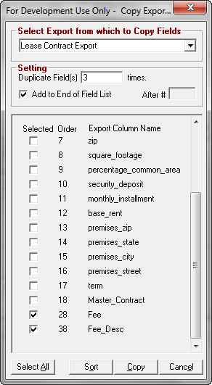
- In the Columns Properties tab, click the Copy Fields From button.
- Select the export from which you want to copy fields (you can select the current export).
- Select by checking the export fields to copy.
- Enter the number of duplicates.
- Enter the position to add the duplicates (at end or after #)
- (Optional) Click the Sort button and indicate how you want to sort the duplicated fields (by export order or by export column name).
- Click Copy.

Automatic Export Mode
In Automatic Export Mode, an export can be created and then run at predetermined time intervals, producing an output file.
To set up Auto Export:
- Select System -->Painters->User Painter to open the User Painter window.
- Select (or create) a user. This user will not be a normal user of the system, but a special user id reserved for running Auto Export process.
- Select Automatic Export Mode as the Run Mode for this user.
- Exit User Painter.
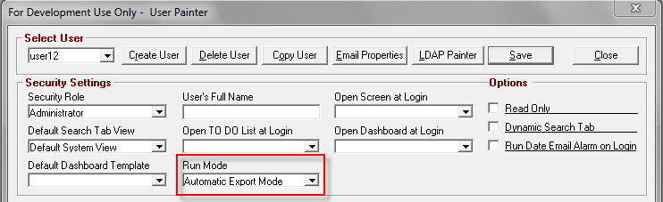
- Log in to Contract Logix with the user selected above. The system will run under the Automatic Export Mode and launch the Automatic Export dialog box. You can run Automatic Export Mode on a particular machine (such as DB server), and keep the Contract Logix Automatic Export window open.
- Fill out the Automatic Export dialog box for each export:
  - Click Add
  - Select an Export file (must already have been created in Export Painter)
  - Interval Unit
  - Interval
  - Next run time
  - Status Active
  - Enter a pathname for the output file
- Save.
- Make sure Auto Export On is enabled.

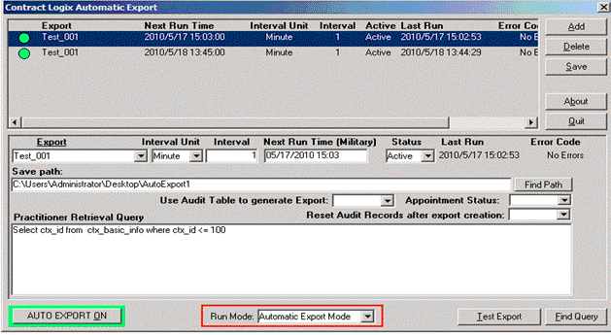

System Utilities and Functions

User ID Batch Update will update Our Company Contacts whether Owner or not
Previously, only Owners would be updated using User ID Batch Update. Now there is an option 'Our Company Contacts' in User ID Batch Update to update all or selected our company contacts, whether owner or not. If this box is checked, you can select Original users from the drop down, and set to other users, multiple times.

OCR Image Documents and Batch Convert to PDF
We have added OCR support for all kinds of PDF files (including image-based PDF), which means, now in Global Search, all PDF files are searchable. Under System—Utilities two new functions are available: OCR all Image Documents and Batch Convert Image Documents to PDF.

Supports "%APPDATA% in the Temporary Directory
In System—Personal Settings—Temporary Files Settings you can enter a pathname where temporary files created by the application will be stored. Contract Logix now supports the variable %AppData% which contains the full path to the Application Data folder of the logged-in user.

Added checks for problems when OCX registration fails during web update
During installation or update of the system (web version), if the system detects that the OCX registration has failed, it will automatically do the following checks:
- Check if the current Windows user is a Windows Administrator Role and if not, prompt user to log in as an Administrator.
- If it detects the OS is Windows Vista or Windows 7 and if the UAC (User Account Control) is turned on, it will prompt users to turn off the UAC.
- If 1) and 2) above are done, it will attempt to automatically register the OCX to fix the issue.

What’s New in Build 10.1.0309.11

New Features
1. Based on the request from Kaiser: Add word wrap to description field on clause painter.
2. Add View/Screen Copy in utilities feature.

Bug fixes:
1. Should hide the CL status bar when users switch to other IE tab.
2. In earlier build, we were able to open properties screen for a field, change the visible to yes or no, leave the properties screen open, highlight the next field, select visible yes/no, etc. This does not work anymore. Now you have to close out the properties window each time. This is not correct.
3. The e mail alarm drop down for e mail templates is missing the scroll bar.
4. Mail merge not filling in data for fields in email or contract documents: Customer has a database where her emails used for alarms are not adding in any data from the exported fields. This is occurring on a test database but is working properly on her production database. I created a new email template using both the sample export and and export she created yet none of these worked for her. I have made sure that the fields have data in them as well.
5. Contract alarm auto-snooze issue: Customer has a contract alarm dated 2/28/11. The alarm is set to forward a year ahead to 2/28/12 when it expired. However when the customer goes into the action item and completes it, The alarm gets reset again to 2/28/13. She has to go back into the the details screen and reset it back to 2/28/12. There is no auto-forward set up in the contract alarm screen so I don’t know why it’s adding another year when the action item for the contract is completed.
6. I have found an error in how the Report Writer is rendering the SQL select statements when one has a report that implements a Date Range Comparison in the Filter Wizard:
Below is the problem I found in the SQL statement produced by the Report Writer. See the bolded words. If the wizard is going to implement an "And," which may be a problem since you now allow one to choose such operator in the Static Filter dialogue, it certainly should not be within parentheses. The proper rendering would be: only to add an "And" before any parenthesis, only if there is no operator already at the end of a string of static filters (see my example, an AND is at the end of my static filter for Contract owners, which would cause a problem even if the "And" wasn't in parenthesis).
WHERE
(v_ctx_contacts_internal.owner = 'Y')
AND (v_ctx_action_items.action_status = '117145' ) AND ( And Convert(datetime, v_ctx_action_items.action_date,102 ) <= Convert(datetime,'2011/03/04' ,102 ))ORDER BY
action_date ASC,ctx_id ASC,last_name ASC,action_type ASC
7. Failed to insert action item when reply an email.
Cannot edit the Email Template drop down on new email.
8. Sorting issue: Sort the email list by Email Name. Do ASAP.
9. Should not add extra stuff in subject line when Receive Email Module is turn off.
10. I went into advanced design. I highlighted the data field. I went into
properties. I selected visible:no. I saved and closed. The field was
still there. When I went back to advanced design, properties, it said
visible: yes.
11. Failed to refresh contract contact data.
12. Should filter data after auto received email when user selected filter radio button.
13. Failed to copy screen in view painter.

What’s New in Build 10.1.0317.11

New Features
1. Add Report writer Copy in utilities feature.
2. Add users Copy and roles copy in utilities feature.
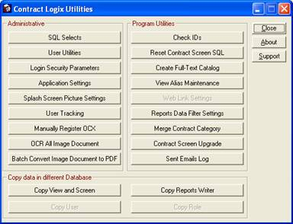

Bug fixes:
1. This system locks up when user click Display All Related button for some special contracts.
2. Error Description: Null object reference at line 14 in pfc_retrieve event of object dw_browse of u_tabpg_dm_data.
3. I am trying to import data from the attached import file. All I am trying to do is update the custom_int1 field with the value of the number of items column (3rd column) from the import file.
Using the Vending Transaction import I created, the attached file and the ctx record #4 can you see why the custom_int1 field is not getting updated.

What’s New in Build 10.1.0325.11

New Features
1. Add Match case option for find function in the OCR result window.

Bug fixes:
1. Need not bring the Email window to top when it receiving email.
2. The new email window should referenced to the contract number when user select the radio button with the contract number.
3. If I have a set of contracts in the browse and then switch the view, the record count is "0" and doesn't get updated until I click to bring the focus to the browse.
4. I noticed that CL requires valid filter dates if there is a filter and any record with a null/blank value for the associated date is not displayed. Has it always been this way? Is there any work around so we can show blank values in either the filter or the dataset? A “skip” for the filter at run-time would be nice.
5. Unable to view the contacts when the contacts count more than 32768.
6. Failed to send due date alarm email when the 'day before' field is set to zero on the work flow painter.
7. Failed to saveas to pdf when the default printer is not 'Contract Logix PDF Writer'.
8. Failed to export lookup dddw data. (From Pat's email 'Clause Map and doc comparison issue on version 10' 03/22/2011).

What’s New in Build 10.1.0329.11

New Features
1. Export other contact data in export painter. (From Jim's email 'NUEVATEL - CONTRACT.OTHER_CONTACTS.CONTACT_DETAILS')

Bug fixes:
1. Failed to search the SQL Server key words 'not, and, or' for the CTX search feature.
2. This is occuring on two machines that were recently updated. They are unable to get into the program. Everyone else is now unable to view contracts on the other machines. We removed the prior installation before running the update.

What’s New in Build 10.1.0408.11

New Features
1. Add new feature for exporting Other Contact data:
As shown below:
The definition for exporting Other contact details or user defined data is:
From Contract Logix Screen field, select Contacts->detail, then select from Link to Screen field to export the information of Other Contacts, Our company contact and Contracted contact.
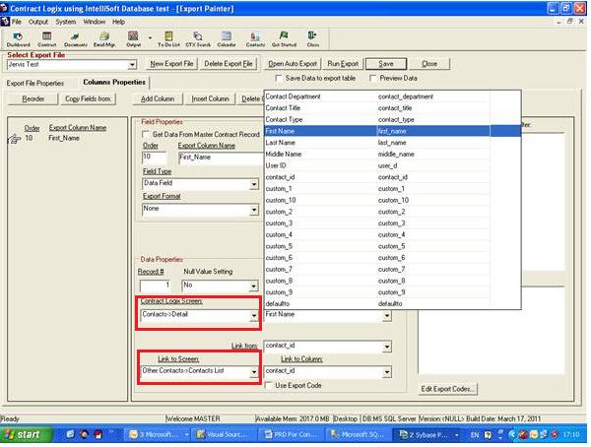
The definition for exporting Contact Number is:
Similar to the above, from Contract Logix screen field, select Contacts->Phone Numbers.

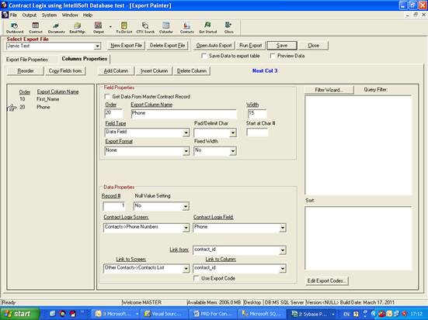
There are three corresponding items to Link to Screen: Our company contact, Contracted contact and Other Contact, and we default the Link to Screen to Our Company Contact by default.

Bug fixes:
1. The notes section of the Custom Data window of the Details Tab. If you apply a date stamp, it should make the date stamp on a distinct line.
2. Support large field (length = 8000) for the import painter.
(From Jim: Why do we get an error for larger fields when the notes/comments fields have a length of 8,000? In addition, Version 10 expanded to have 5 custom notes fields so we should accommodate larger imports.)
3. Need to have full access to Type& Category field in Document Manger.
Missing an opportunity to exploit our capabilities in Doc Mgr ….e.g. to be able to categorize types of documents and report on them. Examples are agreements, addendums, licenses, certifications etc. Need the latter to be able to do “Compliances” which many prospects ask for.
4. Reset the tab page properties when change the value of category field.
5. Fix Copy User Utility bug:
From Jim: When I tried this utility, the pop up for “Copy View” was launched and I clicked on a DB and nothing happened.
6. Add space between the time and the name of company.
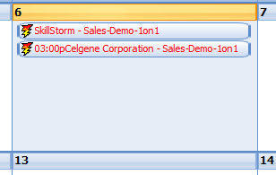

What’s New in Build 10.1.0415.11

New Features
1. Support open pdf file inside of contract logix system.

Bug fixes:
1. Bug description:
V10 Date alarm Email's subject line different than email body: the user is receiving contract alerts but the subject line(Cynthia bowen) is different than what the email body is listing as the contract record(the villages at greystone).
2. Set the dependency for status field in contract status track window.
3. Bug description: Failed to update data when changed status in action items.
4. Bug description:
The CLX MS Word toolbar freezes when user opens another Word file outside CL (Fixed in client version only).

What’s New in Build 10.1.0425.11

New Features
1. Support select display name for dropdown company dddw.
2. Add custom status field in contract detail screen.
3. Add debug Log for Date Alarm.
4. New image thumbnail cp activex is used in CLX, which support to display multiple page PDF.

Bug fixes:
1. Failed to add document before user saved contract.
2. Display which documents in document manager are using the document library document when user wants to delete it.
3. When user creates an new Contract by Copy CTX or Use Template, it should verify the necessary data. The modification we made is:
After the customer conducts Copy CTX or Use Template, the system will check the data immediately. If there is data not completed, a message will prompt up as shown in the screen shot below:
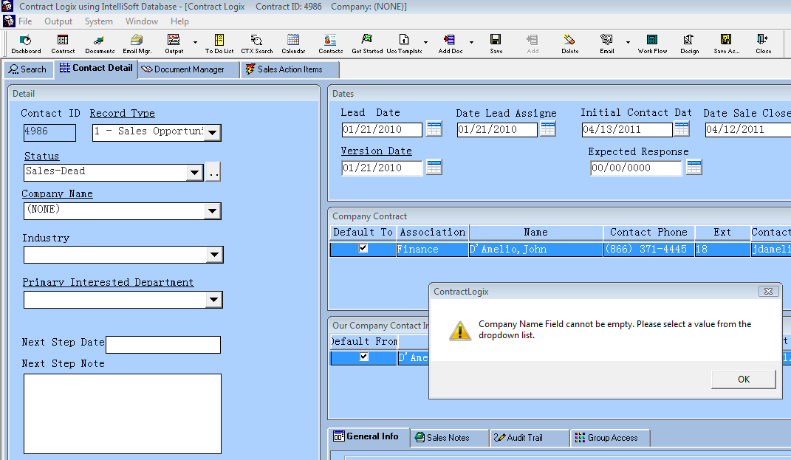
4. Failed to copy role in utilities: I copied the below role (using the new utility) from the below site. As you can see, the “Access” is empty.
5. Failed to update screen.

What’s New in Build 10.1.0506.11

New Features
1. Add 'Open in Document Manager(Select)' menu item for document manager.
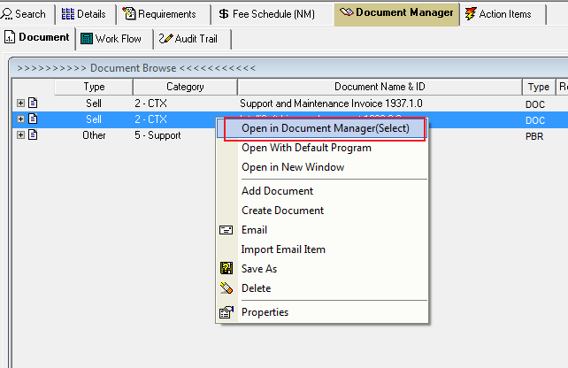
2. Added 'Open .pdf Documents within' options.

Bug fixes:
1. Master Contract Search (binoculars) Search Criteria getting cut off. Buttons on bottom right hand corner too.
2. I am trying to write a report that shows the value of the ASSOCIATION field in Our Company Contacts, but the only value I can seem to pull is the Contact Type field associated with the contact, even if I have changed the ASSOCIATION in the contract.
3. Performance issue for adding clause function on template painter.
4. The snooze function is not working for to do list.
5. Workaround word toolbar grayed out bug.

