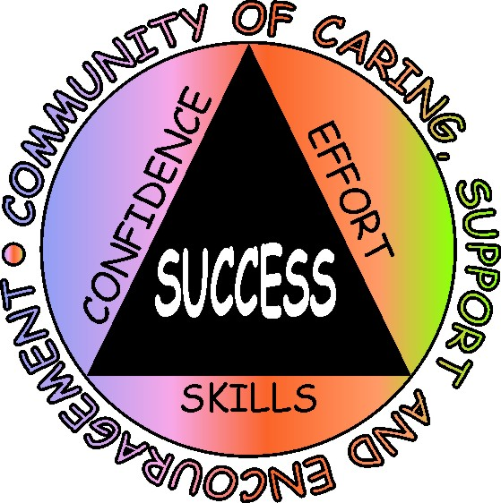 Making a Difference in Student Achievement and Behavior

School counselor led classroom and group lessons focused on helping students develop cognitive, social and self-management skills lead to improved student performance.

Strong evidence of effectiveness based on U.S. Department of Education guidelines for conducting rigorous research:
- Four randomized comparison group studies measuring FCAT math and reading
- Replicated in multiple settings: 50 school counselors in 36 schools in two school districts with over 1100 students in grades 5, 6, 8 and 9.
- Follow-up study shows SSS students continue to make substantial gains two years after participating in the program.
- 2007 National Panel for Evidence-Based School Counseling evaluated the SSS program & found “Strong and Promising evidence of effectiveness”.

Consistent findings:
- FCAT NRT reading scores improved for approximately 78% of SSS students. The average increase was 25 percentile score points compared to 5 for district and state.
- FCAT NRT math scores improved for approximately 86% of SSS students. The average increase was 30 percentile score points compared to 7 for district and state.
- Several Action Research studies from different districts show similar gain patterns on the FCAT developmental scale scores (see sample on page 4).

Improved behavior:
- Teacher ratings of student behavior improved for approximately 70% of SSS students. The average gain was 20 percentile points. The nationally normed behavior scale focused on academic, social and self-management skills.

Support for SSS program strong:
- Over 97% of teachers (grades 5-9) rated the program as helpful or very helpful in meeting student academic and classroom management needs
- Over 90% of principals surveyed (Elementary, Middle and High) supported school counselors implementing the SSS program.

Other SSS programs:
- Ready to Learn, grades K-1
- Ready for Success, grades 2-3
- Parent Success Skills, grades 4-10
- Spanish cultural translation of SSS
- Haitian Creole cultural translation of SSS

For more information on the research supporting the SSS program go to
www.studentsuccessskills.com or contact:
Greg Brigman, Ph.D.
561-297-3616

Research Base for Student Success Skills:
Five Key Reviews
Of Research

The skills and strategies highlighted in the Student Success Skills program were selected based upon the recurring dominant themes that emerged from the following five extensive reviews of research:

Wang, et al. (1994)
- Reviewed 50 years of research on “What helps students learn”.

Hattie, et al. (1996)
- Reviewed 10 years of research on the effects of learning skills interventions on student learning

Masten & Coatsworth (1998)
- Reviewed 25 years of research and identified the most critical factors associated with academic and social competence

Marzano, et al. (2001).
- Reviewed 10 years of research on classroom instruction and
summarized research-based strategies for increasing student achievement.

Zins, et al. (2004).
- Reviewed 10 years of research on the relationship of social and emotional learning to academic success.

All five reviews found very similar skills sets that were considered to be critical to student success. These skills sets include:

- Cognitive and meta-cognitive skills such as goal setting, progress monitoring, memory skills and healthy optimism.

- Social skills such as interpersonal skills, social problem solving, listening, and teamwork skills.

- Self-management skills such as managing attention, motivation, anxiety and anger.

The SSS program organizes these three critical skill sets into five strategy categories (see next page).

Student Success Skills

SSS Strategies & Skills are Organized Under Five Categories

Goal Setting/Planning & Progress Monitoring & Success Story Sharing:
Students share successful strategies weekly using two tools
- Student Success Skills: Seven Keys to Mastering Any Course
- Life Skills: Five ways to insure high energy and positive mood

Creating a Caring, Supportive and Encouraging classroom community:
- Combining Social-Emotional and Academic Skills:
- What a CSE community looks like, sounds like and feels like
- Listening with Eyes, Ears and Heart: Practice with Attending, listening, empathy and encouragement
- Sharing improvements & recognizing others for improvement
- Encouraging things to say and do

Cognitive & Memory Skills:
- Picking out the most important ideas
- Graphic organizers --Outlining—concept mapping
- Chunking into note cards and reviewing at least six times
- Location Memory: BodyPeg System

Story Structure

Performing Under Pressure: Managing Test Anxiety
- Safe Place and Breathe, Picture Focus ( calming strategy)
- Meta-cognitive strategies—positive self-talk and cognitive reframing strategies
- Keep Kool tunes ( calming strategy)
- Test taking strategies
- Mental practice—picturing successfully using your strategies

Building Healthy Optimism:
- Kaizen: Looking for even very small improvement and the notion of continuous improvement.
- Setting goals and sharing successes weekly
- Language of Optimism (Don’t doubt your ability, try something different if what you are doing is not working).
Student Success Skills:
A case example in a large urban school district

In 2004 the district was awarded the Office of Safe and Drug Free Schools Elementary and Secondary School Counseling Grant which funded Student Success Skills (SSS) implementation through district guidance services.

Year 1:
- 50 school counselors trained by Dr. Brigman
Year 2:
- 40 school counselors trained by Dr. Brigman, plus 4 counselors identified and trained as SSS trainers
Year 3:
- 30 school counselors were trained by district SSS-trained counselors

Training:
- Three full days spread over the first three months of the school year: One day for the SSS Classroom program followed approximately one month later with one day for the SSS Group program, followed approximately one month later with one day to share successes, plan for data collection and plan for future implementation.
- School counselors volunteer to participate in training
- Training methods include modeling, role playing, and coaching
- Manuals for the five SSS classroom guidance lessons and eight SSS small group counseling sessions provided.
- District guidance services coordinates all training and provides support and assistance in data collection and analysis with support from the SSS trainers.

2006 RESULTS
FCAT Developmental Scale Score (DSS) Mean Improvement from 2005 to 2006

Grade  Level | Subject | N | Mean DSS Improvement
Grade  Level | Subject | N | District | State | Student Success Skills
4 | Reading | 92 | 166 | 172 | 299
5 | Reading | 61 | 33 | 46 | 178
6 | Reading | 7 | 89 | 108 | 210
7 | Reading | 14 | 117 | 128 | 341
9 | Reading | 10 | 62 | 70 | 202
4 | Math | 92 | 129 | 124 | 239
5 | Math | 60 | 141 | 140 | 229
6 | Math | 7 | 25 | 48 | 46
7 | Math | 14 | 136 | 133 | 258
9 | Math | 10 | 60 | 56 | 104

Refereed Articles in National Journals

Supporting Student Success Skills and Ready to Learn

Brigman, G., & Campbell, C. (2003). Helping students improve academic achievement
and school success behavior. Professional School Counseling, 7, 91-98.

Brigman, G., Webb, L., & Campbell, C. (2007). Building skills for school success:
Improving academic and social competence. Professional School Counseling, 10,
279-288.

Brigman, G. & Webb, L. (2008). Education: An Individual Psychology approach to school consultation. Journal of Individual Psychology,64(4), 506-515.

Brigman, G. & Webb, L. (2007). Student Success Skills: Impacting achievement through large and small group work. Journal of Group Dynamics: Theory, Practice and Research, 11 (4), 283-292.

Brigman, G. & Webb, L. (2003). Ready to learn: Teaching kindergarten students school success skills. Journal of Educational Research, 96 (5), 286-292.

Brigman, G., Webb. L.& Campbell, C. (2007) Building skills for school success: Improving the academic and social competence of students. Professional School Counseling, 10 (3), 279-288.

Brigman, G., Lane, D., Lane, D., Switzer, D., & Lawrence, R., (1999). Teaching children school success skills. Journal of Educational Research, 92 (6), 323-329.

Campbell, C., & Brigman, G. (2005). Closing the achievement gap: A structured
approach to group counseling. Journal for Specialists in Group Work, 30, 67-82

Carey, J., Dimmitt, C., Hatch, T., Lapan, R. & Whiston, S. (2008). Report of the National Panel for Evidence-Based School Counseling: Outcome research coding protocol and evaluation of Student Success Skills and Second Step. Professional School Counseling, 11 (3), 197-206.

Miranda, A., Webb. L., Brigman, G. & Peluso, P. (2007). Student success skills: A promising approach to closing the achievement gap for African Americans and Latino students. Professional School Counseling, 10 (5), 490-497.

Villares, E., Brigman, G., & Peluso, P. (2008). Ready to Learn: An evidence-based Individual Psychology linked curriculum for prekindergarten through first grade. Journal of Individual Psychology, 64(4), 386-402.

Webb. L. & Brigman, G. (2006). Student Success Skills: Tools and strategies for improved academic and social outcomes. Professional School Counseling, 10 (2), 112-120.

Webb, L. & Brigman, G. (2007). Student Success Skills: A structured group intervention for school counselors. Journal for Specialists in Group Work, 32, 190-201.

Webb, L. & Brigman, G., & Campbell, C. (2005). Linking school counselors and student
success: A replication of the Student Success Skills approach targeting the academic
and social competence of students. Professional School Counseling, 8, 407-413.

Webb, L., Lemberger, M., & Brigman, G. (2008). Student Success Skills: A review of a research based school counselor intervention influenced by Individual Psychology. Journal of Individual Psychology,64(3), 339-352.

