Climate Change in Cambrdige
Assessed Exercise 2
Aleksandr Petrosyan
Queens' College
ap886

Analysis
Figure 1 Shows the Average Temperature in Cambridge since 1961.
By performing appropriate computation, it was found that the line is best described by the closed form where
is the temperature,- the time in Years, and is the period of the sinuoidal change. By reasoning this is found to be 1 year.

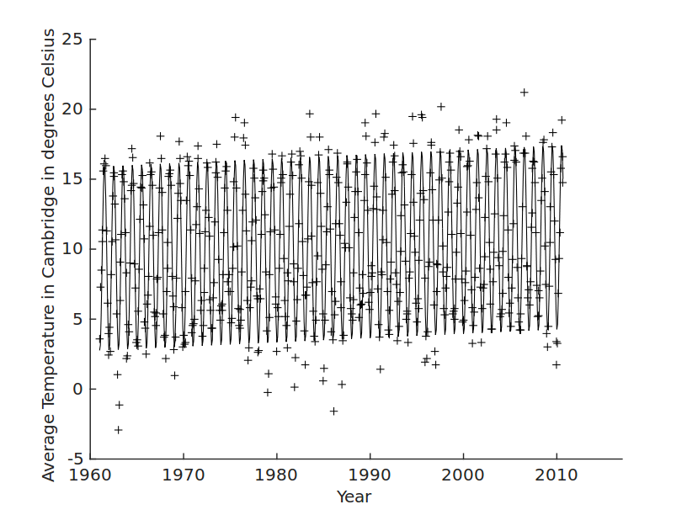Figure 1: Graph of Average Temperature as a function of time. Experimental datapoints marked with + signs, best fit line drawn in solid black. Analyzing the linear terms of the closed form (see above) it was found that the change in temperature over the past 50 years was 1.54 degrees Celsius

Below is a histogram of the precipitation (e.g. rainfall) data in Cambridge. It indicates a generally even, near-normal distribution with the most common factor of 50mm per month.

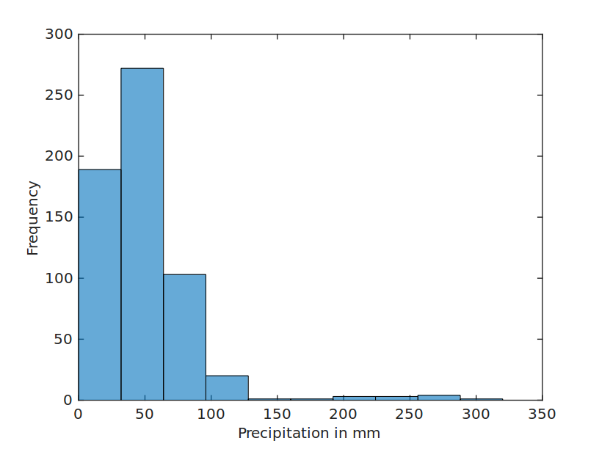Figure 2: Precipitation data in Cambridge. Bin size is 10 mm, time interval of data samples - one month. The most frequent amount is 50mm.

Appendix
Matlab_Assessed_Exercise_2_ap886.m

% 2.1 Data and Fit
%%

% Read File
M = dlmread ( 'cambridge.dat', ' ', 4,3);

%Since the Genius who made the file decided to delimit with spaces not tabs
%NEED Quirks to get actual data out.
yy = M(:,1); %get Months
mm = M(:,3) + M(:,4) ; %Get Years
tmax = M(:,6) + M(:,7) + M(:,8); %Get Rest of Data
tmin = M(:,11) + M(:,12) + M(:,13);
af = M(:,17) + M(:,18) + M(:,19) + M(:, 20);
rain = M(:,21) + M(:,22) + M(:,23) + M(:, 24);
% A standing ovation to MathWorks. Even the Simplest compilers would just
% Throw away all spaces and give you a nice table.

% Define Floatpoint Years

t = yy + (mm-1)/12;
avtemp = (tmax + tmin)/2;

% Plot
hold on
plot (t,avtemp,'k+'); %Plot using black line with + Markers
xlabel ('Year','fontsize', 14);
ylabel ('Average Temperature in Cambridge in degrees Celsius', 'fontsize', 14);
set (gca, 'fontsize', 14, 'linewidth', 1); %Nice Touch

%Perform Fit
% Create a vector of initial trial Values
a_0 = [10, 0.1, 5.5, 0]; % a_0 a_1 a_2 \delta

%Need to define slsine.m to use chi^2 fit
% because:
% a) Makes code concise and human readable
% b) makes the second argument a function by all definitions
% which is impossible to make in the same file: see
% http://stackoverflow.com/questions/5363397/
% in-matlab-can-i-have-a-script-and-a-function-definition-in-the-same-file

%Fit to the Graph
a = fminsearch ( @(a) slsine(a,t,avtemp),a_0)

% Result of Computation is
% a_0 = 9.3257
% a_1 = 0.0308
% a_2 =-6.6440
% \delta = 1.4156
plot (t,a(1) + a(2) * (t-1961) + a(3) * sin (2*pi*t + a(4)),'k')
xlim ([1960,2017]);
ylim ([-5,25]);
hold off
print -dsvg ChangeInTemp.svg

%%
%(a)

%The rise of the Temperature is a(2) * 50
a(2)*50
% = 1.5376

%(b) histogram
histogram (rain, 10)
xlabel ('Precipitation in mm','fontsize', 14);
ylabel ('Frequency', 'fontsize', 14);
set (gca, 'fontsize', 14, 'linewidth', 1);
print -dsvg Rain.svg

%(c) The Graphs Are of Good Quality, Change in Temp needs to be
% Flipped 90 degrees, to be more visible

slsine.m

function chisq = slsine (a, t,y)
chi = y - (a(1) + a(2) * (t-1961) + a(3) * sin (2*pi*t + a(4)));
chisq = sum (chi.^2)

Justification for using two files is given in the Comments. Thuis is a tecnhical limitation, as Matlab doesn't allow declaring functions in script files.

