O365/AzurE: APPROVAL Request [Linked] To Receive Secure File-ATTACHMENT

# AS A – I WANT – SO THAT

1. **AS A**: “SharePoint Processes Owner” – **I WANT**: Less trusted and usually anyone from the organization or external-B2B users to request a document template or form – **SO THAT:** there is traceability and approval process linked to such request and only on approval will the requestor receive the template/form/document by one of the means – email or creation in document library in SharePoint for offline/online-processes to be completed using those template forms – well, because the organization is still not entirely digitally ready but also, external/3rd party/agency entities will be involved and all those cannot be given access to SharePoint or even trained to use SharePoint.
2. **AS A**: “User of SharePoint” – **I WANT**: to be able to receive a “form/template/document” from single source SharePoint document library such that I can enter info like, purpose and other business needed metadata – **SO THAT:** I can get such request approved and receive an attachment or link to form/template/document” such that it can be downloaded and printed and after the long running workflow, if required scan back and upload to the original request item and close the loop.

**Disclaimer: This was narrated by one business client and was a real requirement, though it sounds like a Newsletter subscription or download request – Whitepapers, Software etc. The goal with this solution is to make it as generic as possible.

# Solution ApProach

1. Allow users to create a list item for specific content-type/classification with properties that are required for approval.
   1. A work-flow kicks-in and starts approval process (with some/any arbitrary precheck conditions to stop approval process to run again for same item.
2. On Approval process completing and marked approved
   1. The workflow attaches the appropriate document template associated with such list-item-content-type/classification from the secured-document-library and then sends notification/link to the requestor or assigned-to email.
3. So,
   1. First SharePoint entity is the external/end-user facing list that does not provide the template/form until approval.
   2. The other SharePoint entity is internal admin facing document- library holds the document template/form, for corresponding list-item content type from above – such that only the admin and workflow can access it – update certain metadata and upload/attach it to the related-instance of the request-list-item and send email/notification with link/attachment.

**Disclaimer: One might say why list-item and content-type separated from document-template: why not have a document-content-type and let the user create a blank document etc. and fill out properties in the document and use Label/Barcode policy features etc. Yes, it is marginally possible – but slightly clunky considering the fact that



# SOLUTION DESIGN

## Infomration Architecture

### Content Types:

**1. “RequestForTemplateOfTypeBase”**

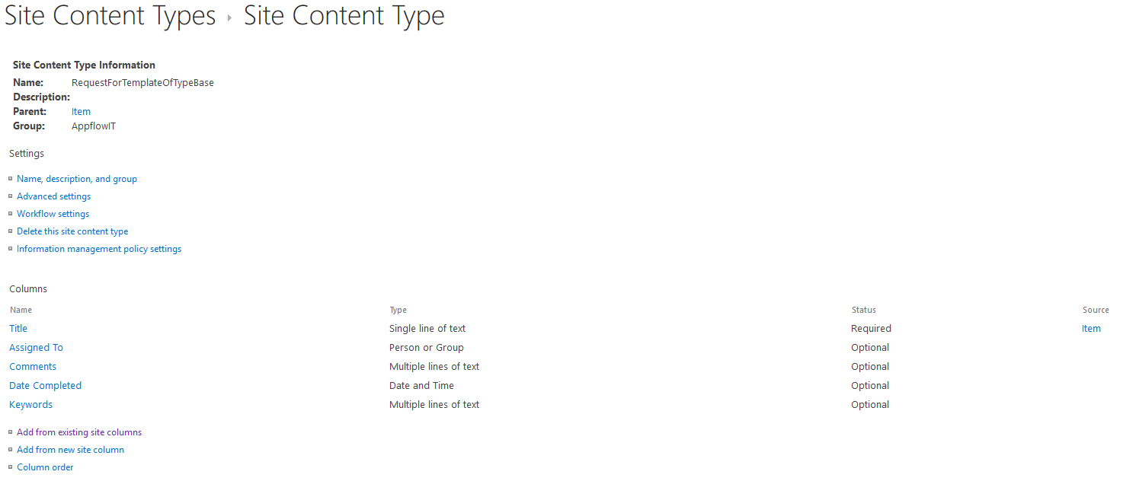

**2. “RequestForTemplateOfTypeAX1” | “DocFormTemplatesOfTypeBX2”**

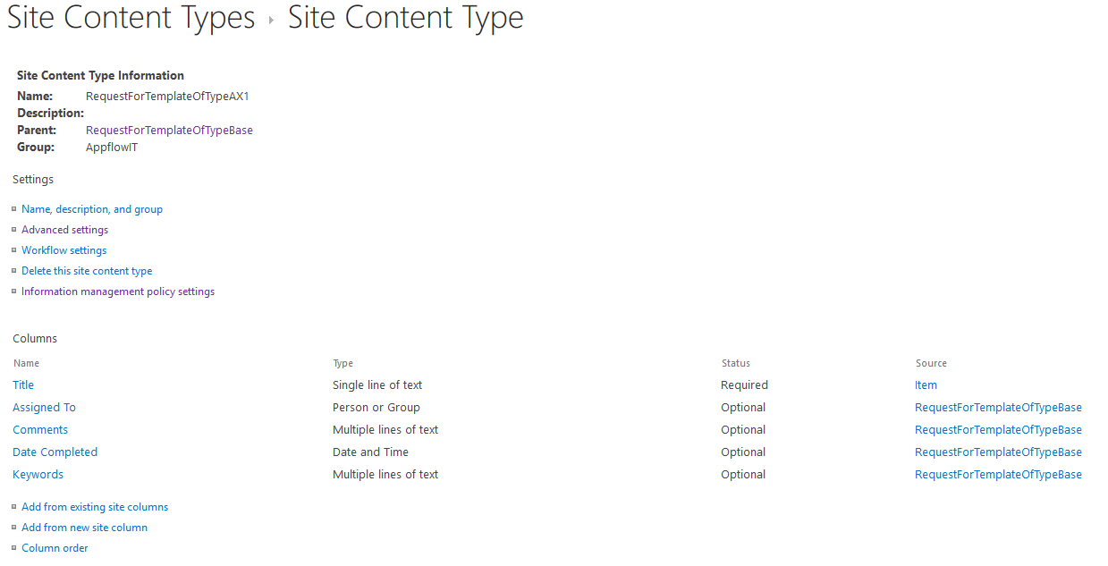

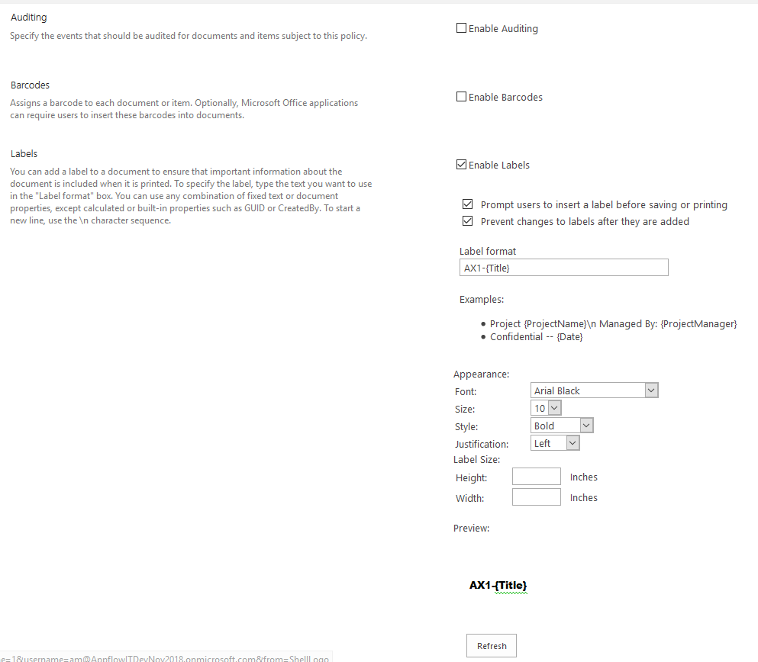

### Document Library: A document librarY with content types

**2. “RequestForTemplateOfTypes” Folder – This document library folder will have associated/added document content types.**

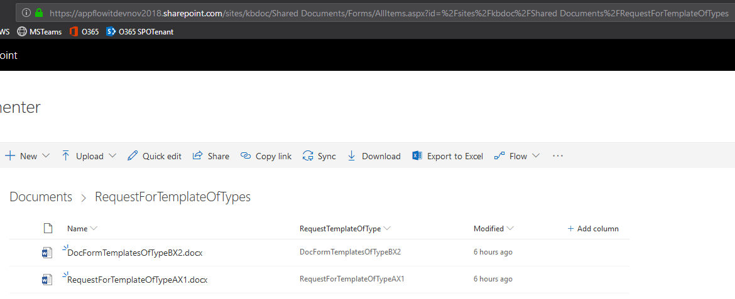

**2. “RequestForTemplateOfTypes” – This list is setup to allow end users to raise request for the secured file based on content-type and it relevant metadata/properties.**

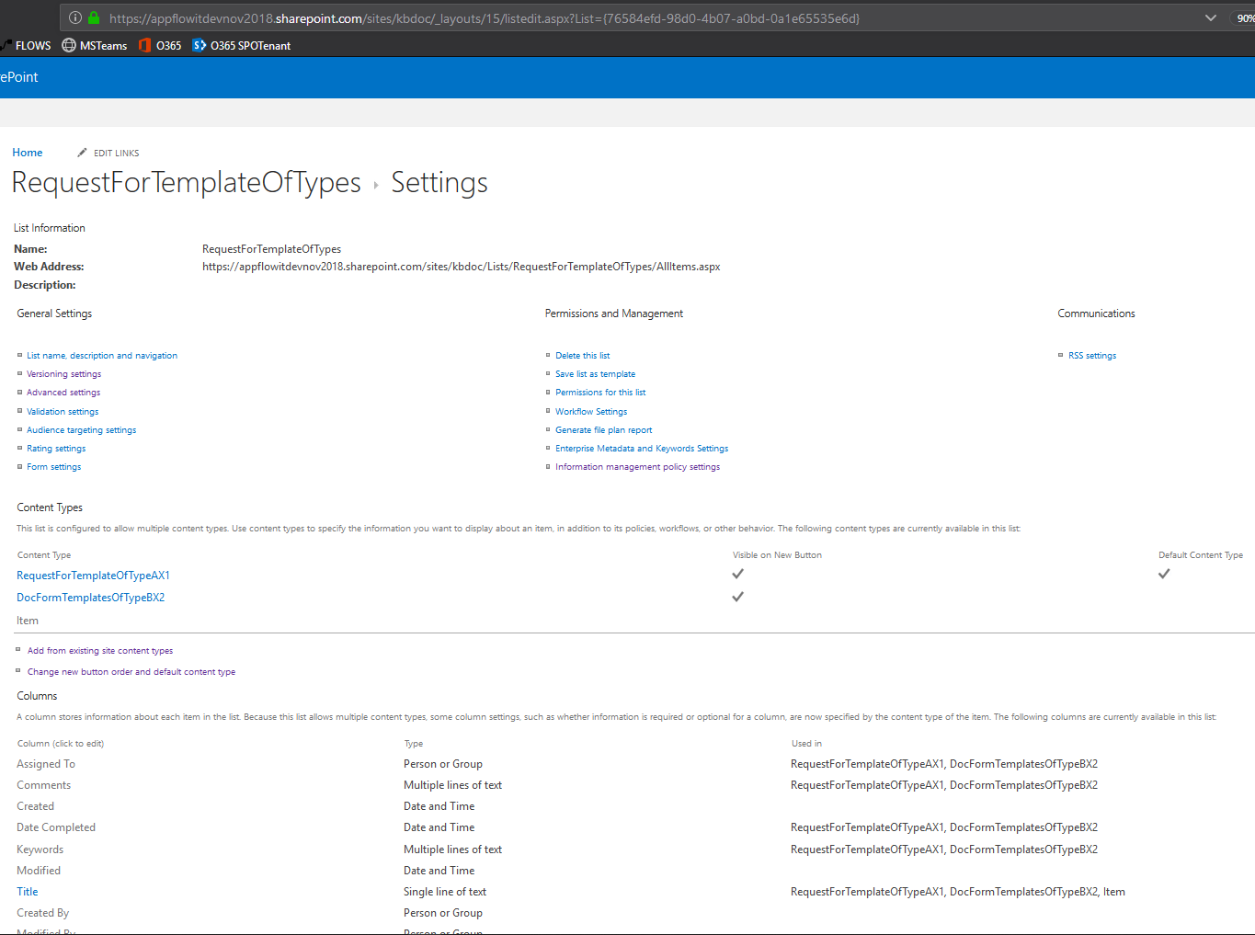

**AND Some additional security/access related constraints due to nature of the scenario… Including clamping down the Shared Document (RequestForTemplateOfTypes folder) library access – limited to only admin/workflow-process users.**

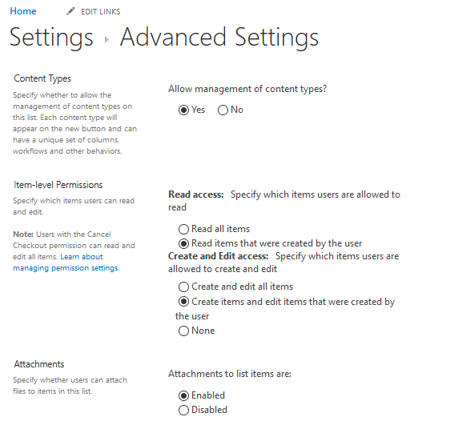

## FLOW DESIGNER

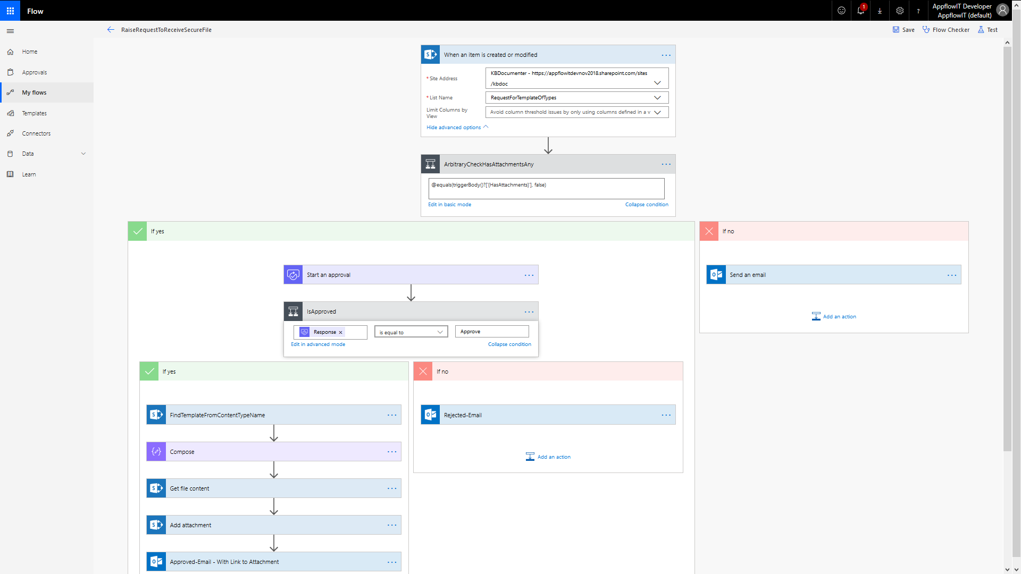

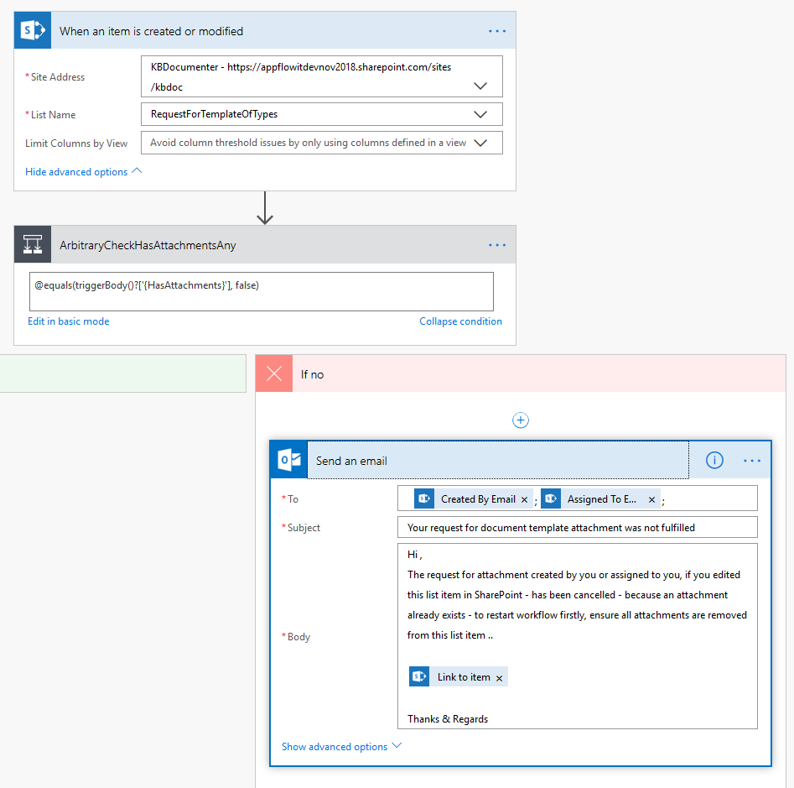

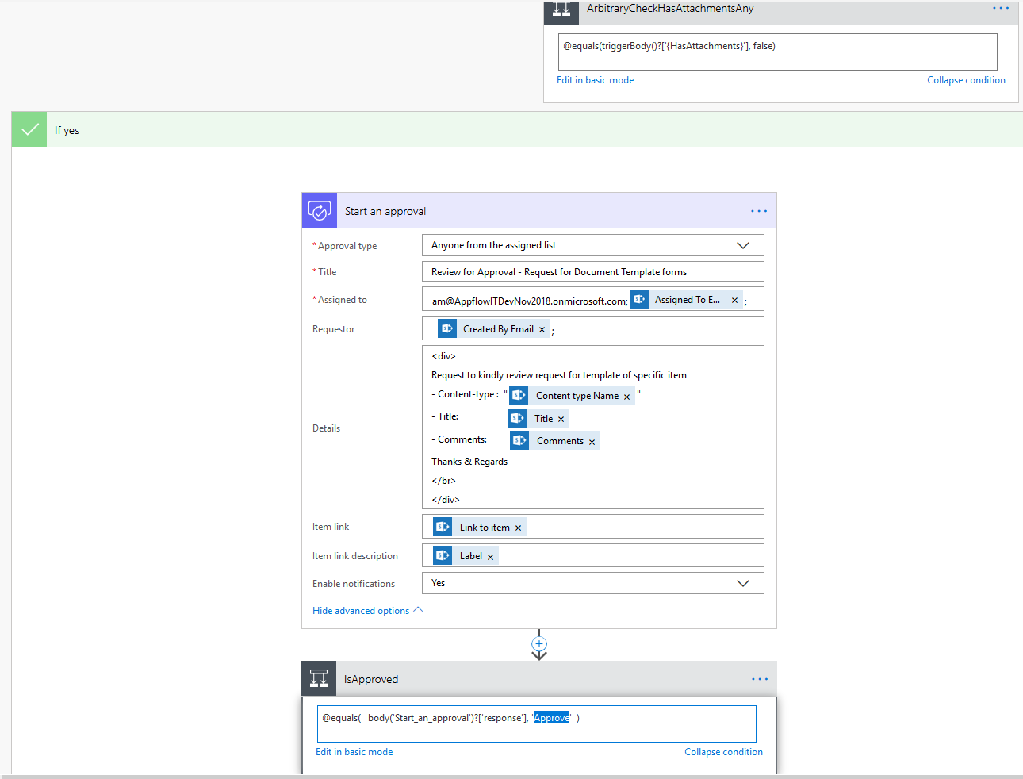

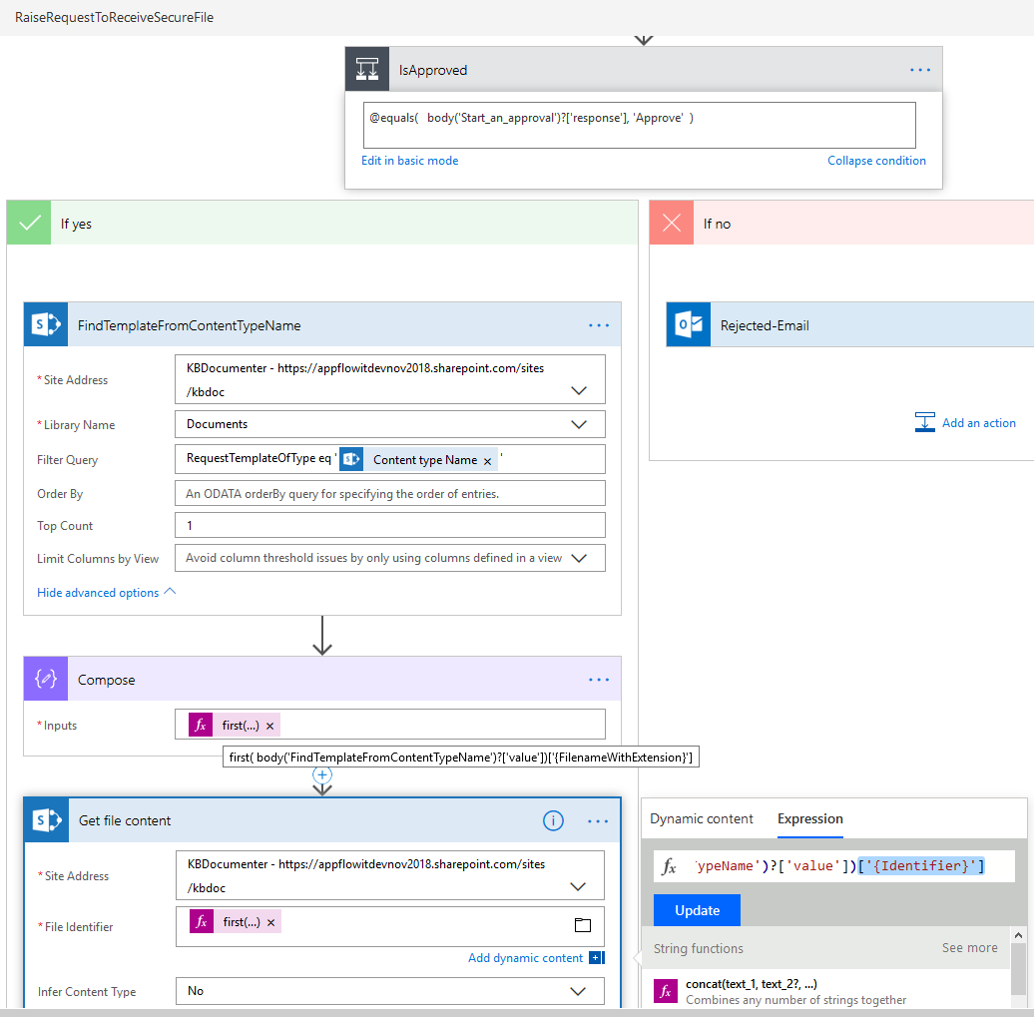

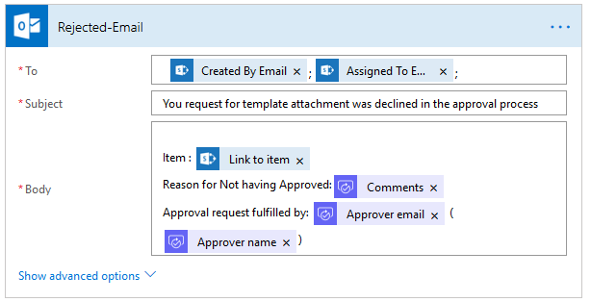

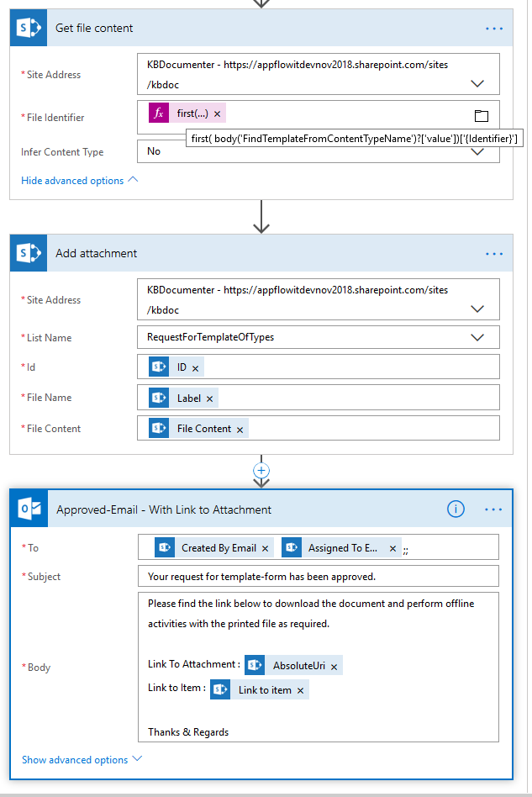

## TEST – RUN

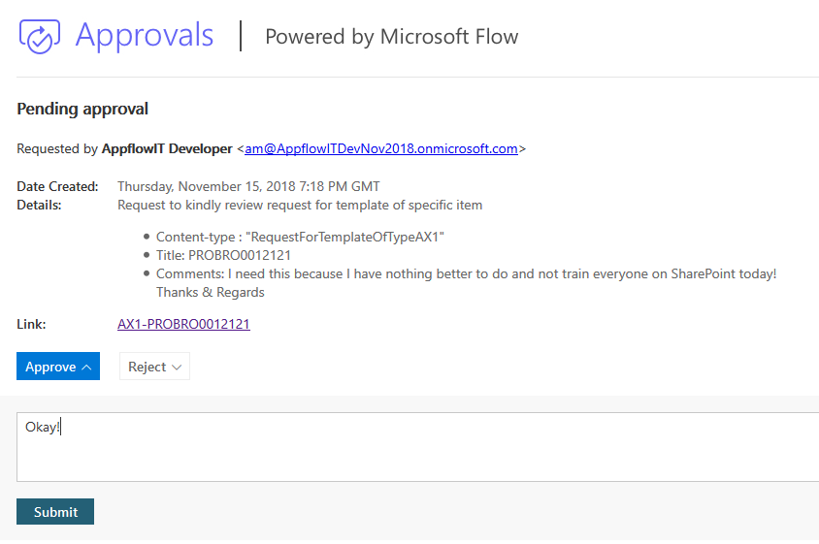 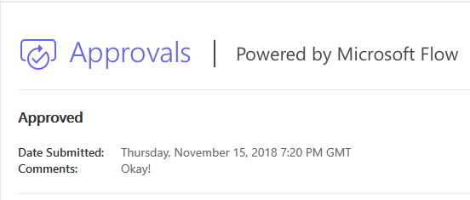

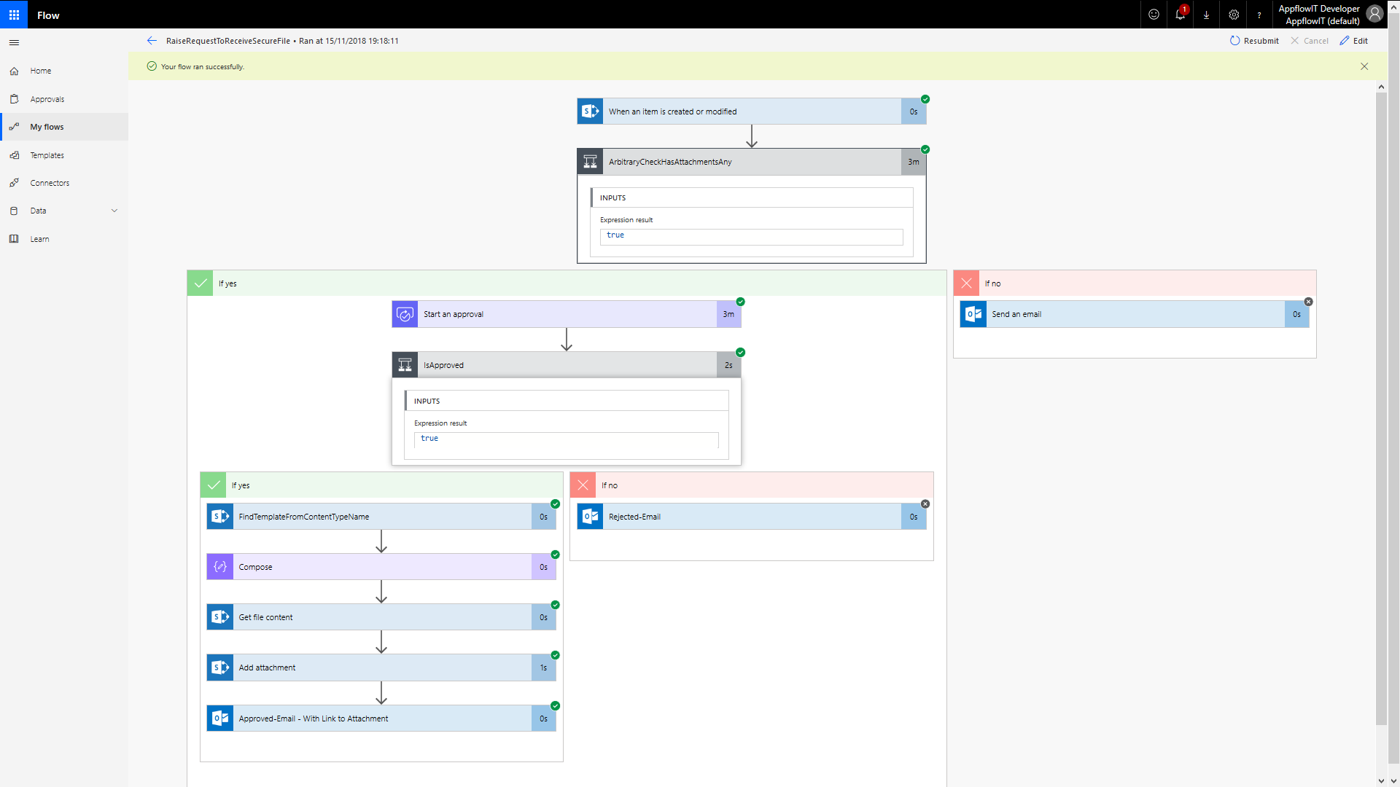

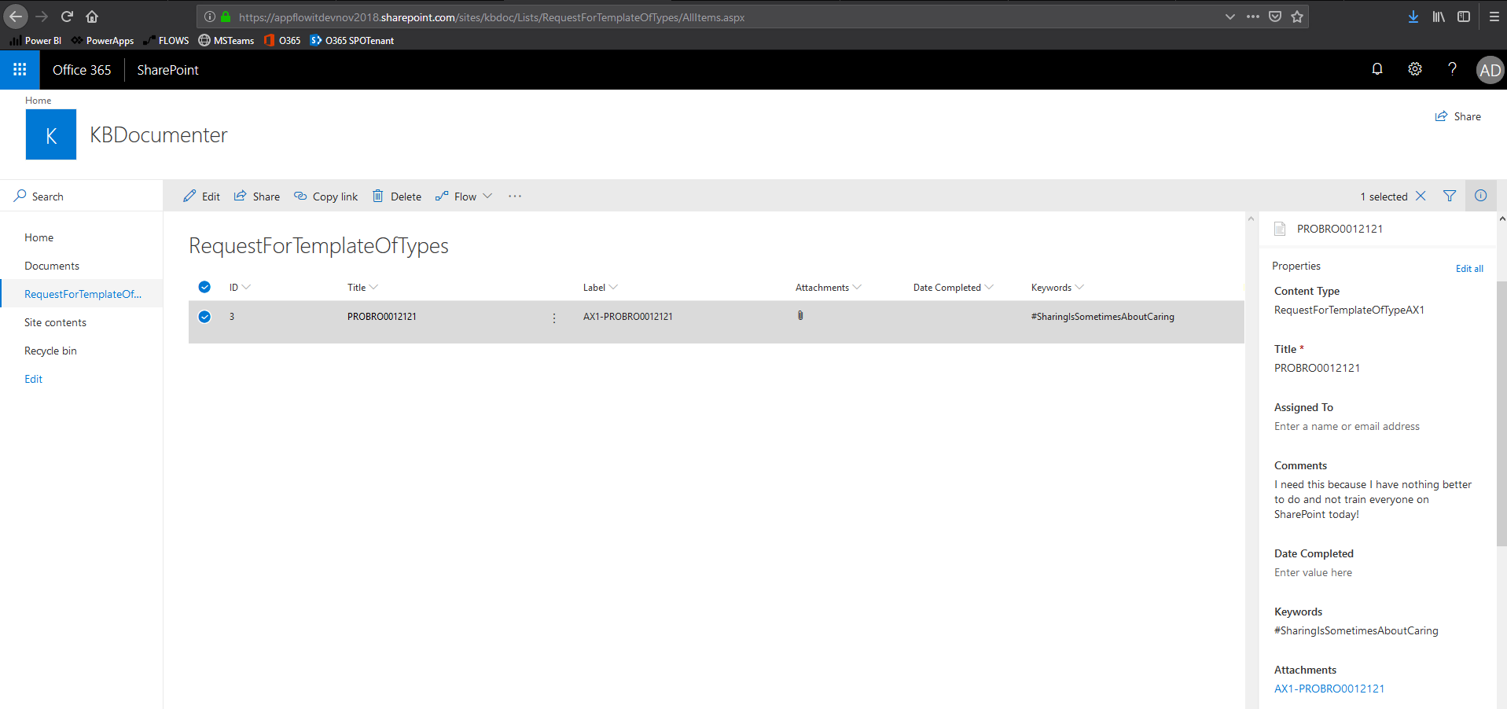

# HOPE THIS HELPED!?

Kindly feedback your thoughts and suggestions and ideas, that would be magical to get them😊

Cheers, Aaseaf Mahkahti | [sharepointjob@outlook.com](mailto:sharepointjob@outlook.com)

# DISCLAIMER

This document is provided “as-is”. Information and views expressed in this document, including URL and other Internet Web site references, may change without notice. You bear the risk of using it.

Some examples depicted herein are provided for illustration only and are fictitious.  No real association or connection is intended or should be inferred.

This document does not provide you with any legal rights to any intellectual property in any Appflow IT Solutions Ltd. products. You may copy and use this document for your internal, reference purposes.

© 2018 Appflow IT Solutions Ltd. All rights reserved.