O365/Azure FLow – OutLook-Meeting [Linked] SharePOint-Documents

# AS A – I WANT – SO THAT

1. **AS A**: Meeting Manager – **I WANT**: *To Create* a meeting (hosted/planned/scheduled) in SharePoint (List) and Outlook, to be able to then – associate such meeting(s) to - documents in other libraries in the site – **SO THAT:** “Meeting Participants” can link such meeting item (using Lookup field) to their authored documents according to the meeting’s theme/agenda/title.
2. **AS A**: Meeting Participant – **I WANT**: *To Receive* an invite/notification to accept/decline attendance in the meeting through outlook client (o365/Exchange) **– SO THAT:** I can clearly identify “active” meetings in SharePoint in such document libraries where I author documents that will be associated with meeting(s) later (review/approval processes).
3. **AS A**: Process Manager – **I WANT**: To be able to have meeting invites/list-items being tagged/categorized/grouped such that, the meetings can be identified in the document libraries (lookup fields) based on such categorization (possibly prefixed/suffixed to the title of such meeting record).

# Solution ApProach

1. Solution Option**#1**: **Ask “Meeting Manager”** to **create meeting invite(s) in outlook calendar** for a primary user (as a connection/credential/login) let a flow (office365 or azure logic app) be triggered on create/update/delete of such calendar invite item.
2. Solution Option**#2**: **Ask “Meeting Manager”** to **create a SharePoint list item first** such that meeting invite information like, Title, Attendees, Body/Description, Location, Start and End Datetime, etc. can be captured/filled-in and for the creation/modification of such list item – an O365/Azure Flow will accordingly create/update a calendar invite.

**Shared/Common Solution Requirement**: Would need a Service-Account /API-Permissioned/AD-Exchange-Licensed user login to be able to host the calendar and perform API based updates from o365/azure flow (connections).

Solution Pros/Cons/Evaluation:

* **Solution (#1)** from above, where the initial trigger is to listen-to/get-trigger-by - the Outlook calendar invite being created/updated/deleted, and then reference/associated/clone SharePoint list item is created/modified/deleted in synchronized way through the o3365/azure flow. **The advantage** is that “Meeting Manager” continues doing what they do best with Outlook and Meeting Invite subject, body and other metadata is replicated in SharePoint list for further consumption in the lookup fields of other document libraries. **The disadvantage** is that given the “Process Managers” requirement of having multiple types of meeting invites means additional metadata has be to be captured from the outlook meeting invite item [which is a challenge] **and also**, creating multiple or secondary calendars for the same login/user/service-account will cause inherent Outlook limitation of “[Only Tallying Responses for Primary Calendar](https://www.slipstick.com/outlook/calendar/response-meeting-request-tallied/)”. In such situation, if only primary calendar has to be used then either there will be need for dedicated user-login for each type of invite “Process Manager” has identified or “Meeting Manager” will be forced to diligently prefix/suffix the exact type/tag that can be identified and mapped in to a SharePoint list item field for meeting record.
* **Solution (#2)** from above, the Meeting Manager will be expected to create a SharePoint list item to add essential calendar invite metadata using a SharePoint List Item based Form (however friendly it could be made), which would not give the same experience – Yet, it can easily avoid the issue of “tallying” since, SharePoint list can have additional metadata (choice) fields for classification/tagging/grouping that can be consistently prefix/suffixed to the calendar invite.

# SOLUTION DESIGN

With the debate of solution choice in previous section – it can be concluded that **Solution#2:** where “Meeting Manager” must create/update a SharePoint list item to then have a triggered-flow create/update the Outlook Meeting invite with prefixed categorization/grouping in the subject/title - maintained in the primary calendar of the service-account user for all such meeting-invite-types.



## Infomration Architecture – LIST (Content Type) Fields

List-ContentType Name: **ReviewMeeting**

|  |  |  |  |
| --- | --- | --- | --- |
| Field-Display Name | Type |  | Details |
| **Allow In Lookups** | **Yes**/No | Optional | Setting this field controls the “Title In Lookup” calculated column to automagically show-hide this item/title in the Lookup fields in other document libraries/lists where they will be referenced. This without forcing user to delete item maintains referential integrity and yet reduced the filtering out of lookup choices. |
| **Title** | Single line of text | **Required** | This also uniquely identifies the records and forms part of the Subject line in the Meeting invite |
| **MeetingTypePrefix** | Choice | **Required** | This choice field allows classification/categorization/tagging of the meeting such that some additional form of identification and filtering can be done – again through smart utilization in the “Title in Lookup” calculated column as well. |
| **Starts At** | Date and Time | **Required** | Meeting invite start date time |
| **Ends At** | Date and Time | **Required** | Meeting invite end date time |
| **Meeting Details** | Multiple lines of text | Optional | Meeting invite description, body |
| **Required Attendees** | Person or Group | **Required** | Active directory lookup of “People” only with multiple entries allowed – later the flow extracts Email part of the user-profile-record and does csv in the Attendees field of Outlook Calendar Invite Item. |
| **Optional Attendees** | Person or Group | Optional | Same as Attendees field but for the optional field in outlook invite. |
| **Meeting Room** | Person or Group | Optional | Also a People picker field such that rooms have been defined as a resource in the active directory – alternatively, as Location field as Single line Text field can be added/utilized in place or in addition to this field. |
| **Allow Create Event** | Yes/No | Optional | This is another flag, that further allows “Meeting Manager” to control the automatically triggering Flow when item is created/updated – Thus this lends a choice if the manager does not want to send out invites at time of creating this list item – also helps for bulk uploads and other scenarios. |
| **Title In Lookups** | Calculated | Optional | This is a calculated field to be used as the field to be selected when creating Lookup fields in other Lists/Libraries/ContentTypes linked to this [MeetingReviews] list. The formula effectively blanks the value in this field which causes the Lookup dropdowns in consuming Lists/Libraries to NOT show such blank values and that is the entire list item in this list.  Formula: **=IF([Allow In Lookups],CONCATENATE(TEXT([Starts At],"ddMMMyy"),"-",Title),"")** |
| **Assigned To** | Person or Group | Optional | Can be used as “Owner” or “Meeting Manager” contact if creator of this list item is not the same. |
| **MeetingWorkspaceLink** | Single line of text | Optional | This is the URL to be formed in the Flow to a page which then provides filtered views of documents and associate items to this Meeting. |
| **OutlookCalendarEventID** | Single line of text | Optional | This is the ID of the invite in the calendar – that gets created when the flow creates/updates such meeting invite based on this list item’s creation/editing etc..   * This is the primary field that helps the flow identify if a meeting invite for this list item exists or requires to be newly created. |

## FLOW DESIGNER

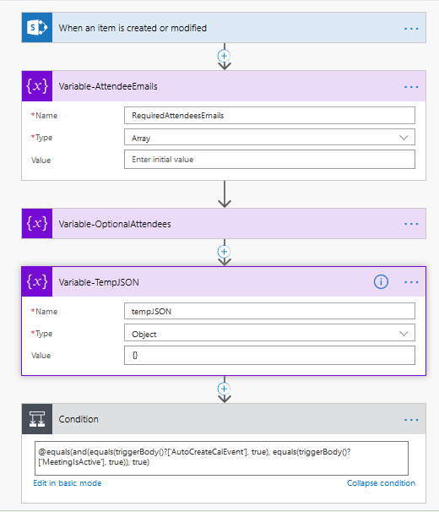

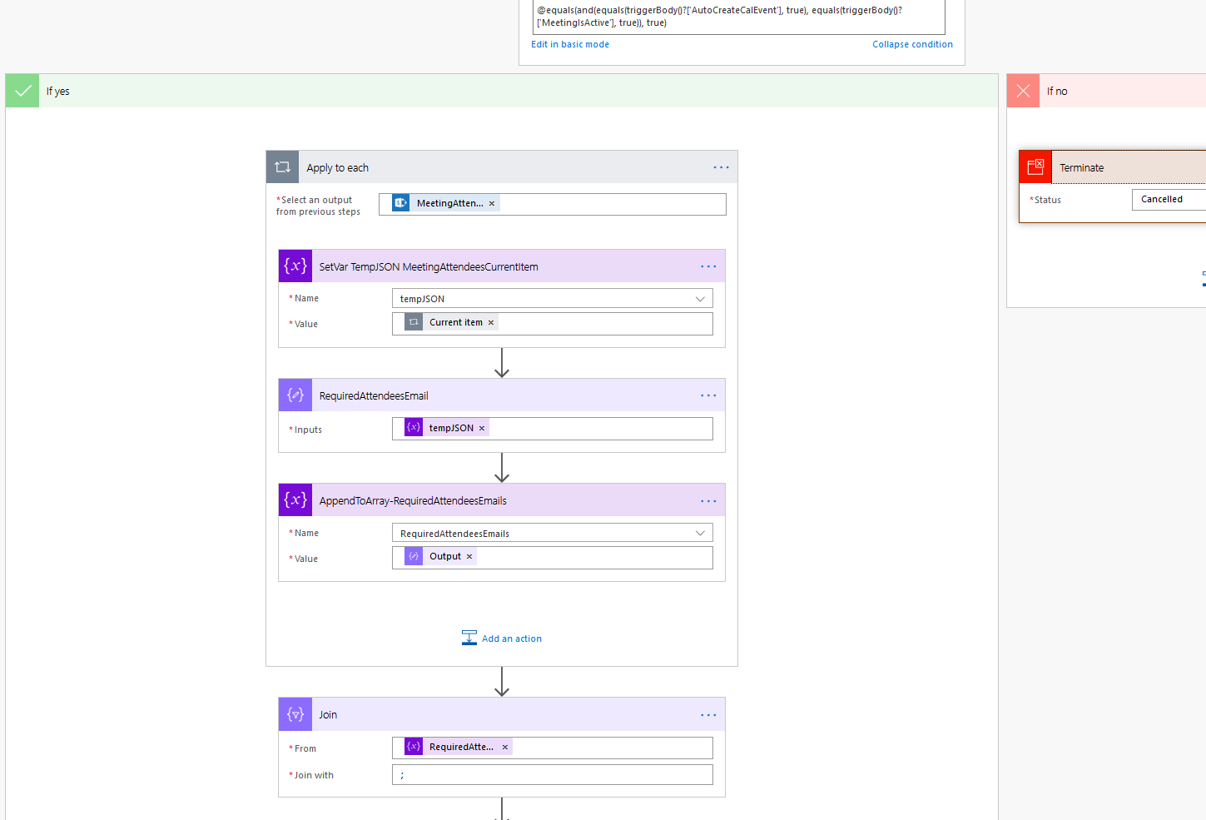

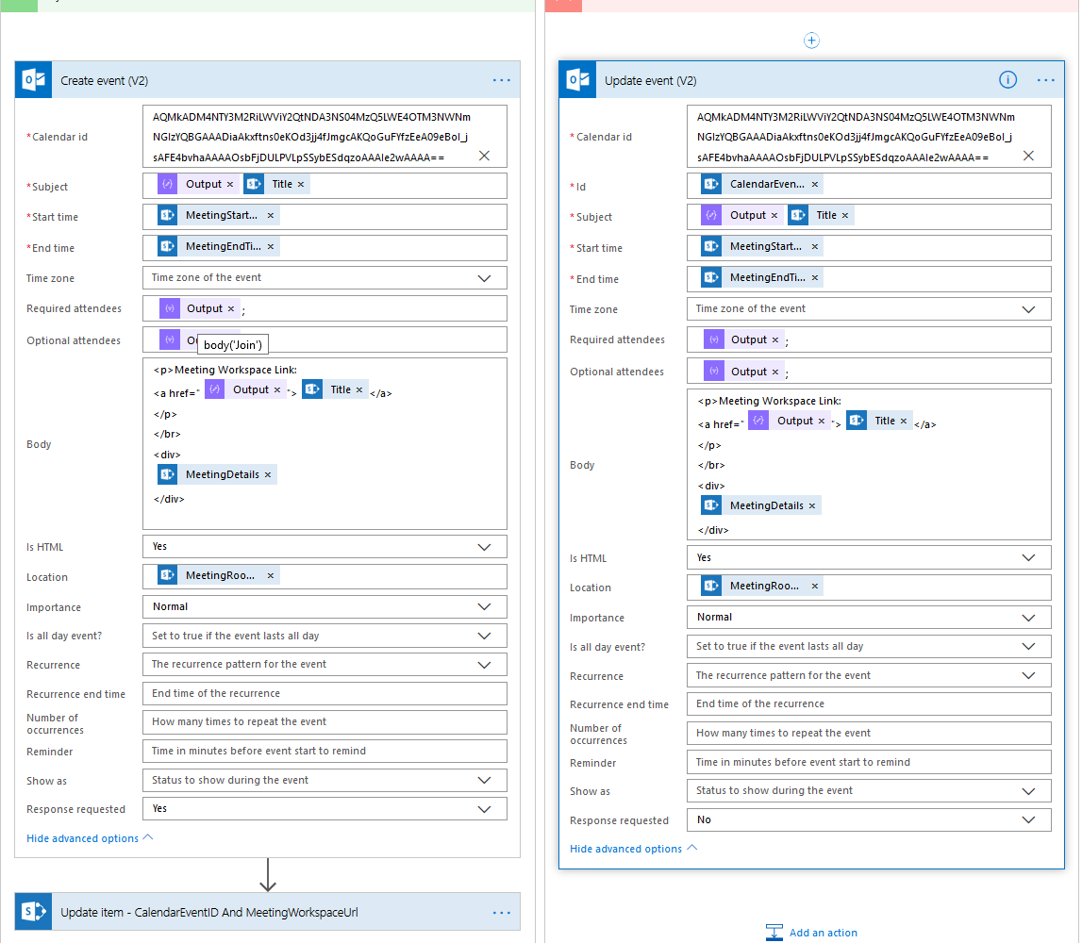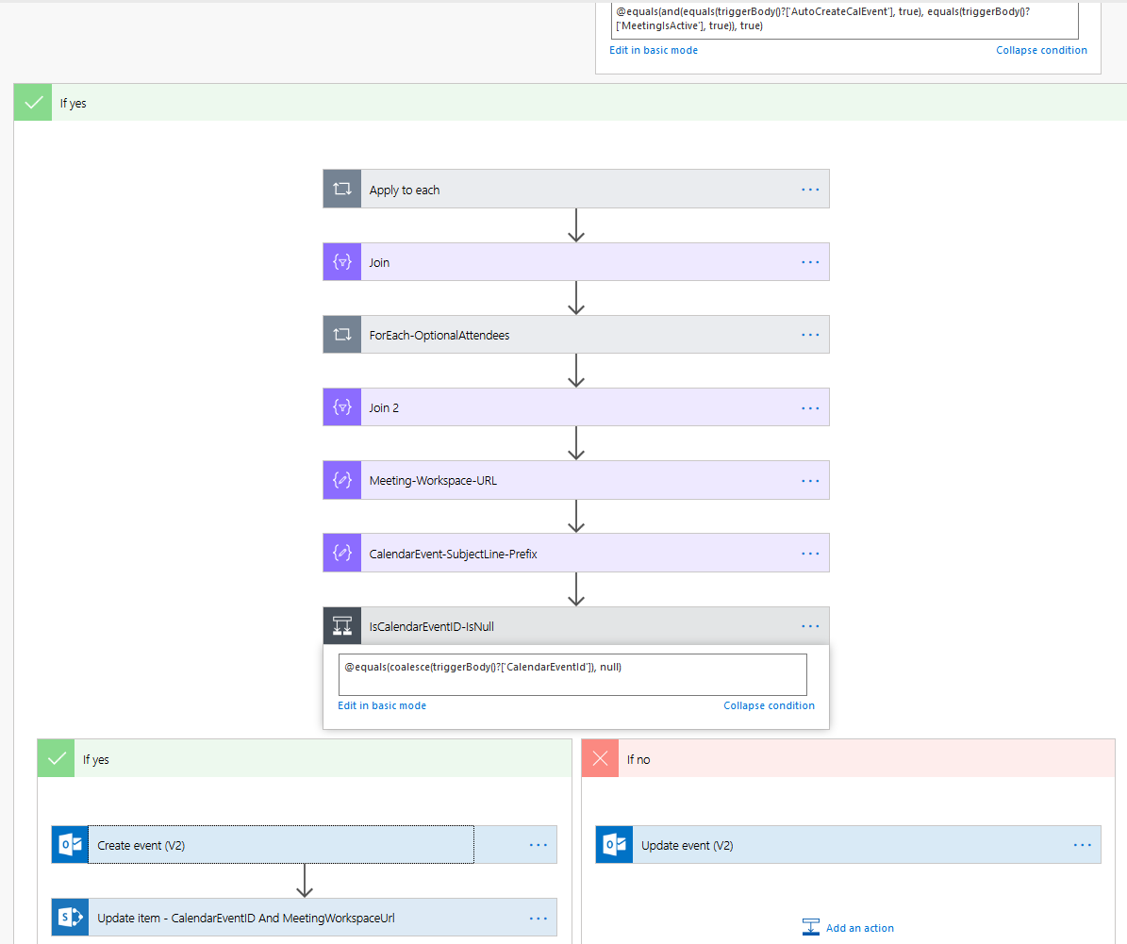

# HOPE THIS HELPED!?

Feedback your thoughts suggestions and ideas and it would be magical to get them 😊 Cheers, Aaseaf Mahkahti | [sharepointjob@outlook.com](mailto:sharepointjob@outlook.com)

# DISCLAIMER

This document is provided “as-is”. Information and views expressed in this document, including URL and other Internet Web site references, may change without notice. You bear the risk of using it.

Some examples depicted herein are provided for illustration only and are fictitious.  No real association or connection is intended or should be inferred.

This document does not provide you with any legal rights to any intellectual property in any Appflow IT Solutions Ltd. products. You may copy and use this document for your internal, reference purposes. s018 Appflow IT Solutions Ltd. All rights reserved.