O365/Azure FLow – URI [Linked] SharePOint-Documents

# AS A – I WANT – SO THAT

1. **AS A**: User/Admin of third-party-line-of-business software – **I WANT**: To click on a link containing custom parameters pointing to a SharePoint page so that I can reach the appropriate list-item/folder/document-set if already exists/created otherwise/else *creates new* *automagically* (workflow-activity) - with the metadata/details/information of the specific record in my ‘third party software’ – **SO THAT:** I can have an entity record in my Third-party-software/ERP-Line-Of-Business-App/Database integrated/linked with SharePoint list-item/folder/document-set to upload documents associated with such entity-record … kind’a – CRM integration with SharePoint?

** **Disclaimer**: Above use-case is too technical and binding to solution!

# Solution ApProach

1. Third party System/Software/Program/Script forms a URL link to SharePoint page with agreed query string parameters.
2. When user clicks on such link – they are brought to a generic SharePoint page – which triggers a “Http Request” MS-Flow with parameters from the SharePoint page URL.
3. The MS-Flow will search based on a unique field/parameter value for list-item/folder/document-set in the specific Document Library/List
   1. If it does not find one – the Flow actions to create one with all metadata appropriately updated.
4. In either case, it forms the URL-Path to the item/folder/document-set and returns as a “Http Response”.
5. On receiving such response, the SharePoint page – redirects to such URL.
6. Further enhancements and complexities can be considered in terms of validations, input-forms/confirmations, security etc.

** **Disclaimer**: Using Document Set in this implementation below - is not ultimately-necessary or the only option and alternative simpler-solutions like creating a simple SharePoint List with Key field(s) that then points to a Folder in any/other Library – Would even be more desirable (and simpler) for many scenarios. In this implementation, I stuck around with Document Set option to explore and work with SharePoint REST-API and Flow integration.

# SOLUTION DESIGN

## Infomration Architecture

**Content Type**: KBDocumentSet

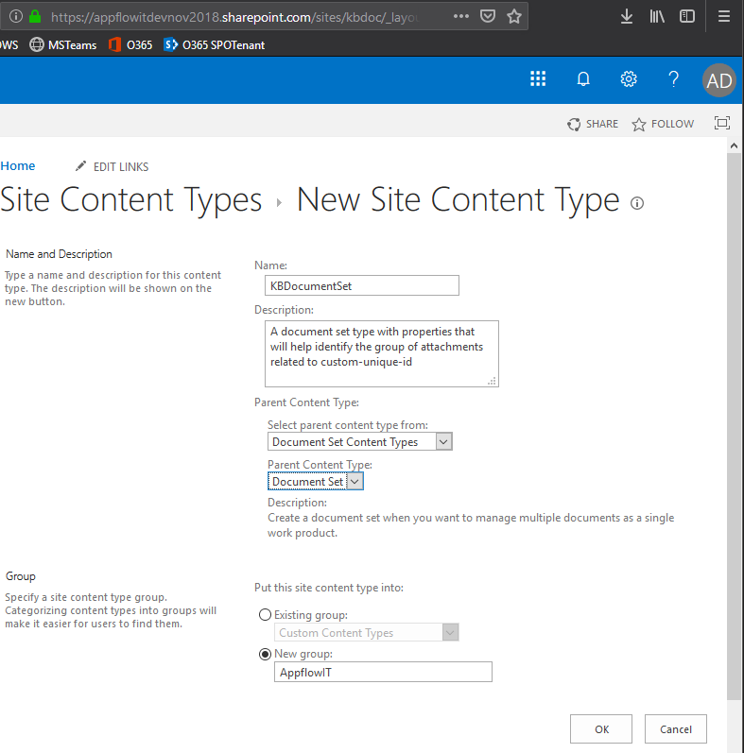 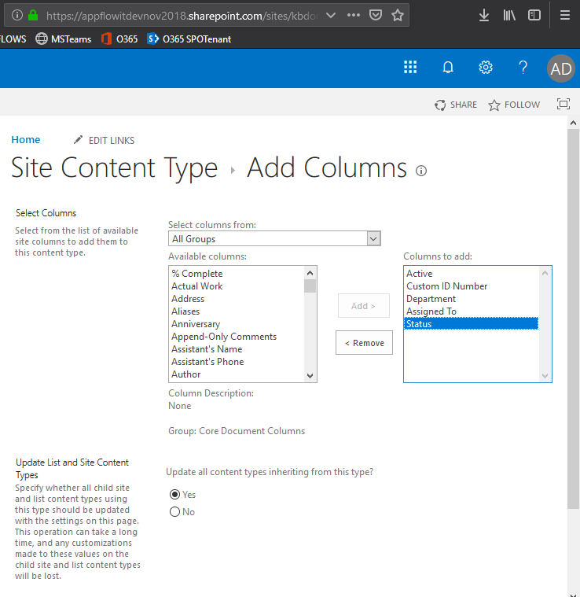

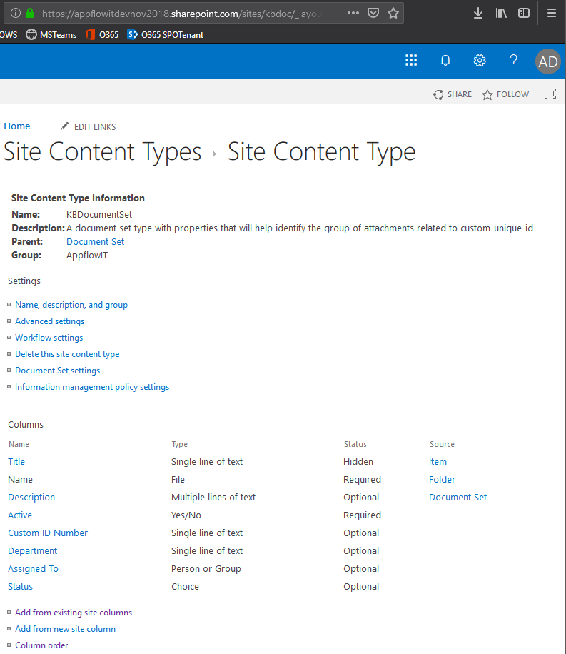 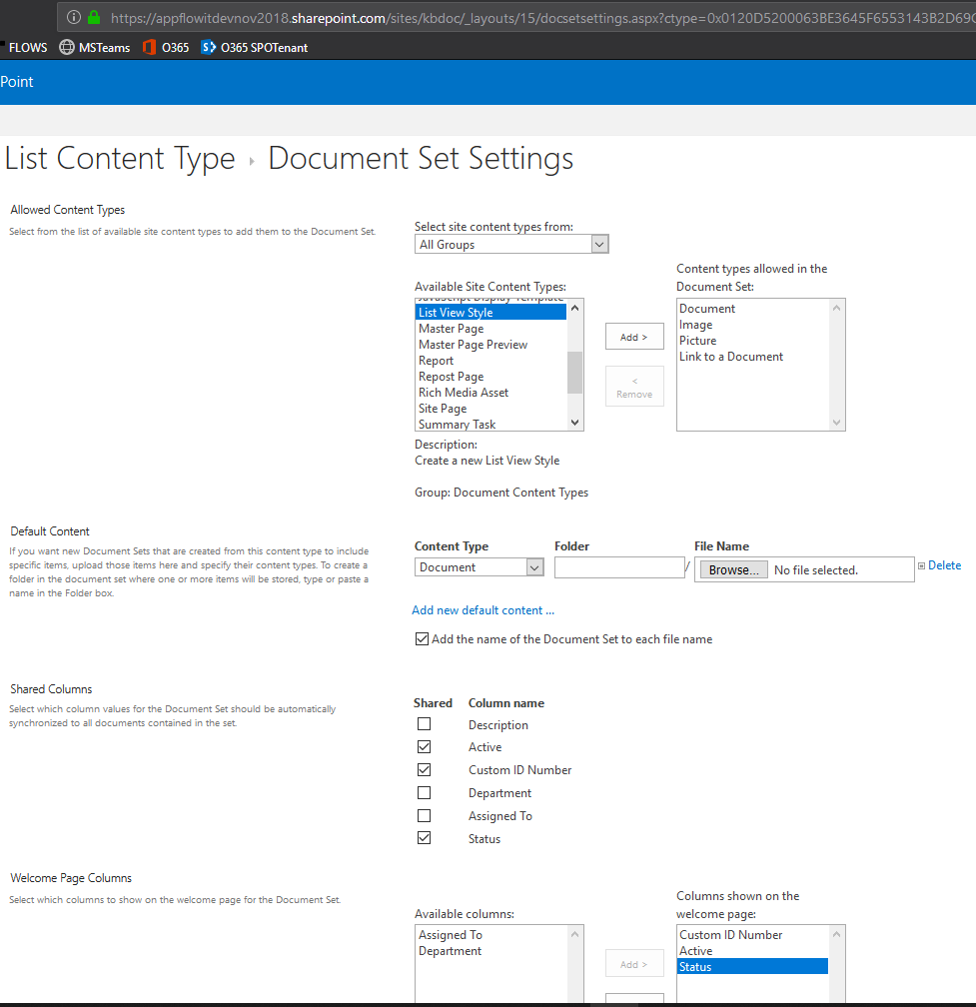

**Document Library:** KBDocuments(KBDocumentSet content type added)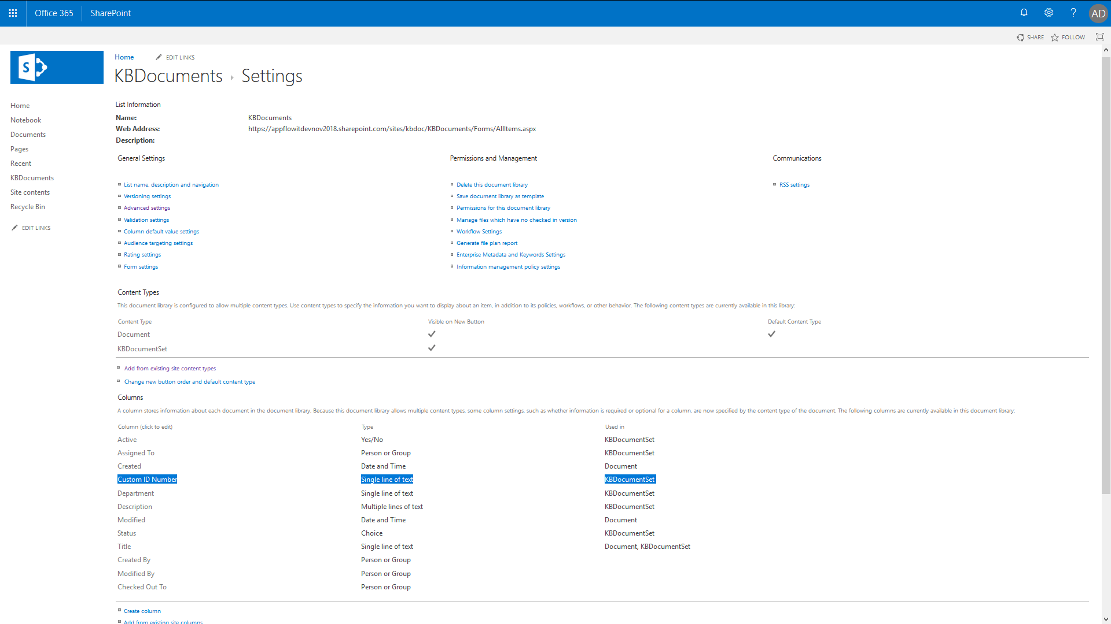

|  |  |  |
| --- | --- | --- |
| **Column (click to edit)** | **Type** | **Used in** |
| ***Custom ID Number*** | Single line of text | **KBDocumentSet** |
| Active | Yes/No | **KBDocumentSet** |
| Assigned To | Person or Group | **KBDocumentSet** |
| Department | Single line of text | **KBDocumentSet** |
| Description | Multiple lines of text | **KBDocumentSet** |
| Status | Choice | **KBDocumentSet** |
| Title | Single line of text | Document, **KBDocumentSet** |
| Created By / Modified By / Checked Out To | Person or Group |  |
| Created / Modified | Date and Time | Document |

## FLOW DESIGNER

The flow is triggered with a HTTP (POST) Request with a JSON payload with parameters from the LineOfBusiness-URL Transformed-by-SharePoint-Page-Script (JQUERY/Ajax)!

** Tip when working with (HTTP) Flows 🡺 Do it in parts and output the Responses to peek in the results/schema/data.

## PART 1 🡺 REQUEST + UPDATE (DOCUMENT SET) + RESPONSE

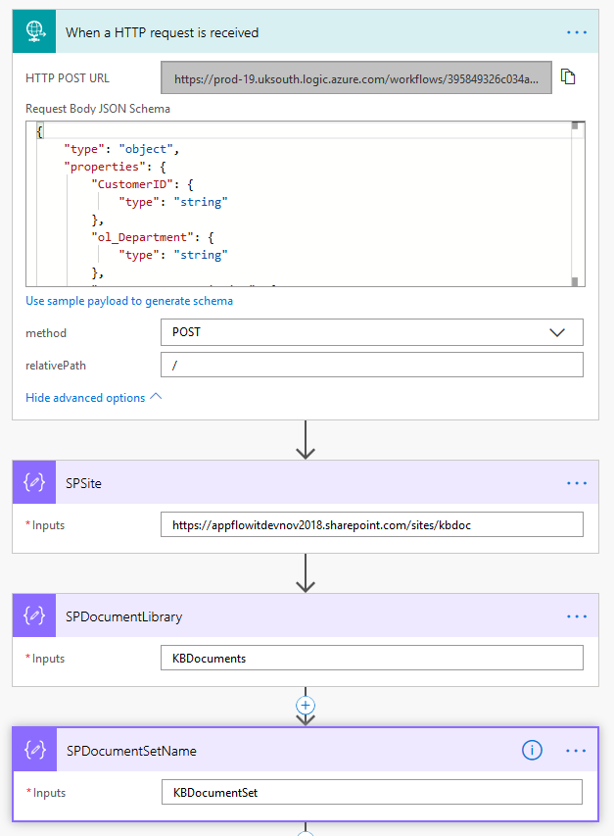 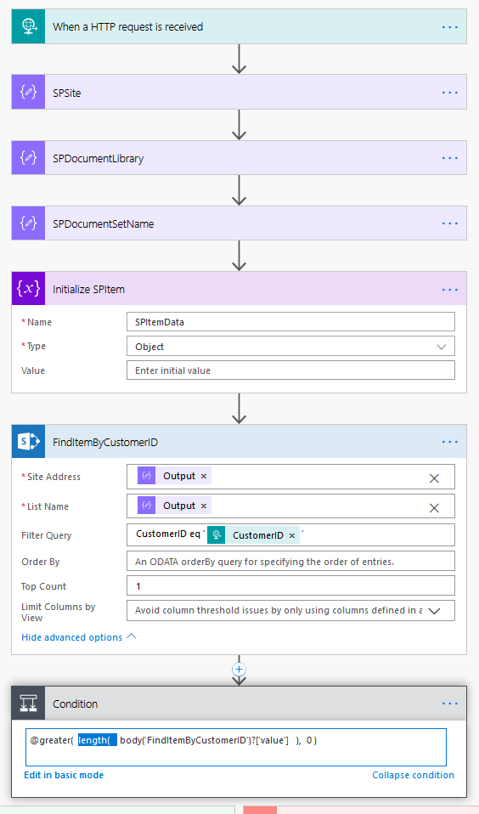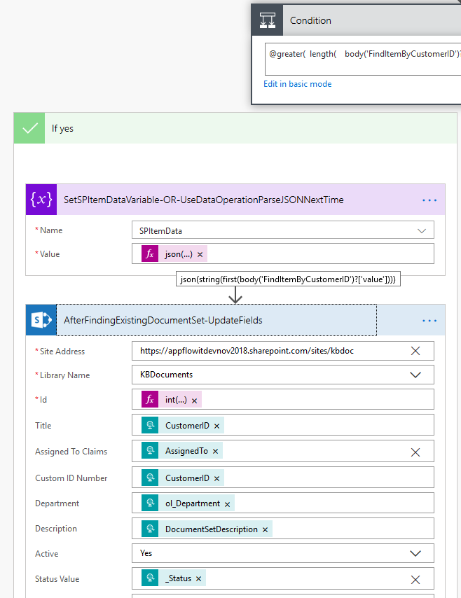

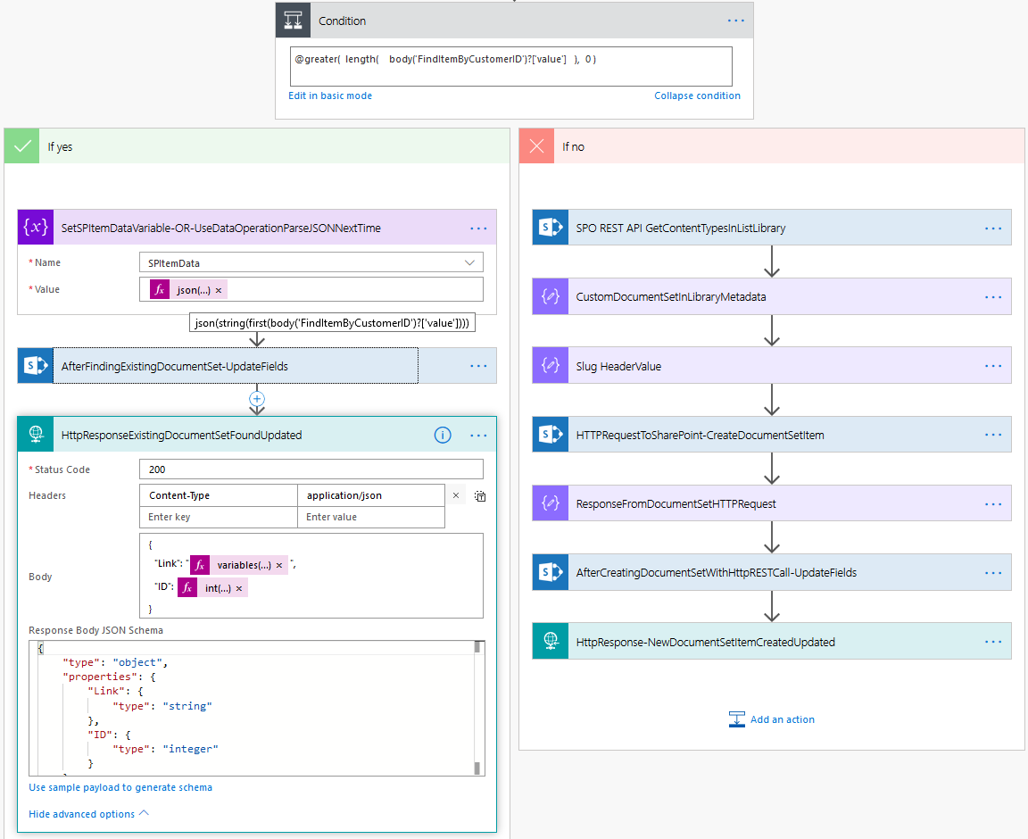

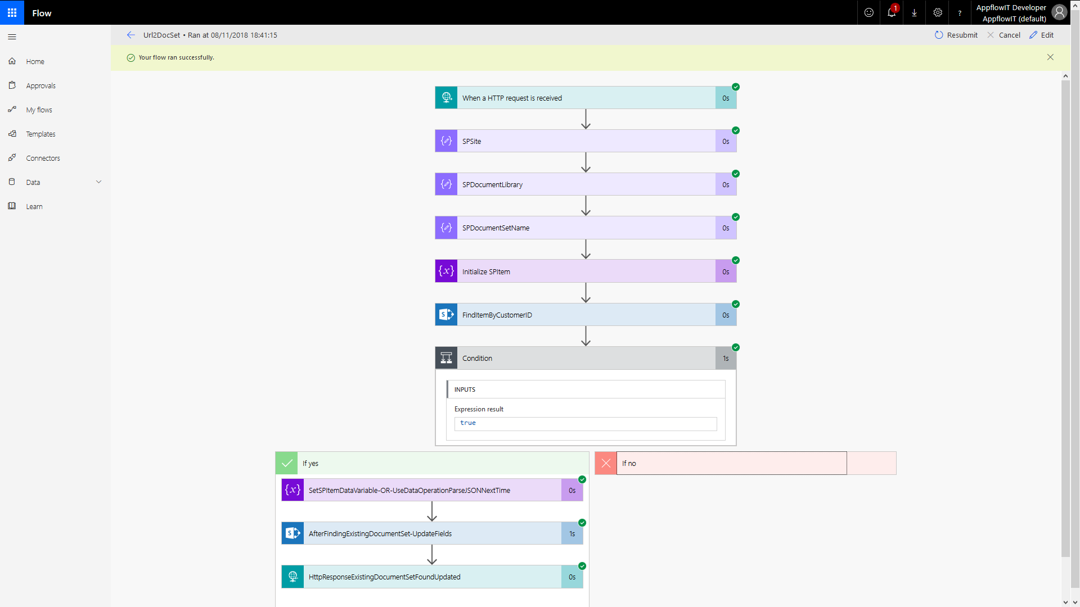

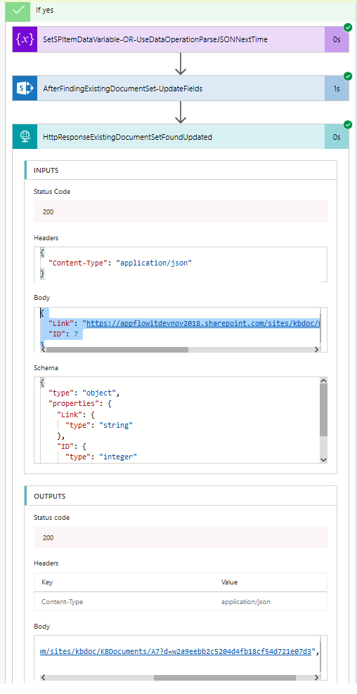 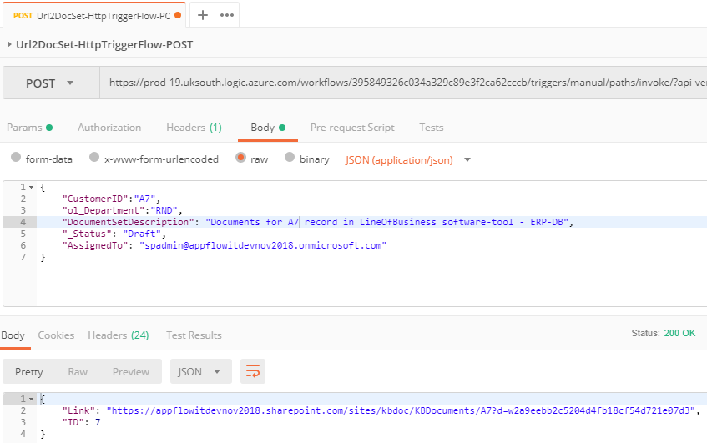

## PART 2 🡺 REQUEST (Same as Part-1) + CREATE NEW (DOCUMENT SET) + RESPONSE

Ref-Only: <https://sharepointycl.wordpress.com/2018/05/03/creating-sharepoint-online-document-set-in-microsoft-flow/>

Ref-Only: JavaScript client call to REST API: 

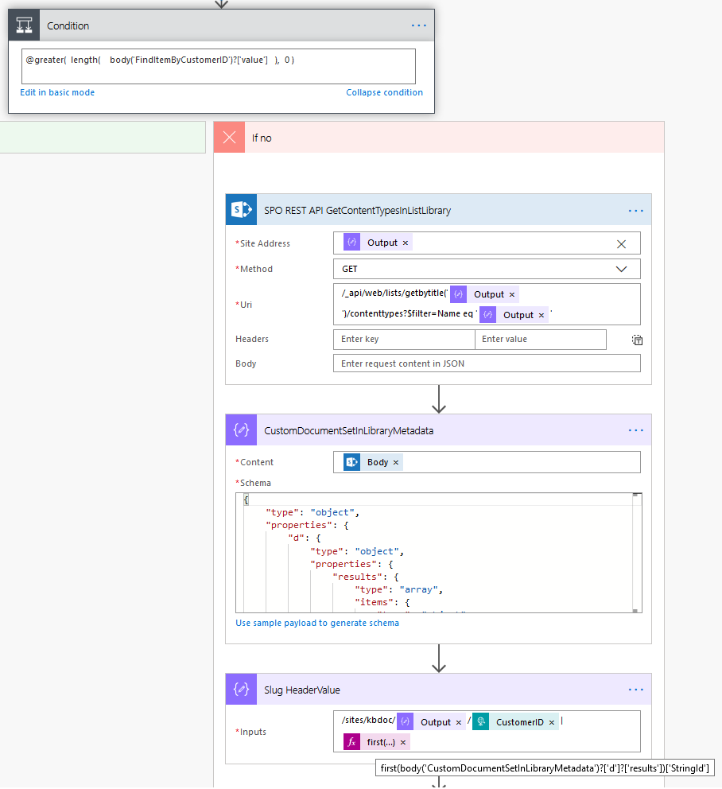

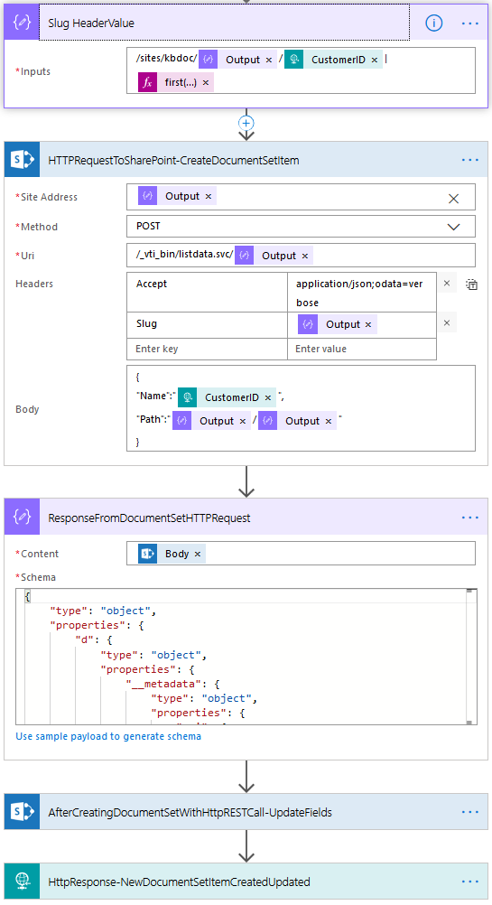

**first**(body('CustomDocumentSetInLibraryMetadata')?['d']?['results'])[**'StringId'**]

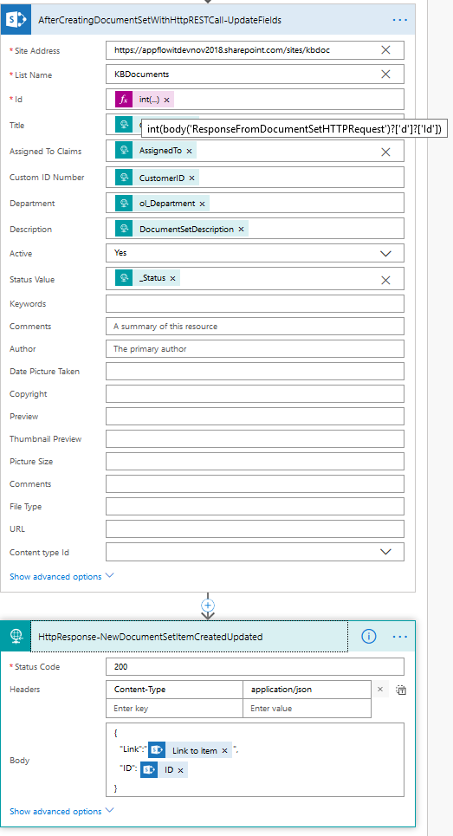

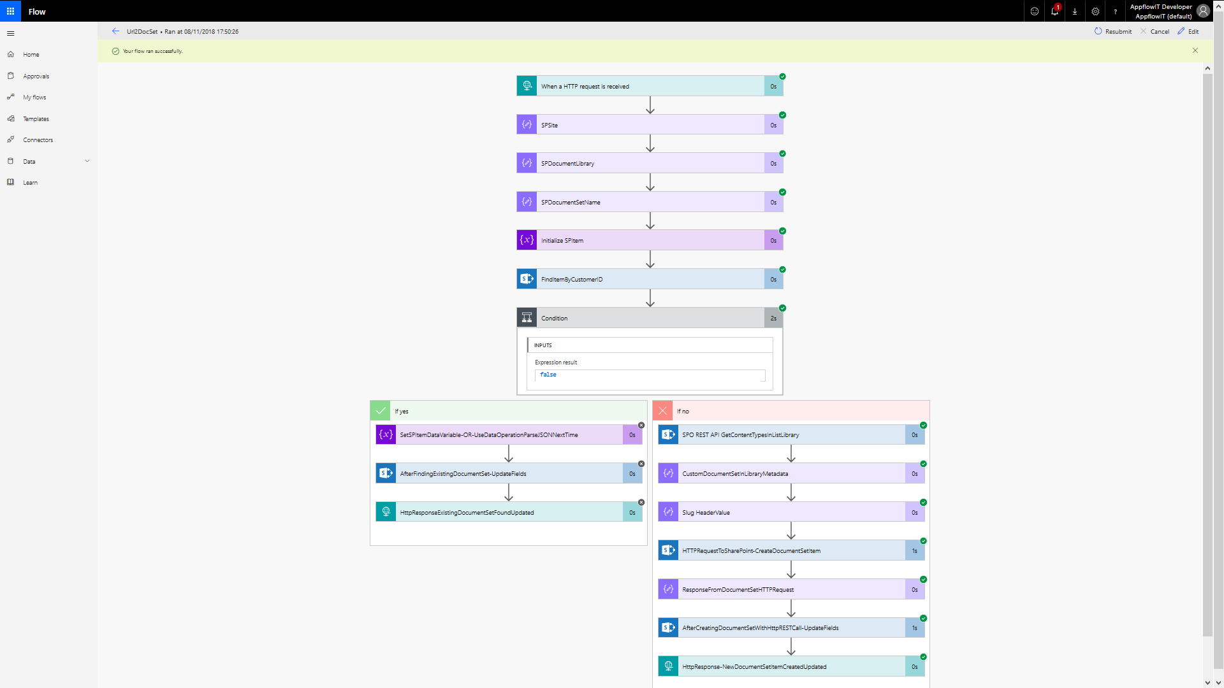

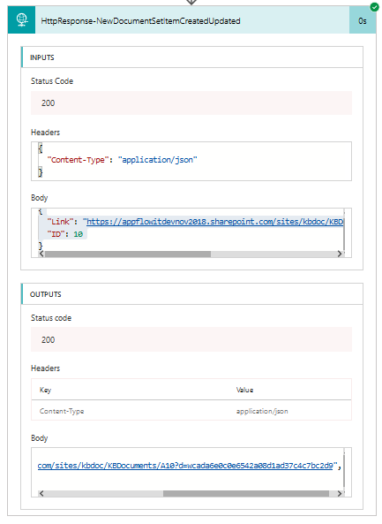 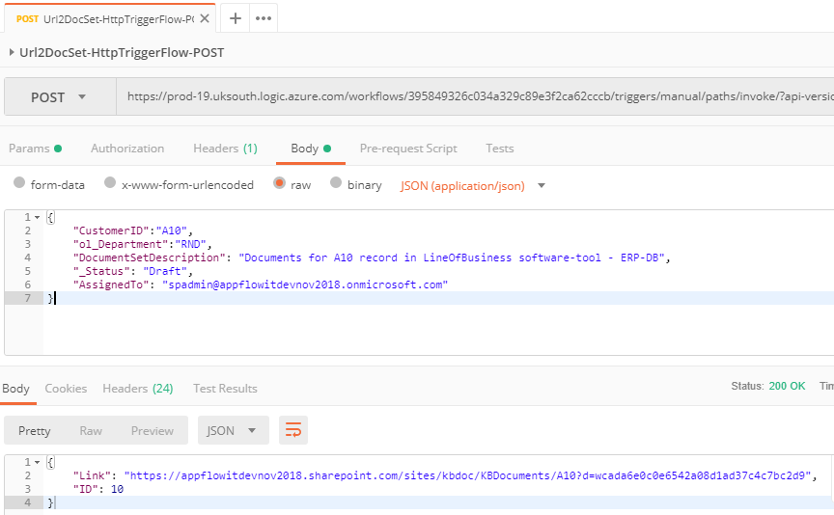

# SUPPORT – ENVIRONMENT – TOOLS – CONFIGURATION

## TOOLS: SOAPUI | POSTMAN (Chrome) | FIDDLER

1. SOAPUI: Download and Install OSS(free) version from - <https://www.soapui.org/downloads/soapui.html>
2. **POSTMAN**: Download and install for Chrome from - <https://www.getpostman.com/download?platform=win64>
3. CAML-QUERY:
   1. <https://saketa.com/sharepoint-caml-query-builder/>
   2. [https://**www.biwug.be**/resources](https://www.biwug.be/resources)

## CONFIGURATION: **AllowING** custom script on sitecollection pages

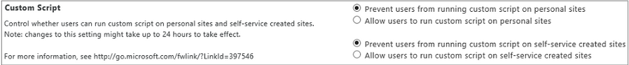

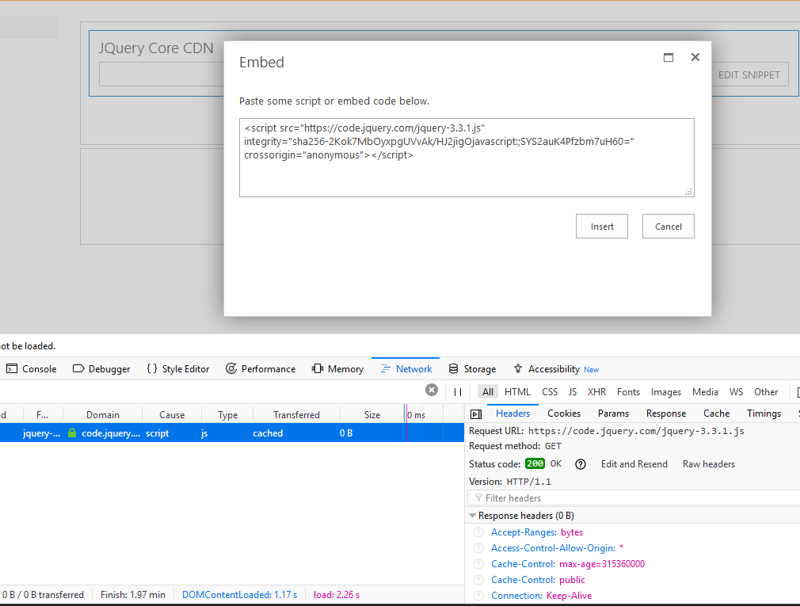

## CONFIGURATION: Ensure Document Sets Site-Collection Feature enabled

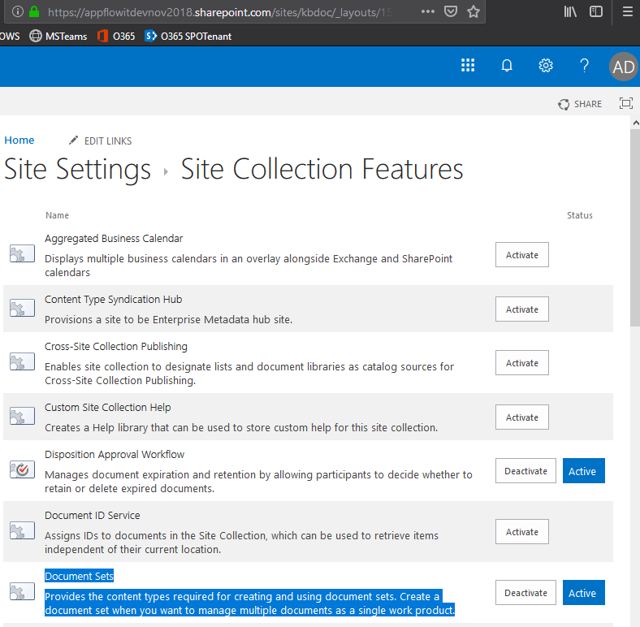

# HOPE THIS HELPED!?

Kindly feedback your thoughts and suggestions and ideas, that would be magical to get them😊

Cheers, Aaseaf Mahkahti | [sharepointjob@outlook.com](mailto:sharepointjob@outlook.com)

* **Disclaimer**: The purpose of this write-up/document is partially for reference/blogging – partially for self-promotion, hence not everything is necessarily elaborated step-by-step and word-by-word.

