O365 – PowerX– Contract Terms Picker

# AS A – I WANT – SO THAT

1. **AS A**: PMO-Legal-And-General-Contracts Manager – **I WANT**: To maintain changes in the Excel file data sources – that multiple legal personnel can update any time – **SO THAT:** The documents are reflecting the current contract terms and other updates.
2. **AS A**: Project Manager – **I WANT**: To raise a contract change request from the one or more Excel data sources based on selection – **SO THAT:** I can create new document for further processing with updated/latest contract terms.

** Disclaimer: As a consultant to keep things simpler, I would negotiate if the customer/client/user is open to pushing these Excel-Tables in a SharePoint list – while still knowing that, certain Excel usage scenarios are complex and interdependent, like formulas and referencing across sheets etc. Hence, it is assumed here that,

* **Excel data source(s) is a *hard* requirement** **from the customer.**

# Solution ApProach

1. Excel file- where data is represented in the form of Table format and the excel-table has an identifiable name.
2. A PowerApps app/form that gets data from this excel sources/tables and allows selections from such relevant information.
3. A pen input capture control, that collects chosen line-items and such pen-input-image and emails it all out.

# SOLUTION DESIGN

## Infomration Architecture

1. What I did for this sample scenario: Went to the internet=Google! – searched for “contract terms” or such, copied contents from one of the online published – recruitment contracts of employment and pushed it into an Excel sheet – slight formatting and wrapped the listing within a “Table” with a name.

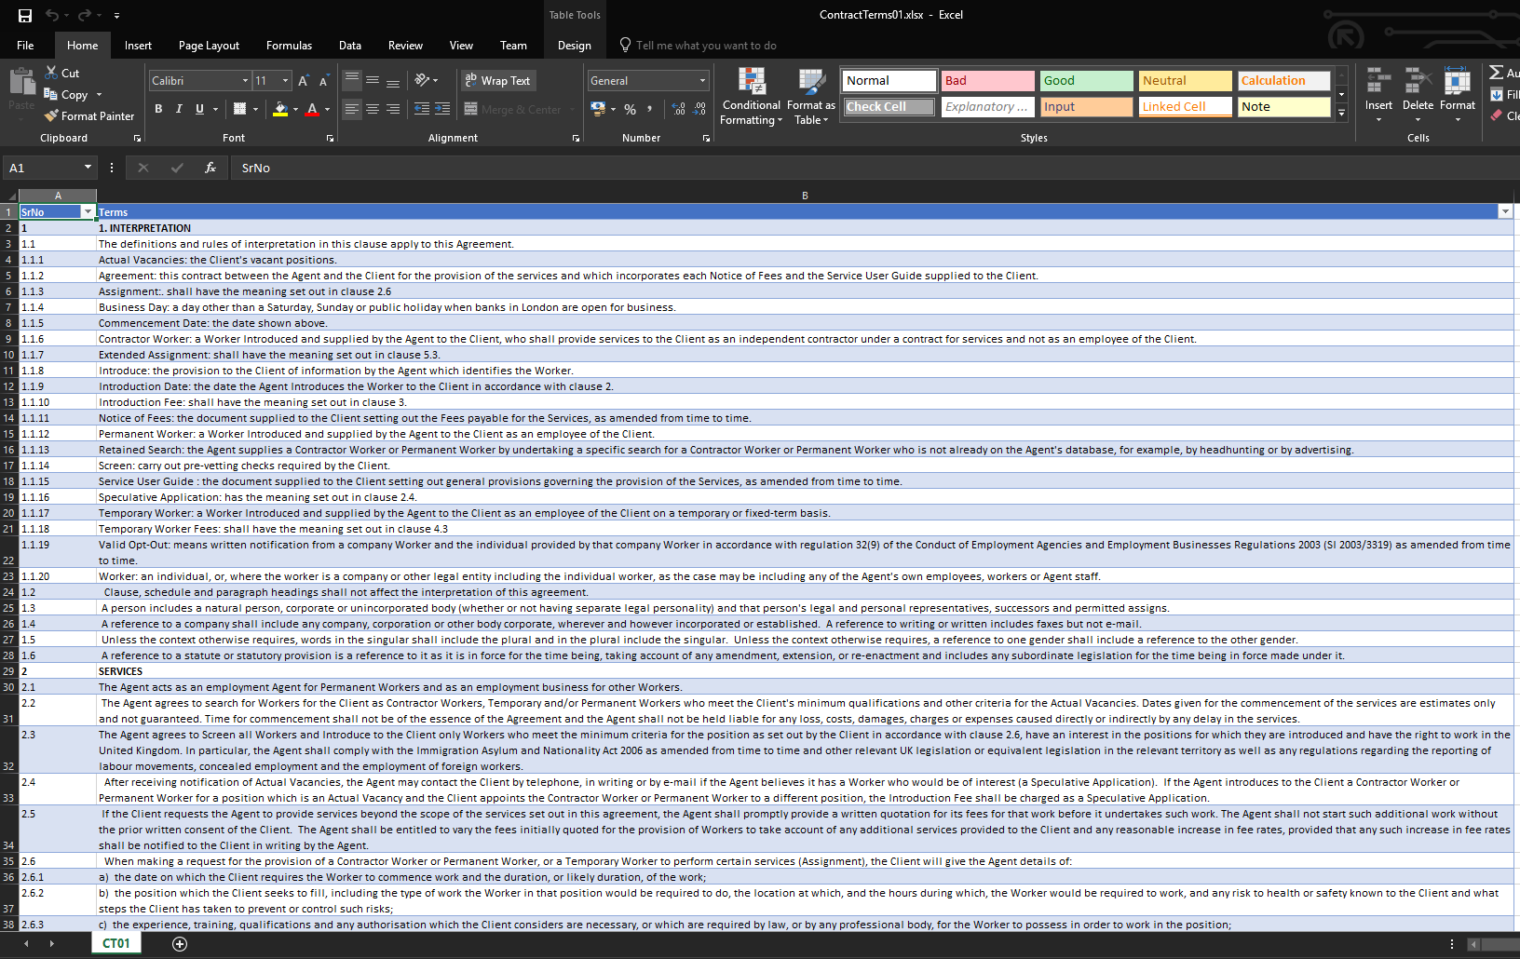

1. Pushed the file to One-Drive within O365 – this to make it convenient using a Connector for One-Drive-For-Business from PowerApps to retrieve the Excel data directly from such data-source-connection.

**  **

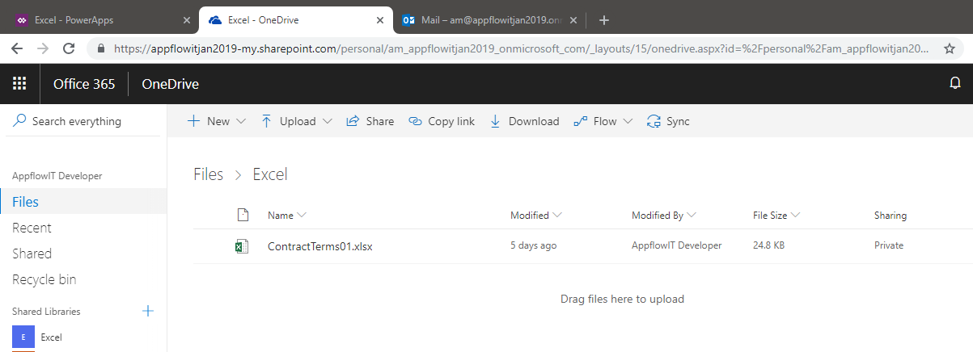

## POWERAPPS DESIGNER

Shows the left-hand-side “gallery control” binding to the Excel table data-source connection-object in PowerApps called “TermSet1” and since, the excel is a flat list of items creating a hierarchy on the fly with filtering whole numbers.

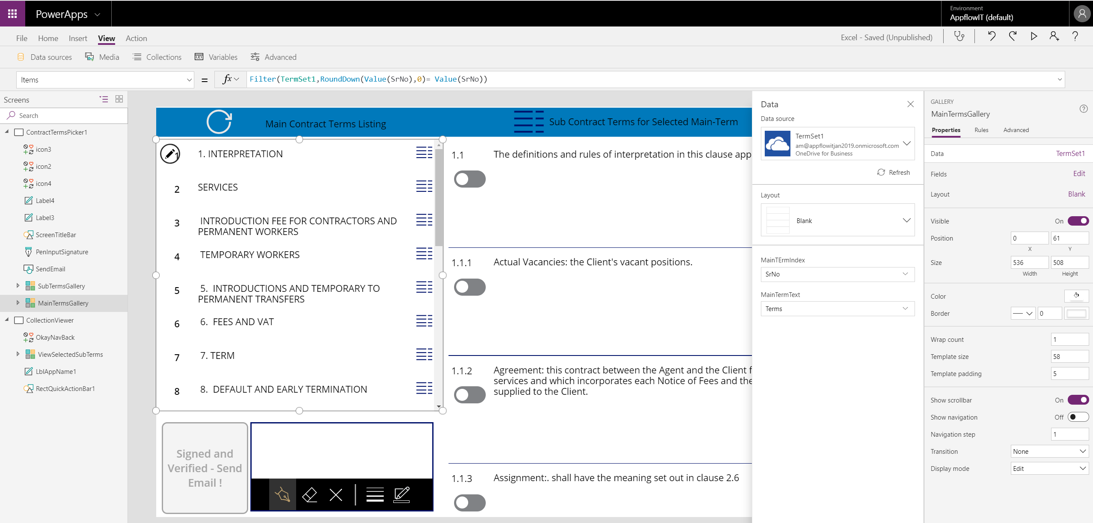

Left hand-side gallery is now bound to the filtered collection from above screenshot and screen-shot below shows how PowerApps is like Excel (also like Windows/ASP.NET Forms)… and such label control is bound to a row in the data-source.

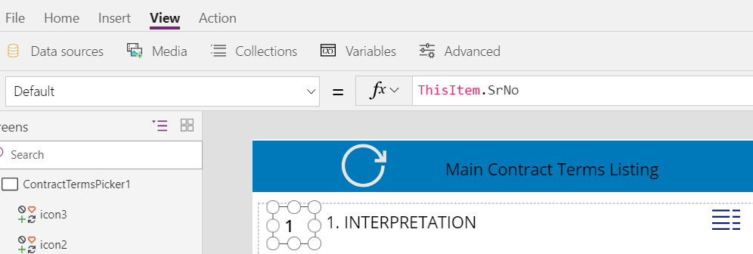

Similarly, below shows another binding to label/text control.

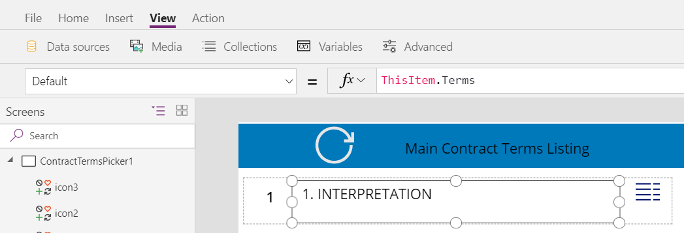

This

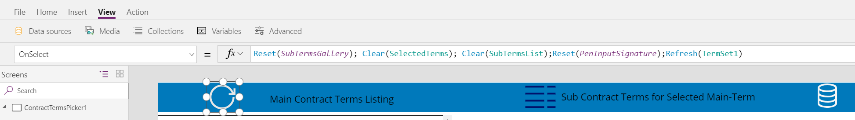

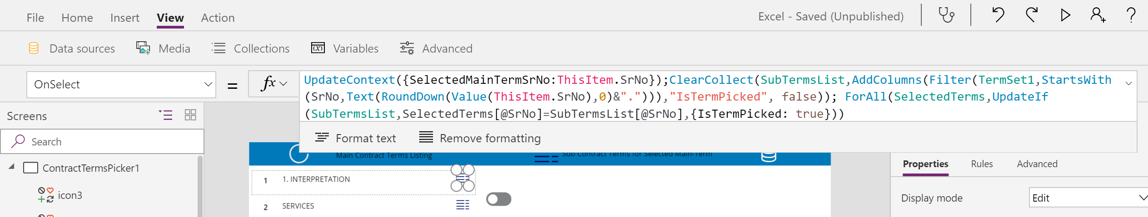

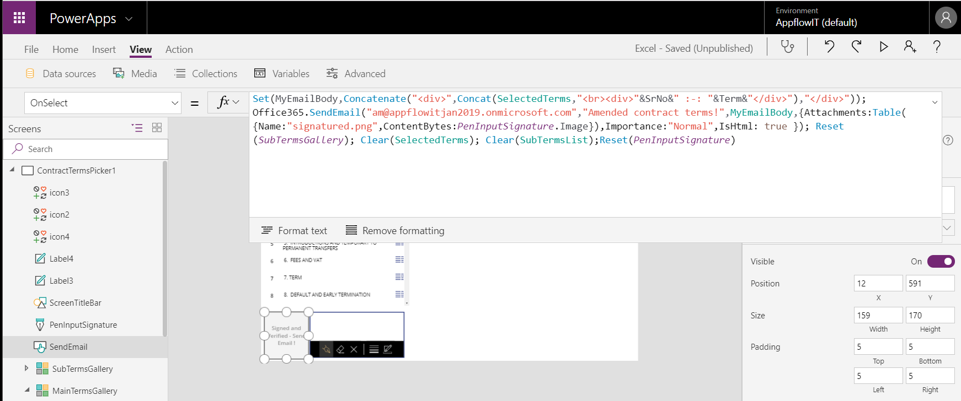

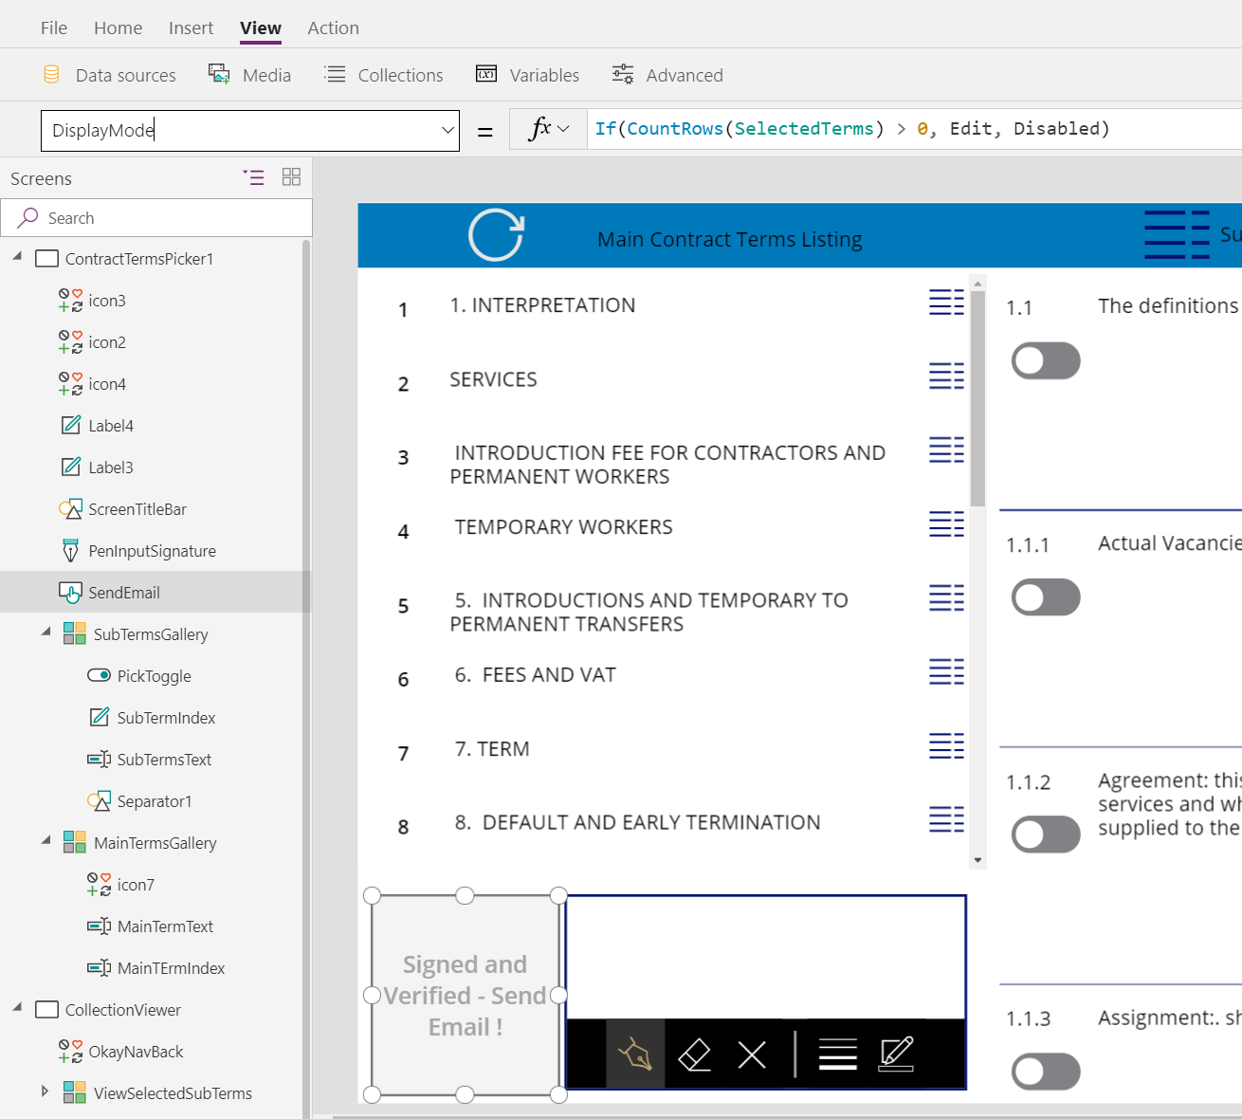

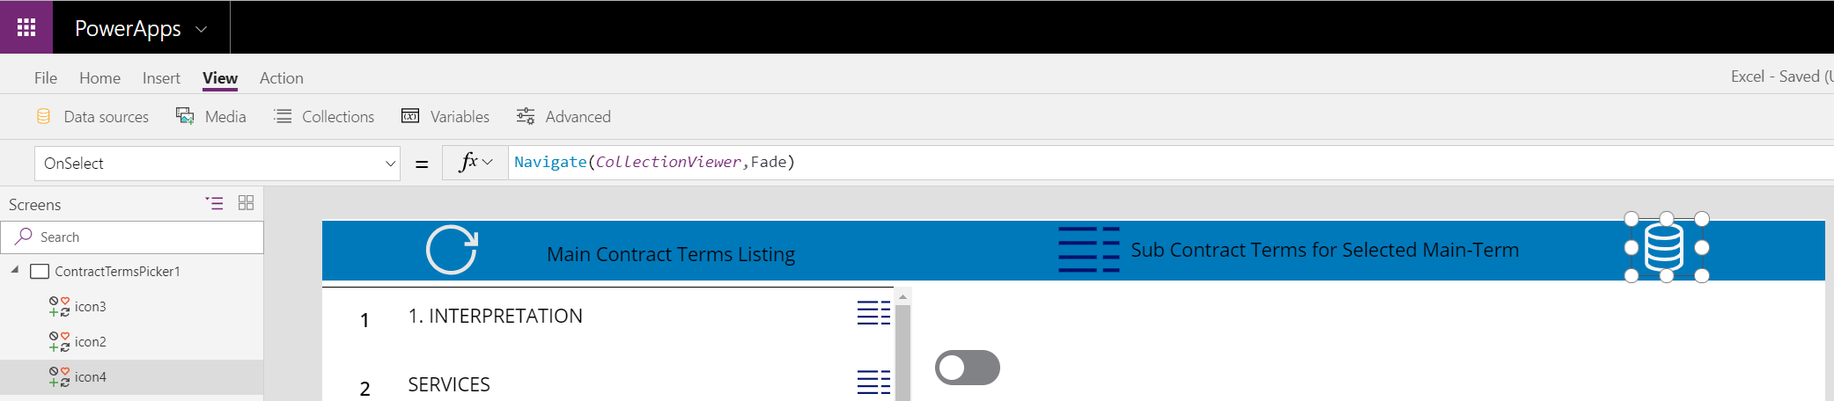

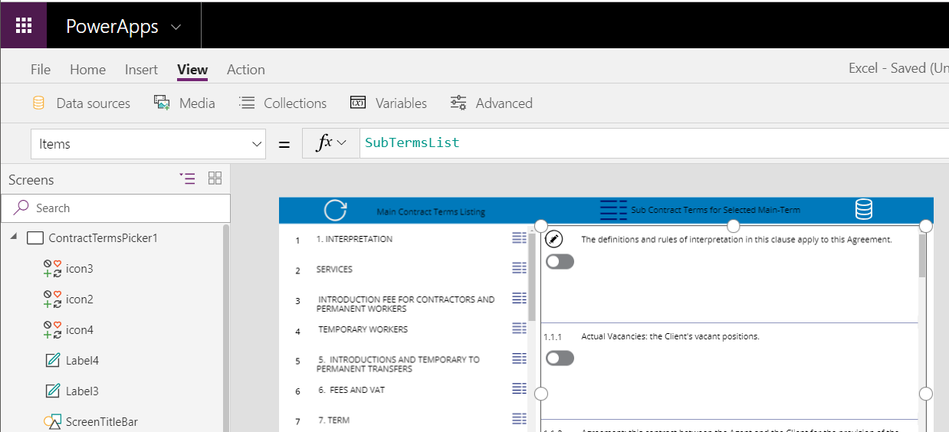

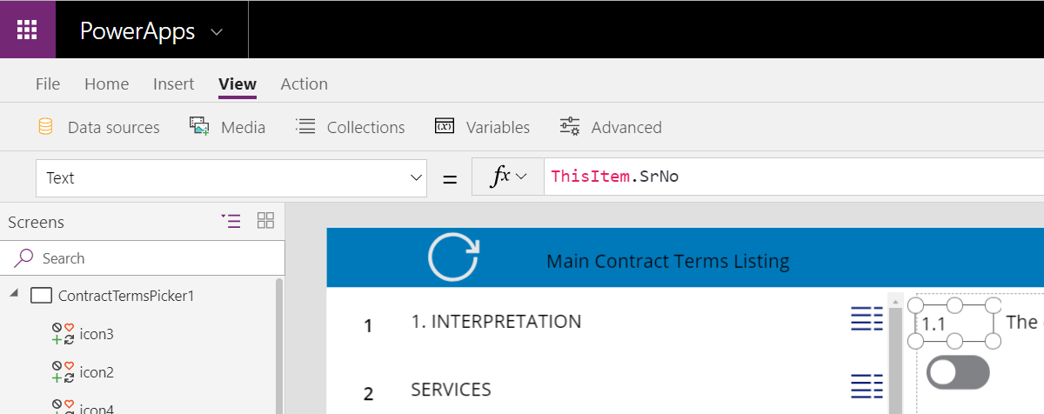

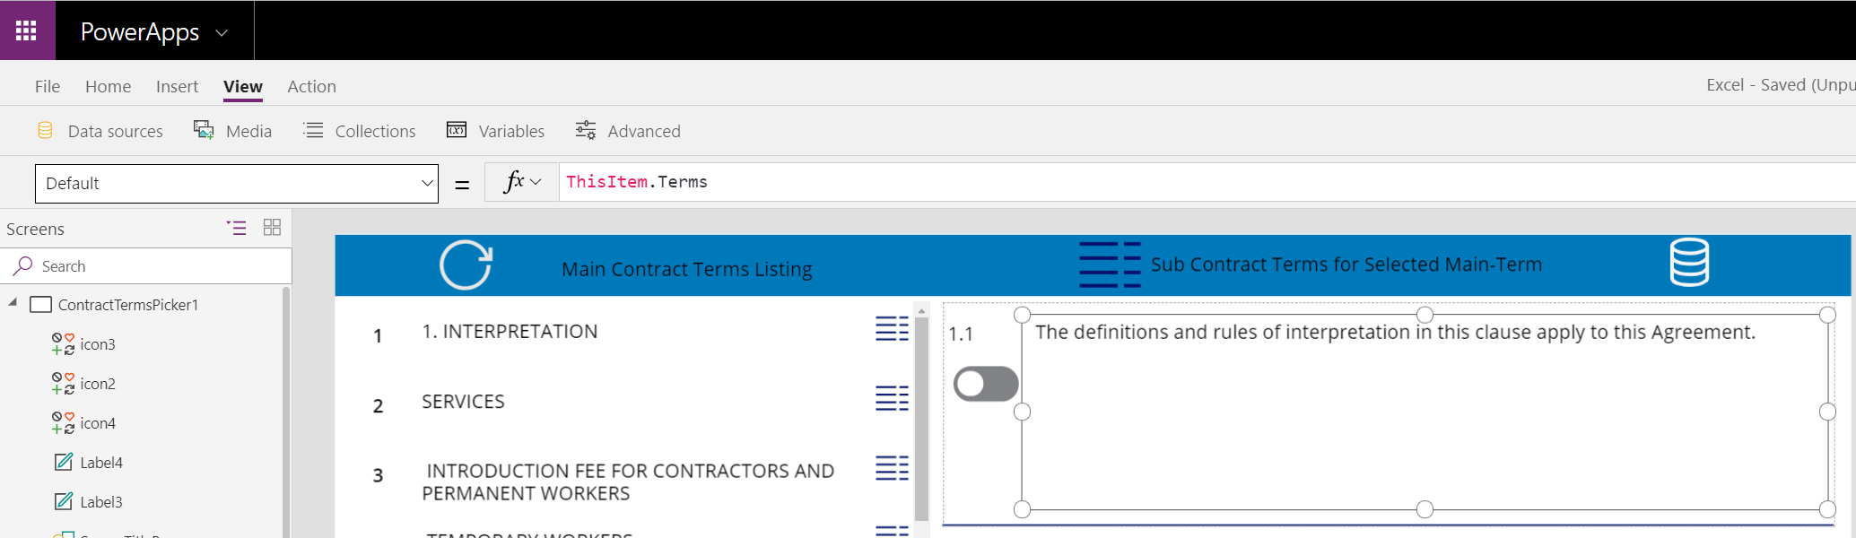

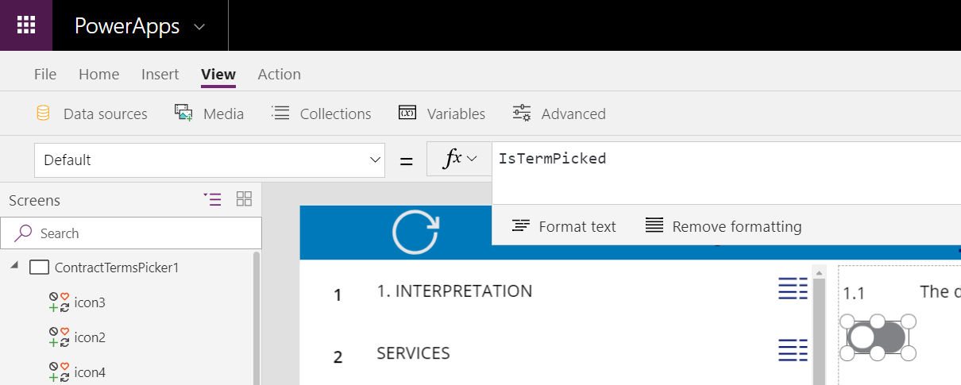

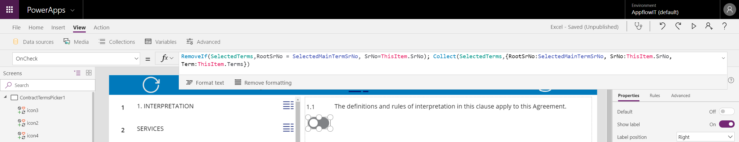

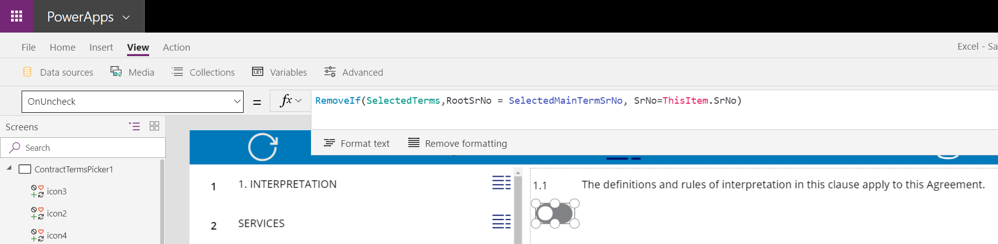

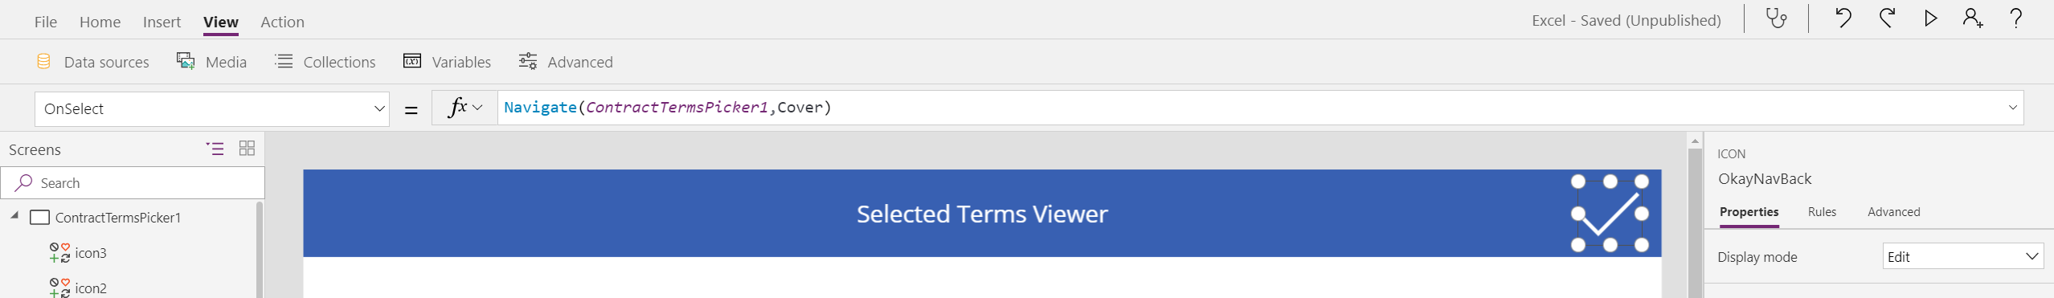

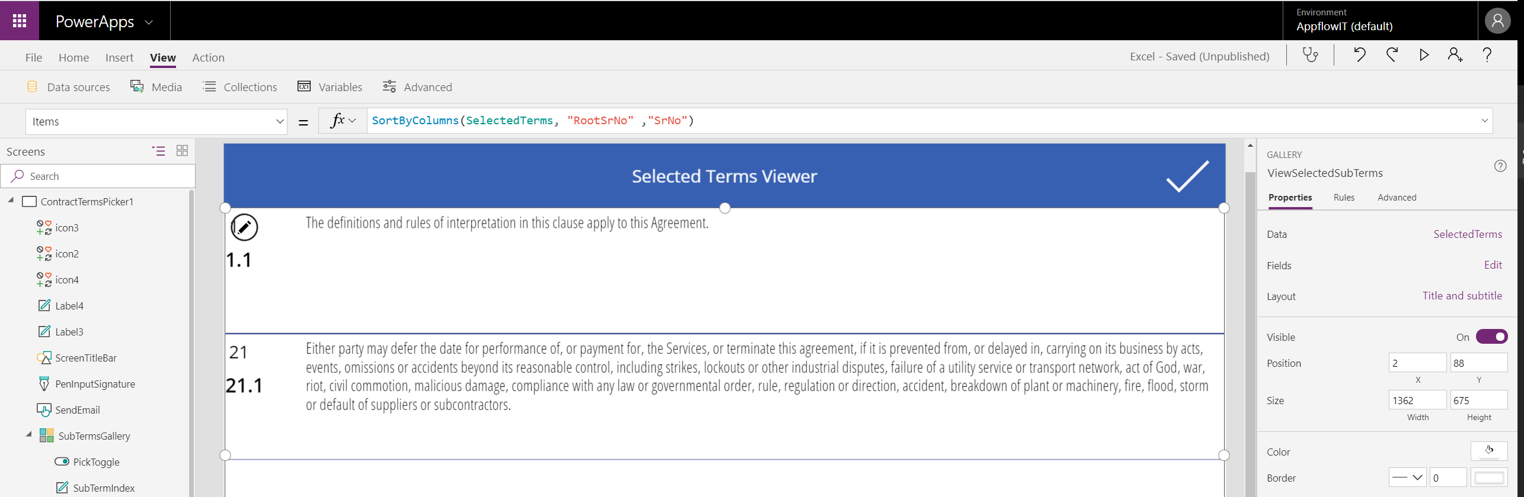

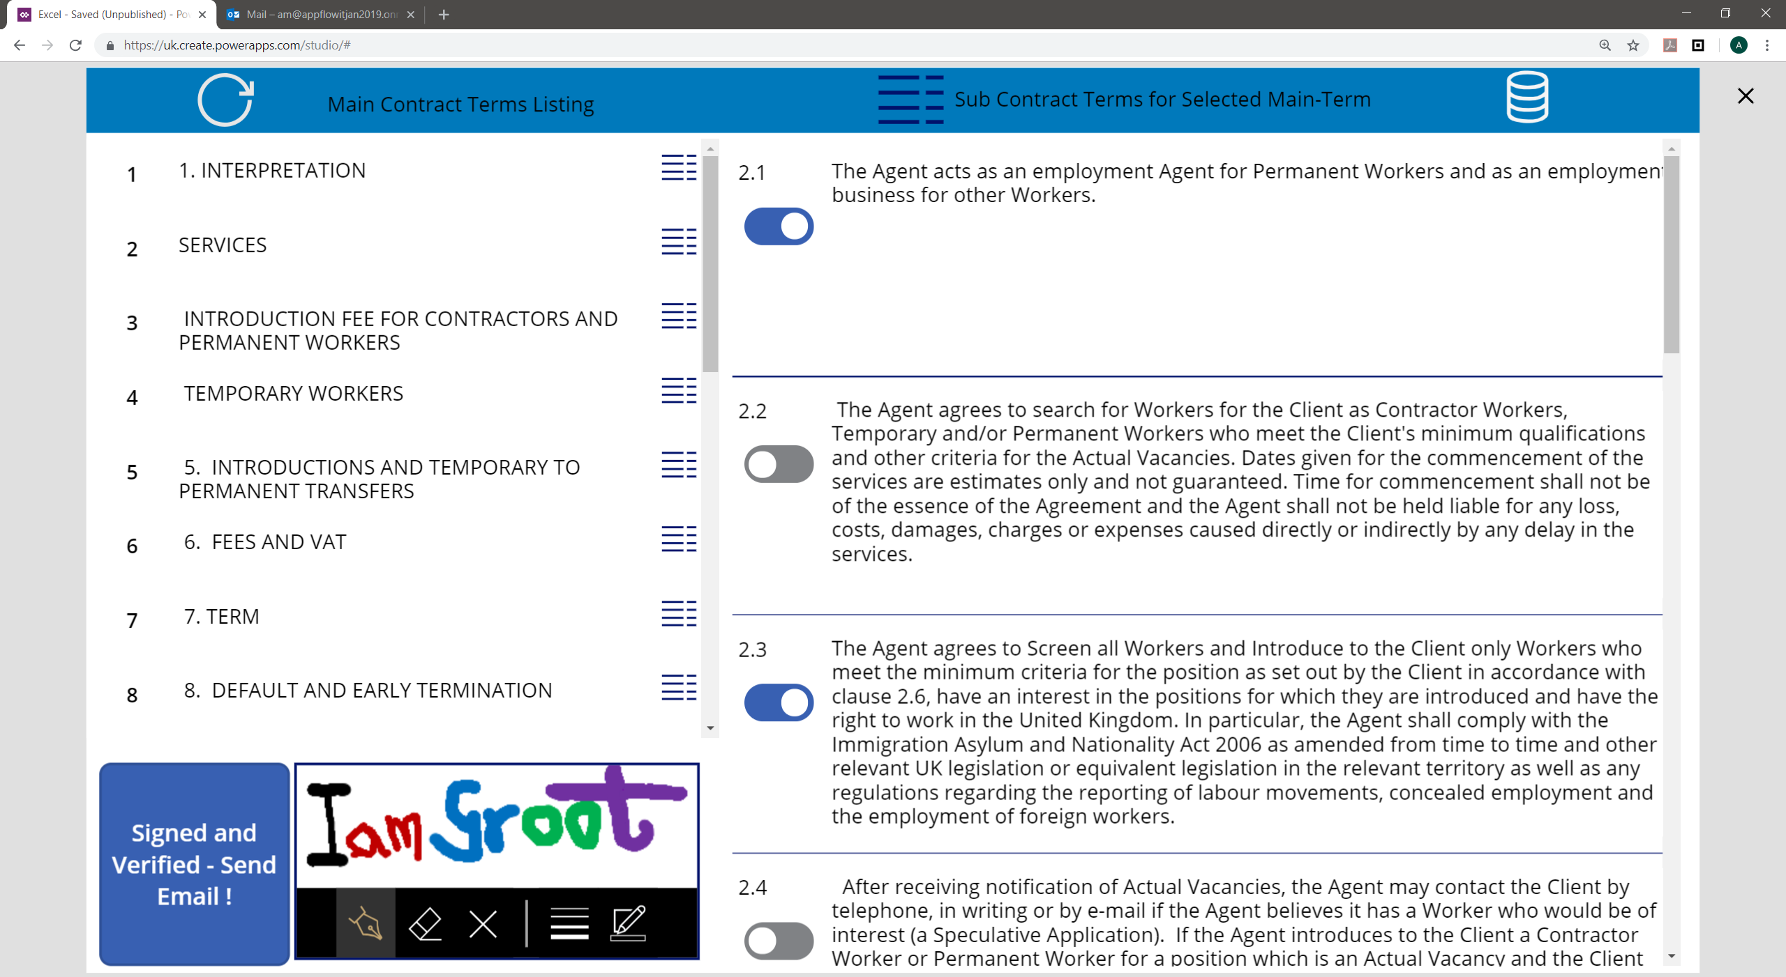

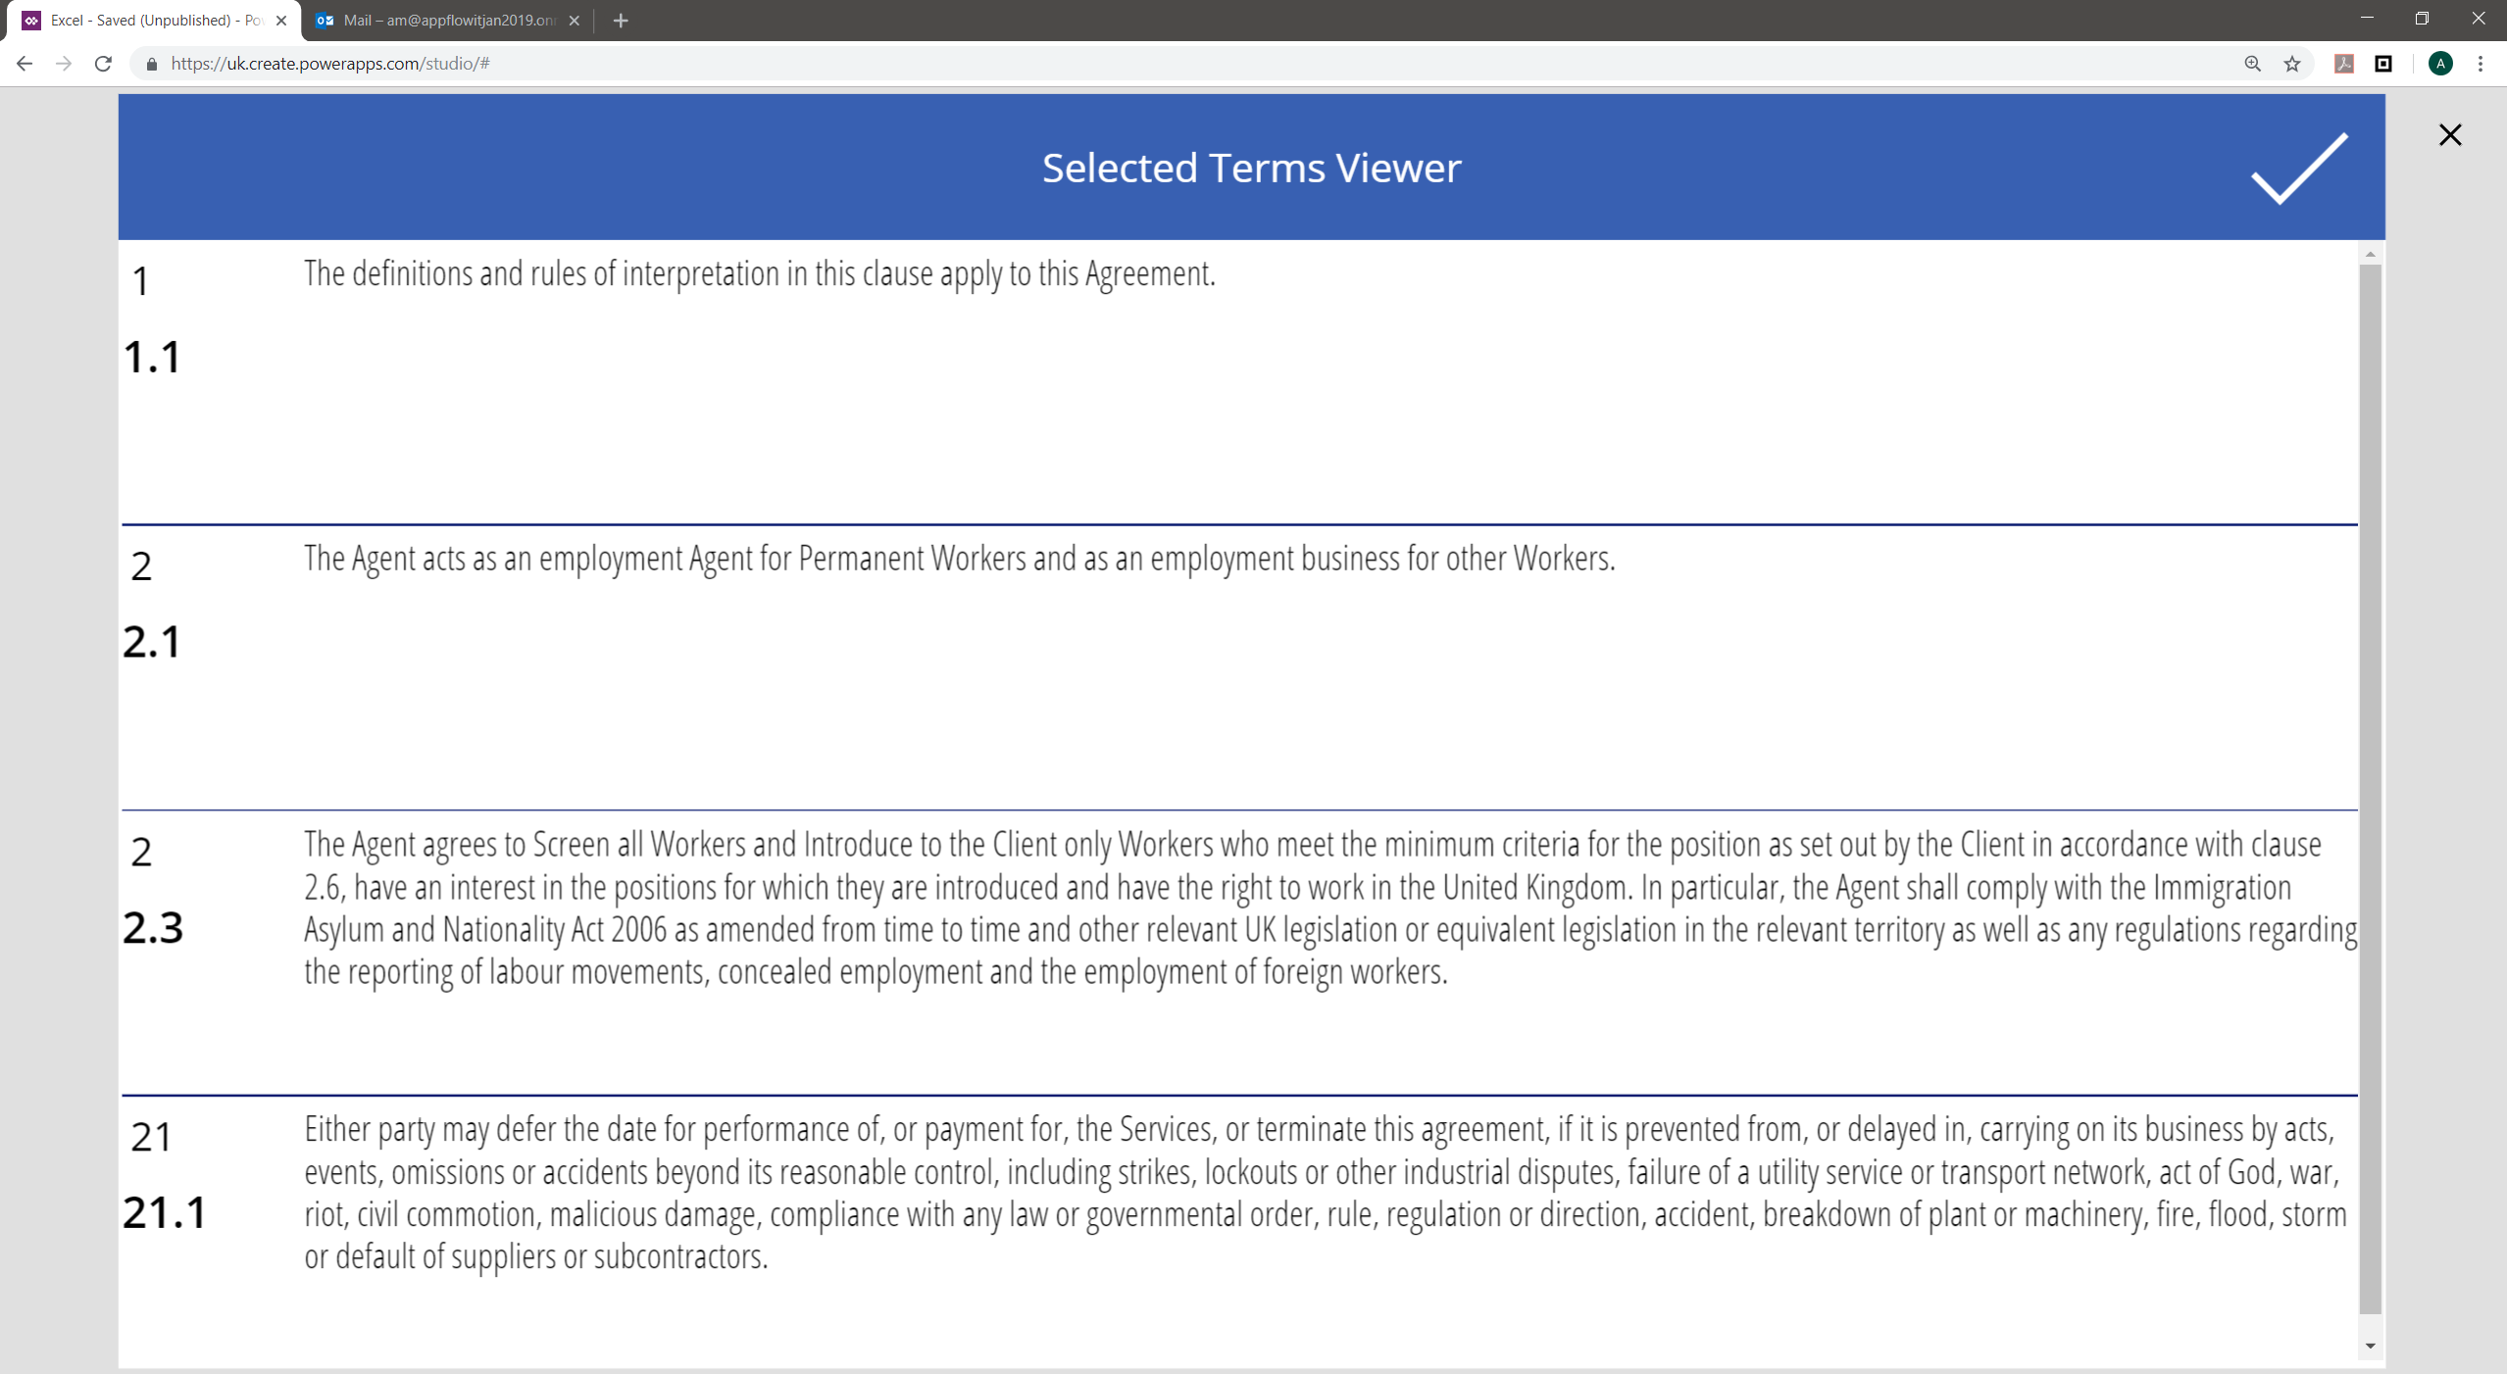

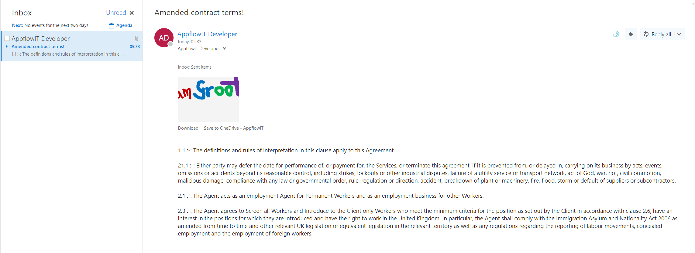

# REFERENCES – SUPPORT – ENVIRONMENT – TOOLS – CONFIGURATION

## REFERENCES

|  |  |
| --- | --- |
| Formulas | **Functions | Signals | Enumerations | Named Parameters**  <https://docs.microsoft.com/en-us/powerapps/maker/canvas-apps/formula-reference> |
| Controls | <https://docs.microsoft.com/en-us/powerapps/maker/canvas-apps/reference-properties#controls> |
| Properties | <https://docs.microsoft.com/en-us/powerapps/maker/canvas-apps/reference-properties#all-properties> |
| POWERAPP  FLOW | <https://flow.microsoft.com/en-us/blog/return-data-to-powerapps/> |

## BLOG

1 MS Graph to Excel data in SharePoint: <http://www.lotusbetaanalytics.com/how-to-access-files-stored-in-onedrive-or-in-a-sharepoint-site-with-microsoft-graph-and-the-excel-api/>

# HOPE THIS HELPED!?

Kindly feedback your thoughts and suggestions and ideas, that would be magical to get them😊

Cheers, Aaseaf Mahkahti | [sharepointjob@outlook.com](mailto:sharepointjob@outlook.com)