OUTLOOK.COM: PARKED CAR REMINDER

# AS A – I WANT – SO THAT

1. **AS A**: Some one! smart enough to use Outlook.com – **I WANT**: to have a simple app that notifies and makes me conscious of the spot where I parked the car and parking charges and PCM-signage-boards to comply – **SO THAT:** I can develop a good habit of checking parking charges and ticket purchase and time keeping – to stop myself from getting those crazy parking ticket charges ever again!!!

# Solution ApProach

1. Have a personal outlook.com email account
2. Create a Bing Map Dev Center account with same outlook.com email account - <https://www.bingmapsportal.com>
3. Sign in and link outlook.com to any of the phone’s email apps – preferably apps from Microsoft
4. Download and install mobile apps for **Flow**, **To-Do**, **Email**, Authenticator etc. and sign-in with same outlook.com personal email.
5. Write up and put together the Flow button app with notification and use the mobile device parameters to achieve a neat little parking-ticket manager app…

*\*\* I Would have loved to throw in the package.zip for this solution – since it is – just for fun! And not organizational – But to extract, share or transfer – from outlook.com account – you are required to have a “Premium Account” with work/school credentials. Although, I could attach (right in the end of this docx) the .json file which could be useful(ish) for Visual Studio Logic App template (ResourceGroup project) deployment scenarios … I guess recreating the flow would be faster!?*

# SOLUTION DESIGN

## Infomration Architecture

**Flow Button Input parameters:**

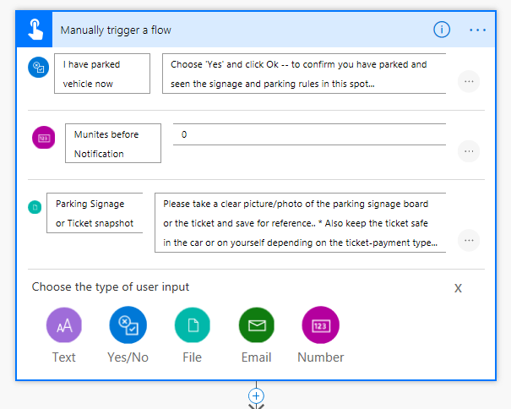

## FLOW DESIGNER

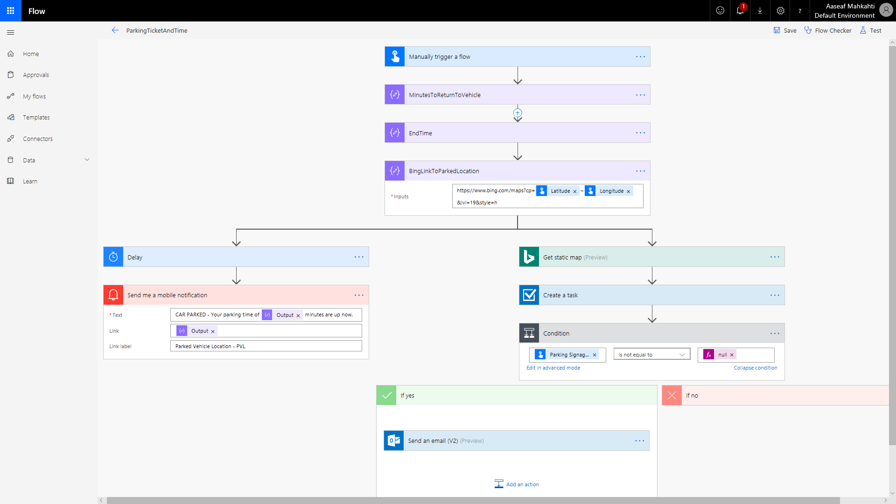

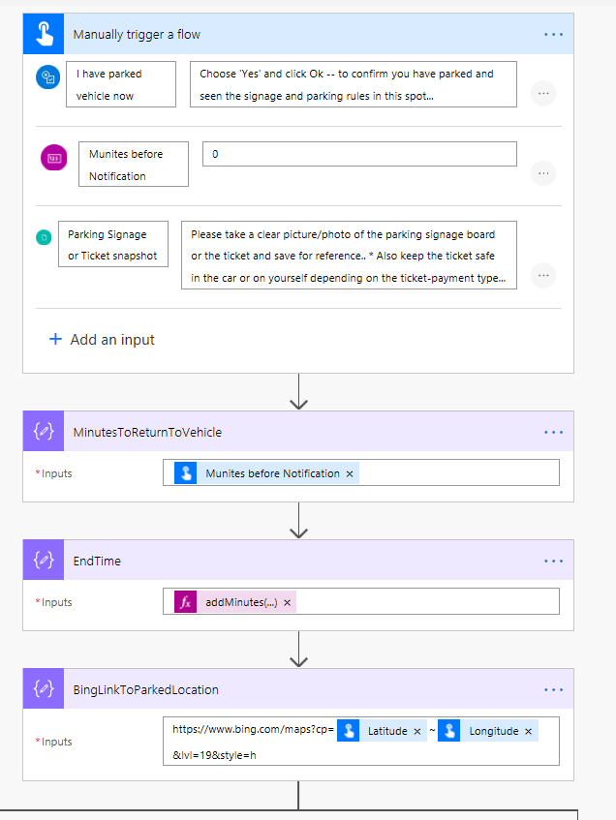

**FROM THIS POINT A PARALLEL BRANCH IS TO BE CREATED ….**

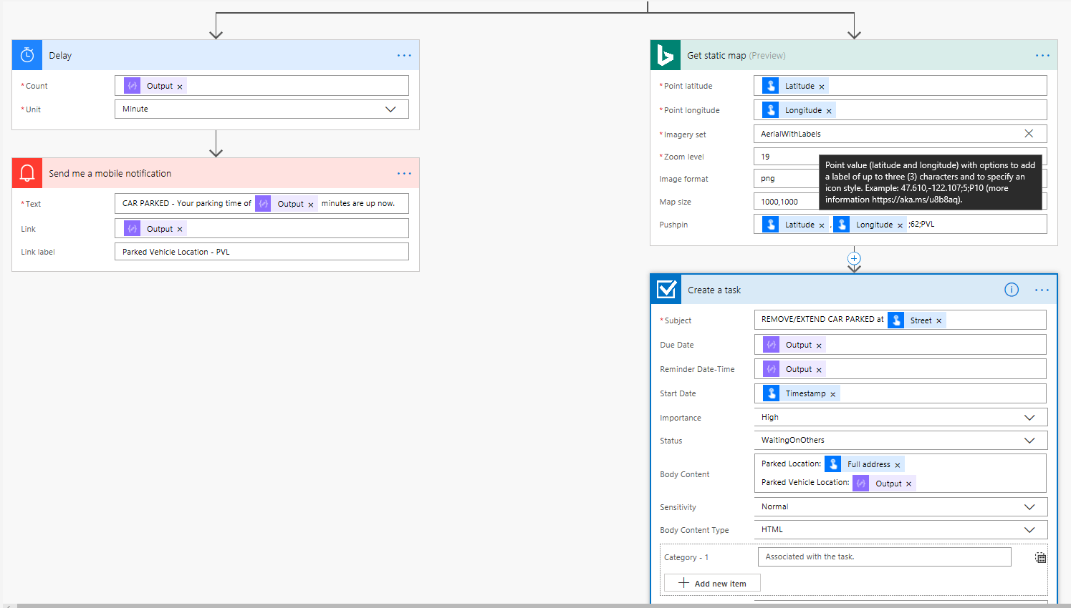

** BING MAP PUSHPIN reference link:: <https://msdn.microsoft.com/en-us/library/ff701719.aspx>

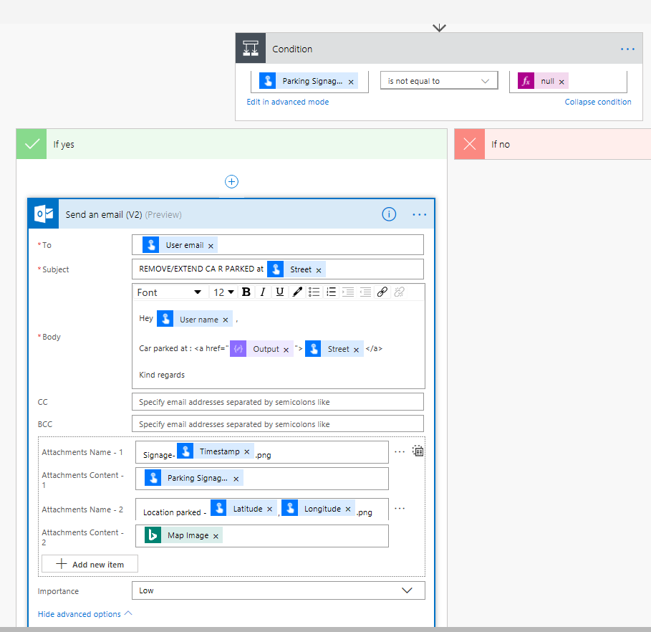

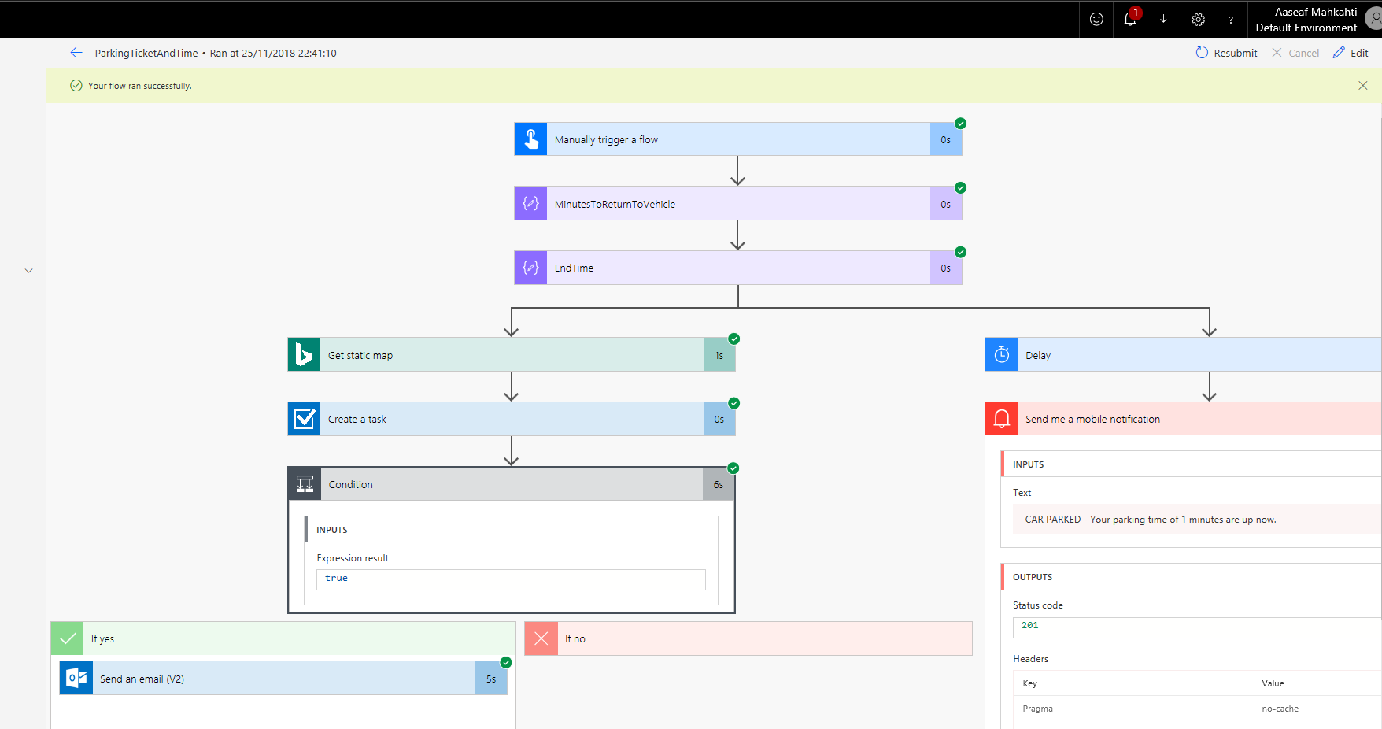

FIND THE FLOW APP – IN YOUR FAVORITE MOBILE-DEVICE – IOS/ANDROID – AND LOGIN WITH OUTLOOK.COM A/c

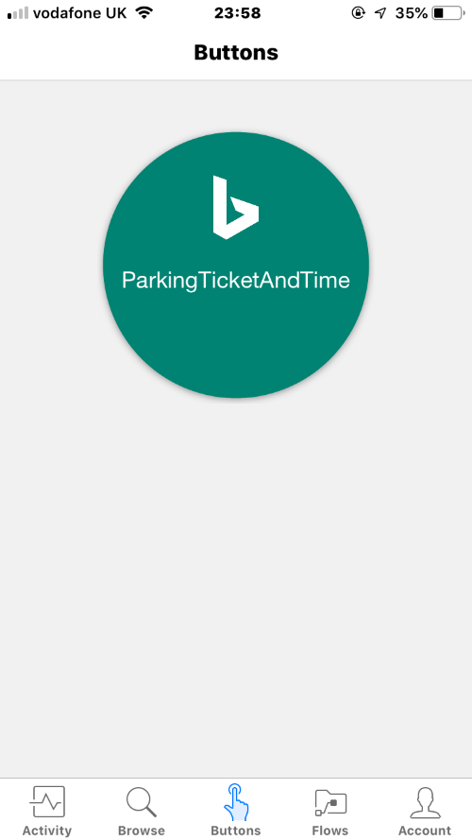 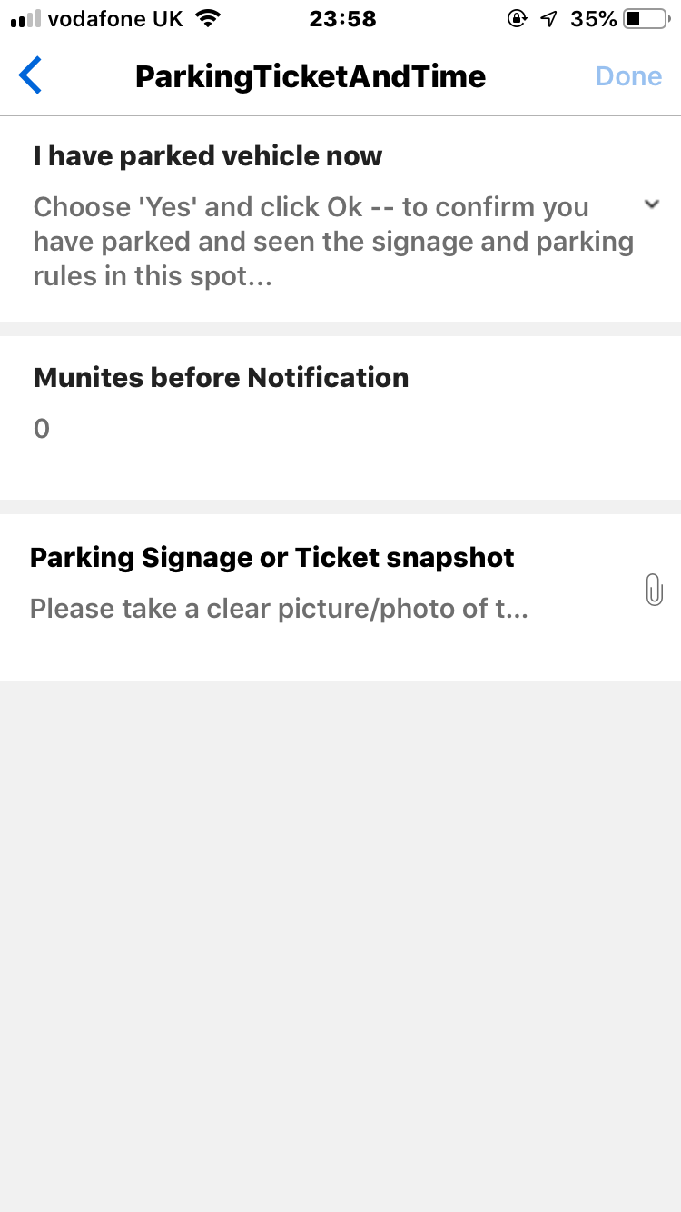 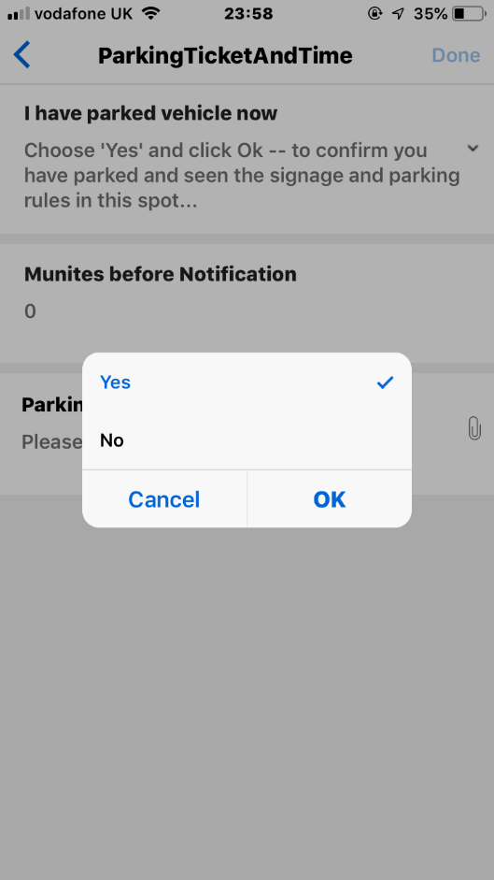

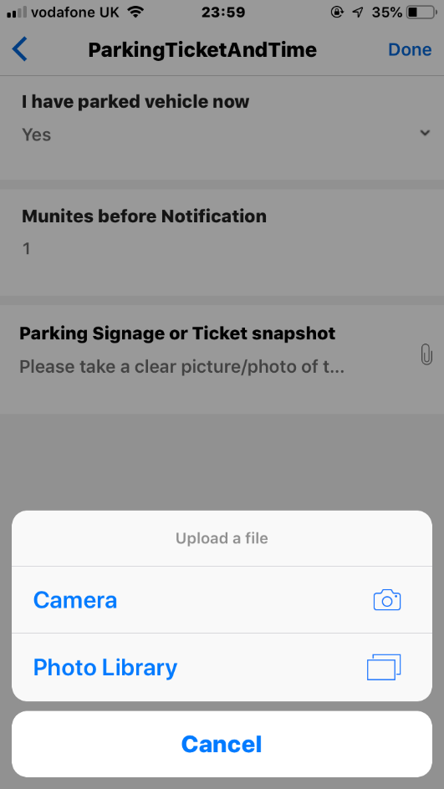 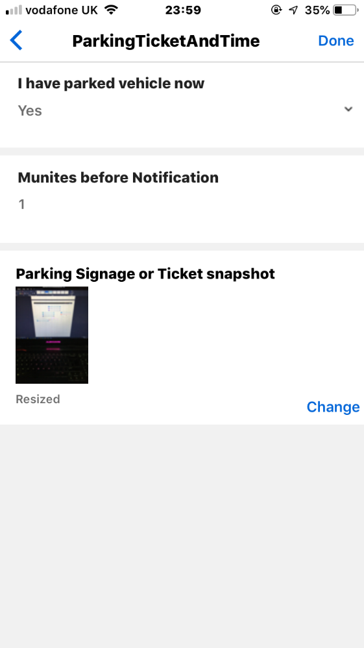 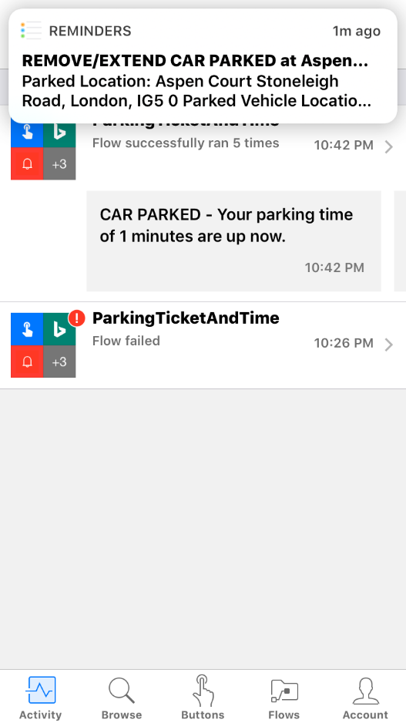

EMAIL AND ATTACHMENTS – THAT CAN BE CAPTURED THROUGH FLOW BUTTON APP …

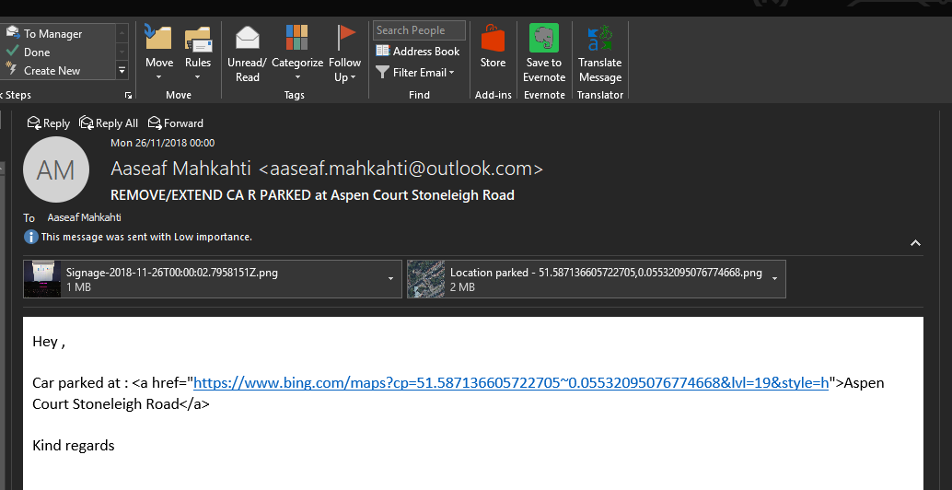

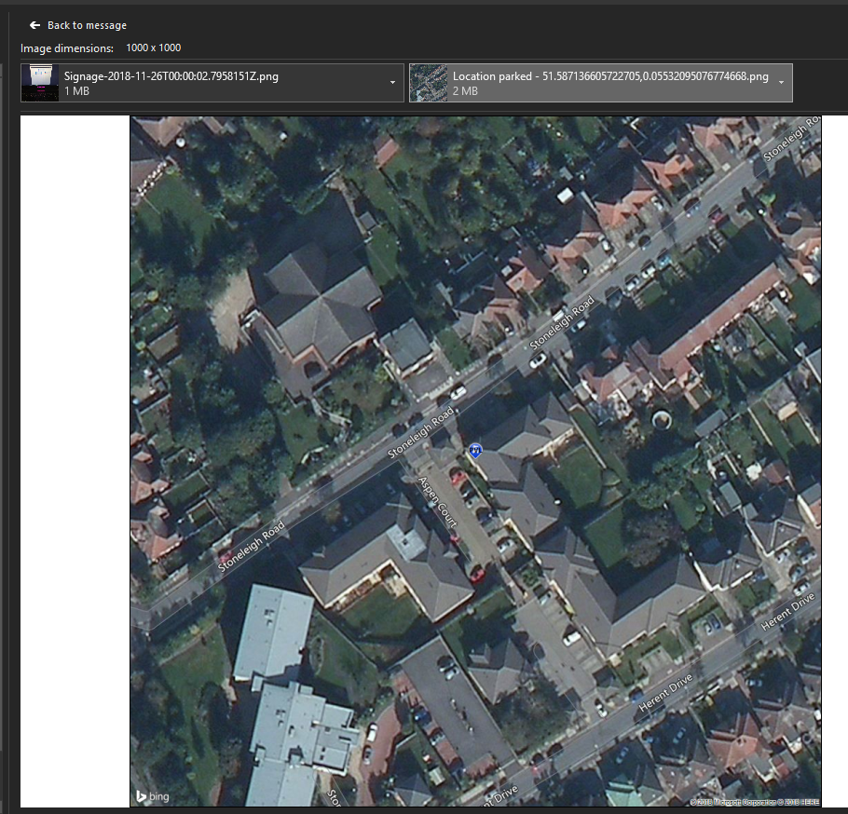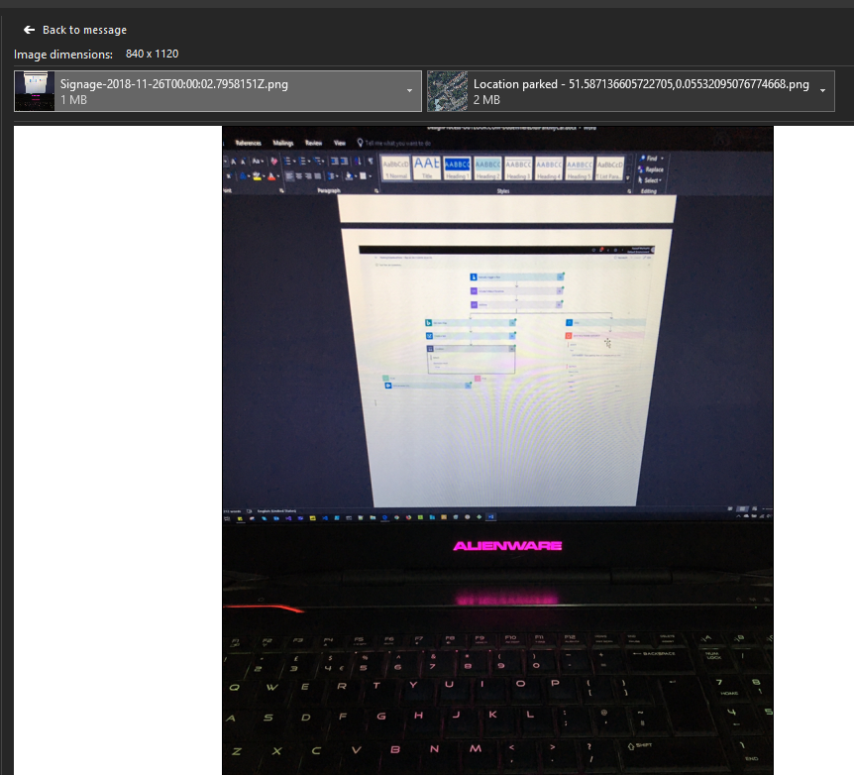

# SUPPORT – ENVIRONMENT – TOOLS – CONFIGURATION

## BING MAP API KEY

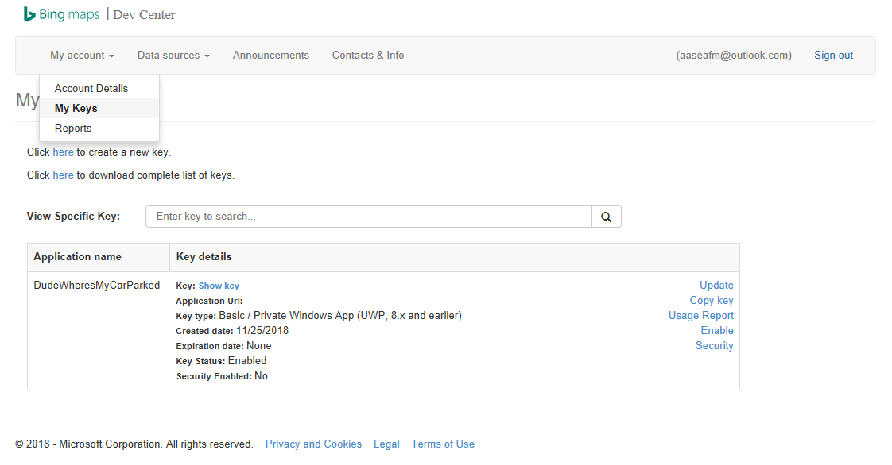

## JSON EXTRACT OF THE ABOVE IMPLMENTED FLOW (file attached)

Double-click/Download file 🡪 Open Visual Studio 2017+ And Create A ResourceGroup cloud project 🡪 Select Logic App template 🡪 Copy contents of this attached file in the LogicApp.json and deploy as it would be necessary to your Azure subscription -> configuring/creating connections for this could be a process in itself.



## CONNECTORS:

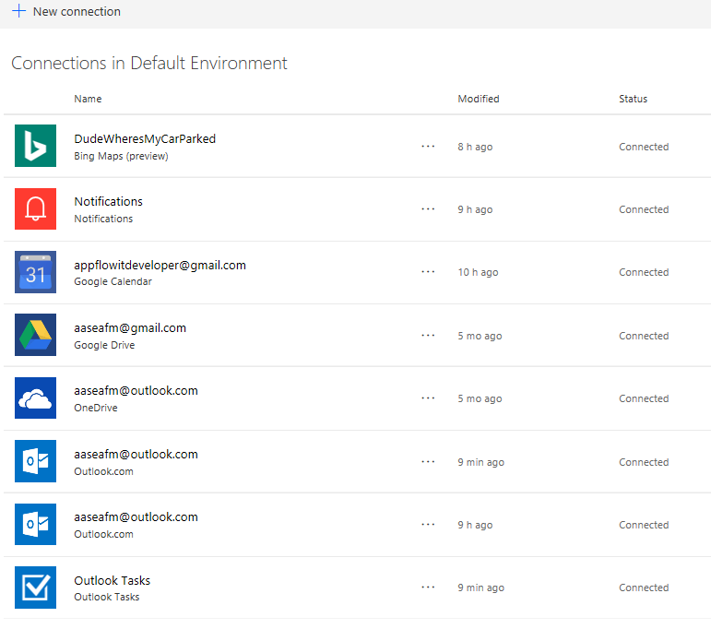

# HOPE THIS HELPED!?

Kindly feedback your thoughts and suggestions and ideas, that would be magical to get them😊

Cheers, Aaseaf Mahkahti | [sharepointjob@outlook.com](mailto:sharepointjob@outlook.com)