Design Process: Data Scrape (Find Microsoft MVP) => Iterate Items + Pages => LinkedIn Search with browser => Click buttons (Connect + Send Now) on LinkedIn! Bulk-Connect UI-RPA

**As A**: Linked-in networker and software developer!

**I Want:** To Connect to all possible Microsoft MVPs …

# **Visit**: [https://mvp.microsoft.com/en-us/MvpSearch](https://mvp.microsoft.com/en-us/MvpSearch?&lo=United%20Kingdom&sc=e&ps=48&pn=1)

**So That**: I can be influenced and help clients deliver the best value through my services.

Solution: Thought of Power Platform (UI Flow, but the thing still does not work with browsers!) and tried third-party tool but too restricted for a trial / free-for-ever!! Haha ….

1. <https://docs.uipath.com/studio/docs/extension-for-edge-chromium>

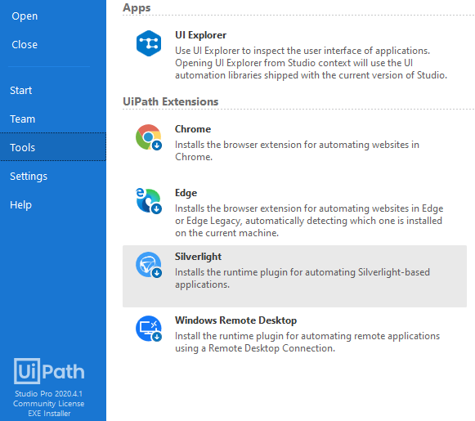 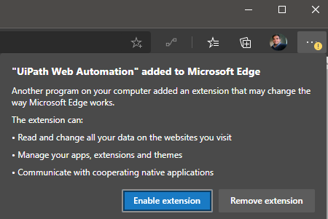

1. Watch some YouTube and Read some blog! Heard-start, Smart-skills and all that!

[](https://www.youtube.com/watch?v=96pDRsPbb10) [](https://www.youtube.com/watch?v=vIAJvk4quqA) ……

1. Open Browser => Data Scraping (Url with Search parameters in querystring)
2. Store output to System.Data.DataTable variable
3. (optional) Write to Excel

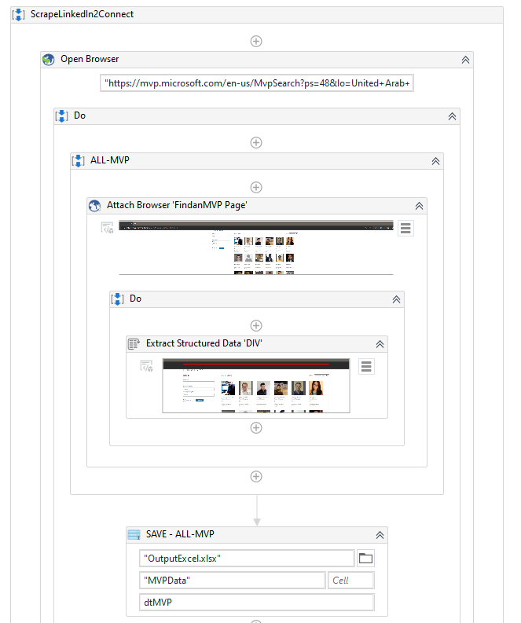

1. FOR-EACH
   1. Create Linkedin search string with required filtering-criteria : Connection-levels , Country etc…
   2. Parameterize keywords= with the “Name” column value from earlier scraped data.
   3. Push it in a new Open-Browser action (** Hoped to find way to reuse browser window!)

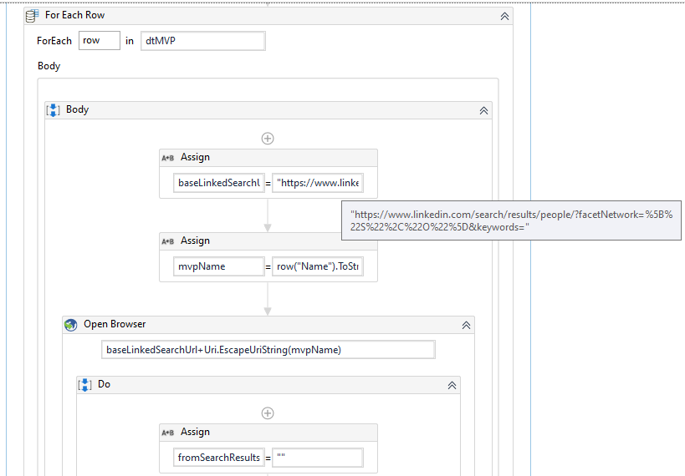

1. Select “Get OCR Text” activity from UIPath selected and follow to select ui-element. Changing parameter to variable mvpName and using * for element parented (probably can remove that, I guess). **Ensuring output of this action is assigned to fromSearchResults variable…**

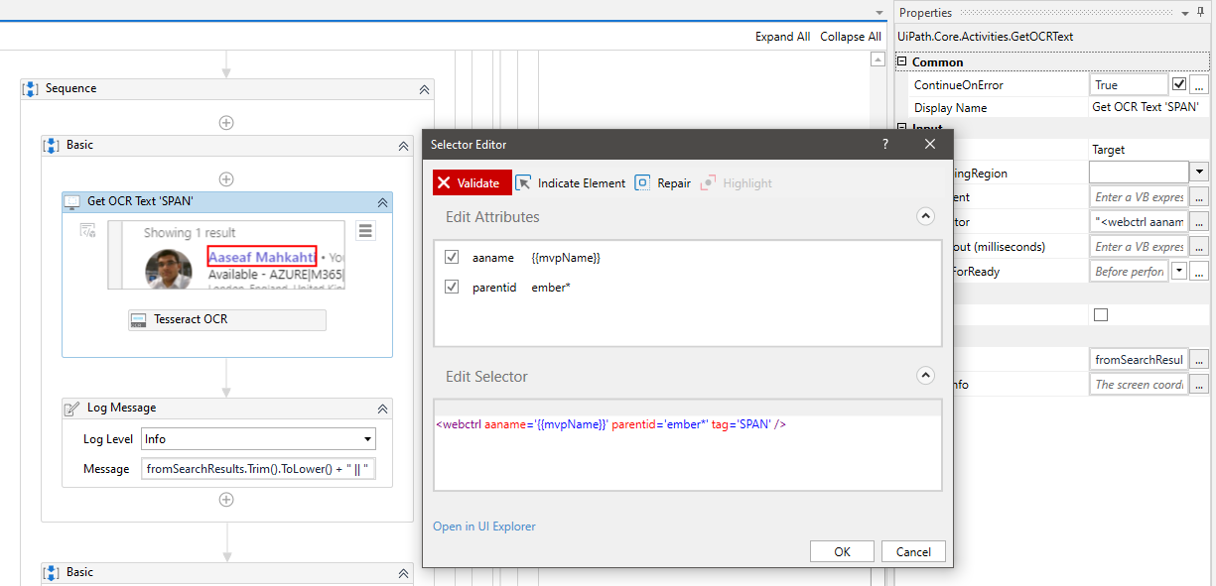

1. Check Recording options in the Menu and select Basic => Click type and once Saved-Exit recording – certain modifications were required => note the adding of the **aria-label and adding of the fromSearchResults variable…. Ensuring ContinueOnError was required and when exception does occur the program seems to be doing nothing, but it continues… and change of tag from span to button…**

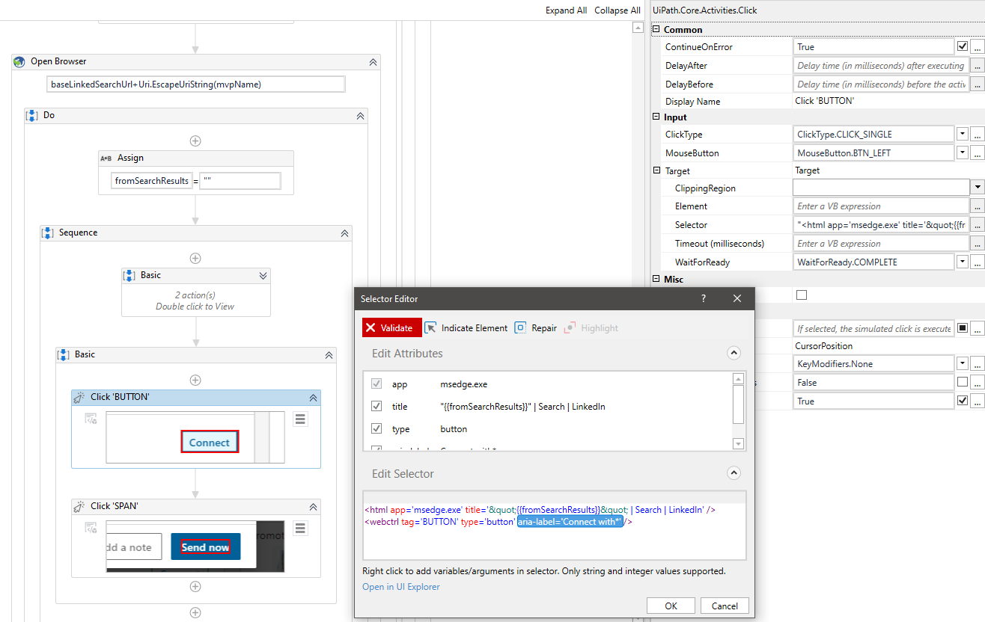

1. Check Recording options in the Menu and select Basic => Click type and once Saved-Exit recording – certain modifications were required => note the **aria-label and adding of the fromSearchResults variable…. Ensuring ContinueOnError was required and when exception does occur the program seems to be doing nothing, but it continues… and change of tag from span to button…**

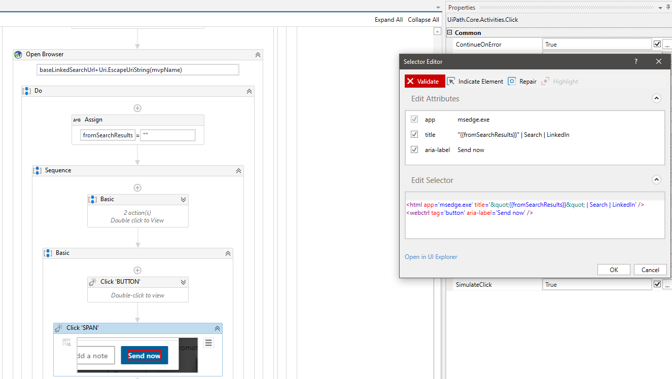

1. Result – It Works: Hits & Misses few; Continues (with plenty of delay!) on error … But when the BOT clicks Connect & Send Now! And Loops back to new Row/Window … We say it works for now!!

