One Off Data Migration from Excel – SAL_GenesisData.xlsx

# Acknowledging Triggers for initiating Flow for an Excel file saved to One-Drive/SharePoint/Group/Me/User.

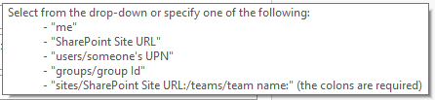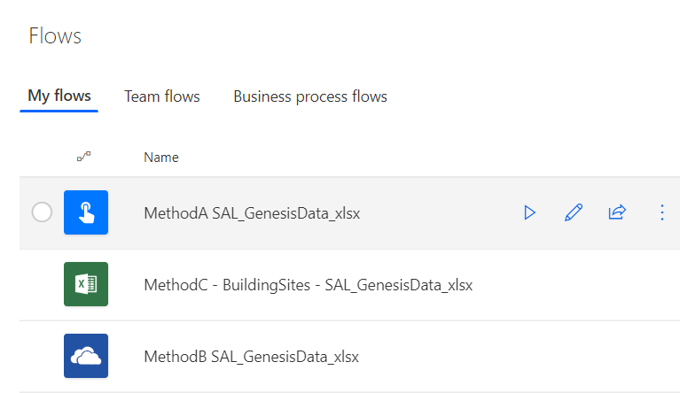

**Method A**: Manually trigger a flow (with button for mobile only) – In this approach all connection details must be statically presented, and the process would be to upload the file to one-drive in a predefined location and then use the mobile app to trigger the flow.

**Method B**: With only slight variation on the Method-A; This is a One-Drive File Item 🡺 Flow context menu approach, is to use OneDrive file context menu or for selected file! and run the flow. *Can’t see immediate advantage in this scenario – but in some other situations this “flow trigger” may be more relevant; so, only initial screenshot is provided below for reference… ONE disadvantage of this approach is that, if you try to load the file more dynamically (based on selected-file context)– the static schema-typing are not available and Table-row-columns metadata is lacking from the “Dynamic content” window/panel.*

**Method C** (Excel Flow Add-in) show cases a more hands-on and controlled approach with, Excel table’s row level processing option – where one-or-multiple rows can be selected for a single table and flow runs can be programmed accordingly. For this instance of the scenario/requirement – this approach/method would not fit – since the flow would be executed per row based only on user’s selection. *Can’t see immediate advantage in this scenario – but in some other situations this “flow trigger” may be more relevant; so, only initial screenshot is provided below for reference…*

# Method-A

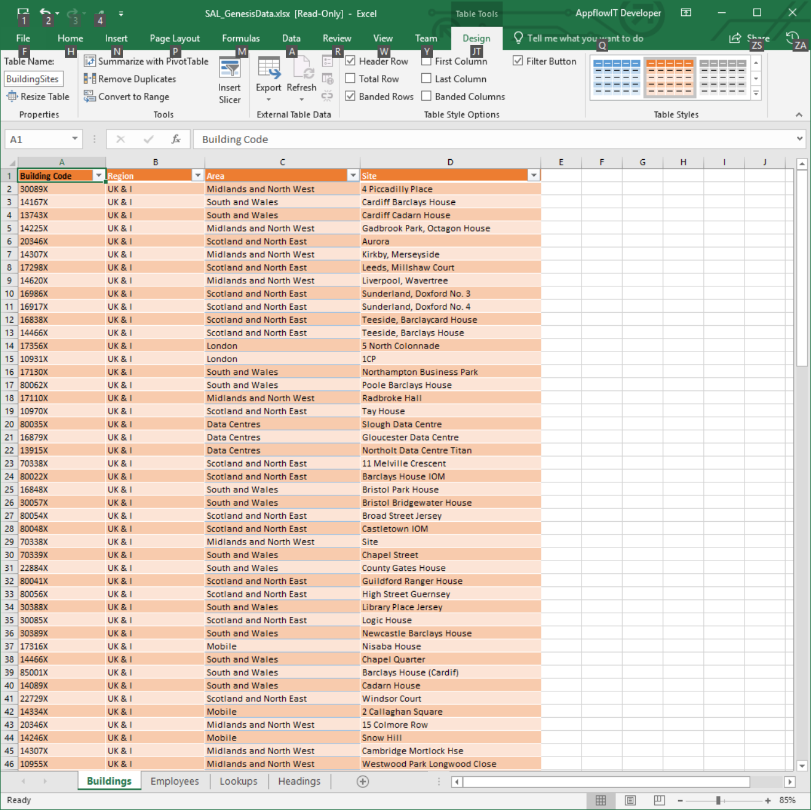 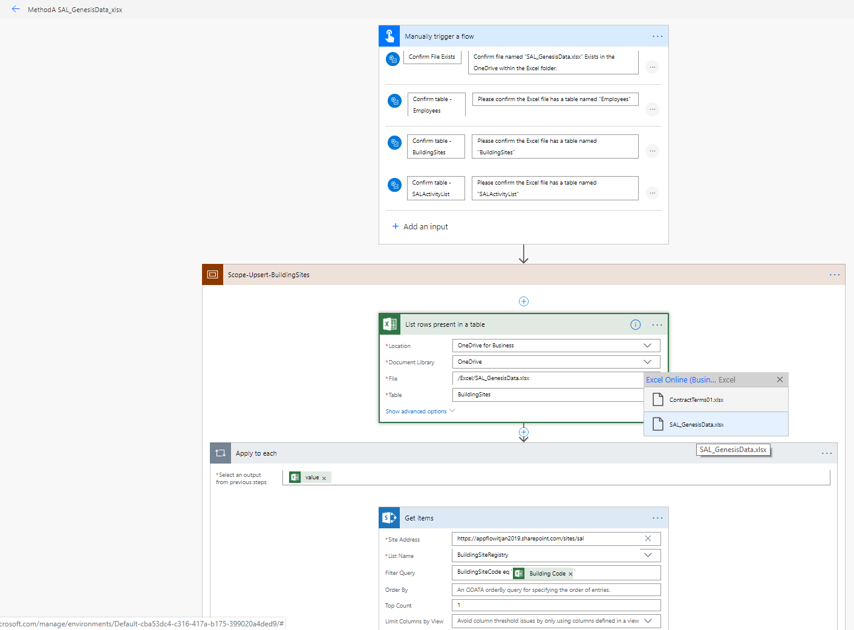

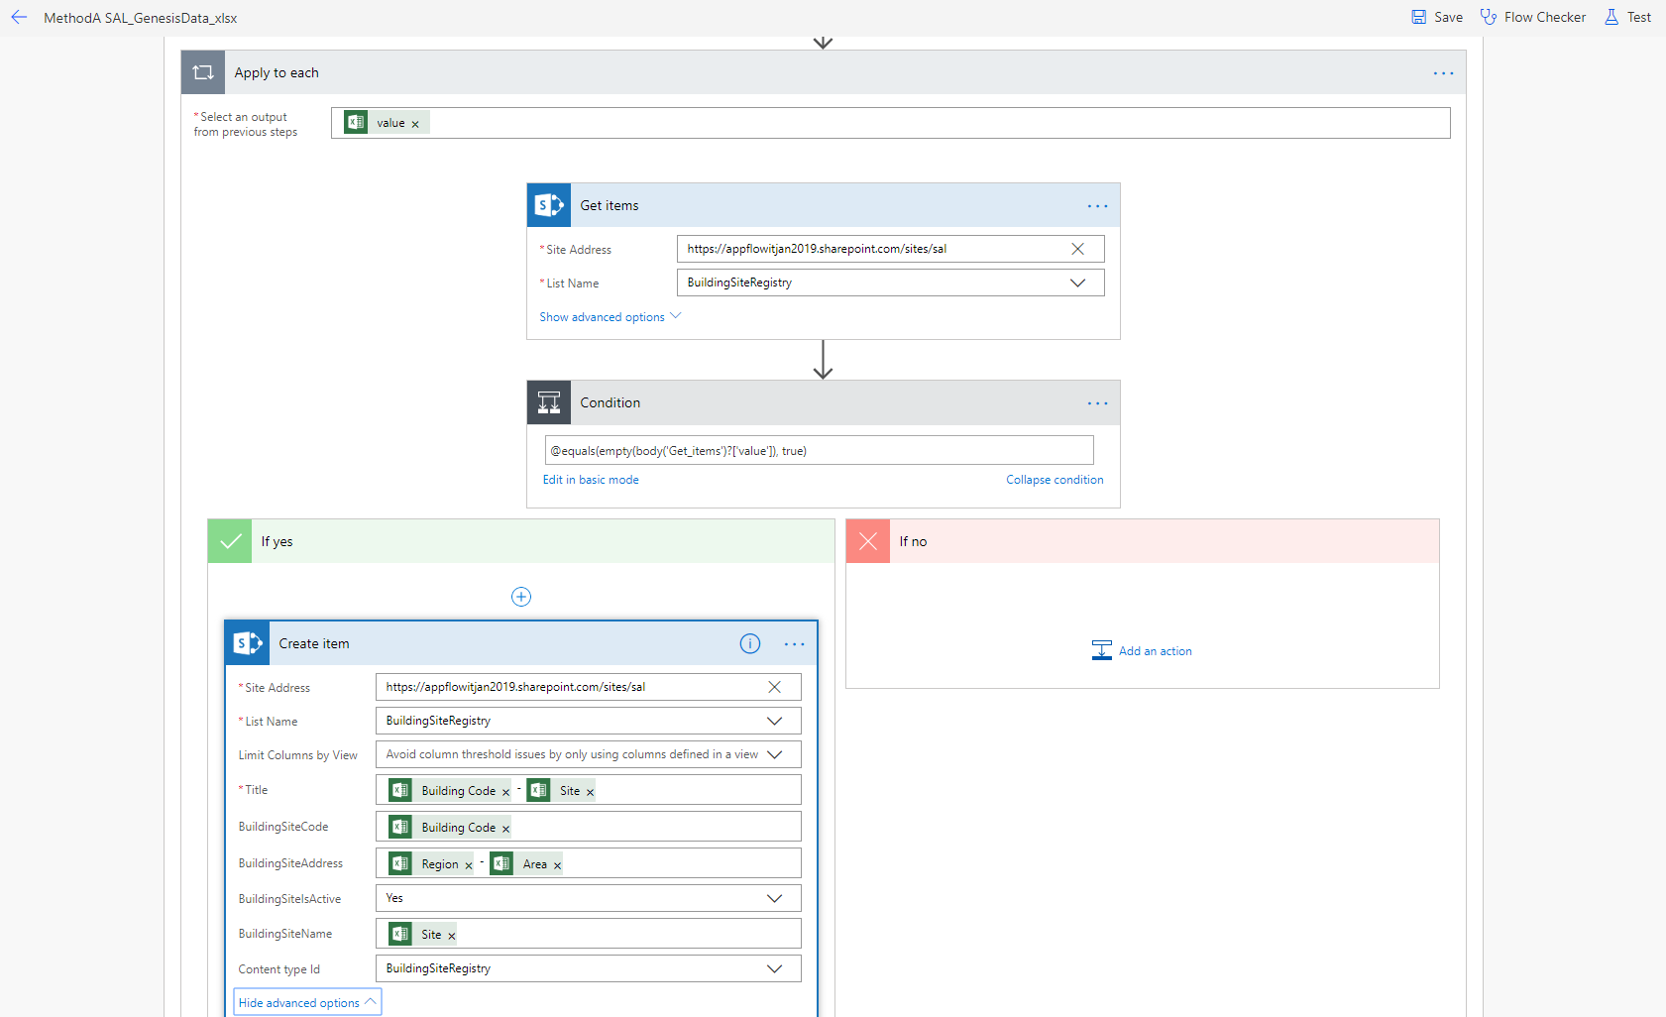

**BUILDINGS**

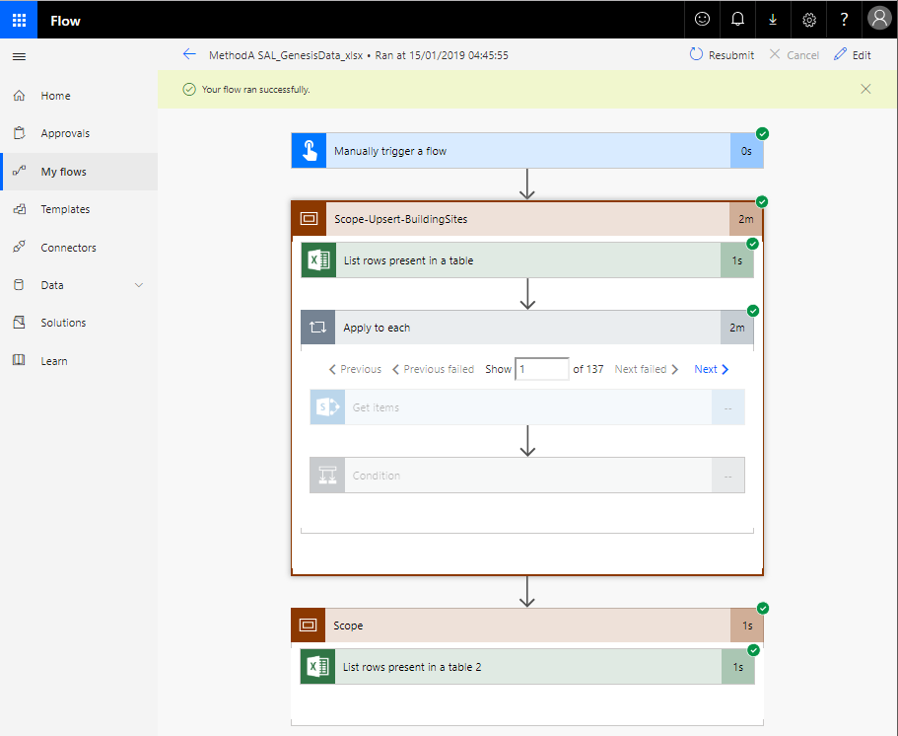

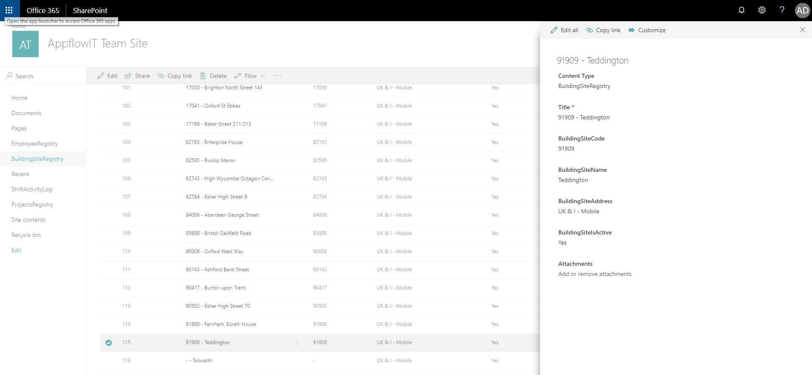

**EMPLOYEES**

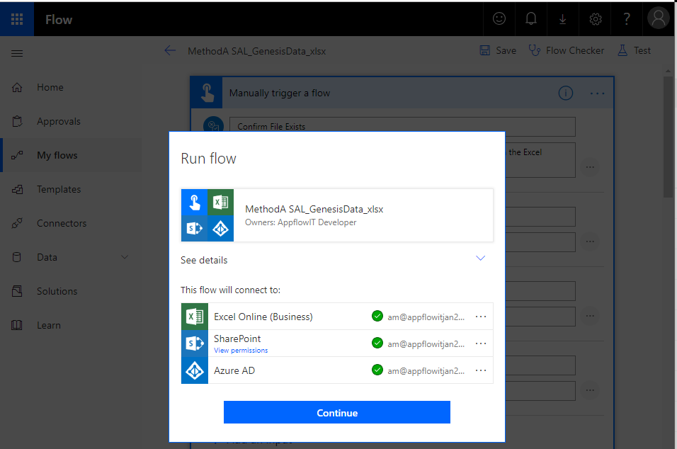

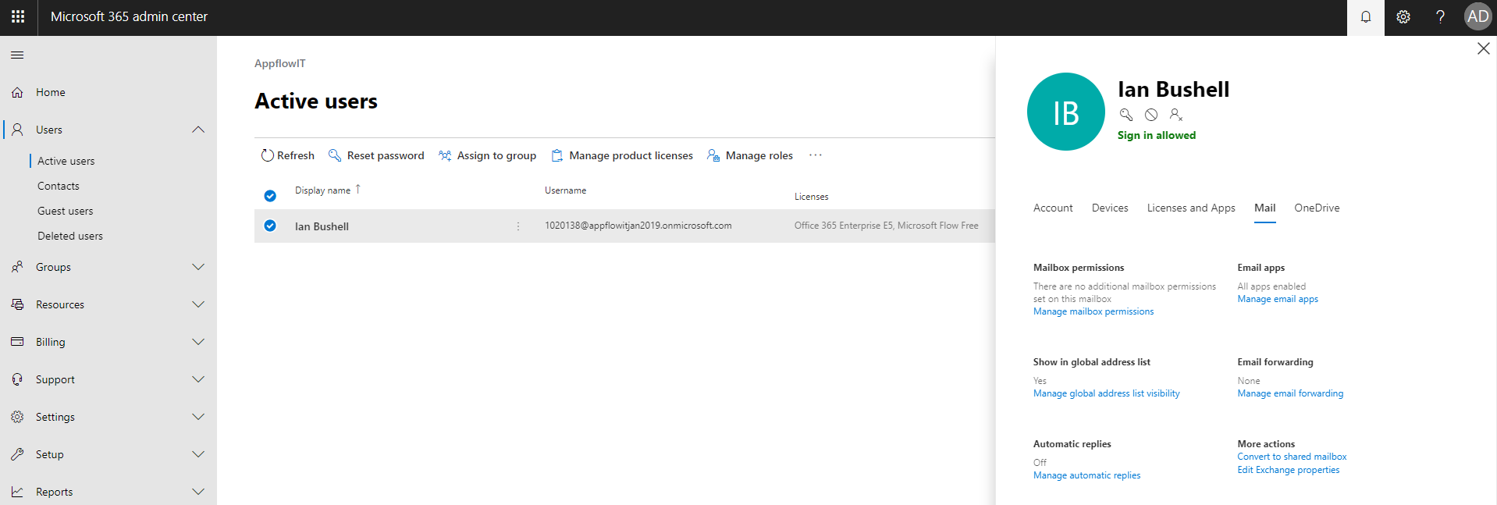

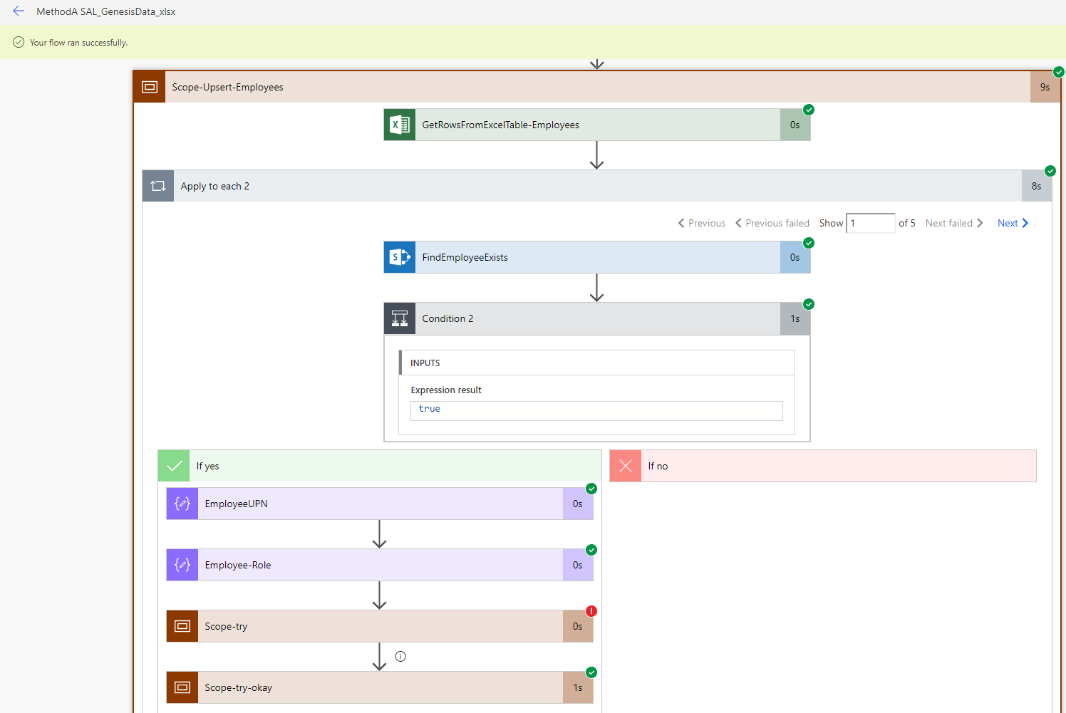

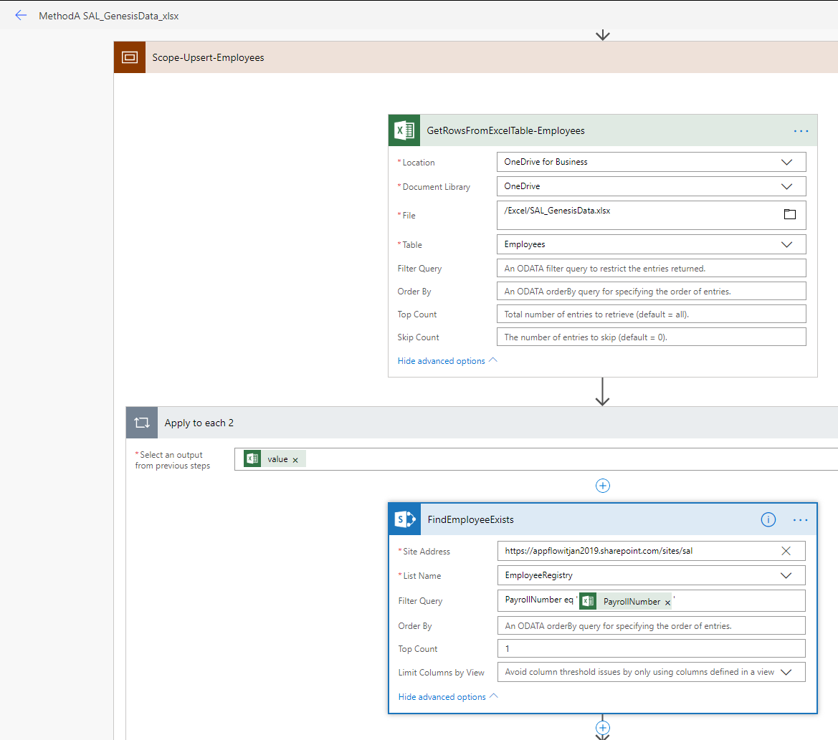

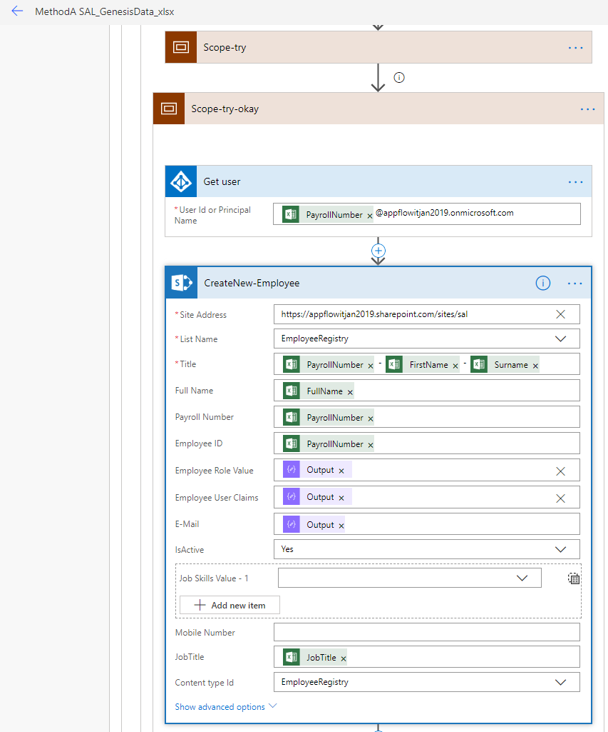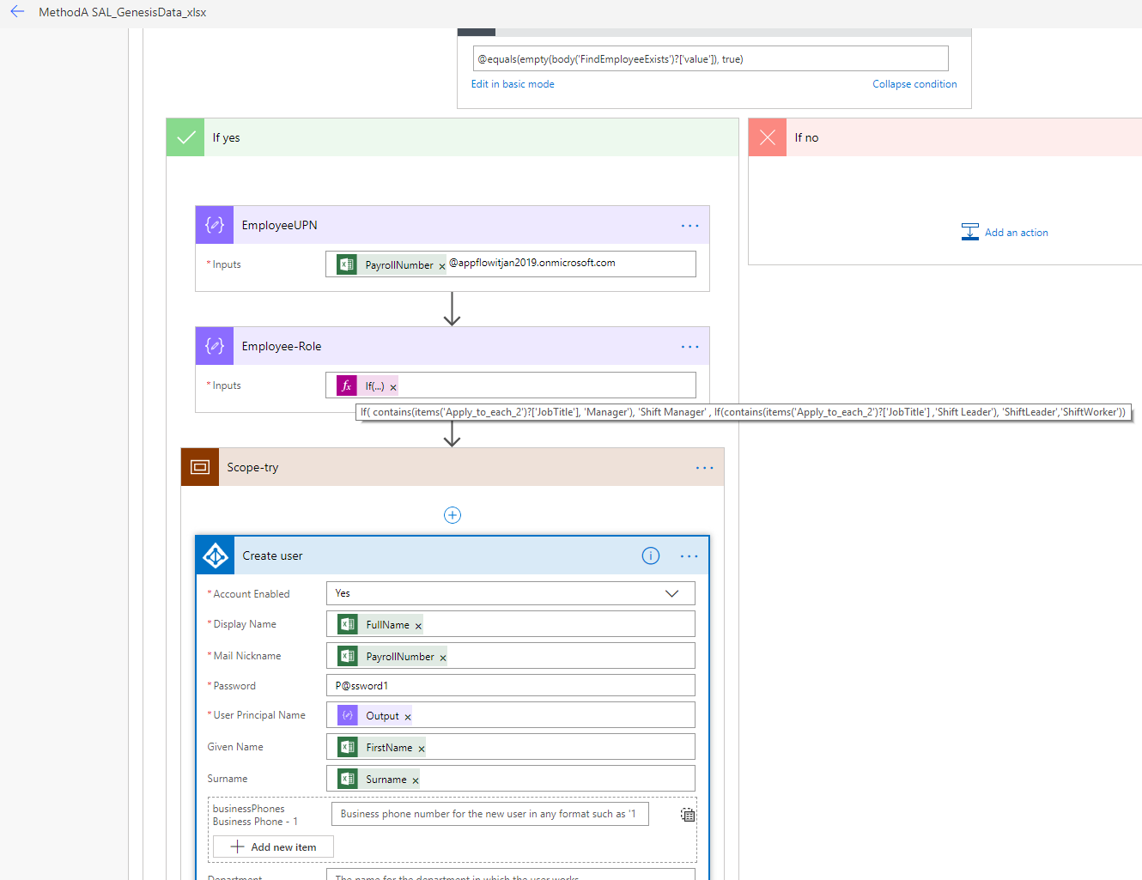

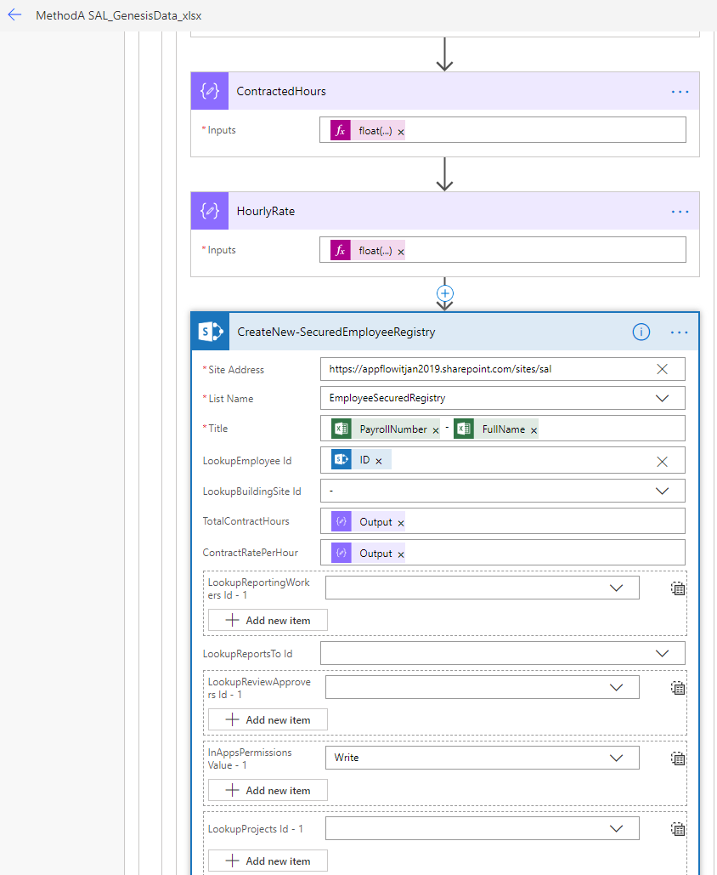

# 

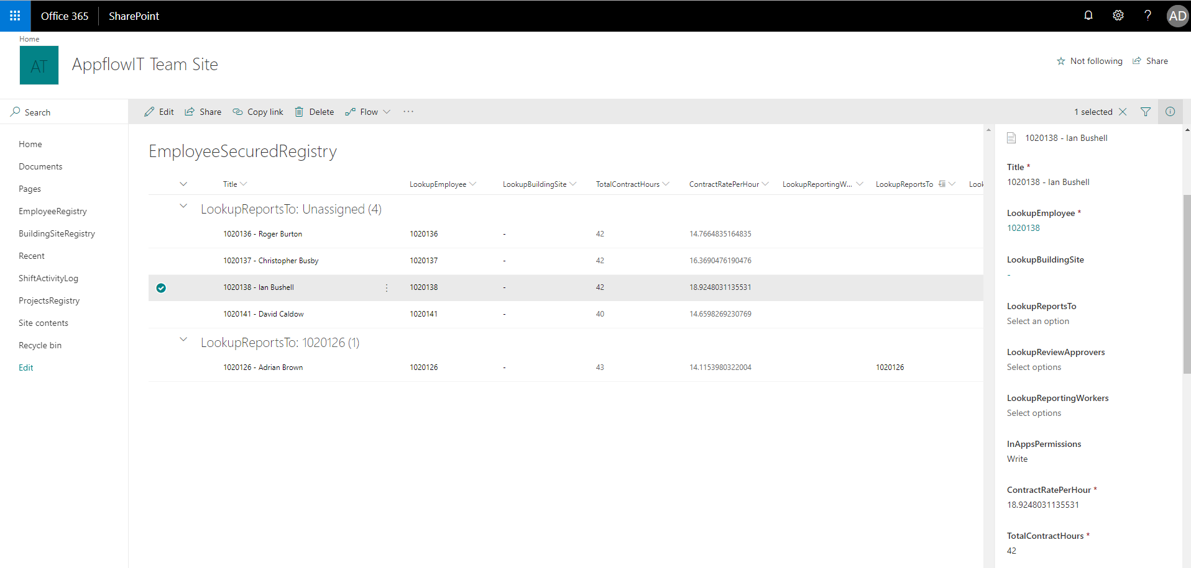

# Method-B

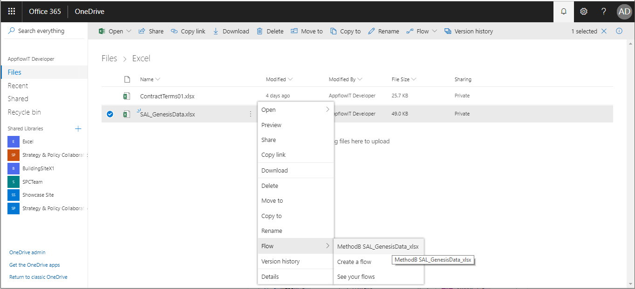

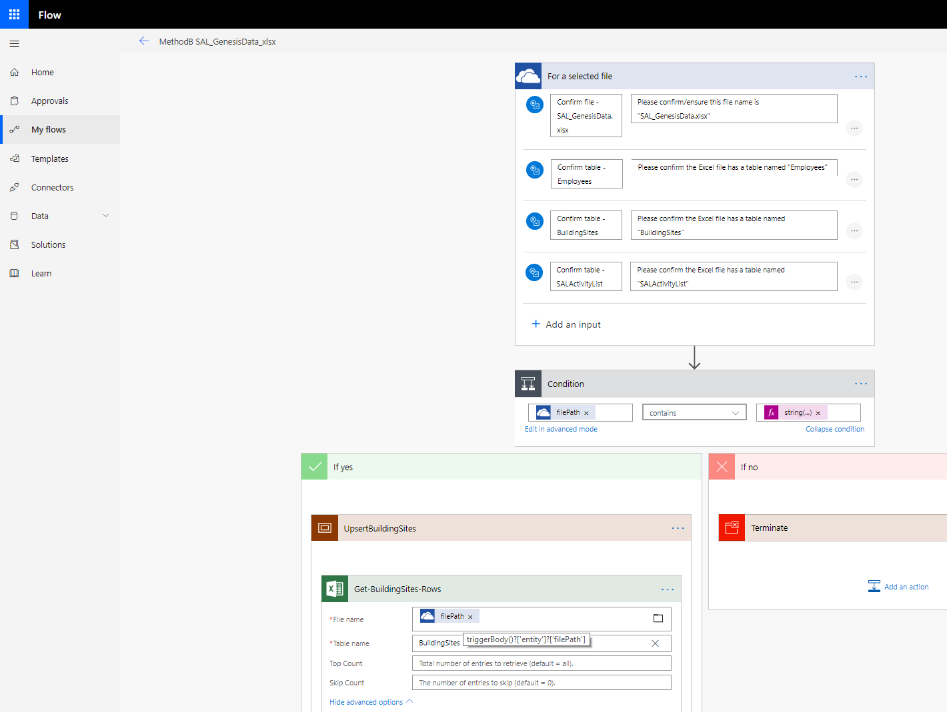

# Method-C

Reference: [**https://flow.microsoft.com/en-us/blog/excel-bpf-todo-and-more/**](https://flow.microsoft.com/en-us/blog/excel-bpf-todo-and-more/)

