**INSTALLING SHAREPOINT 2016**

**AutoSPInstaller**

[**https://github.com/brianlala/AutoSPInstaller/releases/**](https://github.com/brianlala/AutoSPInstaller/releases/)

[**https://spbreed.wordpress.com/2015/09/04/autospinstaller-with-sp2016-on-win2016-and-sql2016/**](https://spbreed.wordpress.com/2015/09/04/autospinstaller-with-sp2016-on-win2016-and-sql2016/)

[**https://docs.microsoft.com/en-us/sharepoint/install/install**](https://docs.microsoft.com/en-us/sharepoint/install/install)

* 1. Provision E:\ and F:\ for SQL and Logs

* 1. Join the server to a domain (Server Manager\Local Server[Domain])

* 1. **Fully functional SharePoint install requires at least 9 service accounts**. Below PowerShell script can be used to automate Service account creation and to configure “No password expiry” policies. Update the CSV file with required values: [Create-ADUsers.ps1](https://onedrive.live.com/?id=3B2C0C2B403E6F59%212061&cid=3B2C0C2B403E6F59&group=0)

* 1. **Add replicating directory changes permission to spprofilesync account**

|  |  |
| --- | --- |
| [**https://blog.devoworx.net/2015/10/25/grant-user-profile-synchronization-service-account-to-replicate-directory-changes-permission-on-a-domain/**](https://blog.devoworx.net/2015/10/25/grant-user-profile-synchronization-service-account-to-replicate-directory-changes-permission-on-a-domain/) |  |

[AD-Users-Computers => "DomainName" => (right click) Delegate Control… => Select User => "create custom task to delegate" -> this folder, existing objects…. => Permissions: Replicating Directory Changes.]

<https://technet.microsoft.com/en-us/library/Hh296982.aspx>

* 1. PowerShell Environment => $profile
  2. [**https://technet.microsoft.com/en-us/library/bb613488(v=vs.85).aspx**](https://technet.microsoft.com/en-us/library/bb613488(v=vs.85).aspx)

<https://blogs.technet.microsoft.com/rmilne/2015/01/29/creating-powershell-profile-for-integrated-scripting-environment-ise/>

[**Set-ExecutionPolicy**](https://blogs.msdn.microsoft.com/pasen/2011/12/07/set-executionpolicy-windows-powershell-updated-your-execution-policy-successfully-but-the-setting-is-overridden-by-a-policy-defined-at-a-more-specific-scope/): (<https://blogs.msdn.microsoft.com/pasen/2011/12/07/set-executionpolicy-windows-powershell-updated-your-execution-policy-successfully-but-the-setting-is-overridden-by-a-policy-defined-at-a-more-specific-scope/>)

* 2. Though SharePoint adds required firewall ports during setup, I used the below scripts to add required firewall ports in advance
     1. [Create-FWRulesDB.ps1](https://onedrive.live.com/?id=3B2C0C2B403E6F59%21493&cid=3B2C0C2B403E6F59&group=0)
     2. [Create-FWRulesWFE.ps1](https://onedrive.live.com/?id=3B2C0C2B403E6F59%21493&cid=3B2C0C2B403E6F59&group=0)

* 1. **Download and Install SQL server 2016** preview from <https://www.microsoft.com/en-us/evalcenter/evaluate-sql-server-2016>. Use SQLService accounts created in step 3 while configuring SQL services

* 1. Pre configure app domain using <http://sharepointchick.com/archive/2012/07/29/setting-up-your-app-domain-for-sharepoint-2013.aspx>

* 1. Clone AutoSPSourcebuilder from <https://github.com/brianlala/AutoSPSourceBuilder>
  2. Clone AutoSPInstaller from <https://github.com/brianlala/AutoSPInstaller>
  3. Common Prerequisites (in case for SP2013 on Win2016)

Import-Module ServerManager

Add-WindowsFeature Net-Framework-Features,Web-Server,Web-WebServer,Web-Common-Http,Web-Static-Content,Web-Default-Doc,Web-Dir-Browsing,Web-Http-Errors,Web-App-Dev,Web-Asp-Net,Web-Net-Ext,Web-ISAPI-Ext,Web-ISAPI-Filter,Web-Health,Web-Http-Logging,Web-Log-Libraries,Web-Request-Monitor,Web-Http-Tracing,Web-Security,Web-Basic-Auth,Web-Windows-Auth,Web-Filtering,Web-Digest-Auth,Web-Performance,Web-Stat-Compression,Web-Dyn-Compression,Web-Mgmt-Tools,Web-Mgmt-Console,Web-Mgmt-Compat,Web-Metabase,WAS,WAS-Process-Model,WAS-NET-Environment,WAS-Config-APIs,Web-Lgcy-Scripting,Windows-Identity-Foundation,Server-Media-Foundation,Xps-Viewer –Source D:\sources\sxs

*From <*[*https://absolute-sharepoint.com/2017/08/the-tool-was-unable-to-install-web-server-iis-role-sharepoint-2016-on-windows-server-2016.html*](https://absolute-sharepoint.com/2017/08/the-tool-was-unable-to-install-web-server-iis-role-sharepoint-2016-on-windows-server-2016.html)*> s*

* 1. Download #SP2016 preview from <http://www.microsoft.com/en-us/download/details.aspx?id=48712> and mount it as, **MOUNT-DISKIMAGE** C:\ISO\SharePoint Server 2016 IT Preview.ISO

* 1. Now navigate to AutoSPSourceBuilder  and to create SlipStreamed version of #SP2016,

* + ***PS F:\AutoSPSourceBuilder> .\AutoSPSourceBuilder.ps1 -GetPrerequisites:$true  -Destination “F:\AutoSPInstaller\SP\2016”***

[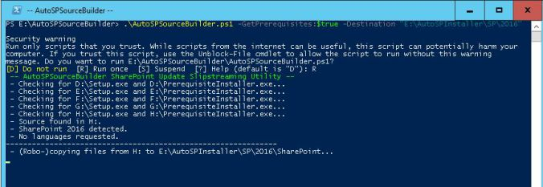](https://spbreed.files.wordpress.com/2015/09/autosourcebuilder.jpg)

* + Now prepare AutoSPInstallerInput.xml for SharePoint 2016. Its highly recommended use <https://autospinstaller.com/>***to generate this config today. But*** as of today (09/03/2016) online   tool to generate config file for SP2016 is not supported. Only notable difference wrt to AutoSPInstaller between #SP2013 and #SP2016 is the introduction MinRoles to simplify the deployment and scaling. For more details refer <http://blogs.technet.com/b/wbaer/archive/2015/05/12/what-s-new-in-sharepoint-server-2016-installation-and-deployment.aspx>

* 1. Select <SingleServerFarm Provision=”true” /> for single server farm setup. Attached is the sample Config file for SP2016 for your reference. [AutoSpInstallerInput.xml](https://onedrive.live.com/?id=3B2C0C2B403E6F59%212062&cid=3B2C0C2B403E6F59&group=0)

[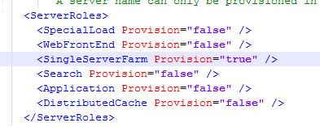](https://spbreed.files.wordpress.com/2015/09/minroles.jpg)

* 1. Now run the .\AutoSPInstallerLaunch.bat. Installation will be a breeze.

[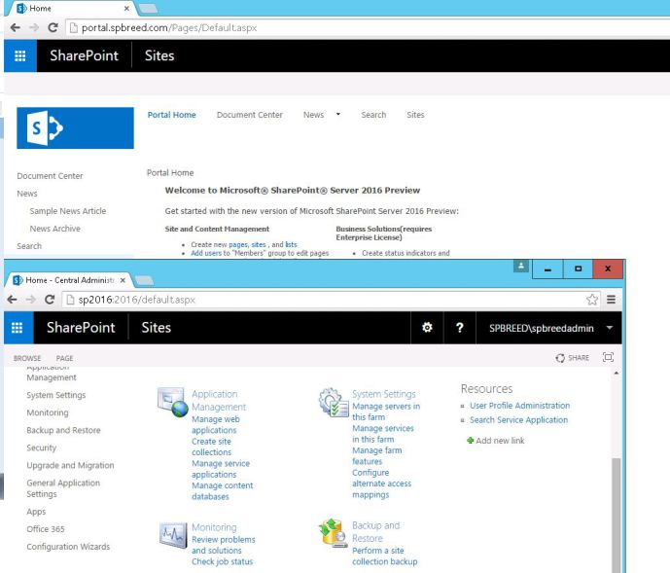](https://spbreed.files.wordpress.com/2015/09/portal.jpg)

* 1. Enable TLS 1.1 and TLS 1.2 support in SharePoint Server 2016 [Readiness for High-Trust Apps]

{

* + <https://docs.microsoft.com/en-us/sharepoint/security-for-sharepoint-server/enable-tls-1-1-and-tls-1-2-support-in-sharepoint-server-2016#sql2012>
  + <https://www.nartac.com/Products/IISCrypto>
  + <https://www.sysadmins.lv/blog-en/test-web-server-ssltls-protocol-support-with-powershell.aspx>
  + <https://forums.asp.net/post/1695893.aspx#1695893>

}

I**nstall Setup: AppFabricWorkflowManager2016.docx**

