As part of a migration project/assignment/freelance-job ,, that allowed a template set-of-folder structure to be created when a new listitem/worker record was added to list...

* **replace(toLower(outputs('SPHTTP-GetFolderItem')?['body/d/Folder']?['__deferred/uri']), toLower(outputs('SPSiteURL')), '')**
* **concat('"', outputs('SPHTTP-GetFolderObject')?['body/d/UniqueId'], ',', replace(outputs('SPHTTP-GetFolderItem')?['body/d/__metadata/etag'], '"', ''), '"')**

There are a plenty blogs out there to show that this works with 2 steps : Get etag and odata.type API call -- and then the rename itself.

Somehow, something has changed that etag is matched with the Uniqueid of the SP.Folder inside the SP.Item containing the folder object ... Hence, requiring an additional step which was easy to discover considering the linked-data API/Urls that are returned with the other API calls.

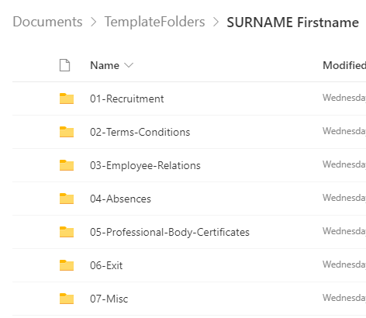

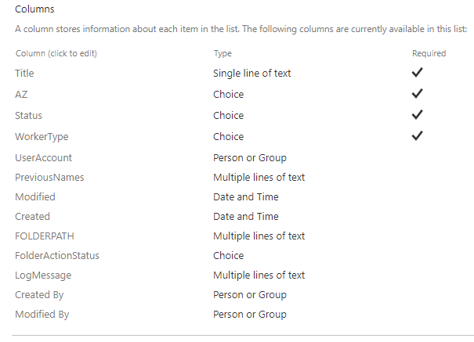

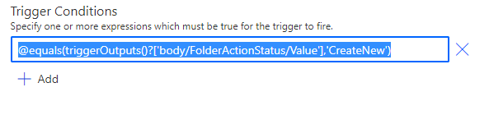

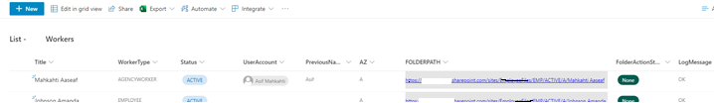

AND a bit of on-disk folder/files changes before migration to SharePoint/OneDrive Online ....

A PowerShell script as TDD (Test Driven Development) as it gets with me !



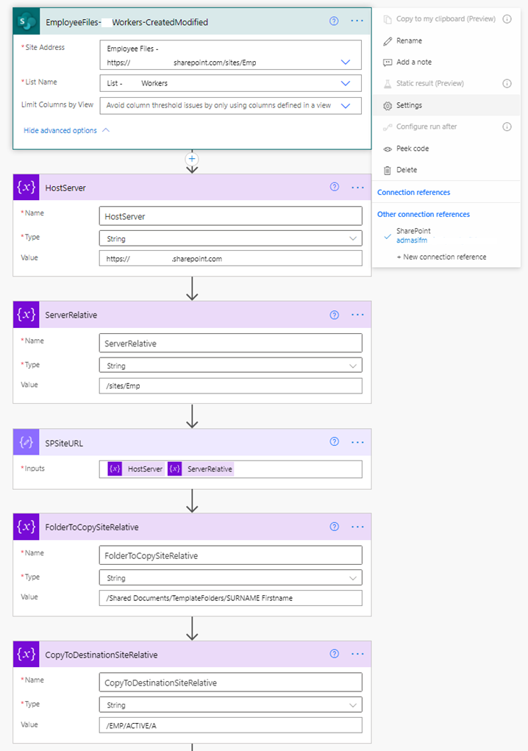

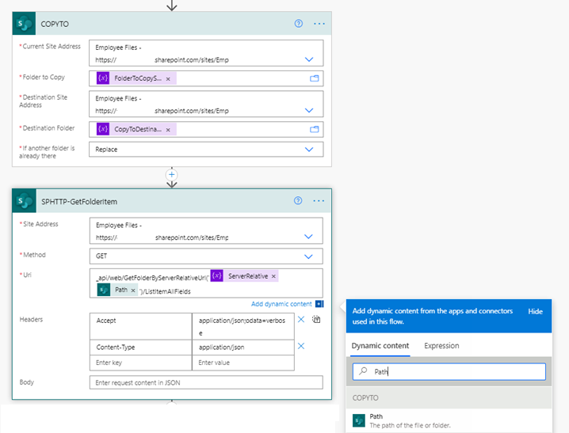

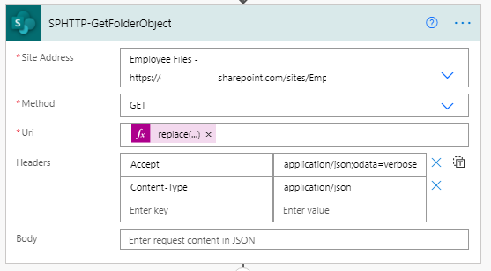

**replace(toLower(outputs('SPHTTP-GetFolderItem')?['body/d/Folder']?['__deferred/uri']), toLower(outputs('SPSiteURL')), '')**

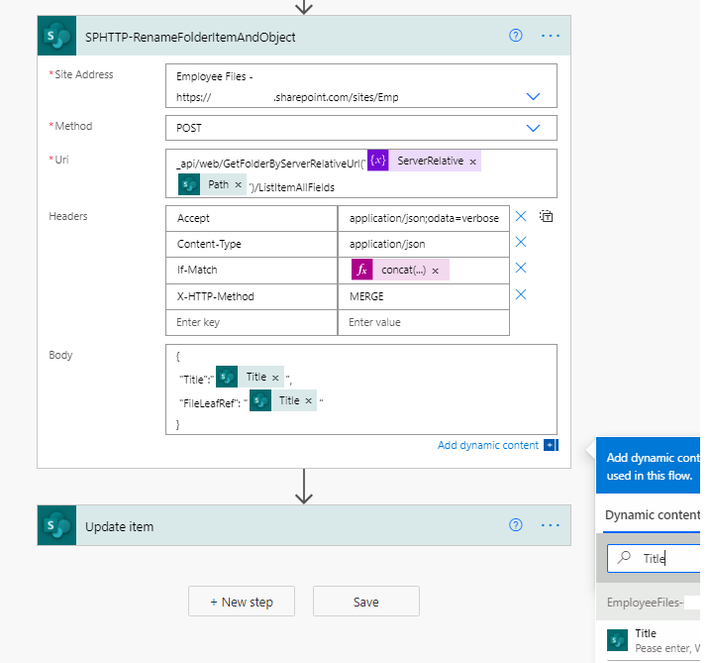

**concat('"', outputs('SPHTTP-GetFolderObject')?['body/d/UniqueId'], ',', replace(outputs('SPHTTP-GetFolderItem')?['body/d/__metadata/etag'], '"', ''), '"')**

