# MS-Graph API + Azure Authentication + MS-Teams

This is a part of the whole – solution. Hence, it is not intended to be end-2-end functional or practical but, further enhancements on the way for a more complete story-scenario-based app in next few weeks…

While I was exploring **MS-Teams** integration with use of,

– **MS-Graph REST API** and **Azure Application Authentication/Authorization** from **O365-MS-Flow** for a user on-boarding process

– Including minor **O365-MS-PowerApps form**

– To create MS-Teams group-channels “programmatically” based on the user’s chosen “Topic” which happens to be a Managed Metadata Term store “term”. With user data stored in the SharePoint online custom list.

– But mainly, using a MS-Graph API to “Add Members” to such Group/Channel.

*Story in Pictures below:*

# The MS-PowerApps and SharePoint lists/data

### A Custom list “CallMeSME” which allows a new SME registration where a mildly customized MS-PowerApps form is used to perform New-Edit entries.

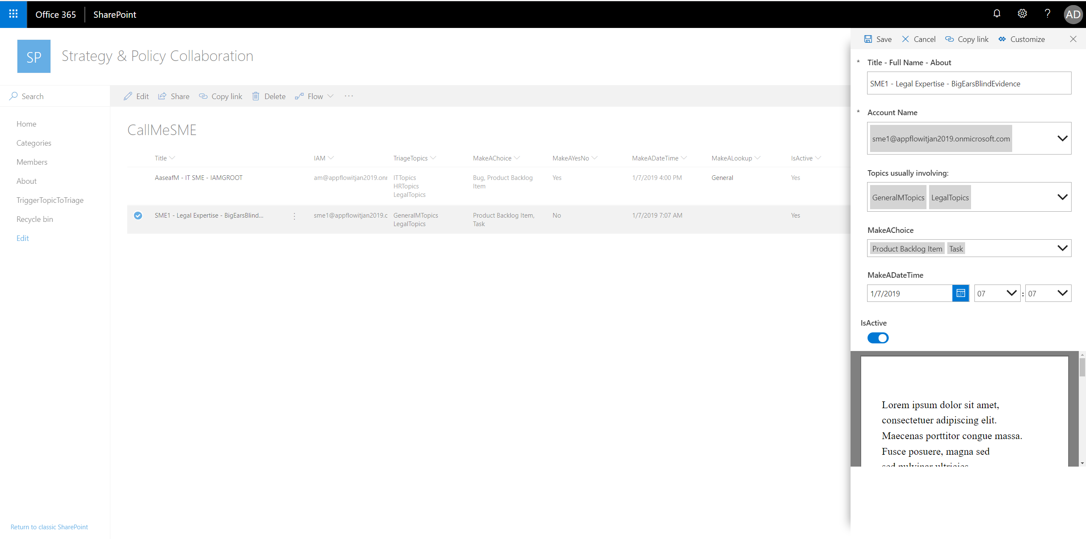

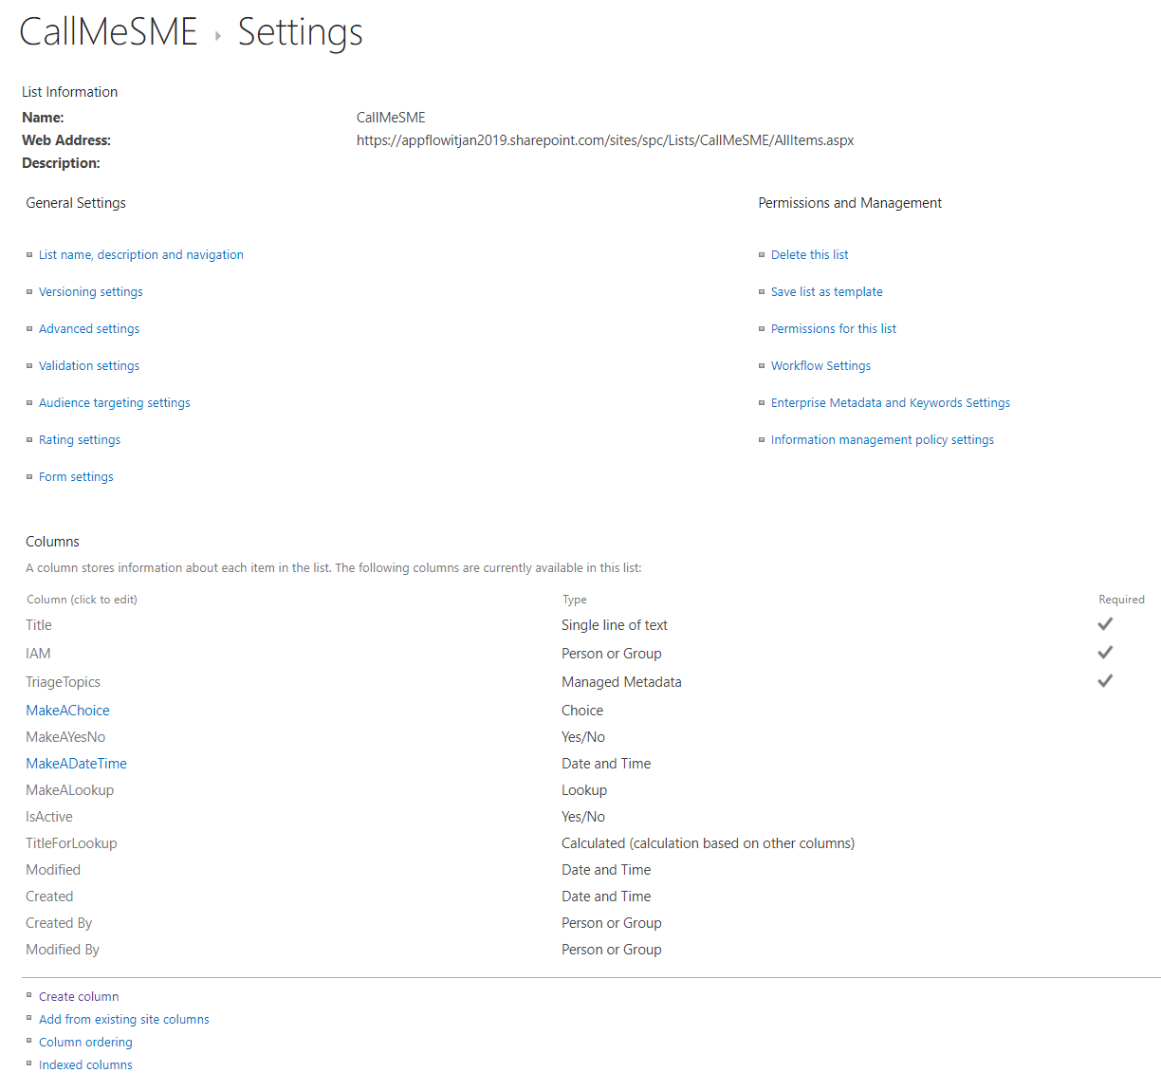 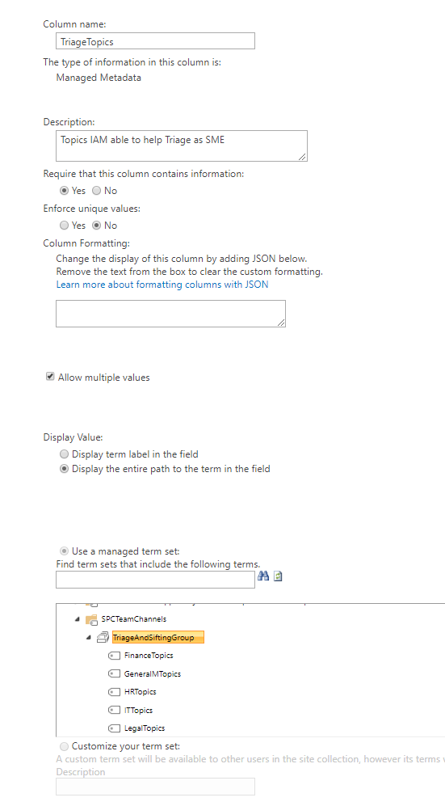

The MS-Flow coming up in the next section, is intended to **create “Channels”** which are associated with an SME (on-boarded/registering user)

– so that they can create such Trigger-Topics - as demonstrated below from an MS-Teams embedded PowerApps from.

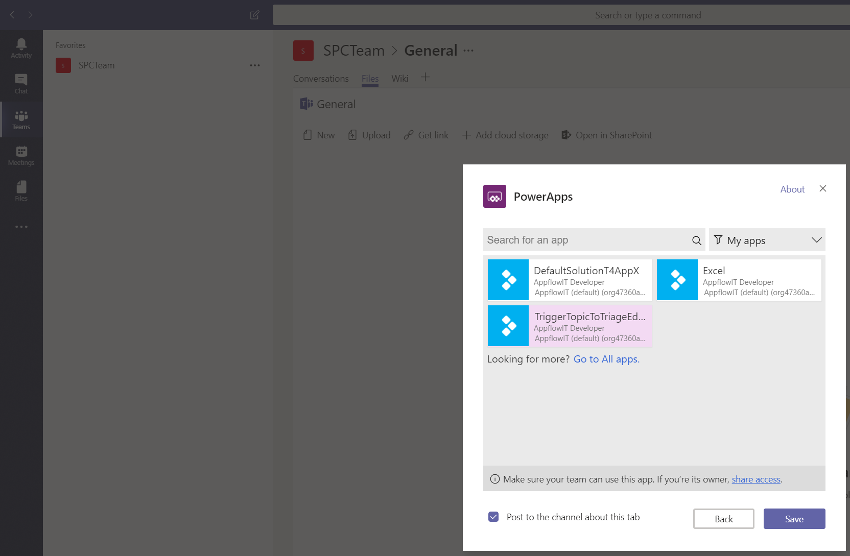 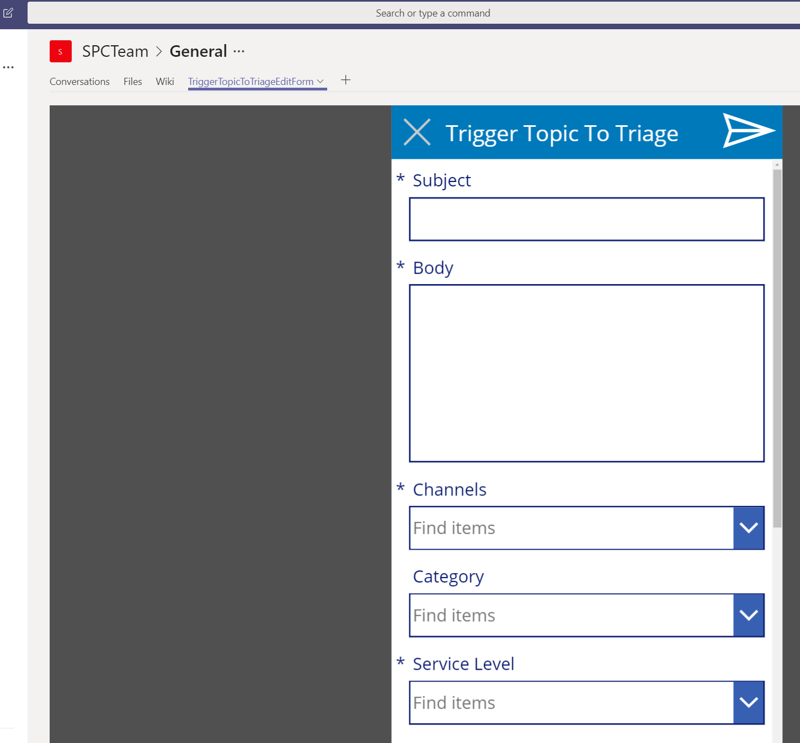

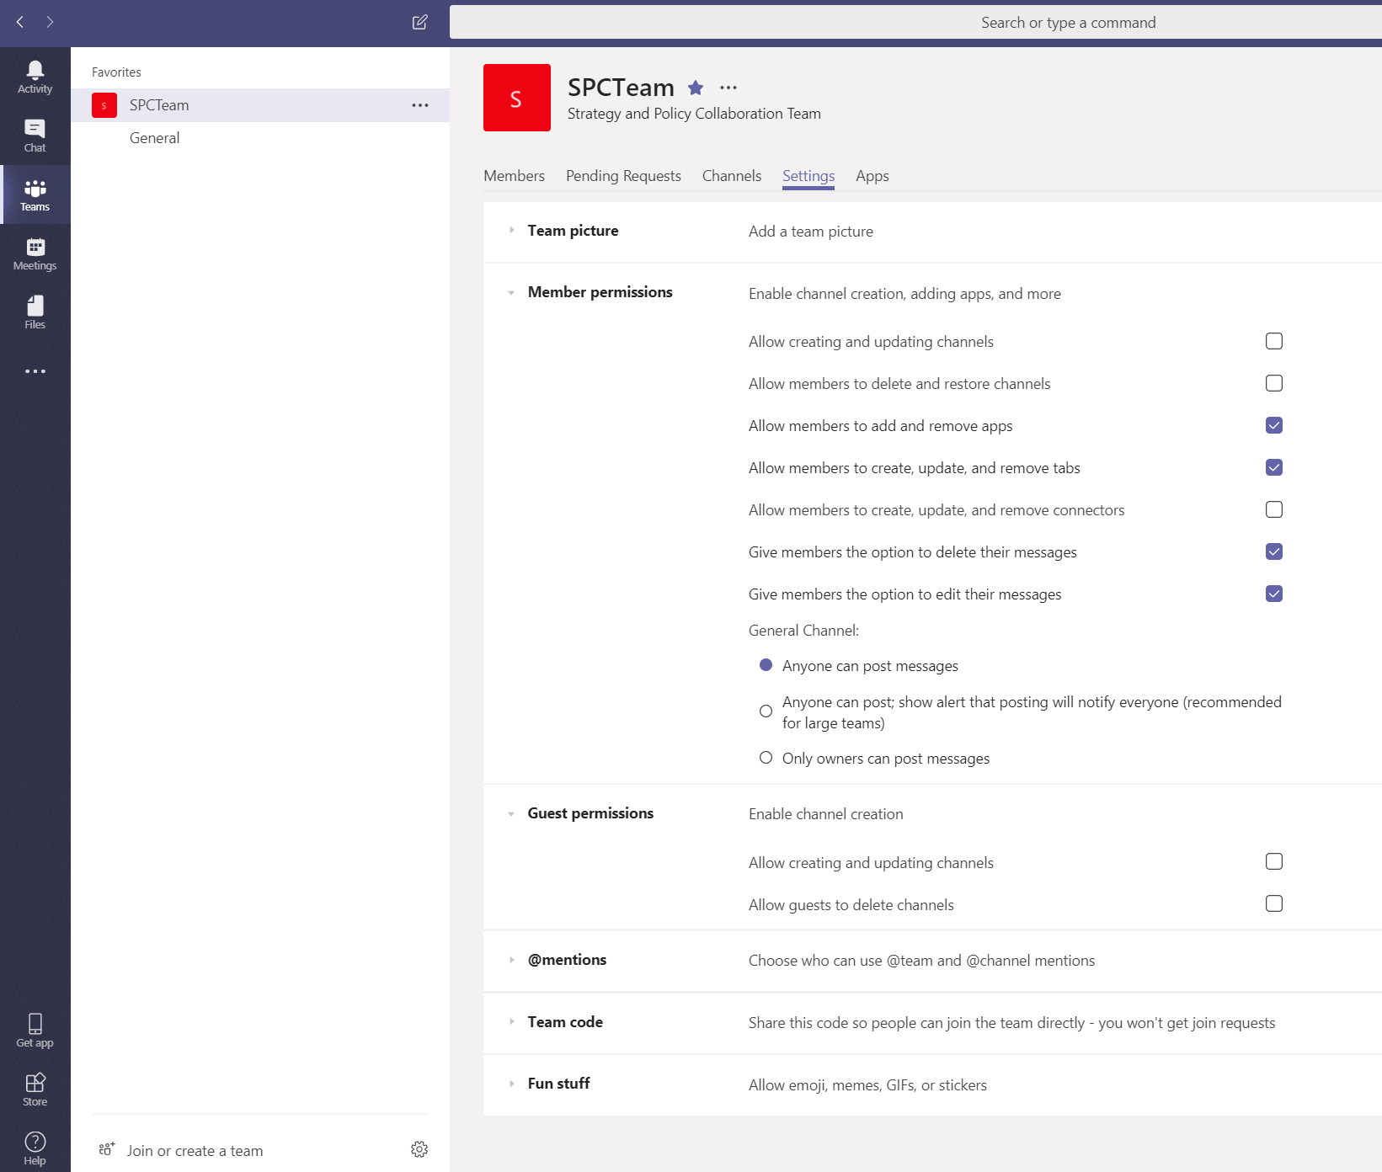

# The Flow

The flow trigger, when SME list items is created/modified. Also, initialising the Azure AD App Authentication parameters – detailed in later section of MS-Graph API

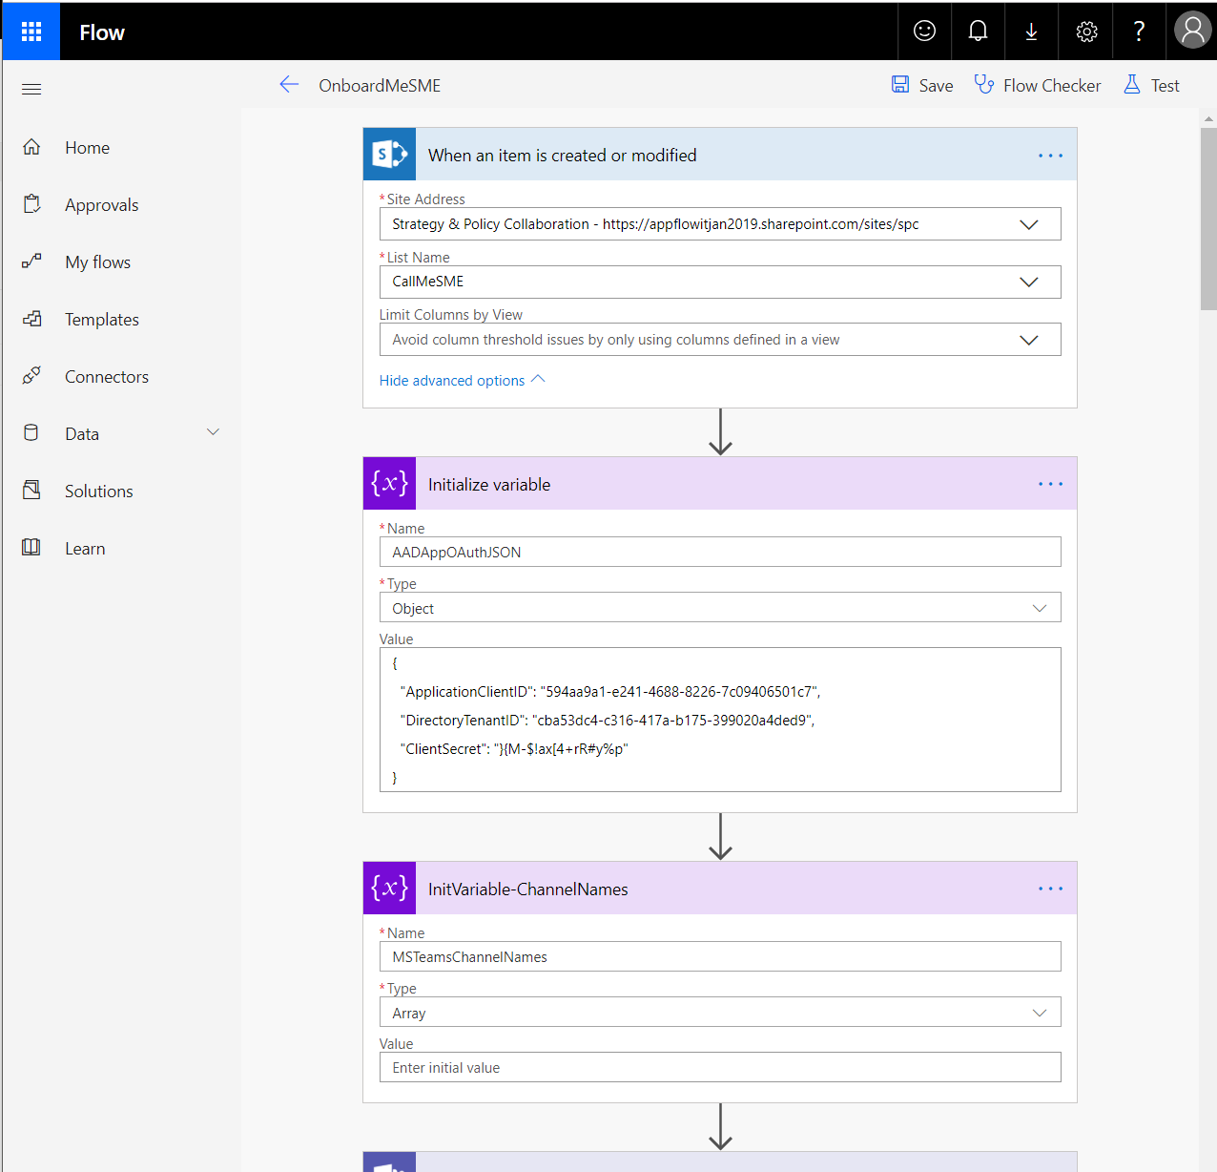

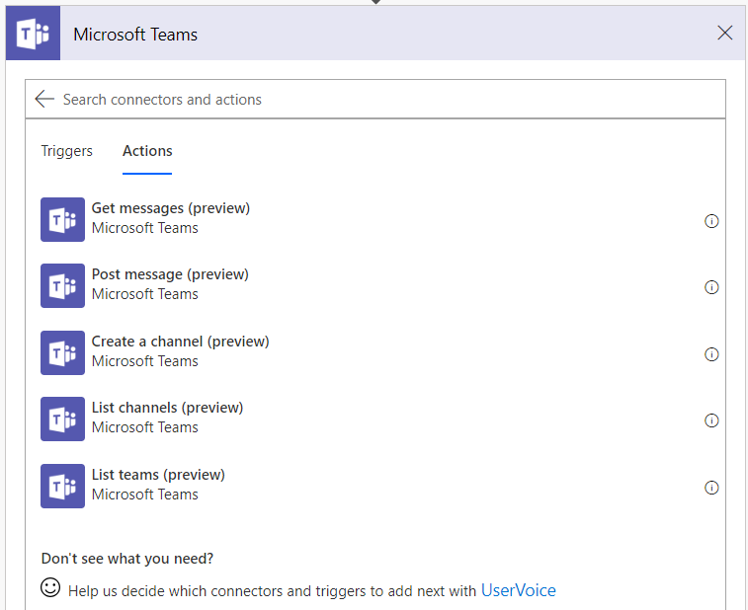 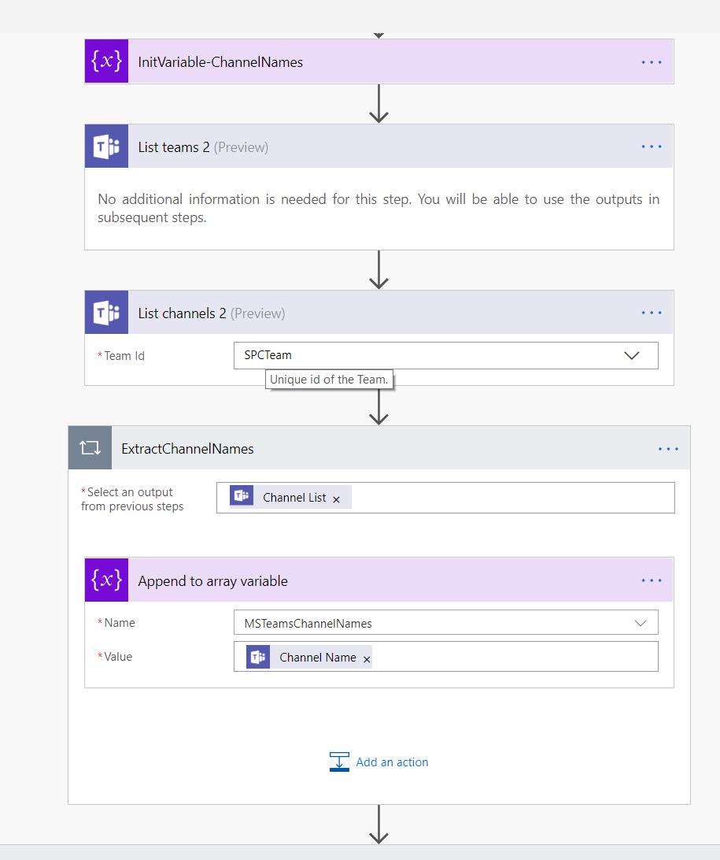

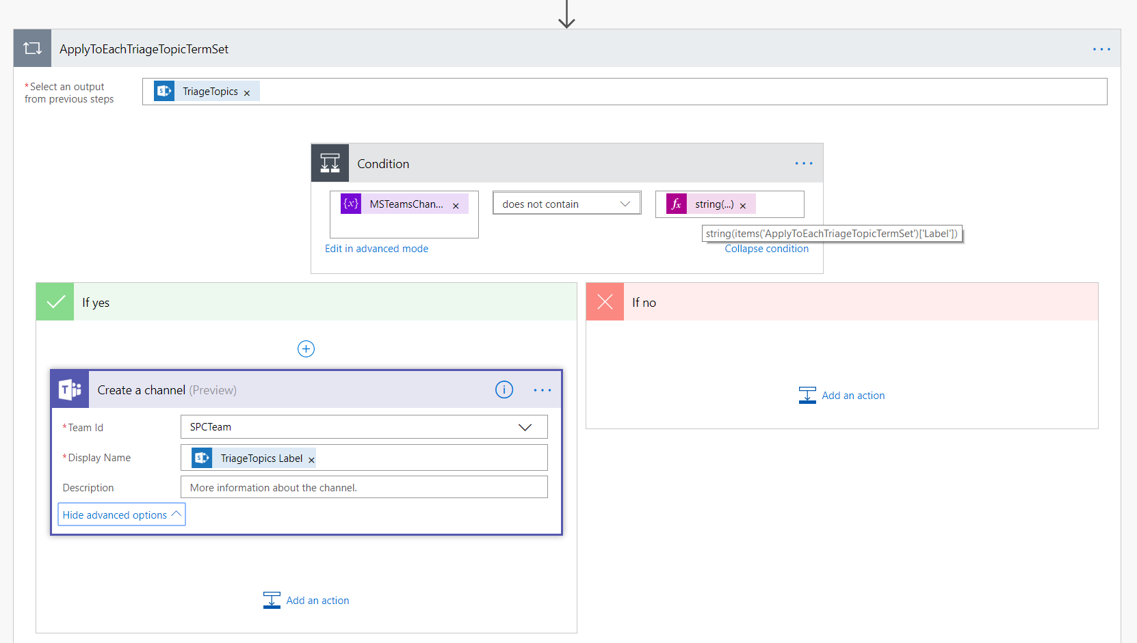

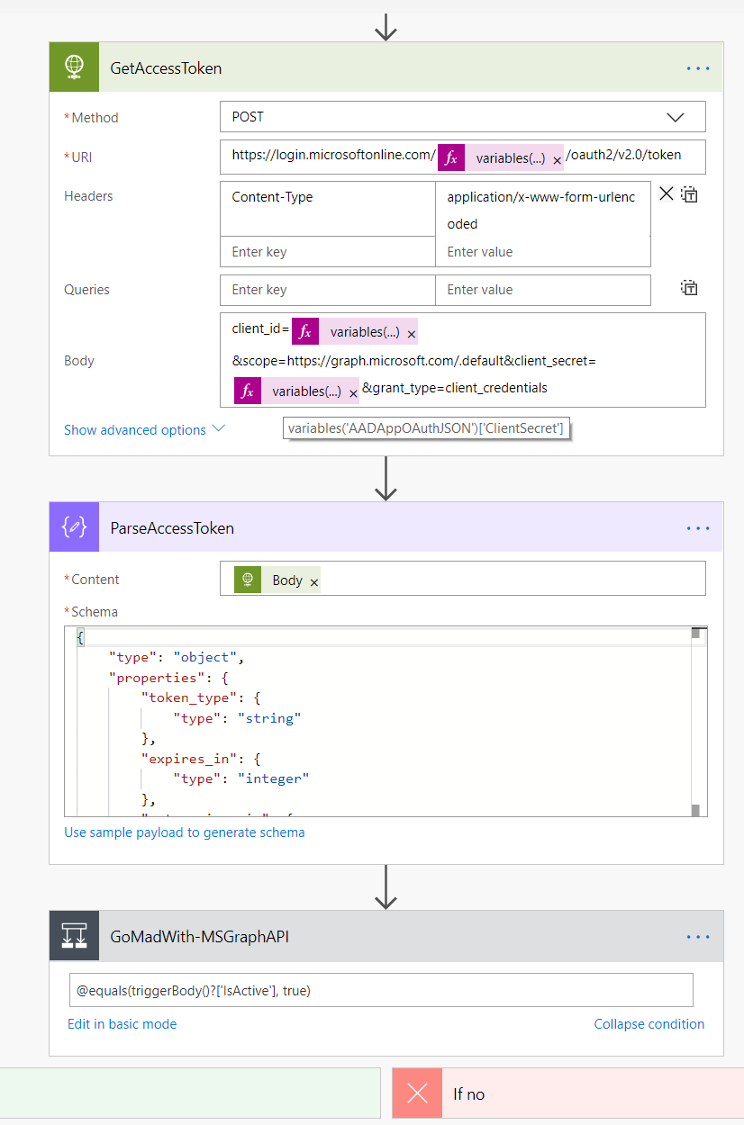

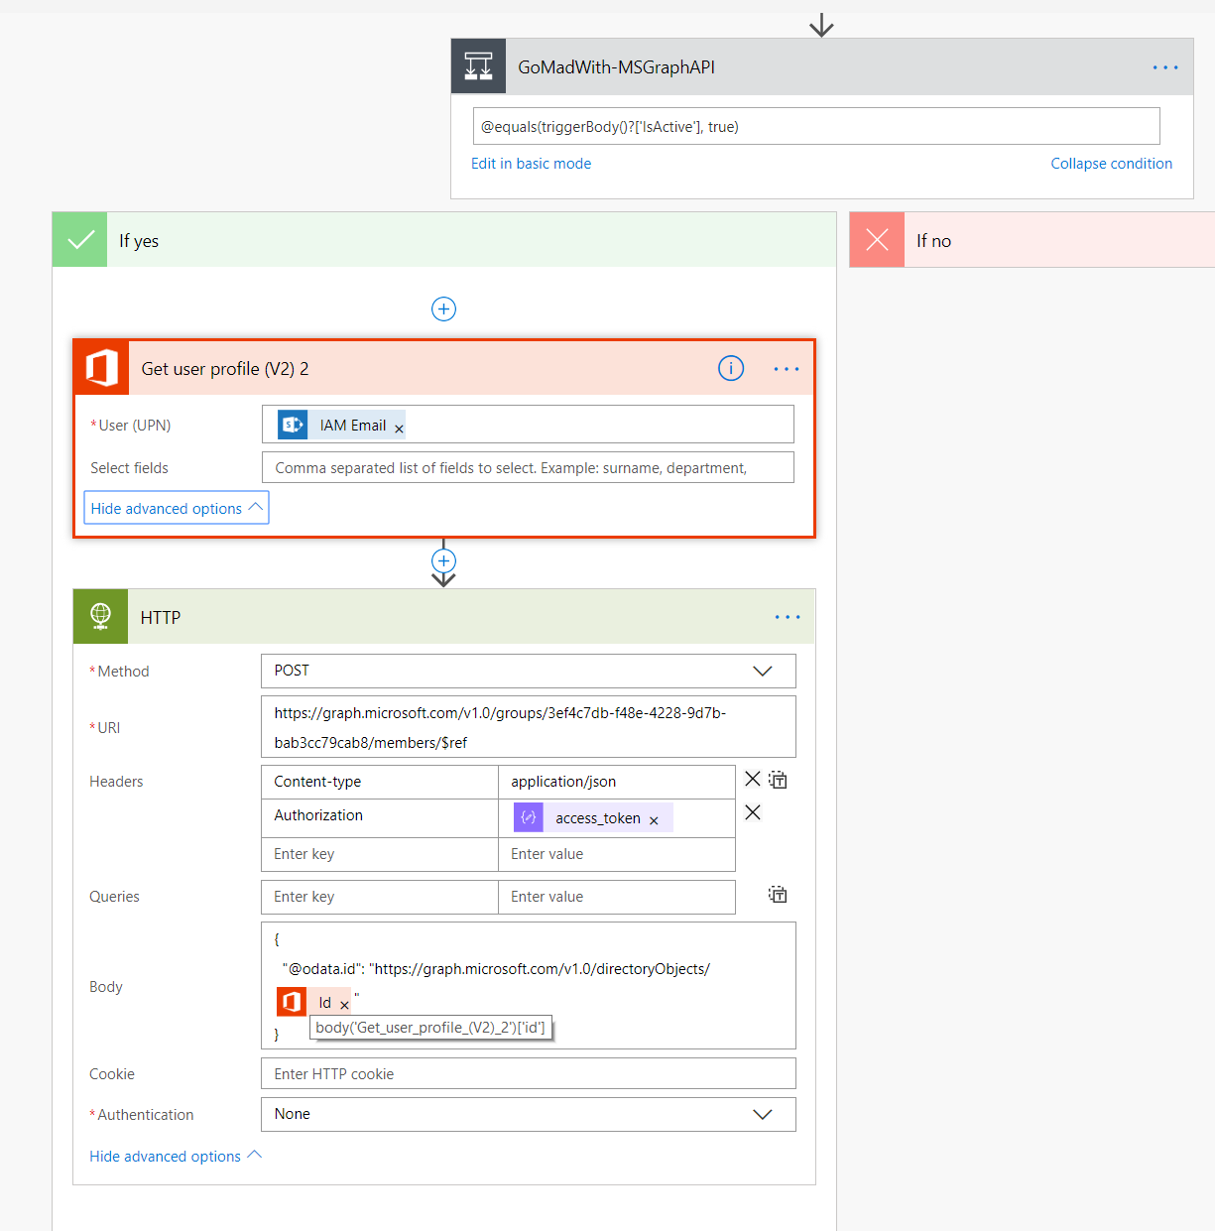

FLOW Trigger and Execution ….

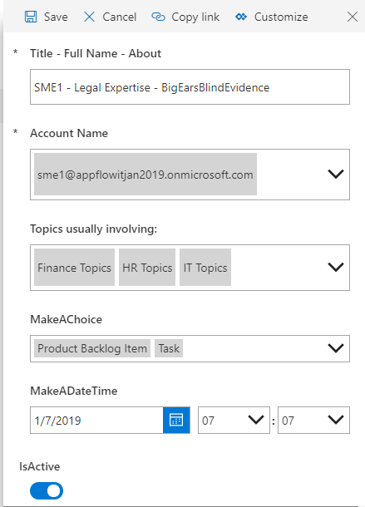

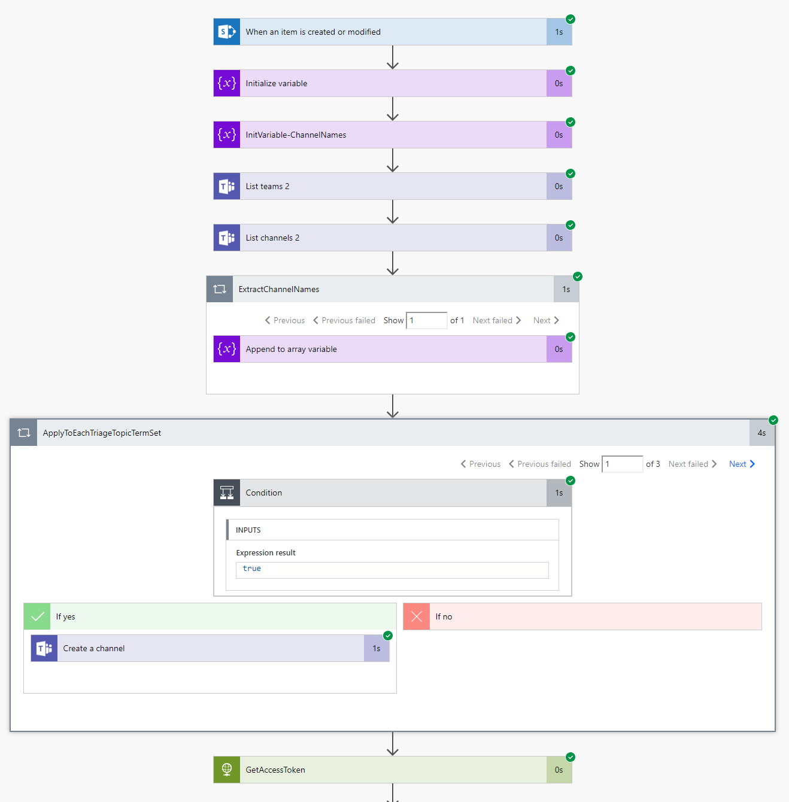

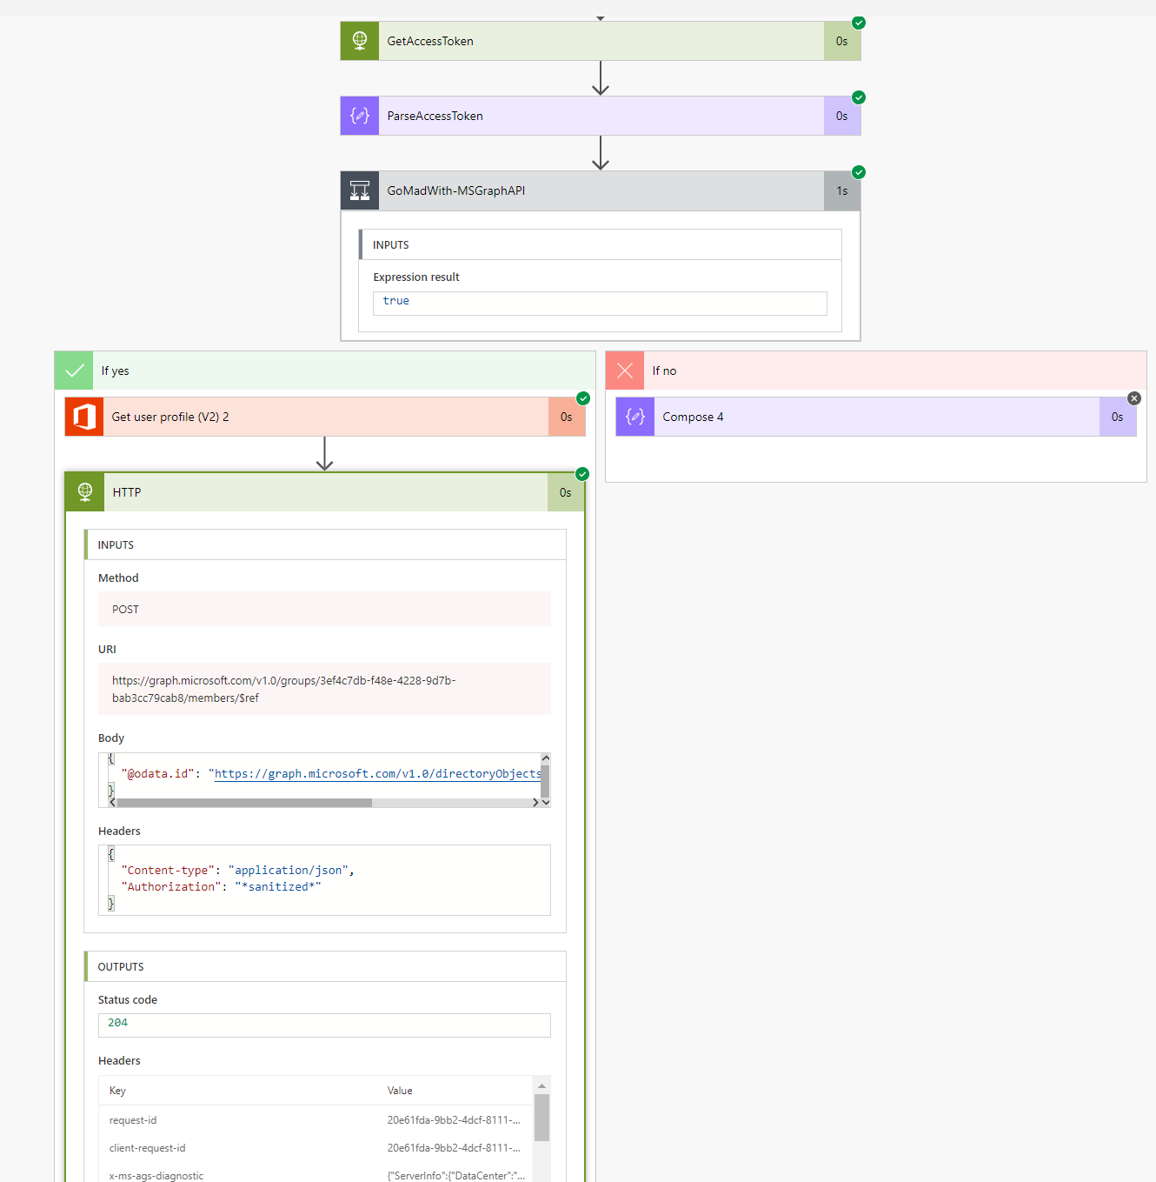

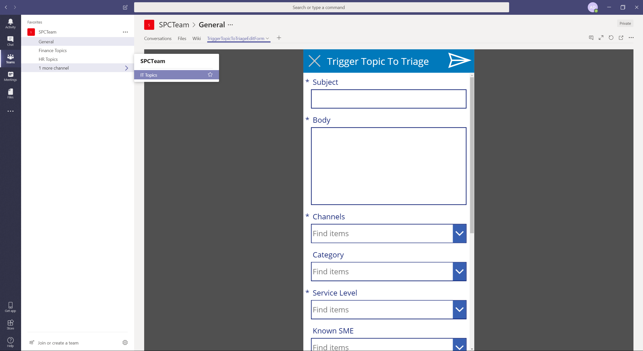

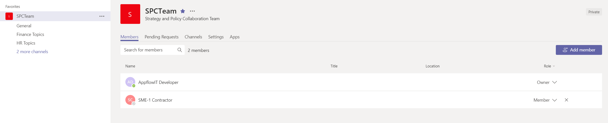

# MS-Graph API and Azure App Authentication

### Yes, at this basic connectivity extension level to perform actions not provided by MS-Flow/Logic-Apps connectors (Built-in, Basic, or Premium) – MS-Graph and Custom Connectors come to rescue.

