Learn Process: O365/Outlook.com

Microsoft - FORMS

# AS A – I WANT – SO THAT

1. **AS A**: User of Outlook.com/O365 MS-Forms – **I WANT**: To be able to have e2e solution for data-entry and distributable forms/surveys/quizzes/polls to be taken by an audience – **SO THAT:** Without involvement of developers/analysts/and-friends! – I can Create such simple forms/surveys/quizzes/polls and can also champion a self-service paperless office – where possible.
2. **AS A**: Consultant for Outlook.com/O365 MS-Forms – **I WANT**: To be able to learn/know/experience about MS-Forms and its limits/boundaries and capabilities/features including any automation options at all – **SO THAT:** I can make and impart pragmatic and confident recommends to the Users about this product - To-Use MS-Forms and decide/architect why NOT-To-Use alternatives like POWERAPPS – Or use this tool as stop-gap-proof-of-concept-mockup scenarios for requirements elicitation and process placeholder/visualization.

# PROOF OF CONCEPT ONY - SOLUTION DESIGN/ARCHITECTURE

1. MS-FORMS is like a survey/quiz and the data collected through this approach goes to some hidden data-sink which can be EXPORTED with Excel or Viewed/Printed in the browser or Embedded in various other forms like OneDrive/One-Note/Excel-sheets.
2. Each subquery/question’s response is clubbed on the web dashboard to form a summary and presented as a single page application like feature (from Responses tab) for the editor/creator of the forms.
3. MS-FORMS have very little validation capabilities and NO ability to control what gets entered, hence the responses must be either very choice/date/rating/other-specific-types or free-open-text field data.

|  |  |  |  |
| --- | --- | --- | --- |
| **References** | [**MS-Forms FAQ**](https://support.office.com/en-us/article/frequently-asked-questions-about-microsoft-forms-495c4242-6102-40a0-add8-df05ed6af61c) | [**MS-Forms Help**](https://support.office.com/en-US/client/results?Shownav=true&lcid=1033&ns=microsoftforms&version=16&omkt=en-US&ver=16&mode=Touch) | **MORE WITH MS-FORMS …** |

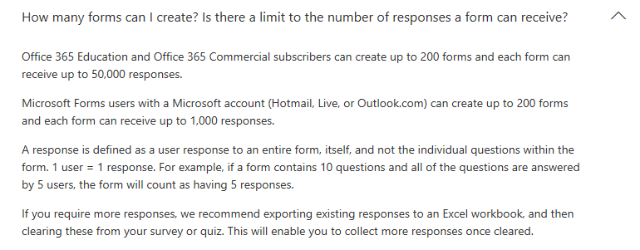

## CREATING A MS-FORM WITH **IN-BROWSER DESIGNER**

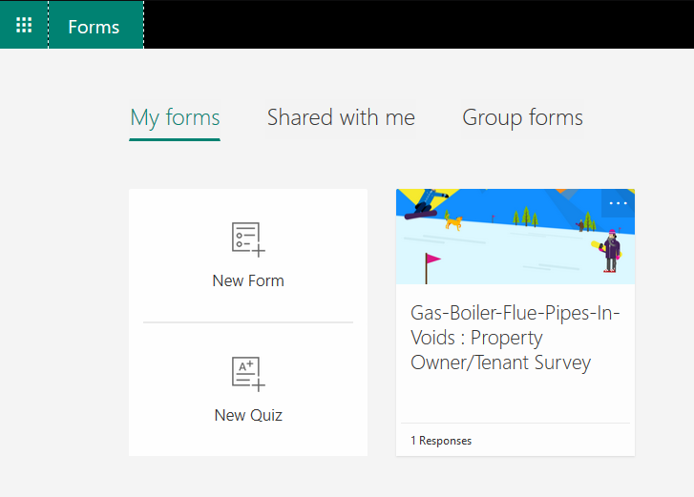

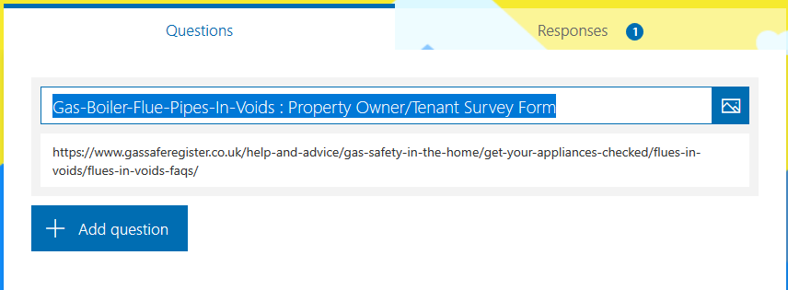

#### BRANCHING BASED ON CHOICE – From Left-Menu Select “Branching” …

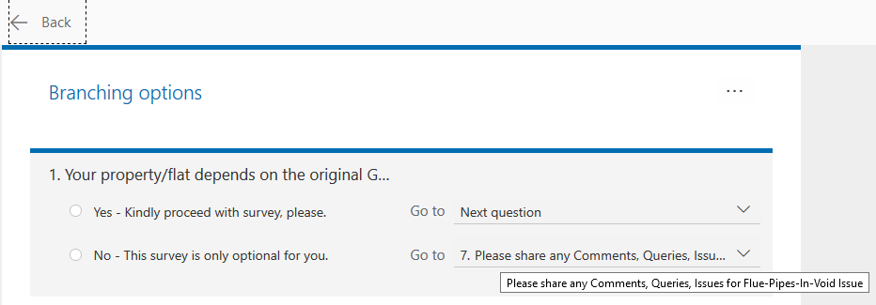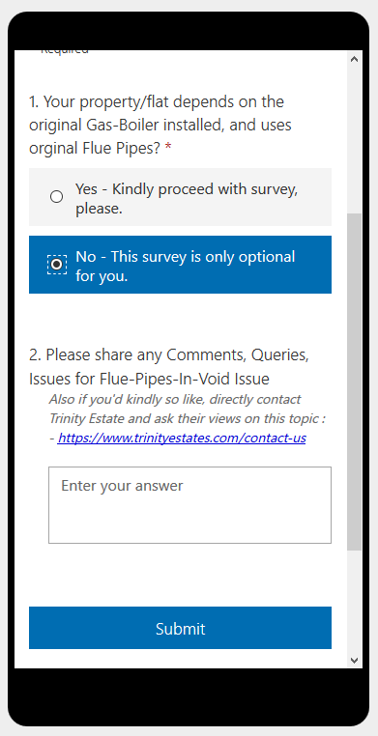

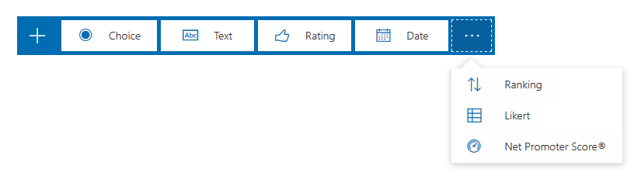

#### A typical field types - Besides, Choice, Text, Date, Rating (as used in the POC form below).

1. Ranking – Is very much like choice, but involves ordering capability for user to able to sort/rank the choices

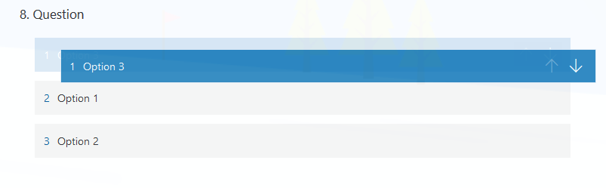

1. s[NPS – Net Promoter Score](https://www.process.st/calculate-nps/): is a standard way to survey - if audience is – Promoter , Passive or Detractor

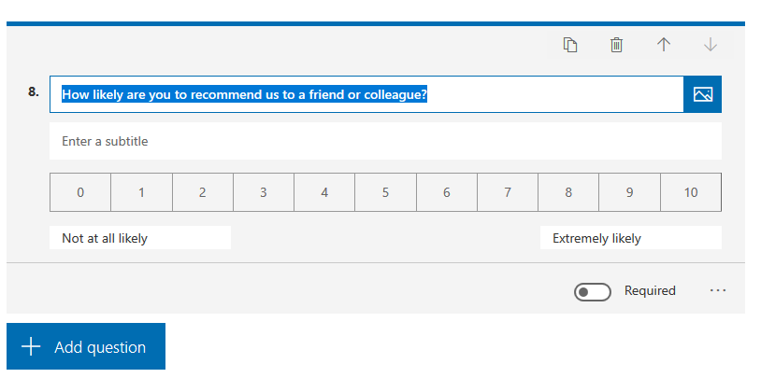

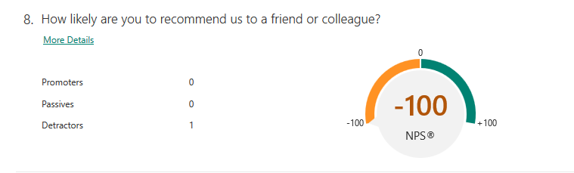

1. Likert – is like a matrix of choices for each statement/query – this is also choice oriented.

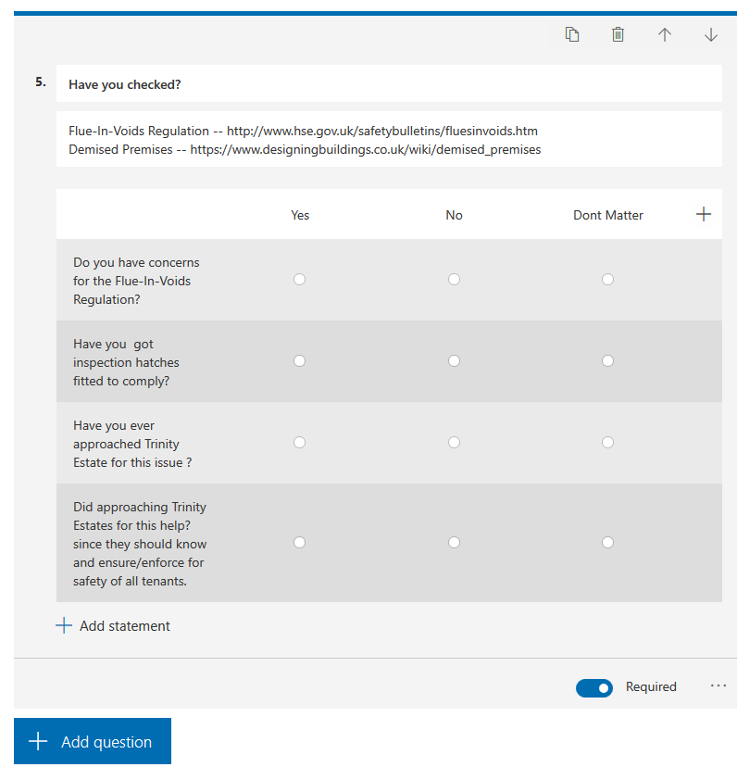

#### FORM **SETTINGS** | FORM **THEME** | FORM **SHARING**/DISTRIBUTION | FORM **COPY**

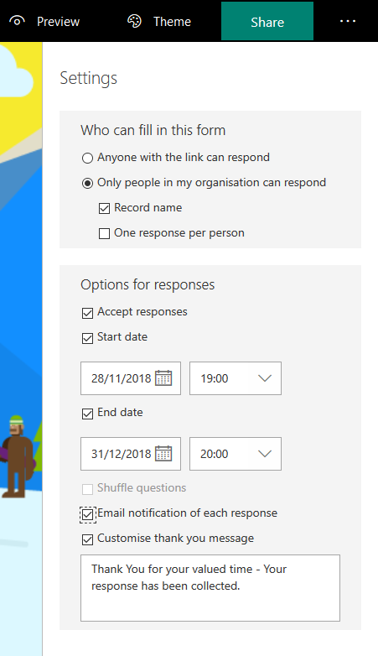 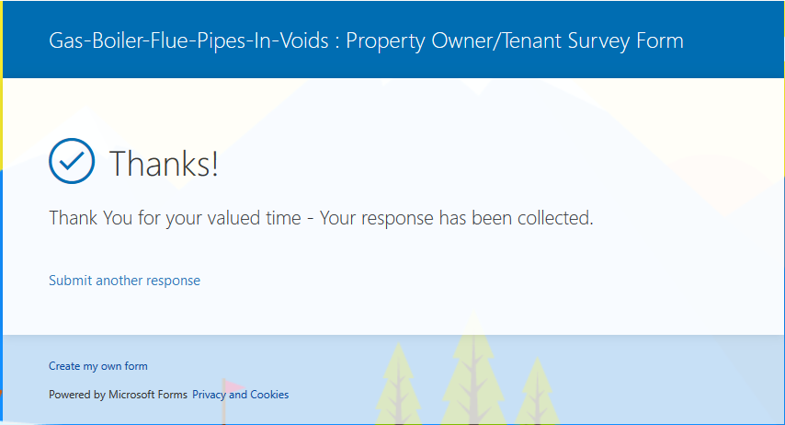

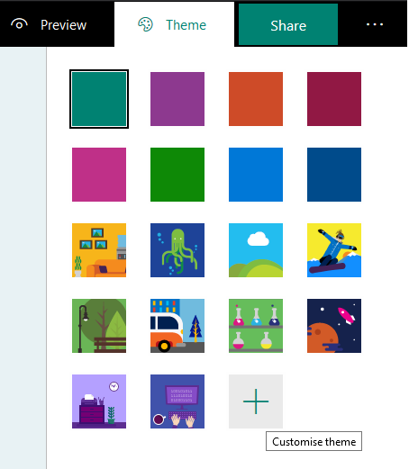 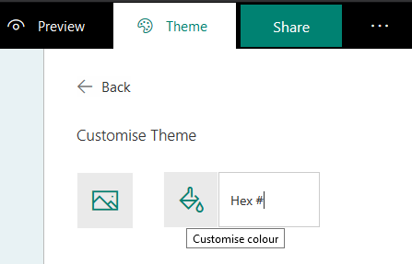

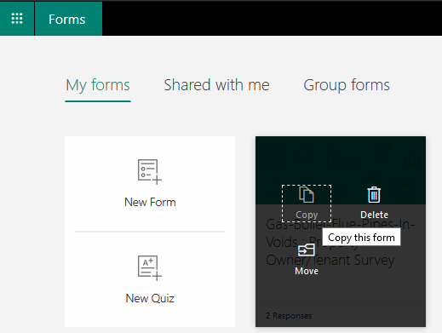 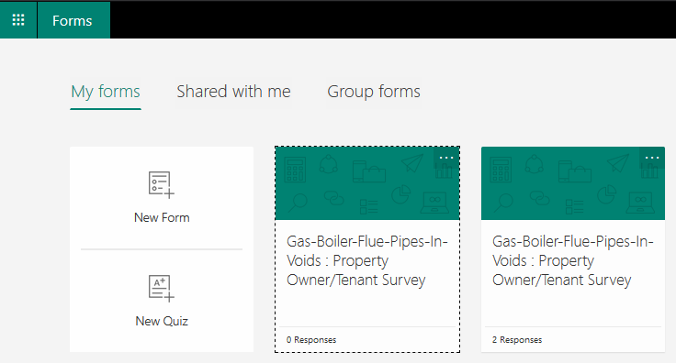

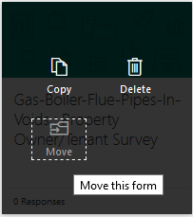 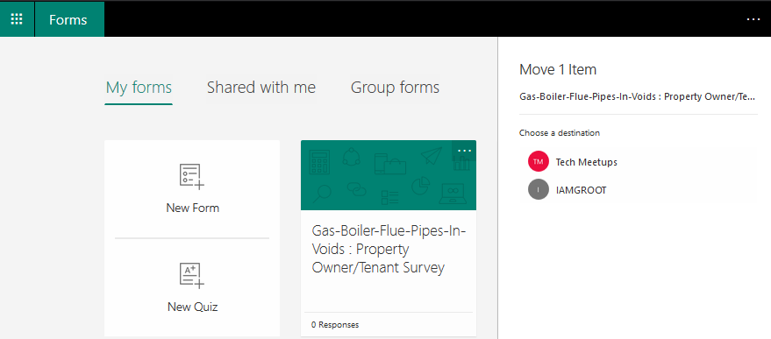 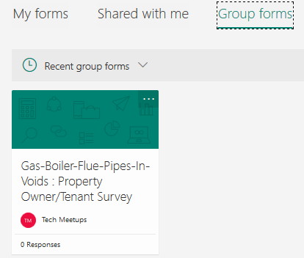

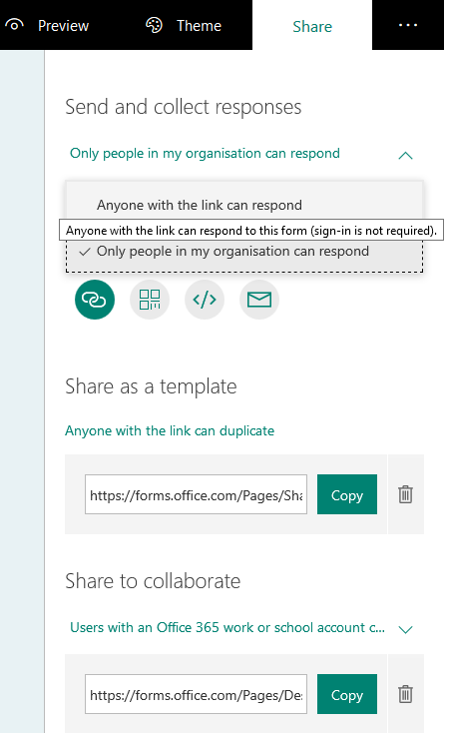 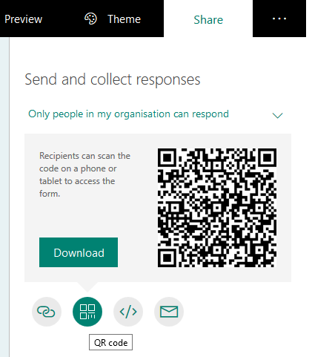

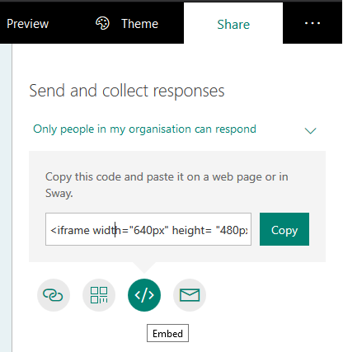 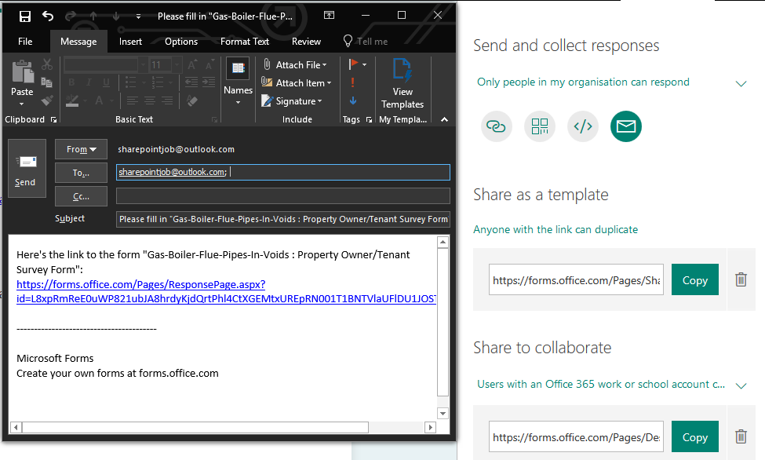

 

#### RESPONSES – DASHBOARD | EXPORT OPTIONS

#### 

#### 

## USE MS-FLOW TRIGGER and ACTION associated with MS-FORMS

Also at: <https://flow.microsoft.com/en-us/blog/building-scratch-forms-responses/>

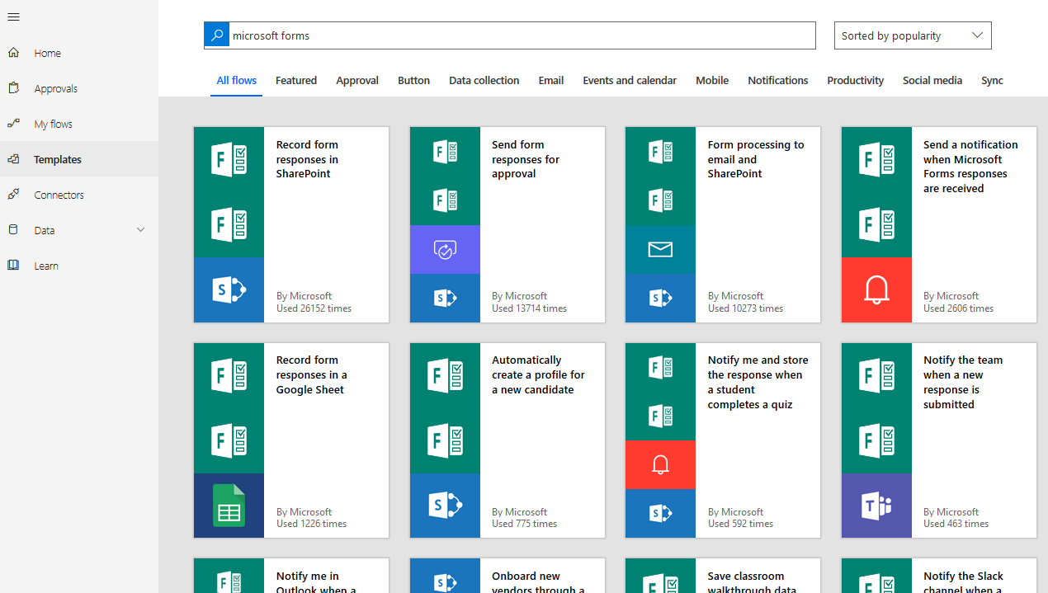

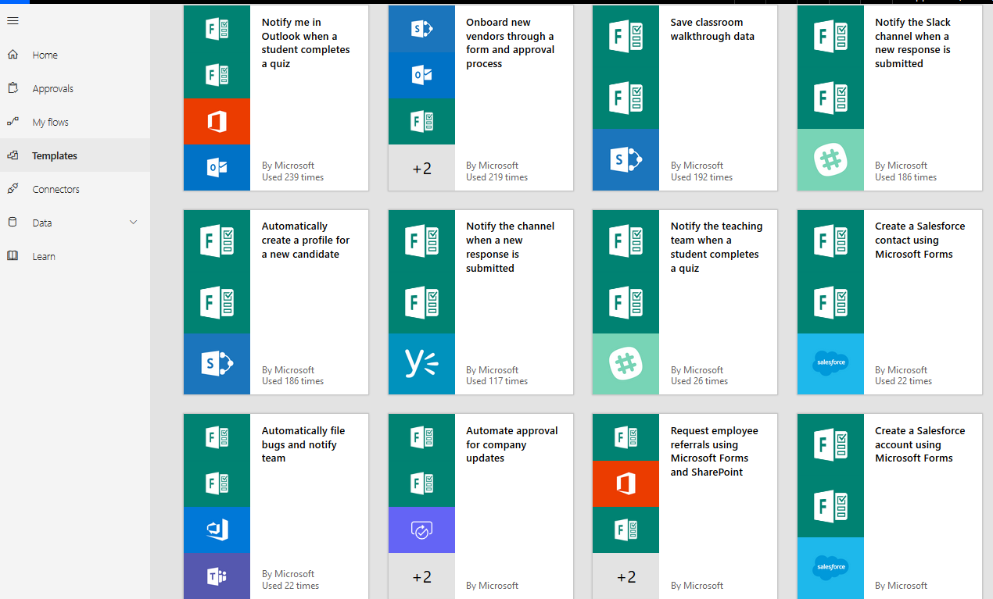

But I had already gone through with my explorations below …. But, very important decision in such design is the “trigger poll threshold” – something to lookout for. 

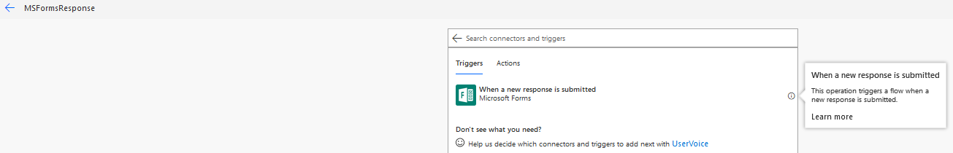

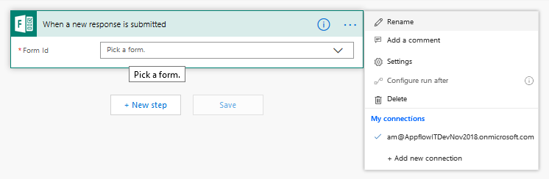

s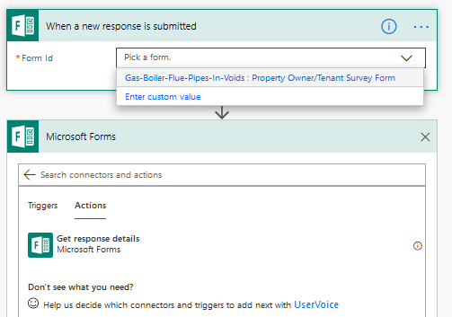 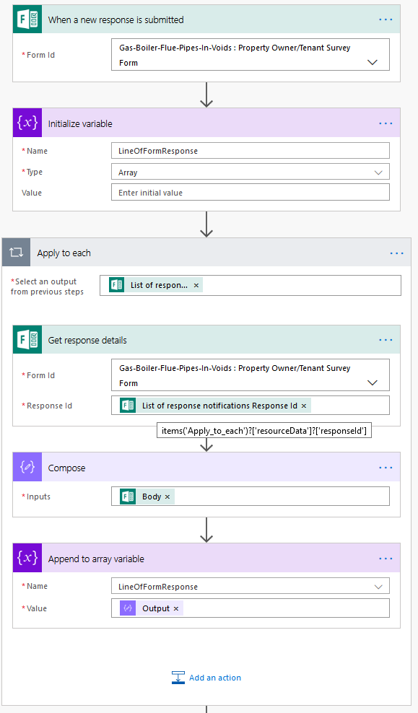

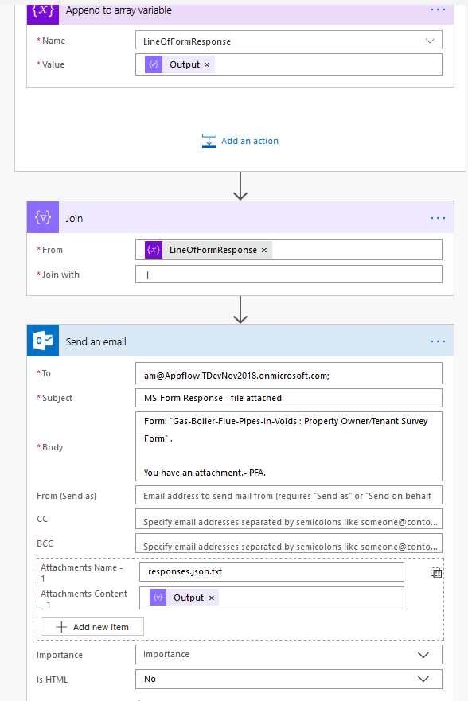

# REFERENCES – SUPPORT – ENVIRONMENT – TOOLS – CONFIGURATION

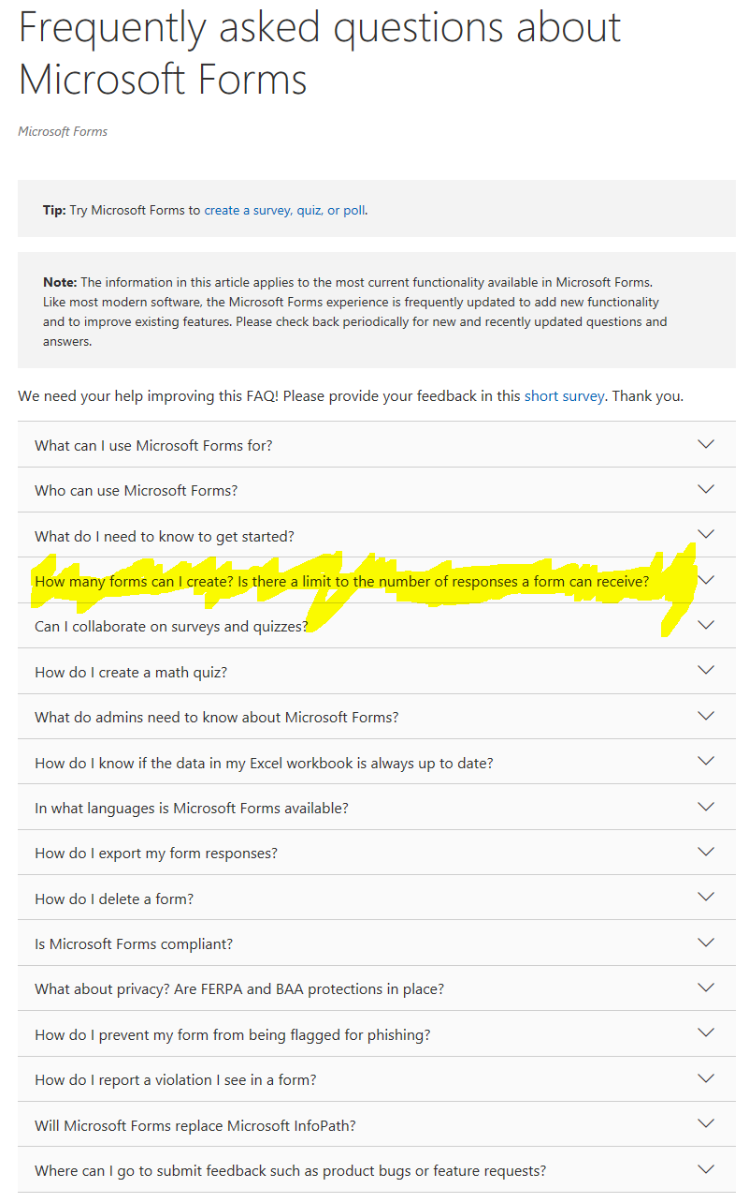**MS-Forms Help**: <https://support.office.com/en-US/client/results?Shownav=true&lcid=1033&ns=microsoftforms>

**MS-Forms Connector-API**: <https://docs.microsoft.com/en-us/connectors/microsoftforms/>

[**MS-Forms FAQ**](https://support.office.com/en-us/article/frequently-asked-questions-about-microsoft-forms-495c4242-6102-40a0-add8-df05ed6af61c)– Microsoft answers many queries here.

**Blog:** [**Services Comparable**](https://blog.capterra.com/best-free-survey-tools-power-your-research/) **to MS-Flow**. *NB:* ***OUTLOOK.COM has MS-Forms (FREE)*** *option.*

**BLOGGER-01:** <https://collab365.community/ultimate-guide-microsoft-forms/>

**THINGS TO-DO WITH MS-FORMS:** [**https://support.office.com/en-us/forms/**](https://support.office.com/en-us/forms/)

|  |  |  |
| --- | --- | --- |
| Format [Add a picture or logo to a form header](https://support.office.com/en-us/article/add-a-picture-or-logo-to-a-form-header-0b3ce567-5713-4d18-bc65-4247864acaec)  [Add a picture to a question](https://support.office.com/en-us/article/add-a-picture-to-a-question-72ffc881-c22e-4069-8468-400d1c580871)  [Change your picture size](https://support.office.com/en-us/article/change-your-picture-size-15ce2fb5-4159-401c-b039-0587a19a3823)  [Delete a picture](https://support.office.com/en-us/article/delete-a-picture-fdcb1862-9909-44f9-99d8-1d1bf1ea1909) | Share and collaborate [Send your form or quiz to others and collect responses](https://support.office.com/en-us/article/send-and-collect-responses-for-your-form-2eaf3294-0cff-492d-884d-a1dee909e845)  [Share a quiz or form as a template](https://support.office.com/en-us/article/share-a-form-or-quiz-as-a-template-82ea9d8a-260a-47a0-afdb-497f3d746e3f)  [Share your quiz or form and collaborate with others](https://support.office.com/en-us/article/share-a-form-to-collaborate-d5bb5cf0-8401-4c15-bb8c-8e108cd7e69b) | CREATE AND RECORDS [**Sign in to Microsoft Forms**](http://forms.office.com/)  [**Create a new form**](https://support.office.com/en-us/article/create-a-form-with-microsoft-forms-4ffb64cc-7d5d-402f-b82e-b1d49418fd9d) **or** [**Create a new quiz**](https://support.office.com/en-us/article/create-a-quiz-with-microsoft-forms-a082a018-24a1-48c1-b176-4b3616cdc83d)  [**Check your form results**](https://support.office.com/en-us/article/check-your-form-results-02859424-341d-406f-b32a-9a0fbaf357af)  [**Check your quiz results**](https://support.office.com/en-us/article/check-your-quiz-results-c4a9b45c-d62f-4eb7-b5db-ad81892c7c07) |
| Format [Add a video to a question](https://support.office.com/en-us/article/add-a-video-to-a-question-40b41cf5-0f8d-49b4-b73d-6e0421bc7d6d)  [VIDEO: Explore new question types](https://www.microsoft.com/en-us/videoplayer/embed/RE1YgJm)  [Change a form theme](https://support.office.com/en-us/article/change-a-form-theme-895ca902-833b-4f56-9488-f36480d837ef)  [Adjust settings for your form or quiz](https://support.office.com/en-us/article/adjust-your-form-or-quiz-settings-in-microsoft-forms-f255a4ba-e03c-4e12-b880-f7e8b62e0665)  [Use branching in Microsoft Forms](https://support.office.com/en-us/article/use-branching-in-microsoft-forms-16634fda-eddb-44da-856d-6a8213f0d8bb)  [How to get missing data in Forms](https://support.office.com/en-us/article/how-to-get-missing-data-in-forms-9fb98299-4dcc-41a4-bb29-34a9c3daf8cc)  [Copy a form](https://support.office.com/en-us/article/copy-a-form-4b91b775-b984-4afd-b5fe-6396c71d7697)  [Delete a form](https://support.office.com/en-us/article/delete-a-form-2207e468-ce1b-4c4a-a256-caf631d87af0)  [Print a form](https://support.office.com/en-us/article/print-a-form-22100b98-ba3c-41c1-9513-f76caca664fc) | IntegratE [Embed a form in a Sway](https://support.office.com/en-us/article/embed-a-form-in-a-sway-b746cae9-0225-47ca-972c-bc899ec2a475)  [Insert a form or quiz into OneNote Online](https://support.office.com/en-us/article/insert-a-form-or-quiz-into-onenote-0a96a3a7-5e36-4eda-abc6-99417911f0bc)  [Create a form in OneDrive for Business](https://support.office.com/en-us/article/create-a-form-with-microsoft-forms-4ffb64cc-7d5d-402f-b82e-b1d49418fd9d#picktab=bkmk_onedrivebusiness)  [Create a form in Excel Online](https://support.office.com/en-us/article/create-a-form-with-microsoft-forms-4ffb64cc-7d5d-402f-b82e-b1d49418fd9d#picktab=excel_online)  [Create, edit, and collaborate on a form in Microsoft Teams](https://support.office.com/en-us/article/create-edit-and-collaborate-on-a-form-in-microsoft-teams-333b97a3-41d9-48bc-a1cb-84a96bd44e14)  [Insert a form or quiz into PowerPoint](https://support.office.com/en-us/article/insert-a-form-or-quiz-into-powerpoint-1a316f81-9ea7-4bc2-bda0-024c0d780df1) | Admin tasks [Set up for Microsoft Forms](https://support.office.com/en-us/article/set-up-microsoft-forms-cc52287a-4550-464d-9a1b-457bf9df2240)  [Security and privacy](https://support.office.com/en-us/article/security-and-privacy-in-microsoft-forms-7e57f9ba-4aeb-4b1b-9e21-b75318532cd9)  [Microsoft Forms data storage](https://support.office.com/en-us/article/frequently-asked-questions-about-microsoft-forms-495c4242-6102-40a0-add8-df05ed6af61c#datastorage)  [Turning on or off Microsoft Forms](https://support.office.com/en-us/article/turn-off-or-turn-on-microsoft-forms-8dcbf3ab-f2d6-459a-b8be-8d9892132a43)  [Microsoft Forms and user accounts](https://support.office.com/en-us/article/microsoft-forms-and-user-accounts-47dec490-d437-4f27-8335-f5907b32db1e)  [Transfer ownership of your form](https://support.office.com/en-us/article/transfer-ownership-of-your-form-921a6361-a4e5-44ea-bce9-c4ed63aa54b4)  [Data storage for Microsoft Forms](https://support.office.com/en-us/article/data-storage-for-microsoft-forms-97a34e2e-98e1-4dc2-b6b4-7a8444cb1dc3)  [**Block Internet access during a quiz**](https://support.office.com/en-us/article/block-internet-access-during-a-quiz-6bd7e31d-5be0-47c9-a0dc-c0a74fc48959) |

# HOPE THIS HELPED!?

Kindly feedback your thoughts and suggestions and ideas, that would be magical to get them😊

Cheers, Aaseaf Mahkahti | [sharepointjob@outlook.com](mailto:sharepointjob@outlook.com)