Dataverse DateTime: GMT / BST – Daylight Saving

## **User Problem:**

Date/Time (within context of **Model-driven Apps as a D365-CRM Tool**) - The App does not handle BST -- Needs investigation and possible resolution.

* During 6 months between April - September (included) the CLOCKS in the UK (England, Wales, Scotland, N.Ireland) are MOVED by 1 (One / an) HOUR ahead of GMT (Greenwich Mean Time - GMT is also equal to UTC)
  + This moving of clocks is akin to switching to a new time zone and is called - DST (Daylight Saving Time) and for UK it is BST (British Summer Time)
  + **In D365/Dataverse/Model-driven-apps:  The effect users observe is that - the System/Computer time/clock in SUMMER shows +1hr while D365 time zone settings (or Local User time) continues to remain GMT = UTC and hence fields continue to retrieve and display the time zone record was saved in.**

## **Get? / Understand BST/GMT:**

**WINTER = GMT = UTC = Oct-Mar**

**|||**

**SUMMER = BST = UTC+1 = Apr-Sept**

<https://en.wikipedia.org/wiki/British_Summer_Time>

Youtube: [Why do we change the clocks? - BBC News - YouTube](https://www.youtube.com/watch?v=Cq1MDKgQ9xA)

Youtube: [Daylight Saving Time Explained - YouTube](https://www.youtube.com/watch?v=84aWtseb2-4)

 ** If only humour helps! [Daylight Savings Time](https://www.youtube.com/watch?v=EKFOj8BEDxU) **

## **An Experiment: Simulate digital clocks moving back-forth**

1. On a device/laptop that allows changing DateTime manually. Go to the operating systems (Windows 10) Settings → Date & Time → turn **off** ”Set the time automatically” and also turn **off** “Set the time zone automatically“
2. Using the “Set the date and time manually” Change button – feel free to choose a date within Winter or Summer.
3. Assuming time zone is “UTC+00:00 Dublin, Edinburg, Lisbon, London” – then, focusing on the “Adjust for daylight saving time automatically“ toggle
   1. ***If Date set in step 2, is in Summer ie: April-September then → toggling to “On” indicates BST ie: pushing the clocks forward and “Off“ indicates GMT ie: Pulling the clock back***
   2. RESET System time and day-light-saving settings - by turning "Sync now" by turning ON both "Set the time automatically" and "Set the time zone automatically" AND keeping the "Adjust for daylight saving time automatically“ toggle also to ON -- between trials of (a) and (b) independently.
   3. If Date set in step 2 is in Winter ie: October-March then → toggling to “On“ or “Off“ would indicate UTC=GMT

## **Dataverse / D365 Datetime:**

Youtube: [**Explaining Date and Time in Dataverse using PowerApps**](https://youtu.be/cFxmRHt8uzg?t=168) <<https://youtu.be/cFxmRHt8uzg?t=168>>

<https://docs.microsoft.com/en-us/powerapps/developer/data-platform/behavior-format-date-time-attribute>

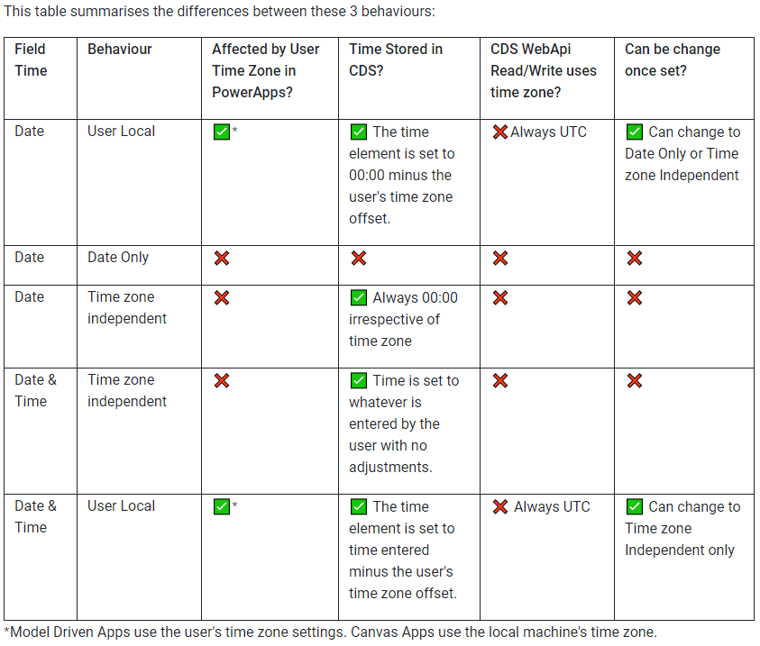

Source: [**Develop1 Limited Blog | DateTimes – it’s never the last word!**](https://www.develop1.net/public/post/2019/01/26/DateTimes-never-the-last-word)

## **Timezones without BST – WindowsOS Updates**

[**Timezones that do not observe daylight saving time and Outlook (microsoft.com)**](https://support.microsoft.com/en-us/topic/ce563938-8871-5c5e-dfe3-3c73e04b02ca)

[Daylight saving time help and support - Windows Client| Microsoft Docs](https://docs.microsoft.com/en-us/troubleshoot/windows-client/system-management-components/daylight-saving-time-help-support)

[Daylight Saving Time & Time Zone - Microsoft Tech Community](https://techcommunity.microsoft.com/t5/daylight-saving-time-time-zone/bg-p/DSTBlog)

## **Timezone related settings for User:**

Changing App-Personalization; Office Profile; and System/Device clocks - shows different outcomes.

1. Time zone Independent datetime field/column shows same time that was used during saving record
2. User Local datetime reflects the change from the App’s Personalization time zone setting
3. Modified On/Created On are Datetime (Column type) and User Local (Datetime Format / Behaviour) yet - continue to show datetime they were created/modified - even when personalization setting is changed - possibly indicating they reflect/display the user’s device (ie: via the browser) time zone.

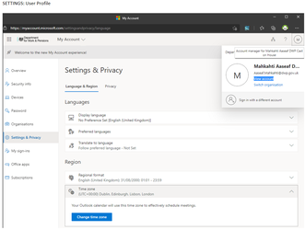

<Other Dimensions to Datetime design/choices>

* Note 1: In the context of the application being used/consumed only within the UK and for a fact that “time” in Winter or Summer is the same “time” the user’s would like to report/view for a captured field’s date/time --- using [ Datetime with Timezone independent behaviour] is a likely logical design-time choice - Once Timezone independent datetime behaviour is selected, it cannot be changed for the column-metadata.
* Note 2: For users of Model-driven apps - App personalization setting would remain GMT (UTC+0) . Records when created and fields that are Datetime + User Local will take the date + **time** according to [for Model-driven apps run in the browser) the User’s App Personalization time zone setting.

## **Conclusion / Recommendation:**

1. **Users Operating/Using the App from the UK -- should ensure their App Personalization and certainly their Office365/Active Directory login are set to GMT (UTC+00:00 Dublin London,)**
2. **IT Administrators can ensure for the user's device - Adjust Daylight saving time zone setting is ENABLED (turned/toggle ON)**

Conclusion of understanding (from Aaseaf.Mahkahti): Time difference will impact ==> only when USER's System/Device/OS Time is NOT enabled-for-automatic DST adjustment ----AND/OR----- The App Personalization And/Or Office profile setting is NOT set to GMT that-is/should-be same-as OS/Device time zone – for UK only based users.