+ Aspire: C# ASP.Net Core WebApi (EntraID AuthNZ) + Microsoft: DevTunnel (cli+aspire+sdk)

+ Power Platform: Custom Connector

5W1H – What, Why, When, Where, Who & How!
What - Objectives /Goals | Create a minimal Aspire C# ASP.NET Core Web-API with EntraID secured-api, and configuring to use Microsoft.DevTunnel, such that API can be “accessed” with tenant authNZ enabled URIs; from such Remote-Clients/SaaS as a Power Platform connector (or Postman desktop) Then => Create a custom connector to ping that local running API via the devtunnel url and consume the custom-connector in Power Automate/Apps for tenant-users.
Why - Requirement | A Learn Process using Aspire (C# ASP.NET Core API); securing API with EntraID Multi-tenant.  A Learn Process using Microsoft.DevTunnels (this setup removes deployment overhead and keeps focus on iterations before CI/CD|DevOps & Cloud deployment choices/costs)
When | ~ days (Estimates / Plans)
Where | (Workspaces / Platforms): Local disk path: D:\1\RK\aspire\asp999 | Project Name: asp999
Who (notes / digests / references) | https://aspire.dev  DevTunnel (Aspire) | DevTunnel (CLI) | DevTunnels (SDK)  Overview Session: Securely test and debug your web apps and webhooks with Dev Tunnels  Advanced Session: Advanced Dev Tunnels Features | OD122  Code: Expose Local Hosted App Globally Using devtunnel in .NET Aspire  How to Register an App in Microsoft Entra ID - Microsoft identity platform ++ Introduction - Training | Microsoft Learn
How | Install/Create/Configure New Aspire Project (Azure EntraID secured WebApi)  Install/Understand/Use: Microsoft.DevTunnel cli and nuget-package from Aspire API/Host.  Setup Custom Power Platform Connector and consume in App/Automate.

5W1H – What, Why, When, Where, Who & How! 1
Install | Create | Configure – Aspire.ApiService 2
ACTION: Create New Aspire Project 2
Task: Ensuring latest install/upgraded: ASPIRE CLI 2
Task: Aspire New on command-line (Terminal for Windowsx64 App) 2
Task: Open in Visual Studio (Insiders) Professional 2
Task: Add OpenApi/Swagger for API project 2
ACTION: Secure Aspire Web-API with EntraID OAuth2* (AuthNZ) 3
Task: Securing Aspire ASP.NET Core Api; with EntraID (Authentication/Authorization) 3
Task: Testing Web-API Client-flow (Admin Delegated) OAuth2* flow works with PowerShell 7
DevTunnel (cli ) || Aspire...DevTunnel(c#/nuget) || DevTunnel (sdk) 8
ACTION: Install CLI: Microsoft.devtunnel 8
ACTION: Aspire.Hosting.DevTunnels | Aspire (for C#) 11
Task: CLI: Login with service principal & Create temp/perm/anonymous/authenticated Tunnels 11
Power Platform: Custom Connector + Use from App 16
MISC ……… 22

Install | Create | Configure – Aspire.ApiService

ACTION: Create New Aspire Project

Task: Ensuring latest install/upgraded: ASPIRE CLI
winget install Microsoft.Aspire Microsoft.Azd Microsoft.Azure.Az Microsoft.Azure.Auth Microsoft.AIShell
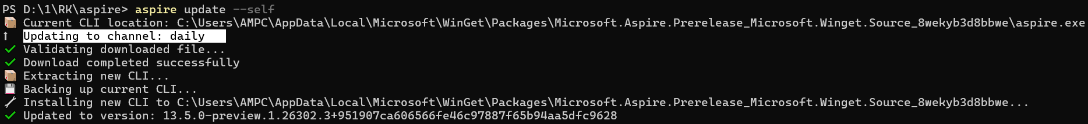

Task: Aspire New on command-line (Terminal for Windowsx64 App)
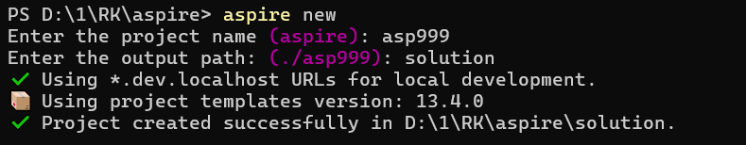

Task: Open in Visual Studio (Insiders) Professional
Aside-Task: Removing the WebApp project (given the focus of this lab is on the API project) –AND-ALSO-- Renaming URLs to align with broader lab-folders-projects-organization …. This project being called "asp999" all API local port ends in "999" (optional/organizational/internal)
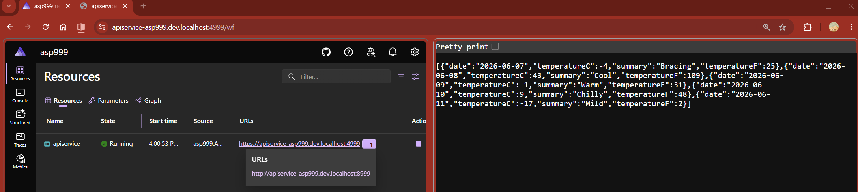

Task: Add OpenApi/Swagger for API project
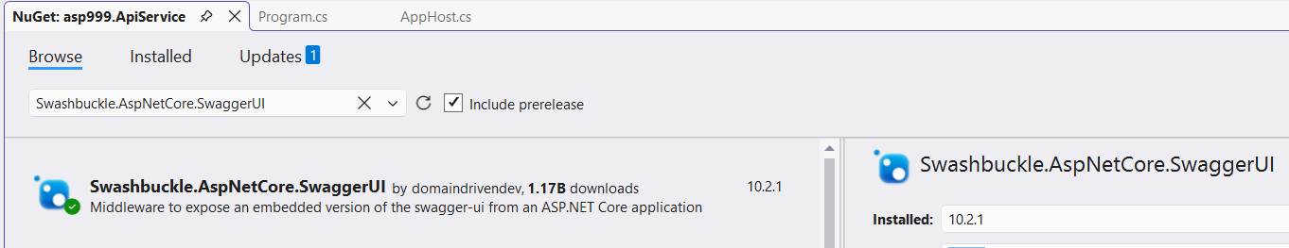 | VS: Install-Package Microsoft.AspNetCore.OpenApi  CLI: dotnet add package Microsoft.AspNetCore.OpenApi  Installed Swashbuckle.AspNetCore.SwaggerUI 10.2.1 from https://api.nuget.org/v3/index.json to C:\Users\AMPC\.nuget\packages\swashbuckle.aspnetcore.swaggerui\10.2.1  Installing NuGet package Swashbuckle.AspNetCore.SwaggerUI 10.2.1.  Writing assets file to disk. Path: D:\1\RK\aspire\asp999\asp999.ApiService\obj\project.assets.json  Successfully installed 'Swashbuckle.AspNetCore.SwaggerUI 10.2.1' to asp999.ApiService

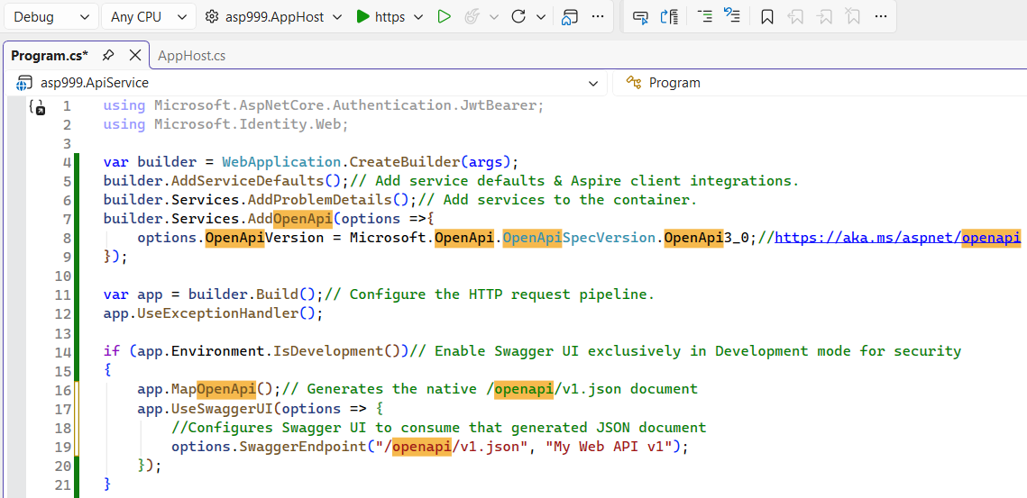 | 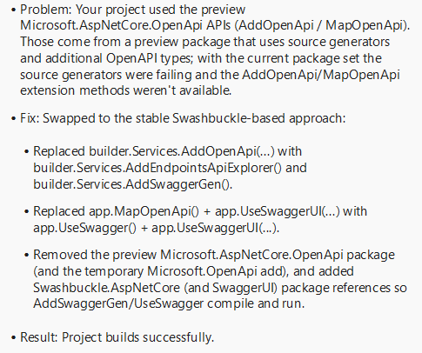
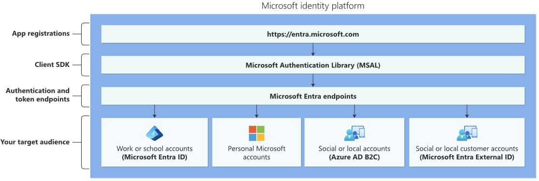 | // Use Swashbuckle (stable) for OpenAPI generation/UI instead of preview AddOpenApi/MapOpenApi  builder.Services.AddEndpointsApiExplorer();  builder.Services.AddSwaggerGen();  ….  if (app.Environment.IsDevelopment())// Enable Swagger UI exclusively in Development mode for security  {  // Enable Swagger middleware to serve the generated OpenAPI spec and the Swagger UI  app.UseSwagger();  app.UseSwaggerUI(options => {  // Configures Swagger UI to consume the generated JSON document  options.SwaggerEndpoint("/swagger/v1/swagger.json", "My Web API v1");  });

ACTION: Secure Aspire Web-API with EntraID OAuth2* (AuthNZ)
- OAuth 2.0 and OpenID Connect standard-compliant authentication service enabling developers to authenticate several identity types (Work/School, Personal, Azure-AD-B2C and Entra-External-ID)
- The open source MSAL libraries are recommended as they provide built-in support for Conditional Access scenarios, single sign-on (SSO) experiences for your users, built-in token caching support, and more.
  - SAMPLES: MSAL +authorization grants & token flows for app types & scenarios.
- Programmatic configuration of your applications through the Microsoft Graph API and PowerShell so you can automate your DevOps tasks.

Task: Securing Aspire ASP.NET Core Api; with EntraID (Authentication/Authorization)
To secure a multi-tenant ASP.NET Core Web API within a .NET Aspire ecosystem using Microsoft Entra ID:
- Decouple single-tenant constraints & explicitly enforce scope-based & tenant-based authorization.
- To achieve this, the OIDC OpenID Authority points to the shared /organizations endpoint instead of a specific Tenant GUID.
- Entra ID (Azure AD) → OAuth2/JWT → App Roles / Scopes → API Authorization Policies → Tenant Isolation Layer.
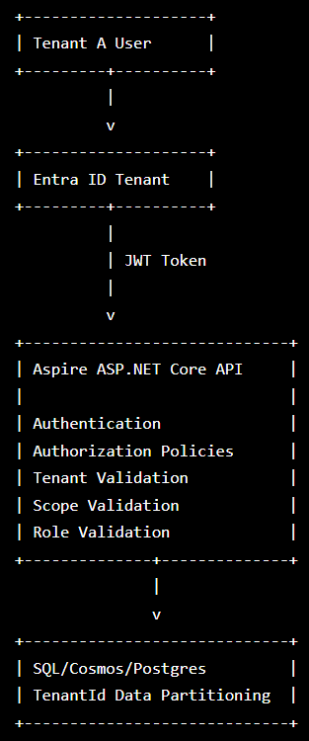 | 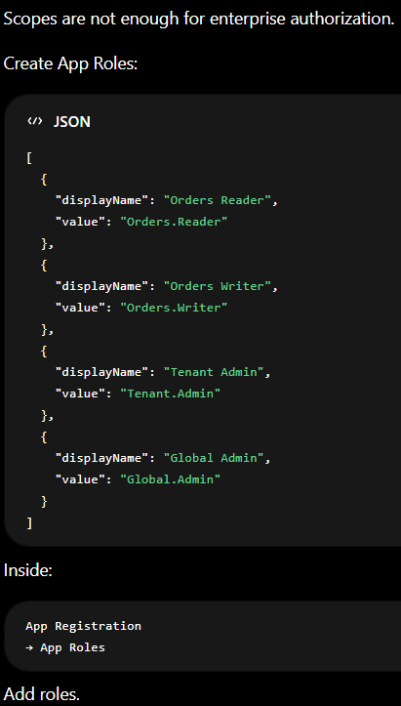 | 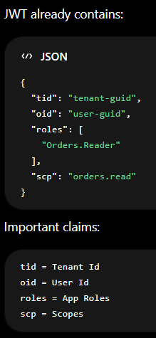
Step 1: Microsoft Entra ID App Provisioning
Configure the App-Registration to accept multi-tenant sign-ins, define authorization scopes, and register application roles. Manually via Azure-Portal
- Navigate to the Microsoft Entra admin centre -> App registrations -> New registration.
- Name: AspireWebApi-MultiTenant-Asp999
- Supported account types: Select Allow all tenants.
- Leave Redirect URI blank for a pure Web API. Click Register.
- Copy the Application (client) ID from the Overview pane.
- Navigate to Expose an API
  - Expose an API: Click “Add” next to Application ID URI.
    - Accept the default (api://<client-id>).
  - Expose an API: Click Add a scope.
    - Create two structural scopes for route-level segregation:
      - Scope 1: ASP999.Read <Display Name: Read access to API routes>
      - ----------------------------
      - Scope 2: ASP999.Write <Display Name: Write access to API routes>
      - ----------------------------
      - Set Who can consent to Admins and users.
AZ : CLI(Microsoft.Azure.Az)
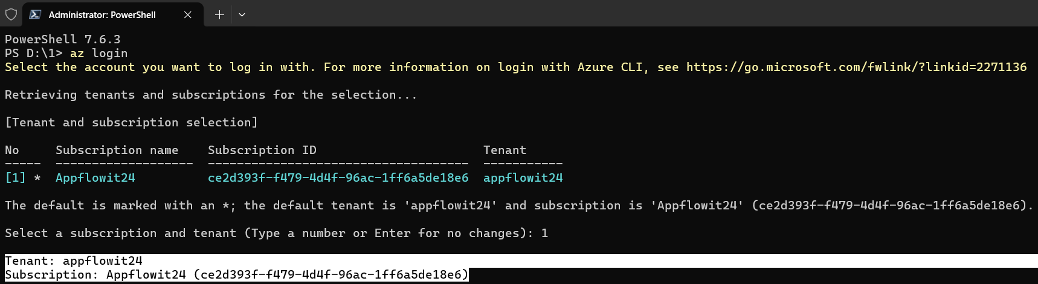
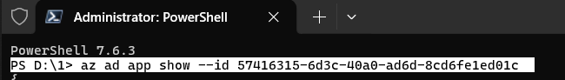
Step 2: .NET Aspire AppHost Plumbing | Update your AppHost/Program.cs
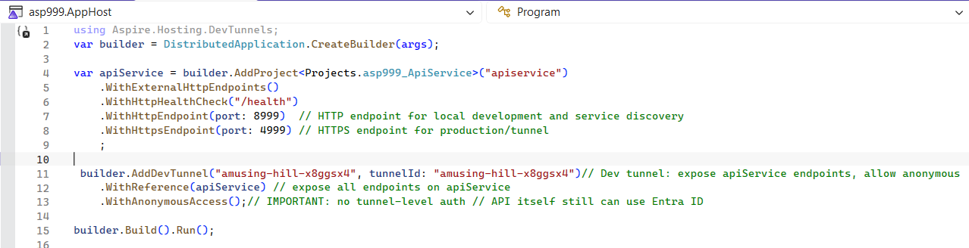

Step 3: ASP.NET Core Web API Core Implementation
- Dependencies Setup: Add the core Microsoft Identity orchestration packages to your Asp999.ApiService.csproj:
dotnet add package Microsoft.Identity.Web
dotnet add package Microsoft.AspNetCore.Authentication.JwtBearer
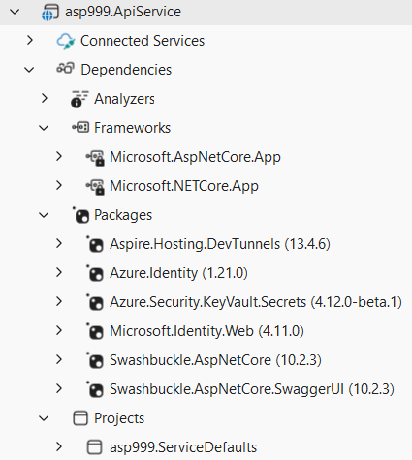 | 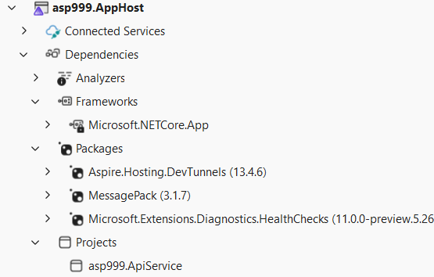

- Configuration (appsettings.json)
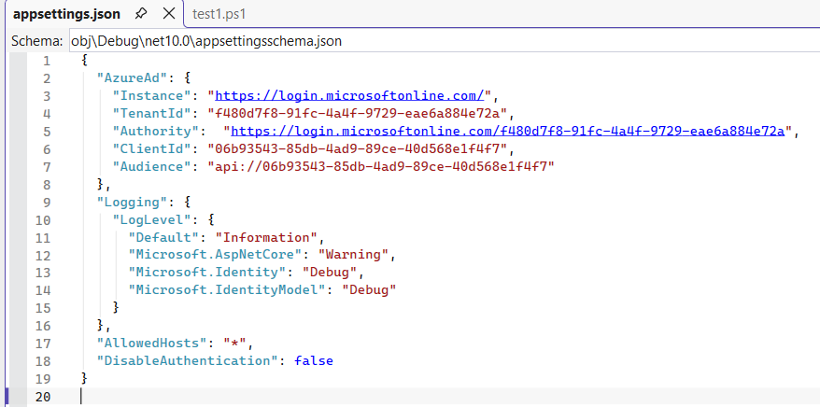

- Middleware Configuration (Program.cs)
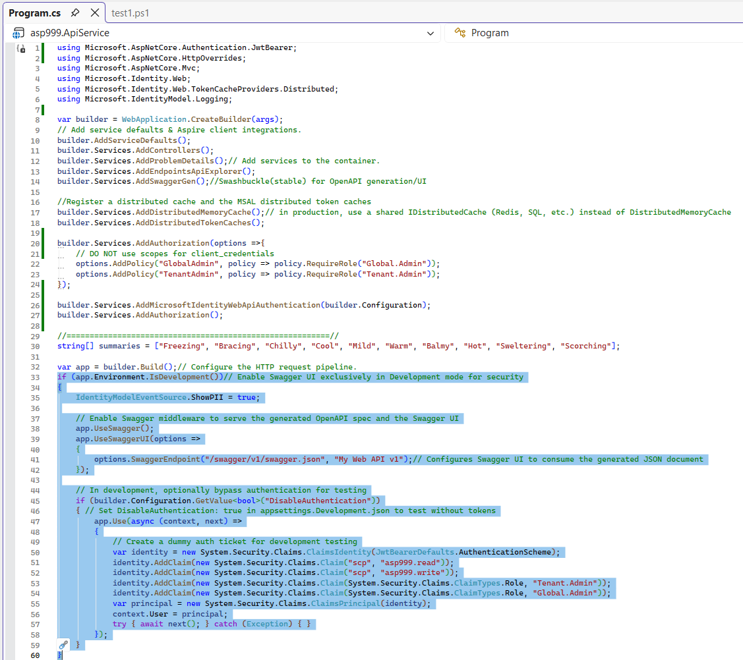 | 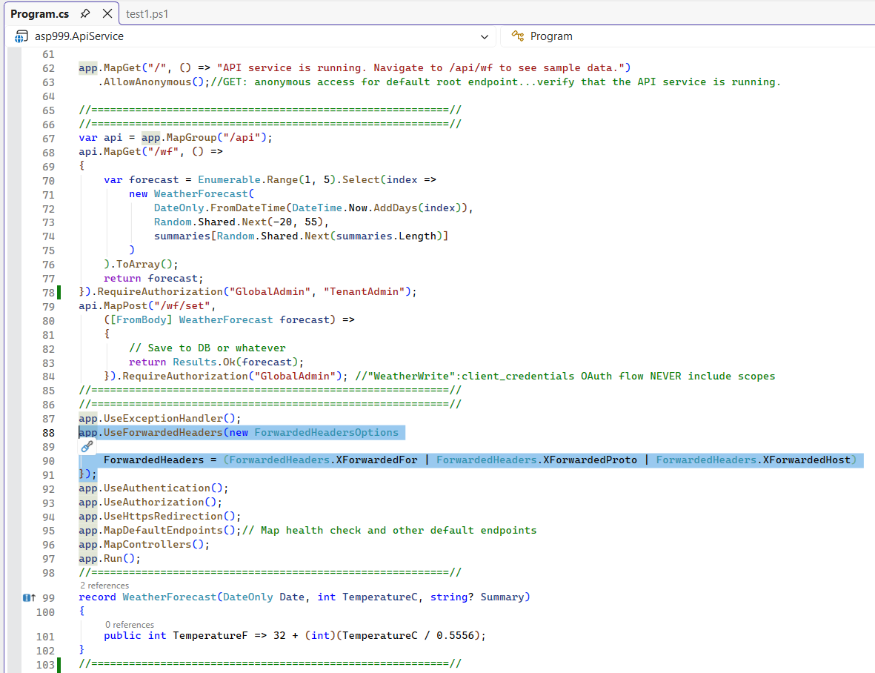

- Enforcing Advanced Route-Based Scope & Tenant Isolation
  - To defend endpoints from unauthorized cross-tenant calls, evaluate incoming claims inside the route execution scopes. Controller Implementation Example

Add-On/Aside: Azure KeyVault <beside appsettings.json>
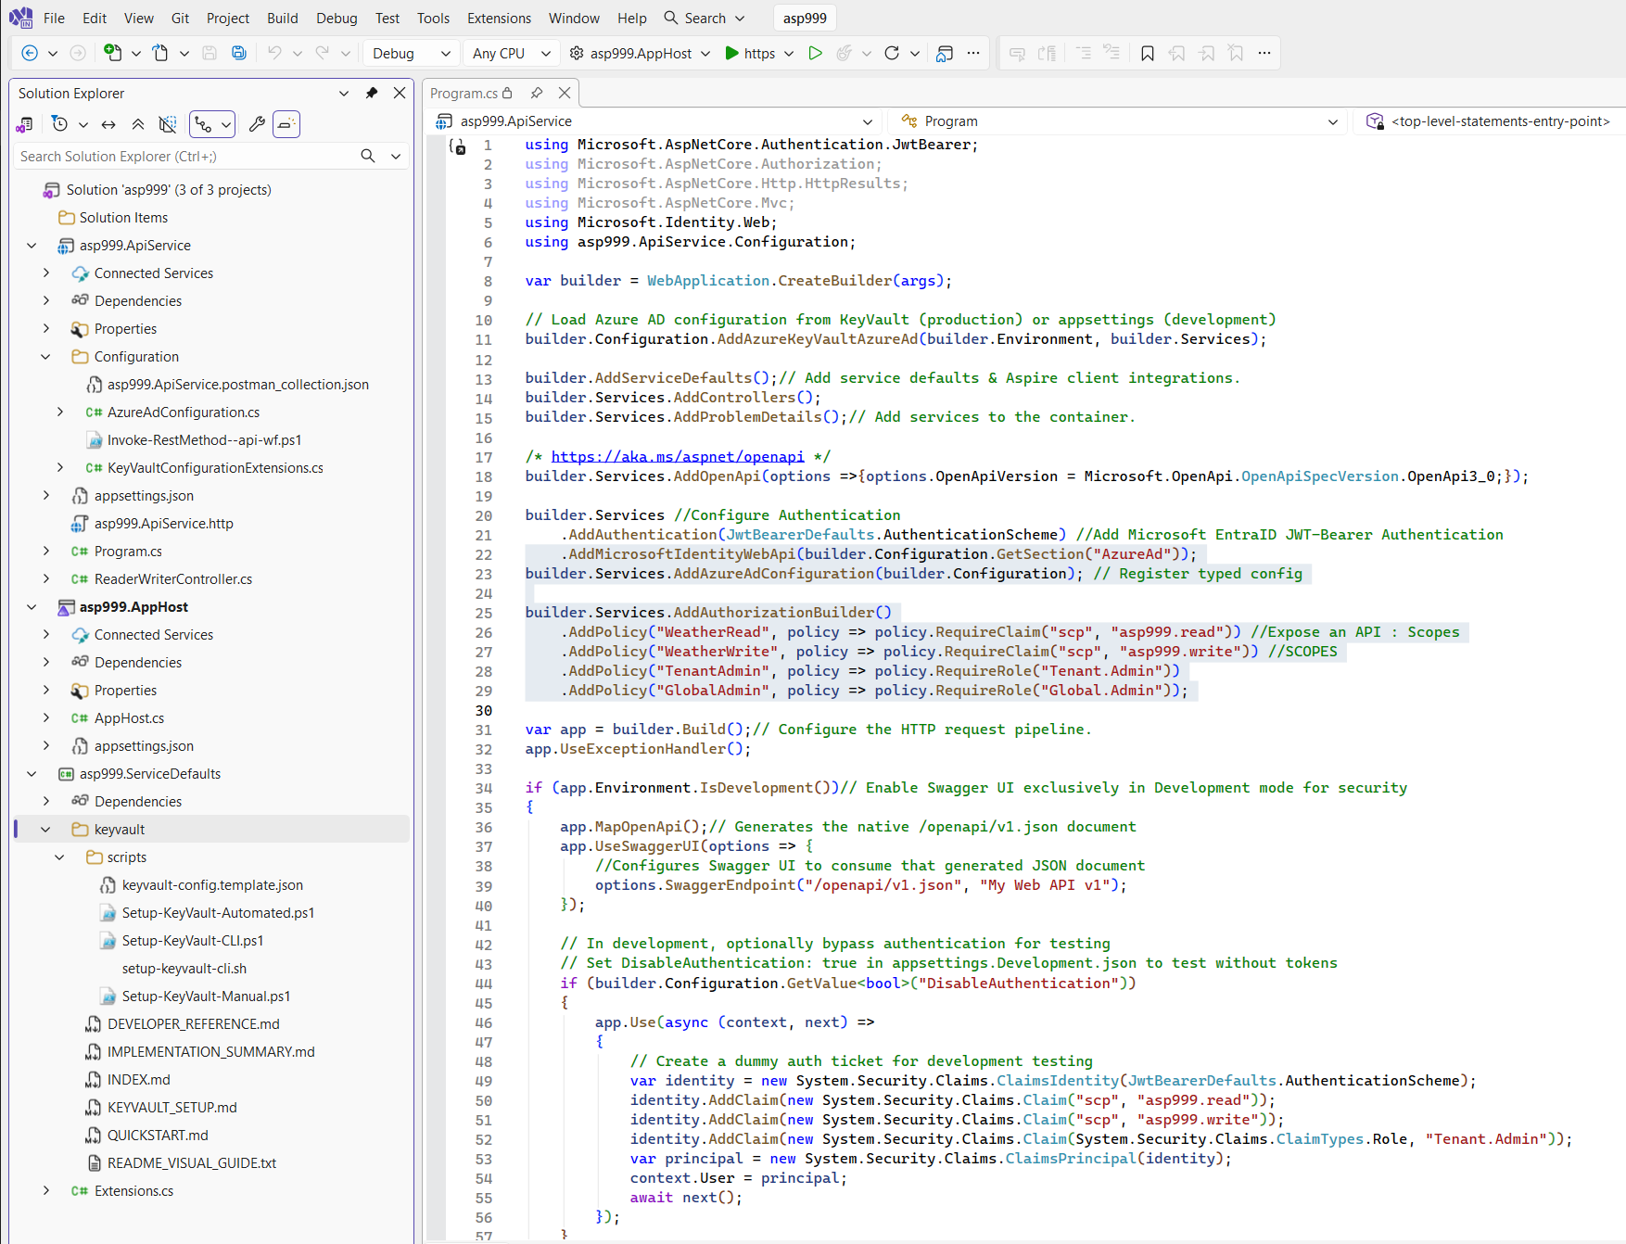

Task: Testing Web-API Client-flow (Admin Delegated) OAuth2* flow works with PowerShell
** This task assumes DevTunnel working – else use https://localhost:4999
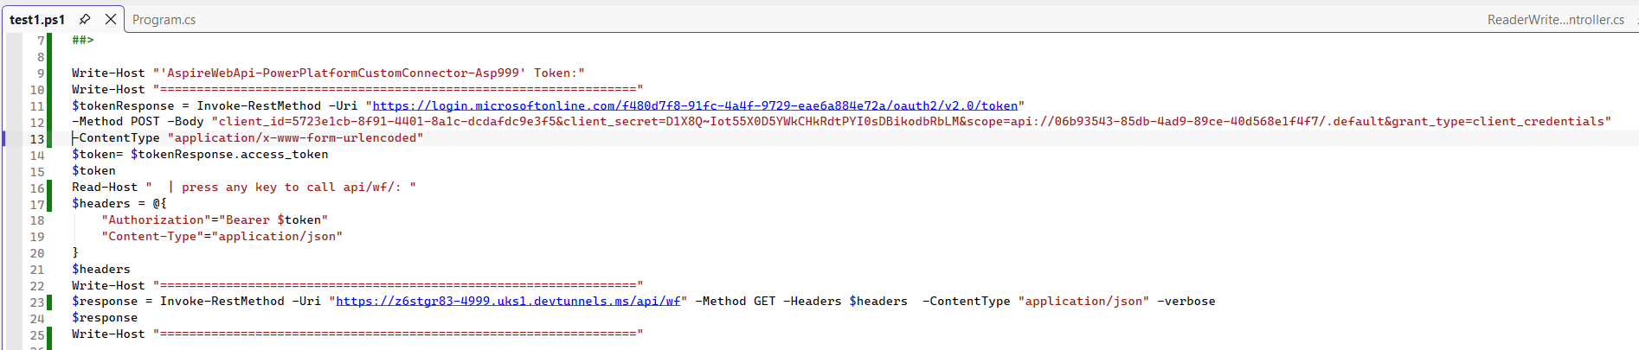

DevTunnel (cli ) || Aspire...DevTunnel(c#/nuget) || DevTunnel (sdk)

ACTION: Install CLI: Microsoft.devtunnel
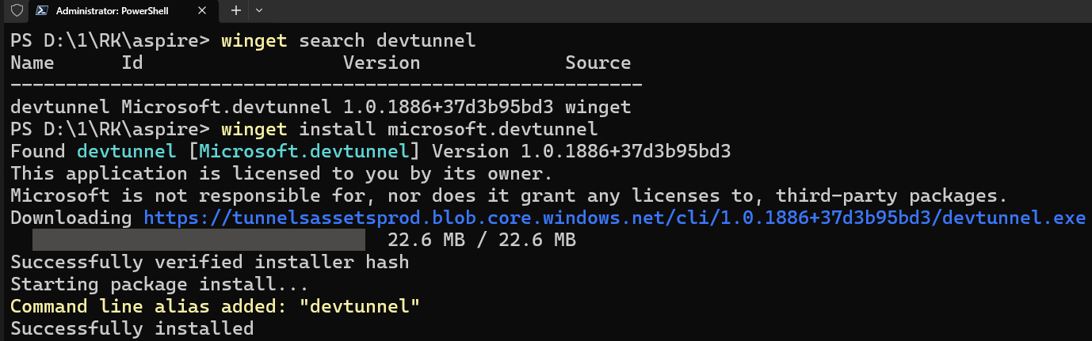 | 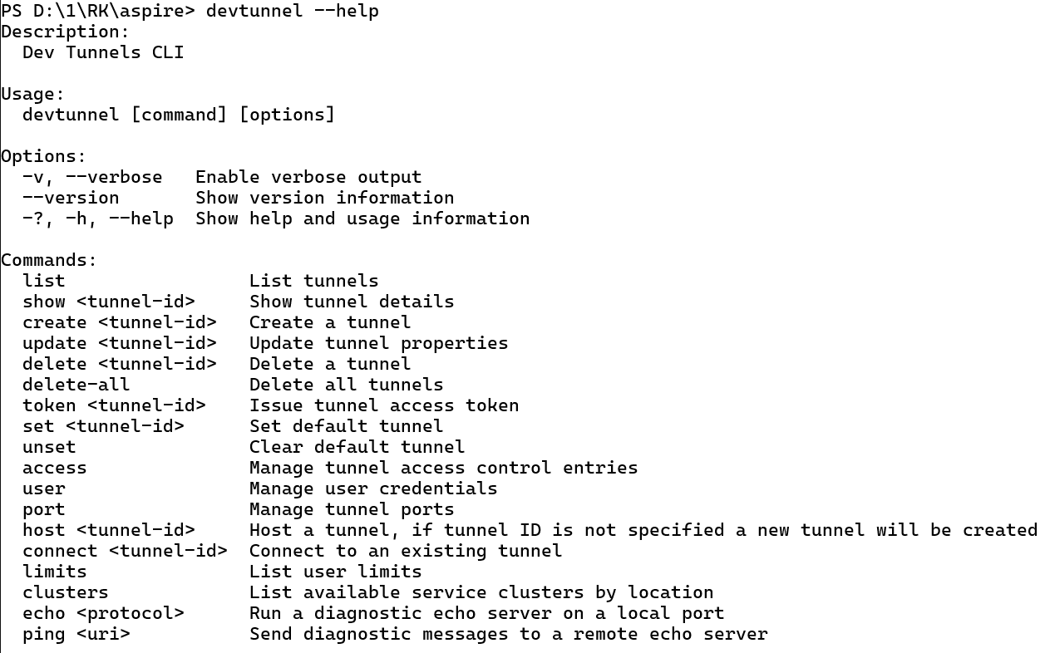 |  | 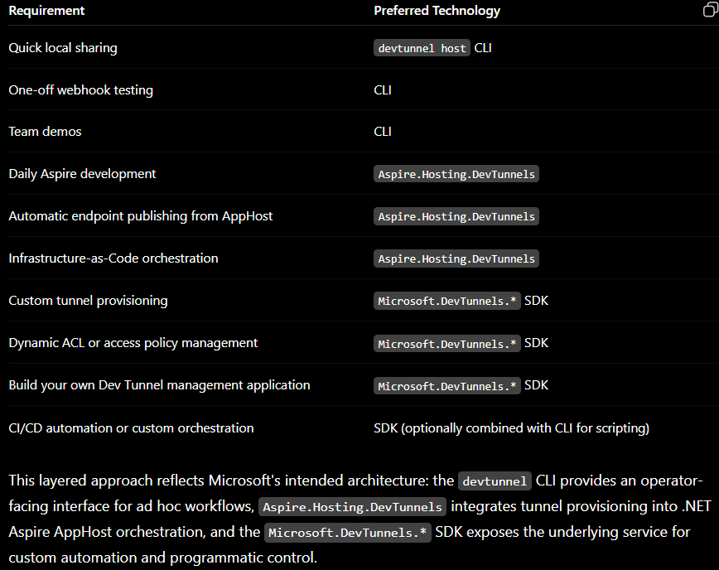
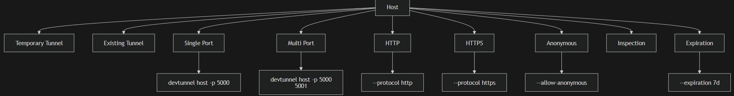
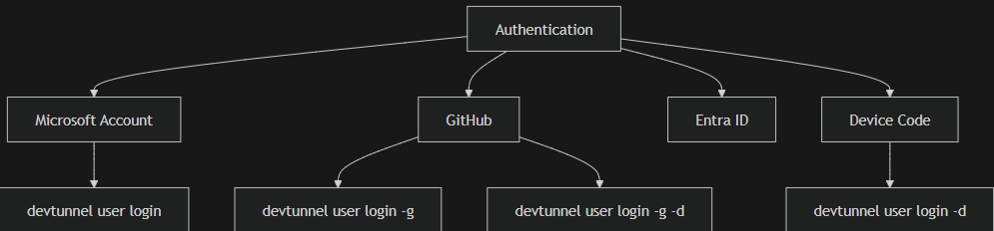 |  | 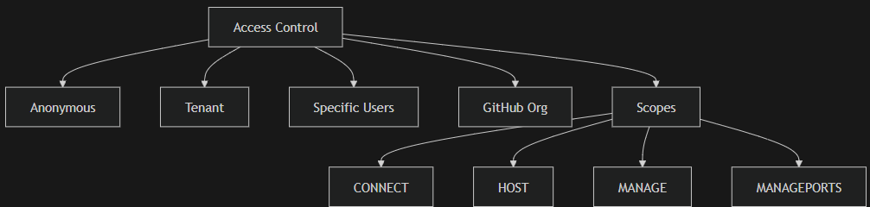

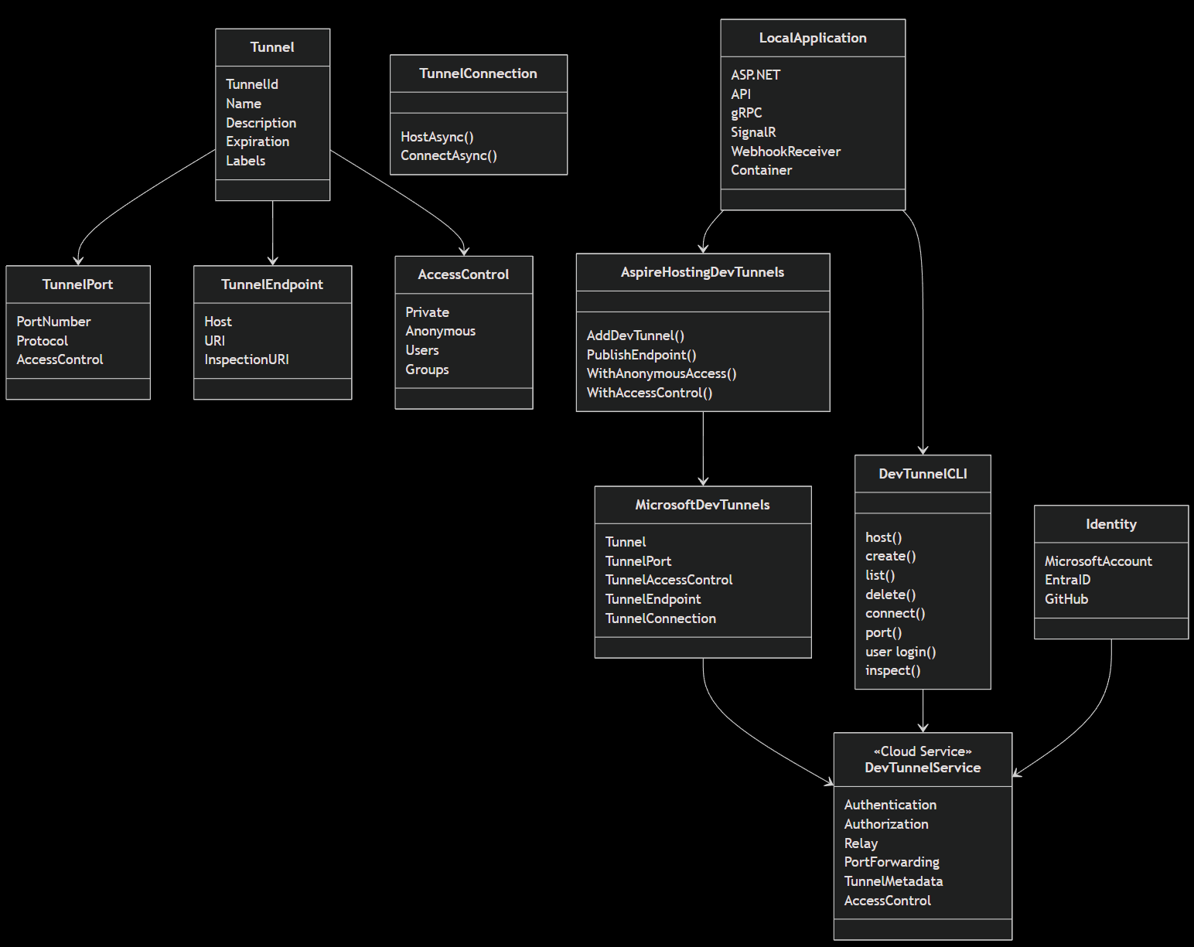 | 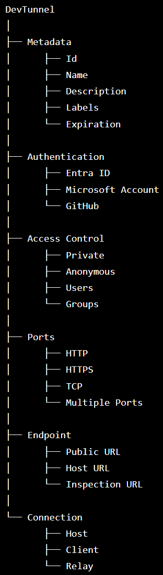

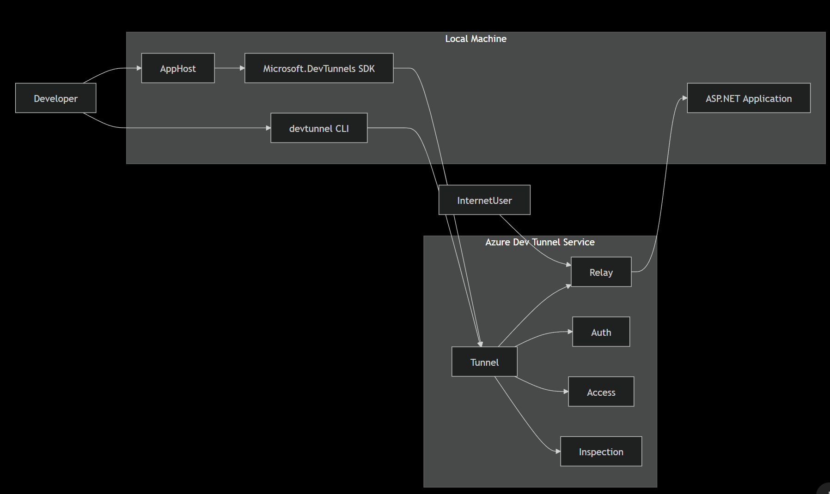 | 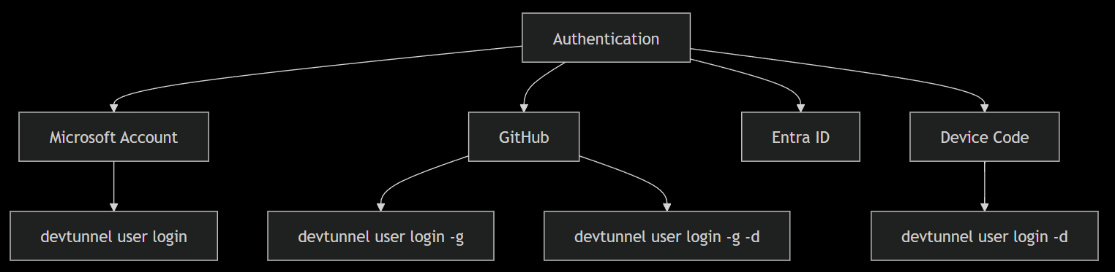
https://learn.microsoft.com/en-us/azure/developer/dev-tunnels/cli-commands | The following represents the practical scenarios supported by Microsoft today.
  mindmap  root((devtunnel))  user  login  microsoft  github  device-code  logout  show  create  name  description  labels  expiration | host  temporary-tunnel  existing-tunnel  single-port  multi-port  http  https  anonymous  inspect  host-header  expiration  connect  tunnel-id  port  token  local-forwarding | list  all-tunnels  owned  accessible  show  tunnel-details  ports  access-control  endpoints  delete  tunnel  port  create  list  show  update  delete | access  create  list  update  delete  token  create  show  revoke  echo  diagnostics  relay-test  connectivity  clusters  relay-region  cluster-discovery | Devtunnel  │  ├── Identity  │ ├── login  │ ├── logout  │ └── show  │  ├── Tunnel  │ ├── create  │ ├── list  │ ├── show  │ └── delete  │  ├── Hosting  │ ├── host  │ └── connect | ├── Ports  │ ├── create  │ ├── update  │ ├── show  │ ├── list  │ └── delete  │  ├── Security  │ ├── access  │ └── token  │  └── Diagnostics  └── echo
  # | Scenario | CLI | Aspire | SDK
  1 | Temporary tunnel | ✔ | ✔ | Optional
  2 | Persistent tunnel | ✔ | ✔ | ✔
  3 | Public anonymous tunnel | ✔ | ✔ | ✔
  4 | Authenticated tunnel | ✔ | ✔ | ✔
  5 | Multiple ports | ✔ | ✔ | ✔
  6 | HTTP endpoint | ✔ | ✔ | ✔
  7 | HTTPS endpoint | ✔ | ✔ | ✔
  8 | TCP forwarding | ✔ | ✔ | ✔
  9 | Webhook receiver | ✔ | ✔ | No
  10 | Mobile device testing | ✔ | ✔ | No
  11 | Share with teammate | ✔ | ✔ | No
  12 | GitHub webhook | ✔ | ✔ | No
  # | Scenario | CLI | Aspire | SDK
  13 | Stripe webhook | ✔ | ✔ | No
  14 | Azure Event Grid callback | ✔ | ✔ | No
  15 | Teams Bot callback | ✔ | ✔ | No
  16 | Local container exposure | ✔ | ✔ | No
  17 | AppHost automatic tunnel | No | ✔ | No
  18 | Programmatic tunnel creation | No | No | ✔
  19 | Programmatic ACL management | No | No | ✔
  20 | Programmatic lifecycle automation | No | No | ✔
  21 | Inspection endpoint | ✔ | ✔ | ✔
  22 | Expiration management | ✔ | ✔ | ✔
  23 | Named tunnel reuse | ✔ | ✔ | ✔
  24 | CI automation | ✔ | Partial | ✔

ACTION: Aspire.Hosting.DevTunnels | Aspire (for C#)

Task: CLI: Login with service principal & Create temp/perm/anonymous/authenticated Tunnels
Aspire: Dev Tunnel ↓ Configure ACL ↓ Host ↓ Return URL ↓ Update Power Platform Connector.
Azure-DevOps: Pipeline ↓Login using SP ↓ Create tunnel ↓ Host tunnel ↓ Run integration tests ↓ Delete tunnel
winget install Microsoft.devtunnel
devtunnel user login (user option)
devtunnel user login --tenant-id …. --client-id …. --client-secret …. (service principal option)
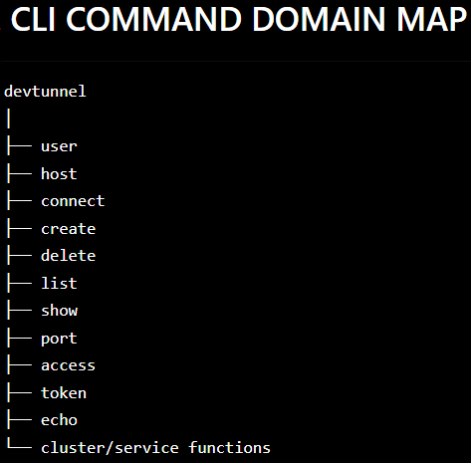 | 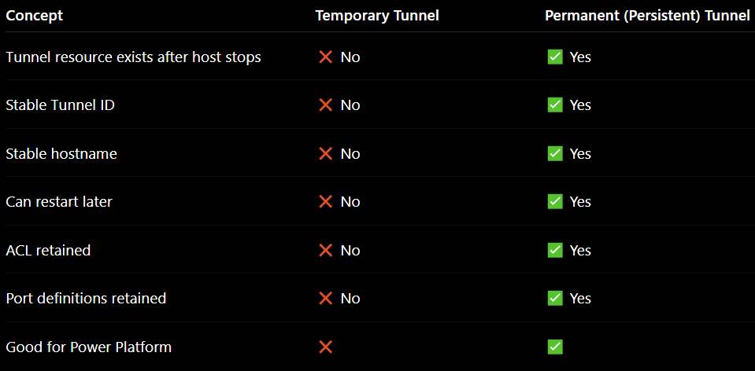 | 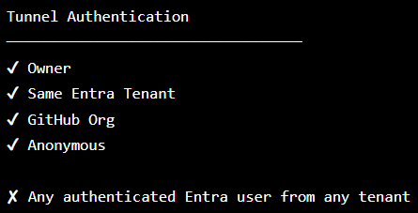
** If a requirement is: The tunnel itself must require Microsoft Entra authentication (not anonymous), and any authenticated user from any Entra tenant should be able to connect
Persistent Tunnel:
devtunnel create --name aspire-api --expiration 30d
devtunnel port create <TunnelId> -p 7208 --protocol https
devtunnel access create <TunnelId> [ --anonymous || --tenant ]
devtunnel host <TunnelId> (starts host for stored tunnel)
Note: “Microsoft stores metadata such as: Tunnel ID, Tunnel Name, Tunnel Description, ACL, Ports, Hostname, Expiration, Labels”
Temporary Tunnel:
devtunnel host -p 7208 (starts host for given port)
||| ALM: Create Configure Ports Configure ACL Host Delete
Middle ground for Tunnel security at connection time: ** For multi-tenant OAuth testing with Power Platform, Postman, Swagger and browsers, Microsoft's recommended practice is generally: make the tunnel reachable (fully anonymous or using a generated x-tunnel-auth token -&- protect the API with Entra ID / Scopes+Roles)
devtunnel token create 7m8x9abc --scope connect|manage..
curl -H "X-Tunnel-Authorization: tunnel eyJhbGciOi..." https:/7m8x9abc-7208.devtunnels.ms/swagger
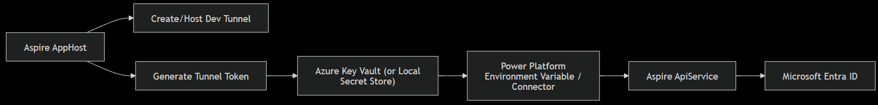

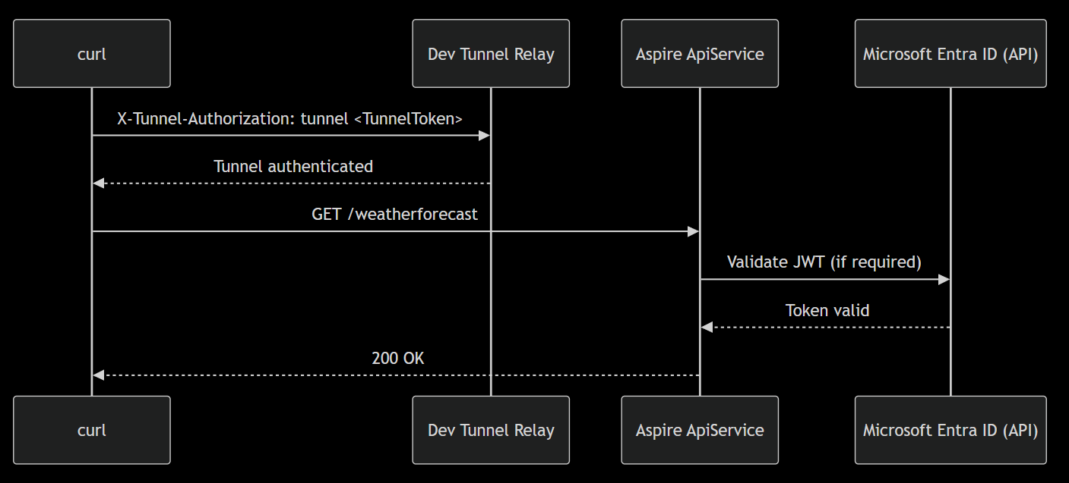 | 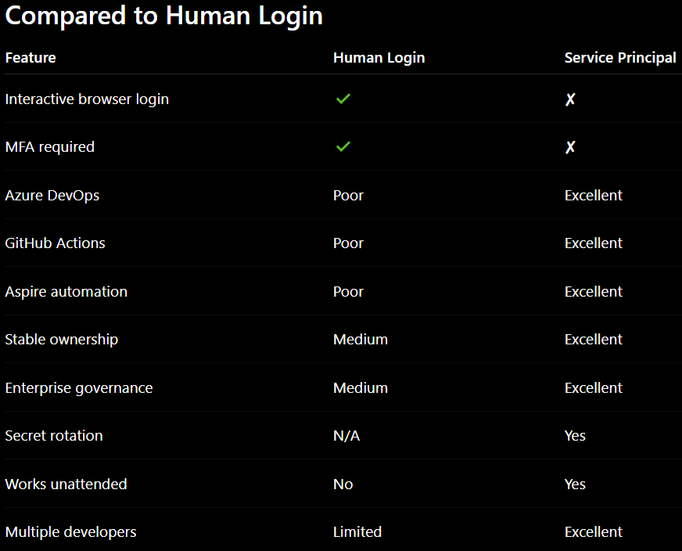 | 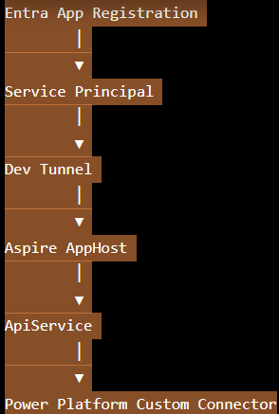

This screenshot captures active/live running asp999.ApiService via the asp999.AppHost where the devtunnel has been named and also hosted/running locally – thereby giving the tunnel uri using which swagger is being accessed as it would be from the internet/remote-clients.
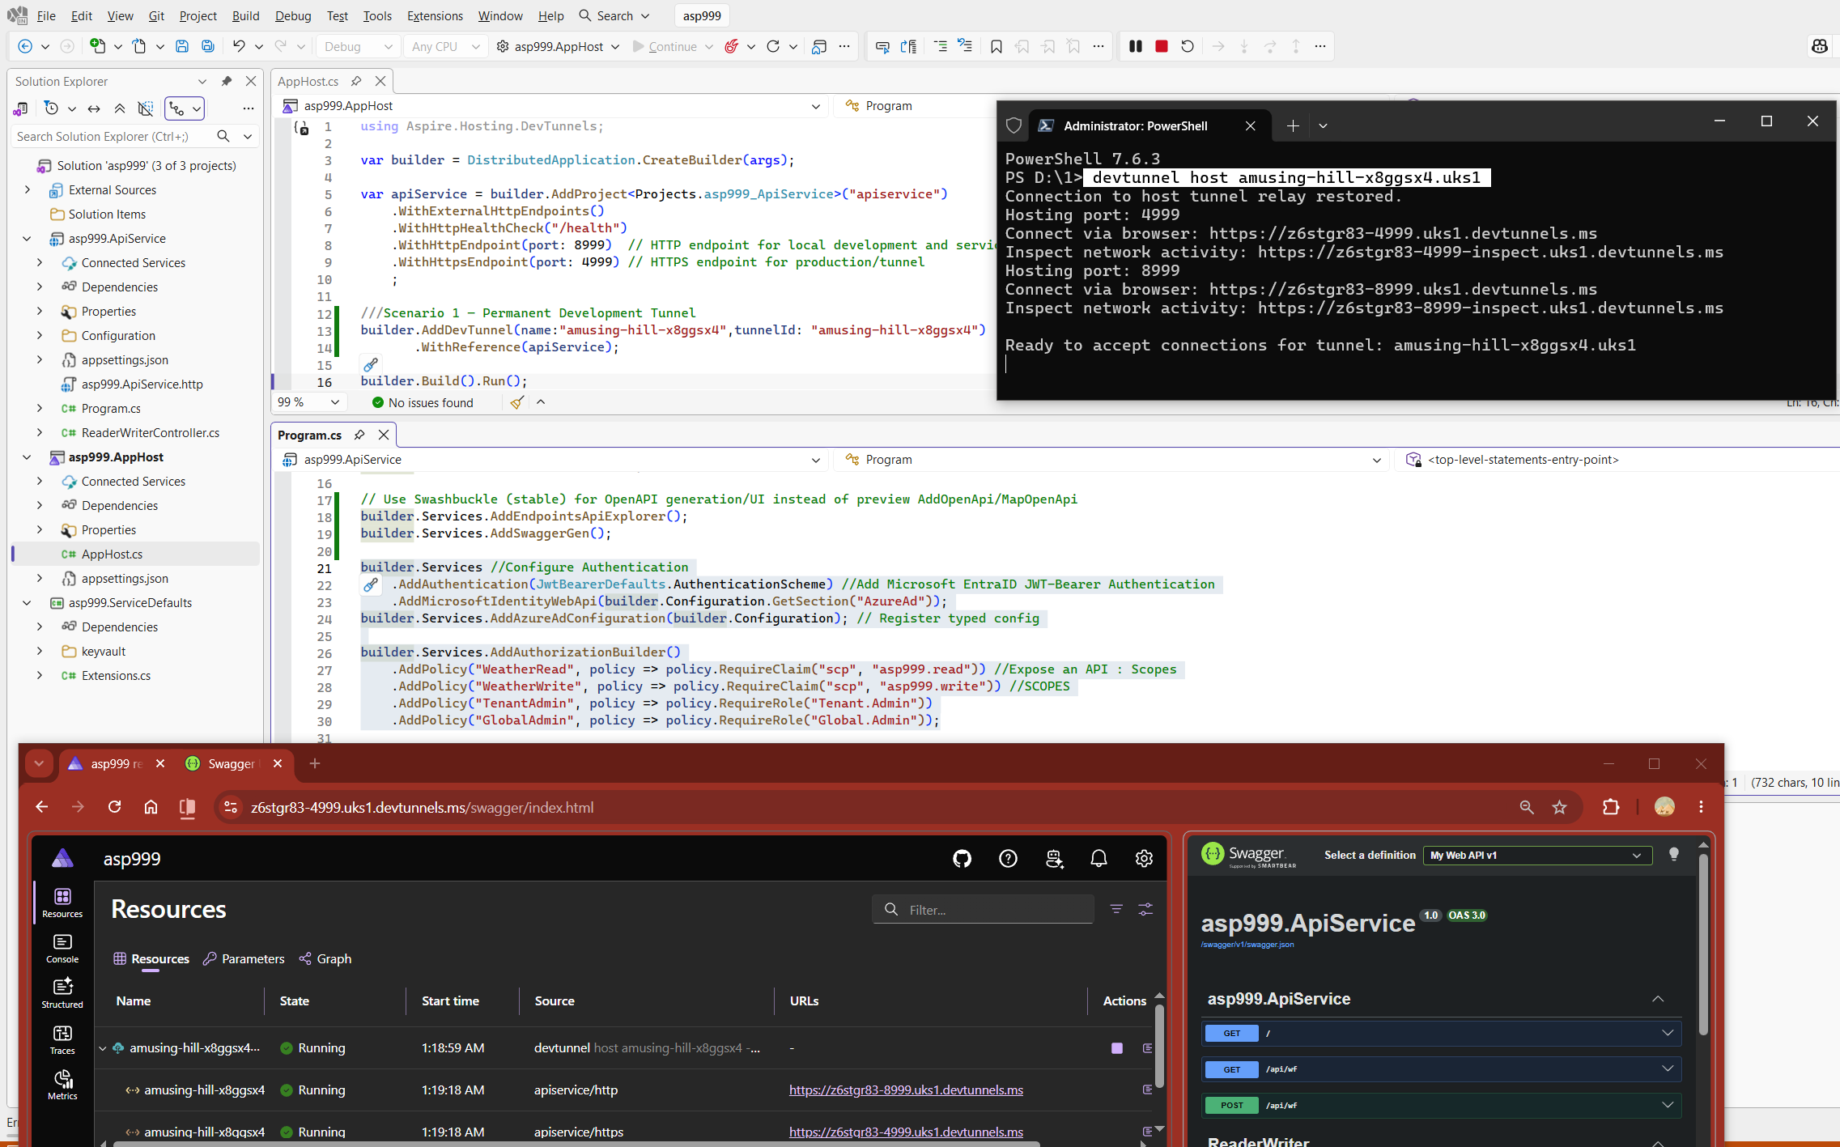
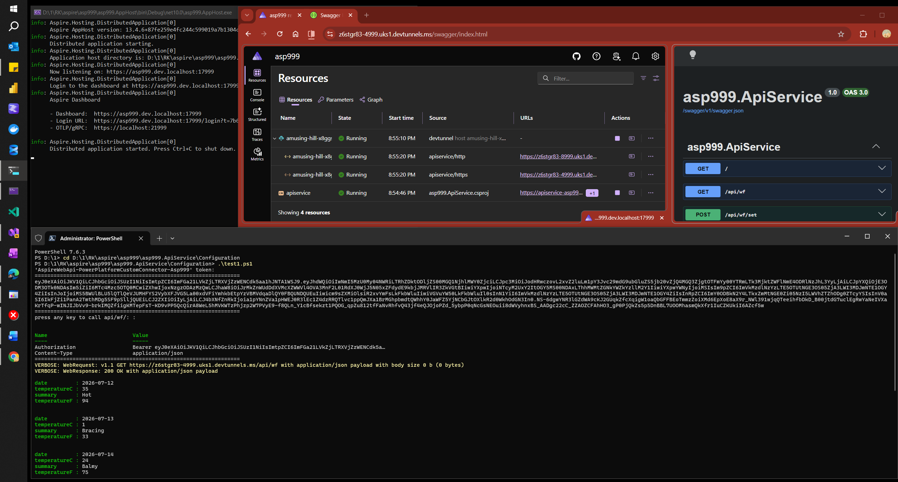
Task: Aspire.Host.App: Configure to use the setup tunnels (anonymous & authenticated/access)
 | https://www.nuget.org/packages/Aspire.Hosting.DevTunnels
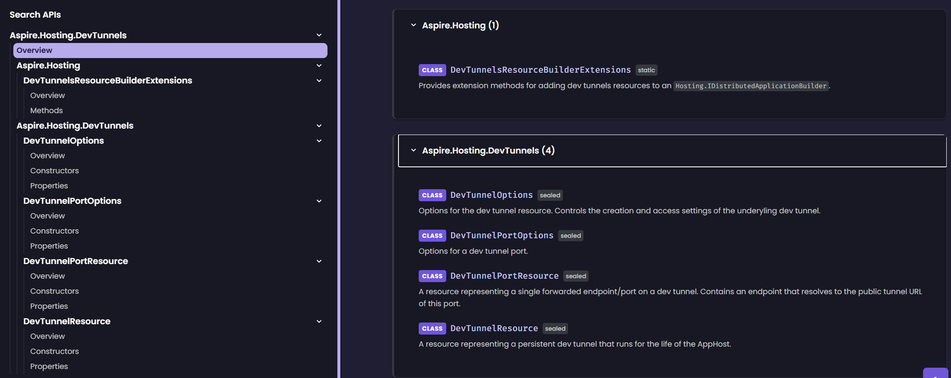 | 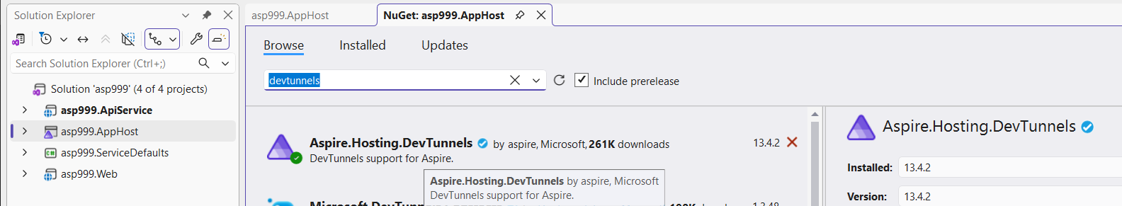  …\asp999.AppHost\asp999.AppHost.csproj  <ItemGroup>  <PackageReference Include="Aspire.Hosting.DevTunnels" Version="13.4.2" />  </ItemGroup>  Installed Aspire.Hosting.DevTunnels 13.4.2 from https://api.nuget.org/v3/index.json to C:\Users\AMPC\.nuget\packages\aspire.hosting.devtunnels\13.4.2  Successfully installed 'Aspire.Hosting.DevTunnels 13.4.2' to asp999.AppHost
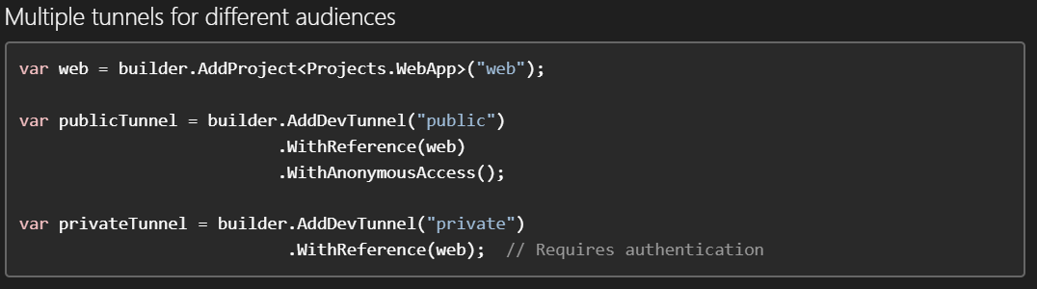 | 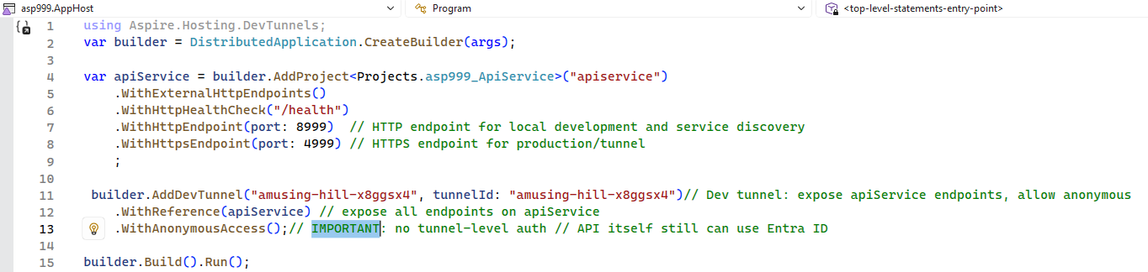

Power Platform: Custom Connector + Use from App
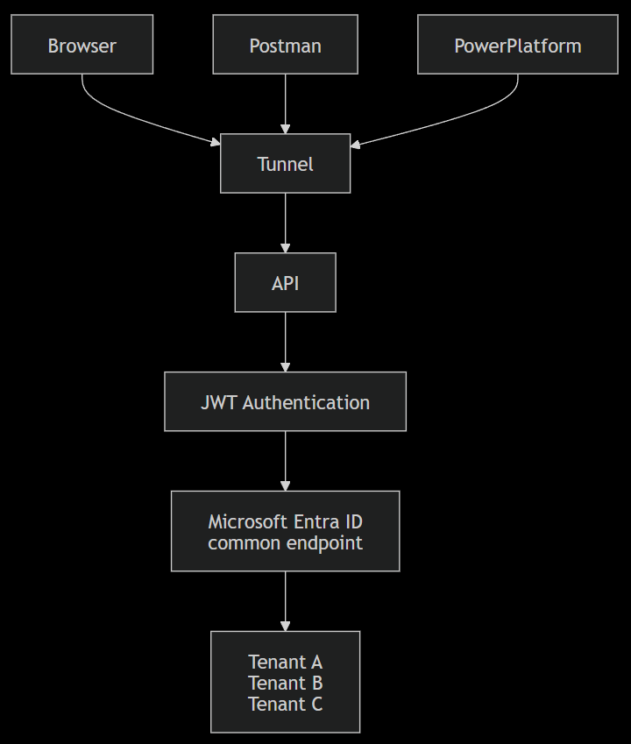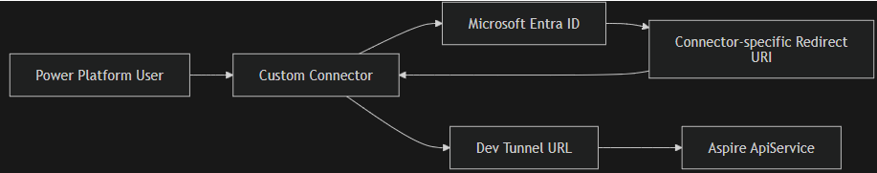 | 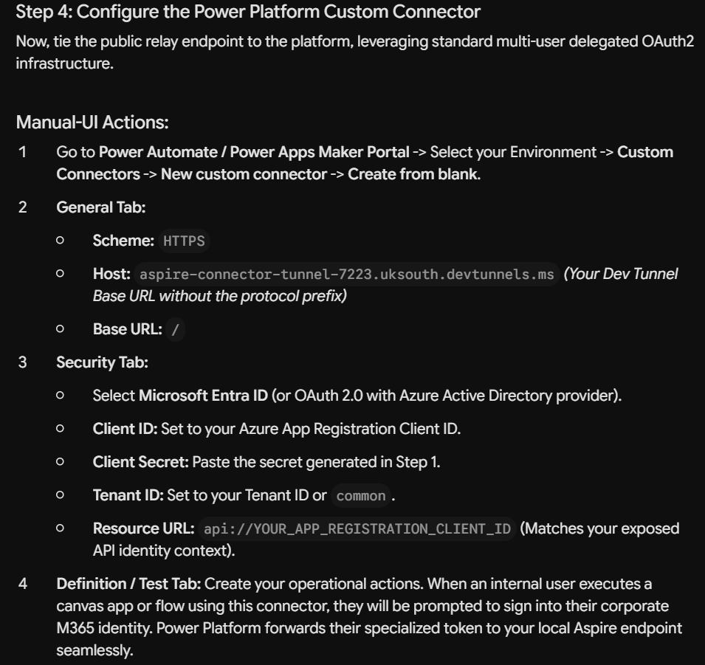
Registering App with Entra tenant to access “AspireWebApi-MultiTenant-Asp999” from PP-CustomConnector |  | Enterprise Application – Grant Admin permissions to all tenant users (on behalf of admin)
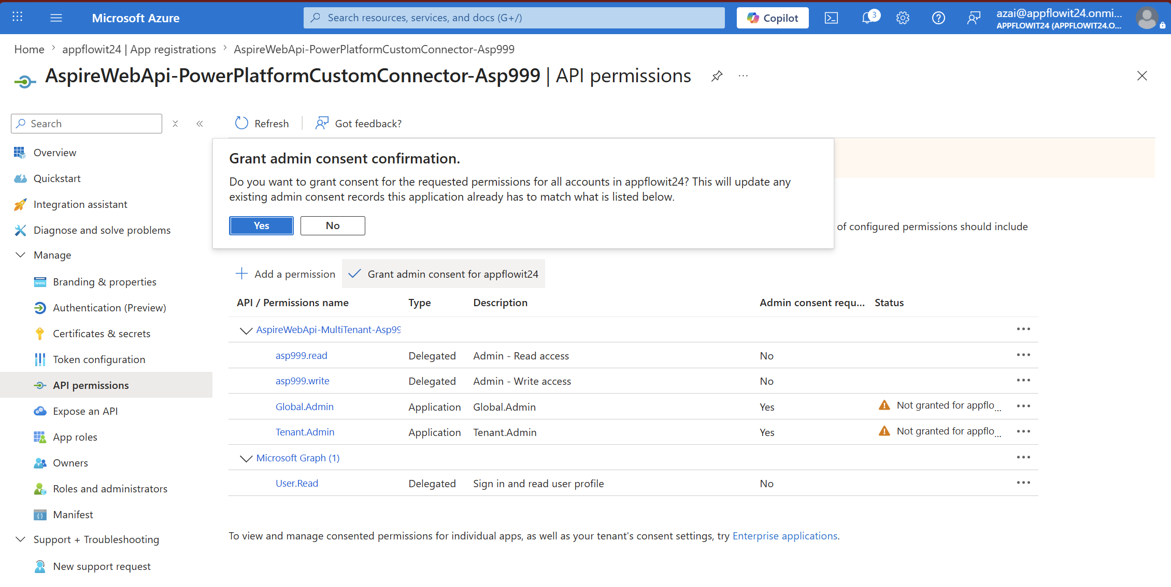 |  | 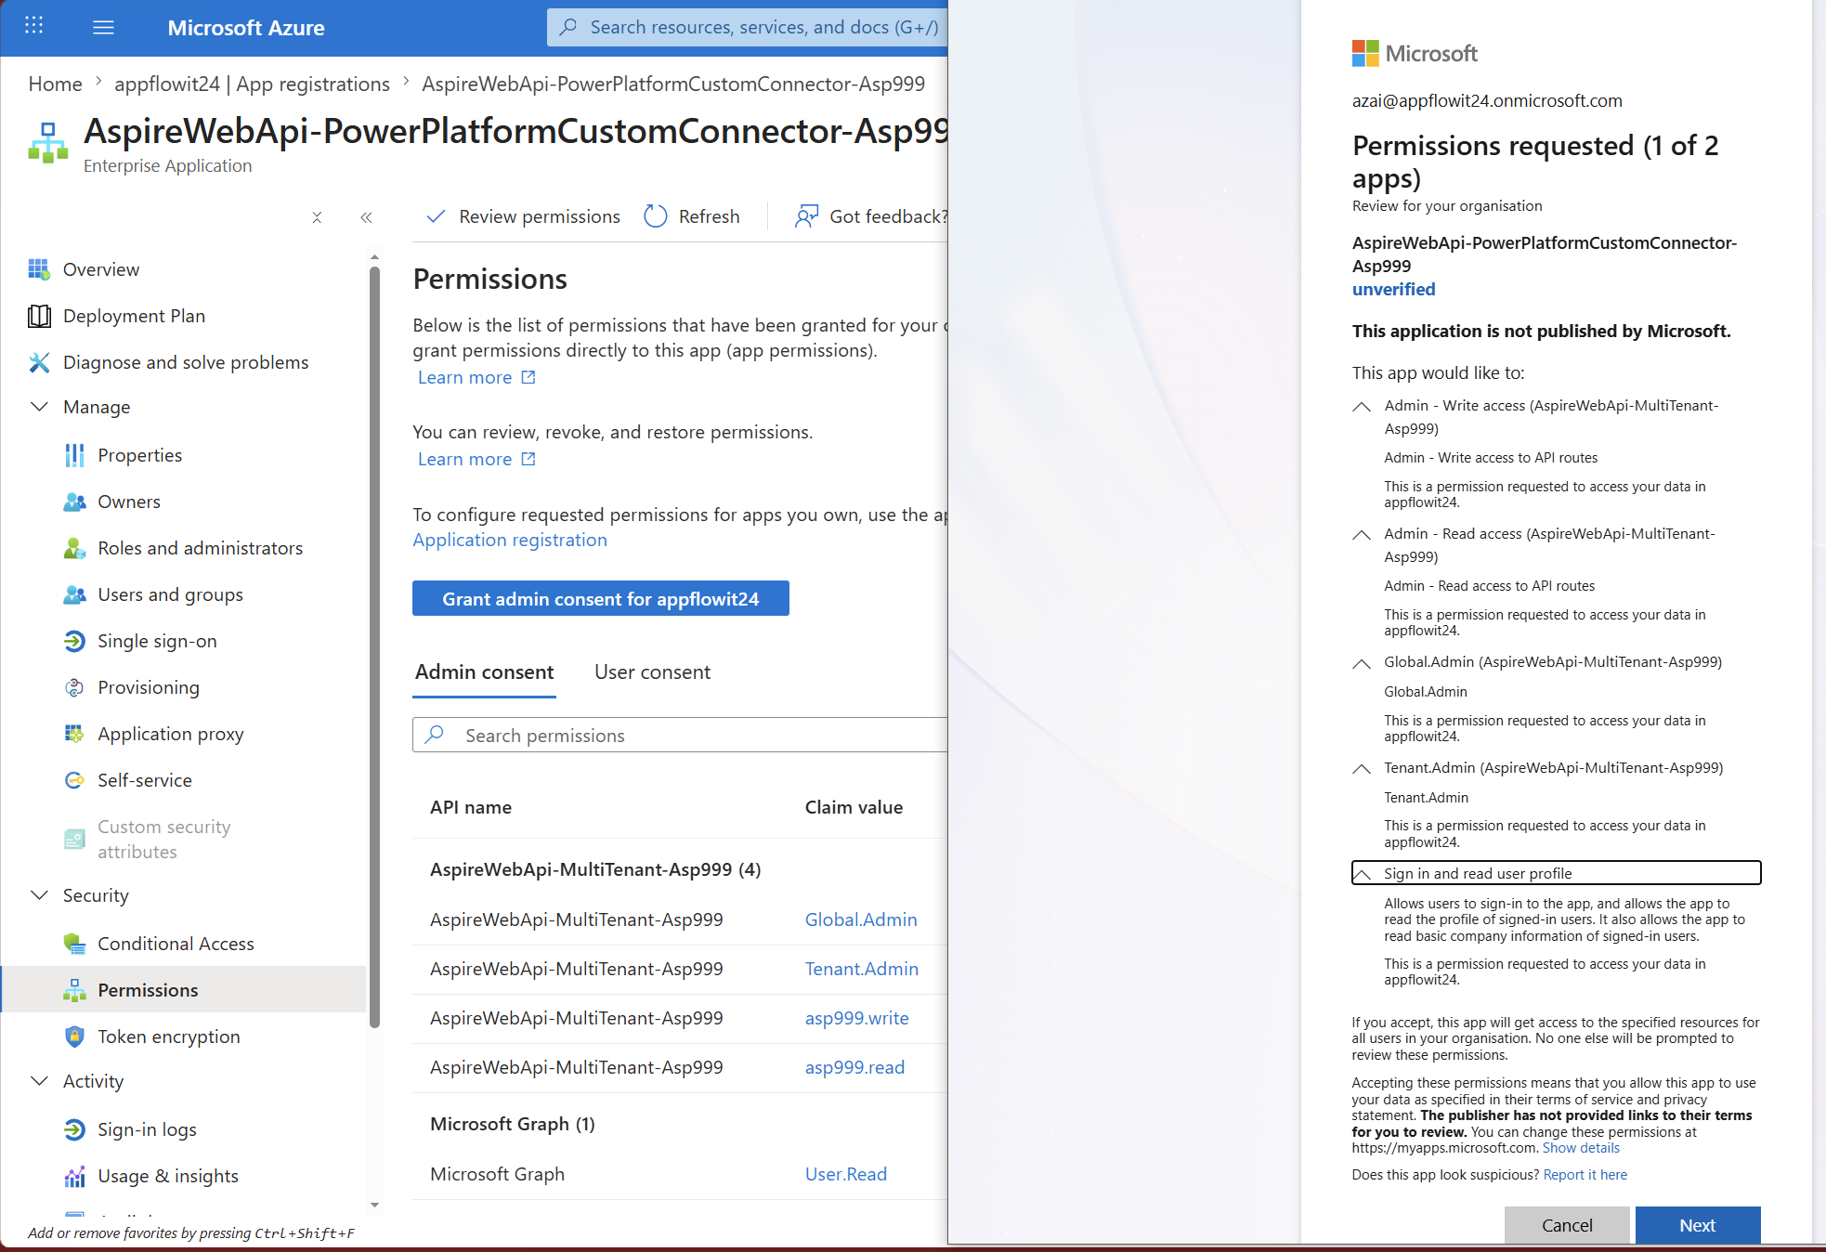

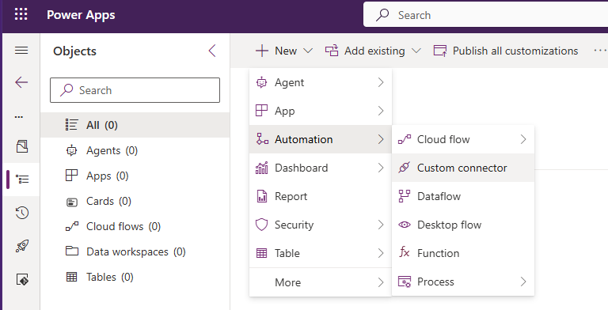 | 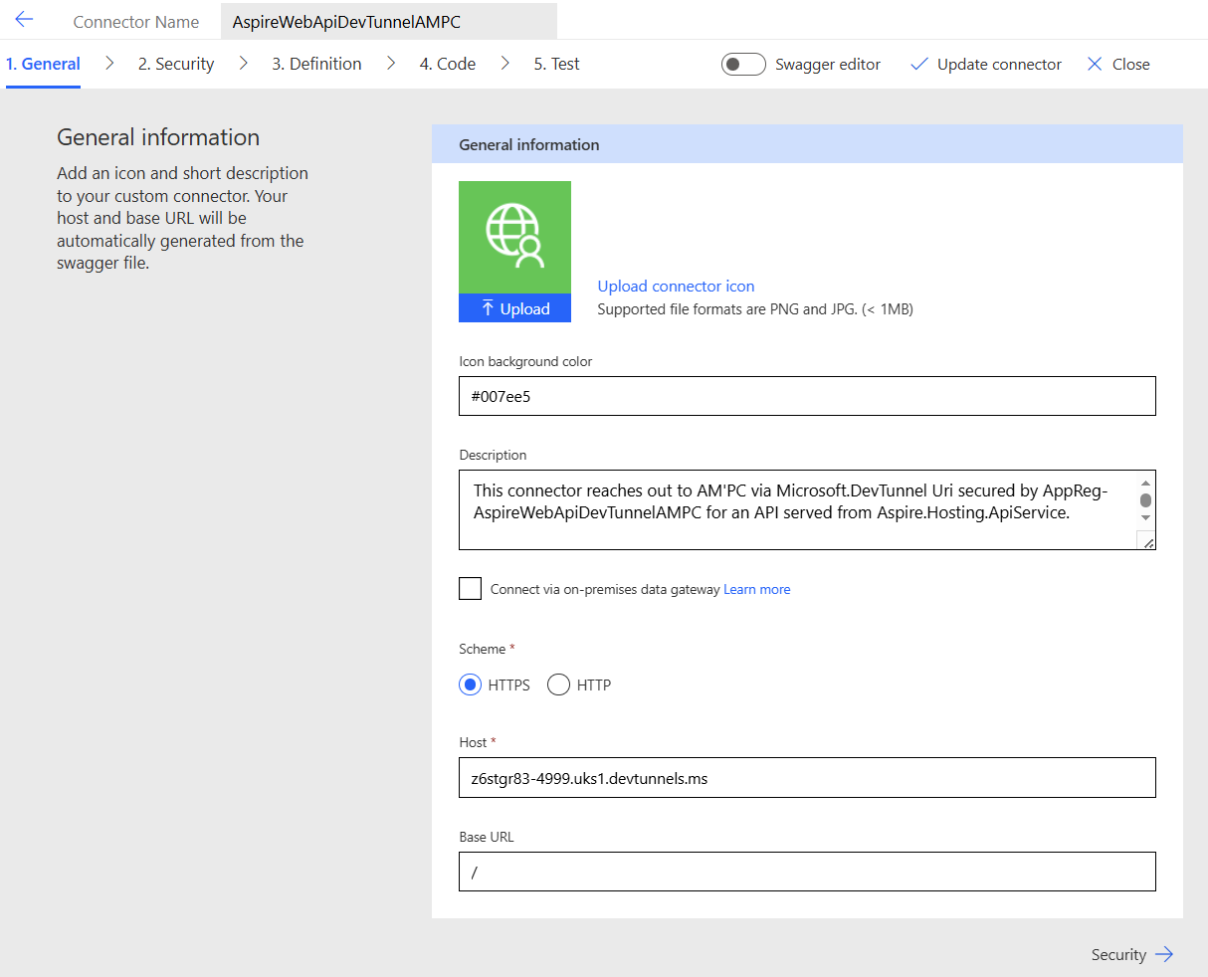 | 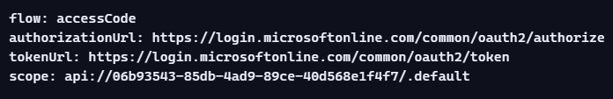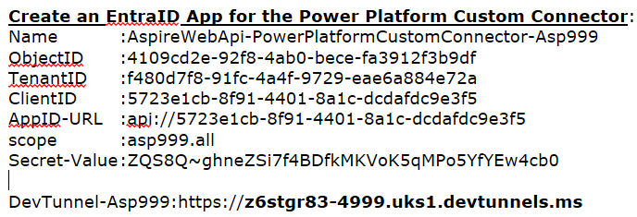
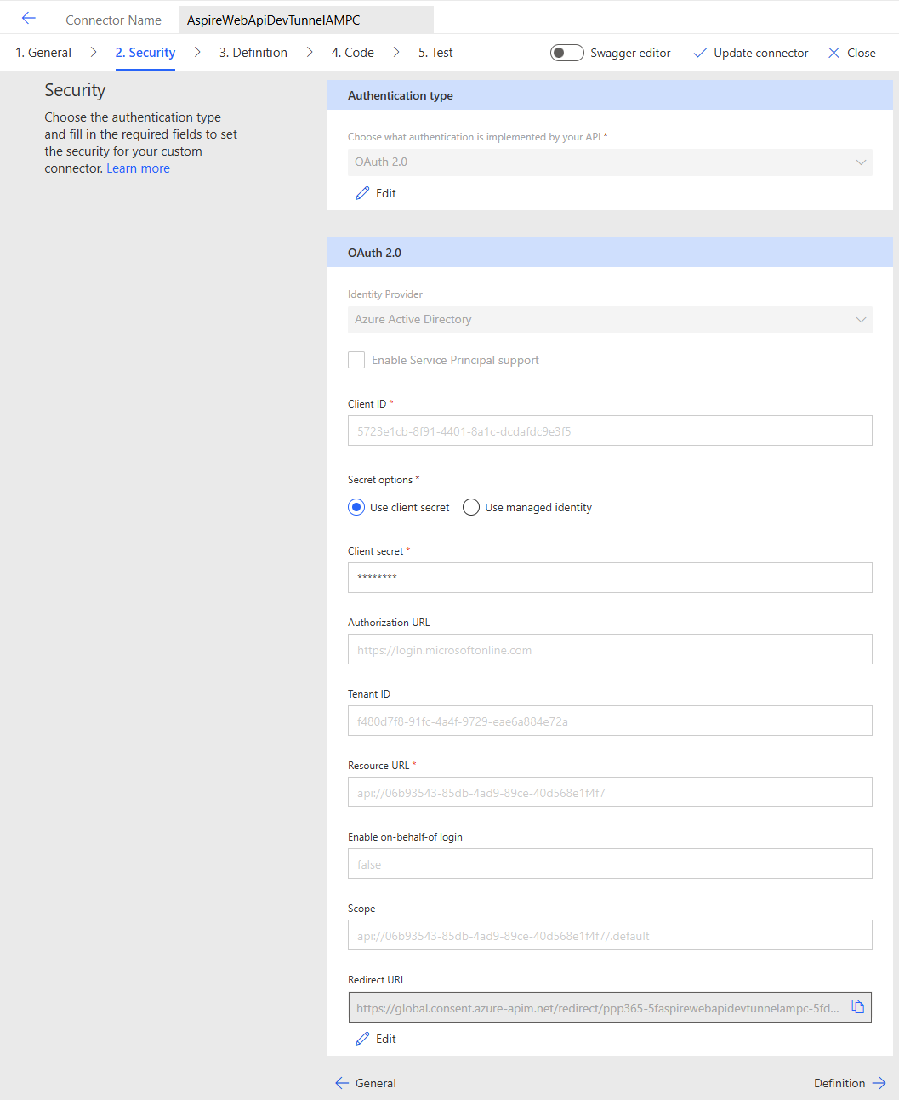 | 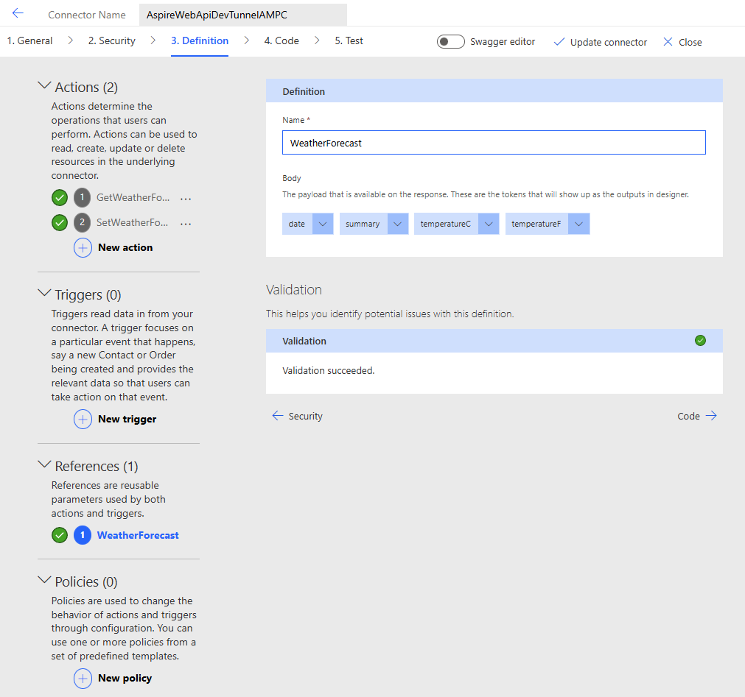 | 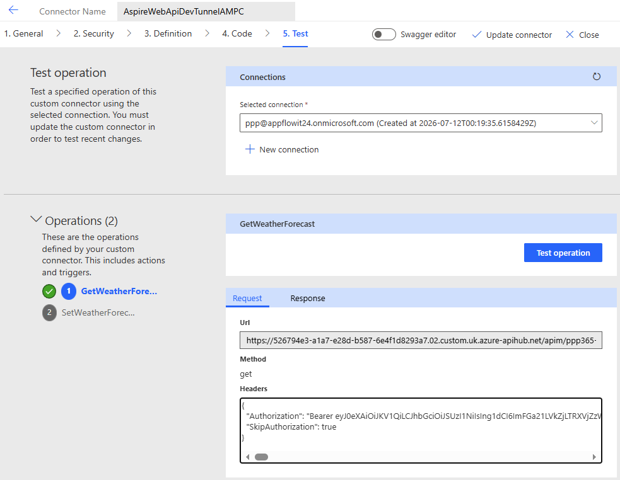
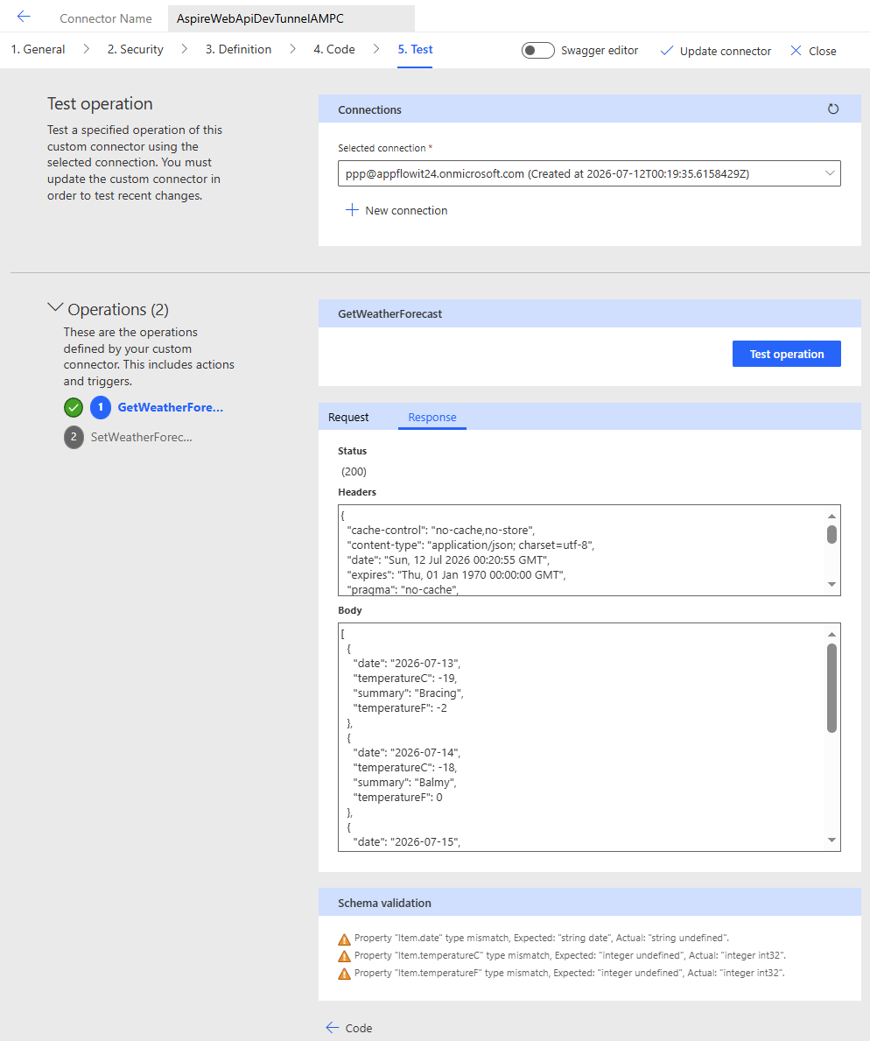 | 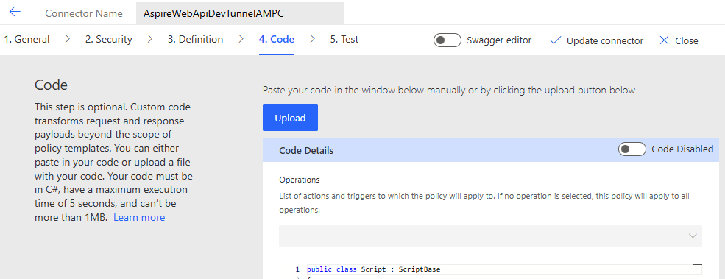  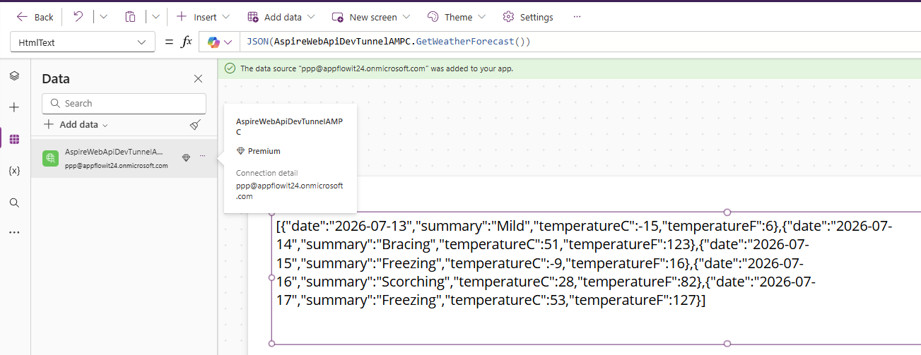
swagger: "2.0"  info:  title: AspireWebApiDevTunnelAMPC  description: >  This connector reaches out to AM'PC via Microsoft.DevTunnel Uri secured by  AppReg-AspireWebApiDevTunnelAMPC for an API served from Aspire.Hosting.ApiService.  version: "1.0"  host: z6stgr83-4999.uks1.devtunnels.ms  basePath: /  schemes:  - https  consumes:  - application/json  produces:  - application/json | paths:  /api/wf:  get:  summary: Get weather forecast  description: Returns a 5‑day weather forecast.  operationId: GetWeatherForecast  responses:  "200":  description: Successful response  schema:  type: array  items:  $ref: "#/definitions/WeatherForecast"  security:  - oauth2-auth:  - api://06b93543-85db-4ad9-89ce-40d568e1f4f7/.default  /api/wf/set:  post:  summary: Set weather forecast  description: Saves a weather forecast entry.  operationId: SetWeatherForecast  parameters:  - in: body  name: forecast  required: true  schema:  $ref: "#/definitions/WeatherForecast"  responses:  "200":  description: Successful response  schema:  $ref: "#/definitions/WeatherForecast"  security:  - oauth2-auth:  - api://06b93543-85db-4ad9-89ce-40d568e1f4f7/.default | definitions:  WeatherForecast:  type: object  properties:  date:  type: string  format: date  temperatureC:  type: integer  summary:  type: string  temperatureF:  type: integer  securityDefinitions:  oauth2-auth:  type: oauth2  flow: accessCode  authorizationUrl: https://login.microsoftonline.com/common/oauth2/authorize  tokenUrl: https://login.microsoftonline.com/common/oauth2/token  scopes:  api://06b93543-85db-4ad9-89ce-40d568e1f4f7/.default: Full access to AspireWebApi

The Architectural Scope of Azure API Management
APIM is not just an API gateway. It is a full API lifecycle platform with:
Gateway Layer  - Reverse proxy  - Routing  - Versioning  - Protocol translation  - CORS  - Rate limiting  - Quotas  - Caching  - JWT validation  - mTLS  - IP filtering  - Backend selection  - Load balancing | Developer Portal  - API documentation  - Try-it console  - Subscription keys  - Product bundles  - Developer onboarding  - Branding  - Self-service registration | Policy Engine (the real magic)  This is where most architects spend their time. APIM’s policy engine is the most powerful part:  - Validate JWT  - Extract claims  - Rewrite headers  - Transform payloads  - Inject variables  - Call external services  - Add caching  - Add retry logic  - Add circuit breakers  - Add logging  - Add correlation IDs  - Add conditional logic  - Add XML/JSON transformations  - Add SOAP → REST conversion  - Add GraphQL → REST bridging | Security & Identity  - OAuth2  - OpenID Connect  - Entra ID  - Client certificates  - Subscription keys  - IP restrictions  - Private endpoints  - VNET integration  - Managed identities | Deployment & Automation  - ARM templates  - Bicep  - Terraform  - GitHub Actions  - Azure DevOps  - CI/CD  - Versioning  - Revisions  - Multi-region deployment | Monitoring & Observability  - Azure Monitor  - Application Insights  - Logging  - Metrics  - Tracing  - Alerts  - Diagnostics | Hybrid & Multi-Cloud  - Self-hosted gateway  - Kubernetes integration  - On-premises gateway  - Private API exposure  - Multi-cloud routing | Cost & Governance  - Pricing tiers  - Consumption vs. Developer vs. Premium  - Multi-region replication  - Quotas  - API products  - Governance policies

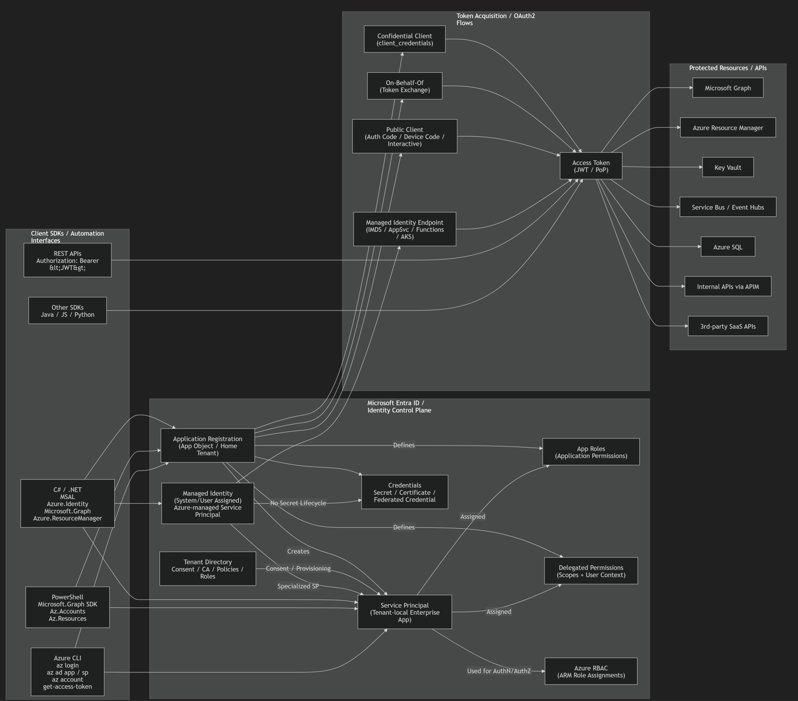
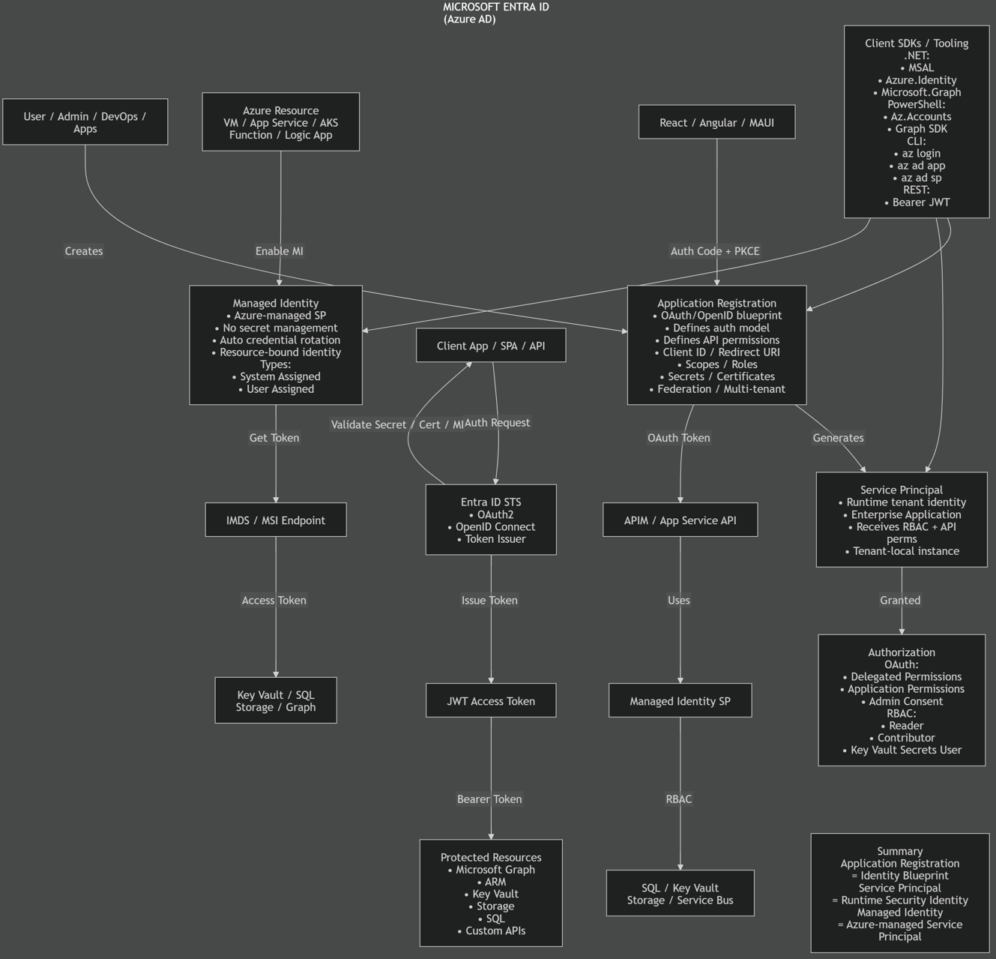

2026 Full Enterprise Feature Mapping | Client Apps  (Web / Mobile / SPA / MAUI / React)  ↓  Entra External ID  (Authentication + Federation + MFA)  ↓  APIM / Backend APIs  ↓  Microservices / Functions / AKS  ↓  Data + AI Layer  (SQL / Cosmos / Fabric / AI Foundry)  ↓  Governance + Security  (Purview + Sentinel + Defender + Key Vault) | Azure AD B2C was only/primarily:  - identity-centric  - authentication-centric  **Identity is now treated as a full enterprise security plane, not merely a login system.  The Microsoft architecture in 2026:  - identity + governance  - identity + security operations  - identity + data governance  - identity + AI-aware security  - zero-trust native  - cross-cloud / multi-SaaS governance
  Legacy Azure AD B2C Capability | 2026 Microsoft Stack
  Customer identity | Entra External ID
  Social login federation | Entra External ID
  Custom user journeys | Entra External ID + custom auth extensions
  MFA/passwordless | Entra ID Authentication Methods
  API authorization | Entra ID + OAuth2/OIDC
  Conditional access | Entra Conditional Access
  Identity governance | Microsoft Entra ID Governance
  Risk/adaptive auth | Microsoft Entra ID Protection
  Secrets/certs | Azure Key Vault
  API protection | Azure API Management
  Customer data governance | Microsoft Purview
  SIEM/SOC | Microsoft Sentinel
  Threat/XDR | Microsoft Defender XDR
  Audit/compliance | Purview + Sentinel + Entra logs
  Event-driven identity | Logic Apps + Event Grid + Functions
  Mobile/web auth SDKs | MSAL / Azure.Identity

