Sri Gouru. Neelakanta Reddy, _{B.Tech ., MISTE.,} Cell : 9440164412
Civil Engineering Consultant, Off : 9052589896
Approved Panel Valuer for: Off : 9440048100
A.P.G. Bank, State Bank of India, PNB, Door No:- 21/659,
Indian Bank, Canara Bank, Karnataka Bank, Beside L.G Show Room,
Union Bank of India, Bank of India, 7 Roads, Kadapa,
Central Bank of India, Indian Overseas Bank Y S R (Dist), A.P.
Axis Bank, HDFC Bank, ICICI Bank, Repco, LIC HFL. TPT
Indian Institution of Valuers F – 13622. FILE NO : 2603117
VALUATION REPORT

ANDHRA PRADESH GRAMEENA BANK
District : Y S R
Branch : POLICE LANE BRANCH, KADAPA
Date : 25-03-2026
“Sri Satya Sai Appartment”
Stilt, Ground Floor + 4 Upper Floors
Builder : - M/S KHAN INFRA TECH
MANAGING PARTNER :- Sri P.Inthyaj Khan S/o Sri P.SATHAR KHAN.
Applicant :
Sri P . Ravindra Reddy, S/o Sri P. Rami Reddy.
Middela Narasapuram, Kadapa Town, Y.S.R (Dt)
G.P.A. Deed No : 259/2022 As Per Agreement Extent : 0.91 Cents (Out Of 9.18 Cents)
Survey No’s : 347/2 & 350/4 Actual Net Extent : 0.82 Cents (Out Of 8.29 Cents)
Door No : 44/34-3-17 Flat No : 402 (Fourth Floor)

PLAN APPROVED UNDER : - B.A.NO : 1013/0240/B/KAD/CMPT/2022 Dt : 10-03-2022
Valuation Report of Residential Semi Finished Building In “Sri Satya Sai Apartment ” Flat No : 402, In Fourth Floor, Door No : 44/34-3-17, (Survey No.’s : 347/2 & 350/4), Prakruthi Nagar, Chemmumiahpeta Village Field At Kadapa Municipal Corporation of Y.S.R (Dt).

Valuation: Rs 53,04,000/-
(RUPEES FIFTY THREE LAKHS FOUR THOUSAND ONLY)
KADAPA MUNICIPAL CORPORATION Y.S.R (Dt).

VALUATION REPORT (IN RESPECT OF FLATS)
(To be filled in by the Approved Valuer)
I.GENERAL
1. | Purpose for which the valuation is made |  |  |  | : | Bank Purpose
2. | a) |  |  | Date of inspection | : | 24-03-2026
2. | b) |  |  | Date on which the valuation is made | : | 25-03-2026
3. | List of documents produced for perusal
3. | i) Sale Deed |  |  |  | : | Deed No.259/2022, Dt: 05-01-2022
3. | ii) Plan Approval |  |  |  | : | B.A.NO : 1013/0240/B/KAD/CMPT/2022 Dt : 10-03-2022
3. | iii) Regd. Market Value Certificate |  |  |  | : | Copy enclosed
4. | Name of the owner(s) and his/ their address (es) with phone no. ( details of share of each owner in case of joint ownership) |  |  |  | : | Applicant  Sri P . Ravindra Reddy,  S/o Sri P. Rami Reddy.  Middela Narasapuram, Kadapa Town, Y.S.R (Dt)
5. | Brief description of the property (Including leasehold/ freehold etc) |  |  |  | : | Free Hold
6. | Location of property
6. | a) | Survey No./ Plot No: |  |  | : | Survey No’s : 347/2 & 350/4
6. | b) | Door No. |  |  | : | Door No : 44/34-3-17,
6. | c) | T.S. No / Village |  |  | : | Chemmumiahpeta Village
6. | d) | Ward / Taluka |  |  | : | Ward No :- 44, Prakruthi Nagar,
6. | e) | Mandal / District |  |  | : | Kadapa Municipal Corporation  Of Y.S.R (Dt).
7. | Postal address of the property |  |  |  | : | In Site Door No : 44/34-3-17, (Survey No.’s : 347/2 & 350/4), Prakruthi Nagar, Chemmumiahpeta Village Field At Kadapa Municipal Corporation of Y.S.R (Dt).
8. | City / Town |  |  |  | : | Kadapa City
 | Residential Area |  |  |  | : | Yes
 | Commercial Area |  |  |  | : | --
 | Industrial Area |  |  |  | : | --
9. | Classification of the area |  |  |  | :
9. | i) |  | High / Middle / Poor |  | : | Middle
9. | ii) |  | Urban / Semi Urban / Rural |  | : | Urban
10. | Coming Under Corporation limit / Village panchayath / Municipality |  |  |  | : | Corporation Limits

11 | Whether Covered Under Any State / Central Govt. enactments (e.g. Urban Land Ceiling Act) or notified under agency Area / Scheduled Area / cantonment area |  | : | No
12 | In Case it is an Agricultural Land, any conversion to house site plots contemplated |  | : | NA
13 | Boundaries of the Property |  | :
13 | As Per Deed |  | : | As Per Deed
13 | East | 40 Feet Wide Road | : | 40 Feet Wide Road
13 | West | Site of Plot No: A.22 | : | Site of Plot No: A.22
13 | North | 50 Feet Wide Road | : | 50 Feet Wide Road
13 | South | Site of Plot No:- A.10 | : | Site of Plot No:- A.10
14.1 | Dimensions of the site
14.1 | As Per Deed |  | : | As Per Deed
14.1 | East | 50’0” (or) 15.25 m | : | 50’0” (or) 15.25 m
14.1 | West | 50’0” (or) 15.25 m | : | 50’0” (or) 15.25 m
14.1 | North | 80’0” (or) 24.40 m | : | 80’0” (or) 24.40 m
14.1 | South | 80’0” (or) 24.40 m | : | 80’0” (or) 24.40 m
14.1 | Extent | 372.10 Sqmt (or) 4000.00 Sqfts (or) 9.18 Cents |  | 372.10 Sqmt (or) 4000.00 Sqfts (or) 9.18 Cents
 | As Per Deed Total Extent : 372.10 Sqmt (or) 4000.00 Sqfts (or) 9.18 Cents
14.2 | Latitude and Longitude of the site |  | : | Latitude | 14.455887, 78.809609
14.2 |  |  | : | Longitude | 14.455887, 78.809609
15 | Extent of the site |  | : | 372.10 Sqmt (or) 4000.00 Sqfts (or) 9.18 Cents
16 | Extent of the Site Considered for valuation  (Least of 14A & 14B ) |  | : | 39.68 Sqyds (or) 0.82 Cents
17 | Whether occupied by the owner / tenant? If occupied by tenant, Since how long? Rent received per month. |  | : | Owner
II. | APARTMENT BUILDING
1. | Nature of the Apartment |  | : | Residential
2. | Location |  | : | Flat No :- 402, (Fourth Floor), Door No : 44/34-3-17,
 | T. S. No. |  | : | Survey No :- 347/2 & 350/4,
 | Block No. |  | : | “Sri Satya Sai Appartment”
 | Ward No. |  | : | Ward No:-44, Chemmumiahpeta Village Filed,
 | Village/ Municipality / Corporation |  | : | Kadapa Municipal Corporation
 | Door No., Street or Road (Pin Code) |  | : | Site Door No : 44/34-3-17, (Survey No.’s : 347/2 & 350/4), Prakruthi Nagar, Chemmumiahpeta At Kadapa Municipal Corporation of Y.S.R (Dt).
3. | Description of the locality Residential /  Commercial / Mixed |  | : | Residential
4. | Year of Construction |  | : | Under Construction
5. | Number of Floors |  | : | Stilt + GF + 4 Upper Floors
6. | Type of Structure |  | : | R.C.C. Framed
7. | Number of Dwelling units in the building |  | : | 10 Flats
8. | Quality of Construction |  | : | Good
9. | Appearance of the Building |  | : | Good
10 | Maintenance of the Building |  | : | Good
11 | Facilities Available |  | : | Yes
 | Lift |  | : | Yes
 | Protected Water Supply |  | : | Yes
 | Underground Sewerage |  | : | --
 | Car Parking - Open/ Covered |  | : | Open
 | Is Compound wall existing? |  | : | Yes
 | Is pavement laid around the Building |  | : | Yes
III | FLAT |  | :
1 | The floor on which the flat is situated |  | : | Fourth Floor
2 | Door No. of the flat |  | : | Flat No : 402,
 | Boundaries Of the Flat
 | North |  | : | Open to Sky
 | South |  | : | Open To Sky
 | East |  | : | Corridor, & Flat No : 401
 | West |  | : | Open To Sky
 | Dimensions of the Flat |  |  | As Per Deed |  |  | As Per Plan
 | North |  |  | 44.44 Sqyds (or) 0.91  Cents |  |  | 0.82 Cents (Out Of 8.29  Cents)
 | South
 | East
 | West
3 | Specifications of the flat |  | :
3 | Roof |  | : | R.C.C Roof
3 | Flooring |  | : | Tiles
3 | Doors |  | : | Wooden Doors
3 | Windows |  | : | Upvc Windows
3 | Fittings |  | : | Yes
3 | Finishing |  | : | Tiles
4 | House Tax |  | : | Yes
4 | Assessment No. |  | : | 1013105139
4 | Tax paid in the name of |  | : | M/s. Khan Infratech & Managing Partner,Pathan  Inthyaj Khan
4 | Tax amount |  | : | Rs. 3,807/-
5 | Electricity Service Connection no. |  | : | NA
5 | Meter Card is in the name of |  | : | NA
6 | How is the maintenance of the flat? |  | : | Good
7 | Sale Deed executed in the name of |  | : | Managing Partner : A . Yugandhar Reddy  S/o A . Venkata Subba Reddy
8 | What is the undivided area of land as per Sale Deed? |  | : | 39.68 Sqyds (or) 0.82 CENTS (As Per Plan)
9 | What is the plinth area of the flat? |  | : | 1475.00 Sqft
10 | What is the floor space index (app.) |  | :
11 | What is the Carpet Area of the flat? |  | : | 1253.75 Sqft
12 | Is it Posh/ I class / Medium / Ordinary? |  | : | I Class
13 | Is it being used for Residential or Commercial purpose? |  | : | Residential
14 | Is it Owner-occupied or let out? |  | : | Owner
15 | If rented, what is the monthly rent? |  | : | ---
IV | MARKETABILITY
1 | How is the marketability? |  | : | Good
2 | What are the factors favoring for an extra  Potential Value? |  | : | It Is Good Residential Area, All Civic  Amenities Are Very Near To In this Property, Like School, Colleges, Apartments, etc.,
3 | Any negative factors are observed which affect the market value in general? |  | : | No
V | Rate |  |  |  | :
1 | After analyzing the comparable sale instances, what is the composite rate for a similar flat with same specifications in the adjoining locality? - (Along with details/reference of at- least two latest deals/transactions with respect to adjacent properties in the areas) |  |  |  | : | -----
2 | Assuming it is a new construction, what is the adopted basic composite rate of the flat under valuation after comparing with the specifications and other factors with the flat under comparison  (give details). |  |  |  | :
3 | Break - up for the rate |  |  |  | :
3 | i) | Building/Flat + Services |  |  | : | Building = 1475.00 Sqft x Rs 2250.00 =  Rs 33,18,750/-
3 | ii) | Land + Others |  |  | : | = 39.68 Sqyds x Rs 47,520/- Sqyds  = Rs 18,85,593/-
4 | Guideline rate obtained from the Registrar's office(an evidence thereof to be enclosed) |  |  |  | : | Copy Enclosed

VI | COMPOSITE RATE ADOPTED AFTER DEPRECIATION
a. | Depreciated building rate | : | 0.00
 | Replacement cost of flat with Services {V (3)i} | : | Rs 33,18,750/-
 | Age of the building | : | 0.00
 | Remaining Life of the building | : | New One
 | Life of the building estimated | : | 60
 | Depreciation percentage assuming the salvage value as 0% per Year | : | Rs 33,18,750/-
 | Depreciated Ratio of the building | :
b. | Total composite rate arrived for valuation | :
 | Depreciated building rate VI (a) | : | Rs 33,18,750/-
 | Rate for Land & other V (3)ii | : | Rs 18,85,593/-
 | Total | : | Rs 52,04,343/-

Details of Valuation:
Sr.  No. | Description | Qty. | Rate per unit Rs. | Estimated Value  Rs.
1 | Present value of the flat | 1475.00/- Sqft | -- | Rs 52,04,343/-
 | Car Parking |  |  | Rs 1,00,000/-
2 | Wardrobes | -- | -- | --
3 | Showcases & Cupboards | -- | -- | --
4 | Kitchen Arrangements
5 | Superfine Finish |  |  | --
6 | Interior Decorations  (False Ceiling)
7 | Electricity deposits / electrical  fittings, etc.,
 | Extra collapsible gates / grill works  etc., | -- | -- | --
9 | Potential value, if any | -- | -- | --
10 | Others | -- | -- | --
Total |  |  |  | Rs 53,04,343,/-  Say Rs 53,04,000/-
(Valuation: Here, the approved valuer should discuss in details his approach (Market Approach, Income Approach and Cost Approach) to valuation of property and indicate how the value has been arrived at, supported by necessary calculation. Also, such aspects as impending threat of acquisition by government for road widening/ public service purposes, submerging & applicability of CRZ provisions (Distance from sea-coast/ tidal level must be incorporated)and their effect on i) Salability ii) Likely rental value in future and iii) any likely income it may generate may be discussed).

Photograph of owner/representative with property in background to be enclosed.
Screen shot of longitude/latitude and co-ordinates of property using GPS/Various Apps/Internet sites
As a result of my appraisal and analysis, it is my considered opinion that the present fair market value of the above property in the prevailing condition with aforesaid specifications is Rs. 53,04,000/- (Rupees Fifty Three Lakhs Four Thousands only).
The Realizable value of the above property is Rs.45,08,000/- (Rupees Forty Five Lakhs Eight Thousand only).
The distressed value Rs. 39,78,000/- (Rupees Thirty Five Lakhs Fifty Thousand only).

Place : Kadapa

Date : 25-03-2026

Signature

(Name and Official seal of the Approved Valuer)

The undersigned has inspected the property detailed in the Valuation Report dated
on . We are satisfied that the fair and reasonable market value of the property is Rs. (Rupees .
only).

Signature

(Name Of The Branch Manager)

Date :

Encl :

1. Declaration from the valuation in Format E (Annexure II of The Policy on the Valuation
of Property and Empanelment of Valuers).
2. Model code of conduct for Valuer (Annexure III of The Policy on Valuation of
Properties and Empanelment of Valuers).

Annexure-II
Format - E
DECLARATION FROM VALUERS

I hereby declare that-

- The information furnished in my valuation report dated 25-03-2026 is true and correct to the best of my knowledge and belief and I have made an impartial and true valuation of the property.

- I have no direct or indirect interest in the property valued;

- I have personally inspected the property on 24-03-2026 The work is not
sub- contracted to any other valuer and carried out by myself.

- I have not been convicted of any offence and sentenced to a term of Imprisonment;

- I have not been found guilty of misconduct in my professional capacity.

- I have read the Handbook on Policy, Standards and procedure for Real Estate
Valuation, 2011 of the IBA and this report is in conformity to the
“Standards” enshrined for valuation in the Part-B of the above handbook to the best
of my ability.

- I have read the International Valuation Standards (IVS) and the report submitted to
the Bank for the respective asset class is in conformity to the “Standards”
as enshrined for valuation in the IVS in “General Standards” and “Asset Standards”
as applicable.

- I abide by the Model Code of Conduct for empanelment of valuer in the Bank. (Annexure III- A signed copy of same to be taken and kept along with this declaration)

- I am registered under Section 34 AB of the Wealth Tax Act, 1957 - Yes

j. I am the proprietor / partner / authorized official of the firm / company,
who is competent to sign this valuation report.

k. Further, I hereby provide the following information:

Sl. No. | Particulars | Valuer comment
1 | background information of the asset being valued; | 1) 0.82 Cents of freehold land belonging to the client. This House bearing In Site Survey No’s: In Site Door No : 44/34-3-17, (Survey No.’s : 347/2 & 350/4), Prakruthi Nagar, Chemmumiahpeta Village Field At Kadapa Municipal Corporation of Y.S.R (Dt).
2 | Purpose of valuation and the appointing authority | For collateral security. The Manager, APGB, Police Lane Branch, Kadapa, Y.S.R (Dt).
3 | identity of the valuer and any other experts involved in the valuation; | I am Govt. Registered valuer
4 | disclosure of valuer interest or conflict, if any; | I does not any current or contemplated future financial interest in the property appraised.
5 | Date of appointment, valuation date and date of report; | Date of appointment : 24-03-2026,  Valuation date : 25-03-2026,  Date of report : 25-03-2026.
6 | inspections and / or investigations undertaken; | In the inspection of the property measurements are taken, and boundaries enquired etc.,
7 | nature and sources of the information used or relied upon; | Sufficient information has been assembled by means of inspection, enquiry, computation and analysis to ensure that the valuation is properly supported. Sources of information are:  1.Land area statement provided by the client. 2.Google locations. 3.Investigation of surrounding land property prices.
8 | procedures adopted in carrying out the valuation and valuation standards followed; | Land & building method. This report is prepared in accordance with International Valuation Standards.
9 | restrictions on use of the report, if any; | The report is used for the mentioned and intended use only. It should not be used for legal purposes.
10 | major factors that were taken into account during the valuation; | Not found any
11 | major factors that were not taken into account during the valuation; | Not found any
12 | Caveats, limitations and disclaimers to the extent they explain or elucidate the limitations faced by valuer, which shall not be for the purpose of limiting his responsibility for the Valuation report. | Please refer to legal opinion.

Date : 25-03-2026
Place: Kadapa Signature of the Valuer

Annexure-III
MODEL CODE OF CONDUCT FOR VALUERS
Integrity and Fairness
- A valuer shall, in the conduct of his/ its business, follow high standards of integrity and fairness in all his / its clients and other valuers.

- A valuer shall maintain integrity by being honest, straight forward, and forthright in all professional relationships.

- A valuer shall endeavour to ensure that he/ I provides true and adequate information and shall not misrepresent any facts or siuations.

- A valuer shall refrain from being involved in any action that would bring disrepute to the profession.

- A valuer shall keep public interest foremost while delivering his services.

Professional Competence and Due Care

- A valuer shall render at all times high standards of service, exercise due diligence, ensure proper care and exercise independent professional judgement.
- A valuer shall carry out professional services in accordance with the relevant technical and professional standards that may be specified from time to time.
- A valuer shall continuously maintain professional knowledge and skill to provide competent professional service based on up-to-date developments in practice, prevailing regulations / guidelines and techniques.
- In the preparation of a valuation report, the valuer shall not disclaim liability for his/ its expertise or deny his/ its duty of care, except to the extent that the assumptions are based on statements of fact provided by the company or its auditors or consultants or information available in public doain and not generated by the valuer.
- A valuer shall not carry out any instruction of the client insofar as they are incompatible with the requirements of integrity, objectivity and independence.
- A valuer shall clearly state to his client the services that would be competent to provide and the services for which the client can have a separate arrangement with other valuers.
Independence and Disclosure of Interest
- A valuer shall act with objectivity in his/ its professional dealings by ensuring that his/ its decisions are made without the presence of any bias, conflict of interest, coercion, or undue influence of any party, whether directly connected to the valuation assignment or not.

- A valuer shall not take up an assignment if he/ it or any of his/its relatives or associates is not independent in terms of association to the company.

- A valuer shall maintain complete independence in his/ its professional relationships and shall conduct the valuation independent of external influences.

- A valuer shall wherever necessary disclose to the clients , possible sources of conflicts of duties and interests , while providing unbiased services.

- A valuer shall not deal in securities of any subject company after any time when he/it first becomes aware of the possibility of his/its association with the valuation, and in accordance with the Securities and Exchange Board of India (Prohibition of Insider Trading ) Regulations, 2015 or till the time the valuation report becomes public, whichever is earlier.
- A valuer shall not idulge in ‘‘Mandate snatching’’ or offering ‘‘convenience valuations’’ in order to cater to a company or client’s needs.

- As an independent valuer, the valuer shall not charge success fee.
- In any fairness opinion or independent expert opinion submitted by a valuer, if there has been a prior engagement in an unconnected transaction, the valuer shall declare the association with the company during the last five years.
Confidentiality
- A valuer shall not use or divulge to other clients or any other party any confidential information about the subject company, which has come to his/ its knowledge without proper and specific authority or unless there is a legal or professional right or duty to disclose.
Information Management
- A valuer shall ensure that he /it maintains written contemporaneous records for any decision taken, the reasons for taking the decision, and the information and evidence in support of such decision. Ths shall be maintained so as to sufficiently enable a reasonable person to take a view on the appropriateness of his /its decisions and actions.
- A valuer shall appear, co-operate and ba available for inspections and investigations carried ourt by the authority, any person authorized by the authority, the registered valuers organization with which he/ it is registered or any ther statutory regulatory body.
- A valuer shall provide all information and recorde as may be required by the authority, the Tribunal, Appellate Tribunal, the registered valuers organization with which he /it is registered , or any other statutory regulatory body.
- A valuer while respecting the confidentiality of information acquired during the course of performing professionall services, shall maintain proper working papers for a period of three years or such ;onger period as required in its contract for a specific valuation, for production before a regulatory authority or for a peer review.In the event of a pending case before the Tribunal or Appellate Tribunal, the record shall be maintained till yhe disposal of the case.
Gifts and Hospitality
- A valuer or is/ its relative shall not accept gifts or hospitality which undermines or affects his independence as a valuer.
Explanation: For the purposes of this code the term ‘relative’ shall have the same meaning as defined in clause (77) of Section 2 of the Companies Act, 2013 (18 of 2013).
- A valuer shall not offer gifts or hospitality or a financial or any other advantage to a public servant or any other perso with a view to obtain or retain work for himself/ itself, or to obtain or retain an advantage in the conduct of profession for himself/ itself.
Remuneration and Costs.
- A valuer shall provide services for remuneration which is charged in a transparent manner, is a reasonable reflection of the work necessarily and properly undertaken, and is not inconsistent with the applicable rules.
- A valuer shall not accept any fees or charges other than those which are disclosed in a written contract with the person to whom he would be rendering service.
Occupation, employability and restrictions.
- A valuer shall refrain from accepting too many assignments, if he/ it is unlikely to be able to devote adequate time to each of his/ its assignments
- A valuer shall not conduct business which in the opinion of the authority or the registered valuer organization discredits the profession.

Place : Kadapa
Date : 25-03-2026 Signature
(Name and Official seal of the Approved Valuer)

LOCATION - MAP

Way to Builtop

I.T.I.Circle

Way to Sandhya Circle

Indian Oil Petrol Bunk

Over bridge

PROPERTY
Prakruthi Nagar

Rayachoty Road

Photo’s
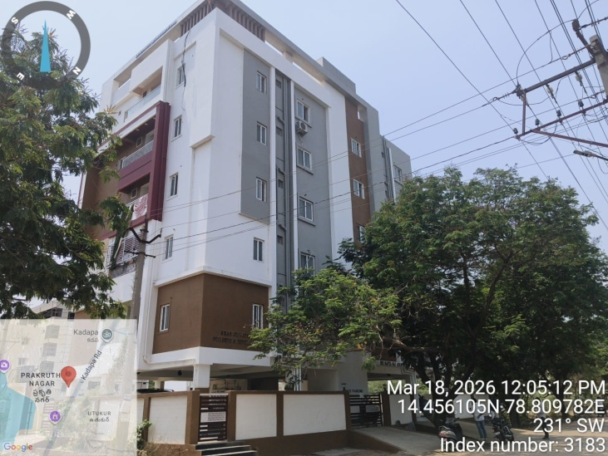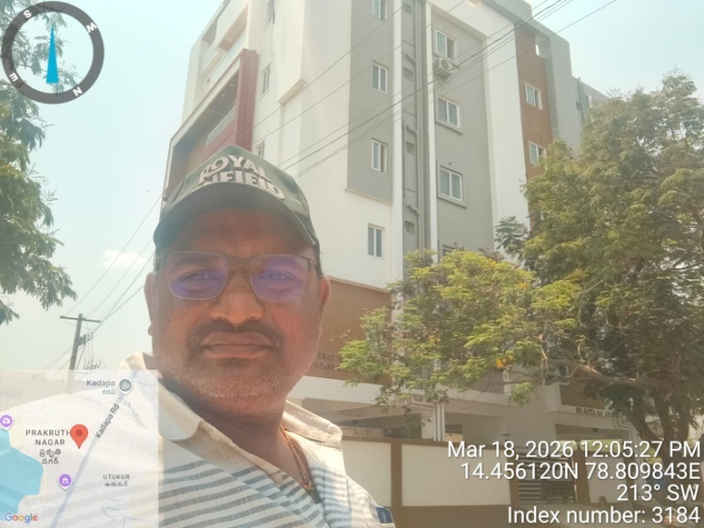

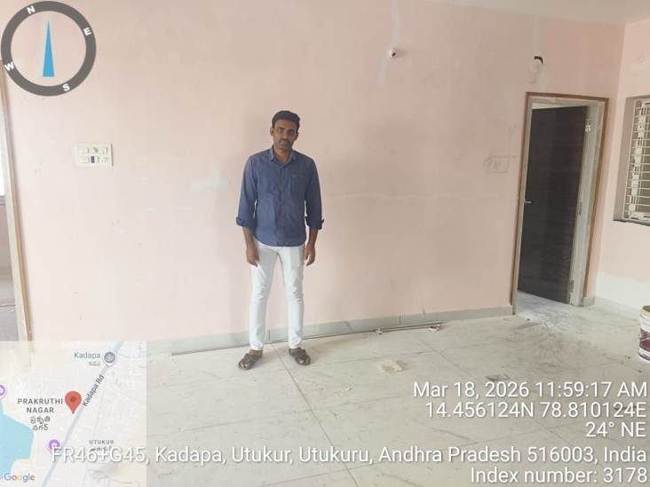

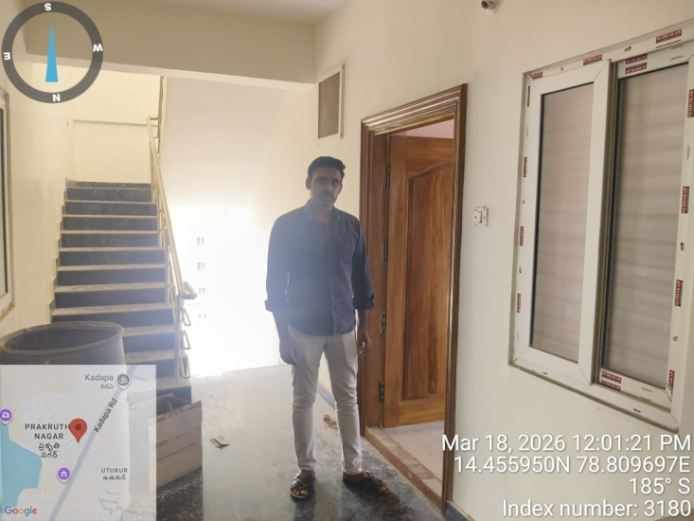

Google - Map’s

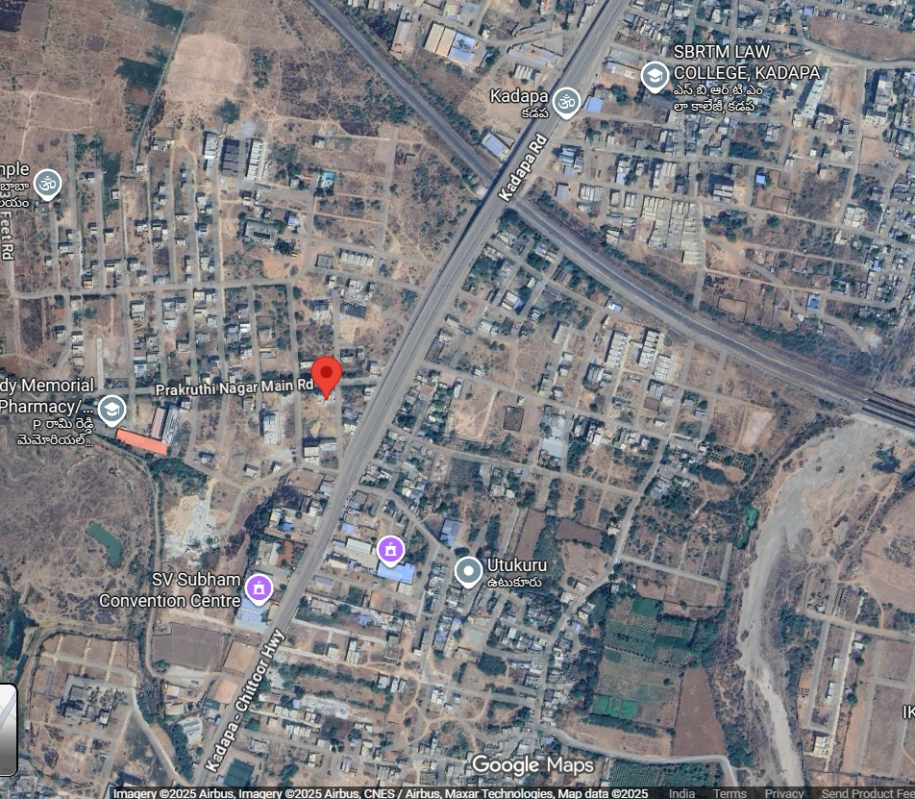

14°27'21.2"N 78°48'34.6"E

14.455887, 78.809609

Sri Gouru. Neelakanta Reddy , _{B.Tech ., MISTE.,} Cell : 9440164412
Civil Engineering Consultant , Off : 9052589896
Approved PANEL Valuer for : Off : 9440048100
A.P.G.Bank , State Bank of India , Door No :- 21/659,
Indian Bank, Canara Bank, Bank of Baroda, Beside Airtel Room,
Union Bank Of India, Bank of India , 7 Roads, Kadapa,
Central Bank Of India, Indian Overseas Bank, Y S R (Dist) , A.P.
Axis Bank, Hdfc Bank, ICICI Bank, Repco, LIC HFL. TPT & RPR
Indian Institution of Valuers F – 13622. FILE NO - 2603117

ADDITIONS WORK
ESTIMATION FOR THE PROPOSED ADDITIONS TO THE CONSTRUCTION OF Residential Semi Finished Building In “Sri Satya Sai Apartment ” Flat No : 402, In Fourth Floor, Door No : 44/34-3-17, (Survey No.’s : 347/2 & 350/4), Prakruthi Nagar, Chemmumiahpeta Village Field At Kadapa Municipal Corporation of Y.S.R (Dt).
BY : Applicant :-
Sri P . Ravindra Reddy, S/o Sri P. Rami Reddy.
S.No Description of work Rate / per Amount
1) PROPOSED TO PROVIDE SHOW CASE INCLUDING MATERIAL COST AND CONVEYANCE OF ALL MATERIAL & LABOUR CHARGES..,
1 1,50,000.00 Rs 1,50,000.00
2) PROPOSED TO PROVIDE WARD ROBES INCLUDING MATERIAL COST AND CONVEYANCE OF ALL MATERIAL & LABOUR CHARGES..,
3 1,50,000.00 Rs 4,50,000.00
3) PROPOSED TO PROVIDE KICTHEN RACKS INCLUDING MATERIAL COST AND CONVEYANCE OF ALL MATERIAL & LABOUR CHARGES..,
1 Rs 75,000.00
4) PROPOSED TO PROVIDE KITCHEN PLOT FORM , INCLUDING COST OF AND CONVEYANCE OF MATERIAL AND LABOUR CHARGES COMPLETELY
1 Rs 30,000.00
5) PROPOSED TO PROVIDE POP (FALSE CEILING) INCLUDING MATERIAL COST AND CONVEYANCE OF ALL MATERIAL & LABOUR CHARGES.,
1 Rs 1,80,000.00

<<< 2 >>>
6) PROPOSED TO PROVIDE SAFETY GRILL & SAFETY GRILL IN DOOR AND WINDOWS INCLUDING MATERIAL COST AND CONVEYANCE OF ALL MATERIAL & LABOUR CHARGES.,
L.S Rs 1,40,000.00
7) PROPOSED TO PROVIDE BATH ROOM WALL TILES & FLOOR TILES IN BATH ROOMS INCLUDING MATERIAL COST AND CONVEYANCE OF ALL MATERIAL & LABOUR CHARGES.,
2 Rs 50,000/- Rs 1,00,000.00
8) PROPOSED TO PROVIDE SANITARY ARRANGEMENTS & FITTINGS INCLUDING MATERIAL COST AND CONVEYANCE OF ALL MATERIAL & LABOUR CHARGES.,
Rs 6,00,000/- Rs 6,00,000.00
9) PROPOSED TO PROVIDE PAINT WORK INCLUDING MATERIAL COST AND CONVEYANCE OF ALL MATERIAL & LABOUR CHARGES.,
Rs 2,50,000/- Rs 2,50,000.00

TOTAL = Rs 19,75,000.00
Say Rs 19,75,000.00
( RUPEES NINETEEN LAKHS SEVENTY FIVE THOUSAND ONLY)

PLACE : KADAPA
DATE : 25-03-2026

The undersigned have inspected the property detailed in the valuation report dated on we are satisfied that the fair and reasonable value of the property is Rs

(Rupees only)

FIELD OFFICER: Manager of the Division / Branch Manager

