Sri Gouru. Neelakanta Reddy, _{B.Tech, MISTE,} Cell : 9440164412
Civil Engineering Consultant, Off : 9052589896
Approved Panel Valuer for: Off : 9440048100
A.P.G. Bank, State Bank of India, Door No :- 21/659,
Indian Bank, Canara Bank, Beside L.G Show Room,
Union Bank of India, Bank of India, 7 Roads, Kadapa,
Central Bank of India, Indian Overseas Bank Y S R (Dist), A.P.
Axis Bank, HDFC Bank, ICICI Bank, Repco, LIC HFL. SYS & TPT
Indian Institution of Valuers F – 13622. FILE NO: 2605115
VALUATION REPORT

ANDHRA PRADESH GRAMEENA BANK
District : Y.S.R
Branch : POLICE LANE BRANCH, KADAPA
Date : 25-05-2026
Belongs to :-
Sri M. Subba Naik, S/o Sri M. Jamla Naik (late).
Door No : 44/37-4-15, Co-Operative Colony, Kadapa, Y.S.R (Dt).

Deed No : 4004/2016 Net Extent : 2.83 Cents
Door No : 44/37-4-15 Survey No : 343
Plot No : 22(part) & 23 (part)

Plan Approved Under B.A.No : 1013/0114/B/KAD/CMPT/2021, Dt : 12-02-2021.

Valuation Report of Residential Building (GF) In Site Survey No : 343, Door No : 44/37-4-15, Plot No : 22(part) & 23 (part), Ward No : 44, In Western side of Rayachoty Road, Near Turning Point Coaching Center ,Chemmumiahpeta Village Field At Kadapa Municipal Corporation of Y.S.R (DT).

Valuation: Rs 87,14,000/-
(RUPEES EIGHTY SEVEN LAKHS FOURTEEN THOUSAND ONLY)
KADAPA MUNICIPAL CORPORATION Y.S.R (DT).

VALUATION REPORT (IN RESPECT OF LAND / SITE AND BUILDING)
I.GENERAL
1. | Purpose for which the valuation is made |  |  |  | : | Bank Purpose
2. | a) |  |  | Date of inspection | : | 23-05-2026
2. | b) |  |  | Date on which the valuation is made | : | 25-05-2026
3. | List of documents produced for perusal
3. | i) Sale Deed |  |  |  | : | Deed No:4004/2016, Dt :30-08-2016
3. | ii) Plan Approval |  |  |  | : | B.A. No : 1013/0114/B/KAD/CMPT/2021, Dt : 12-02-2021
3. | iii) Regd. Market Value Certificate |  |  |  | : | Copy enclosed
4. | Name of the owner(s) and his/ their address (es) with phone no. ( details of share of each owner in case of joint ownership) |  |  |  | : | Belongs to:  Sri M. Subba Naik,  S/o Sri M. Jamla Naik (late).  Door No : 44/37-4-15, Co-Operative Colony, Kadapa, Y.S.R (Dt).
5. | Brief description of the property (Including leasehold/ freehold etc) |  |  |  | : | Free Hold
6. | Location of property
6. | a) | Survey No./ Plot No: |  |  | : | Survey No : 343,
6. | b) | Door No. |  |  | : | Door No : 44/37-4-15
6. | c) | T.S. No / Village |  |  | : | Chemmumiahpeta Village Field,
6. | d) | Ward / Taluka |  |  | : | Ward No :- 44, In Western side of Rayachoty Road, Near Turning Point Coaching Center
6. | e) | Mandal / District |  |  | : | Kadapa Municipal Corporation Of Y.S.R (Dt).
7. | Postal address of the property |  |  |  | : | In Site Survey No : 343, Door No : 44/37-4-15, Plot No : 22(part) & 23 (part), Ward No : 44, In Western side of Rayachoty Road, Near Turning Point Coaching Center, Chemmumiahpeta Village Field At Kadapa Municipal Corporation of Y.S.R (DT).
8. | City / Town |  |  |  | : | Kadapa City
 | Residential Area |  |  |  | : | Yes
 | Commercial Area |  |  |  | : | --
 | Industrial Area |  |  |  | : | --
9. | Classification of the area |  |  |  | :
9. | i) |  | High / Middle / Poor |  | : | Middle
9. | ii) |  | Urban / Semi Urban / Rural |  | : | Urban

10. | Coming Under Corporation limit / Village Panchayath / Municipality |  |  | : | Corporation Limits
11 | Whether Covered Under Any State / Central Govt. enactments (e.g. Urban Land Ceiling Act) or notified under agency Area / Scheduled Area / cantonment area |  |  | : | No
12 | In Case it is an Agricultural Land, any conversion to house site plots contemplated |  |  | : | NA
13 | Boundaries of the Property |  |  | :
13 | As Per Deed No |  |  | : | Actual on the Ground
13 | East |  | House Constructed in Plot No : 36 & 37 | : | House Constructed in Plot No : 36 & 37
13 | West |  | 30 Links Wide Road | : | 30 Links Wide Road
13 | North |  | Site Of A . Subba Chandraiah Remaining Site In Plot No : 23 | : | Site Of A . Subba Chandraiah Remaining Site In Plot No : 23
13 | South |  | Site Of M . Raghu Natha Naik Remaining Site In Plot No : 22 | : | Site Of M . Raghu Natha Naik Remaining Site In Plot No : 22
14.1 | Dimensions of the site
14.1 | As Per Deed No |  |  |  | Actual on the Ground
14.1 | East |  | 33.33 Links (or) 6.70 m | : | 33.33 Links (or) 6.70 m
14.1 | West |  | 33.33 Links (or) 6.70 m | : | 33.33 Links (or) 6.70 m
14.1 | North |  | 93.00 Links (or) 18.71 m | : | 93.00 Links (or) 18.71 m
14.1 | South |  | 92.00 Links (or) 18.51 m | : | 92.00 Links (or) 18.51 m
14.1 | Extent |  | 124.62 Sqmts (or) 149.21 Sqyds (or) 3.08 Cents | : | 124.62 Sqmts (or) 149.21 Sqyds (or) 3.08 Cents
 | As Per Plan Net Extent |  |  | : | 114.57 Sqmts (or) 2.83 Cents
14.2 | Latitude and Longitude of the site |  |  | : | Latitude | 14.448828, 78.806303
14.2 |  |  |  | : | Longitude | 14.448828, 78.806303
15 | Extent of the site |  |  | : | 124.62 Sqmts (or) 149.21 Sqyds (or) 3.08 Cents
16 | Extent of the Site Considered for valuation  (Least of 14A & 14B ) |  |  | : | 114.57 Sqmts (or) 2.83 Cents
17 | Whether occupied by the owner / tenant? If occupied by tenant, Since how long? Rent received per month. |  |  | : | Owners
II. | CHARCTERISTICS OF THE SITE
1. | Classification of the locality |  |  | : | Middle
2. | Development of surrounding areas |  |  | : | Residential
3. | Possibility of frequent flooding / sub-merging |  |  | : | Nil
4. | Feasibility to the civic amenities like school, hospital, bus stop , market etc. |  |  | : | At Walkable Distance
5. | Level of land with topographical conditions |  |  | : | Level of Ground
6. | Shape of the land |  |  | : | Trapezoidal
7. | Type of use to which it can be put |  |  | : | Residential
8. | Any usage restriction |  |  | : | Nil
9. | Is plot in town planning approved layout? |  |  | : | Not Approved
10. | Corner plot or intermittent plot? |  |  | : | Intermittent Plot
11. | Road facilities |  |  | : | Provided
12 | Type of road available at present |  |  | : | Metal Road
13 | Width of road – is it below 20ft. or more than 20ft. |  |  | : | 20’0” Wide Road
14. | Is it land – locked land? |  |  | : | No
15. | Water potentially |  |  | : | Adequate Corporation Tap
16. | Underground Sewerage System |  |  | : | Yes
17. | Is power supply available at the site? |  |  | : | Provided
18. | Advantages of the site |  |  | :
 | 1. |  |  |  | Medium demand locality
 | 2.
19. | Special remarks , if any , like threat of acquisition of land for public service purposes, road widening or applicability of CRZ provisions etc. (Distance From Sea-Coast / tidal level must be incorporated) |  |  |  | Nil
Part –A ( Valuation of land)
1. | Size of plot |  |  | : | Trapezoidal
1. | North & South |  |  | : | 124.62 Sqmts (or) 149.21 Sqyds (or) 3.08 Cents
1. | East & West |  |  | :
2. | Total extent of the plot |  |  | : | 124.62 Sqmts (or) 149.21 Sqyds (or) 3.08 Cents
 | Net Extent Of The Plot ( As Per Plan) |  |  |  | 114.57 Sqmts (or) 2.83 Cents
3. | Prevailing market rate ( along with details / reference of at least two latest deals / transactions with respect to adjacent properties in the areas) |  |  | : | Rs 14,25,000/- Per Cent
4. | Guideline rate obtained from the Registrar’s Office |  |  | : | Rs 12,000/- Sqyds
5. | Assessed / adopted rate of valuation |  |  | : | 2.83 Cent X Rs 14,25,000/- Cent
6 | Estimated value of land |  |  | : | Rs 40,32,750/-

PART –B (VALUATION OF BUILDING )
1. |  | Technical details of the building
 |  | a) | Type of building ( Residential / Commercial / Industrial) |  | : | Residential
 |  | b) | Type of Construction ( Load bearing / RCC / Steel Framed) |  | : | Rcc Framed Structure
 |  | c) | Year of Construction |  | : | 2021
 |  | d) | Age Of The Building |  | : | 05 Years
 |  | e) | Remaining Life Of Structure |  | : | 55 Years
 |  |  | Total Life Of the Building |  | : | 60 Years
 |  | f) | Number of floors and height of each floor including basement, if any |  | : | GF (0.45 Basement)
 |  | g) | Plinth area floor -wise |  | :
 |  |  | Plinth Area
 |  |  | As per Plan |  |  | As Per Actual
 |  |  | GF = 68.09 Sqmts (or) 733.00 Sqfts  FF = 68.09 Sqmts (or) 733.00 Sqfts |  |  | GF = 68.09 Sqmts (or) 733.00 Sqfts  FF = 68.09 Sqmts (or) 733.00 Sqfts
 |  |  | Carpet Area
 |  |  | As per Plan |  |  | As Per Actual
 |  |  | G F & FF = 623.00 Sqft |  |  | G F & FF = 623.00 Sqft
 | f) |  | Condition of the building |  | :
 |  |  | i) | Exterior – Excellent, Good, Normal, Poor | : | Good
 |  |  | ii) | Interior- Excellent, Good, Normal, Poor | : | Good
 | g) |  | Date of issue and validity of layout of approved map/Plan |  |  | B.A. No : 1013/0114/B/KAD/CMPT/2021, Dt : 12-02-2021
 | h) |  | Approved map/ plan issuing authority |  |  | Municipal Commissioner
 | i) |  | Whether genuineness or authority of approve map / plan is verified |  |  | YES
 | j) |  | Any other comments by our empanelled valuers on authority of approved plan |  |  | NA
Specifications of Construction (floor-Wise) in respect of
S.No | Description |  |  | Ground floor |  | Second floors
1. | Foundation |  |  | R.C.C Framed Isolated Footing
2. | Basement |  |  | R.R. Stone Masonry
3. | Superstructure |  |  | Brick Masonry in C.M(1:5)
4. | Joinery / Doors & Windows (please furnish details) About size of frames, shutters, glazing, fitting etc. and specify the of timber) |  |  | Rolling Shutter
5. | RCC Works |  |  | Rcc Roof
6. | Plastering |  |  | Cement Plastering
7. | Flooring, Skirting, demoing |  |  | Granite
8. | Special finish as marble, granite, wooden paneling, grills, etc |  |  | No
9. | Roofing including weather proof course |  |  | NA
10 | Drainage |  |  | Provided
S.No | Description |  |  |  | GF floor
1. | Compound wall |  | : |  | Yes
1. | Height |  | : |  | ---
1. | Length |  | : |  | ---
1. | Type of Construction |  | : |  | ---
2. | Electrical installation |  | :
2. | Type of Wiring |  | : |  | CTS & CONCELED
2. | Class of fittings ( Superior / ordinary/ poor) |  | : |  | ORDINARY
2. | Number of light points & Fan points |  | : |  | ADEQUATE
2. | Spare plug points |  | : |  | PROVIDED
2. | Any other item |  | : |  | MAIN SWITCHES
3. | Plumbing installation
3. | a) | No. of water closets and their type | : |  | NA
3. | b) | No. of wash basins | : |  | NA
3. | c) | No. of urinals | : |  | ---
3. | d) | No. of bath tubs | : |  | ---
3. | e) | Water meter , taps, etc. | : |  | NA
3. | f) | Any other fixtures | : |  | ---
Details of Valuation
S.No | Particulars of item | Plinth area | Roof height | Age of building | Estimated replacement rate of Construction Rs. | Replacement cost  Rs. | Depreciation  Rs. | Net value after depreciation  Rs.
1 | Ground Floor | 733.00 Sqft | 10’ | 5  Years | Rs 2500/- | Rs 18,32,500/- | Rs (-5%) 91,625/- | Rs 17,40,875/-
2 | First Floor | 733.00 Sqft | 10’ | 5  Years | Rs 2500/- | Rs 18,32,500/- | Rs (-5%) 91,625/- | Rs 17,40,875/-
Total |  |  |  |  |  |  |  | RS 34,81,750/-
Part C – (Extra Items) (Amount In Rs.)
1. | Portico | : | Rs 1,00,000/-
2. | Ornamental front door | : | ---
3. | Sit out/ verandah with steel grills | : | ---
4. | Over head Water tank | : | ---
5. | Extra steel / Collapsible gates | : | ---
 | Total | : | Rs 1,00,000/-

Part D – (Amenities) (Amount In Rs.)
1. | Wardrobes | : | Rs 4,00,000/-
2. | Glazed tiles | : | Rs 0.00
3. | Extra sinks and bath tub | : | ---
4. | Marble / Ceramic tiles flooring | : | ---
5. | Interior decorations | : | Rs 1,50,000/-
6. | Architectural elevation works | : | ---
7. | Paneling works | : | ---
8. | Aluminum works | : | ---
9. | Aluminum hand rails | : | Rs 0.00
10. | False ceiling | : | Rs 2,50,000/-
11. | Parking Flooring with rough tiles |  | ---
 | Total | : | Rs 8,00,000/-
Part E – (Miscellaneous) (Amount In Rs.)
1. | Separate toilet room | : | ---
2. | Separate lumber room | : | ---
3. | Separate water tank / Sump | : | ---
4. | Trees, gardening | : | ---
 | Total | : | ---
Part F – (Services) (Amount In Rs.)
1. | Water supply arrangements | : | Rs 1,00,000/-
2. | Drainage arrangements | : | Rs 1,00,000/-
3. | Compound wall | : | --
4. | C.B. deposits, fittings etc. | : | Rs 1,00,000/-
5. | Pavement | : | --
6 | Lift |  | --
 | Total | : | Rs 3,00,000/-
Total abstract of the entire property

Part -A | Land | : | Rs. 40,32,750/-
Part -B | Building | : | Rs. 34,81,750/-
Part -C | Extra Items | : | Rs. 1,00,000/-
Part -D | Amenities | : | Rs. 8,00,000
Part -E | Miscellaneous | : | Rs. 0.00
Part -F | Services | : | Rs. 3,00,000/-
 | Total | : | Rs. 87,14,500/-
 | Say As | : | Rs 87,14,000/-

(Valuation: Here the approved valuer should discuss in detail his approach to valuation of property and indicate how the value has been arrived at, supported by necessary calculations. Also, such aspects as i) Salability ii) Likely rental values in future in iii) Any likely income it may generate, may be discussed).
Valuation Of the property
Fair Market Value Of The Property | Rs 87,14,000/-
Realizable Value of the property  (90 % of the Fair Market Value of the Property) | Rs 78,42,000/-
Distress Sale Value of the Property (80 % of the Fair Market Value of the Property | Rs 69,71,000/-

Photograph of owner/representative with property in background to be enclosed.
Screen shot of longitude/latitude and co-ordinates of property using GPS/Various Apps/Internet sites
As a result of my appraisal and analysis, it is my considered opinion that the present fair market value of the above property in the prevailing condition with aforesaid specifications is
Rs 87,14,000/- (Rupees Eighty Seventy Lakhs Fourteen Thousand Only),
The Book Value of the above Property as of 5,77,000/-
Net Realizable Value of the Above Property is Rs 78,42,000/- (Rupees Seventy Eight Lakhs Forty Two Thousand Only).
Distress Value of the Above Property is
Rs 69,71,000/- (Rupees Sixty Nine Lakhs Seventy One Thousand Only).

Place : Kadapa

Date : 25-05-2026

Signature

(Name and Official seal of the Approved Valuer)

The undersigned has inspected the property detailed in the Valuation Report dated
On . We are satisfied that the fair and reasonable market value of the property is Rs. (Rupees .
Only).

Signature

(Name Of The Branch Manager)

Date :

Encl :

1. Declaration from the valuation in Format E (Annexure II of The Policy on the Valuation
of Property and Empanelment of Valuers).
2. Model code of conduct for Valuer (Annexure III of The Policy on Valuation of
Properties and Empanelment of Valuers).

Annexure-II
Format - E
DECLARATION FROM VALUERS

I hereby declare that-

- The information furnished in my valuation report dated 25-05-2026 is true and correct to the best of my knowledge and belief and I have made an impartial and true valuation of the property.

- I have no direct or indirect interest in the property valued;

- I have personally inspected the property on 23-05-2026 The work is not
Sub-contracted to any other valuer and carried out by myself.

- I have not been convicted of any offence and sentenced to a term of Imprisonment;

- I have not been found guilty of misconduct in my professional capacity.

- I have read the Handbook on Policy, Standards and procedure for Real Estate
Valuation, 2011 of the IBA and this report is in conformity to the
“Standards” enshrined for valuation in the Part-B of the above handbook to the best
of my ability.

- I have read the International Valuation Standards (IVS) and the report submitted to
the Bank for the respective asset class is in conformity to the “Standards”
As enshrined for valuation in the IVS in “General Standards” and “Asset Standards”
As applicable.

- I abide by the Model Code of Conduct for empanelment of valuer in the Bank. (Annexure III- A signed copy of same to be taken and kept along with this declaration)

- I am registered under Section 34 AB of the Wealth Tax Act, 1957 - Yes

j. I am the proprietor / partner / authorized official of the firm / company,
Who is competent to sign this valuation report.

K. I/we undertake and agree to indemnify you, yours successors and assigns at all times
and from time to time from and against all loss, damage and all actions, suits,
Proceedings, expenses, costs, charges, and demands arising out of any act, lapses,
defaults, negligence, errors, mistakes, committed by me in performance of my/our
Professional obligations.

L. Further, I hereby provide the following information:

Sl. No. | Particulars | Valuer comment
1 | background information of the asset being valued; | 2.83 Cents of freehold land belonging to the client. This House bearing In Site Survey No : 343, Door No : 44/37-4-15, Plot No : 22(part) & 23 (part), Ward No : 44, In Western side of Rayachoty Road, Chemmumiahpeta Village Field At Kadapa Municipal Corporation of Y.S.R (DT).
2 | Purpose of valuation and the appointing authority | For collateral security. The Manager, A.P.G.B, Ravindra Nagar Branch, Kadapa, Y.S.R (Dt).
3 | identity of the valuer and any other experts involved in the valuation; | I am Govt. Registered valuer
4 | disclosure of valuer interest or conflict, if any; | I does not any current or contemplated future financial interest in the property appraised.
5 | Date of appointment, valuation date and date of report; | Date of appointment: 24-05-2026,  Valuation date : 25-05-2026,  Date of report : 25-05-2026.
6 | inspections and / or investigations undertaken; | In the inspection of the property measurements are taken, and boundaries enquired etc.,
7 | nature and sources of the information used or relied upon; | Sufficient information has been assembled by means of inspection, enquiry, computation and analysis to ensure that the valuation is properly supported. Sources of information are:  1. Land area statement provided by the client. 2. Google locations. 3. Investigation of surrounding land property prices.
8 | procedures adopted in carrying out the valuation and valuation standards followed; | Land & building method. This report is prepared in accordance with International Valuation Standards.
9 | restrictions on use of the report, if any; | The report is used for the mentioned and intended use only. It should not be used for legal purposes.
10 | major factors that were taken into account during the valuation; | Not found any
11 | major factors that were not taken into account during the valuation; | Not found any
12 | Caveats, limitations and disclaimers to the extent they explain or elucidate the limitations faced by valuer, which shall not be for the purpose of limiting his responsibility for the Valuation report. | Please refer to legal opinion.

Date : 25-05-2026
Place : Kadapa Signature of the Valuer

Annexure-III
MODEL CODE OF CONDUCT FOR VALUERS
Integrity and Fairness
- A valuer shall, in the conduct of his/ its business, follow high standards of integrity and fairness in all his / its clients and other valuers.

- A valuer shall maintain integrity by being honest, straight forward, and forthright in all professional relationships.

- A valuer shall Endeavour to ensure that he/ I provides true and adequate information and shall not misrepresent any facts or situations.

- A valuer shall refrain from being involved in any action that would bring disrepute to the profession.

- A valuer shall keep public interest foremost while delivering his services.

Professional Competence and Due Care

- A valuer shall render at all times high standards of service, exercise due diligence, ensure proper care and exercise independent professional judgment.
- A valuer shall carry out professional services in accordance with the relevant technical and professional standards that may be specified from time to time.
- A valuer shall continuously maintain professional knowledge and skill to provide competent professional service based on up-to-date developments in practice, prevailing regulations / guidelines and techniques.
- In the preparation of a valuation report, the valuer shall not disclaim liability for his/ its expertise or deny his/ its duty of care, except to the extent that the assumptions are based on statements of fact provided by the company or its auditors or consultants or information available in public domain and not generated by the valuer.
- A valuer shall not carry out any instruction of the client insofar as they are incompatible with the requirements of integrity, objectivity and independence.
- A valuer shall clearly state to his client the services that would be competent to provide and the services for which the client can have a separate arrangement with other valuers.
Independence and Disclosure of Interest
- A valuer shall act with objectivity in his/ its professional dealings by ensuring that his/ its decisions are made without the presence of any bias, conflict of interest, coercion, or undue influence of any party, whether directly connected to the valuation assignment or not.

- A valuer shall not take up an assignment if he/ it or any of his/its relatives or associates is not independent in terms of association to the company.

- A valuer shall maintain complete independence in his/ its professional relationships and shall conduct the valuation independent of external influences.

- A valuer shall wherever necessary disclose to the clients, possible sources of conflicts of duties and interests, while providing unbiased services.

- A valuer shall not deal in securities of any subject company after any time when he/it first becomes aware of the possibility of his/its association with the valuation, and in accordance with the Securities and Exchange Board of India (Prohibition of Insider Trading ) Regulations, 2015 or till the time the valuation report becomes public, whichever is earlier.
- A valuer shall not indulge in ‘‘Mandate snatching’’ or offering ‘‘convenience valuations’’ in order to cater to a company or client’s needs.

- As an independent valuer, the valuer shall not charge success fee.
- In any fairness opinion or independent expert opinion submitted by a valuer, if there has been a prior engagement in an unconnected transaction, the valuer shall declare the association with the company during the last five years.
Confidentiality
- A valuer shall not use or divulge to other clients or any other party any confidential information about the subject company, which has come to his/ its knowledge without proper and specific authority or unless there is a legal or professional right or duty to disclose.
Information Management
- A valuer shall ensure that he /it maintains written contemporaneous records for any decision taken, the reasons for taking the decision, and the information and evidence in support of such decision. Ths shall be maintained so as to sufficiently enable a reasonable person to take a view on the appropriateness of his /its decisions and actions.
- A valuer shall appear, co-operate and ba available for inspections and investigations carried ourt by the authority, any person authorized by the authority, the registered valuers organization with which he/ it is registered or any there statutory regulatory body.
- A valuer shall provide all information and recorded as may be required by the authority, the Tribunal, Appellate Tribunal, the registered valuers organization with which he /it is registered, or any other statutory regulatory body.
- A valuer while respecting the confidentiality of information acquired during the course of performing professional services shall maintain proper working papers for a period of three years or schooner period as required in its contract for a specific valuation, for production before a regulatory authority or for a peer review. In the event of a pending case before the Tribunal or Appellate Tribunal, the record shall be maintained till yhe disposal of the case.
Gifts and Hospitality
- A valuer or is/ its relative shall not accept gifts or hospitality which undermines or affects his independence as a valuer.
Explanation: For the purposes of this code the term ‘relative’ shall have the same meaning as defined in clause (77) of Section 2 of the Companies Act, 2013 (18 of 2013).
- A valuer shall not offer gifts or hospitality or a financial or any other advantage to a public servant or any other person with a view to obtain or retain work for himself/ itself, or to obtain or retain an advantage in the conduct of profession for himself/ itself.
Remuneration and Costs.
- A valuer shall provide services for remuneration which is charged in a transparent manner, is a reasonable reflection of the work necessarily and properly undertaken, and is not inconsistent with the applicable rules.
- A valuer shall not accept any fees or charges other than those which are disclosed in a written contract with the person to whom he would be rendering service.
Occupation, employability and restrictions.
- A valuer shall refrain from accepting too many assignments, if he/ it is unlikely to be able to devote adequate time to each of his/ its assignments
- A valuer shall not conduct business which in the opinion of the authority or the registered Valuer organization discredits the profession.

Place : Kadapa
Date : 25-05-2026 Signature
(Name and Official seal of the Approved Valuer)

LOCATION – MAP

Way to Rayachoty

Outer Ring Road

Turing Point Coaching Center

Property

Sri Krishna temple
Bharath Petrol Bunk

PHOTO’S

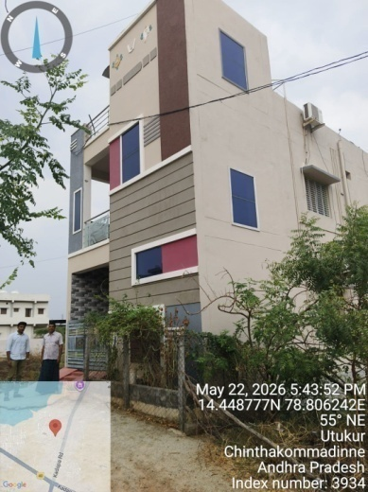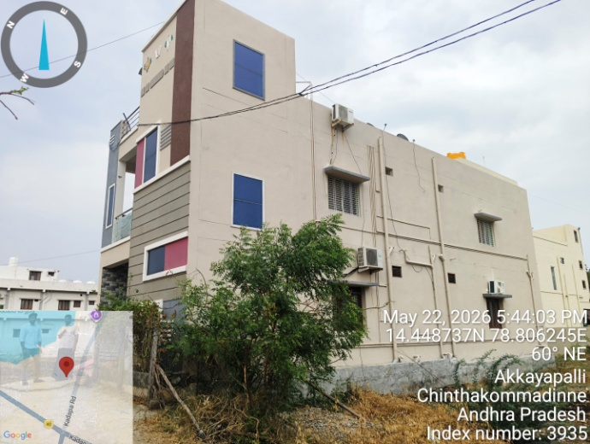

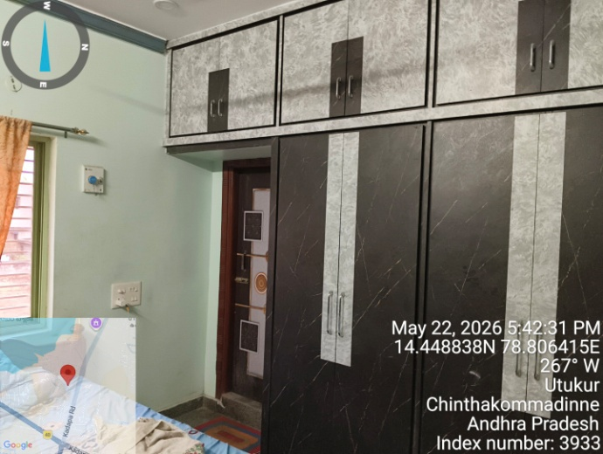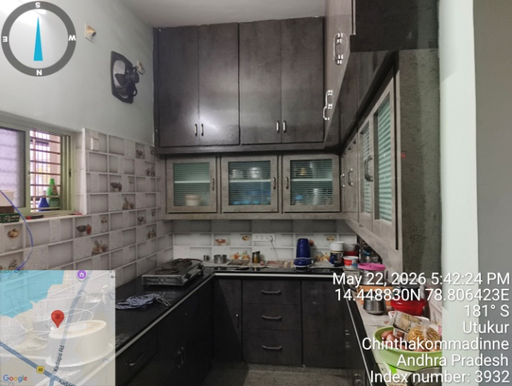

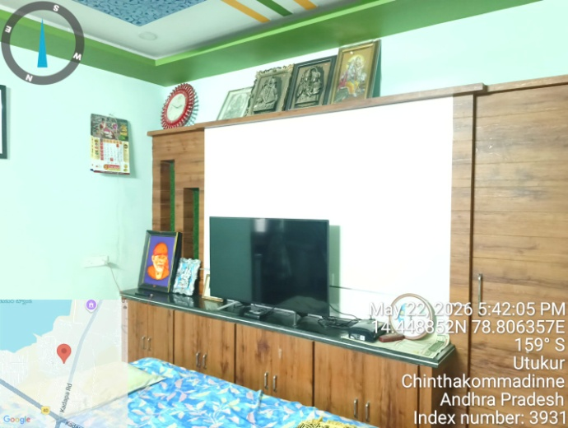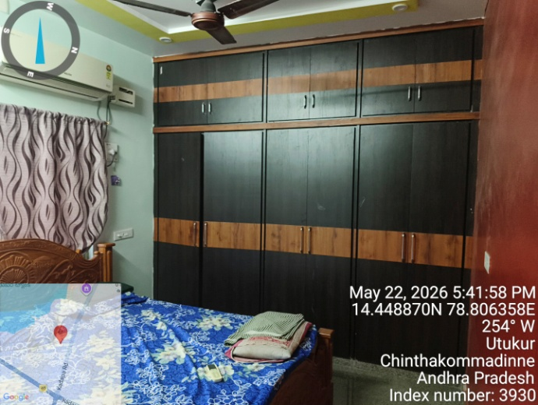

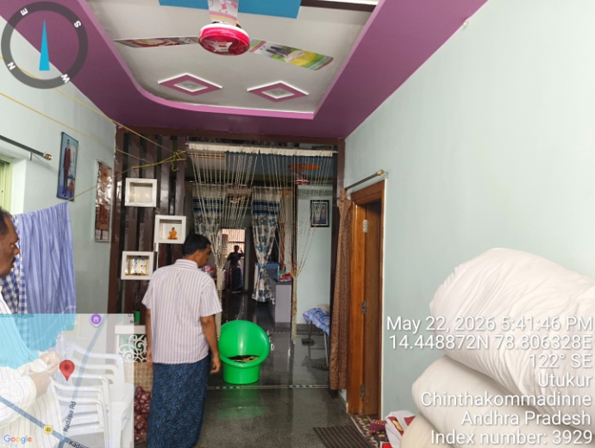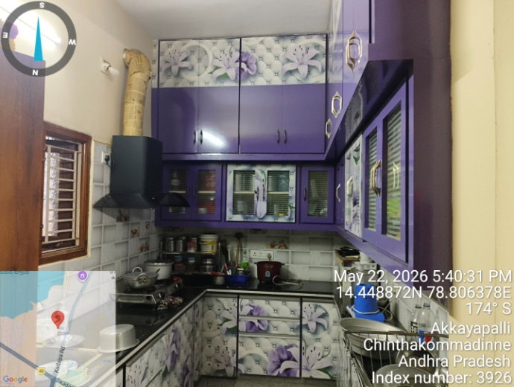

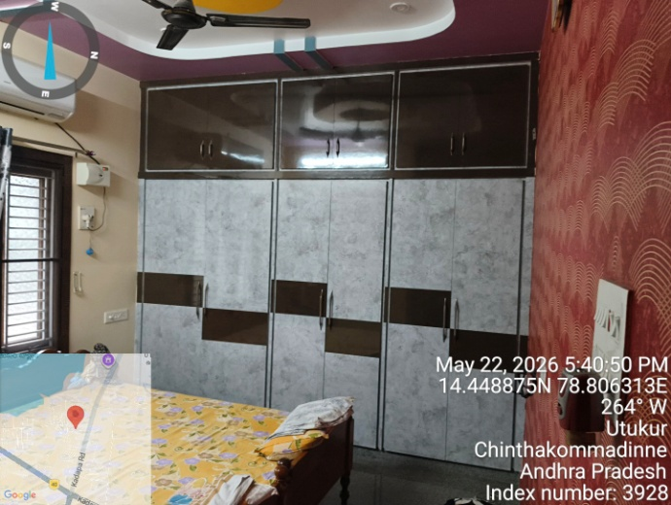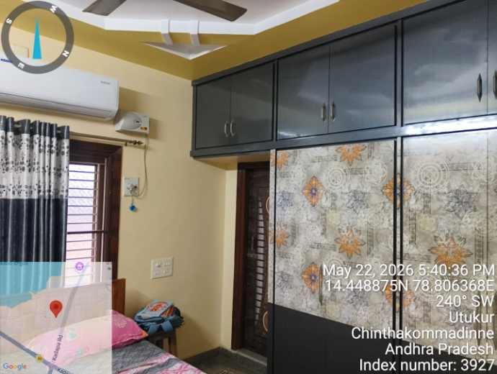

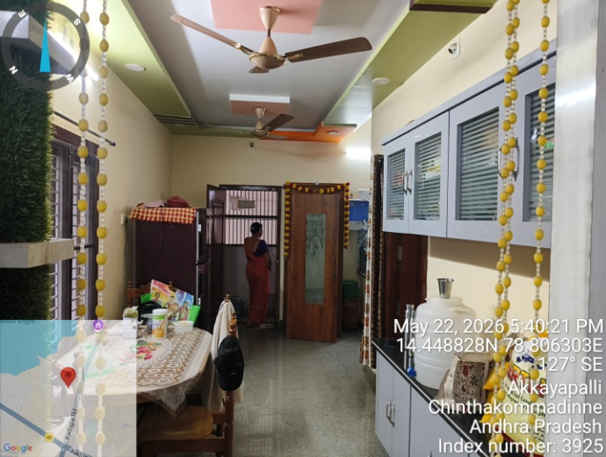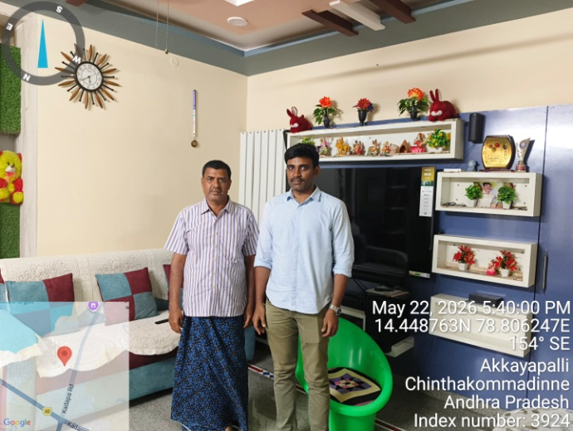

GOOGLE – MAP

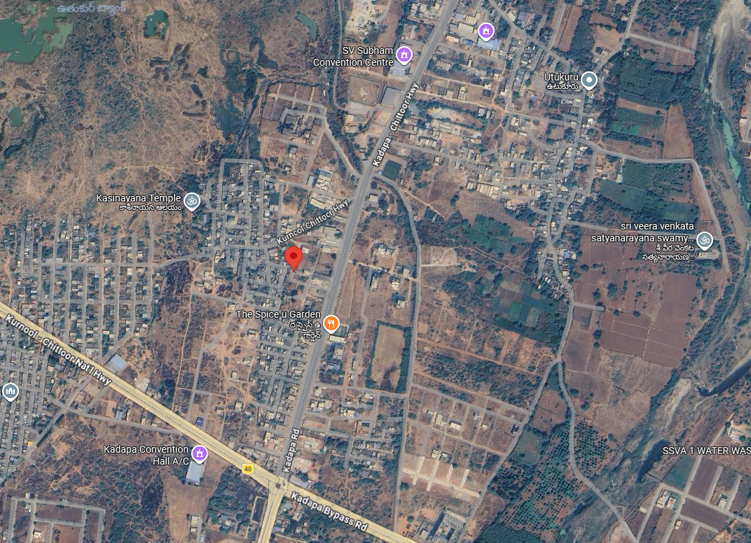

14°26'55.8"N 78°48'22.7"E

14.448828, 78.806303

