What is Reverse Proxy Server

A reverse proxy server is an intermediate connection point positioned at a network’s edge. It receives initial HTTP connection requests, acting like the actual endpoint.

Essentially your network’s traffic cop, the reverse proxy serves as a gateway between users and your application [origin server](https://www.imperva.com/learn/performance/origin-server/). In so doing it handles all policy management and traffic routing.

A reverse proxy operates by:

* Receiving a user connection request
* Completing a TCP three-way handshake, terminating the initial connection
* Connecting with the origin server and forwarding the original request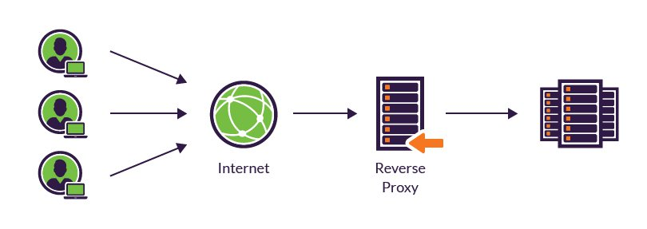

Reverse Proxy vs Forward Proxy

In contrast, a forward proxy server is also positioned at your network’s edge, but regulates outbound traffic according to preset policies in shared networks. Additionally, it disguises a client’s IP address and blocks malicious incoming traffic.

Forward proxies are typically used internally by large organizations, such as universities and enterprises, to:

* Block employees from visiting certain websites
* Monitor employee online activity
* Block malicious traffic from reaching an origin server
* Improve the user experience by caching external site content