OD Marketing & Trading
About Us Our Services Products Contact

Your Trusted Home Appliance & General Trading Partner
Cash & Carry | Hire Purchase | Mobile Money Services
Call to Order Call Now

About Us
OD Marketing and Trading is into trading of all kinds of home appliances and general trading. We sell on hire purchase and cash and carry, making quality appliances affordable for everyone.

Our Services
- All brands of home appliances
- Hire purchase & cash sales
- Mobile Money (MoMo) services

Our Products
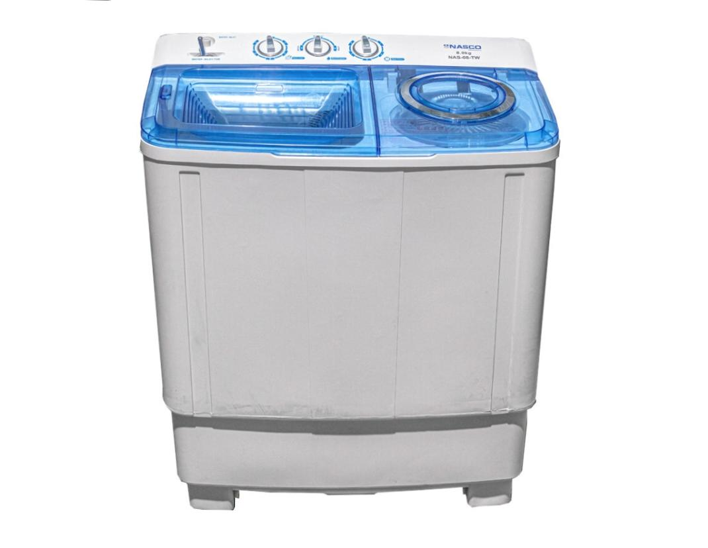

Refrigerators

Televisions

Washing Machines

Microwaves

Air Conditioners

Fans & Other Appliances

Contact Us
Phone: 0208646785 / 0595880585
Click below to call and place your order instantly.
Call 0208646785 Call 0595880585
© 2025 OD Marketing & Trading. All Rights Reserved.

