PYGEOVISION · GEOSPATIAL ANALYSIS REPORT
Building Footprints
n/a (published dataset) · 2.8 km²

604  Buildings | 13.8 ha  Total footprint area | 5.0 %  Share of the area covered by buildings | 219.1  Buildings per km²

Executive summary
- 604 buildings from Microsoft ML Building Footprints fall inside the area, covering 13.8 ha (5.0 % of the area; 219 per km²).
- These are the dataset's polygons, not detections on your own imagery.
Microsoft Global ML Building Footprints: machine-learning detections on Bing/Maxar/Vexcel imagery of various dates (about 1% false positives reported by the project); building heights where available.

Study area and inputs
Area of interest (west, south, east, north) | -80.6250, -5.1800, -80.6100, -5.1650
Centre | -5.1725°, -80.6175°
Area of interest | 2.76 km²
Period | n/a (published dataset)
Output grid | 18 × 17 pixels, EPSG:32717

Results
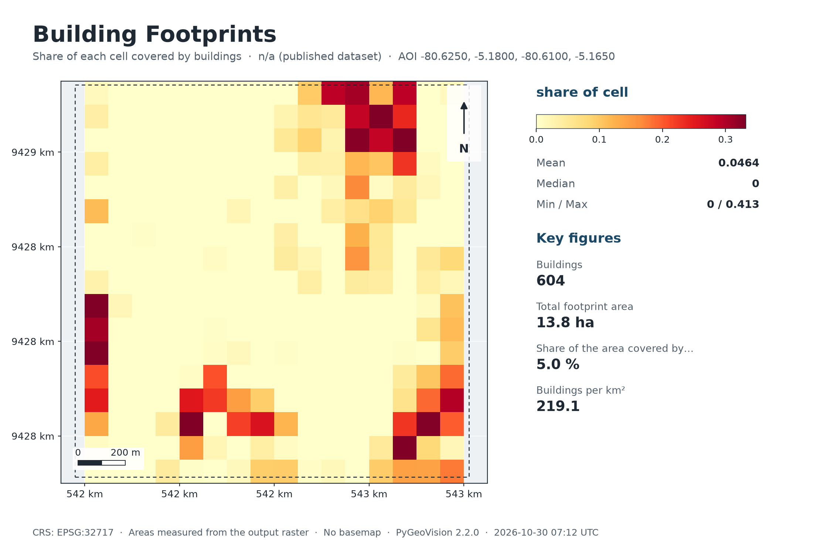
Map: Building Footprints
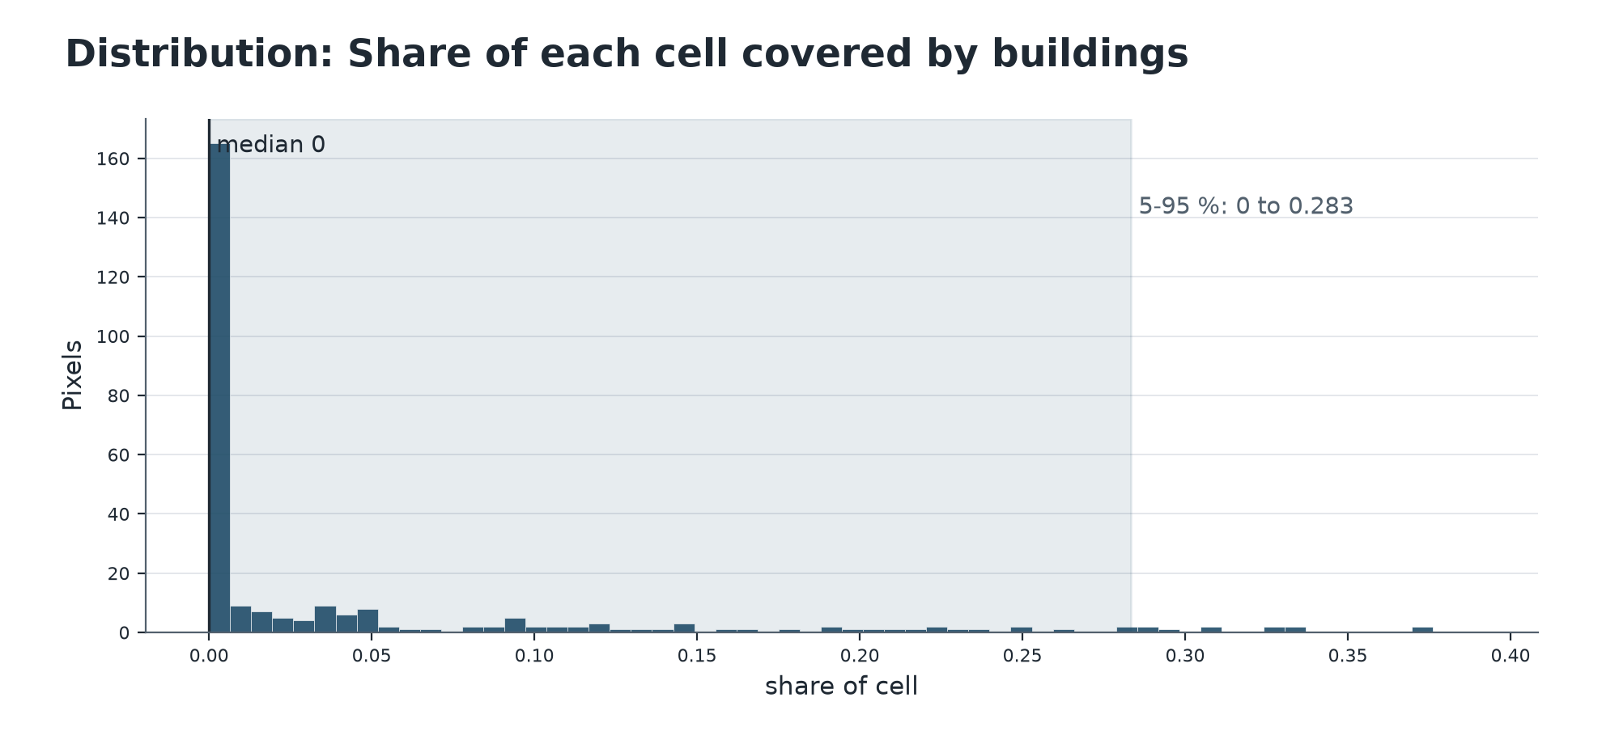
Summary chart
Key statistics (reported by the pipeline)
Measure | Value
Buildings | 604
Total footprint area | 13.8 ha
Share of the area covered by buildings | 5.0 %
Buildings per km² | 219.1
Mean footprint (m²) | 228.9
Median footprint (m²) | 141.0
Highest cell coverage | 41.3 %
Area (km²) | 2.76

Other statistics
Measure | Value
Source | microsoft
Cell m | 100
Footprints file | piura_out/footprints_microsoft/building_footprints.gpkg
Buildings with height | 0
Mean height m | n/a

Value statistics: Share of each cell covered by buildings
Statistic | Value
Minimum (share of cell) | 0.000
5th percentile (share of cell) | 0.000
25th percentile (share of cell) | 0.000
Median (share of cell) | 0.000
Mean (share of cell) | 0.046
75th percentile (share of cell) | 0.045
95th percentile (share of cell) | 0.283
Maximum (share of cell) | 0.413
Standard deviation (share of cell) | 0.089
Over 272 valid pixels.
Value statistics: Buildings per cell
Statistic | Value
Minimum (buildings) | 0.000
5th percentile (buildings) | 0.000
25th percentile (buildings) | 0.000
Median (buildings) | 0.000
Mean (buildings) | 2.022
75th percentile (buildings) | 2.000
95th percentile (buildings) | 11.450
Maximum (buildings) | 21.000
Standard deviation (buildings) | 3.773
Over 272 valid pixels.

Additional layers
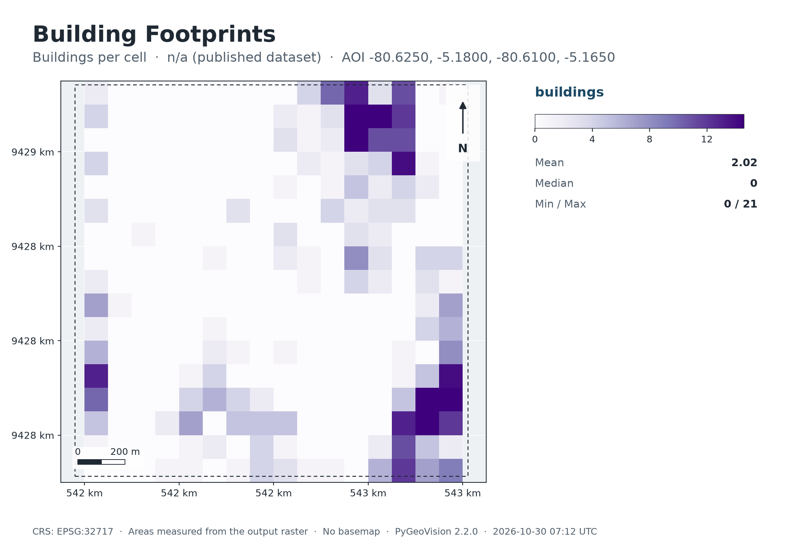
Map: Buildings per cell

Method and parameters
Where are the buildings in the area, how many, and how much ground do they cover?
Published footprints (default): the polygons of Microsoft's Global ML Building Footprints, Google's Open Buildings v3 or OpenStreetMap are read for the box, clipped to it and measured in the local UTM zone. Nothing is detected on your imagery.
building_density.tif is the share of each cell covered by building area (a building counts in the cell holding its centroid); building_count.tif counts buildings per cell.
With a checkpoint the pipeline instead runs a segmentation network you trained (class 1 = building) and writes building_mask.tif.
Pipeline | building_footprints
Area of interest | -80.6250, -5.1800, -80.6100, -5.1650
cell_m | 100
source | microsoft
period | n/a (published dataset)

Interpretation and limitations
How to read the result
- Dataset footprints differ in date: a recent building may be missing and a demolished one still present.
Limitations
- Published footprints are only as complete, accurate and current as their source; compare the three sources if it matters.
- A building_mask.tif result (only when you pass a checkpoint) is the output of a network you trained and has not been checked against reference data; at 10 m individual houses are not resolvable.

Deliverables
Files
File | Type | Contents
piura_out/footprints_microsoft/building_density.tif | GeoTIFF raster | Share of each cell covered by buildings
piura_out/footprints_microsoft/building_count.tif | GeoTIFF raster | Buildings per cell
piura_out/footprints_microsoft/deliverables/building_footprints_report.pdf | PDF report | Complete analysis report
piura_out/footprints_microsoft/deliverables/building_footprints_report.xlsx | Excel workbook | Complete analysis report
piura_out/footprints_microsoft/deliverables/building_footprints_report.docx | Word report | Complete analysis report
piura_out/footprints_microsoft/deliverables/maps/building_footprints_map.png | PNG image | Map or chart for slides and documents
piura_out/footprints_microsoft/deliverables/maps/building_footprints_map_count.png | PNG image | Map or chart for slides and documents
piura_out/footprints_microsoft/deliverables/maps/building_footprints_histogram.png | PNG image | Map or chart for slides and documents
piura_out/footprints_microsoft/deliverables/vectors/building_footprints.gpkg | GeoPackage (all layers) | Vector features with attributes
piura_out/footprints_microsoft/deliverables/vectors/geojson/building_footprints_aoi.geojson | GeoJSON, EPSG:4326 | Vector features with attributes
piura_out/footprints_microsoft/deliverables/vectors/geojson/building_footprints_buildings.geojson | GeoJSON, EPSG:4326 | Vector features with attributes
run_summary.json | JSON | Machine-readable record of this run

Vector layers
Layer | Features | Total area (ha) | Note
buildings | 604 | 13.8

Vector layers made from rasters carry class_id, class_name, color_hex, area_ha, area_m2 (equal-area projection), pct_aoi, cx, cy, pipeline and period; layers a pipeline wrote itself (buildings, roads, streams, fire points) keep their own attributes. Coordinates are WGS 84 (EPSG:4326). The GeoPackage also holds the 'aoi' outline and, for raster-derived layers, a dissolved '<layer>_classes' summary.

References
- Microsoft. Global ML Building Footprints (github.com/microsoft/GlobalMLBuildingFootprints), Open Data Commons Open Database License.
- Sirko, W. et al. (2021). Continental-scale building detection from high resolution satellite imagery. arXiv:2107.12283. (Google Open Buildings v3.)
- OpenStreetMap contributors. Data (c) OpenStreetMap, available under the Open Database License (openstreetmap.org/copyright).

