PYGEOVISION · GEOSPATIAL ANALYSIS REPORT
Urban Expansion (annual 10 m land cover)
2020 to 2023 · 2.8 km²

172.1 ha  Built area, first year | 177.7 ha  Built area, second year | 16.8 ha  Gross gain | 11.2 ha  Gross loss

Executive summary
- Built-up area went from 172.1 ha in 2020 to 177.7 ha in 2023: gross gain 16.8 ha, gross loss 11.2 ha, net 5.6 ha.
- Compound annual growth of the built-up area: 1.1 % per year.
Impact Observatory / Esri 10 m Annual Land Use Land Cover (v02, Sentinel-2 based, CC BY 4.0). Each year is classified independently, so a year-to-year difference contains classifier disagreement as well as real change; single-pixel flips are expected.

Study area and inputs
Area of interest (west, south, east, north) | -80.6250, -5.1800, -80.6100, -5.1650
Centre | -5.1725°, -80.6175°
Area of interest | 2.76 km²
Period | 2020 to 2023
Output grid | 168 × 167 pixels, EPSG:32717
Raster extent area | 2.81 km²
Valid (cloud-free) share | 100.0 %

Results
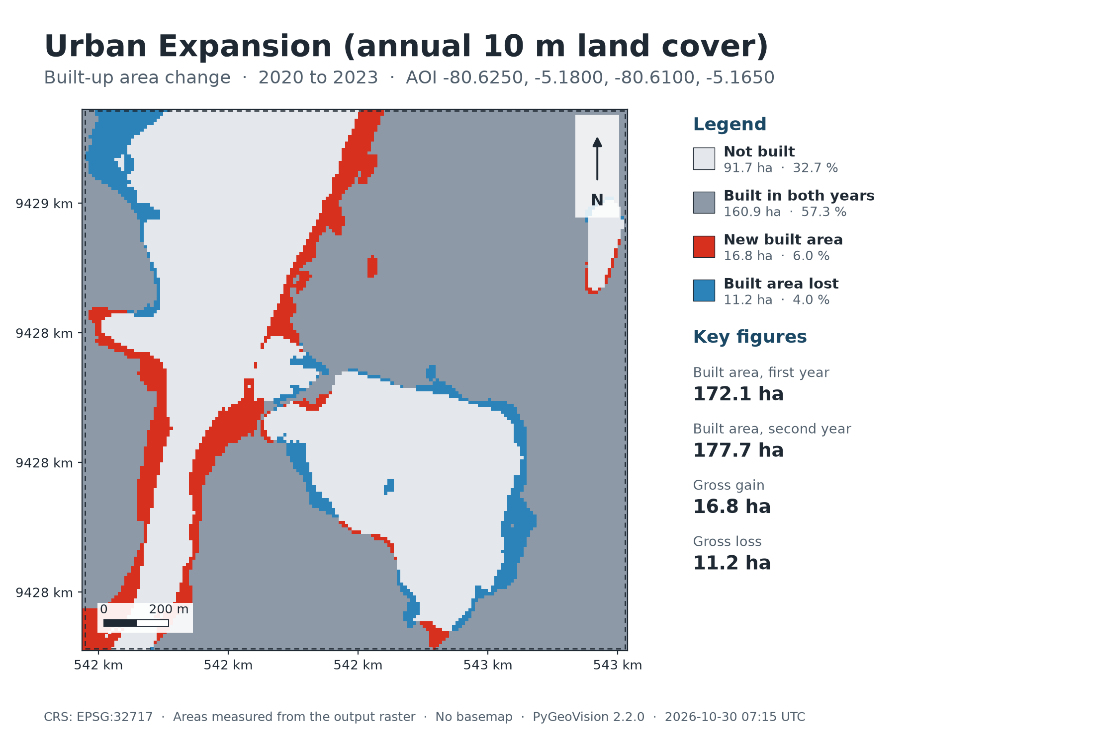
Map: Urban Expansion (annual 10 m land cover)
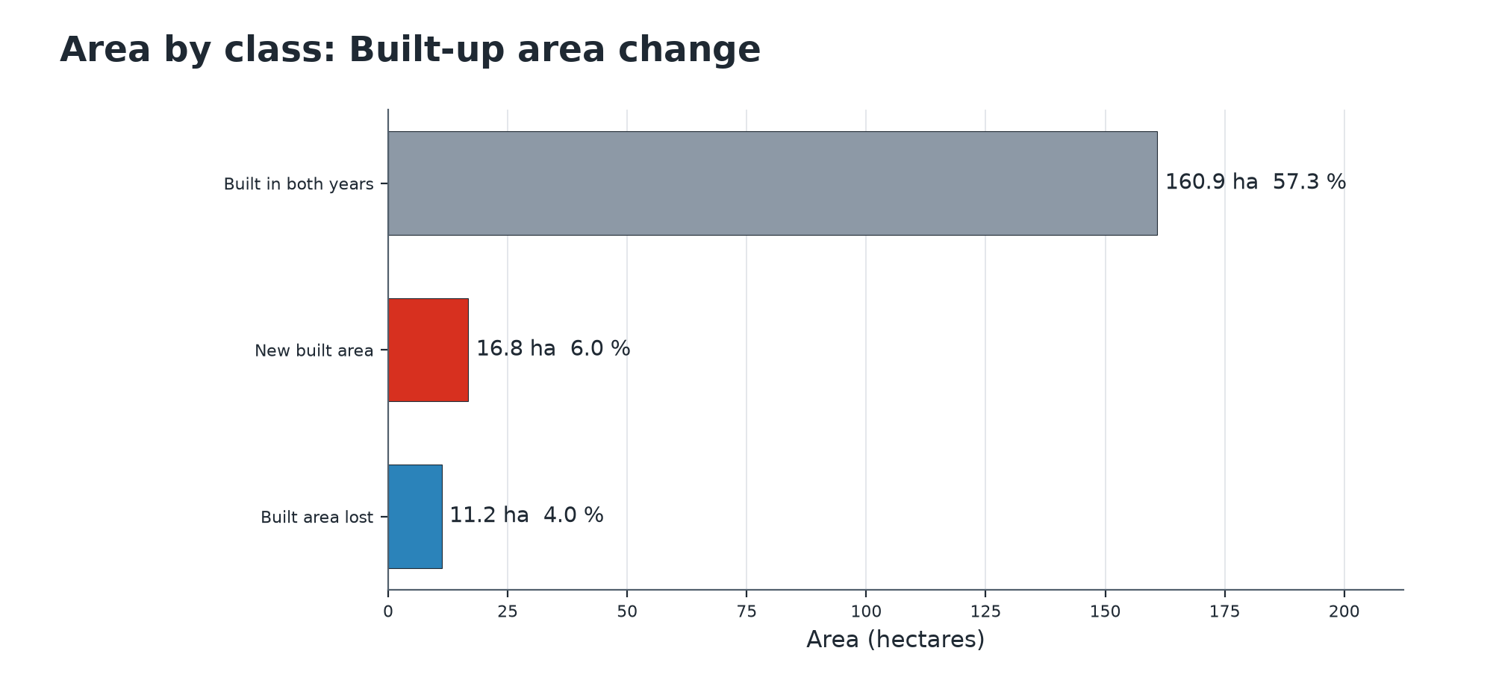
Summary chart
Class areas: Built-up area change
 | Class | Value | Pixels | Area (ha) | Share of valid area | Share of AOI
 | Not built | 0 | 9,173 | 91.7 | 32.7 % | 32.7 %
 | Built in both years | 1 | 16,089 | 160.9 | 57.3 % | 57.3 %
 | New built area | 2 | 1,677 | 16.8 | 6.0 % | 6.0 %
 | Built area lost | 3 | 1,117 | 11.2 | 4.0 % | 4.0 %
Valid area 280.6 ha of 280.6 ha (28,056 of 28,056 pixels). Areas are measured from the output raster.
Key statistics (reported by the pipeline)
Measure | Value
Built area, first year | 172.1 ha
Built area, second year | 177.7 ha
Gross gain | 16.8 ha
Gross loss | 11.2 ha
Net change | 5.6 ha
Built share, first year | 61.3 %
Built share, second year | 63.3 %
Compound annual growth of built area | 1.1 %
Valid share of the area | 100.0 %

Other statistics
Measure | Value
Year before | 2,020
Year after | 2,023
Resolution m | 10.000
Resolution coarsened | no

Method and parameters
How much built-up area appeared or disappeared between two years?
Built area is class 7 of the annual 10 m land-cover product (Impact Observatory / Esri, 2017-2023) on both dates.
A pixel is 'new built' when it is built in the second year only, 'lost' when built in the first year only. Gross gain and loss are reported separately because each year is classified on its own.
Pixels that are no-data or cloud in either year are nodata; percentages are over valid pixels.
Pipeline | urban_expansion
Area of interest | -80.6250, -5.1800, -80.6100, -5.1650
date_after | 2023
date_before | 2020
period | 2020 to 2023

Interpretation and limitations
How to read the result
- 'Built area lost' is more often classifier disagreement (roofs under trees, dust, construction sites) than demolition. Read the gross figures, not only the net.
Limitations
- At 10 m, individual houses and narrow streets are not resolved; small settlements are under-mapped.
- This is a map product's change, not a validated change inventory.

Deliverables
Files
File | Type | Contents
piura_out/urban_expansion/built_area_change.tif | GeoTIFF raster | Built-up area change
piura_out/urban_expansion/deliverables/urban_expansion_report.pdf | PDF report | Complete analysis report
piura_out/urban_expansion/deliverables/urban_expansion_report.xlsx | Excel workbook | Complete analysis report
piura_out/urban_expansion/deliverables/urban_expansion_report.docx | Word report | Complete analysis report
piura_out/urban_expansion/deliverables/maps/urban_expansion_map.png | PNG image | Map or chart for slides and documents
piura_out/urban_expansion/deliverables/maps/urban_expansion_chart.png | PNG image | Map or chart for slides and documents
piura_out/urban_expansion/deliverables/vectors/urban_expansion.gpkg | GeoPackage (all layers) | Vector features with attributes
piura_out/urban_expansion/deliverables/vectors/geojson/urban_expansion_aoi.geojson | GeoJSON, EPSG:4326 | Vector features with attributes
run_summary.json | JSON | Machine-readable record of this run

References
- Karra, K. et al. (2021). Global land use / land cover with Sentinel-2 and deep learning. IGARSS 2021, 4704-4707. (Impact Observatory / Esri 10 m annual land cover, io-lulc-annual-v02, Microsoft Planetary Computer.)

Notes on this run
Parts of the deliverables that could not be produced, or were changed, and why:
- vector layer 'built_change' could not be created: No module named 'scipy'

