## Appian’s Git Workshop Slides: <http://ap.pn/2mrsSlw>

## Common Git Commands

**git init** - create a new repo locally

**git clone <url on the github page for the repo>** - add a remote repo (from github) locally

**git remote** - lists your remotes (where you can pull and push to on github)

**git remote add <remote name - you pick> <remote url from github>**

**git log** - shows all the previous commits

**git status** - shows what files have changed and can be added/committed

**git add <file path + name>**- adds files to get them ready to commit

**git commit -m “message”** - takes the added files and commits them with the given message

**git stash** - saves and removes any changed files that haven’t been committed

**git stash pop** - Applies the changes from the last stash

**git checkout -b <branch-name>** - makes a new branch (which matches your current branch) and switches to it

**git checkout <branch-name>** - switches to the given branch

**git checkout <sha>** - switches to the commit with the given sha

**git checkout <sha> <filename>** - checks out the given file from the commit with the given sha, all other files stay the same

**git branch** - displays all local branches

**git branch -D <branch-name>** - removes the branch with the given name

**git pull <remote> <branch>** - pulls changes from the given remote branch onto your current branch

If you get a merge conflict then resolve them, add the files, and commit

**git push <remote> <branch>** - pushes changes from your local branch to the remote branch.

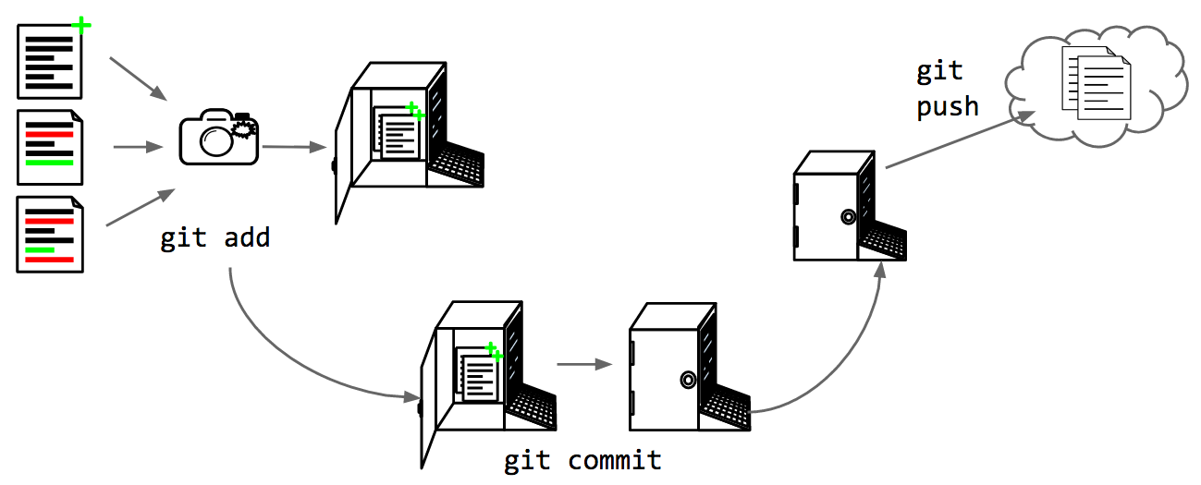

## Common Git Workflows

**Starting Out**

Init your repo locally: **git init**

Add your files: **git add . ←(the period adds all files)**

Commit the added files: **git commit -m “First commit”**

Make your repo on github with no files read: http://ap.pn/2f9rDDH

Add your remote locally: **git remote add <a name of your choice> <remote url from github>**

Push to the remote: **git push <remote name>**

OR

Make a repo on github with files

Clone the repo to your machine (command will be given by github)

**Working on a Feature**

If you have uncommitted changes you will need to add/commit the changes first

Checkout a new branch: **git checkout -b <new branch name>**

**Committing Work**

save your files in your editor

Check which files can be added: **git status**

“add” the files you want to commit: **git add <file path+name to add> <second file>**

To add all files: **git add .←(the period adds all files)**

“commit” your changes: **git commit -m “Meaningful message”**

**Checking out Previous Commits**

If you have uncommitted changes you will need to add & commit the changes first

See your commit history: **git log**

copy the sha (the long string of random characters) for the commit you want

checkout that commit: **git checkout <SHA>**

**Pushing Changes**

Pull any changes from master branch on github before pushing:

**git pull <remote> <master>**

Fix merge conflicts read: http://ap.pn/2f9vi49

Push the change to your branch: **git push <remote> <branch>**

Open a pull request from your branch to the master branch on github