CloudSpokes Challenge: MailChimp Service with Amazon SES

Solution By: Shashidhar Gurumurthy, shashidhar.gurumurthy@gmail.com

Features of the Component:
- A set of Java classes which encapsulates calling MailChimp STS API to send mail vial Amazon SES.
- MailInfoDTO encapsulates the Java object which the client application has to create to send mail. This class does explicit data checking as part of the object creation process to ensure all data required to send a mail is valid.
- MailerException encapsulates the exceptions raised during the MailInfoDTO object creation and mail send process.
- AmazonSESMailChimpMailer & AmazonSESMailChimpMailerImpl are the interface and its implementation which implement the mail send operation.
- The code can run on local infrastructure as well as any cloud platform which supports Java. The core mailer classes are pure Java SE 1.6 compliant and have no other library dependencies. The unit test code depends upon JUnit infrastructure.

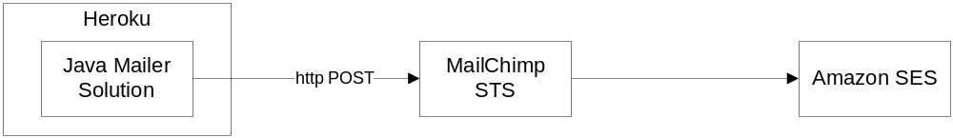

Setup Instructions:
- Setup Amazon SES account.
- Setup MailChimp account. For being able to send mail from MailChimp STS API, using Amazon SES integration, you will need to upgrade account to minimum pay as you go or monthly plan.
- Setup MailChimp to Amazon SES integration on MailChimp > Account > Extras > Integrations > Amazon Simple Email Service.

Here you will need the Amazon AWS Key and Amazon AWS Secret which you will get from the Amazon SES account page: Account > Security Credentials > Access Keys. Generate new access key and use the key and secret information to setup integration on the MailChimp page.

Amazon Account Page:
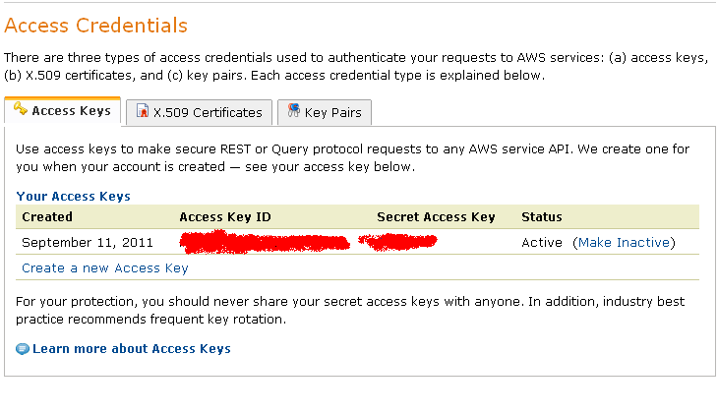
Navigate to the MailChimp – Amazon SES Integrations page: MailChimp > Account > Extras > Integrations > Amazon Simple Email Service. Enter the Amazon AWS key and Amazon AWS Secret and complete the integration process. You will see the connected status as shown below.

MailChimp Integration Amazon Simple Email Service Page:
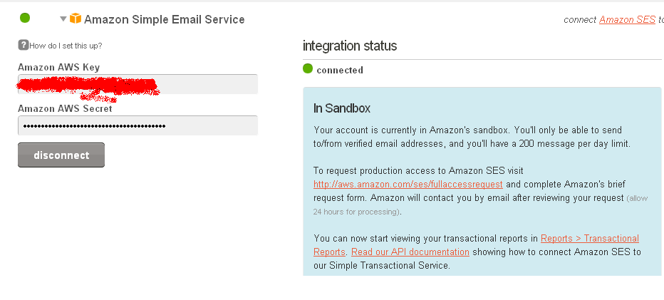
- Navigate to MailChimp > Account > Extras > API Keys & Authorized Apps. Click on Add a key to generate a new key. This key is required to be setup as a System environment variable for the Java mailer solution. The last three characters of the API key would indicate the MailChimp data center you will be connecting to.

MailChimp API Keys:
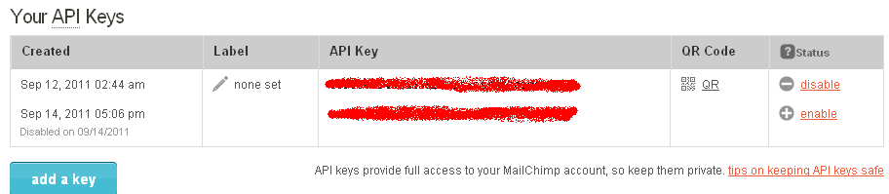

- Set up the environment variable MAILCHIMP_API_KEY to the API keys you generated in the previous step.
  - On a Windows machine, this will be setup in the Control Panel > System > Advanced > Environment Variables
  - On Heroku, this will be a command as follows:
heroku config add MAILCHIMP_API_KEY=<your mailchimp api key>

- In the AmazonSESMailChimpMailerImpl Java class change the value of String SERVER to your MailChimp data center which you retrieved (last 3 characters of the API key) in step 4 above. Currently it is set to “us2”.

Test Instructions:
- Once the above setup steps are completed, you can now test the environment and get ready to send mails.
- If your Amazon AWS account is in sandbox, you can send to/from verified email addresses only and there will be a 200 messages per day limit. If this is the case, get at least one email verified for testing purposes.
- Edit AmazonSESMailChimpMailerTest and change the values of the fields based on your environment. Now execute the AmazonSESMailChimpMailerTest as a JUnit Test and you will be able to see a mail come to the mail ID you configured. See sample email snippet below:
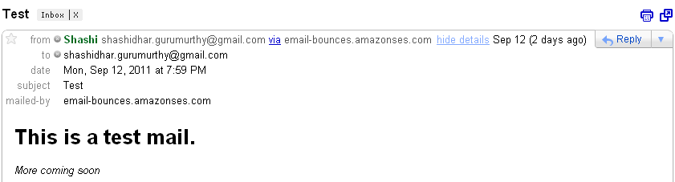

Limitations:
- Trapping of errors from MailChimp – for example when daily message quota is exceeded. This currently shows up as an exception stack trace on the client but the error reason is not very apparent.
- Testing with limits of allowed email addresses per call has not been completed as ran out of message quota for the day.

