Security Groups Release 2 Deployment Guide

Revision History
Author | Revision Number | Date
isv | 1.0 | 09/10/2012

Deployment Instructions 3
1. Organization of Submission 3
2. Application Setup 3
2.1 Ant .Properties File 3
2.2 Build Scripts Setup 4
3. Database Setup 4
4. Deployment Instructions 5
5. Starting 5
6. Verification 5
7. Resource Contact List 13

Deployment Instructions

Organization of Submission

The content of submission follows directory structure provided below:

db_scripts

Contains the SQL statements for updated database table data and queries to be updated in Production environment via Query Tool in order to meet the needs of this assembly.

direct

Contains the sources for TopCoder Direct application added/updated in the course of this assembly. This directory replicates the application development distribution structure and includes only updated and new files.

docs

Contains this document which is the Deployment Guide for the Security Groups Release 2 assembly.

online_review

Contains the configuration, libraries, sources for Online Review application and accompanying utilities developed/updated in the course of this assembly. This directory replicates the application development distribution structure and includes only updated and new files.

test_files

Contains the SQL scripts with sample test data to be used for review purposes only.

web_module

Contains the configuration, libraries, sources for TopCoder Web application developed/updated in the course of this assembly. This directory replicates the application development distribution structure and includes only updated and new files.

Application Setup

The application is expected to be deployed to the following environment:

TopCoder Direct application

JRE 1.5
JBoss 4.2.3.GA
Informix DS 11.0

Online Review application

JRE 1.5
JBoss 4.0.2.GA
Informix DS 11.0

TopCoder Web Module application

JRE 1.5
JBoss 4.0.4.GA
Informix DS 11.0

TopCoder Studio application

JRE 1.5
JBoss 4.0.4.GA
Informix DS 11.0

Ant .Properties File
Following new configuration properties have been defined in token.properties file

Property Name | File property is stored | Example Setting
@securityGroupsManagers@ | token.properties | A comma-separated list of handles of users which are allowed to access Security Groups UI. Empty value means  that all users are allowed to access Security Groups UI

Build Scripts Setup

The build script for Contest Service Facade application (build.xml) provides the following targets which are to be used:

- dist_tcs – compiles and builds binary library JAR for component.

The build script for TopCoder Direct application (build.xml) provides the following targets which are to be used:

- deploy – builds and deploys the TopCoder Direct application to target server.
- deploy-apache-static – copies static web resources to .Apache HTTP server

The build script for Online Review application (build.xml) provides the following targets which are to be used:

- deploy – builds and deploys the Online Review application to target server in local environment.

The build script for Security Groups application (build_security.xml) provides the following targets which are to be used:

- packageSecurityGroups – compiles and builds binary library JAR for component.

The build script for TopCoder Web Module application (build_tc.xml) provides the following targets which are to be used:

- deploy – builds and deploys the TopCoder Web Module web application to target server.

The build script for Studio application (build-studio.xml) provides the following targets which are to be used:

- deploy – builds and deploys the Studio web application to target server.

Database Setup

Follow the instructions from TopCoder Databases Deployment Guide document from http://www.topcoder.com/wiki/display/docs/TopCoder+Databases+Setup+Guide for setting up the database.

Run test_files/updates.sql script against target database to alter the database to meet the needs of reviewing this assembly.

Update existing queries in Query Tool as follows (for details on Query Tool usage see http://www.topcoder.com/wiki/display/docs/TopCoder+Studio+Query+Tool+Usage ):

- Select TCS Catalog database
- Click Query List link on the left
- Locate direct_my_projects query and update it's content (see db_scripts/tcs_catalog/query_tool/query_direct_my_projects.txt)
- Locate direct_my_projects_v2 query and update it's content (see db_scripts/tcs_catalog/query_tool/query_direct_my_projects_v2.txt)
- Locate query_is_user_tc_staff query and update it's content (see db_scripts/tcs_catalog/query_tool/query_is_user_tc_staff.txt)
- Locate direct_project_and_client_for_contest query and update it's content (see db_scripts/tcs_catalog/query_tool/ query_direct_project_and_client_for_contest.txt)
- Select Corporate database
- Click Query List link on the left
- Locate query_project_name query and update it's content (see db_scripts/corporate_oltp/query_tool/query_project_name.txt)
- Locate query_project_id query and update it's content (see db_scripts/corporate_oltp/query_tool/query_project_id.txt)
- Locate query_project_ids query and update it's content (see db_scripts/corporate_oltp/query_tool/query_project_ids.txt)
- Select Transactional database
- Click Query List link on the left
- Locate query_user_handle_email_by_user_id query and update it's content (see db_scripts/informixoltp/query_tool/ query_user_handle_email_by_user_id.txt)
- Locate query_users query and update it's content (see db_scripts/informixoltp/query_tool/ query_users.txt)

Deployment Instructions

This section provides the instructions for integrating and deploying the changes from Security Groups Release 3 assembly in Production environment.

TC Direct Application:

- Copy files under direct directory from submission to dev distribution for TopCoder Direct application
- Re-build Contest Service Facade compnent using ant dist_tcs command
- Build and deploy TopCoder Direct application using ant deploy command
- Copy static files to /mnt/apache/tcdocs directory using ant deploy-apache-static command.

Online Review Application:

- Copy files under online_review directory from submission to dev distribution for Online Review application
- Build and deploy Online Review application using ant deploy command

TopCoder Web Module, Studio Applications:

- Copy files under web_module directory from submission to dev distribution for TopCoder Web Module application
- Build Security Groups component using ant -f build_security.xml packageSecurityGroups command
- Build and deploy TopCoder Web Module application using ant –f build_tc.xml deploy command
- Build and deploy TopCoder Studio application using ant –f build_studio.xml deploy command

The submission was developed against following SVN revisions:

TC Direct Application:

URL: https://coder.topcoder.com/tcs/clients/cronos/applications/direct/branches/security_group_release_assembly_3
Repository Root: https://coder.topcoder.com/tcs
Repository UUID: fb370eea-3af6-4597-97f7-f7400a59c12a
Revision: 219656
Node Kind: directory
Schedule: normal
Last Changed Author: mashannon168
Last Changed Rev: 219261
Last Changed Date: 2012-08-24 10:48:00 -0400 (Fri, 24 Aug 2012)
Online Review Application:

URL: https://coder.topcoder.com/tcs/clients/cronos/applications/online_review/branches/security_group_release_assembly_3
Repository Root: https://coder.topcoder.com/tcs
Repository UUID: fb370eea-3af6-4597-97f7-f7400a59c12a
Revision: 219656
Node Kind: directory
Schedule: normal
Last Changed Author: mashannon168
Last Changed Rev: 219262
Last Changed Date: 2012-08-24 10:53:21 -0400 (Fri, 24 Aug 2012)

Web Module, Studio Applications:

URL: https://coder.topcoder.com/internal/web_module/branches/security_group_release_assembly_3
Repository Root: https://coder.topcoder.com/internal
Repository UUID: cb5b18d2-80dd-4a81-9b1c-945e1ee644f9
Revision: 81860
Node Kind: directory
Schedule: normal
Last Changed Author: mashannon168
Last Changed Rev: 81816
Last Changed Date: 2012-08-24 10:54:37 -0400 (Fri, 24 Aug 2012)

Starting

- Build and deploy the TopCoder Web Module web application
- Start JBoss server instance hosting TopCoder Web Module web application
- Build and deploy the Studio web application
- Start JBoss server instance hosting Studio web application
- Build and deploy the Online Review application
- Start JBoss server instance hosting Online Review application
- Build and deploy the TopCoder Direct application
- Start JBoss server instance hosting TopCoder Direct application

Verification

TC Direct Application

Login to TC Direct application as user who is NOT granted a permission to access security groups UI (see seciton 2.1) using URL like http://cockpit.cloud.topcoder.com/direct/
  - The Dashboard page must be displayed. There must be NO Groups button at the top of the page displayed

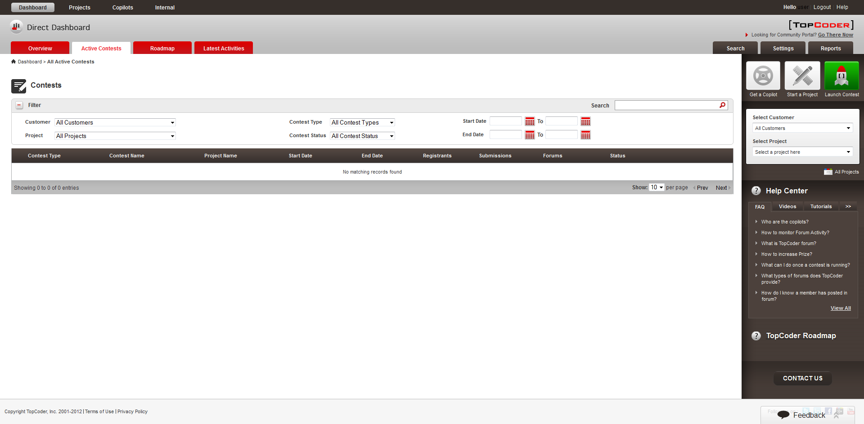

Construct an URL in browser's string for accessing the page from Security Groups UI (for example, http://cockpit.cloud.topcoder.com/direct/group/viewPendingApprovalUserAction.action)
  - The page informing that user does not have a permission to access security groups must be displayed
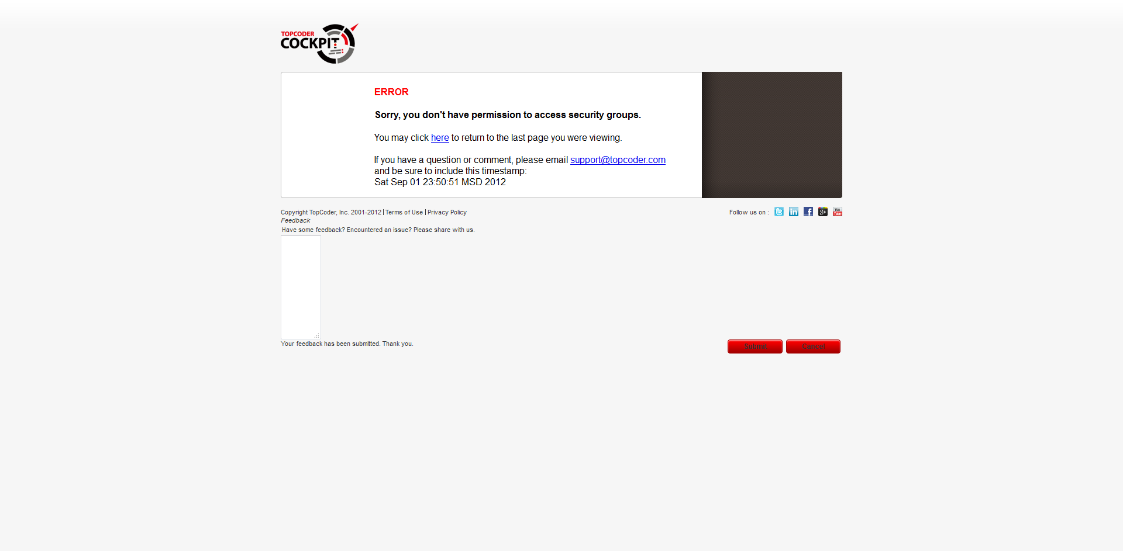

Login to TC Direct application as user who is granted a permission to access security groups UI (see seciton 2.1) using URL like http://cockpit.cloud.topcoder.com/direct/
  - The Dashboard page must be displayed. There must be Groups button at the top of the page displayed

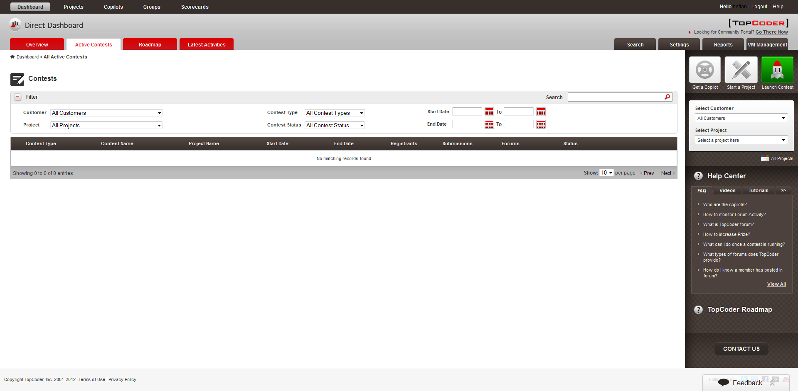

Click Groups button
  - The page listing existing groups must be displayed

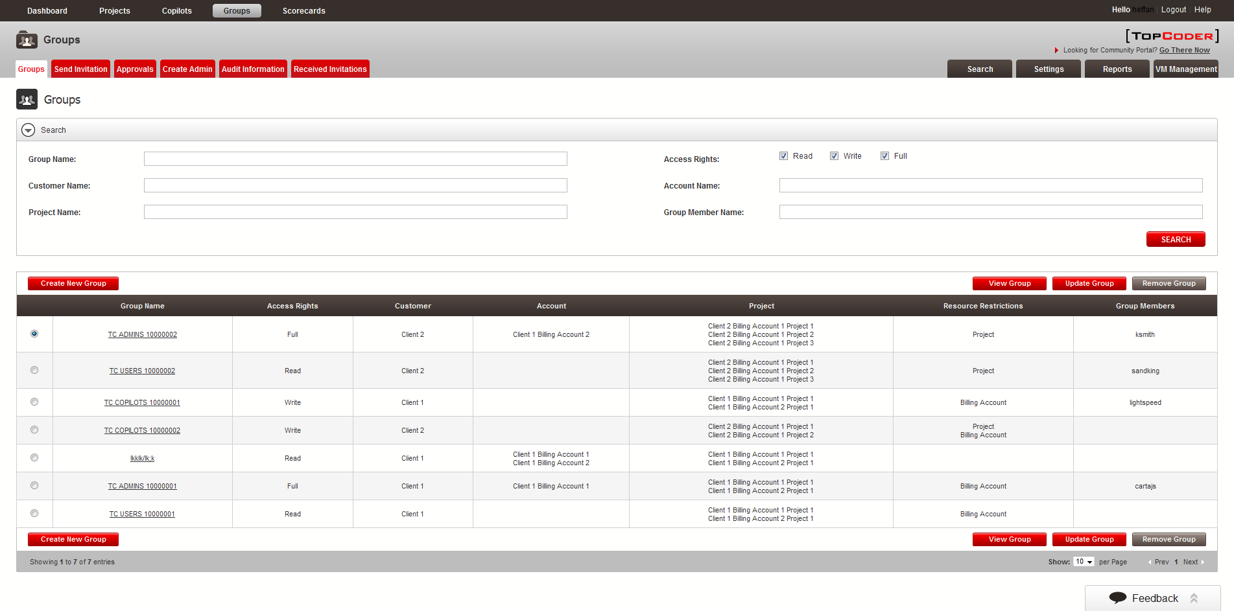

Click sequentially every of the tabs from the groups menu (Send Invitation, Approvals, etc)
  - The respective page must be displayed successfully

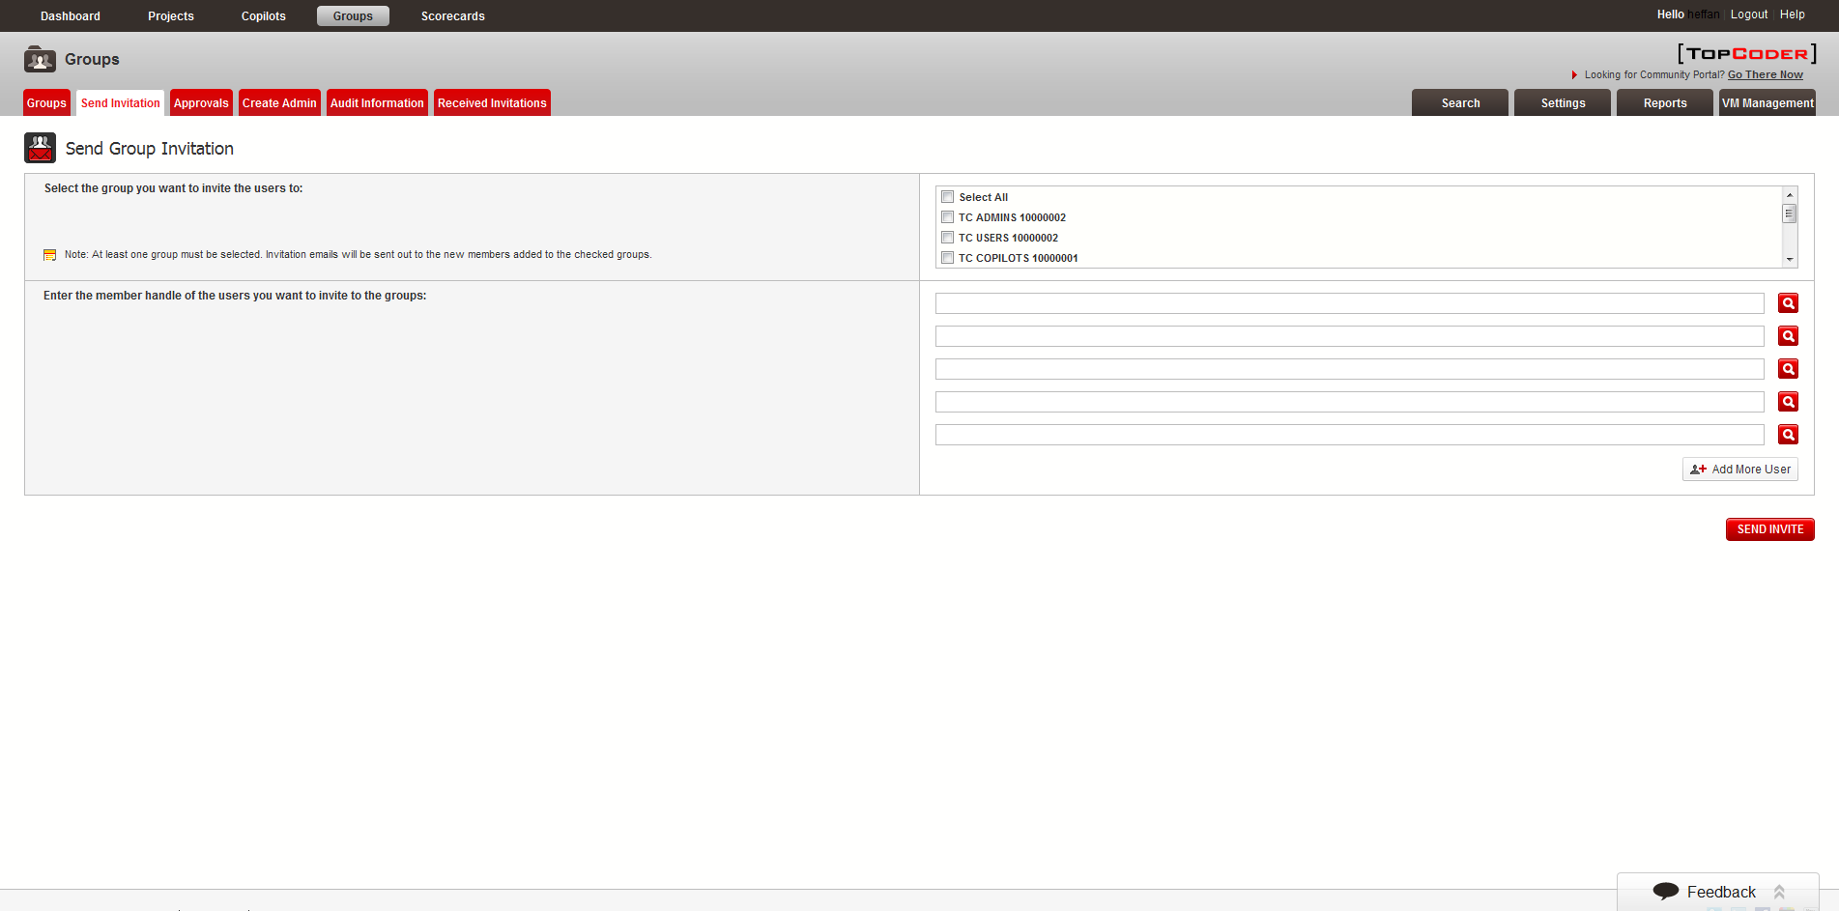

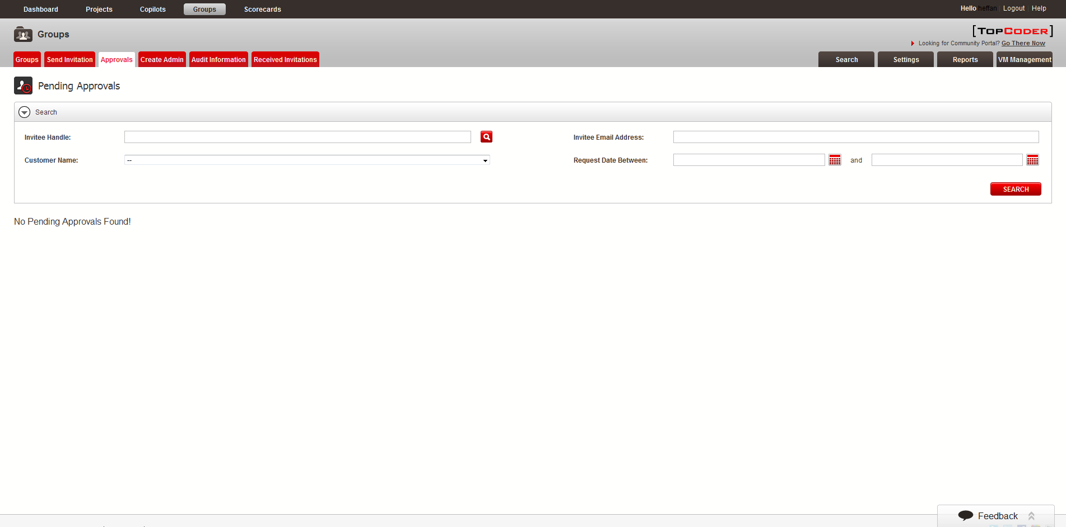

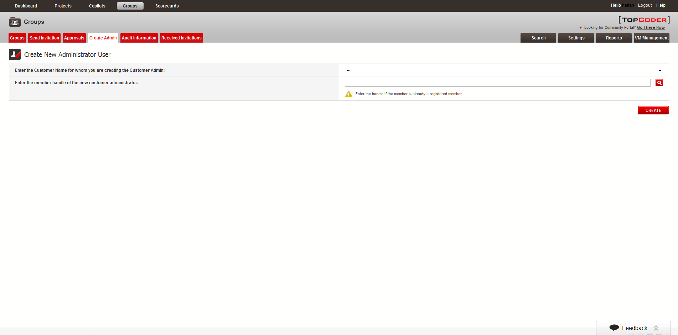

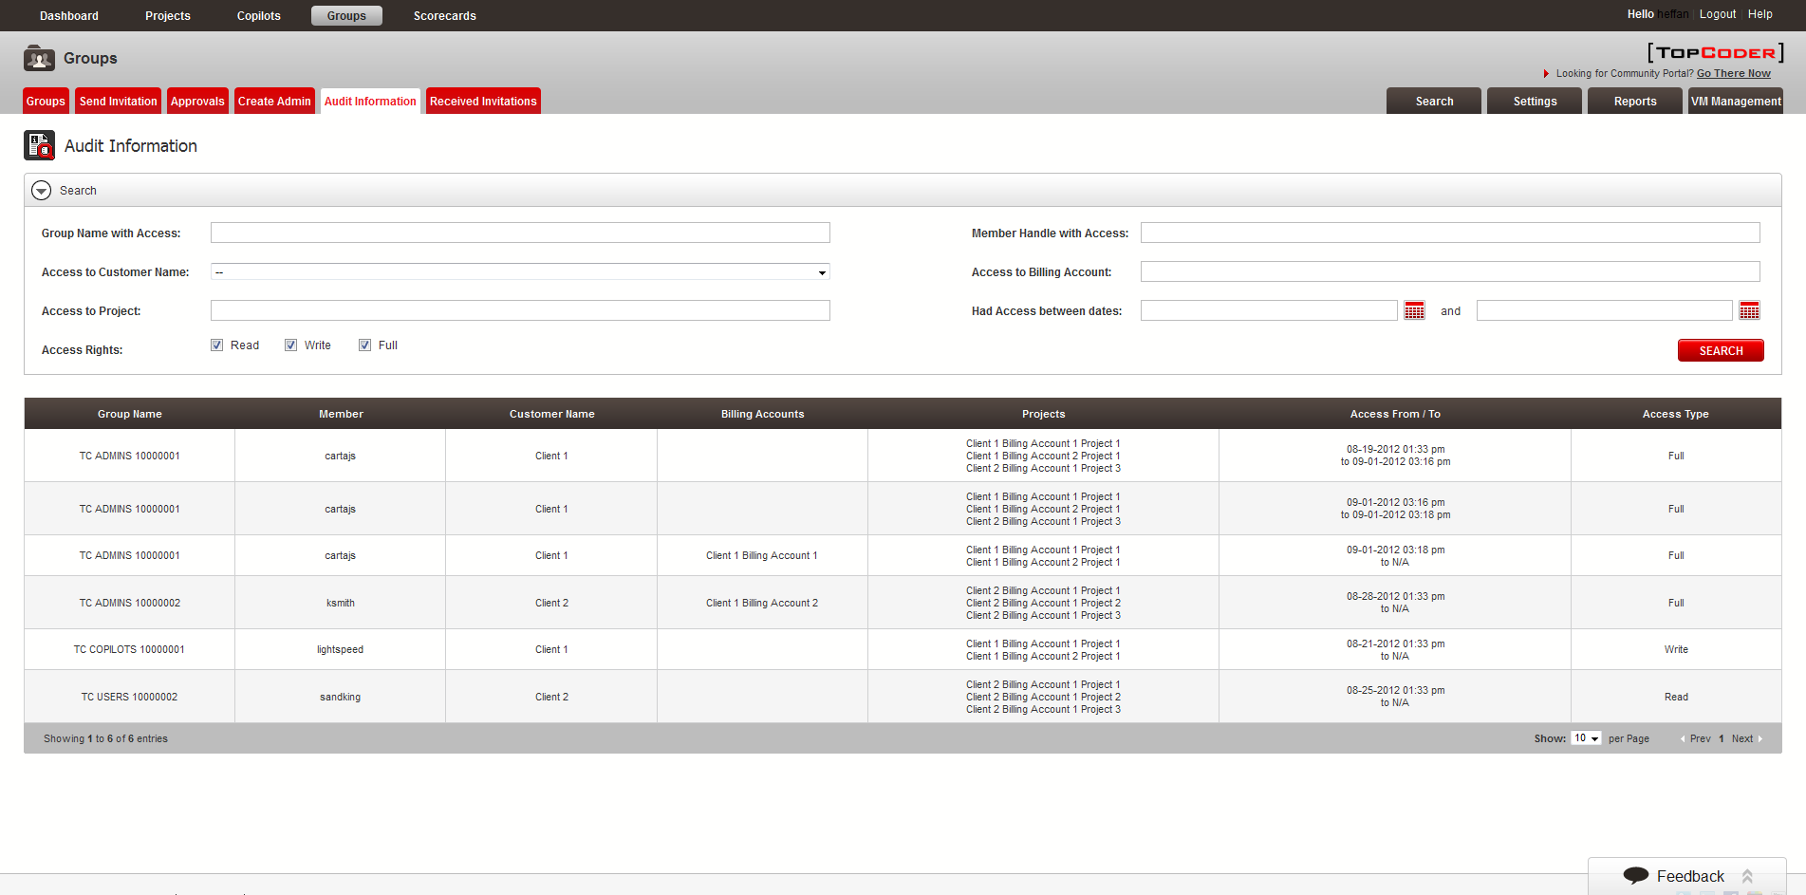

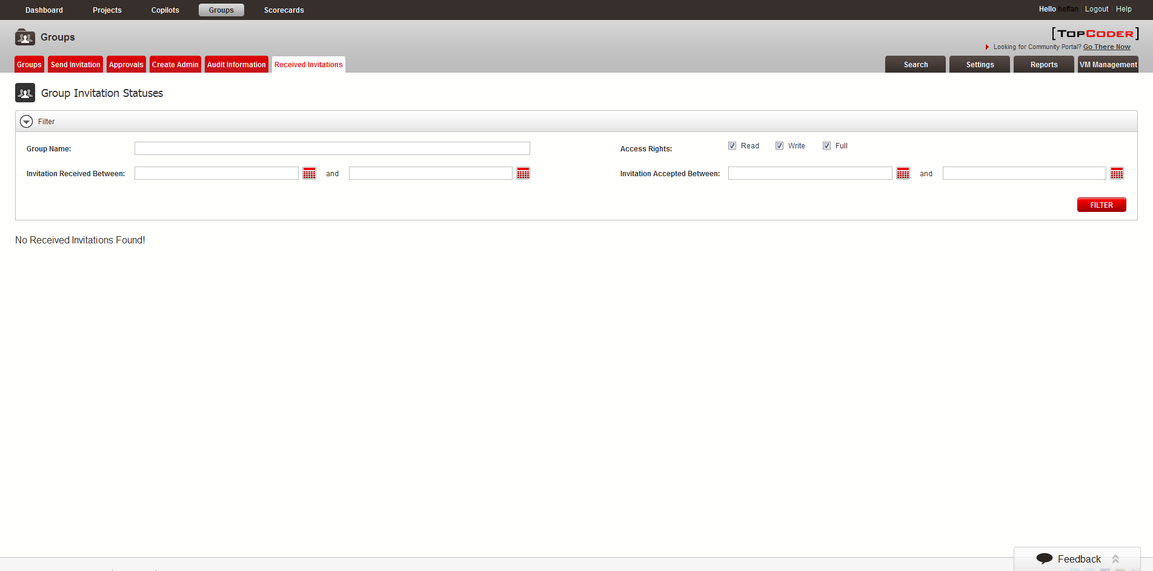

Click Projects button at the top
  - The Active Projects page must be displayed successfully

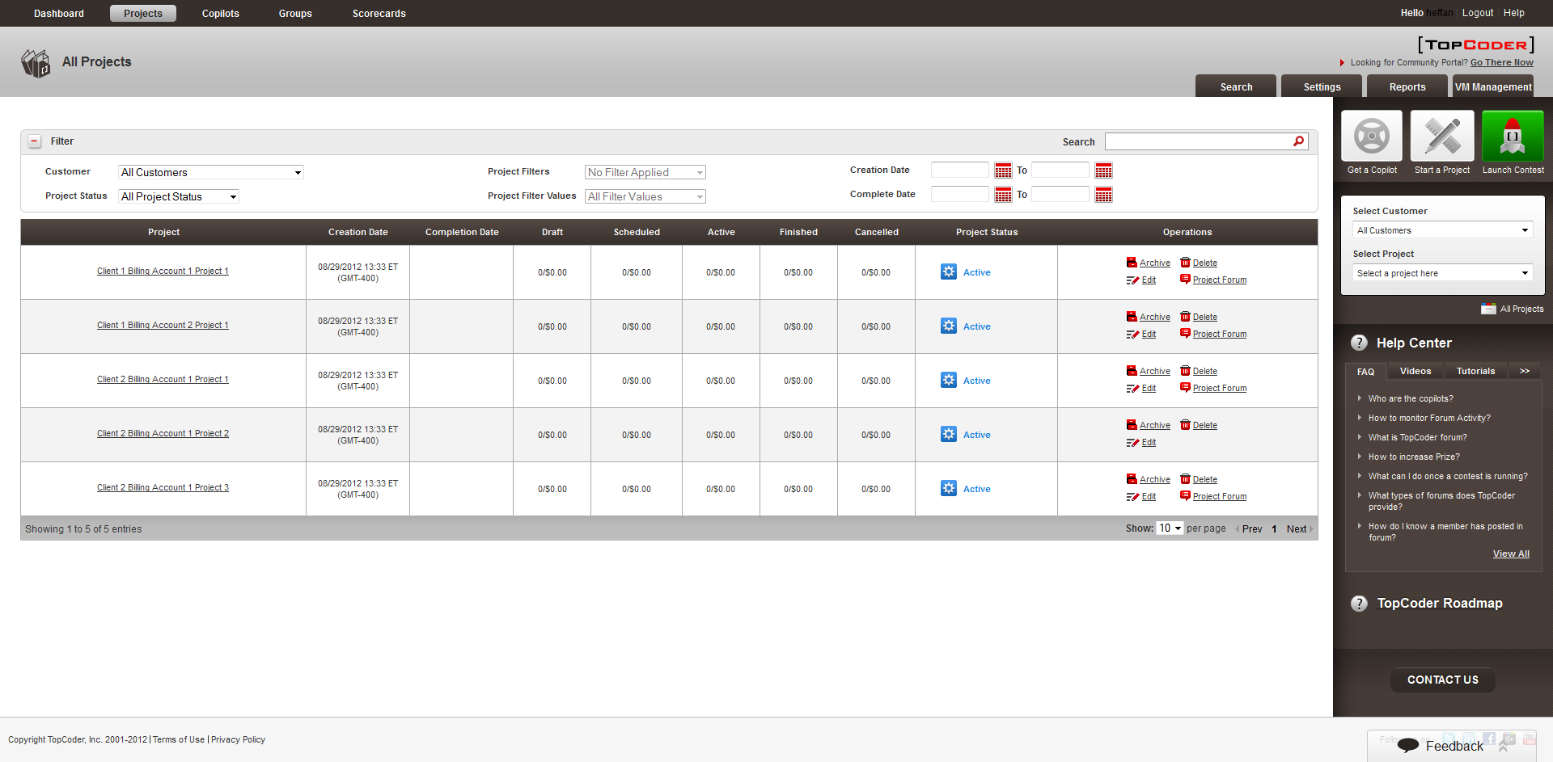

Click Edit button for desired project
  - The Edit Project page must be displayed successfully. The page must display the Group Permissions area for managing the security groups for project.

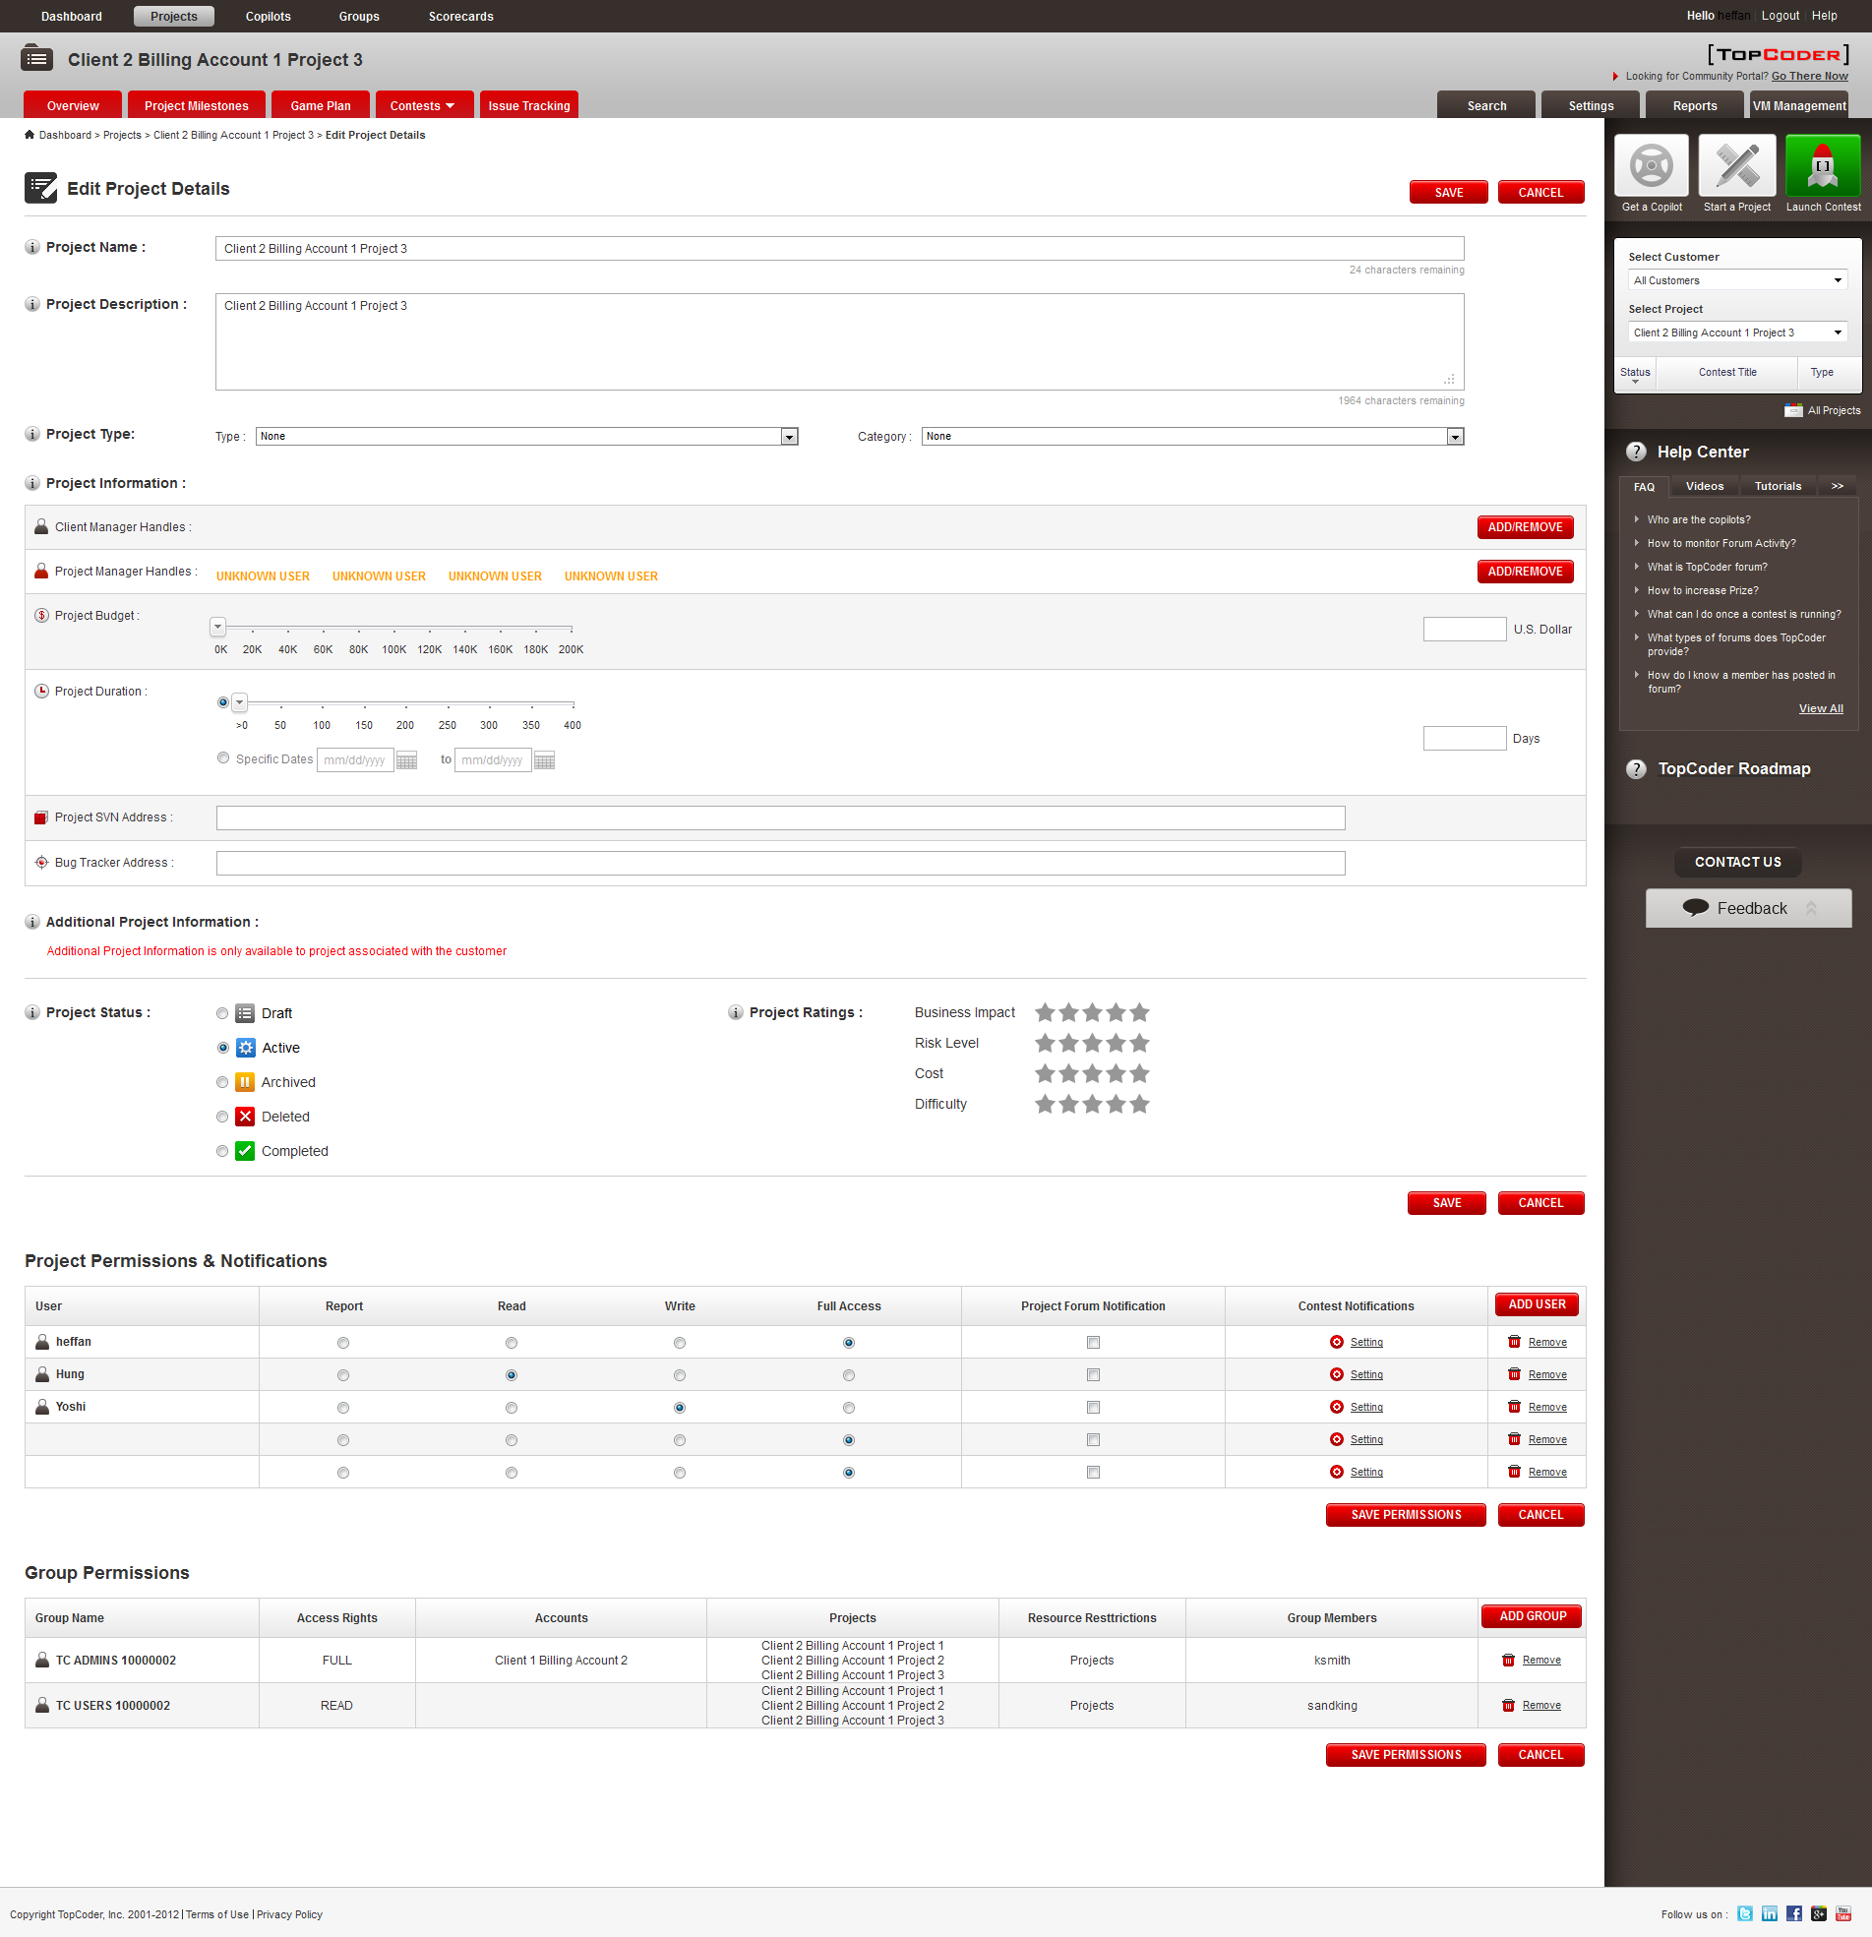

Add/remove desired groups and click Save Permissions button
  - The changes must be saved successfully

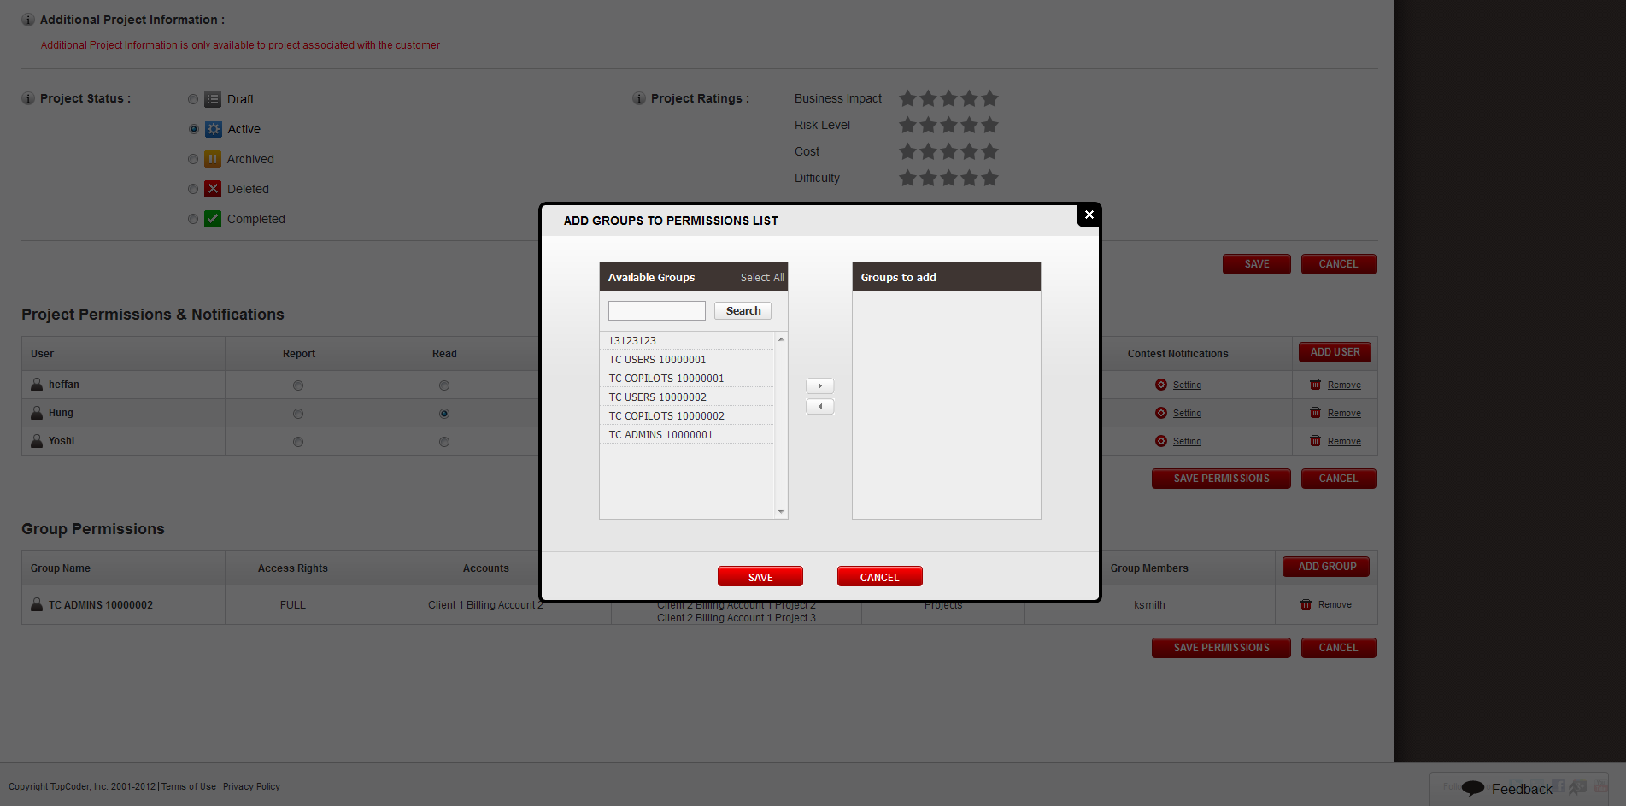

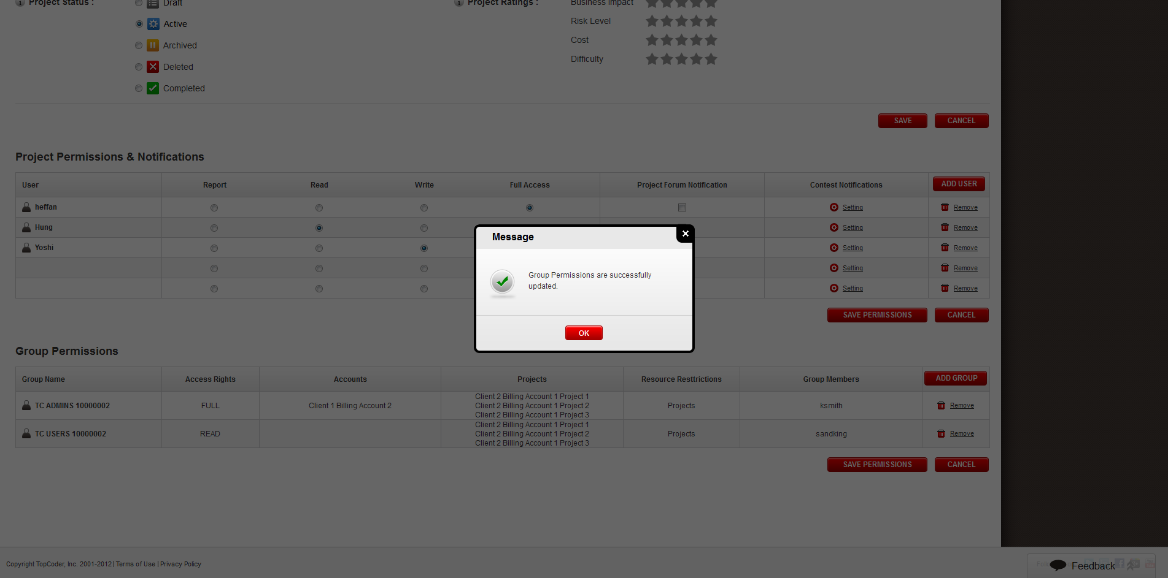
TopCoder Studio application

Visit http://studio.cloud.topcoder.com/?module=Logout logout then http://studio.cloud.topcoder.com/?module=Login login as annej9ny/password.

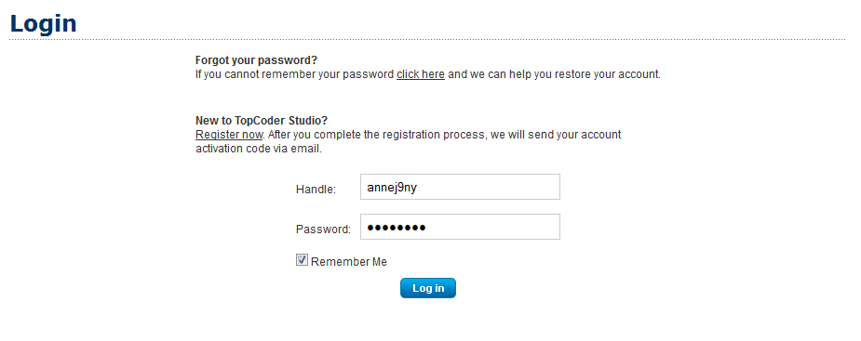

Visit http://studio.cloud.topcoder.com/?module=ViewContestDetails&ct=100. You should see there is no document in downloads section.

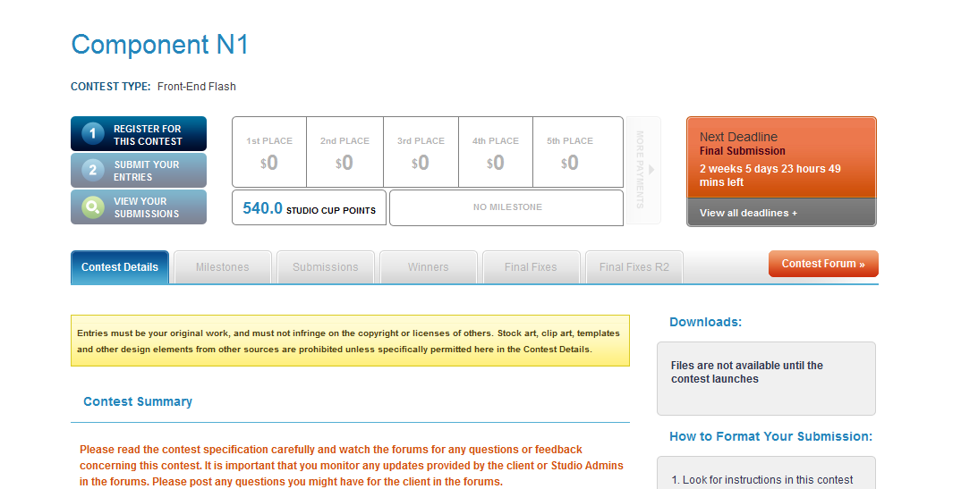

Visit http://studio.cloud.topcoder.com/?module=Logout logout then http://studio.cloud.topcoder.com/?module=Login
login as twight/password.

Visit http://studio.cloud.topcoder.com/?module=ViewContestDetails&ct=100. This time you should see downloads section with documents.

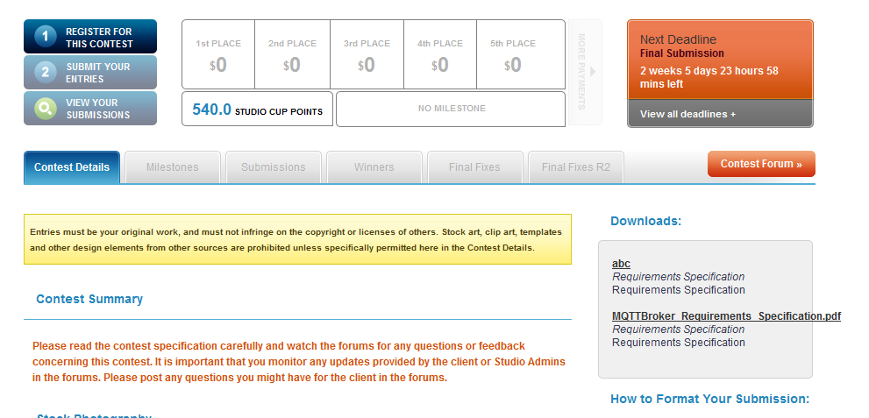

Online Review application

Login to Online Review application using URL like http://tcs.cloud.topcoder.com/review/jsp/login.jsp with annej9ny/password credentials
Visit http://tcs.cloud.topcoder.com/review/actions/NewProject.do?method=newProject page.

- The error page notifying on insufficient permissions must be displayed.

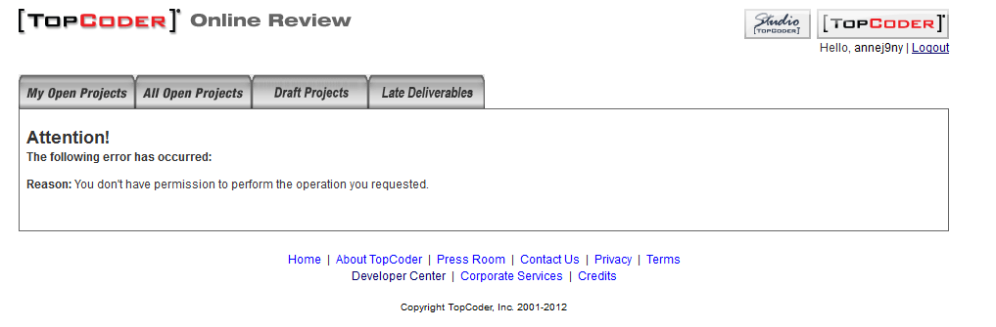
Login to Online Review application using URL like http://tcs.cloud.topcoder.com/review/jsp/login.jsp with cartajs/password credentials
Visit http://tcs.cloud.topcoder.com/review/actions/NewProject.do?method=newProject page
- the Billing Project list should be empty since user doesn’t have permission on tc direct project.

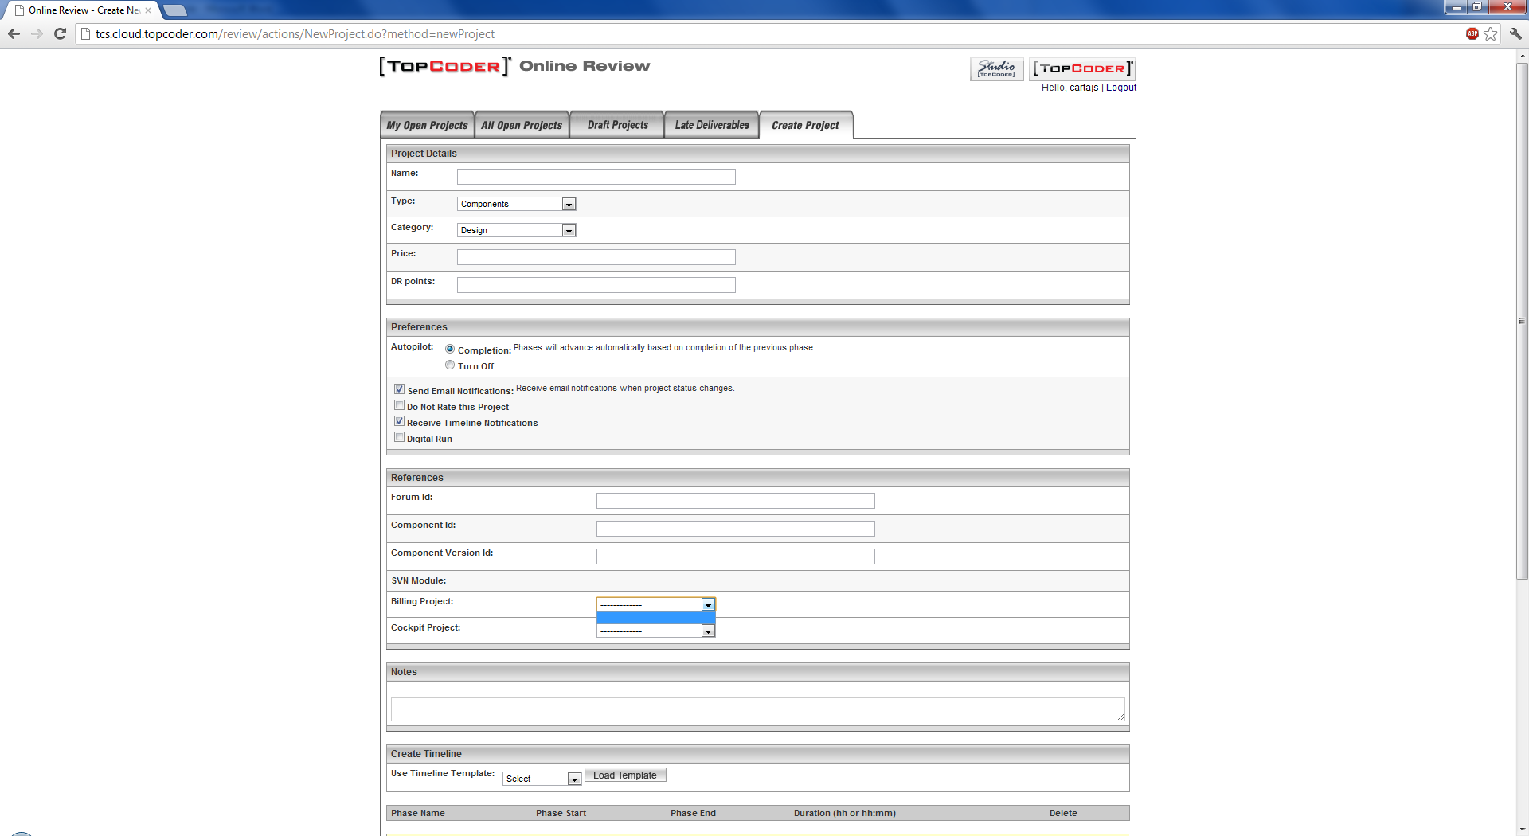

Login to Online Review application using URL like http://tcs.cloud.topcoder.com/review/jsp/login.jsp with heffan/password credentials
Visit http://tcs.cloud.topcoder.com/review/actions/NewProject.do?method=newProject page

- the Billing Project list should be empty since user doesn’t have permission on tc direct project

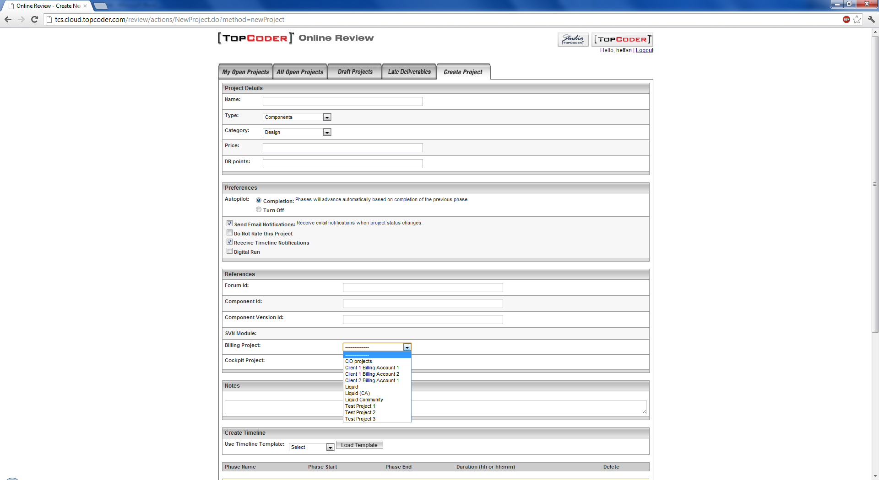

TopCoder Web Module application

Open Home page for TC Web Module application using URL like http://tc.cloud.topcoder.com/tc/
  - The Home page must be displayed successfully.

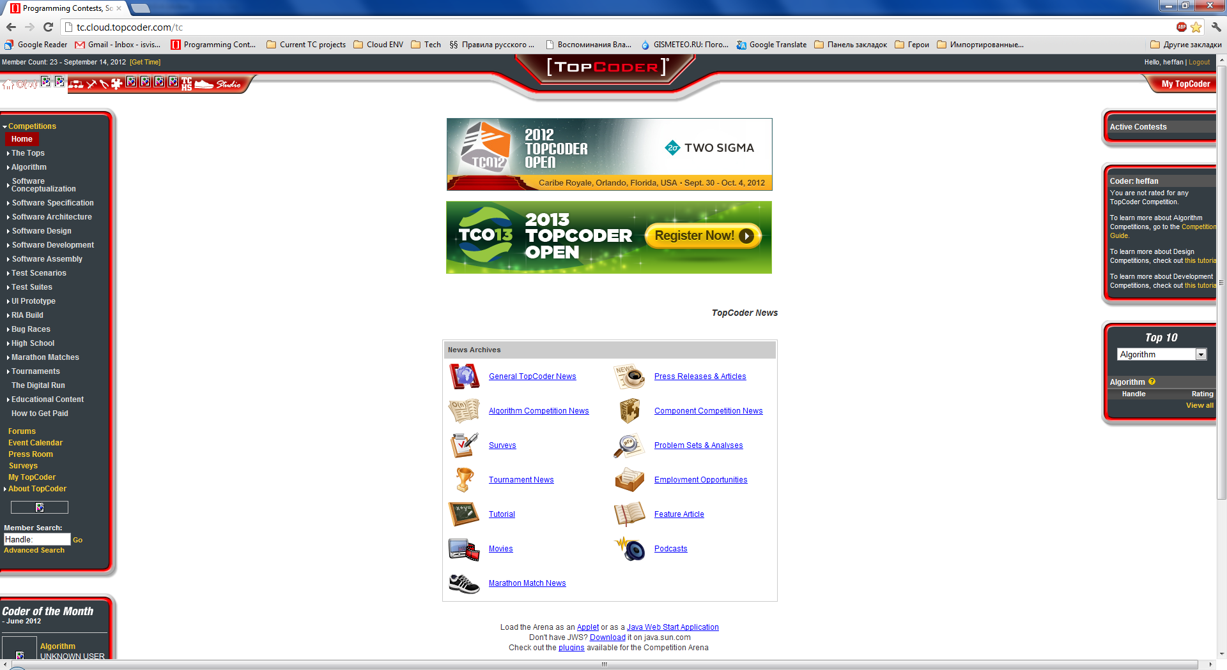

Resource Contact List

Name | Resource Email
isv

