Release Assembly -
TC Direct Issue Tracking Tab Update Assembly 1
Deployment Guide

Revision History
Author | Revision Number | Date
TCSASSEMBER | 1.0 | 03/26/2012

Deployment Instructions 3
1. Organization of Submission 3
2. Application Setup 3
2.1 Ant .Properties File 3
2.2 Build Scripts Setup 3
2.3 Configurations 4
3. Database Setup 4
4. Deployment Instructions 4
5. Starting 5
6. Verification 5
7. Resource Contact List 9

Deployment Instructions

Organization of Submission
The submission follows directory structure provided below:

docs

Contains this document which is the Deployment Guide for the TC Direct Issue Tracking Tab Update 1 assembly.

direct

Contains the new added / updated sources for Direct application in the course of this assembly. This directory replicates the application development distribution structure and includes only updated and new files.

test_files

Contains the helper files to be used for testing/review purposes only.

Application Setup
The application is expected to be deployed to the following environment:

JRE 1.5
JBoss 4.0.2.GA
Informix DS 11.0

Ant .Properties File
Property Name | File property is stored | Example Setting

Build Scripts Setup
The build script for Direct application (build.xml) provides the following targets which are to be used:

- switch-and-checkout –checkout or switch to the defined source code branches for all components defined in subprojects.xml
- dist-backend –rebuilt all the components from the source code.
- first_deploy –must be the first task to execute from command line. It will copy all dependencies to your local JBoss folder.
- deploy –should be the main task to execute from command line. It will build and deploy WAR file.
- deploy-apache-static – deploy the static files to Apache (Used in VM environment).
- deploy-static-files –deploys the static files to JBoss (Used in Local environment).

You can get more information here:
http://www.topcoder.com/wiki/display/docs/TC+Direct+Setup+Guide

Configurations
token.properties

Property | Explanation | Example Setting
@jiraServiceEndPoint@ | The JIRA service end point | https://apps.topcoder.com/bugs/rpc/soap/jirasoapservice-v2
@jiraServiceAdminUserName@ | The username of the JIRA account | jadmin
@jiraServiceAdminUserPassword@ | The password of the JIRA account | admin123
@jiraIssueURLPrefix@ | The prefix of JIRA issue URL | https://apps.topcoder.com/bugs/browse/
@jiraProfilePrefix@ | The prefix of JIRA profile URL | https://apps.topcoder.com/bugs/secure/ViewProfile.jspa?name=
@jiraBugRaceProject@ | The JIRA project name which holds the Bug Race issues.  Note: In production environment, this property must be BUGR. | TEST

conf/IssueTrackingConfig.xml

Property | Explanation | Example Setting
paymentStatusFieldId | The custom field id of custom filed 'Payment Status' | customfield_10030
tcoPointsFieldId | The custom field id of custom filed 'TCO Points' | customfield_10080
applicationNameFieldId | The custom field id of custom filed 'Application or Component Name' | customfield_10072
bugTypeFieldId | The custom field id of custom filed 'Bug Type' | customfield_10073
securityOpenId | The id of security "Open" level | 10041
securityNDAId | The id of security "NDA Members Only" level | 10043

conf/web/WEB-INF/applicationContext.xml

Property | Explanation | Example Setting
createJIRABugIssueAction.issueTypeId | The issue type id when creating Bug Race issue | 1

Database Setup
N/A

Deployment Instructions
This section provides the instructions in Production environment.

- Setup the SSL certification for *.topcoder.com.
- Merge the code in direct directory from submission into SVN branch for Direct application.
- Configuration the application as per section 2.3.
- In direct directory, build and deploy Direct application using ant deploy (or ant first_deploy) command.
- Copy static files using ant deploy-static-files (For VM environment) or ant deploy-apache-static (For Local environment) command.

Note: VM deployment instructions for reviewers are in Reviewer_Setup_Test_Instructions.README document.

Starting
- Build and deploy the Direct application.
- Start JBoss server instance hosting Direct application.

Verification
Please execute test_files/test_data.sql in database to active some billing projects.

- Open http://cockpit.cloud.topcoder.com/direct/home, login as heffan/password.

- Click the “Launch Contest” icon on the top right.
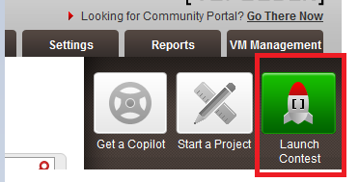

- Launch a software contest, “Software Assembly” for example. Select a “Billing Account”.
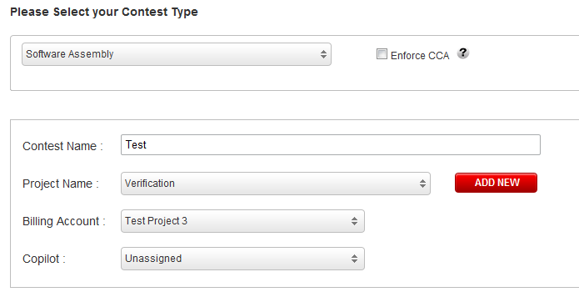
Click “Continue” button to navigate to the final page, Click “SUBMIT & LAUNCH CONTEST” button.
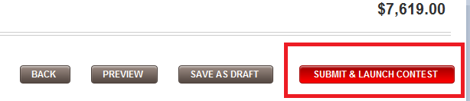

After the contest has been launched, click the “Edit” button to go to contest detail page.
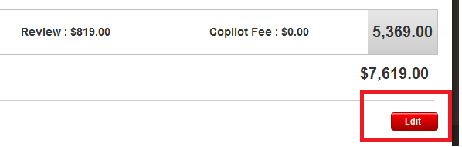

- Click “Issue Tracking” tab to go to contest issue tracking page.
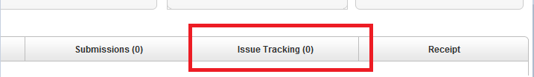

- Default the first created project id is 30005520. You will see the Issues and Bug Races.
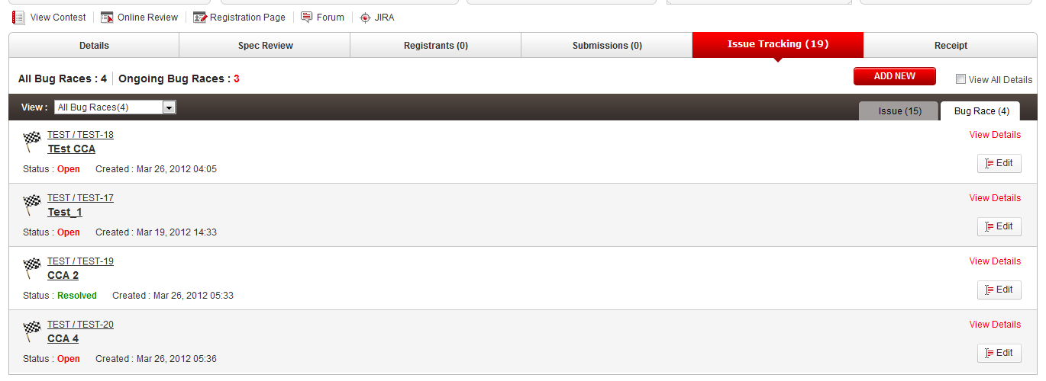

- Click “ADD NEW” button, an adding bug race forum will be displayed.
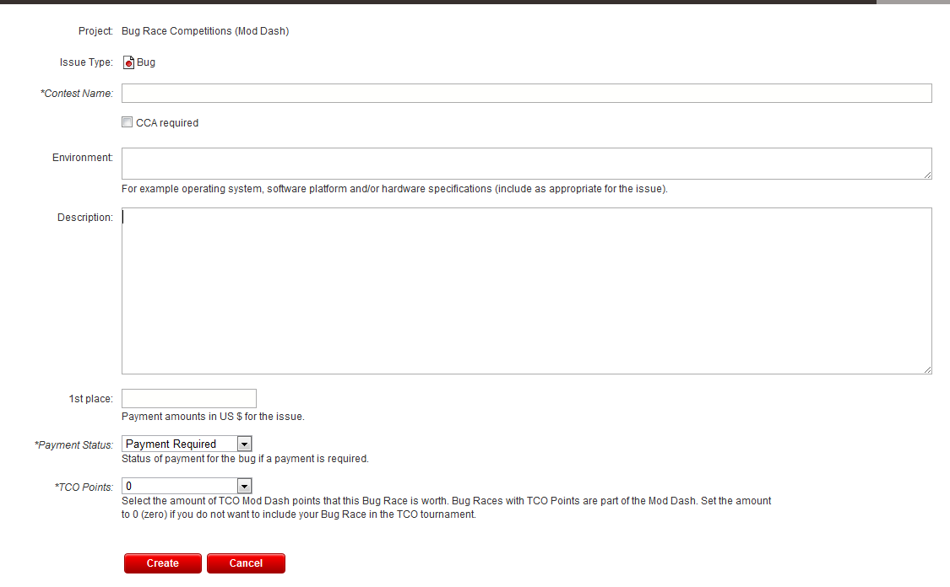

- Fill necessary data, click “Create” button. A JIRA issue will be created. A new row will be added to the bug races list. And the numbers of bug races are also updated.
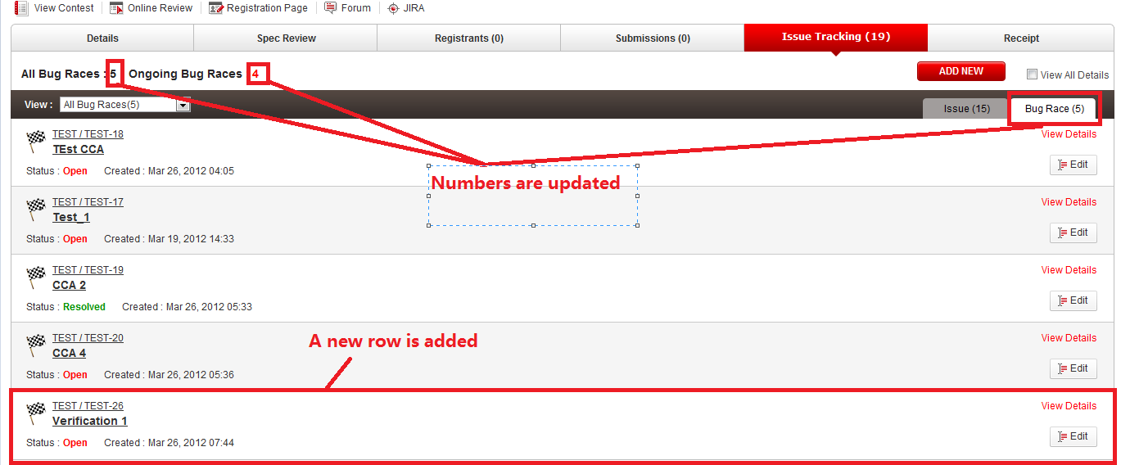

Click “View Detail” link of the new added bug race row, the detail of the new added issue will be displayed.
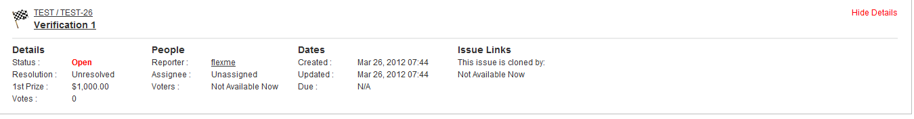

- Open https://apps.topcoder.com/bugs/browse/TEST , you can see the new created bug race issue.
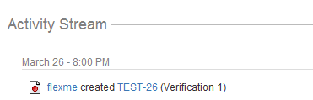

- You can also verify that it also works fine when environment, description, contest name contains tag.
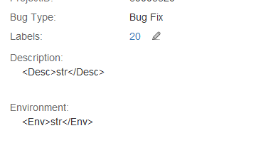
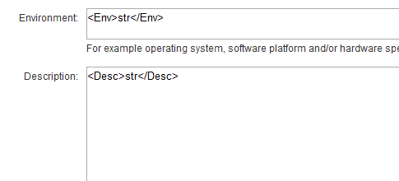

- Please verify the following issue fields.
  - The Bug Type of the new created software contest bug race is Bug Fix.
  - The Project ID is the contest id.
  - The Application or Component Name is the cockpit direct project name.
  - The Priority is Major.
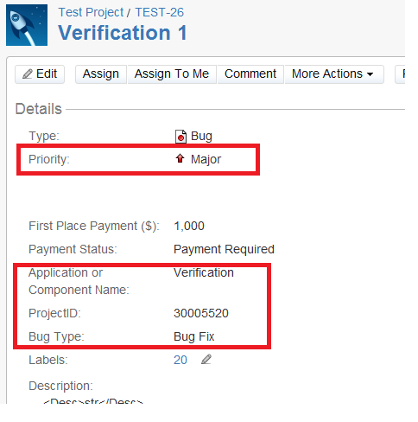

- In contest issue tracking page, click “Edit” button on a bug race row. An editing bug race form will be displayed. After changing some field values, click update button. The JIRA issue will be updated.
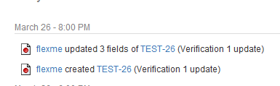

- Launch a new Studio contest following steps in step 3, except that the contest type should be a studio contest type (Web Design for example).

- In the contest issue tracking page of the studio contest, add a new Bug Race issue. Then go to the JIRA issue detail page, you can see that the Bug Type is Studio Bug instead of Bug Fix.
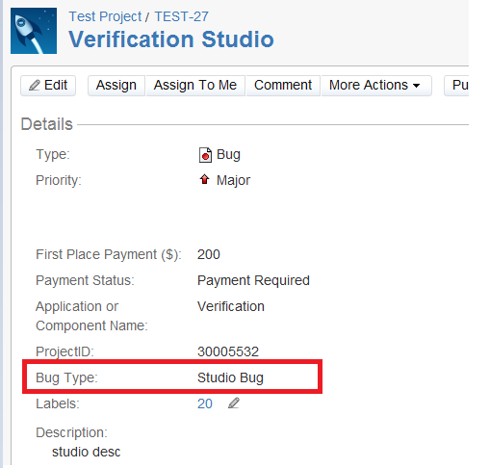

Resource Contact List

Name | Resource Email
TCSASSEMBER

