Topcoder Scorecard Tool
Deployment Guide
(System Assembly - Direct TopCoder
Scorecard Tool Integration)

Revision History
Author | Revision Number | Date
pvmagacho | 1.0 | 08/05/2011

Deployment Instructions 3
1. Organization of Submission 3
2. Application Setup 3
2.1 Grails Environment Setup 3
2.2 Install Informix Database 4
2.3 Application Configuration 4
2.4 Ant .properties File 5
2.5 Build Scripts Setup 6
3. Database Setup 6
4. Deployment Instructions 6
5. Starting 6
6. Verification 7
7. Resource Contact List 13

Deployment Instructions

Organization of Submission

The content of submission follows directory structure provided below:

scorecard.zip

This file is an eclipse project containing all the files for this application. These files will be used to build the deployment file using ANT. You can also use Eclipse with grails plugin or Springsource Tool Suite to import this project.

direct_deploy.zip

This file holds all changed files for the CockPit direct application.

docs

Contains the documents for the Topcoder Scorecard Tool application including this document which is the Deployment Guide for the Topcode Scorecard Tool assembly. Two files are present ScorecardToolDeploymentGuide_Old and ScorecardToolDeploymentGuide.

The ScorecardToolDeploymentGuide_Old is the previous deployment guide. The deployment guide for the last assembly is ScorecardToolDeploymentGuide.doc (this document).

scripts

Contains the database schema files used for updating the database.

ChangLog.txt

Contains the changes in the file.

Application Setup

The application is expected to be deployed to the following environment:

JAVA 1.5+
grails 1.3.7
ant 1.7 (version > 1.7 cannot be used)
Informix 11.5
Cockpit Direct Application

Grails Environment Setup

We are now using ANT to build the application, it will automatically download necessary libraries using Ivy. The following files were added to the application: build.xml, ivy.xml and ivysettings.xml

However a local copy of grails shoud be installed in order to get the plugins correctly. Get grails 1.3.7 from http://dist.springframework.org.s3.amazonaws.com/release/GRAILS/grails-1.3.7.zip
Unzip it inside /home/direct folder (or any other folder). After that run the following commands:
- export GRAILS_HOME=/home/direct/grails-1.3.7
- export PATH=$PATH:$GRAILS_HOME/bin

Also the _Events.groovy file was added to the scorecard scripts/ directory to disable Grails log management. All logging will be done through JBoss.

Install Informix Database
Please follow the instructions in http://www.topcoder.com/wiki/display/docs/TopCoder+Databases+Setup+Guide
to install Informix 11.5 locally and setup the data.

Application Configuration
This application uses grails framework. So it just follows the grails standards. Basically, you only need to configure the data source for development/production environments.
The data source is configured in scorecard_tool/grails-app/conf/ DataSource.groovy
Following is a sample configuration:

// environment specific settings
environments {
development {
dataSource {
//url = "jdbc:hsqldb:mem:devDB"

driverClassName = "com.informix.jdbc.IfxDriver"
url = "jdbc:informix-sqli://localhost:2021/tcs_catalog:INFORMIXSERVER=informixoltp_tcp;DB_LOCALE=en_us.utf8"
username = "informix"
password = "1nf0rm1x"
}
}
test {
dataSource {
// Please DONOT change the data source for test environment because the review table in production database has
// many foreign keys
dbCreate = "create-drop"
url = "jdbc:hsqldb:mem:testDb"
}
}
production {
dataSource {
driverClassName = "com.informix.jdbc.IfxDriver"
url = "jdbc:informix-sqli://localhost:2021/tcs_catalog:INFORMIXSERVER=informixoltp_tcp;DB_LOCALE=en_us.utf8"
username = "informix"
password = "1nf0rm1x"
}
}
}

You can also configure the custom error messages in scorecard_tool/grails-app/i18n/messages.properties, the new custom messages added in this assembly are:

Message Key | Explanation
com.topcoder.admin.scorecards.Scorecard.minimumScore.validator.invalid | The minimum score of a scorecard must be less than the maximum score
com.topcoder.admin.scorecards.Scorecard.scorecardGroups.validator.invalid | The sum weight of scorecard groups must be 100.0
com.topcoder.admin.scorecards.ScorecardGroup.weight.validator.invalid | The weight of scorecard group must be greater than 0 and less or equal to 100
com.topcoder.admin.scorecards.ScorecardGroup.scorecard.validator.invalid | The scorecard of this scorecard group have been used, so it isn’t editable
com.topcoder.admin.scorecards.ScorecardGroup.scorecardSections.validator.invalid | The sum weight of scorecard sections must be 100.0
com.topcoder.admin.scorecards.ScorecardSection.weight.validator.invalid | The weight of scorecard section must be greater than 0 and less or equal to 100
com.topcoder.admin.scorecards.ScorecardSection.scorecardGroup.validator.invalid | The scorecard of this scorecard section have been used, so it isn’t editable
com.topcoder.admin.scorecards.ScorecardSection.scorecardQuestions.validator.invalid | The sum weight of scorecard questions must be 100.0
com.topcoder.admin.scorecards.ScorecardQuestion.weight.validator.invalid | The weight of scorecard question must be greater than 0 and less or equal to 100
com.topcoder.admin.scorecards.ScorecardQuestion.scorecardSection.validator.invalid | The scorecard of this scorecard question have been used, so it isn’t editable
com.topcoder.admin.scorecards.scorecardInUsed | The scorecard has been used, so it isn’t editable

You can configure the root of JSON RESTful service in scorecard_tool/grails-app/conf/Config.groovy
// the root of the JSON RESTful API
grails.'json-rest-api'.root = '/json'

Ant .properties File

Property Name | File property is stored | Example Setting

Build Scripts Setup

There is no need to setup any scripts for ANT build.

The ant build.xml file, found inside the scorecard.zip file contains the following targets that can be used: compile, clean, war and test.
The cockpit build.xml file was also updated to add the following targets: scorecard_war and scorecard_clean. Those are links to the specific scorecard targets war and clean, respectively.

If you install grails 1.3.7 and set the PATH to its bin directory, the grails commands can be used directly as well. THIS IS NOT RECOMMENDED. The following scripts can be used:
grails run-app Run the application in development environment
grails war Package the application into a war file, then you can copy the war file to a J2EE container, the application will run in production environment
grails test-app Run the unit tests and integration tests (You need to run the web application in a web server first before you run grails test-app because the REST Client needs the web application running)

Database Setup
- Install the Informix database as per in 2.2.
- Execute update_roles.sql to update the database. This will add the scorecard administrator role.

Deployment Instructions

1- Execute the database setup as in Section 3

2- Install Grails as described in Section 2.1

3- Unzip the scorecard.zip file and the direct_deploy.zip file found in the submission file into the direct directory (in VM it should be /home/direct/direct).

4- Follow the direct deployment instructions in http://apps.topcoder.com/wiki/display/projects/Cockpit%2CDirect+VM and http://apps.topcoder.com/wiki/display/docs/TC+Direct+Setup+Guide.

If it’s the first time after checkout the following commands should be used: ant switch-and-checkout, ant dist-backend, ant first_deploy.

5- If step 4 has been already done, just run ‘ant deploy’.

Starting

After application is deployed (see section 4), you will need to restart jboss.

If it’s running go to the $JBOSS_HOME/bin directory (using jbb in VM).
Run the script ‘./kill.sh’. Answer ‘y’.

To start jboss again just run the script ‘./start.sh’.

Verification
- Start the application either in development or production environment as per in section 5.
- Open http://cockpit.cloud.topcoder.com/direct/scorecard/ (VM link – real link should be http://www.topcoder.com/direct/scorecard). If you’ve never logged in or have logged out to the application previously, the login page should open.

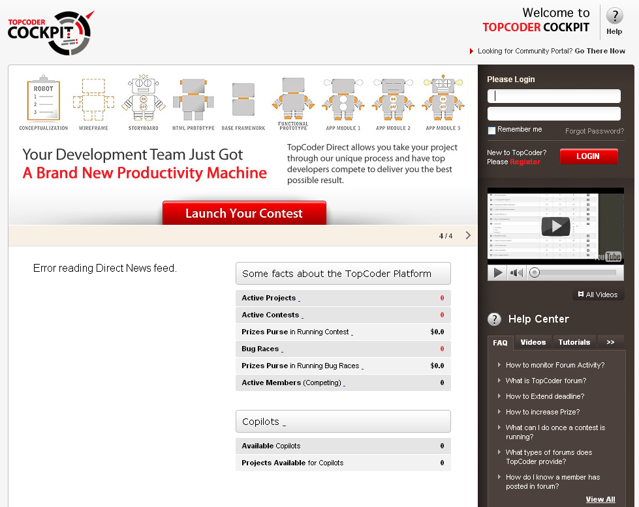

- Login to the direct application using ‘heffan’ user. The main page will show.

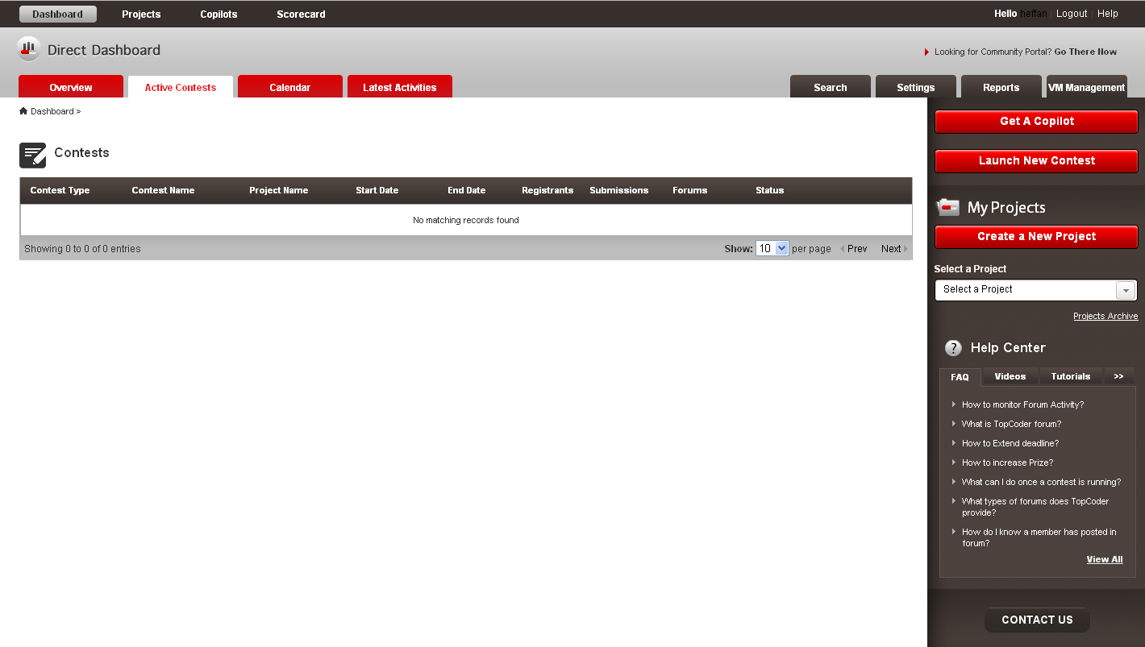

- Click on the Scorecards link on the top of the page. You will see the scorecard finding page as below.

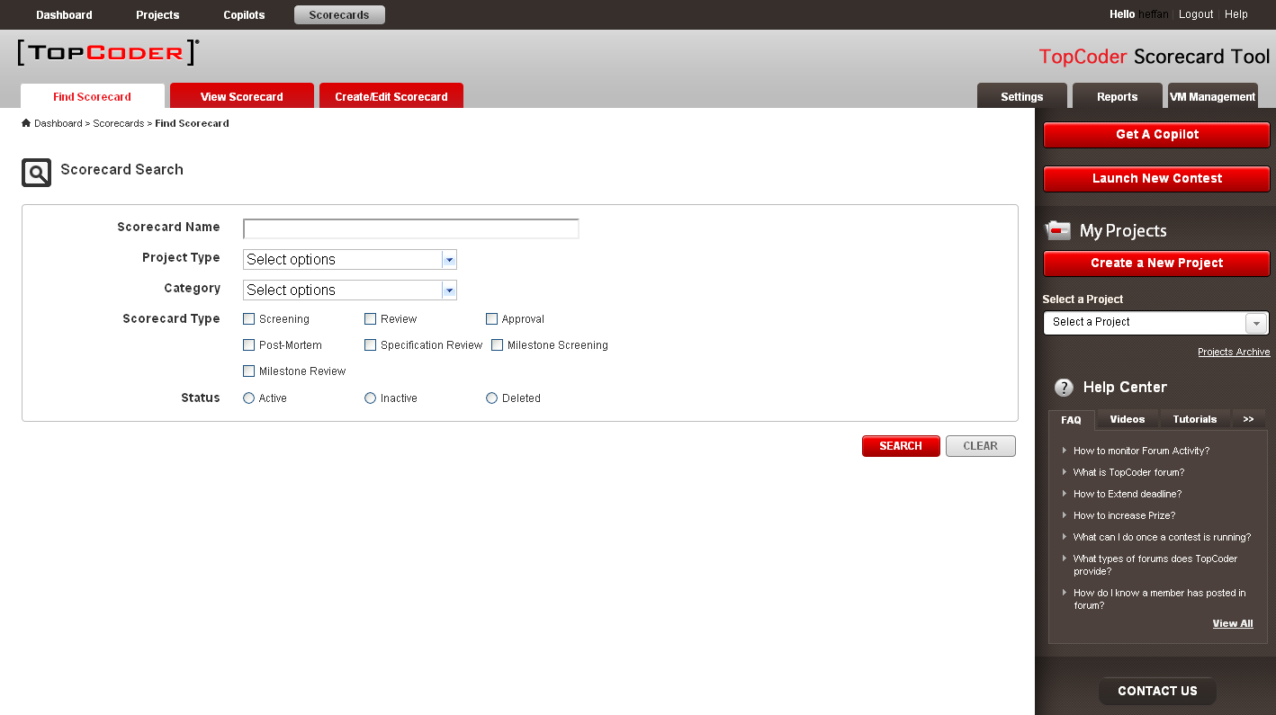

- The Category dropdown will be dynamic loaded when the value of Project Type dropdown changed.
- You can click “SEARCH” button to search scorecard.

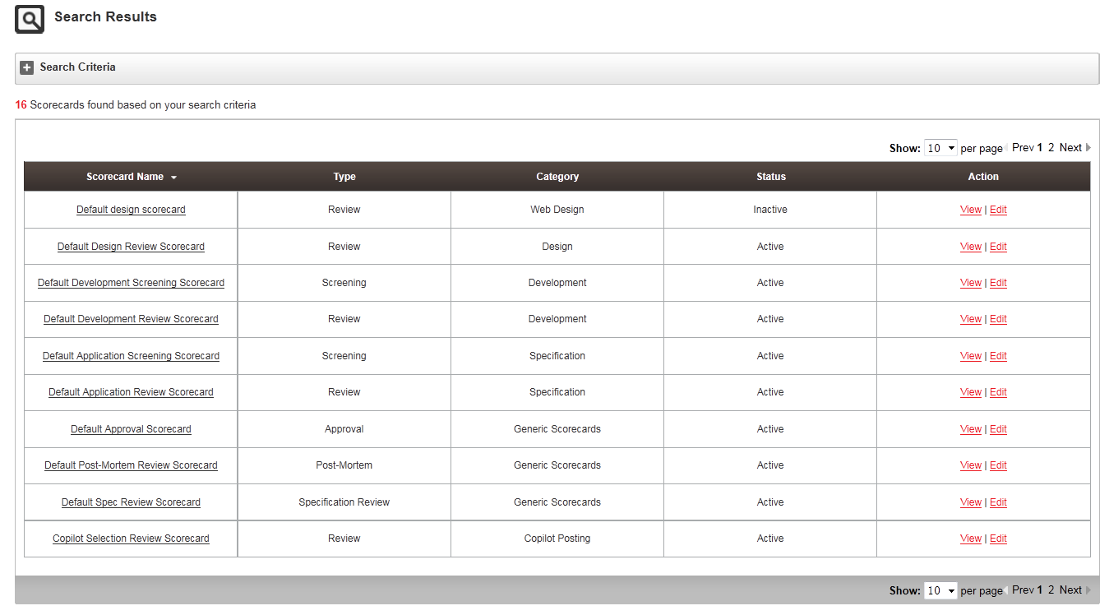

- You can check the paging function works.
- Click the “View” link, the scorecard detail page will be displayed as below.

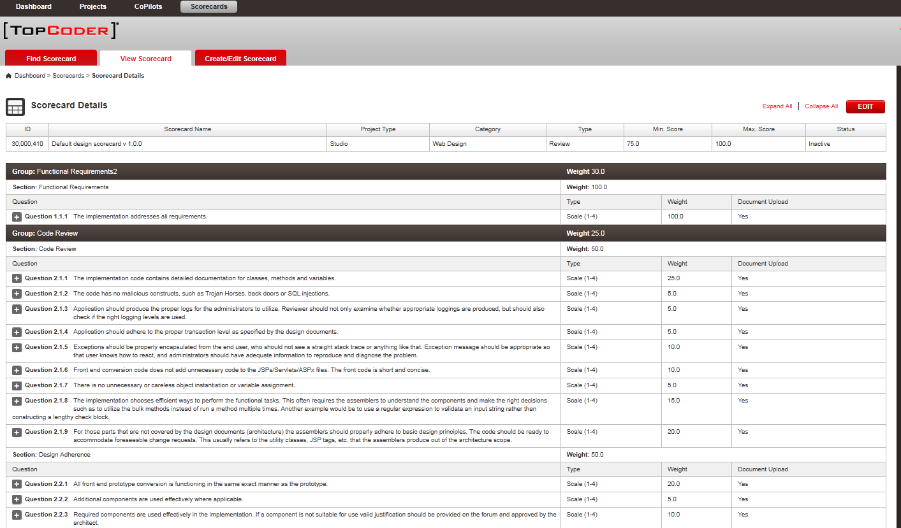

- Youc can click the “Edit” button to edit the scorecard.

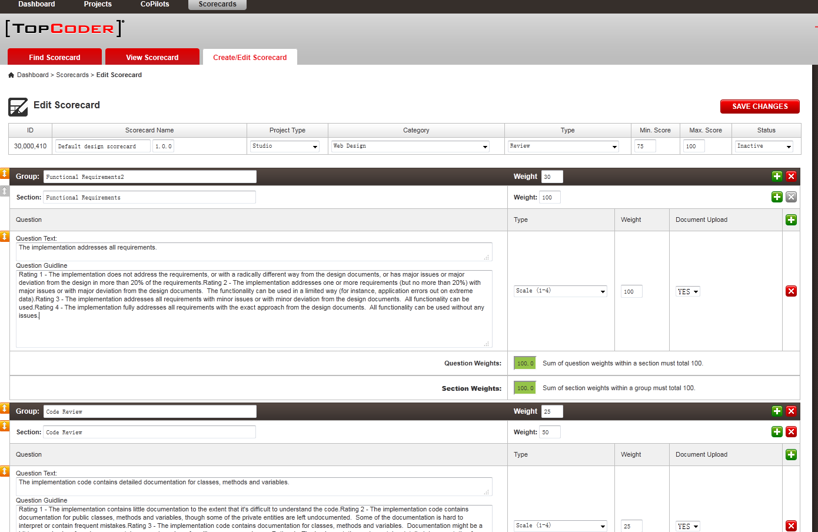

- You can change the configuration values of Scorecard, Scorecard Groups, Scorecard Sections, and Scorecard Questions. You can also add scorecard groups, scorecard sections and scorecard questions.

- You can drag the rows to change the order of groups/sections/questions.

- There are 3 ways to add new questions.

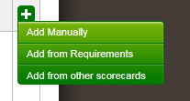

- When you choose “Add from other scorecards” to add new questions. A popup window will be displayed in which you can search the scorecards.

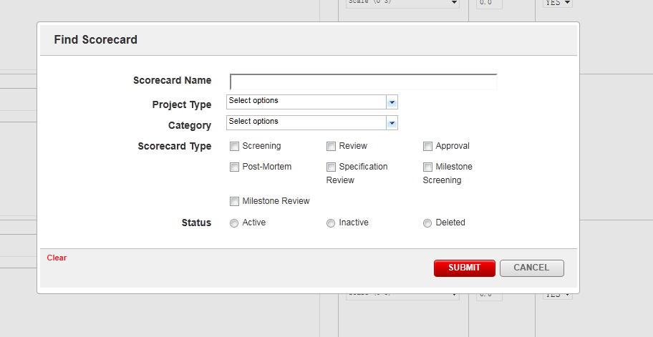

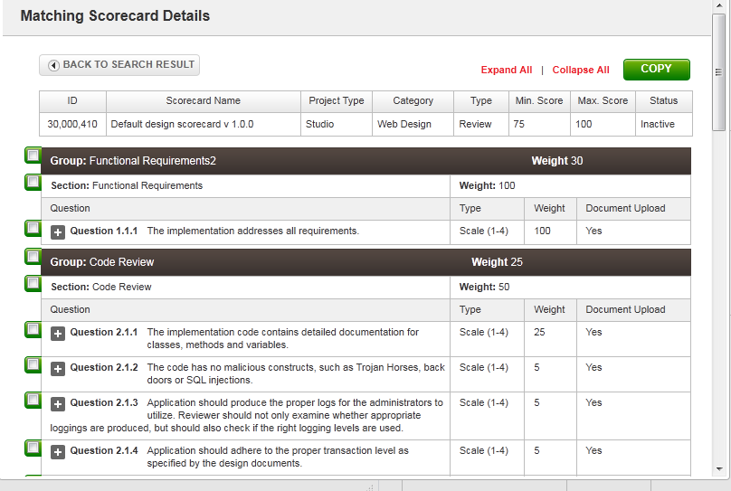

- You can click “SAVE CHANGES” button to save the scorecard. If any error occurs or the data can’t pass validation, a popup window will be displayed.

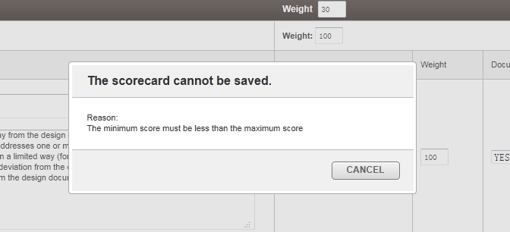

- Click on the logout link on the top of the page. Login again using the ‘user’ user and ‘password’. You will notice that the Scorecards link is no longer in top of the page as ‘user’ does not have scorecard administrator role.

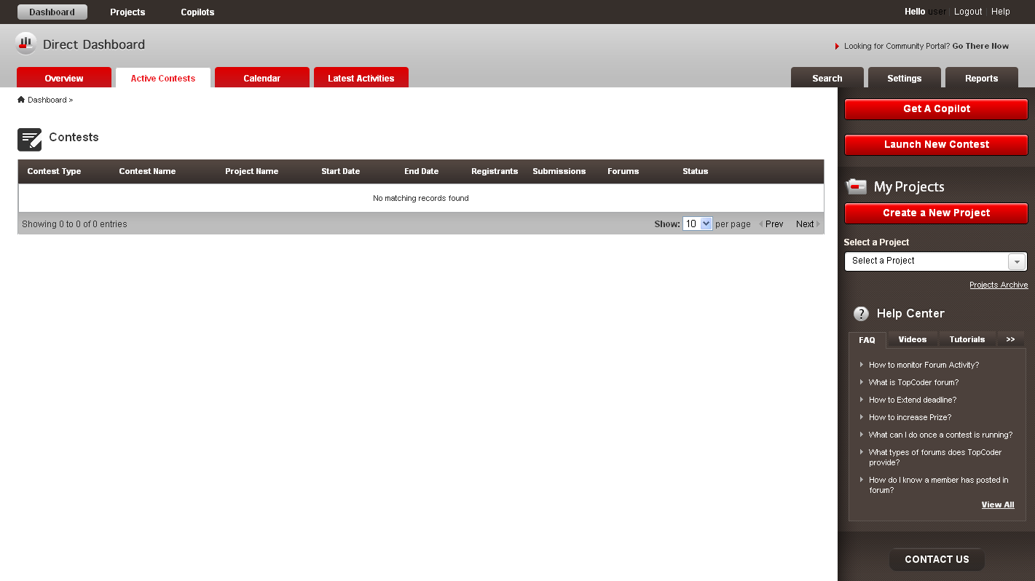
- If you try to go to the scorecards page directly (http://cockpit.cloud.topcoder.com/direct/scorecard) you will be redirectly to the dashboard page.

Resource Contact List

Name | Resource Email
pvmagacho

