Topcoder Scorecard Tool
Deployment Guide

Revision History
Author | Revision Number | Date
TCSASSEMBER | 1.0 | 02/24/2011
TCSASSEMBER | 1.1 | 05/25/2011
TCSASSEMBER | 1.2 | 06/13/2011

Deployment Instructions 3
1. Organization of Submission 3
2. Application Setup 3
2.1 Ant .Properties File 5
2.2 Build Scripts Setup 5
3. Database Setup 6
4. Deployment Instructions 6
5. Starting 6
6. Verification 6
7. Resource Contact List 9

Deployment Instructions

Organization of Submission

The content of submission follows directory structure provided below:

scorecard_tool

This directory is an eclipse project containing all the files for this application. You can use Eclipse with grails plugin or Springsource Tool Suite to import this project.

docs

Contains the documents for the Topcoder Scorecard Tool application including this document which is the Deployment Guide for the Topcode Scorecard Tool assembly.

scripts

Contains the database schema files used for updating the database.

test_files

This directory contains some files used for testing.

Application Setup

The application is expected to be deployed to the following environment:

JAVA 1.5+
grails 1.3.7
Informix 11.5

Grails Environment Setup

You can either install SpringSource Tool Suite or just simply installing the grail.
- If you want to use grails in SpringSource Tool Suite, you can install SpringSource Tool following the instructions here:
http://grails.org/STS+Integration
- If you just want to install grails, please follow the instructions here:
http://grails.org/Installation

Install Informix Database
Please follow the instructions in http://www.topcoder.com/wiki/display/docs/TopCoder+Databases+Setup+Guide
to install Informix 11.5 locally and setup the data.

Application Configuration
This application uses grails framework. So it just follows the grails standards. Basically, you only need to configure the data source for development/production environments.
The data source is configured in scorecard_tool/grails-app/conf/ DataSource.groovy
Following is a sample configuration:

// environment specific settings
environments {
development {
dataSource {
//url = "jdbc:hsqldb:mem:devDB"

driverClassName = "com.informix.jdbc.IfxDriver"
url = "jdbc:informix-sqli://localhost:2021/tcs_catalog:INFORMIXSERVER=informixoltp_tcp;DB_LOCALE=en_us.utf8"
username = "informix"
password = "1nf0rm1x"
}
}
test {
dataSource {
// Please DONOT change the data source for test environment because the review table in production database has
// many foreign keys
dbCreate = "create-drop"
url = "jdbc:hsqldb:mem:testDb"
}
}
production {
dataSource {
driverClassName = "com.informix.jdbc.IfxDriver"
url = "jdbc:informix-sqli://localhost:2021/tcs_catalog:INFORMIXSERVER=informixoltp_tcp;DB_LOCALE=en_us.utf8"
username = "informix"
password = "1nf0rm1x"
}
}
}

You can also configure the custom error messages in scorecard_tool/grails-app/i18n/messages.properties, the new custom messages added in this assembly are:

Message Key | Explanation
com.topcoder.admin.scorecards.Scorecard.minimumScore.validator.invalid | The minimum score of a scorecard must be less than the maximum score
com.topcoder.admin.scorecards.Scorecard.scorecardGroups.validator.invalid | The sum weight of scorecard groups must be 100.0
com.topcoder.admin.scorecards.ScorecardGroup.weight.validator.invalid | The weight of scorecard group must be greater than 0 and less or equal to 100
com.topcoder.admin.scorecards.ScorecardGroup.scorecard.validator.invalid | The scorecard of this scorecard group have been used, so it isn’t editable
com.topcoder.admin.scorecards.ScorecardGroup.scorecardSections.validator.invalid | The sum weight of scorecard sections must be 100.0
com.topcoder.admin.scorecards.ScorecardSection.weight.validator.invalid | The weight of scorecard section must be greater than 0 and less or equal to 100
com.topcoder.admin.scorecards.ScorecardSection.scorecardGroup.validator.invalid | The scorecard of this scorecard section have been used, so it isn’t editable
com.topcoder.admin.scorecards.ScorecardSection.scorecardQuestions.validator.invalid | The sum weight of scorecard questions must be 100.0
com.topcoder.admin.scorecards.ScorecardQuestion.weight.validator.invalid | The weight of scorecard question must be greater than 0 and less or equal to 100
com.topcoder.admin.scorecards.ScorecardQuestion.scorecardSection.validator.invalid | The scorecard of this scorecard question have been used, so it isn’t editable
com.topcoder.admin.scorecards.scorecardInUsed | The scorecard has been used, so it isn’t editable

You can configure the root of JSON RESTful service in scorecard_tool/grails-app/conf/Config.groovy
// the root of the JSON RESTful API
grails.'json-rest-api'.root = '/json'

Ant .Properties File

Property Name | File property is stored | Example Setting

Build Scripts Setup

This application uses grails framework. And the build scripts are provided by grails framework. If you have installed grails 1.3.7 as per in 2.1, the following scripts can be used:
grails run-app Run the application in development environment
grails war Package the application into a war file, then you can copy the war file to a J2EE
container, the application will run in production environment
grails test-app Run the unite tests and integration tests (You need to run the web application in a web server first before you run grails test-app because the REST Client needs the web application running)

Database Setup
- Install the Informix database as per in 2.2.
- Execute scripts/upadte.sql to update the database (You can ignore this step if you use the latest database SVN branch).

Deployment Instructions
- Install the grails environment as per in 2.1.
- Run the application in development environment:
- cd <submission_root>\scorecard_tool
- grails run-app
- Run the application in production environment:
- cd <submission_root>\scorecard_tool
- grails war
- Rename scorecard_tool/target/scorecard_tool-0.1.war to scorecard_tool.war
- copy the generated war file to a J2EE container
- Run the unit tests and integration tests
- cd <submission_root>\scorecard_tool
- grails test-app

Starting

As per in section 4, if the application will be running in production environment, you need to rename the war file from scorecard_tool-x.x.war to scorecard_tool.war , then start the web server after you copy the war file to web server.

Verification
- Start the application either in development or production environment as per in section 5.
- Open http://localhost:8080/scorecard_tool/, you will see the scorecard finding page as below.
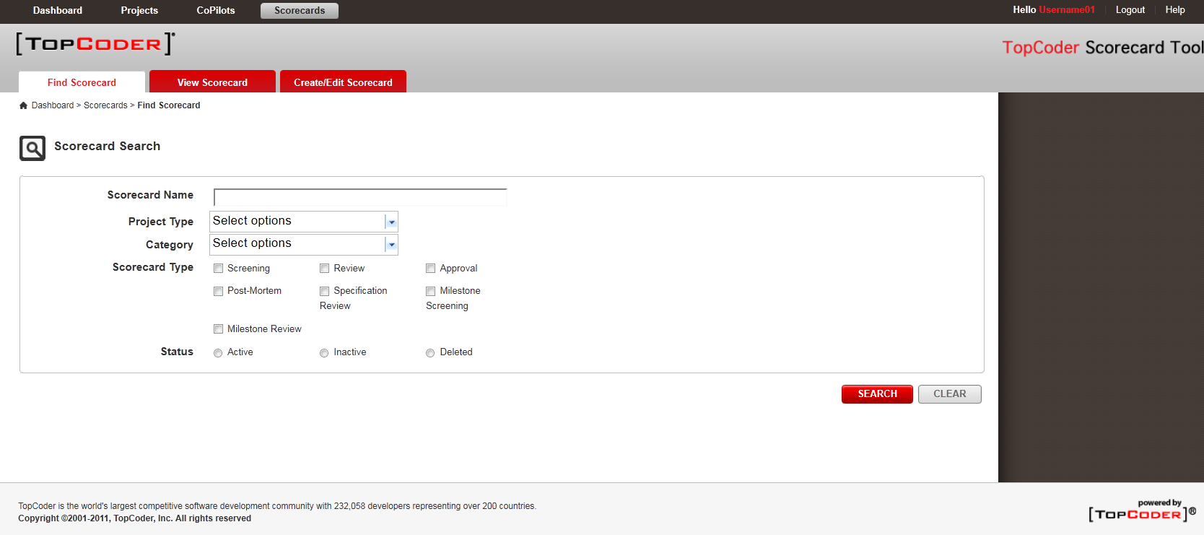

- The Category dropdown will be dynamic loaded when the value of Project Type dropdown changed.

- You can click “SEARCH” button to search scorecard.
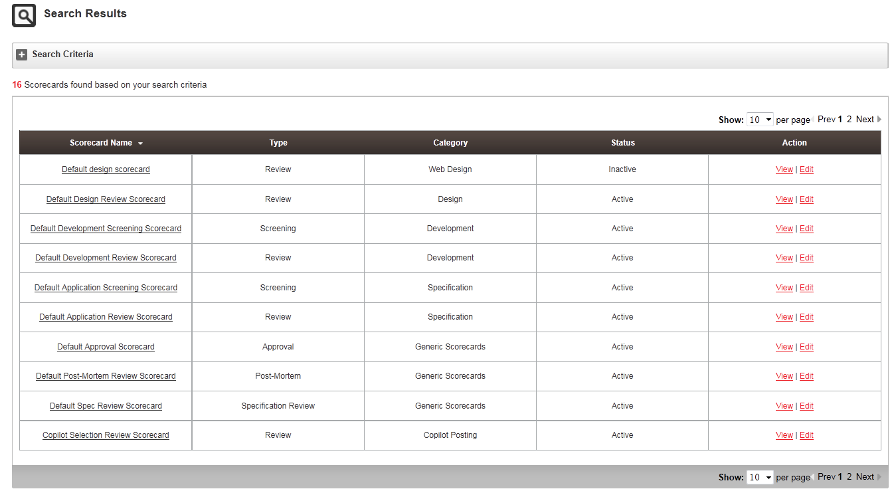

- You can check the paging function works.

- Click the “View” link, the scorecard detail page will be displayed as below.
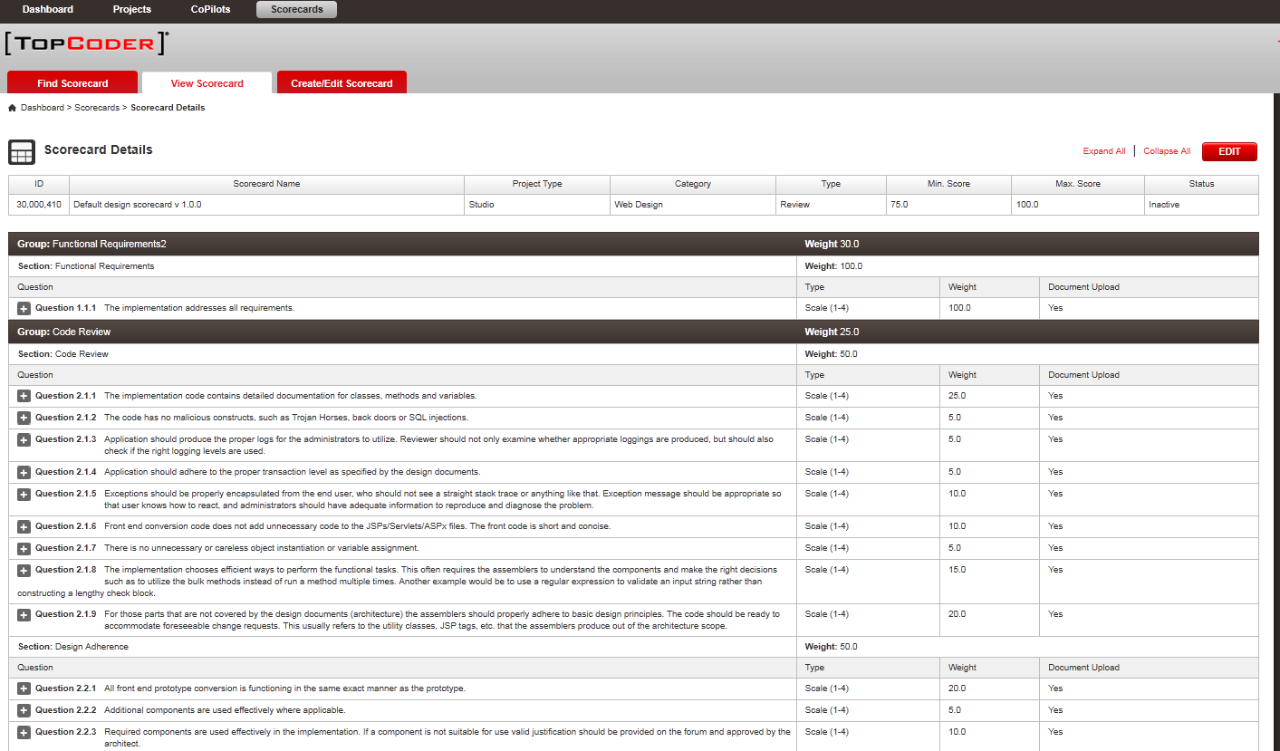

- Youc can click the “Edit” button to edit the scorecard.
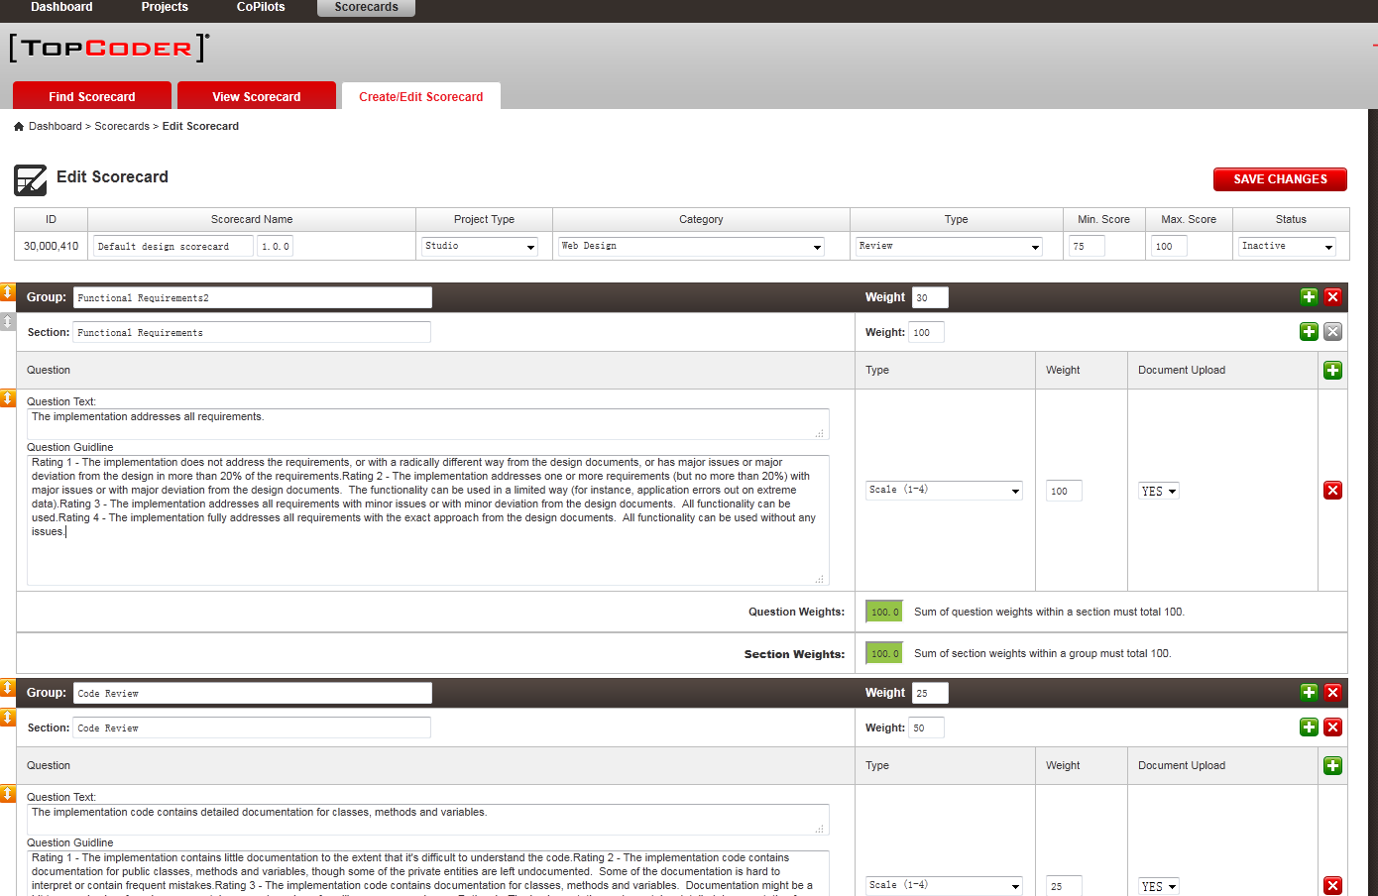

- You can change the configuration values of Scorecard, Scorecard Groups, Scorecard Sections, and Scorecard Questions. You can also add scorecard groups, scorecard sections and scorecard questions.

- You can drag the rows to change the order of groups/sections/questions.

- There are 3 ways to add new questions.
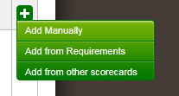

- When you choose “Add from other scorecards” to add new questions. A popup window will be displayed in which you can search the scorecards.
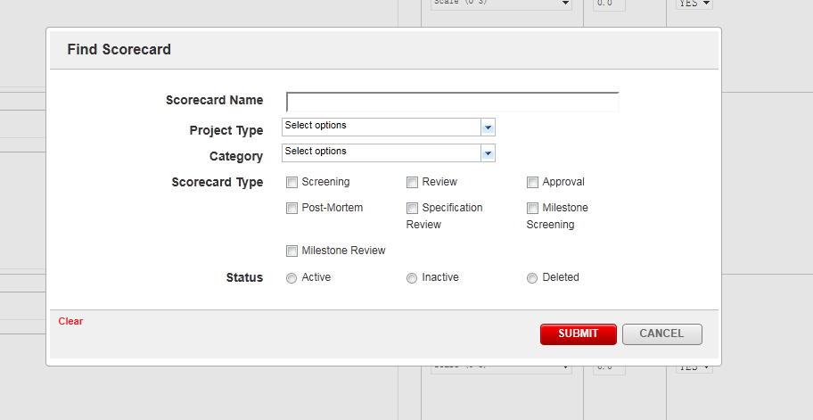
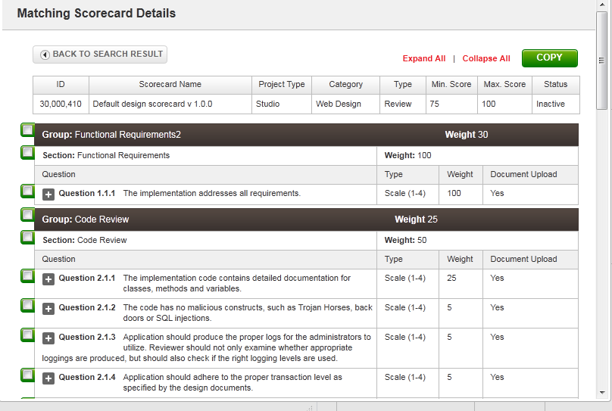

- You can click “SAVE CHANGES” button to save the scorecard. If any error occurs or the data can’t pass validation, a popup window will be displayed.
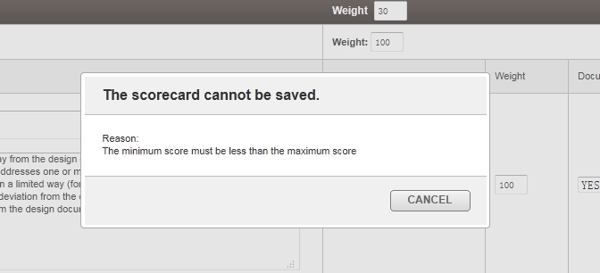

Resource Contact List

Name | Resource Email
TCSASSEMBLER

