Release Assembly - TC Direct Cockpit Release Four Deployment Guide

Revision History
Author | Revision Number | Date
TCSASSEMBER | 1.0 | 05/06/2012

Deployment Instructions 3
1. Organization of Submission 3
2. Application Setup 3
2.1 Ant .Properties File 3
2.2 Build Scripts Setup 3
3. Database Setup 4
4. Deployment Instructions 4
5. Starting 4
6. Verification 4
7. Resource Contact List 5

Deployment Instructions

Organization of Submission

The submission follows directory structure provided below:

doc
Contains the Deployment Guide Document of this assembly.

direct
Contains sources and static files for Direct web application. This directory replicates the application development distribution structure and includes only updated and new files.
query
Contains all the newly added two queries and one updated query
test_files
Contains the SQL files to insert test data
my_fxies_note.txt
The required change note that provides details of how each ticket is fixed.

Application Setup

The application is expected to be deployed to the following environment:

JRE 1.5
JBoss 4.2.3.GA
Informix DS 11.5

Ant .Properties File

Configurations

ejb-jar.xml of contest service façade has the following properties added

Property Name | Sample
copilotWinnerEmailTemplatePath | email_templates/copilot_posting_winner.txt
copilotWinnerEmailFromAddr | directassist@topcoder.com
copilotWinnerEmailBCCAddr | directassist@topcoder.com
ccopilotWinnerEmailSubject | You are selected as copilot for (%PROJECT_NAME%)

Build Scripts Setup
The ANT build script for Direct application (build.xml) provides the following targets which are to be used:

- switch-and-checkout – checkout or switch to the defined source code branches for all components defined in subprojects.xml
- dist-backend – rebuilt all the components from the source code.
- first_deploy – must be the first task to execute from command line. It will copy all dependencies to your local JBoss folder.
- deploy – should be the main task to execute from command line. It will build and deploy WAR file.
- deploy-static-files – deploys the static files to JBOSS.
- deploy-apache-static – deploys the static files to apache server on VM.

Please refer here for more information:
http://www.topcoder.com/wiki/display/docs/TC+Direct+Setup+Guide

Database Setup
- None

Update and add queries via Query Tool

Log into the TC Query Tool to add the new query (on VM use http://tc.cloud.topcoder.com/query/query)

Update query direct_contest_stats_replatforming
- Choose the database TCS_CATALOG
- Choose query direct_contest_stats_replatforming, click edit
- Replace the content with queries/query_direct_contest_stats_replatforming.txt and Save

Deployment Instructions

This section provides the instructions in Production environment.

- Merge the code from submission into SVN for Direct application
- Go to the directory contest_service_facade, run ‘ant dist_tcs’ to rebuild the component
- Build and deploy Direct application using ant deploy (or ant first_deploy ) command.
- Copy static files using ant deploy-static-files command or ant deploy-apache-static if use apache as static file server.

Starting

- Build and deploy the Direct application
- Start JBoss server instance hosting Direct application

Verification

Set up test data first, run the following SQL scripts in order against the test server database:
- test_files/copilot-profile.sql
- test_files/test-data-copilot.sql
- test_files/new_test_data.sql
- test_files/update_billing.sql

Use various browsers to open the link http://localhost:8180/direct or https://[vm_ip]/direct/ , login as heffan / password.

Before verification, please make sure online review is running and auto pilot is turned on.

- Login as tcs account, cd /home/tcs/online_reivew/scripts/auto_pilot
- ant clean dist deploy
- cd /home/tcs/auto_pilot
- Stop the auto pilot: ant stop_ap.
- Restart the auto pilot: ant start_ap

Verify https://apps.topcoder.com/bugs/browse/TCCC-4170 add sending email to copilot posting winner

First you need to setup a SMTP server for testing. If you test on local, you can use http://www.aboutmyip.com/AboutMyXApp/DevNullSmtp.jsp to test

Open the link http://<host>/direct/copilot/postACopilot.action to create a new copilot posting and activate it.

Then open the copilot posting in the online review, it should be in registration phase now.

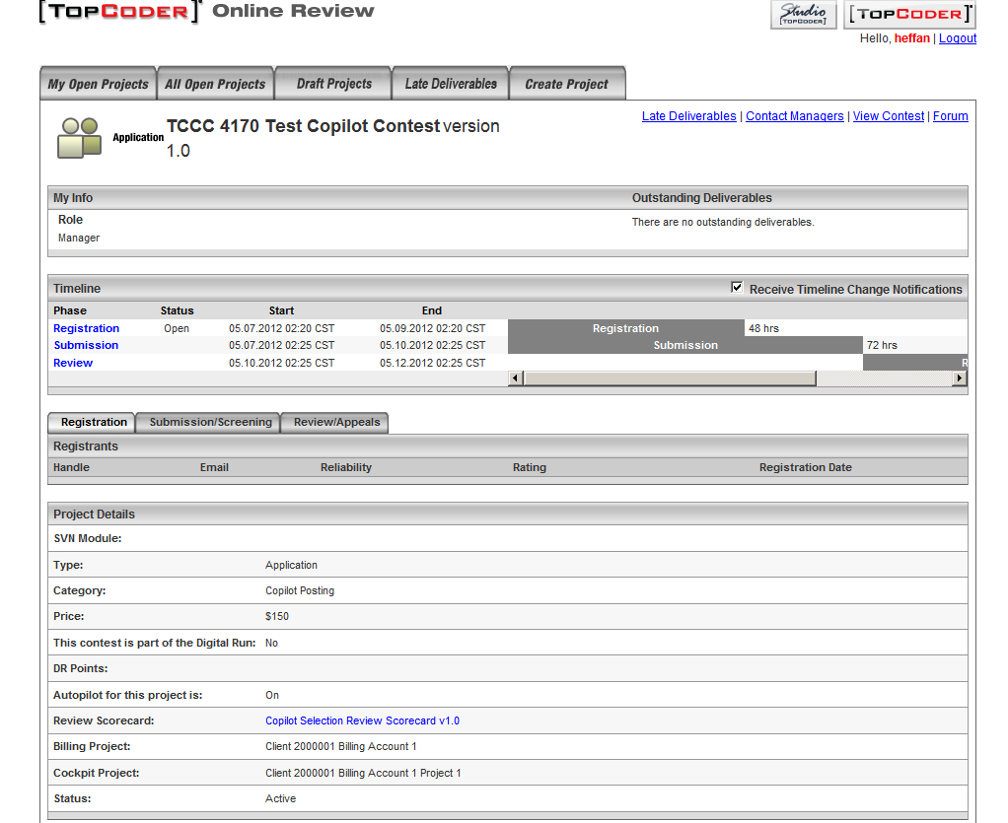

Add submitters to the contest using “Edit Project”

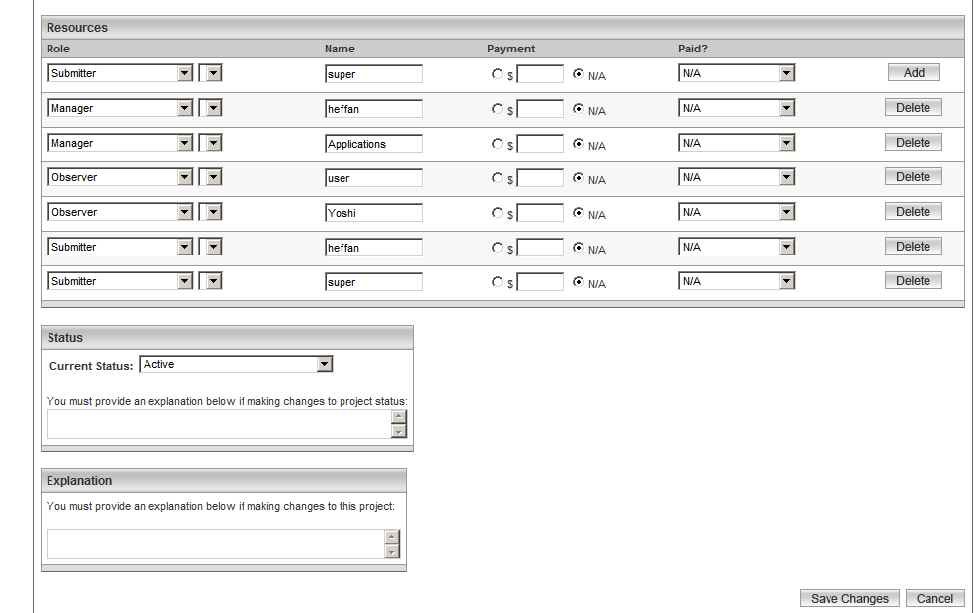

After adding, and submission phase is open, you will see

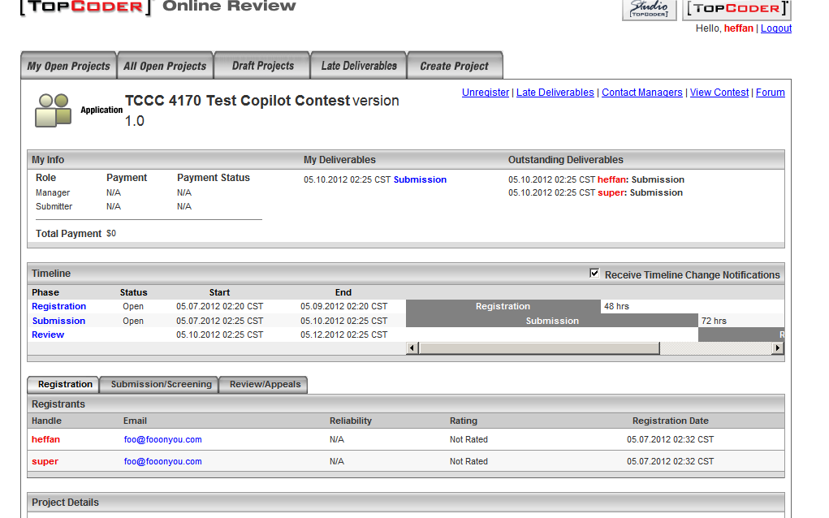

Login as submitter and submit any file as copilot posting submission

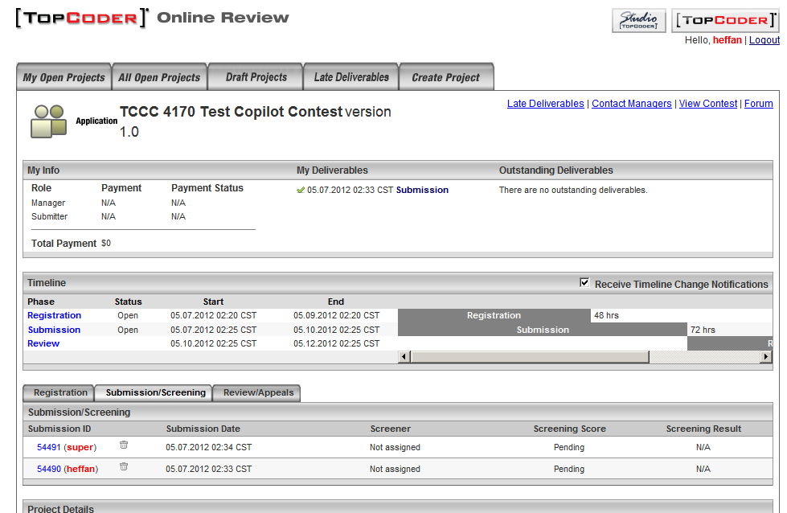

Use edit project to close the submission to move the contest to review phase

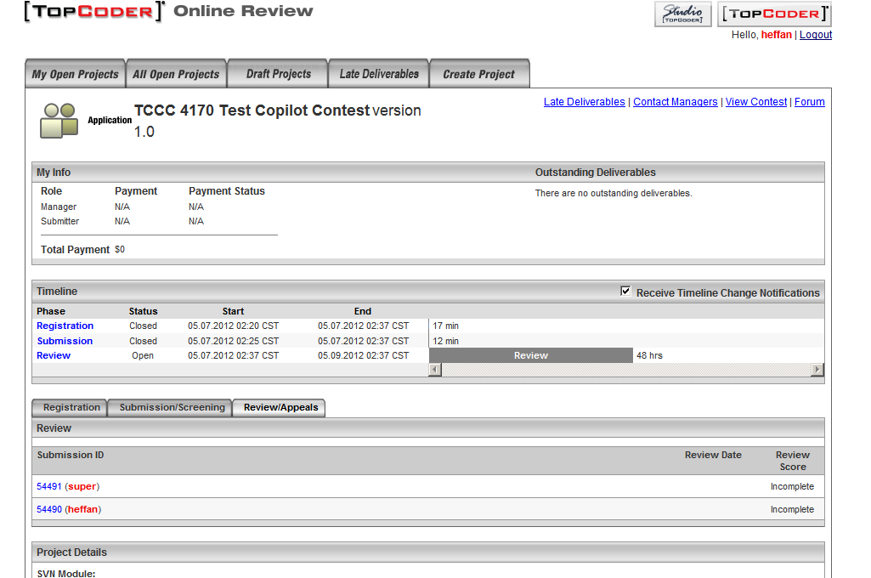

Now open the cockpit copilot page submissions tab

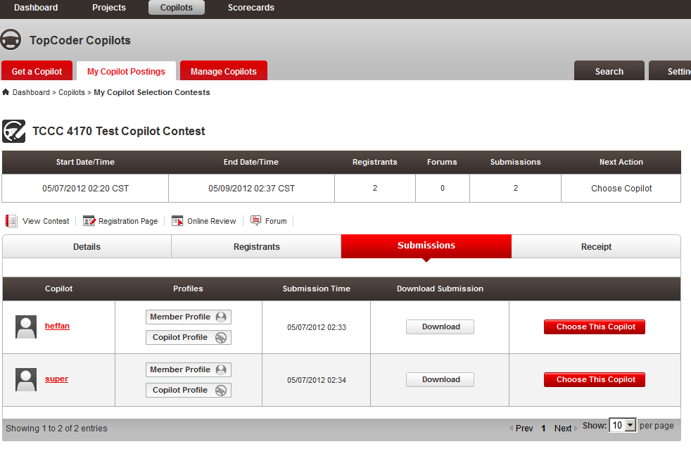

Clicking “Choose the copilot” to choose copilot

Check the email in your test SMTP server, for dev null SMTP test server; you can check the “Last Message” tab

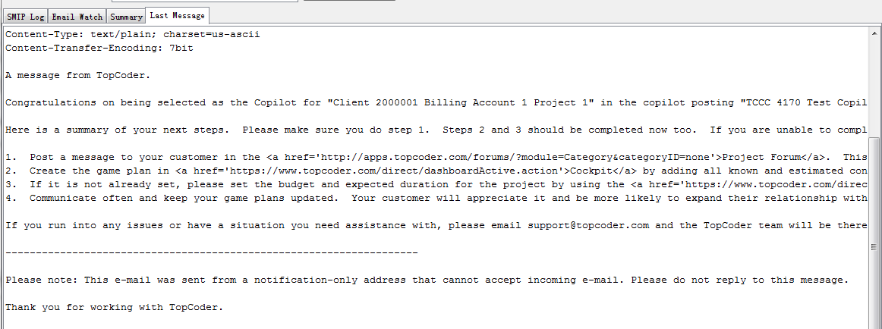

The whole email message is like

A message from TopCoder.

Congratulations on being selected as the Copilot for "Client 2000001 Billing Account 1 Project 1" in the copilot posting "TCCC 4170 Test Copilot Contest". You have been granted access to the project and can access it <a href='https://www.topcoder.com/fdirect/projectOverview?formData.projectId=2000001'>here</a>. On the Project Dashboard, you will find a <a href='http://apps.topcoder.com/forums/?module=Category&categoryID=1234'>project forum</a> that you should use for private communication with the customer and their team. Before going any further, please make sure you have read the <a href='http://apps.topcoder.com/wiki/x/FIXTAg'>Copilot How to Compete Guide</a>.

Here is a summary of your next steps. Please make sure you do step 1. Steps 2 and 3 should be completed now too. If you are unable to complete steps 2 and 3 yet, please let the customer know why in the project forum.

1. Post a message to your customer in the <a href='http://apps.topcoder.com/forums/?module=Category&categoryID=1234'>Project Forum</a>. This will let the customer know that you have been officially selected as the copilot and are ready to start.
2. Create the game plan in <a href='https://www.topcoder.com/direct/dashboardActive.action'>Cockpit</a> by adding all known and estimated contests you plan to run.
3. If it is not already set, please set the budget and expected duration for the project by using the <a href='https://www.topcoder.com/direct/editProject?formData.projectId=2000001'>Edit Project</a> screen. This is very important, and many customers will not proceed with the project until they are set. This will help set expectations for the project.
4. Communicate often and keep your game plans updated. Your customer will appreciate it and be more likely to expand their relationship with you.

If you run into any issues or have a situation you need assistance with, please email support@topcoder.com and the TopCoder team will be there to help. You can also find assistance in our <a href='http://www.topcoder.com/help'>Help Center</a>.

--------------------------------------------------------------------

Please note: This e-mail was sent from a notification-only address that cannot accept incoming e-mail. Please do not reply to this message.

Thank you for working with TopCoder.

Verify https://apps.topcoder.com/bugs/browse/TCCC-4172 combine activate and start spec review in one step

- Verify software contest

Verify activate draft software contest

Create a draft software contest first and open the contest details page

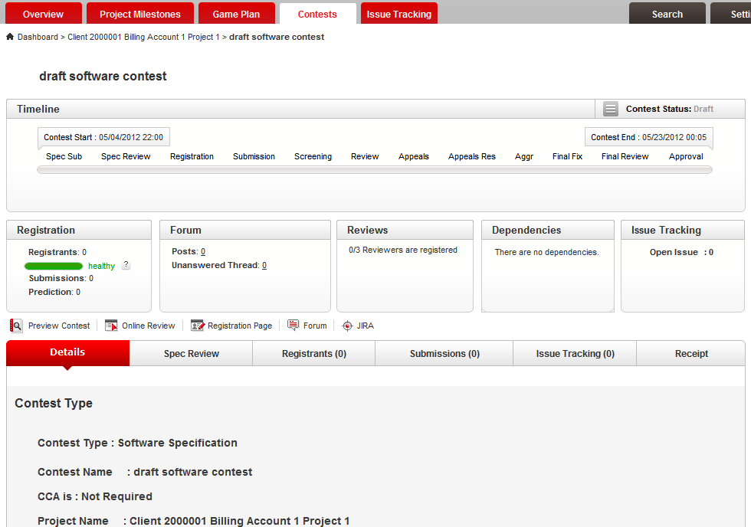

Click the activate contest button at bottom

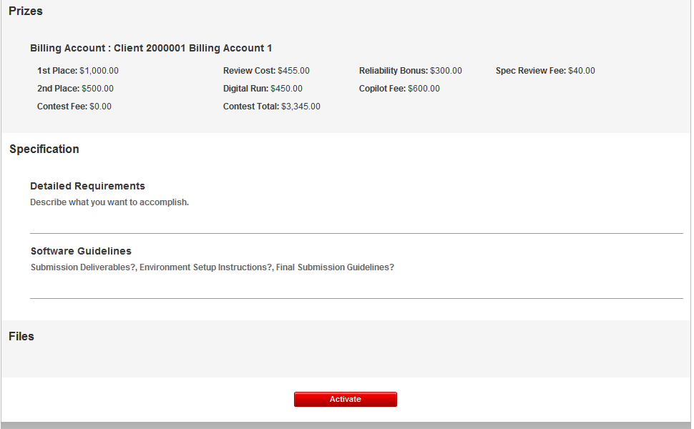

A modal window should show to choose spec review mode

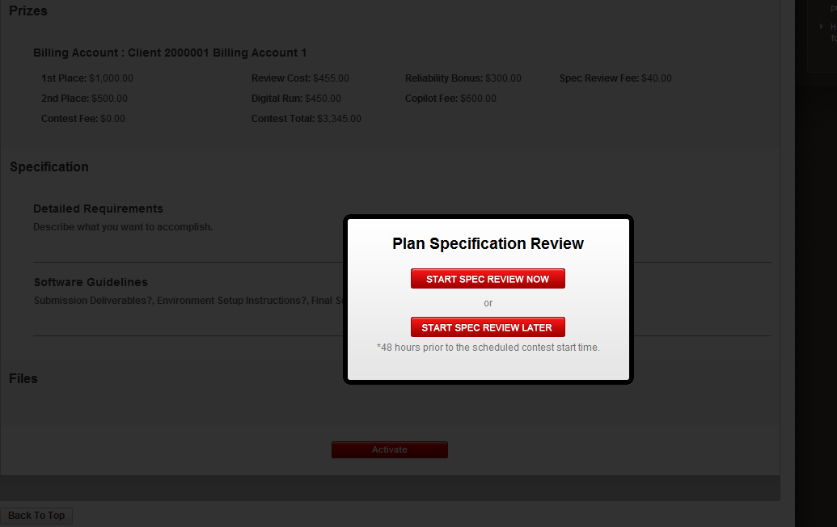

Choose start review now, you will see a confirmation message

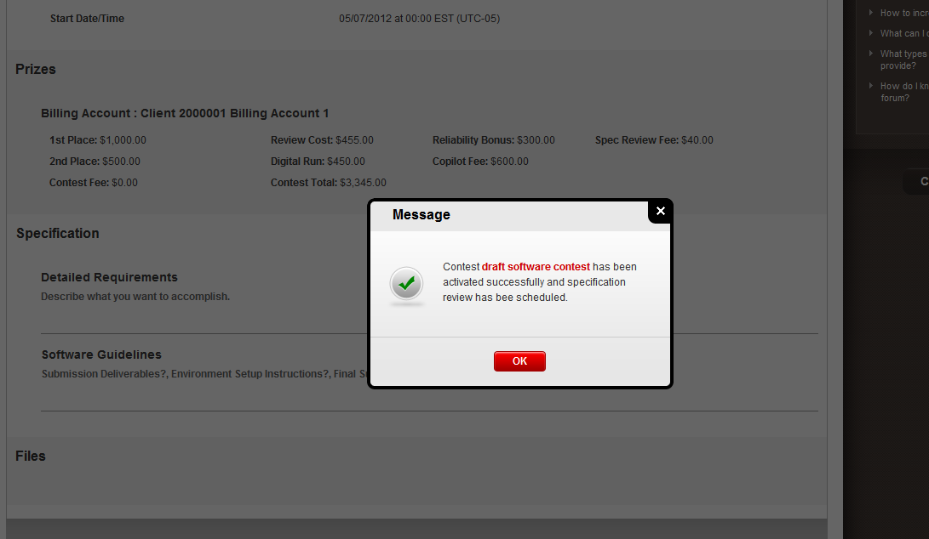

Wait 1 – 2 minute for the Auto Pilot to take effect

Refresh the contest details page; the spec review should be started

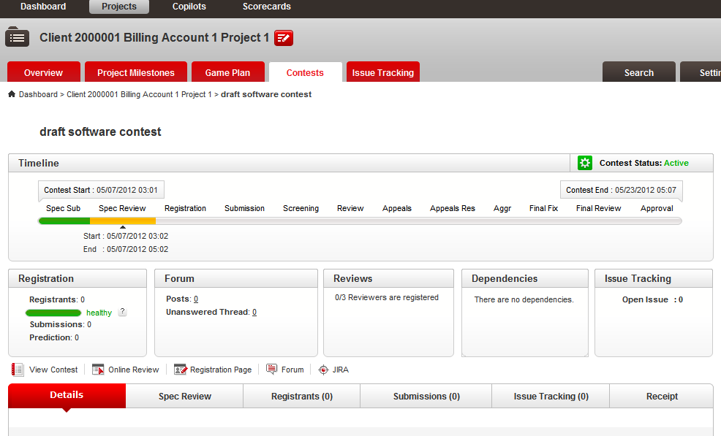

Create another draft contest and follow the same way to verify “Start Spec Review Later”

Verify Launch Software Contest

Go to http://<host>/direct/launch/home

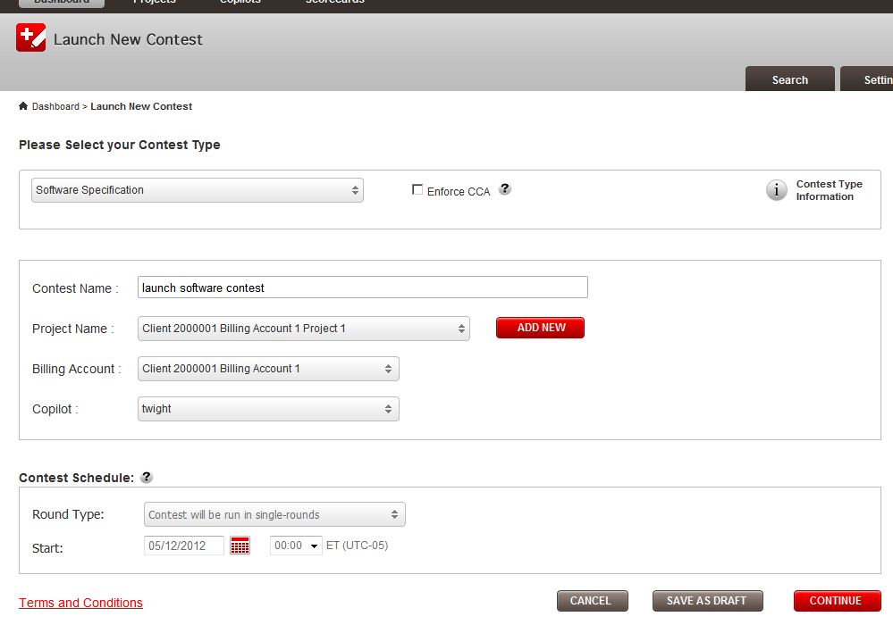

Fill the required field and continue to the last step

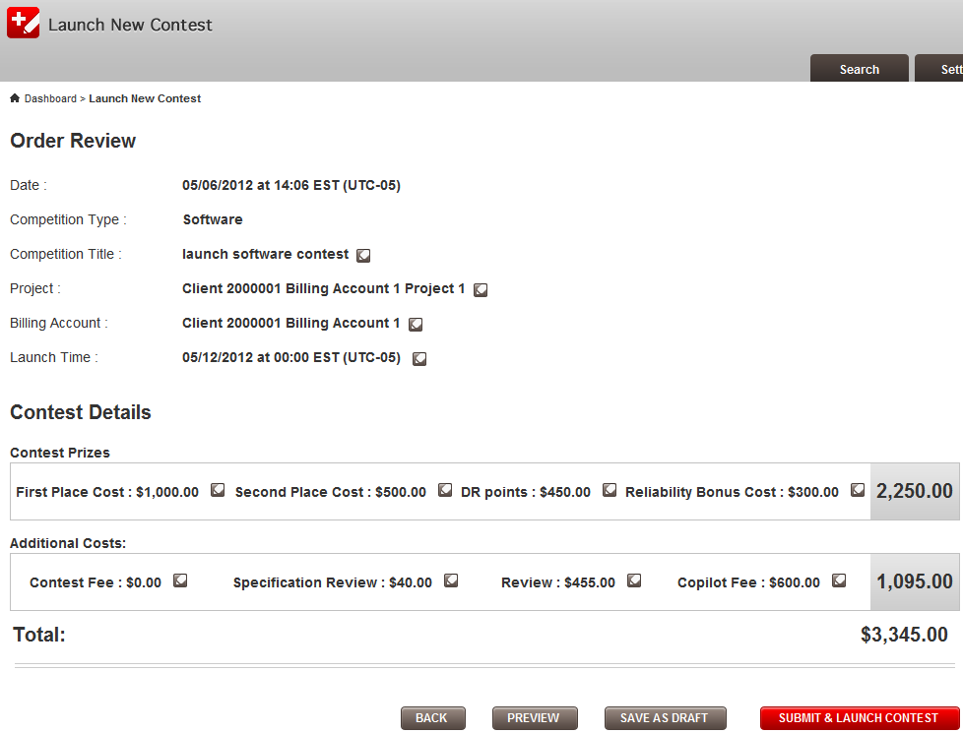

Click “Submit & Launch Contest”

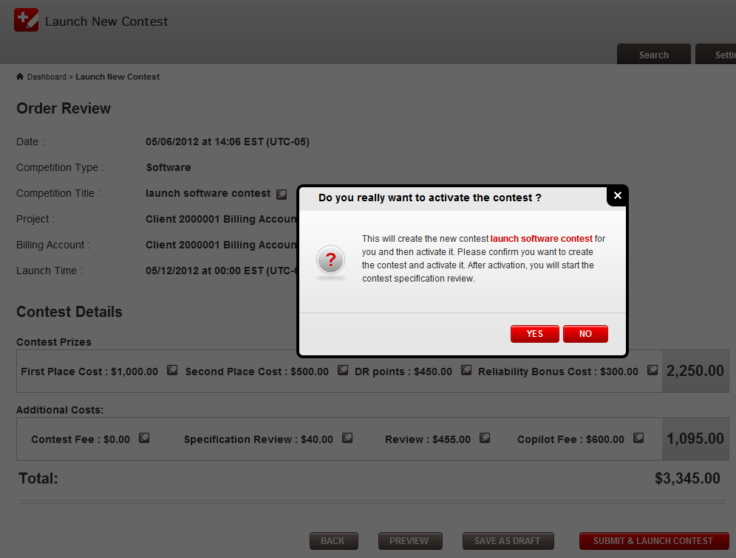

Click “YES”

The spec review modal should be displayed

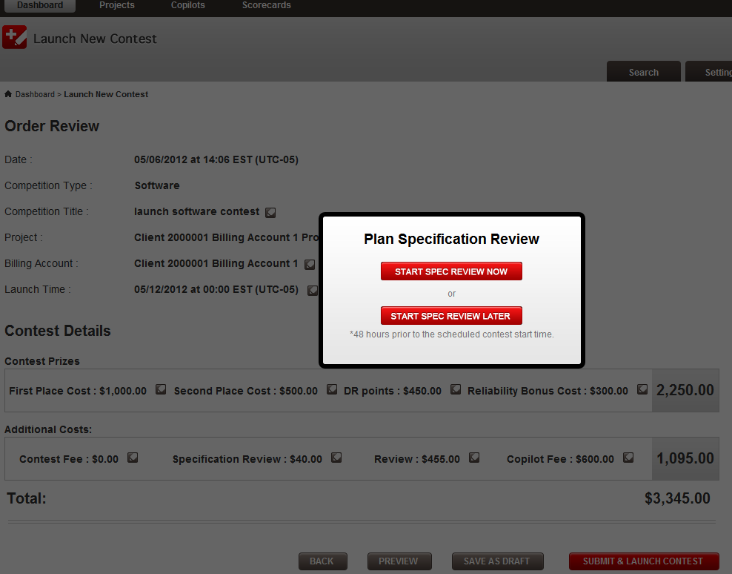

Choose “Start Spec Review Now”, and after running, you should see

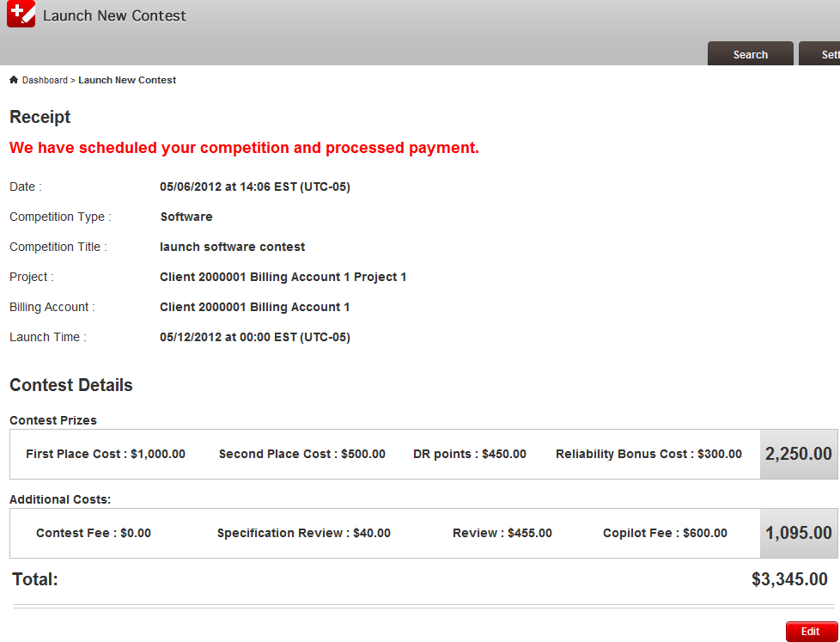

Click edit

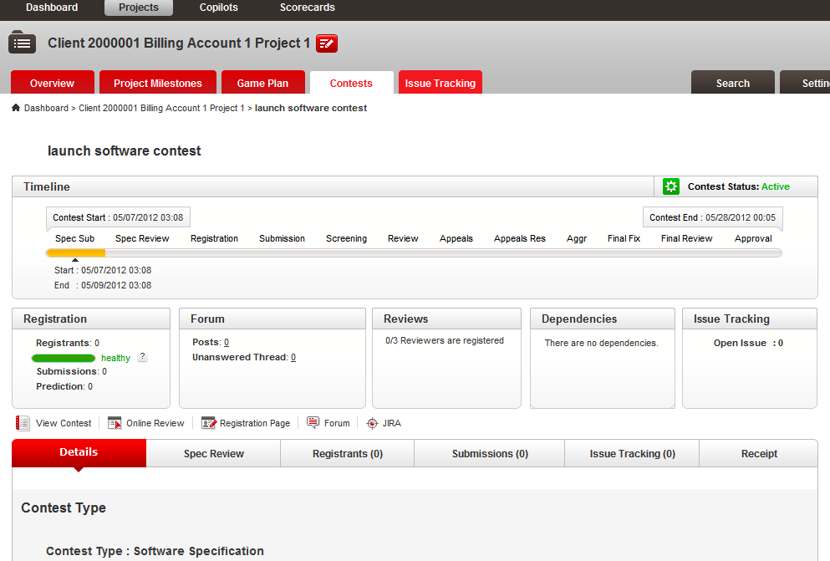

The spec sub is open now, wait a few minutes for the spec review to open

- Do the same flow to test the studio contests
- Test activate draft studio contests
- Test launch new studio contest

- Verify the creation and activation of copilot posting. This contest type does not have specification review phase, so it should not be affected by the update.

Verify https://apps.topcoder.com/bugs/browse/TCCC-4173 cannot remove a user permission in settings->permission if user is 'Read' access.

Go to permission page

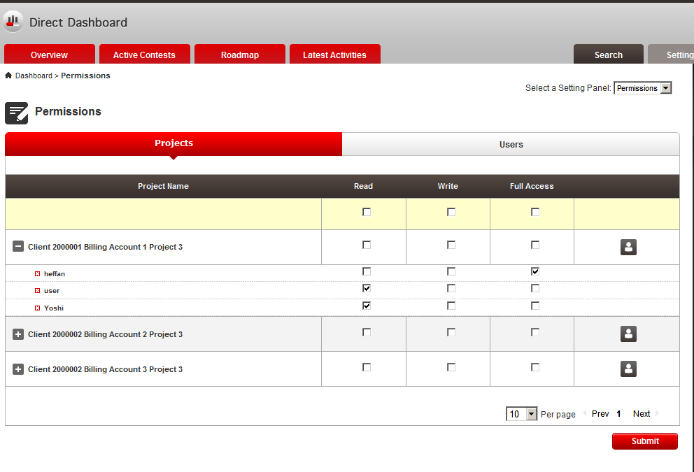

Add a user with read only access

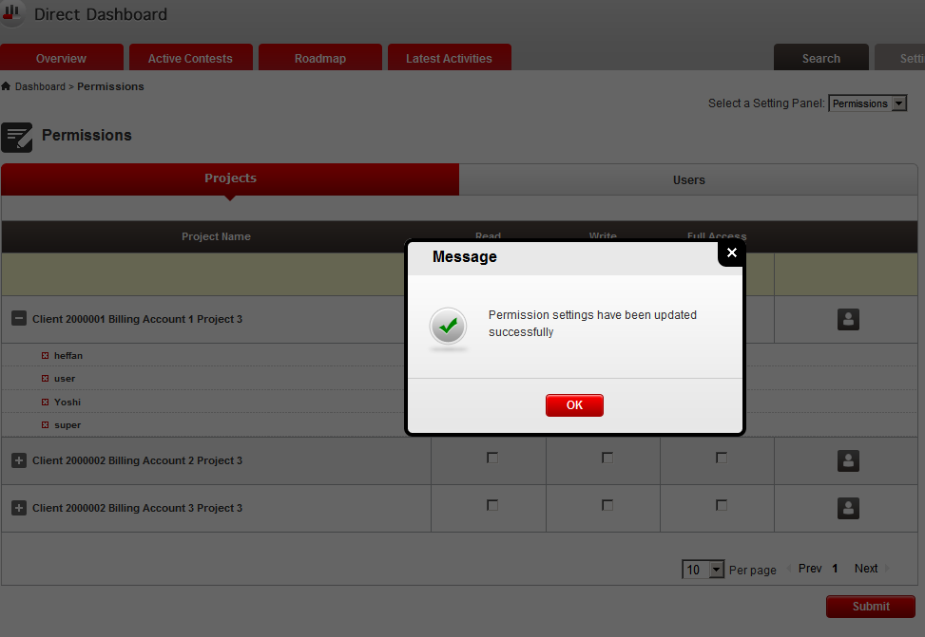

Remove the read only access for the added user

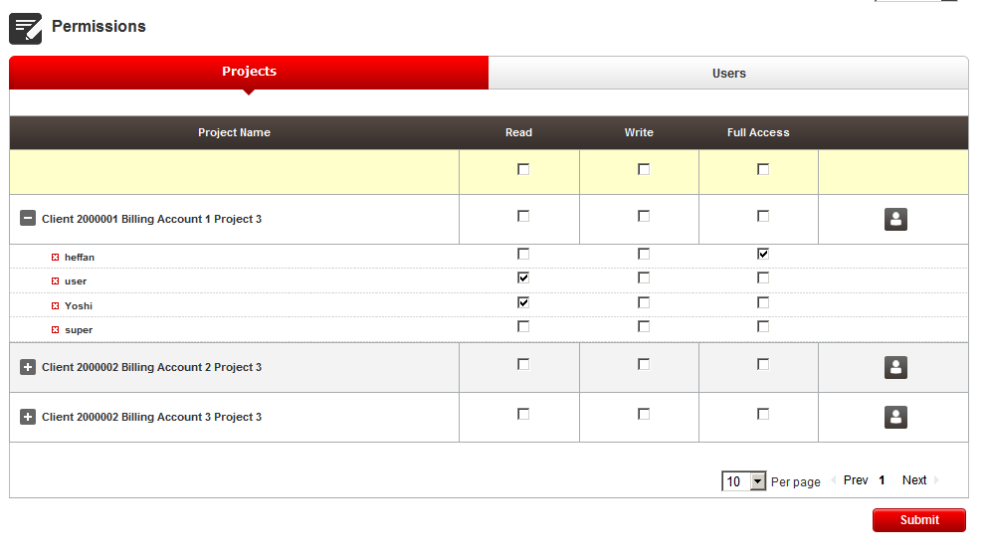
Clicking Submit

The user is removed

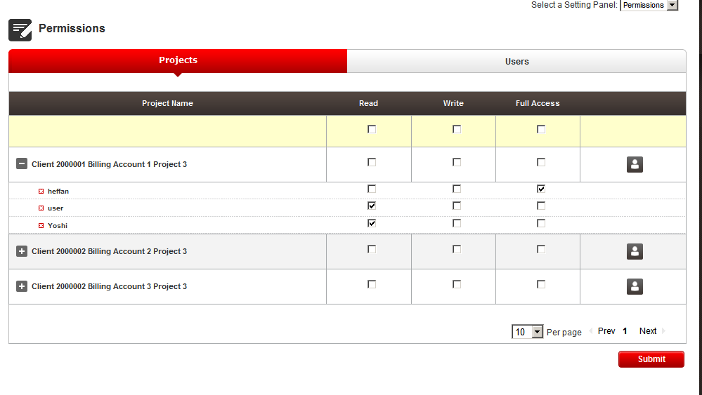

Verify https://apps.topcoder.com/bugs/browse/TCCC-4174 spec review - resubmit bug

You can reuse the contests created in verification of TCCC 4172

Open the contest with spec review open

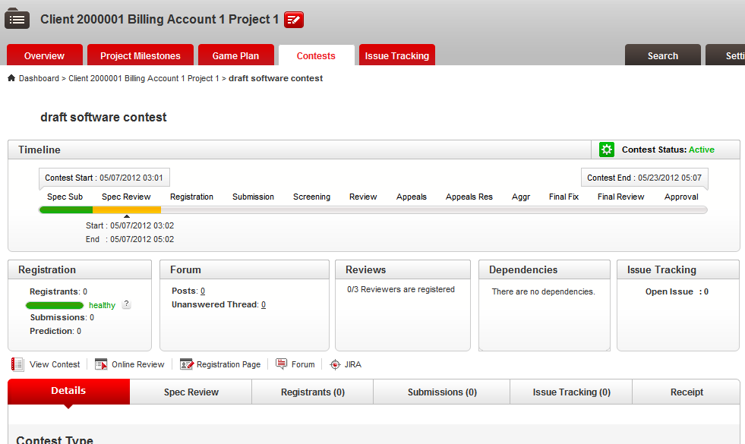

Go to the online review to add spec reviewer

Add spec reviewer by edit project

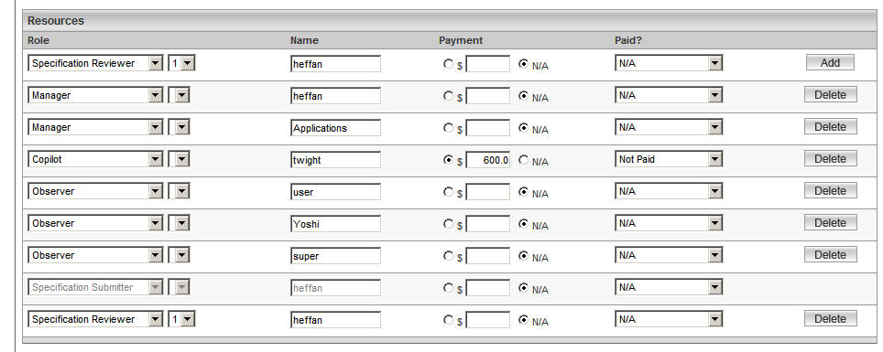

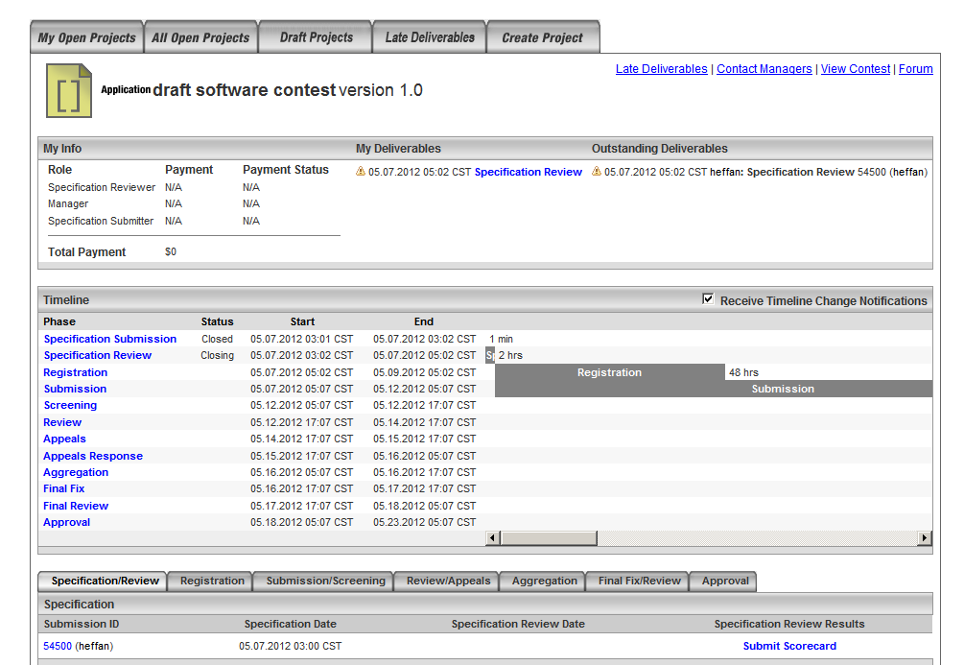

Reject the spec review

Open the spec review tab of the contest in cockpit

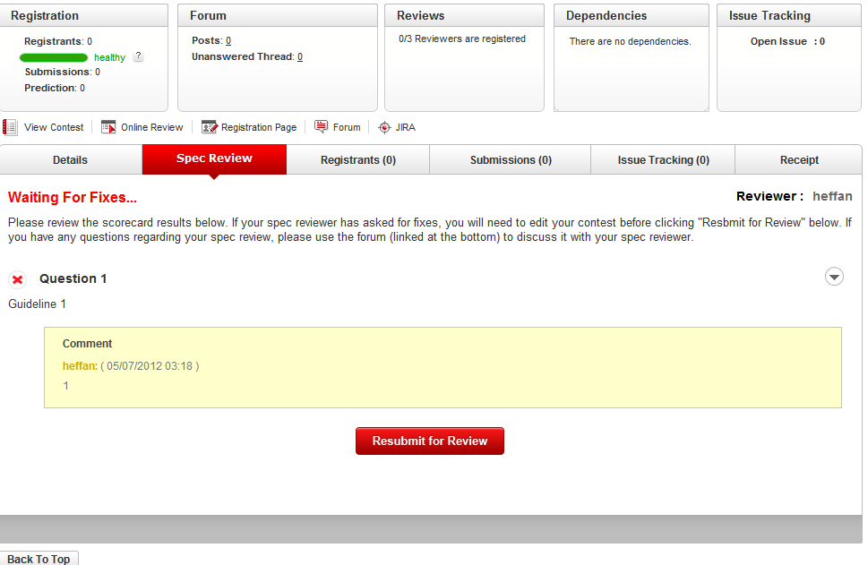

Click the “Resubmit for Review” button

You should see

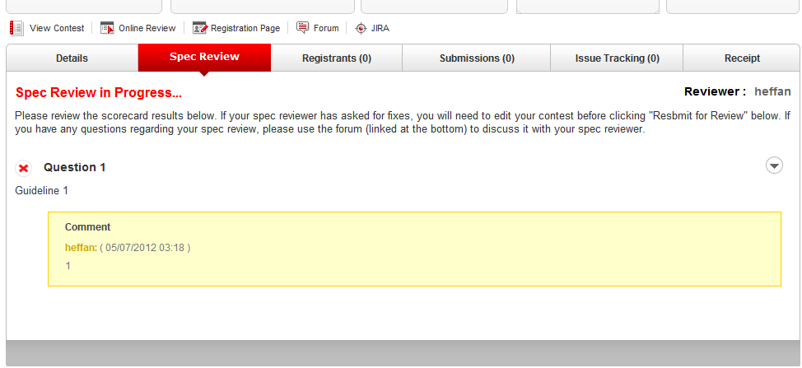

Refresh the page, the resubmit button should be not be displayed

Verify https://apps.topcoder.com/bugs/browse/TCCC-4175 add project link in copilot posting pages.Hint: Make the project name link to the project overview page

You can open the copilot posting created in verification of TCCC 4170

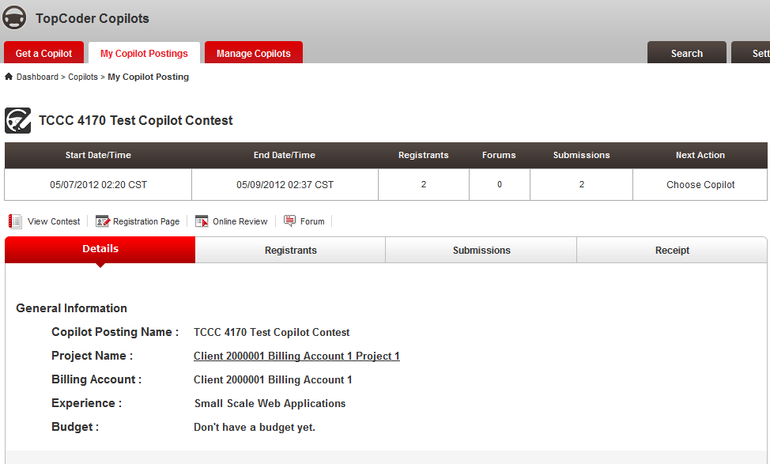

The project name is displayed as a link to the project overview page

Click the link to open project overview page

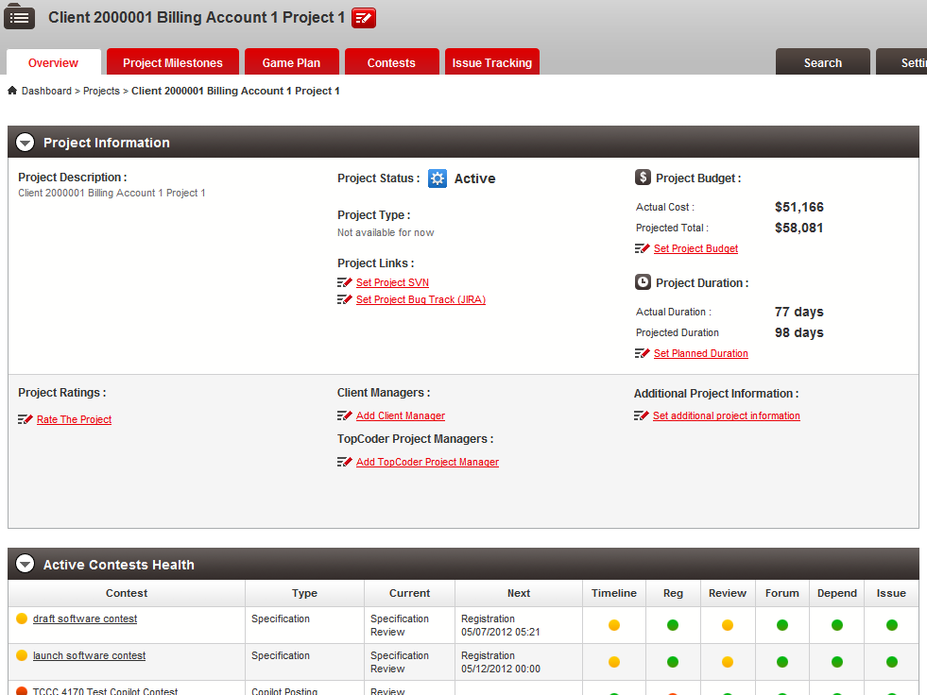

Verify https://apps.topcoder.com/bugs/browse/TCCC-4157 failed contest

Search for all the contests with search tab, you can input nothing and click search button for contest

In all contests, find a contest with status Cancelled – failed review

Open the submission tab of that contest

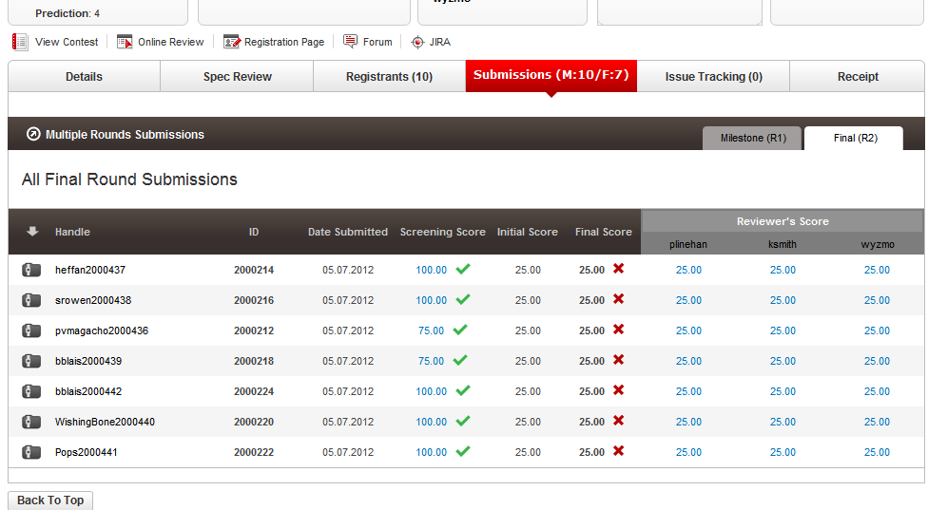

The winner download is not shown and the submission failed review has a X at the right.

Verify https://apps.topcoder.com/bugs/browse/TCCC-4158 Breadcrumbs Missing Project Name

Go the all projects page 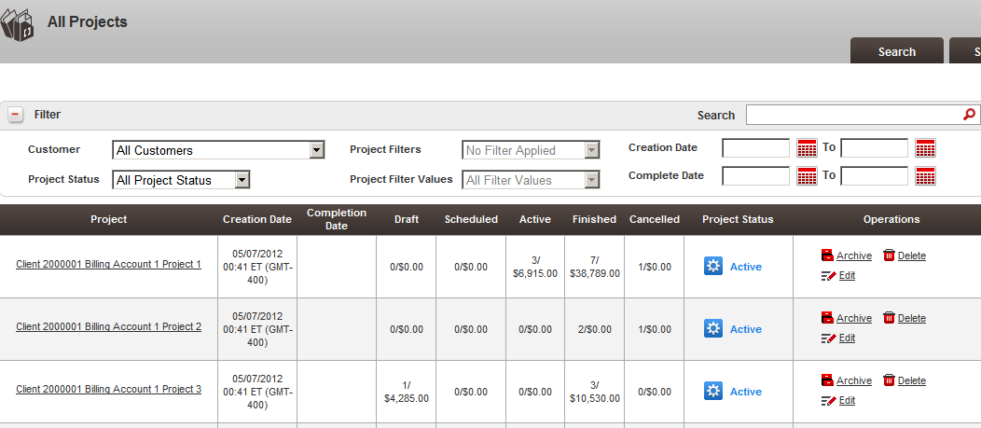

Archive a project

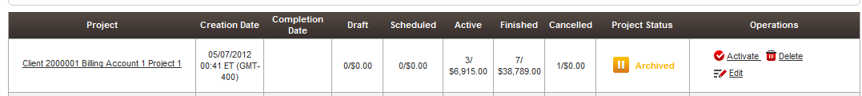

Go to the project contests

Open a contest and you can see project name is displayed

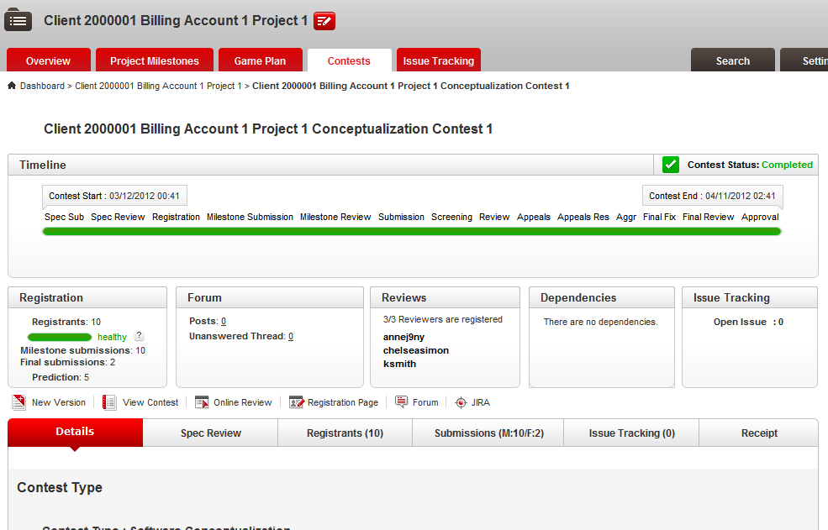

Resource Contact List

Name | Resource Email
TCSASSEMBER

