TopCoder Direct Performance Improvement Enterprise Dashboard Update 1 Deployment Guide

Revision History
Author | Revision Number | Date
TCSDEVELOPER | 1.0 | 01/22/2012

Deployment Instructions 3
1. Organization of Submission 3
2. Application Setup 3
2.1 Ant .Properties File 3
2.2 Build Scripts Setup 3
3. Database Setup 4
4. Deployment Instructions 4
5. Starting 4
6. Verification 4
7. Resource Contact List 7

Deployment Instructions

Organization of Submission

The content of submission follows directory structure provided below:

direct

Contains the sources for TopCoder Direct application added/updated in the course of this assembly. This directory replicates the application development distribution structure and includes only updated and new files.

docs

Contains this document which is the Deployment Guide for the TopCoder Direct Performance Improvement Enterprise Dashboard Update 1 assembly.

test_files

Contains the SQL scripts with sample test data to be used for review purposes only and JARs to fix issues with VMs.

Application Setup

The application is expected to be deployed to the following environment:

JRE 1.5
JBoss 4.2.3.GA
Informix DS 11.0

Ant .Properties File

Property Name | File property is stored | Example Setting

Build Scripts Setup

The build script for TopCoder Direct application (build.xml) provides the following targets which are to be used:

- deploy – builds and deploys the TopCoder Direct application to target server.

Database Setup

No changes to existing database schema have been introduced with this assembly.

Deployment Instructions

This section provides the instructions for integrating and deploying the changes from TopCoder Direct Performance Improvement Enterprise Dashboard Update 1 assembly in Production environment.

- Integrate the files added/updated in this assembly into development distribution for TC Direct application
- Build and deploy TopCoder Direct application using ant deploy command
- Copy static files to /mnt/apache/tcdocs directory using ant deploy-apache-static command.

If necessary consult following online documentation for details on building and deployment of TopCoder Cockpit and Direct applications:

http://apps.topcoder.com/wiki/display/projects/Direct+VM

http://apps.topcoder.com/wiki/display/docs/VM+Image+2.5

Starting

- Build and deploy the TopCoder Direct application
- Start JBoss server instance hosting TopCoder Direct application

Verification

- Login to TC Direct application using URL like http://cockpit.cloud.topcoder.com/direct/ and click Overview tab
  - The Enterprise Dashboard page must be displayed. The Enterprise Health area must have the data for that area retrieved via separate AJAX call. While the call is performed an animated loader image must be dislpayed. Once the data is received it must be displayed in Enterprise Health area.

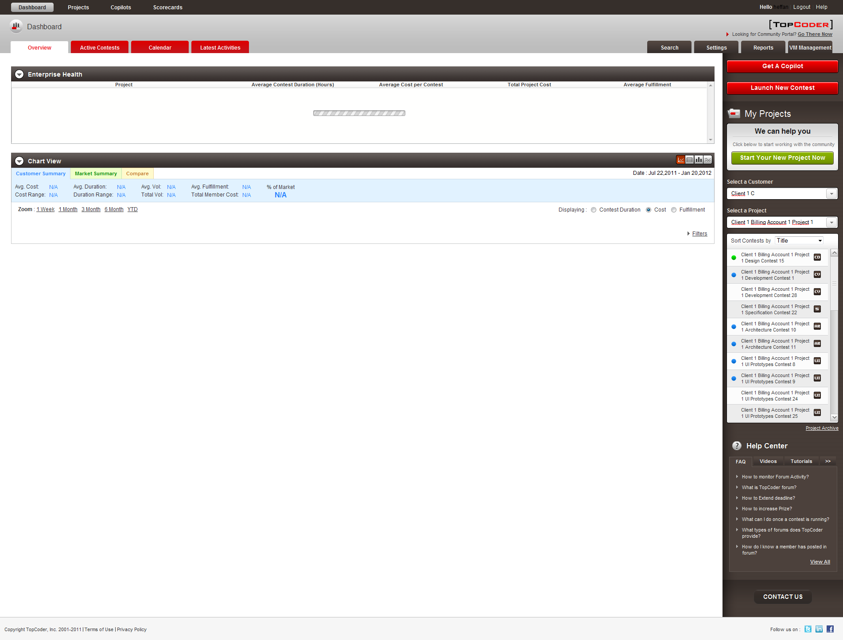

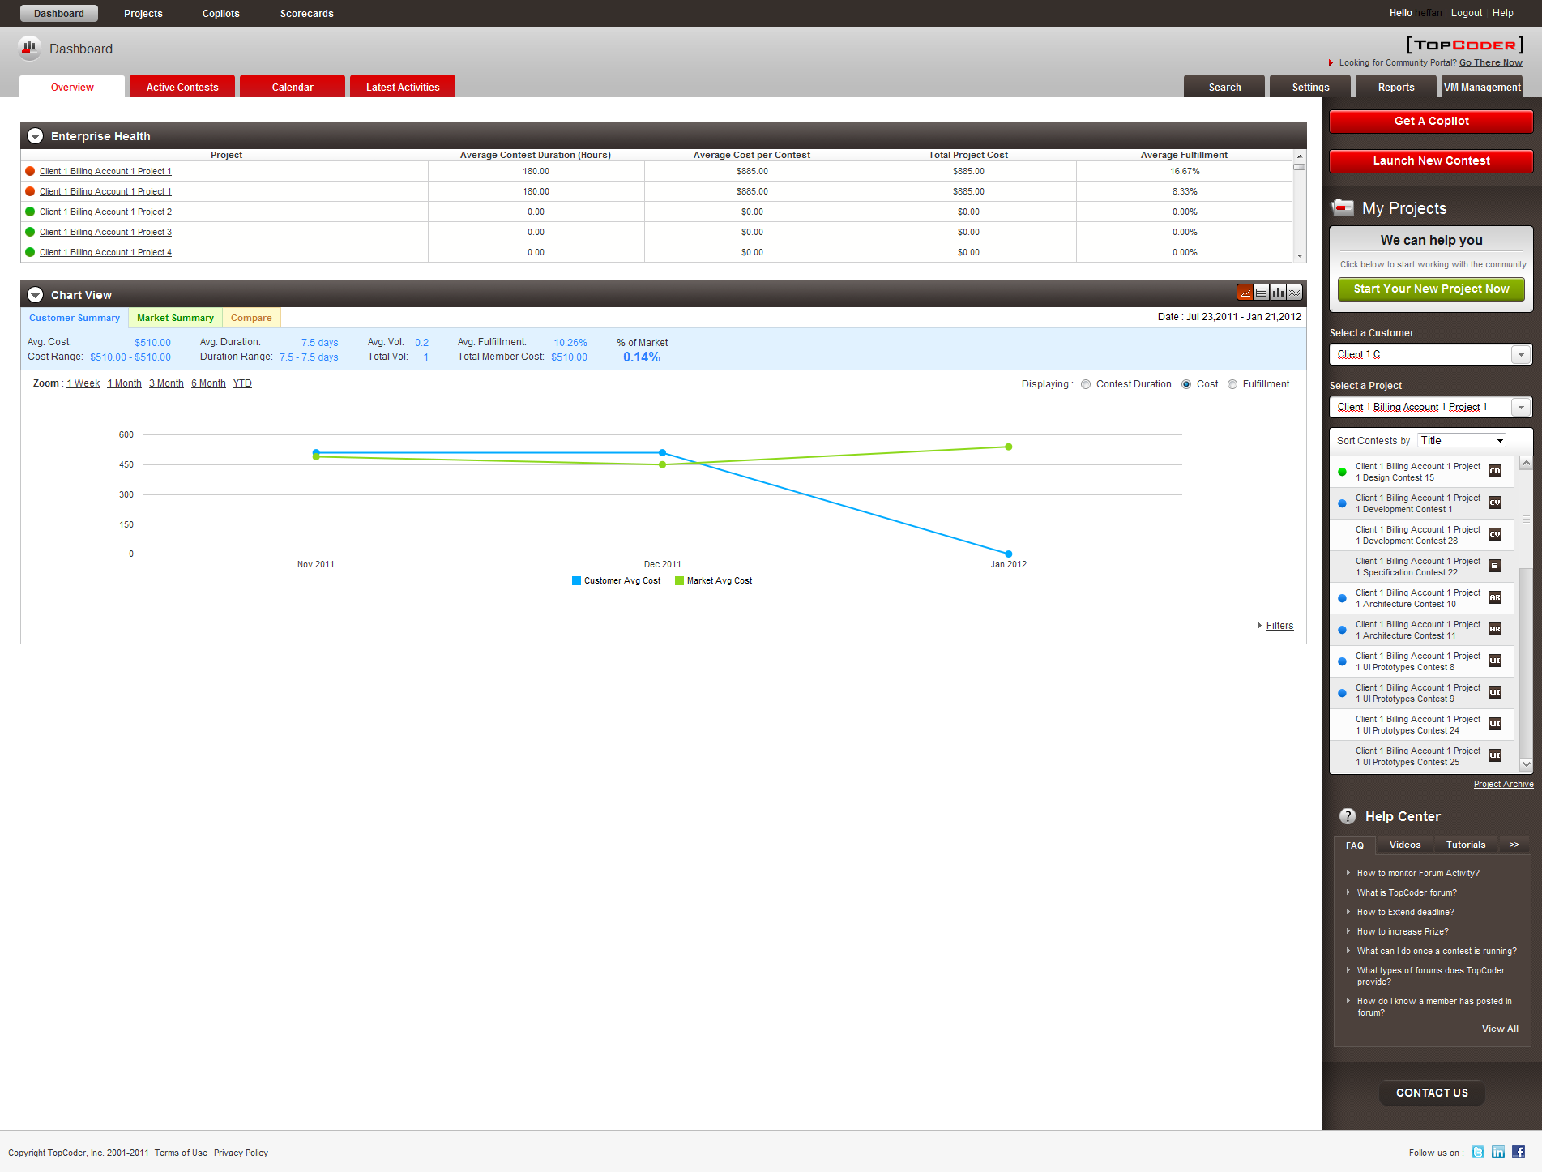

Resource Contact List

Name | Resource Email
TCSDEVELOPER

