Module Assembly - TC Cockpit Enterprise Dashboard Analysis 2 Deployment Guide

Revision History
Author | Revision Number | Date
TCSASSEMBLER | 1.0 | 12/02/2012

Deployment Instructions 3
1. Organization of Submission 3
2. Application Setup 3
2.1 Ant .Properties File 3
2.2 Configurations 3
2.3 Build Scripts Setup 3
3. Database Setup 4
3.1 Update and add queries via Query Tool 4
4. Deployment Instructions 4
5. Starting 4
6. Verification 4
7. Resource Contact List 9

Deployment Instructions

Organization of Submission

The submission follows directory structure provided below:

doc
Contains the Deployment Guide Document of this assembly.

direct
Contains sources and static files for Direct web application. This directory replicates the application development distribution structure and includes only updated and new files.
test_files
Contains the SQL files to insert test data and the tool to load billing accounts mappings

Application Setup

The application is expected to be deployed to the following environment:

JRE 1.5
JBoss 4.2.3.GA
Informix DS 11.5

Ant .Properties File

Configurations

N/A

Build Scripts Setup
The ANT build script for Direct application (build.xml) provides the following targets which are to be used:

- switch-and-checkout – checkout or switch to the defined source code branches for all components defined in subprojects.xml
- dist-backend – rebuilt all the components from the source code.
- first_deploy – must be the first task to execute from command line. It will copy all dependencies to your local JBoss folder.
- deploy – should be the main task to execute from command line. It will build and deploy WAR file.
- deploy-static-files – deploys the static files to JBOSS.
- deploy-apache-static – deploys the static files to apache server on VM.

Please refer here for more information:
http://www.topcoder.com/wiki/display/docs/TC+Direct+Setup+Guide

Database Setup
N/A

Deployment Instructions

This section provides the instructions in Production environment.

- Merge the code from submission into SVN for Direct application
- Build and deploy Direct application using ant deploy (or ant first_deploy ) command.
- Copy static files using ant deploy-static-files command or ant deploy-apache-static if use apache as static file server.

Starting

- Build and deploy the Direct application
- Start JBoss server instance hosting Direct application

Verification

Set up test data first, run the following SQL scripts in order against the test server database:
- test_files/calendar.sql
- test_files/test_data.sql

Login into VM as tc
- Run ~/web/scripts/dwload] ./loadtcsscript.sh
- Run dos2unix loadweeklystat.sh
- Run ~/web/scripts/dwload] ./loadweeklystat.sh

Upload the test_files/projectBillingLoader to the VM
- cd projectBillingLoader
- run ‘ant run’ to load billing accounts mappings

If you run the projectBillingLoader on local environment, please update projectBillingLoader\conf\config.properties, replace ‘env.topcoder.com’ to ‘localhost’

Use various browsers to open the link http://localhost:8180/direct or https://[vm_ip]/direct/ , login as user / password.

Go to http://test.host/direct/enterpriseDashboard/overview

Then click the analytic icon on the left side bar

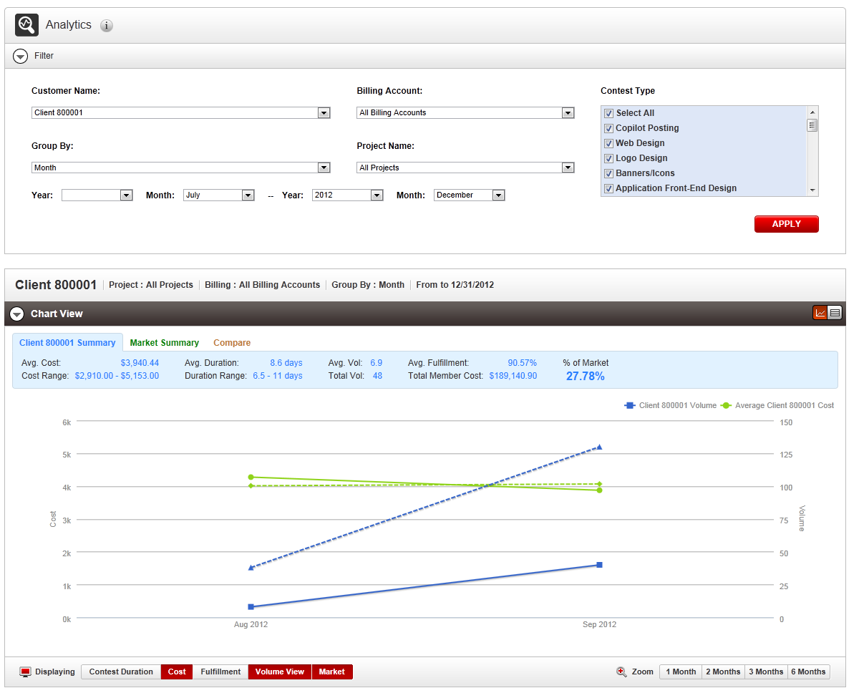

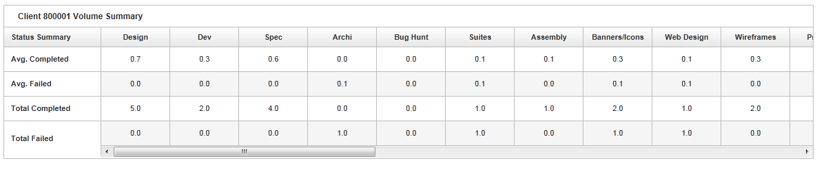

Click the contest duration button

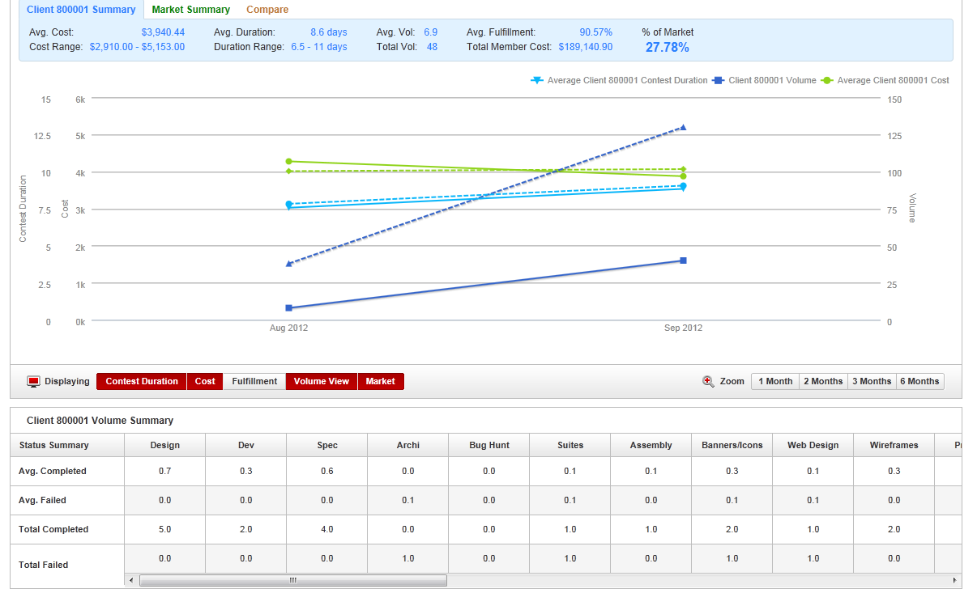

Click the fulfillment button

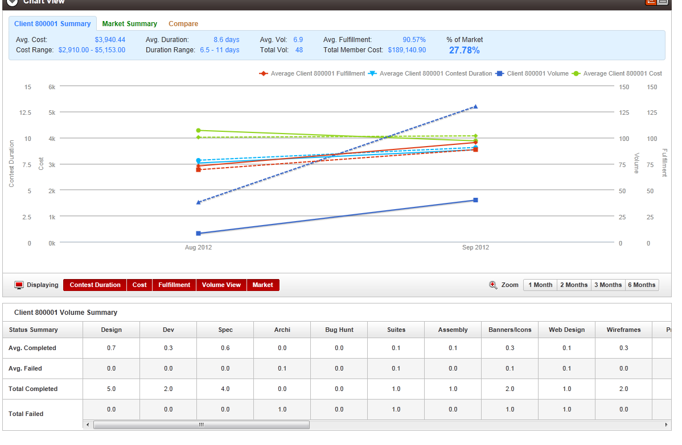
Check compare tab of summary
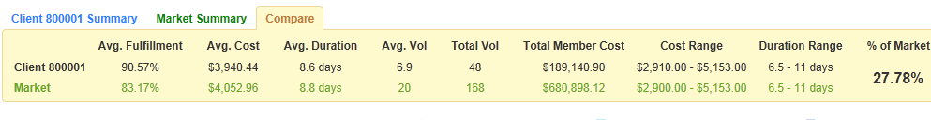

It uses the “customer name”

Uncheck “Volume View”, the volume view summary table is hidden

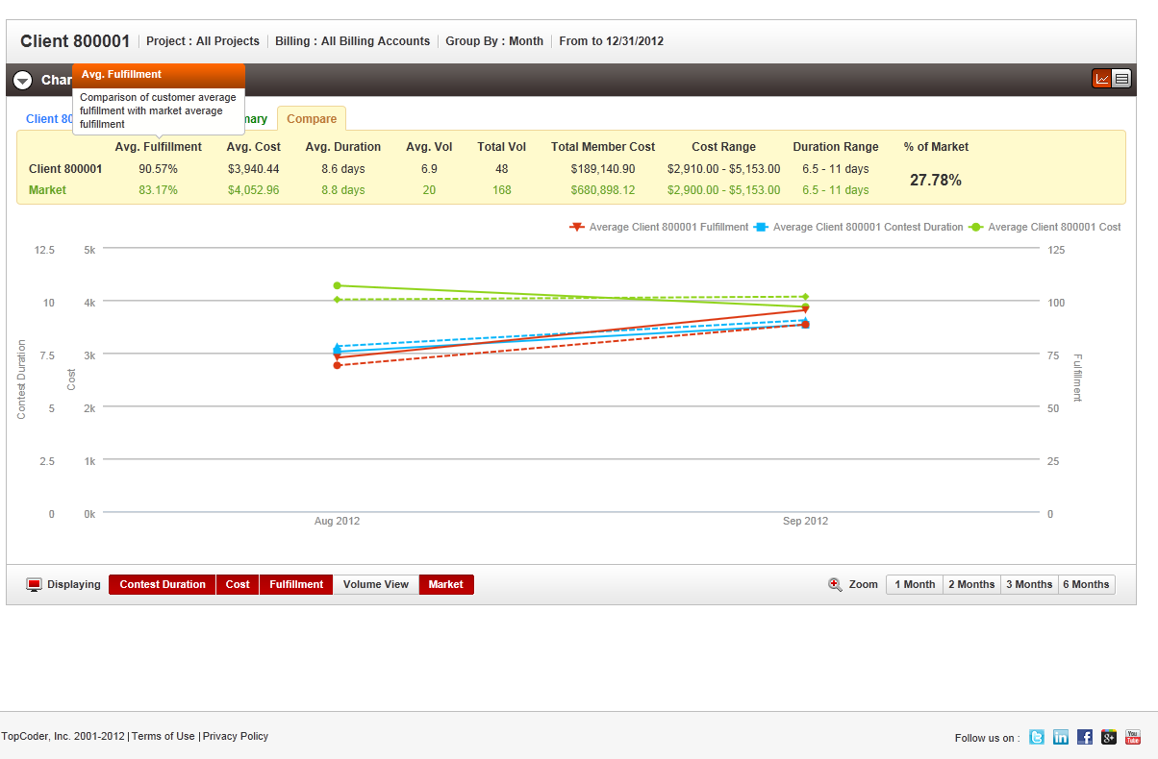

Click the table view button

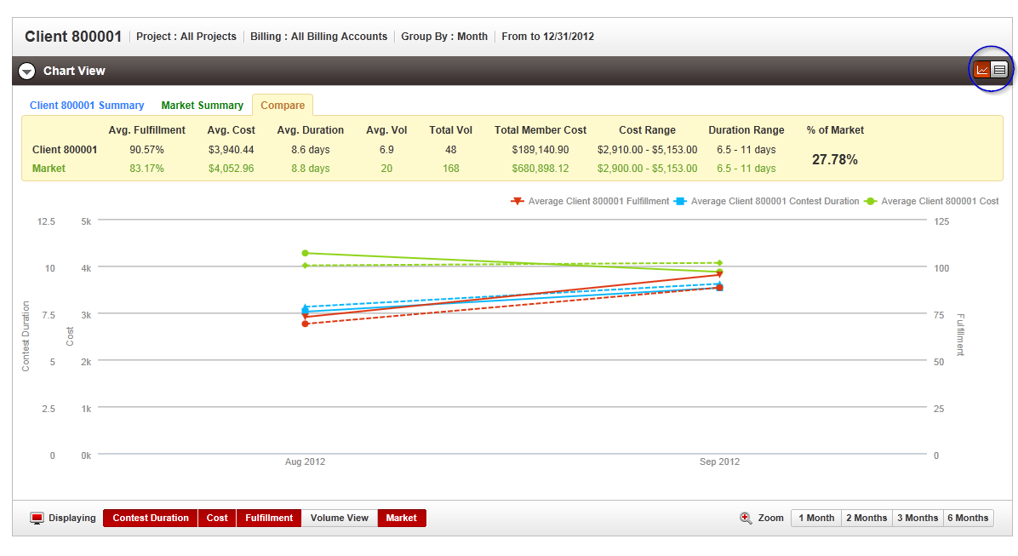

You will see

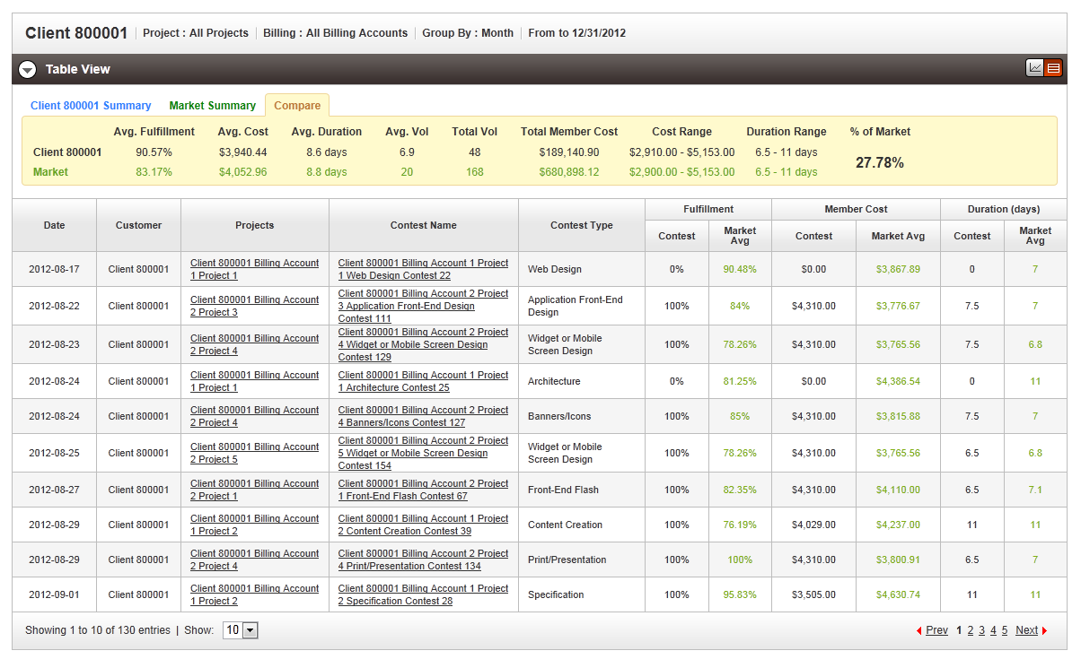

Choose a date range does not have data, and click APPLY you will see

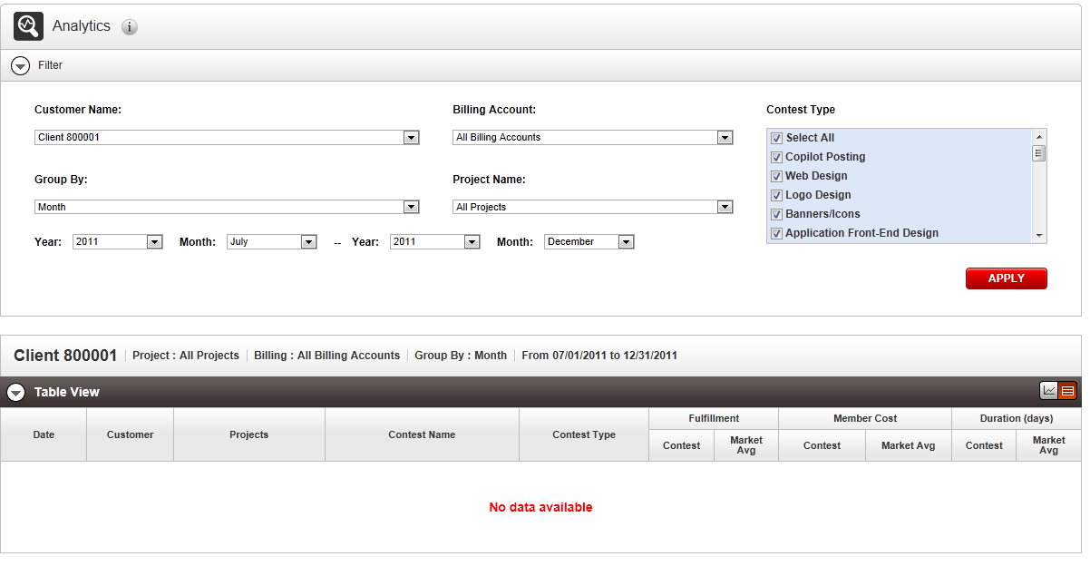

Choose start date large then end date, click apply you will see

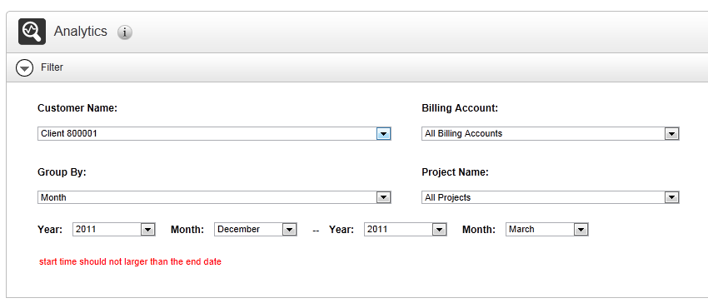

Change the client name

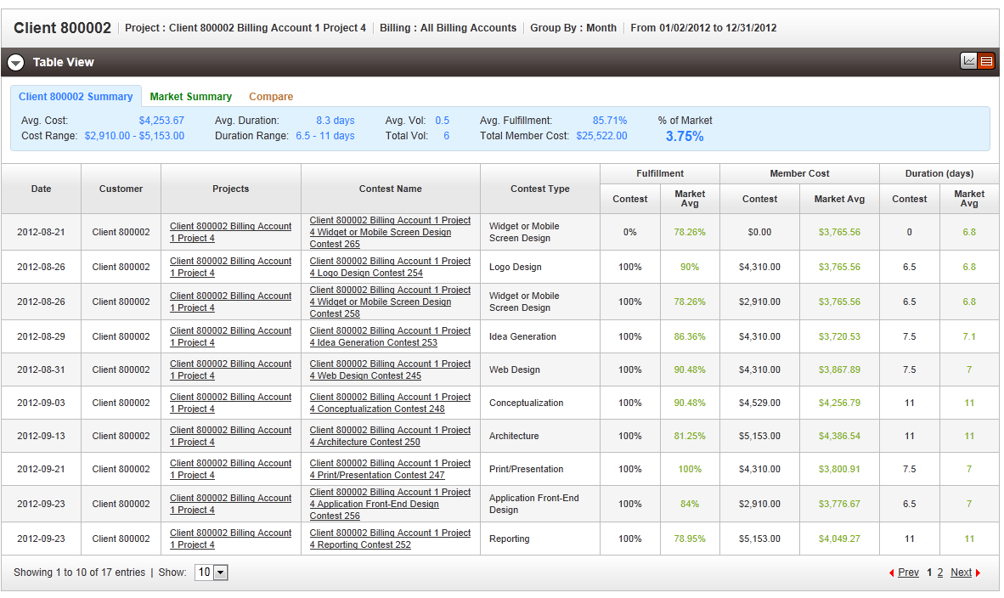

Click the column header to sort

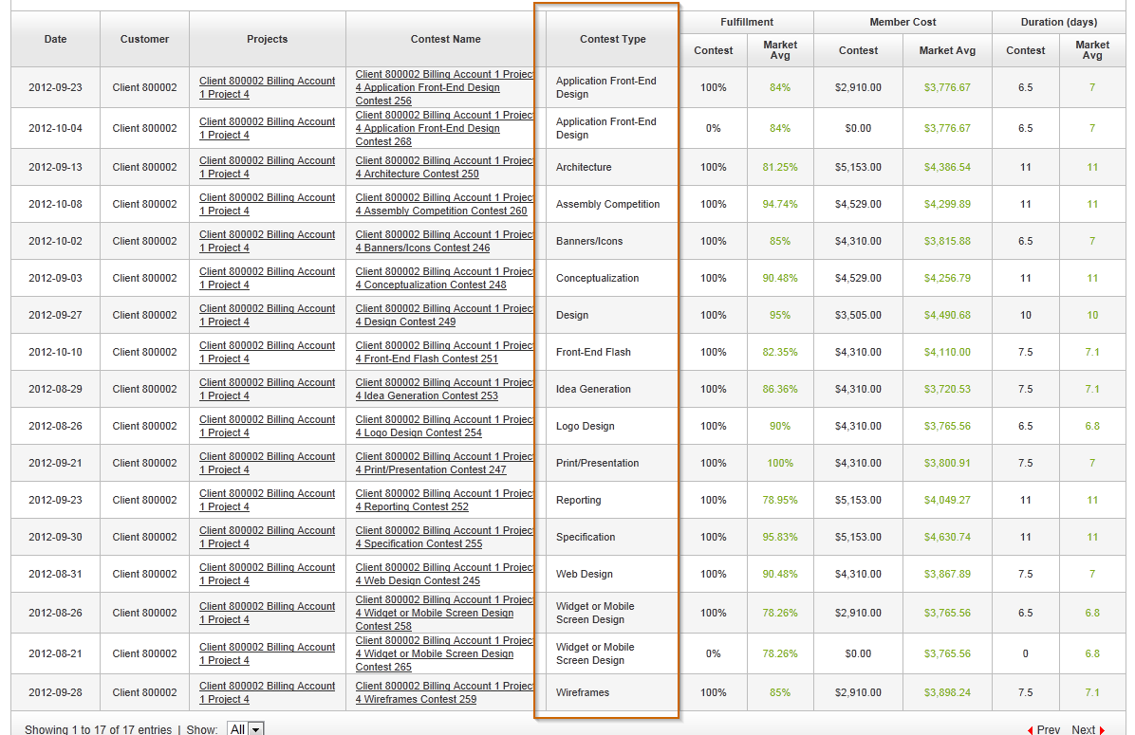

Click chart view again to see chart view of changed client

Verify the customer has been replaced by <customer name>

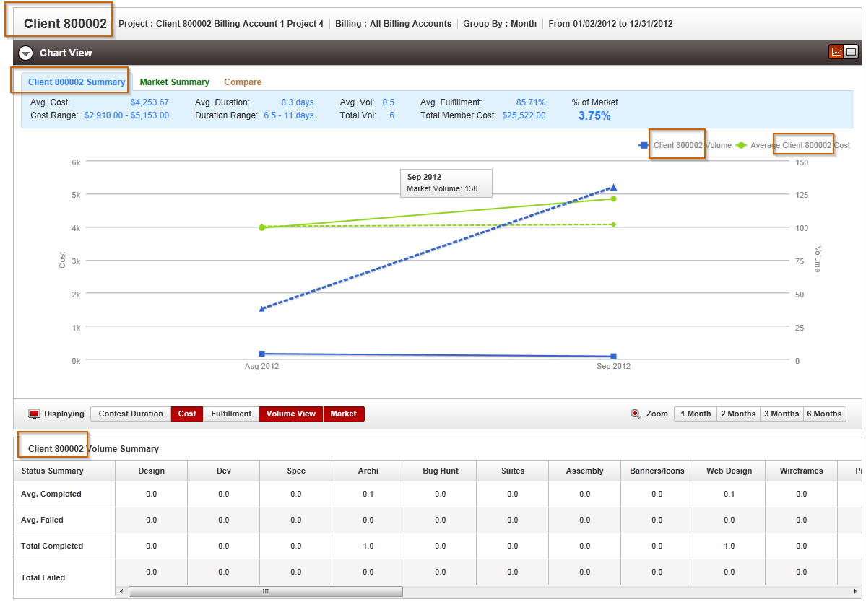

Verify the volume summary table header tip

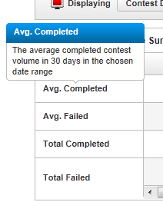

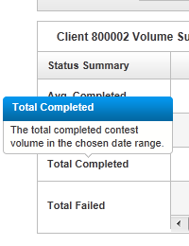

Verify the chart view line point hover

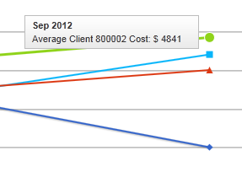

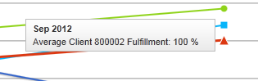

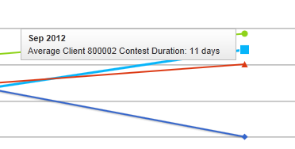
Check the volume summary total aggregation

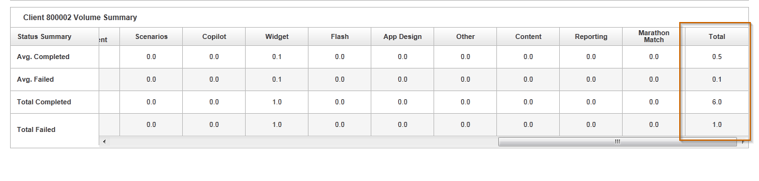

Resource Contact List

Name | Resource Email
TCSASSEMBLER

