Release Assembly - TopCoder Cockpit Modal Windows Revamp Deployment Guide

Revision History
Author | Revision Number | Date
TCSASSEMBER | 1.0 | 08/30/2011

Deployment Instructions 3
1. Organization of Submission 3
2. Application Setup 3
2.1 Ant .Properties File 3
2.2 Build Scripts Setup 3
3. Database Setup 4
4. Deployment Instructions 4
5. Starting 4
6. Verification 4
7. Resource Contact List 5

Deployment Instructions

Organization of Submission

The submission follows directory structure provided below:

doc
Contains the Deployment Guide Document of this assembly.

direct
Contains sources and static files for Direct web application. This directory replicates the application development distribution structure and includes only updated and new files.
updates.txt
list the updates of the modal windows required.

Application Setup

The application is expected to be deployed to the following environment:

JRE 1.5
JBoss 4.2.3.GA
Informix DS 11.5

Ant .Properties File

No .properties files are modified.

Build Scripts Setup

The ANT build script for Direct application (build.xml) provides the following targets which are to be used:

- switch-and-checkout – checkout or switch to the defined source code branches for all components defined in subprojects.xml
- dist-backend – rebuilt all the components from the source code.
- first_deploy – must be the first task to execute from command line. It will copy all dependencies to your local JBoss folder.
- deploy – should be the main task to execute from command line. It will build and deploy WAR file.
- deploy-static-files – deploys the static files to JBOSS.
- deploy-apache-static – deploys the static files to apache server on VM.

Please refer here for more information:
http://www.topcoder.com/wiki/display/docs/TC+Direct+Setup+Guide

Database Setup

- N/A

Deployment Instructions

This section provides the instructions in Production environment.

- Merge the code from submission into SVN branch for Direct application
- Build and deploy Direct application using ant deploy (or ant first_deploy ) command.
- Copy static files using ant deploy-static-files command or ant deploy-apache-static if use apache as static file server.

Starting

- Build and deploy the Direct application
- Run rm –rf /home/direct/jboss-4.2.3.GA/server/default/work/jboss.web/localhost/direct
- Start JBoss server instance hosting Direct application

Verification

Use various browsers to open the link http://localhost:8180/direct or https://[vm_ip]/direct , login as heffan / password.

Create new contest verification

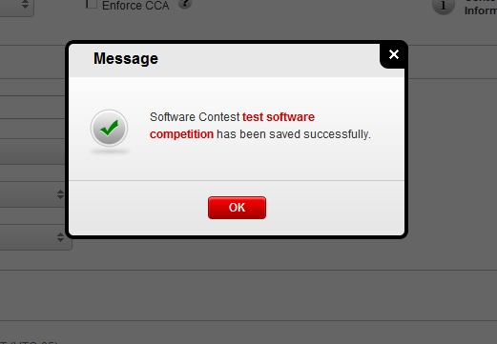
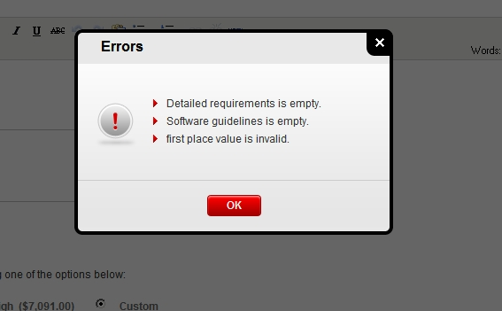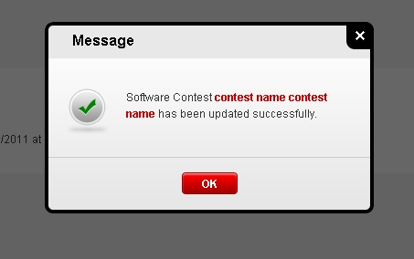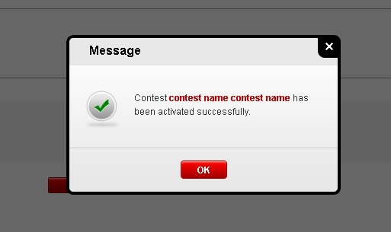

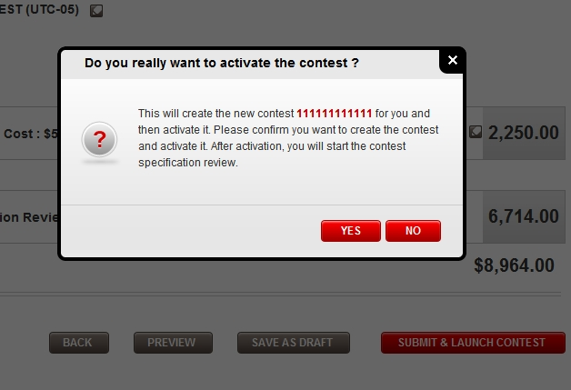

Create new project verification

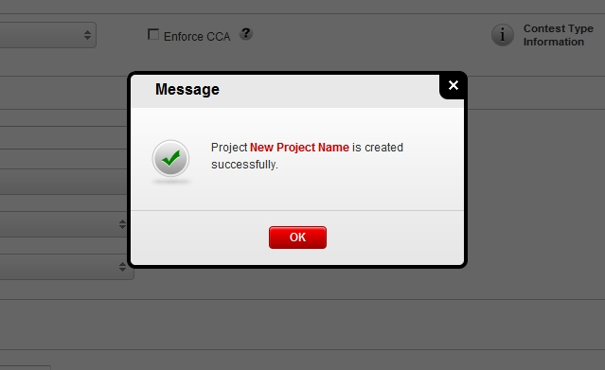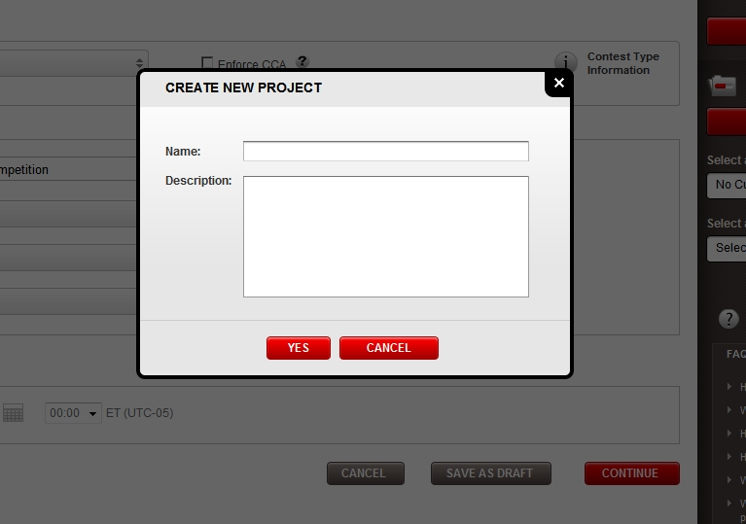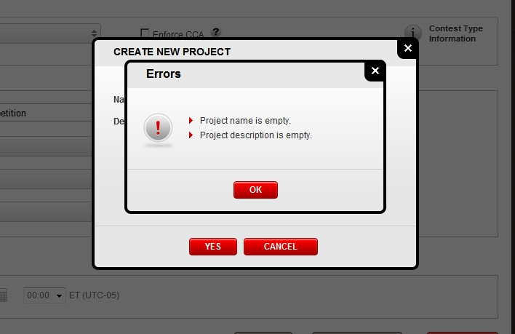
Create copilot posting verification
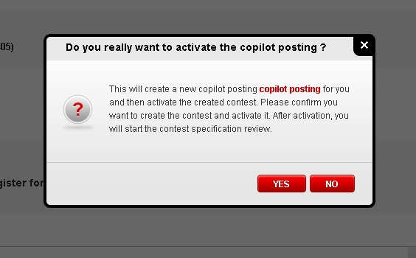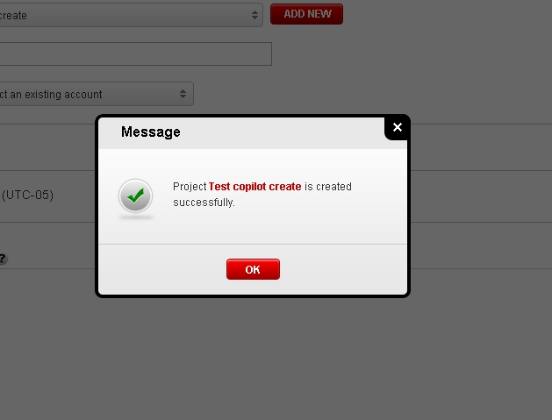
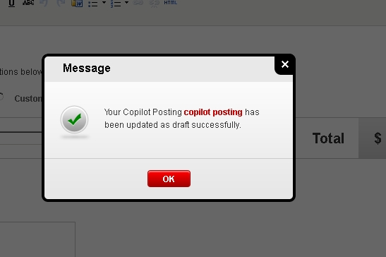

Settings verification

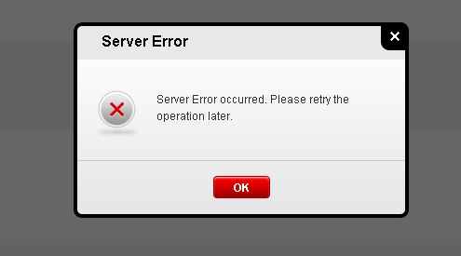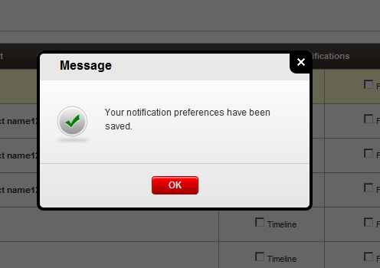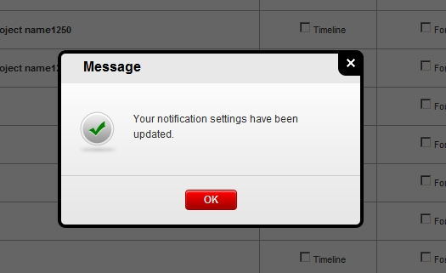

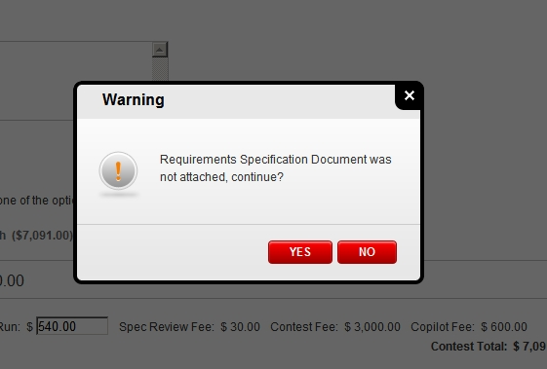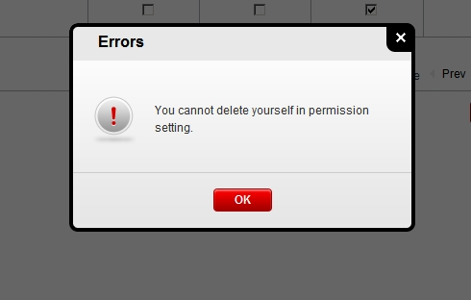

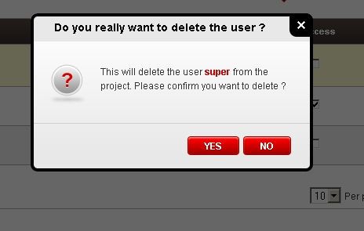

Warnings

Resource Contact List

Name | Resource Email
TCSASSEMBER

