Release Assembly - Release Assembly - TopCoder Cockpit Project Overview Update 1 Deployment Guide

Revision History
Author | Revision Number | Date
TCSASSEMBER | 1.0 | 09/6th/2011

Deployment Instructions 3
1. Organization of Submission 3
2. Application Setup 3
2.1 Ant .Properties File 3
2.2 Build Scripts Setup 3
3. Database Setup 4
4. Deployment Instructions 4
5. Starting 4
6. Verification 4
7. Resource Contact List 5

Deployment Instructions

Organization of Submission

The submission follows directory structure provided below:

doc
Contains the Deployment Guide Document of this assembly.

direct
Contains sources and static files for Direct web application. This directory replicates the application development distribution structure and includes only updated and new files.
db_scripts
Contains all the newly added / updated DDLs and queries for updating database script trunk
query
Contains all the newly added / updated queries and SQL file to add column
test_files
Contains the SQL files to insert test data and images to test copilot header images.
project_service
Contains all the updated source codes and configurations for component Project Service
project_service_facade
Contains all the updated source codes for component Project Service Facade

Application Setup

The application is expected to be deployed to the following environment:

JRE 1.5
JBoss 4.2.3.GA
Informix DS 11.5

Ant .Properties File

No .properties files are modified.

Build Scripts Setup
The ANT build script for the components provides the following targets which are to be used:
- dist_tcs – recompile the component and package it into jar and deployed to the direct libs directory

You need to run ant dist_tcs against the 2 updated components before redeploying direct:
- project_service
- project_service_facade
The ANT build script for Direct application (build.xml) provides the following targets which are to be used:

- switch-and-checkout – checkout or switch to the defined source code branches for all components defined in subprojects.xml
- dist-backend – rebuilt all the components from the source code.
- first_deploy – must be the first task to execute from command line. It will copy all dependencies to your local JBoss folder.
- deploy – should be the main task to execute from command line. It will build and deploy WAR file.
- deploy-static-files – deploys the static files to JBOSS.
- deploy-apache-static – deploys the static files to apache server on VM.

Please refer here for more information:
http://www.topcoder.com/wiki/display/docs/TC+Direct+Setup+Guide

Database Setup

Add new column project_forum_id to tc_direct_project table
- Run query\add_column_project_forum_id.sql on database

Update and add queries via Query Tool

Log into the TC Query Tool to modify the query (on VM use http://tc.cloud.topcoder.com/query/query)

Update query Copilot Profile Info:
- Choose the database TCS_CATALOG
- Choose the query list
- Find the query copilot_profile_info, click edit
- Paste the updated query in query/query_copilot_profile_info.txt and Save
- Create a new command copilot_profile_info
- Add the query into the new command

Update query TC copilot projects
- Choose the database TCS_CATALOG
- Choose the query list
- Find the query tc_copilot_projects, click edit
- Paste the updated query in query/query_tc_copilot_projects.txt and Save
- Click query inputs and add the input : tcdirectid
- Create new command tc_direct_project_copilots
- Add query tc_copilot_projects into the new command

Add direct project copilot contests
- Choose the database TCS_CATALOG
- Create new command : direct_project_copilot_contests
- Create new query direct_project_copilot_contests, click edit
- Paste the new query in query/ query_direct_project_copilot_contests.txt and Save
- Click query inputs and add the inputs : tcdirectid and uid
- Add the new query to the new command

Deployment Instructions

This section provides the instructions in Production environment.

- Merge the code from submission into SVN branch for Direct application
- Merge the code from submission into SVN of project service
- Build and redeploy the component project service
- Merge the code from submission into SVN of project service facade
- Build and redeploy the component project service facade
- Build and deploy Direct application using ant deploy (or ant first_deploy ) command.
- Copy static files using ant deploy-static-files command or ant deploy-apache-static if use apache as static file server.

Starting

- Build and deploy the Direct application
- Start JBoss server instance hosting Direct application

Verification

Set up test data first, run the following SQL scripts in order against the test server database:
- test_files/1_copilots_test_data.sql
- test_files/2_direct_project_and_contests_test_data.sql
- test_files/3_copilot_contests_test_data.sql

Copy test_files/images to the direct/src/web and redeploy the static files

Use various browsers to open the link http://localhost:8180/direct or https://[vm_ip]/direct , login as heffan / password.

Open the link http://test.host/direct/projectOverview?formData.projectId=10000001

You can see the project copilots data and create new project forum button:

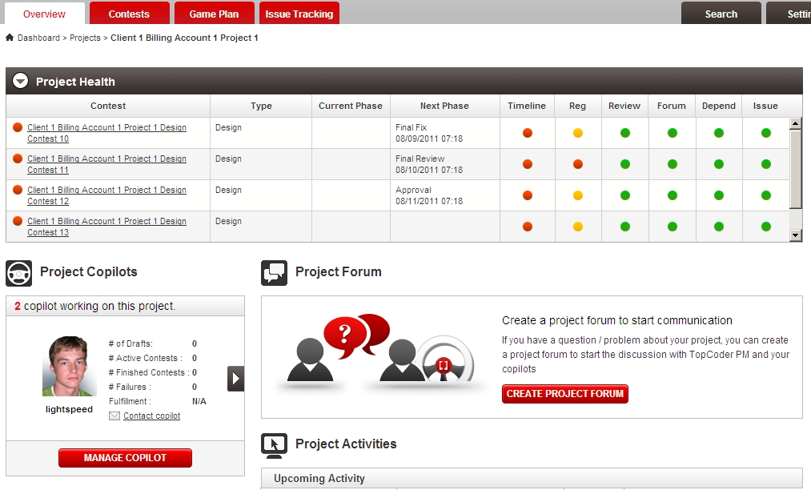

Click the right navigation button to check next copilot:

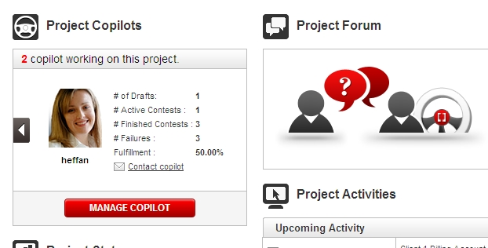

Click Management Copilot to add / Remove copilot

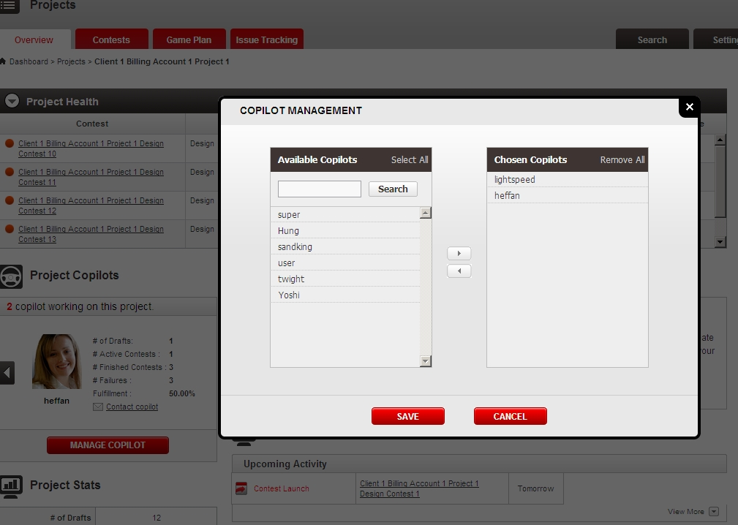

Remove lightspeed and click save, the page gets updated:

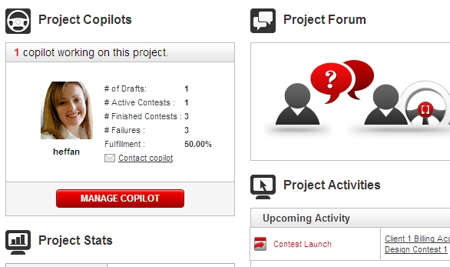

Open the manage copilot again, you can test searching copilots:

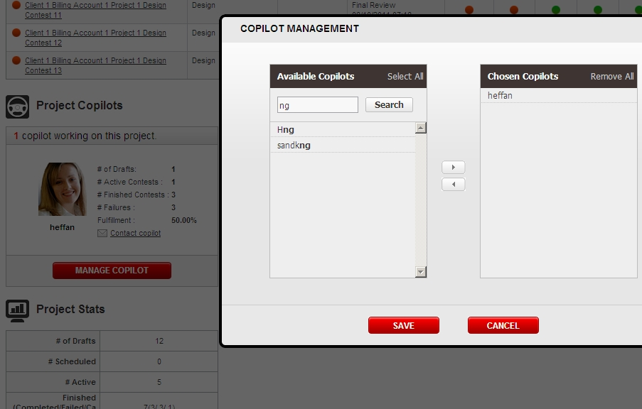

You can click cancel or the right upper close button to close the copilot management widget.

Click the create project forum button to create project forum (mock), and after creation, the page gets automatically refreshed and display LET’S TALK:

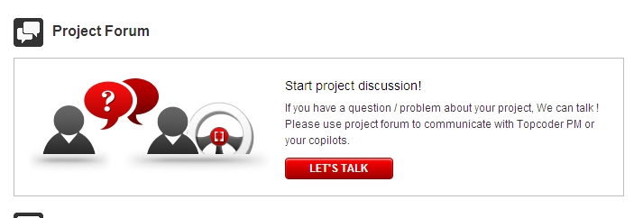

Create a new direct project which does not have copilot assigned and open the project overview page

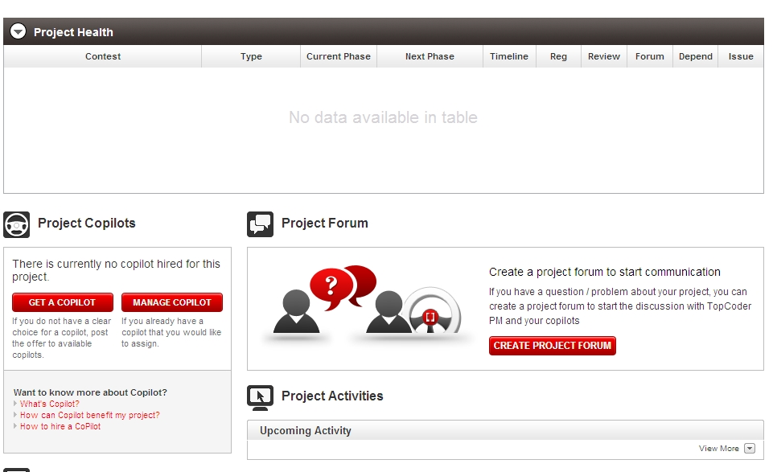

Open the manage copilot to test as previous steps:

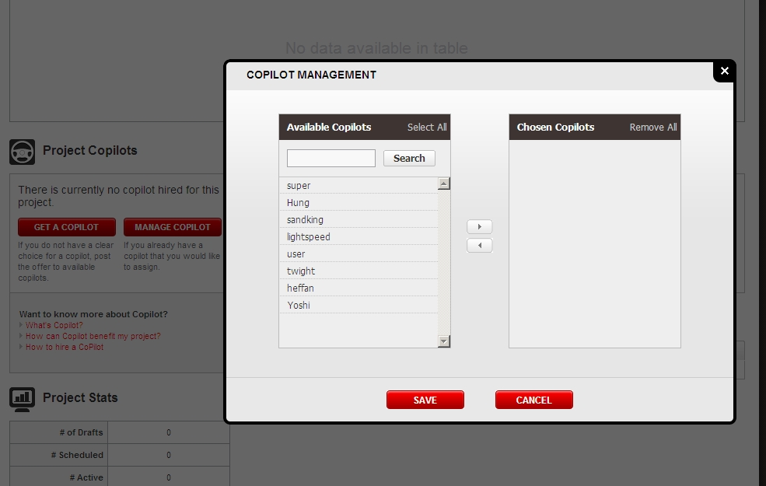

Resource Contact List

Name | Resource Email
TCSASSEMBER

