Module Assembly - TC Cockpit Enterprise Dashboard Analysis 1 Deployment Guide

Revision History
Author | Revision Number | Date
TCSASSEMBLER | 1.0 | 08/18/2012

Deployment Instructions 3
1. Organization of Submission 3
2. Application Setup 3
2.1 Ant .Properties File 3
2.2 Configurations 3
2.3 Build Scripts Setup 3
3. Database Setup 4
3.1 Update and add queries via Query Tool 4
4. Deployment Instructions 4
5. Starting 4
6. Verification 4
7. Resource Contact List 9

Deployment Instructions

Organization of Submission

The submission follows directory structure provided below:

doc
Contains the Deployment Guide Document of this assembly.

direct
Contains sources and static files for Direct web application. This directory replicates the application development distribution structure and includes only updated and new files.
query
Contains all the one updated query
dbscripts
Contains the update db scripts for db scripts svn trunk
test_files
Contains the SQL files to insert test data

Application Setup

The application is expected to be deployed to the following environment:

JRE 1.5
JBoss 4.2.3.GA
Informix DS 11.5

Ant .Properties File

Configurations

N/A

Build Scripts Setup
The ANT build script for Direct application (build.xml) provides the following targets which are to be used:

- switch-and-checkout – checkout or switch to the defined source code branches for all components defined in subprojects.xml
- dist-backend – rebuilt all the components from the source code.
- first_deploy – must be the first task to execute from command line. It will copy all dependencies to your local JBoss folder.
- deploy – should be the main task to execute from command line. It will build and deploy WAR file.
- deploy-static-files – deploys the static files to JBOSS.
- deploy-apache-static – deploys the static files to apache server on VM.

Please refer here for more information:
http://www.topcoder.com/wiki/display/docs/TC+Direct+Setup+Guide

Database Setup
N/A

Update and add queries via Query Tool

Log into the TC Query Tool to add the provided 1 query
(On VM use http://tc.cloud.topcoder.com/query/query)

Add the query direct_dashboard_enterprise_volume_view_week
- Choose the database TCS_DW
- Create the query direct_dashboard_enterprise_volume_view_week with the content of queries/query_direct_dashboard_enterprise_volume_view_week.txt
- Add inputs:
  - tcdirectid
  - billingaccountid
  - clientid
  - pcids
  - sdt
  - edt
- Create new command direct_dashboard_enterprise_volume_view_week
- Add the created new query to the new command

Deployment Instructions

This section provides the instructions in Production environment.

- Merge the code from submission into SVN for Direct application
- Rebuild the updated component topcoder_cockpit_project_milestone_services. Go to the component folder and run ‘ant dist_tcs’
- Build and deploy Direct application using ant deploy (or ant first_deploy ) command.
- Copy static files using ant deploy-static-files command or ant deploy-apache-static if use apache as static file server.

Starting

- Build and deploy the Direct application
- Start JBoss server instance hosting Direct application

Verification

Set up test data first, run the following SQL scripts in order against the test server database:
- test_files/calendar.sql
- test_files/test_data.sql

Login into VM as tc
- Run ~/web/scripts/dwload] ./loadtcsscript.sh
- Run dos2unix loadweeklystat.sh
- Run ~/web/scripts/dwload] ./loadweeklystat.sh

Use various browsers to open the link http://localhost:8180/direct or https://[vm_ip]/direct/ , login as user / password.

Go to http://test.host/direct/enterpriseDashboard/overview
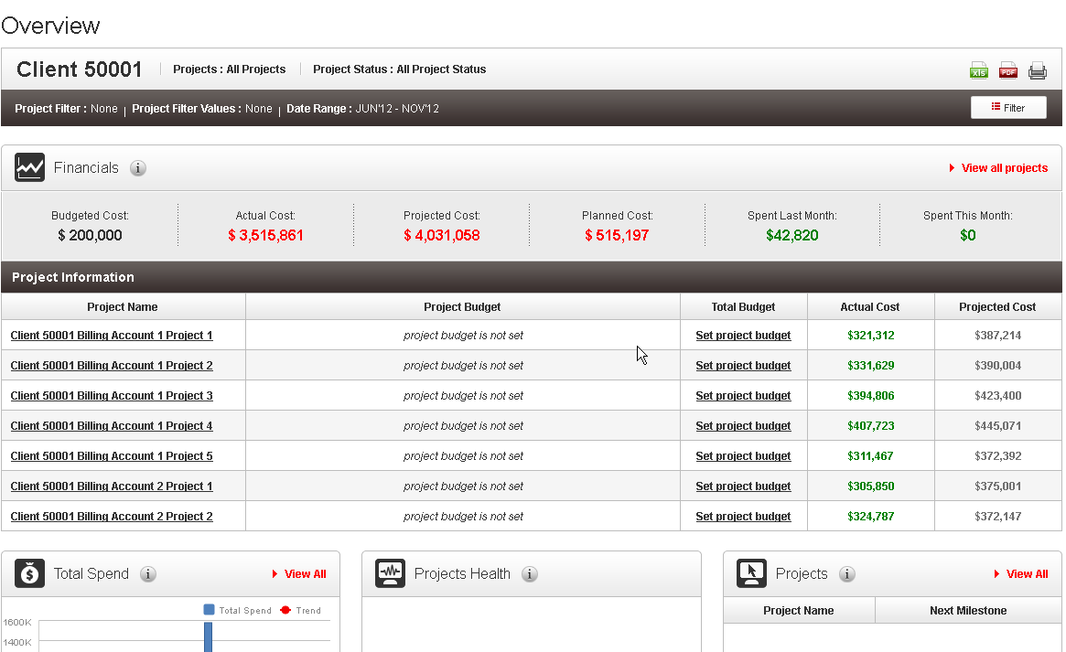

Click the analysis tab

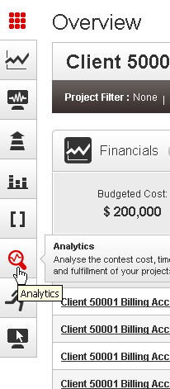

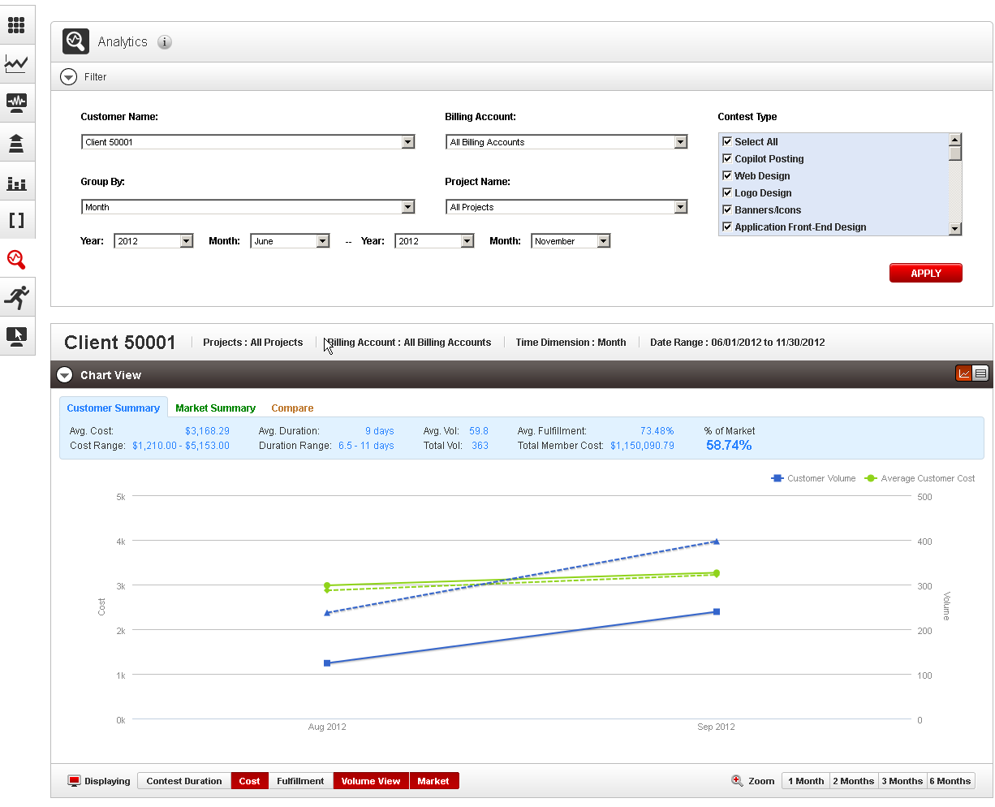

Change the client and try

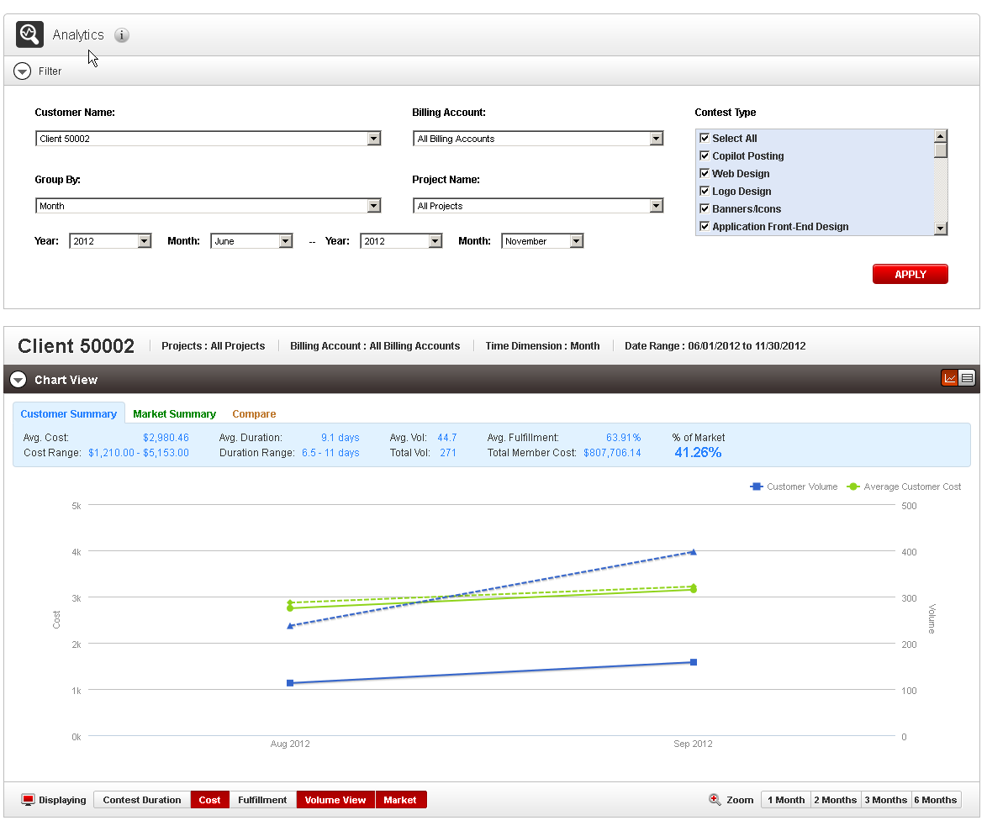

Change group by to week

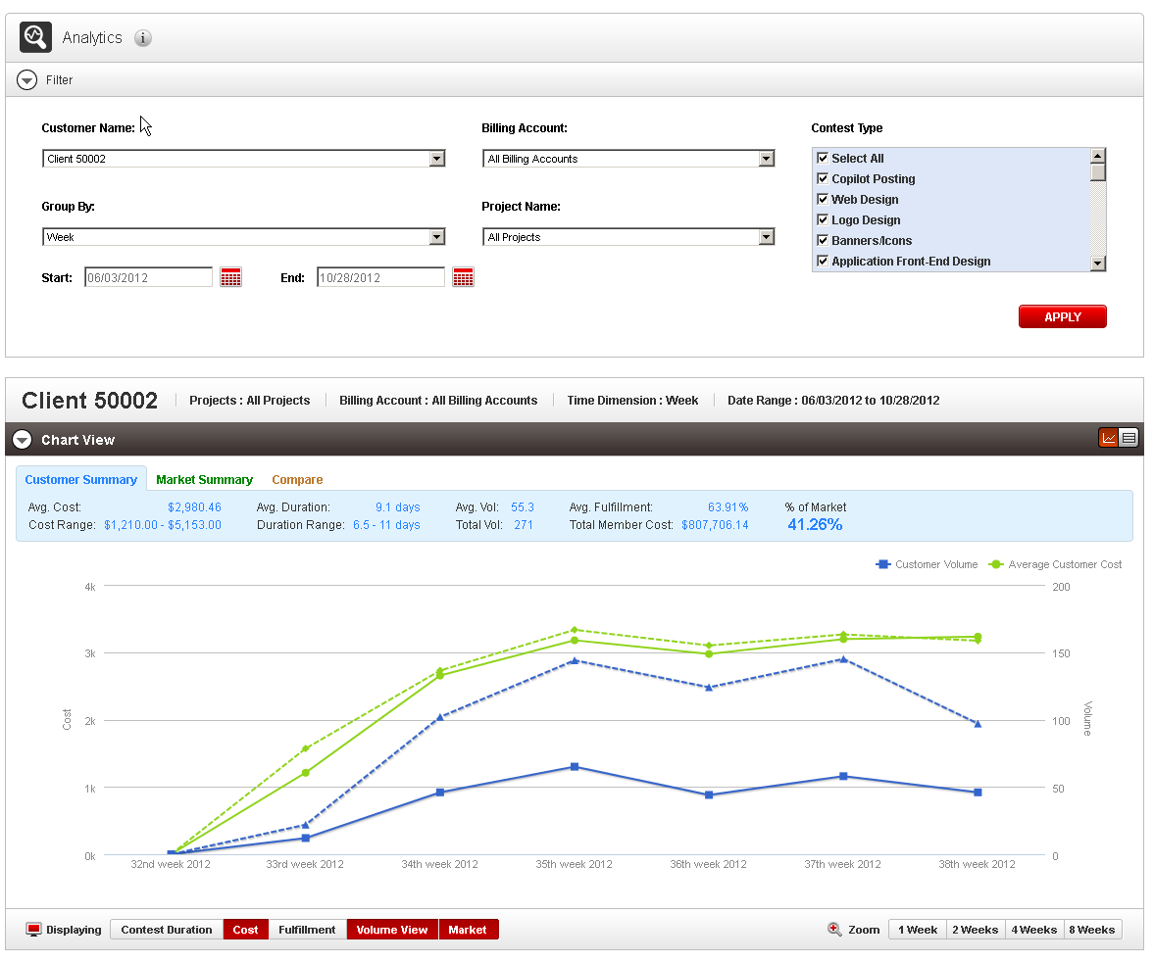

Change group by to quarter

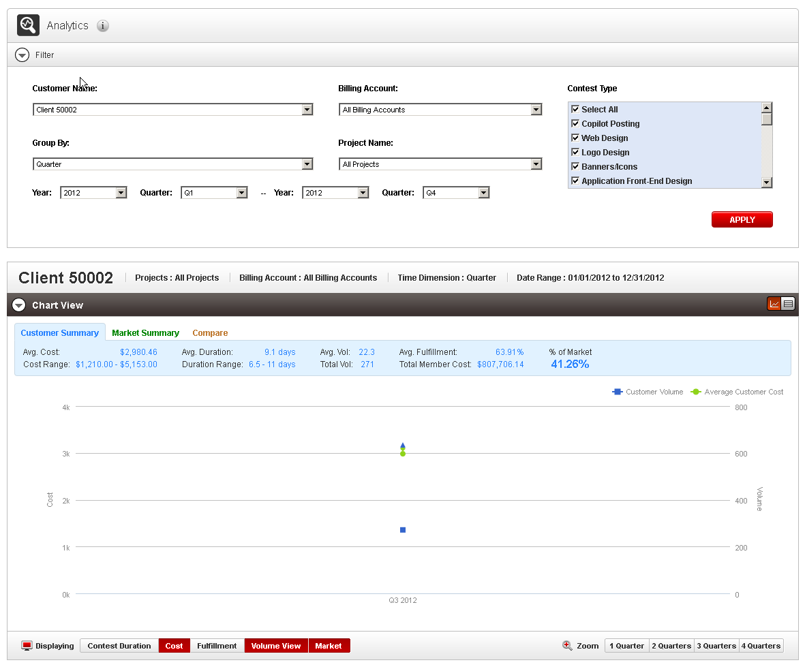

Change group by to year

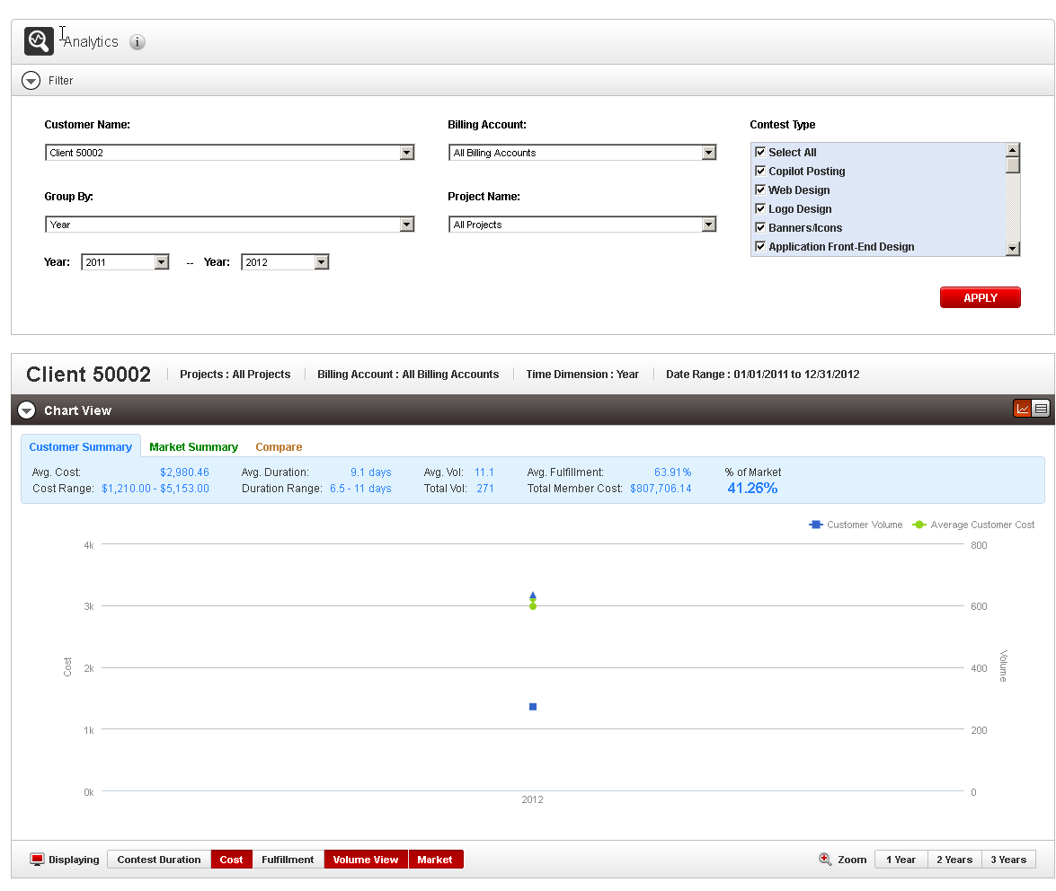

Uncheck market in displaying

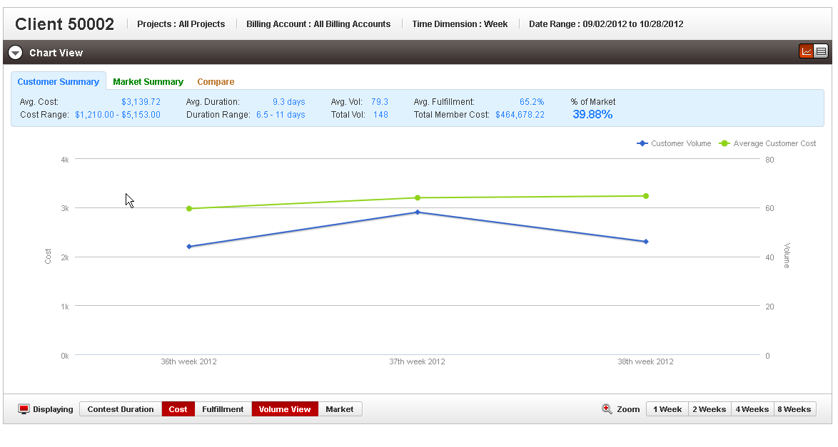

Uncheck volume view in displaying

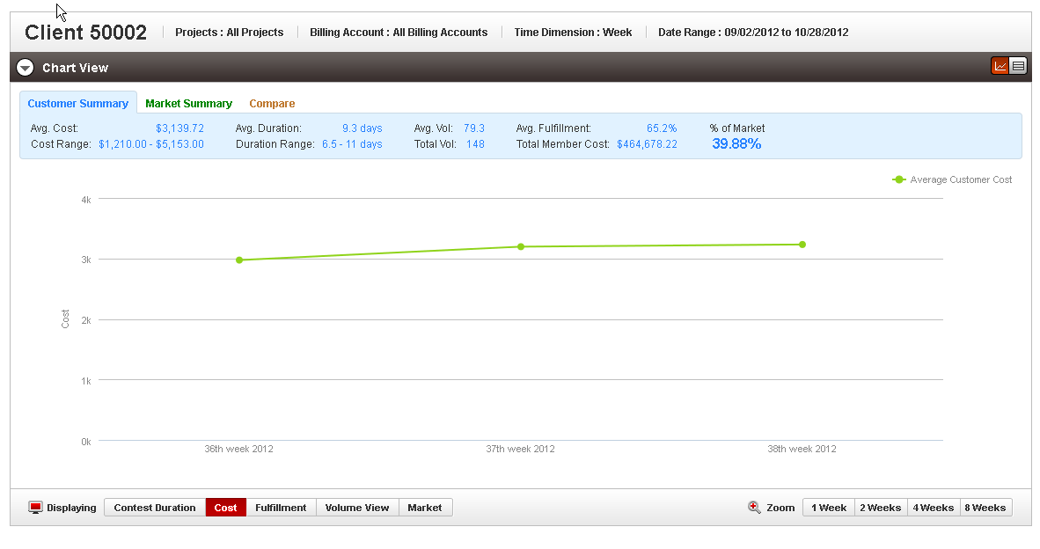

Choose Zoom

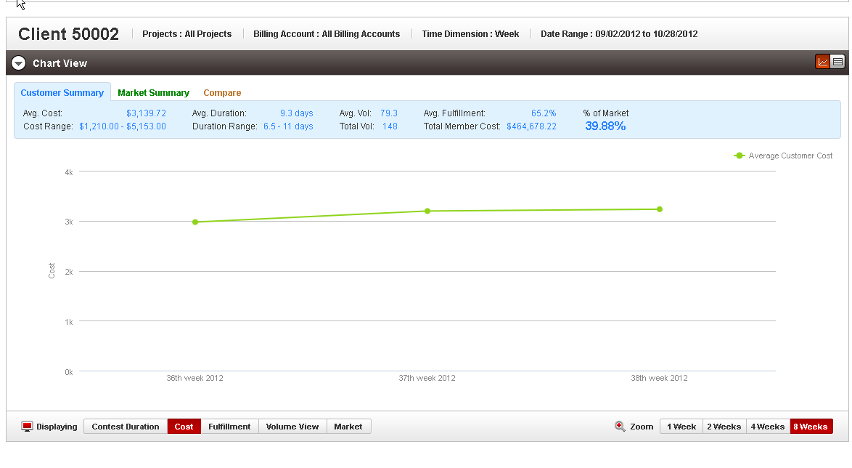
Test hiding legend and showing tip

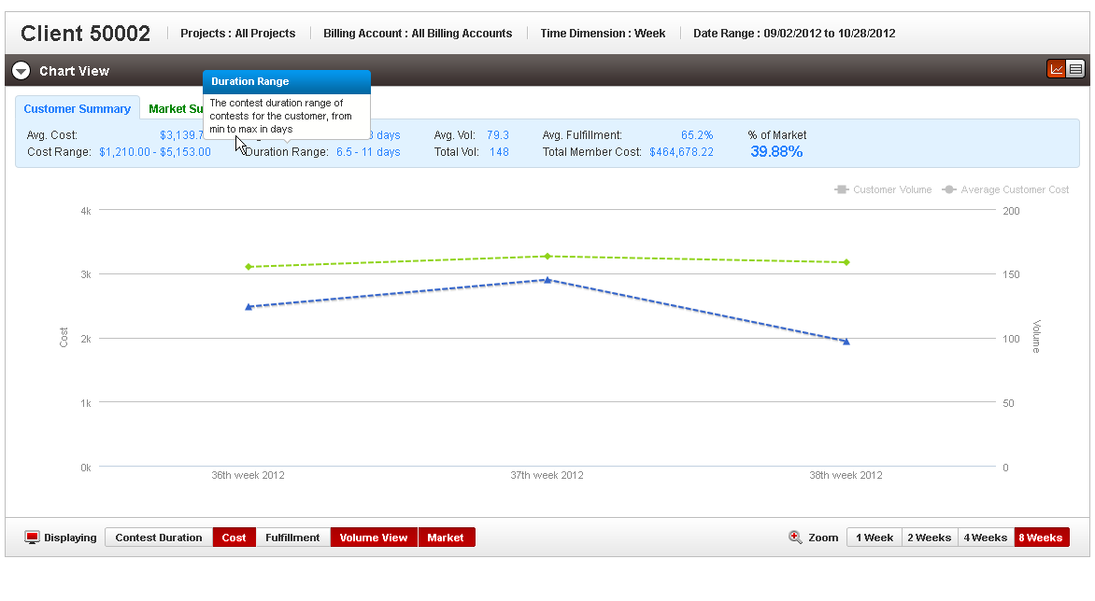
Test Summary tabs

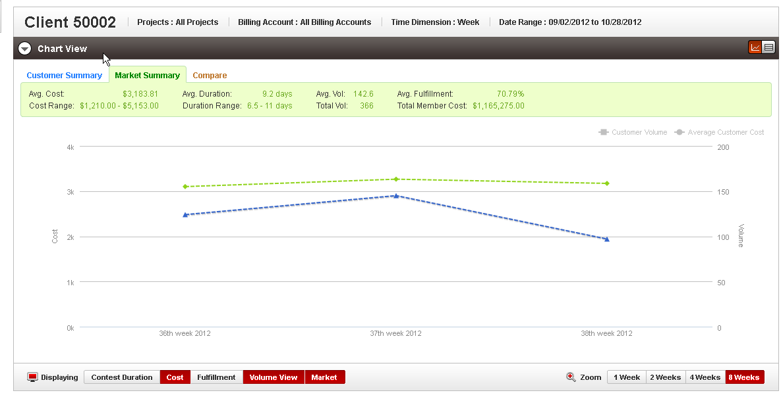

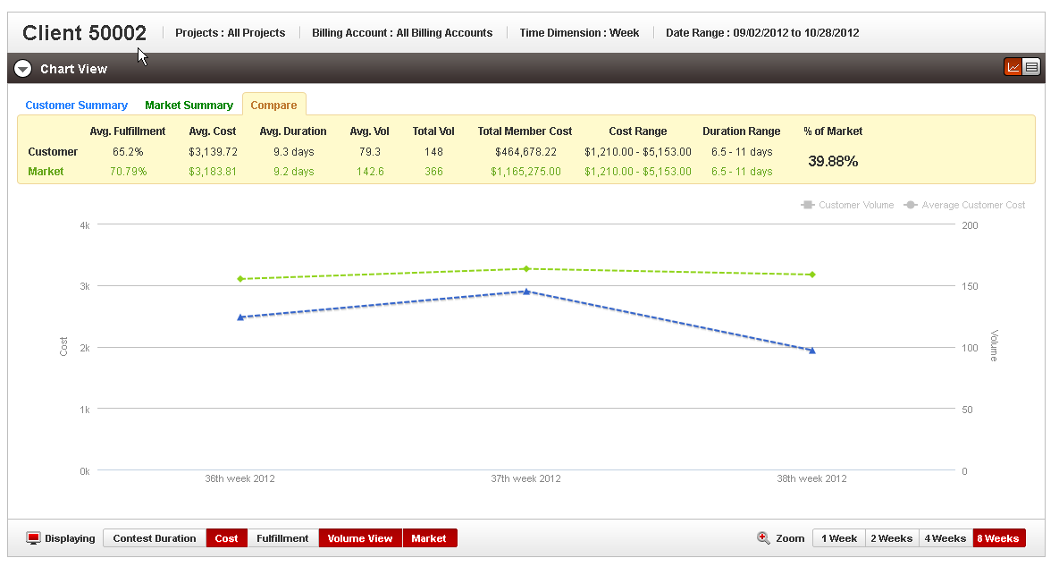

Check the filter panel validation

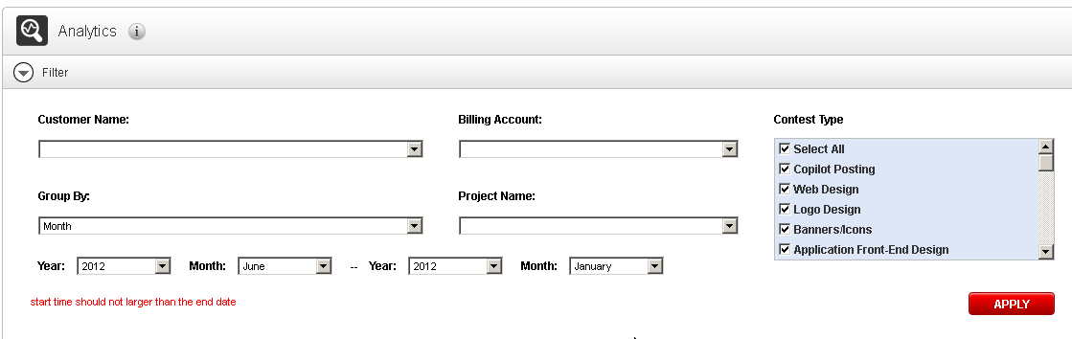

Resource Contact List

Name | Resource Email
TCSASSEMBLER

