Release Assembly - TC Cockpit Permission and Report Update One
Deployment Guide Submission 2 Flexme

Revision History
Author | Revision Number | Date
TCSASSEMBER | 1.0 | 28th/Oct/2011

Deployment Instructions 3
1. Organization of Submission 3
2. Application Setup 3
2.1. Ant .Properties File 3
2.2. Build Scripts Setup 4
3. Database Setup 4
4. Deployment Instructions 5
5. Starting 5
6. Verification 5
7. Resource Contact List 10

Deployment Instructions

Organization of Submission
The included submission was organized as follows:

/
- refactoring_notes.txt
Notes about the refactoring in this assembly.

- changed_files.txt
List the added/updated files in this assembly.

- files_to_be_deleted.txt
List the files which should be deleted from the SVN.

- Reviewer_Setup_Test_Instructions.README
VM and database setup and testing instructions for the reviewers.

docs/
- PermissionReportUpdateDeploymentGuide.doc
Deployment Guide for this submission

queries/
This directory contains SQL text for updated queries.

test_files/
This directory includes SQL scripts that are needed for testing and review. (This will only be valuable for reviewers)

direct/
This directory and subdirectories contain all modified and added source / static files of Direct.

database/
This directory contains the modified and added files for the database trunk in SVN.
https://coder.topcoder.com/internal/database/scripts/trunk

These files are based on revision 80227.

If you deploy the database locally, you can merge the files under this directory to the SVN directory and re-setup the database.

Application Setup
The application is expected to be deployed to the following environment:

JRE 1.5
JBoss 4.2.3.GA
Informix DS 11.0

Ant .Properties File
No changes were performed regarding Ant .Properties file.

Build Scripts Setup
The build script for Direct application (build.xml) provides the following targets which are to be used:

- switch-and-checkout –checkout or switch to the defined source code branches for all components defined in subprojects.xml
- dist-backend –rebuilt all the components from the source code.
- first_deploy –must be the first task to execute from command line. It will copy all dependencies to your local JBoss folder.
- deploy –should be the main task to execute from command line. It will build and deploy WAR file.
- deploy-apache-static – deploy the static files to Apache (Used in VM environment).
- deploy-static-files –deploys the static files to JBoss (Used in Local environment).

You can get more information here:
http://www.topcoder.com/wiki/display/docs/TC+Direct+Setup+Guide

Database Setup
Six queries have been updated and one query has been added in this assembly.

For locally deployment, please follow the instructions from TopCoder Databases Deployment Guide document from http://www.topcoder.com/wiki/display/docs/TopCoder+Databases+Setup+Guide
for setting up the database. Please copy the content from database directory in the submission to the database script directory.

For VM deployment, you can use Query Tool to update/add queries:
- Use Query Tool to update the following queries for database tcs_catalog.
Query Name | Query Content | Updated Inputs
dashboard_billing_cost_report | queries/ query_dashboard_billing_cost_report.txt | Add an input parameter uid
dashboard_contest_cost_breakdown | queries/ query_dashboard_contest_cost_breakdown.txt | Add an input parameter uid
dashboard_cost_report | queries/ query_dashboard_cost_report.txt | Add an input parameter uid
dashboard_market_cost_breakdown | queries/ query_dashboard_market_cost_breakdown.txt | Add an input parameter uid
dashboard_participation_contest_details | queries/ query_dashboard_participation_contest_details.txt | Add an input parameter uid
dashboard_participation_copilots | queries/ query_dashboard_participation_copilots.txt | Add an input parameter uid

- Use Query Tool to add the following queries for database tcs_catalog.
Query Name | Query Content | Inputs
has_cockpit_project_permissions | queries/ query_has_cockpit_project_permissions.txt | tcdirectid  uid

- Use Query Tool to add a new command named has_cockpit_project_permissions, and add the new added query (has_cockpit_project_permissions) to the command.

Deployment Instructions
This section provides the instructions in Production environment.

- Merge the code in direct directory from submission into SVN branch for Direct application
- Build and deploy Direct application using ant deploy (or ant first_deploy) command.
- Copy static files using ant deploy-static-files (For VM environment) or ant deploy-apache-static (For Local environment) command.

Note: VM deployment instructions for reviewers are in Reviewer_Setup_Test_Instructions.README document.

Starting
- Build and deploy the Direct application
- Start JBoss server instance hosting Direct application

Verification
- Run test_files/test_data.sql in database to insert some test data.

- The test data provide some Direct projects and contests. The relationship between Direct projects, contests, Billing Accounts and Customers are described in the following table.
Contest | Direct Project | Permission | Billing Account | Customer
Component N1 | TC  Direct  Project N1 | twight | Test Project 1 | ACME
Component N2
Component N3
Component N4
Component N888
Component N999
Component N6 | TC  Direct  Project N3 | Hung | Test Project 3 | ACME
Component N5 | TC  Direct  Project N2 | Yoshi | Test Project 2 | TopCoder

- Login to Direct as twight/password, open the following URLs directly.
http://localhost:8180/direct/contest/detail.action?projectId=600
http://localhost:8180/direct/contest/viewSpecReview.action?projectId=600&studio=false
http://localhost:8180/direct/contest/contestRegistrants.action?projectId=600
http://localhost:8180/direct/contest/softwareSubmissions.action?projectId=600
http://localhost:8180/direct/contest/contestIssuesTracking.action?projectId=600
http://localhost:8180/direct/contest/receipt.action?projectId=600

(If you are running the application in VM, please change localhost:8080 to cockpit.cloud.topcoder.com)

Because twight has no permission to access contest “Component N6”, the following error page will be displayed.
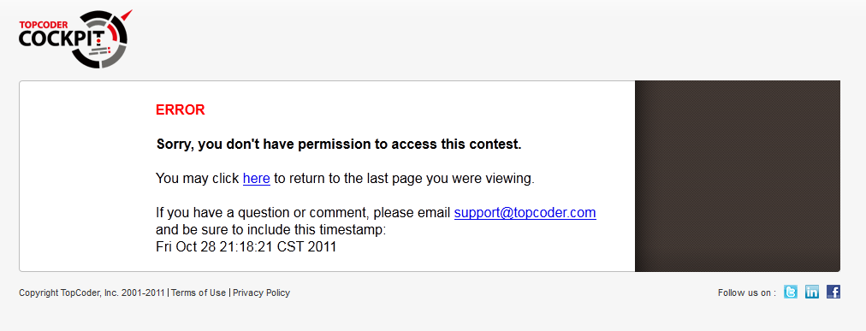

Now you can login as heffan/password and visit those URLs again. No error will occur although heffan has no permission on those contests. Because heffan is TC Staff.

- Login to Direct as twight/password, open the following URLs directly.
http://localhost:8180/direct/projectOverview?formData.projectId=343202
http://localhost:8180/direct/projectDetails?formData.projectId=343202
http://localhost:8180/direct/ProjectGamePlanView?formData.projectId=343202
http://localhost:8180/direct/projectIssueTracking?formData.projectId=343202

Because twight has no permission to access Direct project “TC Direct Project N2”, the following error page will be displayed.
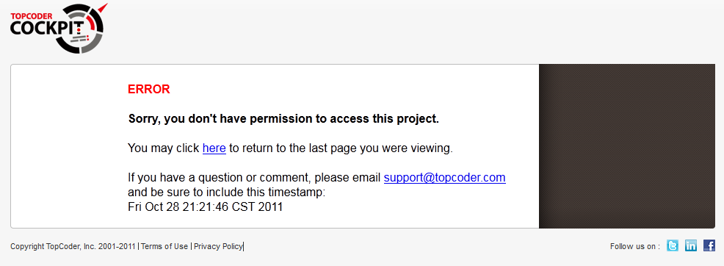

Now you can login as heffan/password and visit those URLs again. No error will occur although heffan has no permission on those projects. Because heffan is TC Staff.

- Login to Direct as twight/password, click “Reports” tab on the top right. Then select “Cost” in the “Select a Report” dropdown. The following page will be displayed.
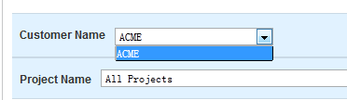

You can see the only “ACME” is on “Customer Name” dropdown. Because twight has only permission on “TC Direct Project N1” whose customer is “ACME”.

You can also try these dropdown values in other report pages like “Billing Cost” and “Participation Metrics”.

- Login to Direct as twight/password, in the “Cost” report page you have opened in step 5, click “Apply” Button. The following page will be displayed.
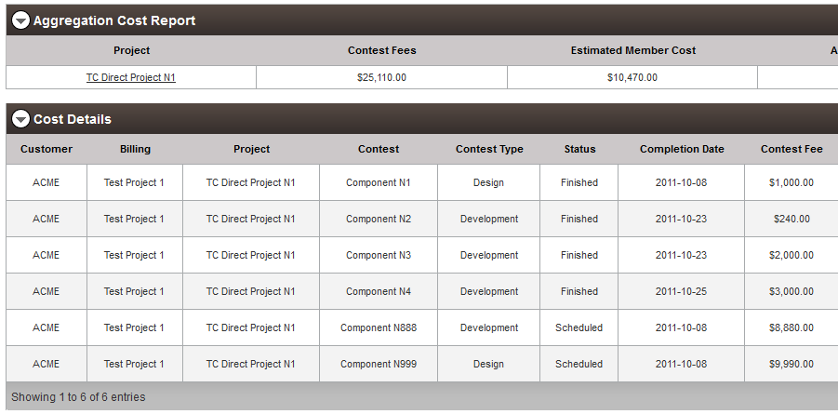

You can see although the value of “Project Name” dropdown is “All Projects”, only the “TC Direct Project N1” are displayed in the result table because twight has permission on only “TC Direct Project N1”.

You can click “Cost Breakdown View” on the top right in the table.
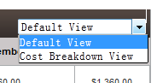
It also works fine.
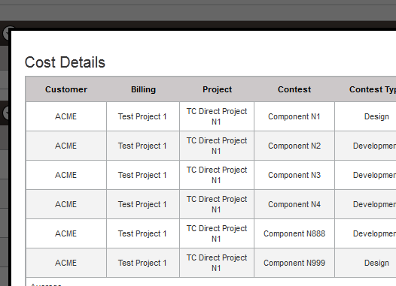

- After you clicked “Apply” button, the request parameters will be displayed in the URL input box of browser.

You can try to change those parameters manually.
For example, you can change formData.customerId=2.
After you open the url you have modified, the error page will be displayed.
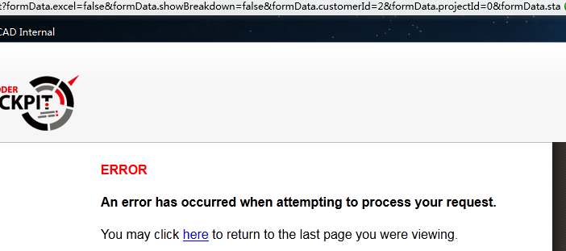

From the JBoss otuput log, you can see the following exception:
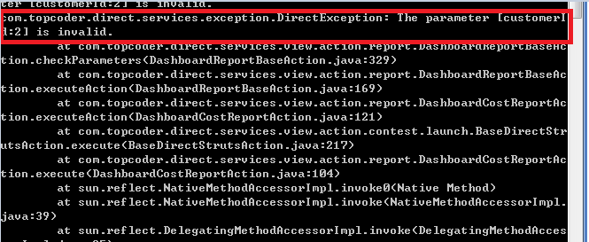

- Login to Direct as user/password, click “Reports” tab on the top right. Then select “Cost” in the “Select a Report” dropdown. Because user is in the group of TC Operations, he can see all the Direct Projects.
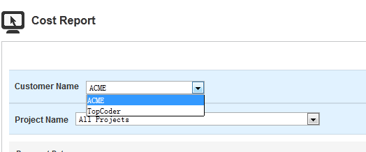

- Login to Direct as lightspeed/password, click “Reports” tab on the top right. Then select “Cost” in the “Select a Report” dropdown. Because lightspeed has no permission on any Direct Projects, the “Customer Name” dropdown will be empty. Click “Apply” button, no error will occur and the results will be empty.
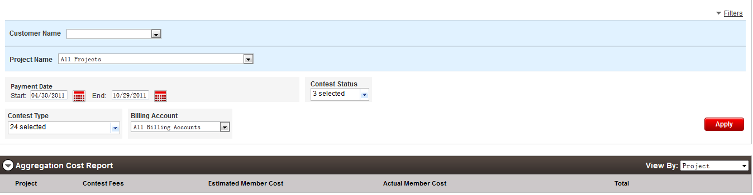

- Login to Direct as heffan/password, click “Reports” tab on the top right. Then select “Participation Metrics” in the “Select a Report” dropdown. The following page will be displayed.
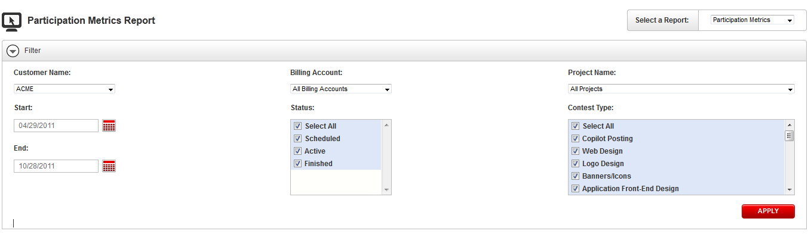

- Click “Apply” button, the following page will be displayed.
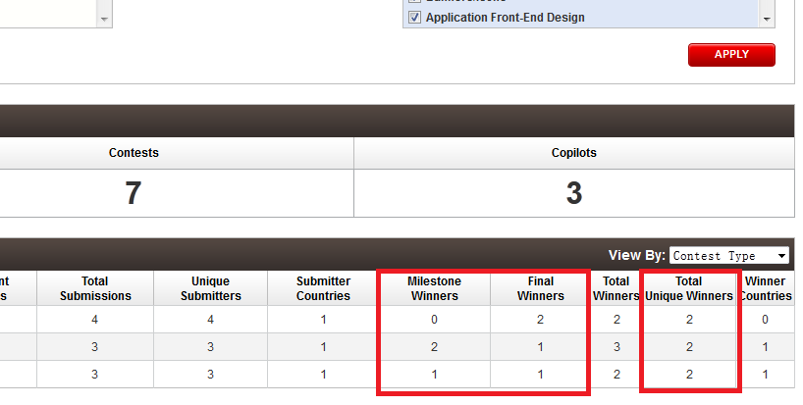

The Milestone Winners, Final Winners and Total Unique Winners should be displayed.

Resource Contact List

Name | Resource Email
TCSDEVELOPER

