Proof Of Concept - TopCoder REST API NodeJS with OAuth Integration Deployment Guide

Revision History
Author | Revision Number | Date
TCSASSEMBLER | 1.0 | 03/17/2013
Deployment Instructions 5
1.Organization of Submission 5
2.Application Setup 6
3.Configurations 6
4.Deployment Instructions 7
5.Verification 11
6.Resource Contact List 17

Deployment Instructions

Organization of Submission
The folder structure:
Name | Description
codes/ | Source codes of this assembly
profile_example.txt | The context needs to be added into your profile file, such as .profile or .bash_profile (depends on the shell you are using) under your home folder.
sqlhosts.informixoltp_tcp | Need to copy to “Informix client SDK’s installation folder/etc”, for example: /opt/IBM/Informix/etc/
Deployment Guide.doc | The deployment guide document.
procedures.sql | SQL Stored procedures to run on the INFORMIX db.
codes/static/crud.html | Html test page to test the crud
testdata.sql | SQL statements to run on the INFORMIX db after running procedures.sql and which can be used to perform CRUD opearations.
Passport-topcoder/ | Passport strategy implementation for Topcoder oauth provider

Here is the console look of all the files :

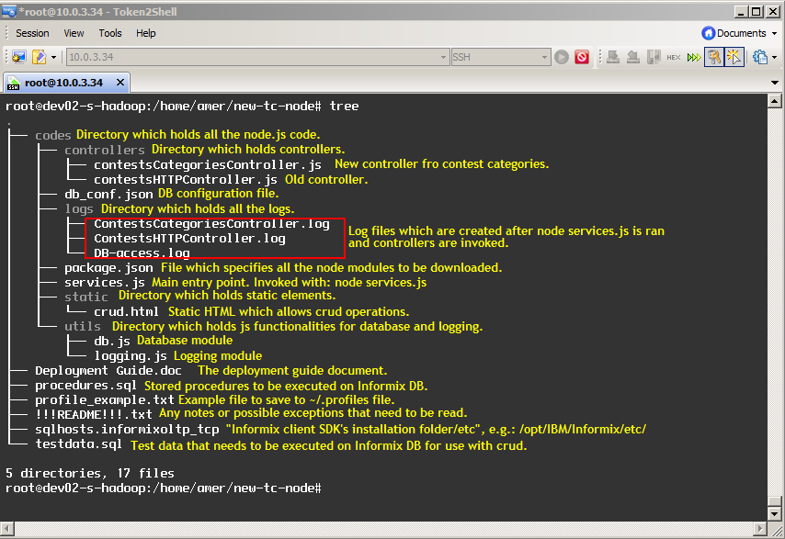

Application Setup
Preconditions:
- Linux System, such as Ubuntu (12.04) with development tool, such as g++, maker.
- Informix Client SDK (used to connect remote Informix Server)
- NodeJS 0.6.18 http://nodejs.org/ - http://nodejs.org/dist/v0.6.18/node-v0.6.18.tar.gz
- Express 3.0.0 http://expressjs.com/
- NodeJS-DB-Informix https://github.com/amitkr/nodejs-db-informix

Configurations
codes\db_conf.json

{
"host": "54.234.234.142", -- Informix Server IP
"user": "informix", -- User Name
"password": "1nf0rm1x", -- Password
"port": 2021, -- Database Port
"database": "tcs_catalog" -- Database Name
}

codes/config.js
  - Configuration used for passport-topcoder strategy

Configuration | Required | Details | example
clientID | Yes | Id of the client. It can be obtained by registering for an account here.https://tctest1.3scale.net/ | fbd0b481
clientSecret | Yes | Client secret. It can be obtained by registering for an account here.https://tctest1.3scale.net/ | 2da15d080cccdbc2f717543d1897fdb2
callbackURL | Yes | The url to which the ouath server will redirect after authorization | http://localhost:8080/topcoderoauth/callback
apiHost | Yes | Host name of topcoder api server | api.cloud.topcoder.com
Scope | Yes | Scope of authorization(Permission list) | ["FORUMS_REST", "CONTEST_REST", "NODE_REST"]

codes\getContestById.sql and codes\getContestTypes.sql are the SQL statements used in the assembly.

Deployment Instructions
  - Install NodeJS from http://nodejs.org/.
Please refer https://github.com/joyent/node/wiki/Installation about how to install NodeJS. In general, for *nux OS
wget http://nodejs.org/dist/v0.6.18/node-v0.6.18.tar.gz
tar -zxf node-v0.6.18.tar.gz
cd node-v0.6.18
./configure
Make
sudo make install
  - Install Informix Client SDK. It can be downloaded from http://www-01.ibm.com/software/data/informix/downloads.html
After you download and unpack the package, please refer to its installation guide at doc/Client_install_guide.pdf to install.

  - Copy sqlhosts.informixoltp_tcp “Informix client SDK’s installation folder/etc”, for example: /opt/IBM/Informix/etc/, open it with any editor and you can change the Informix Server’s IP and Port.
informixoltp_tcp onsoctcp 54.234.234.142 2021
  - Open your shell profile (for example, if you are using C shell, the file name should be .profile under your home folder) and add the content of profile_example.txt to your file. Change the INFORMIXDIR according to your system. And reboot the system or run the profile to make sure the settings effective.
INFORMIXDIR='/opt/IBM/informix'
  - Go to codes folder, run npm install.

Note: If the DB server is 54.234.234.142, steps 7 – 8 can be skipped. Because stored procedures are already executed
  - Open db_conf.json and you can modify the database connection parameter if necessary. [NOTE] NodeJS-DB-Informix reads the host and port information from Informix Client SDK’s configuration file instead of this file, but we leave it here to follow the test case of NodeJS-DB-Informix, they may change the implementation later.
  - Install Server Studio from this location: http://serverstudio.com/downloads/
Go to File > New Connection
Use the following information to connect if you don’t have other VM to use:
server: informixoltp_tcp
host: 54.234.234.142
user: informix
password: 1nf0rm1x
port: 2021
database: tcs_catalog
table: project_category_lu
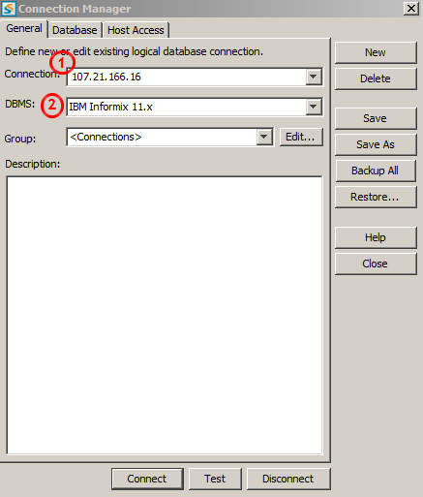
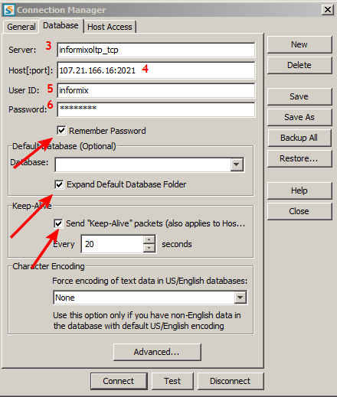
Click Test and then Connect.
Right click on the database, chose New > SQL Editor:
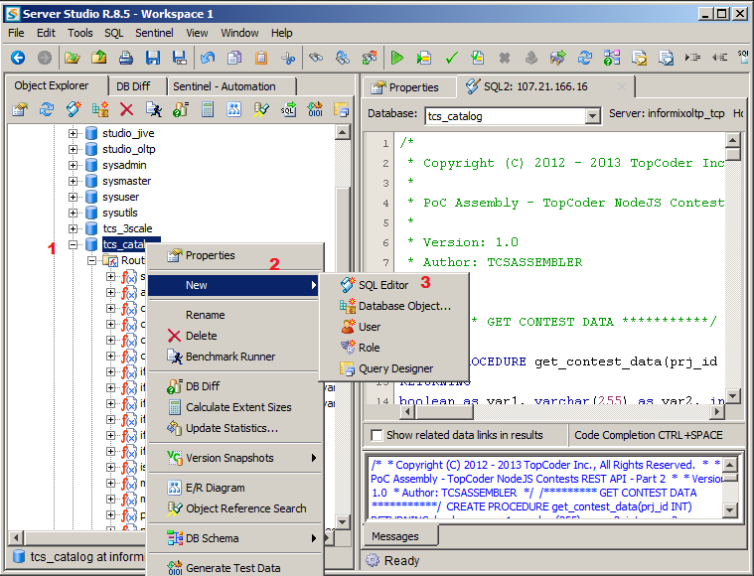
Copy everything from procedures.sql and execute it. This will create all the necessary stored procedures on the server.
After that copy everything from testdata.sql and execute it. This will create new records which have no foreign key constrictions and which can be easily updated, deleted, etc.
8. Navigate to passport-topcoder folder and execute command npm install
9. Copy the passport-topcoder folder and paste it into codes/node_modules
10. Open /etc/hosts and add the following entry
50.19.74.91 api.cloud.topcoder.com
The ip should be replaced by Topcoder oauth provider server ip.
11. Navigate to codes folder and execute the command node services

On executing node services command, the express server should start successfully and Listening on port 8080 and Ctrl+C to exit... message should be shown. Instead if error message(Could not load default informix_bindings) is shown, check whether LD_LIBRARY_PATH variable is set properly.
Execute echo $LD_LIBRARY_PATH
It should display the path of informix client sdk libraries. If not, execute the following command.
export LD_LIBRARY_PATH=/opt/IBM/informix/lib:/opt/IBM/informix/lib/c++:/opt/IBM/informix/lib/cli:/opt/IBM/informix/lib/client:/opt/IBM/informix/lib/client/csm:/opt/IBM/informix/lib/csm:/opt/IBM/informix/lib/dmi:/opt/IBM/informix/lib/esql

The above command assumes that informix is installed under /opt/IBM/informix

Verification
- Once the express server is successfully started, navigate to http://localhost:8080/client> It should show the client page.

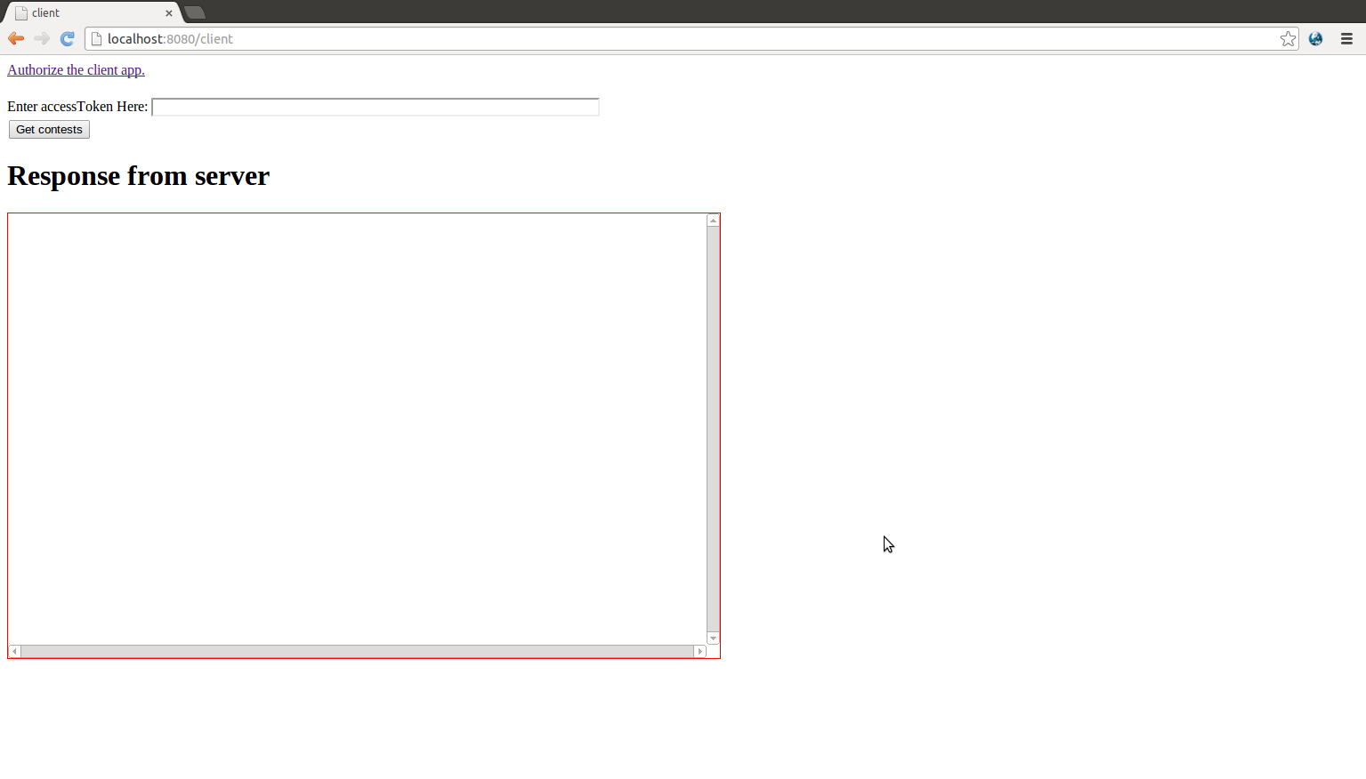

- Click on Authorize the client app link. It should take to Topcoder authorization/login page

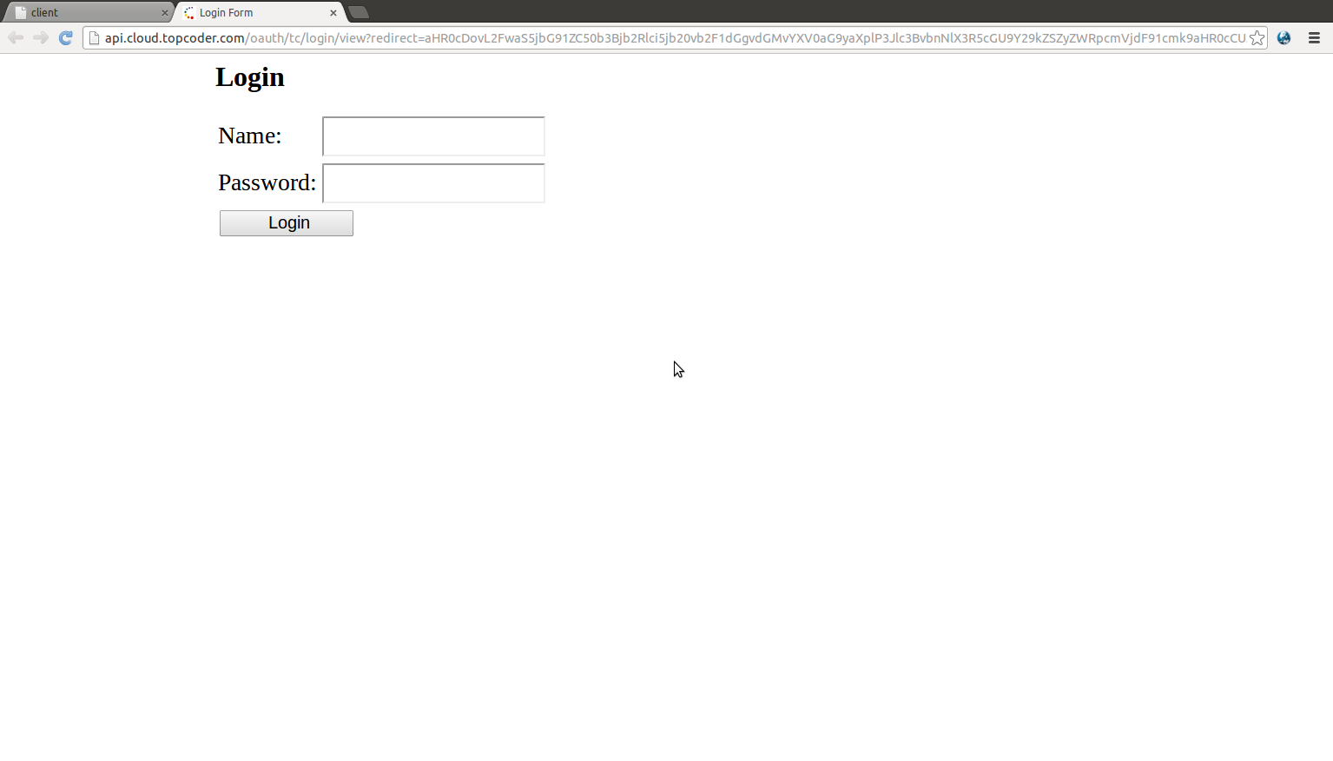
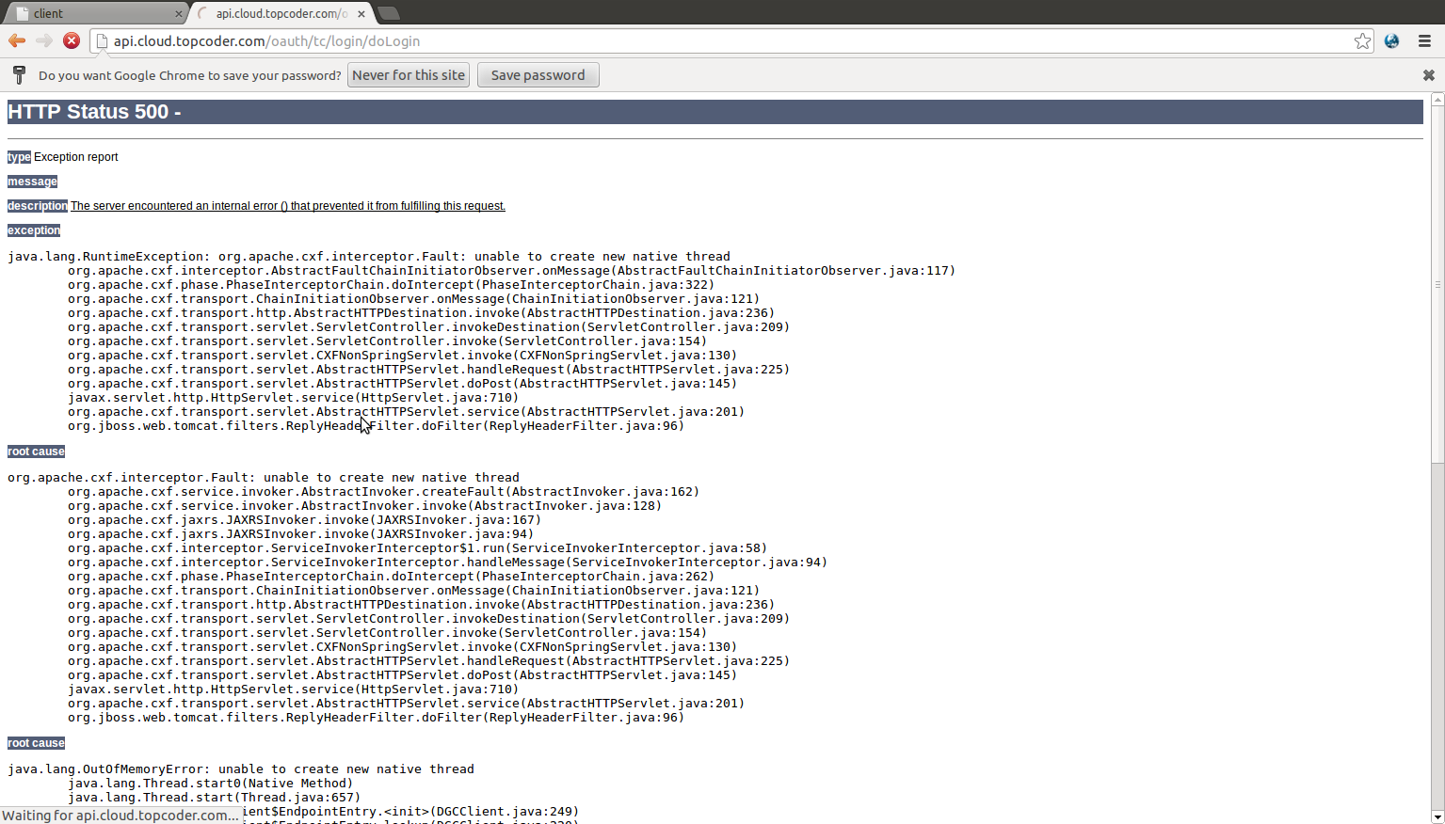
- Login with following credentials: heffan/password. It should show the permission page. But sometimes it shows error page as shown below. And sometimes it says invalid username and password. If the error page is shown hit refresh a couple of times. If it says invalid username and password, try again a couple of times with correct username and password.

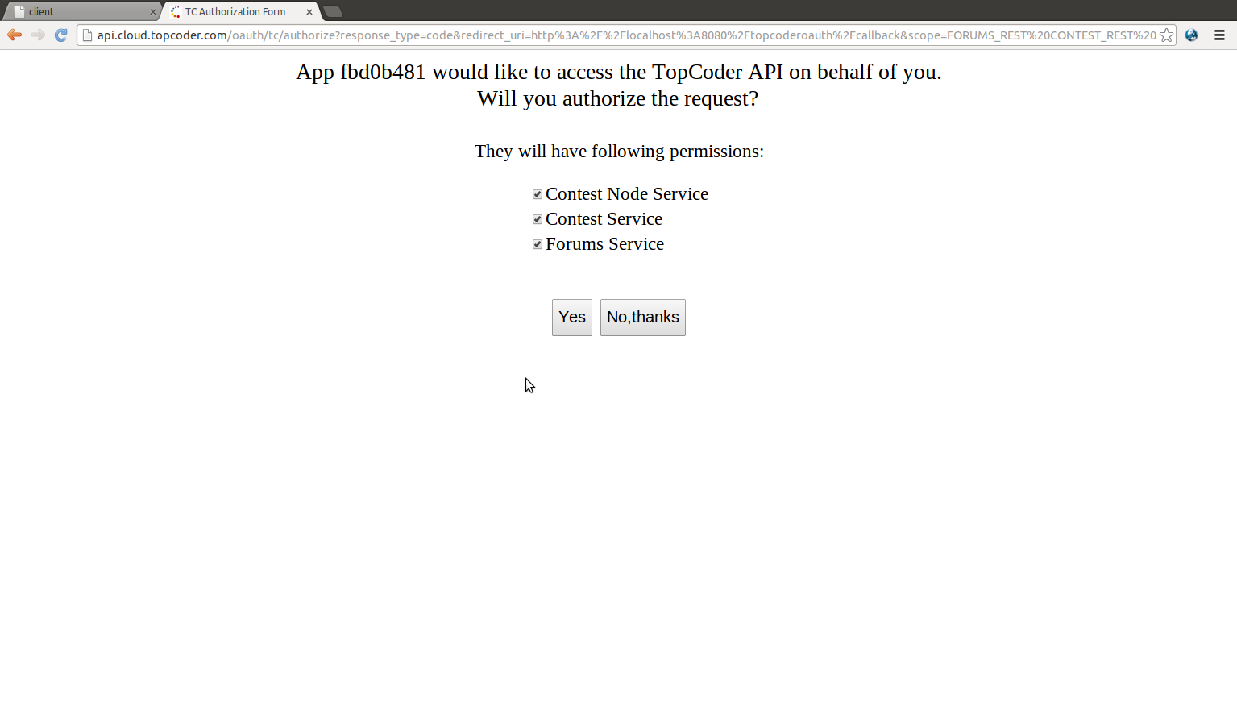
- Click yes, it should take to the auth success page which contains the scope, access token and expiration time.

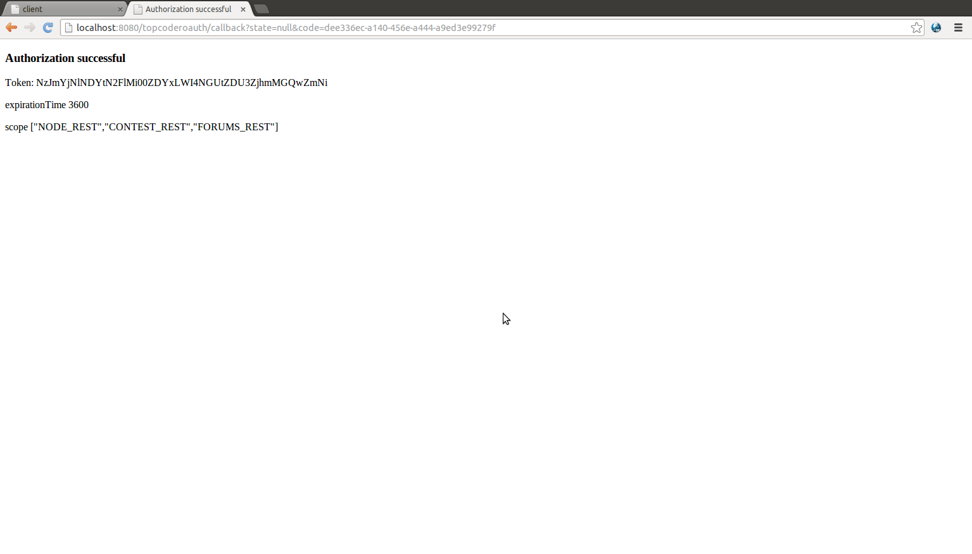

- If No, thanks is clicked on step step 3, auth failure page should be shown.

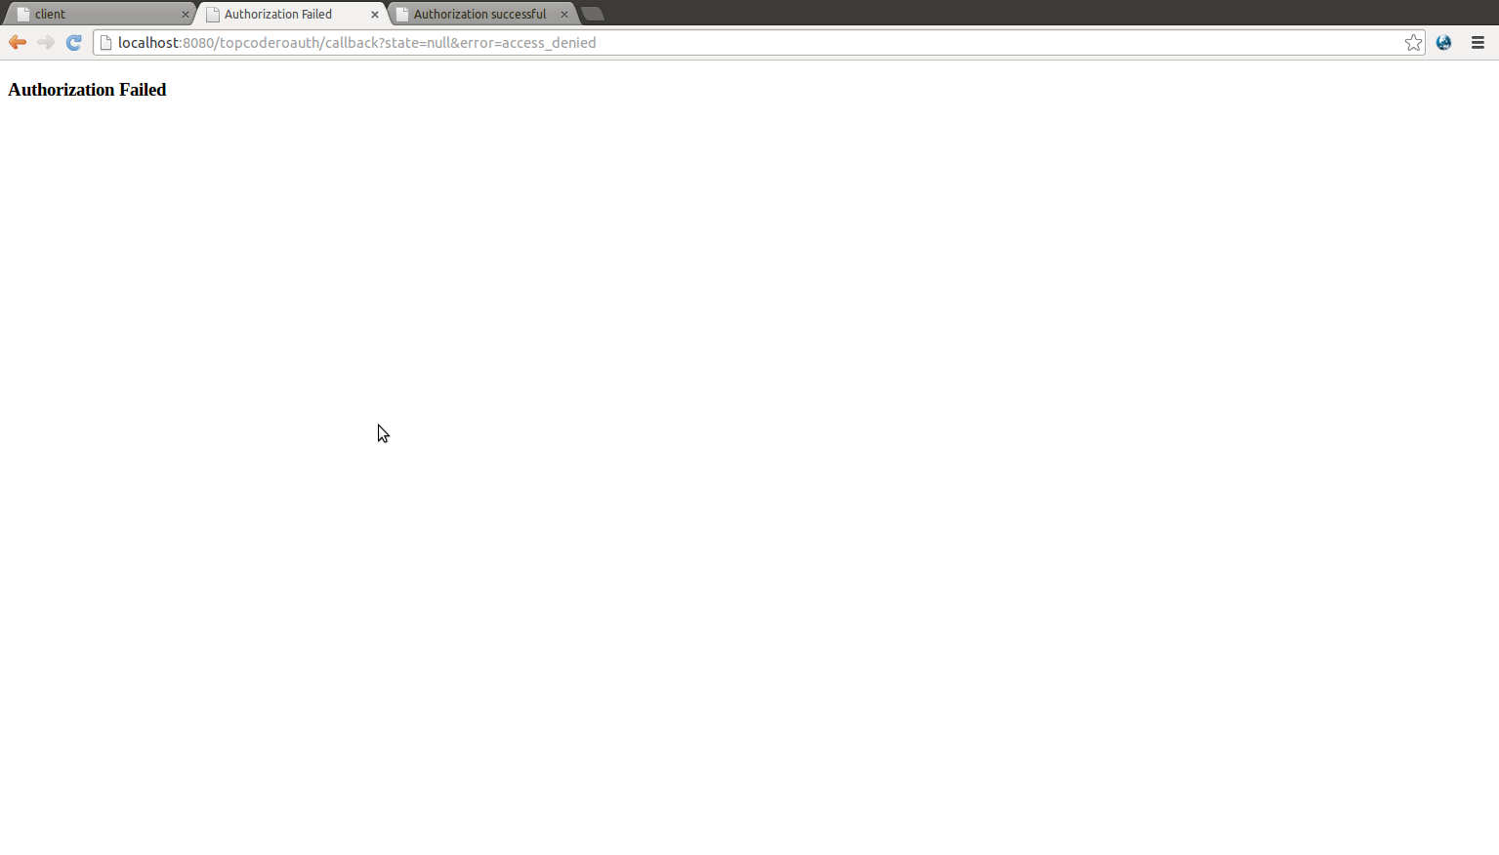

- Copy the accesstoken from the page shown in step 4. And paste it into the text box seen in client page. Click “Get contests button”. It should validate the token and return the contests in json format if the token is valid. The json will be displayed in red bordered box.

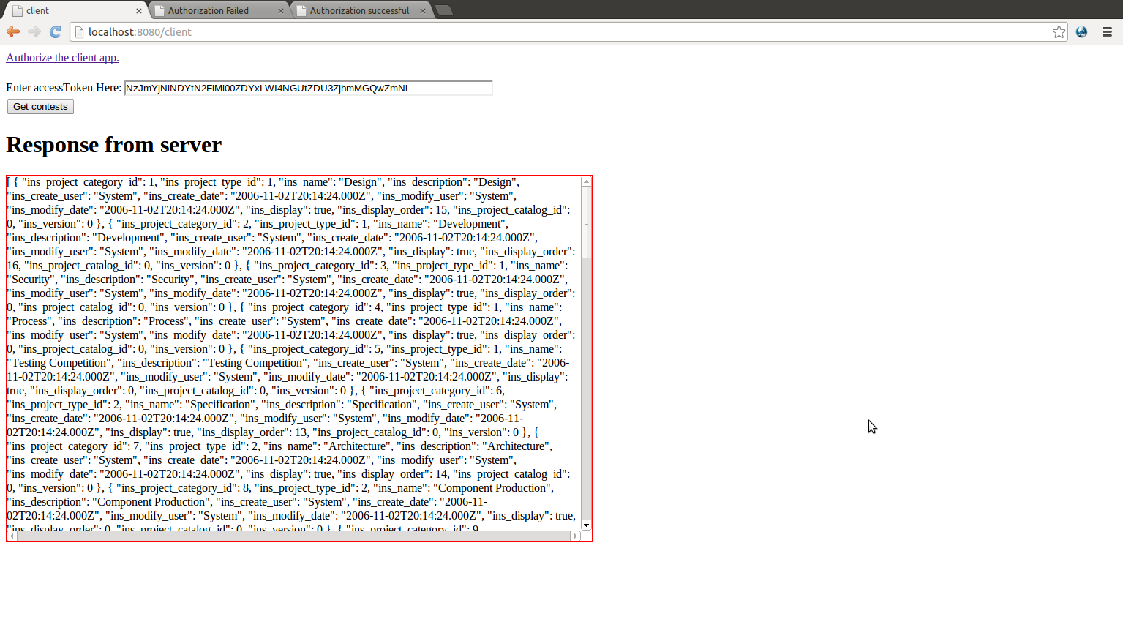

- In order to test the unauthorized token, In the screen mentioned in step 3 (Authorization screen), unselect the Contest Node service and click “Yes”. Use the access token obtained to get the contest dat as mentioned in step 6. This should receive “Not authorized” response from server.

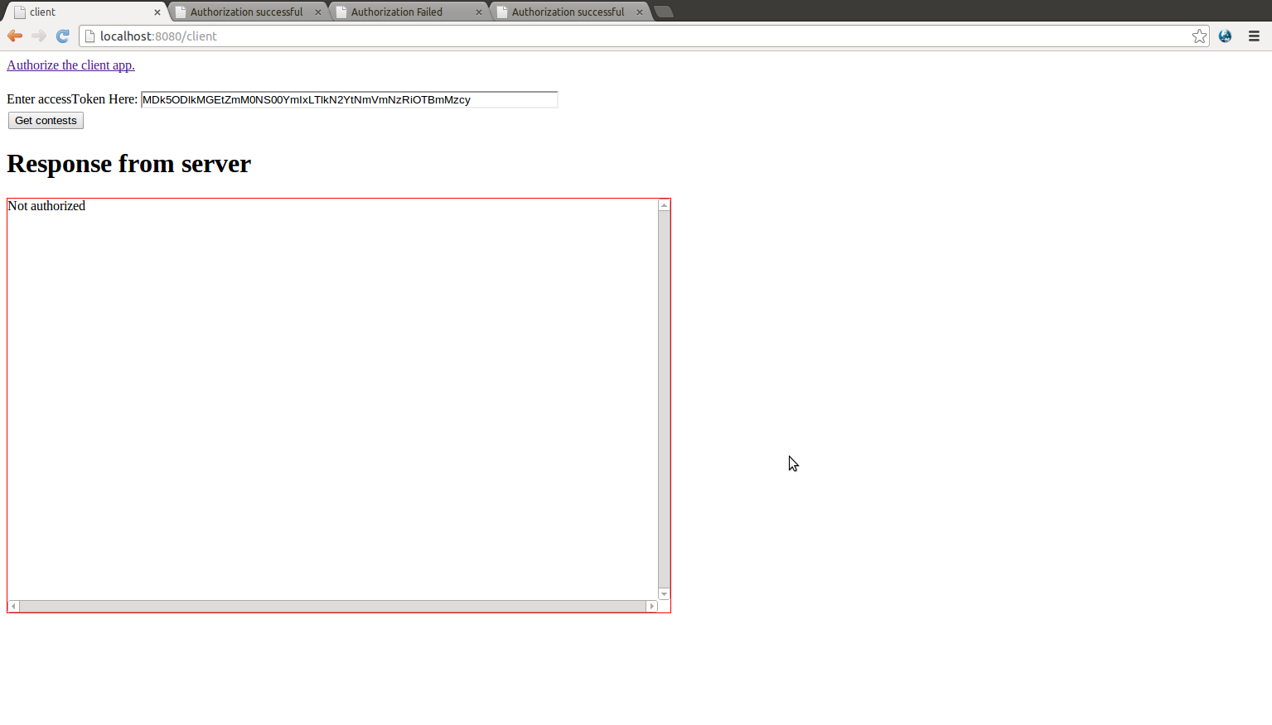

Important notes:
The VM shows weird behavior at times
1. It rejects correct username/password
2. It sends error page showing some java stack trace when validating the token. In this case the red bordered box will show the error page returned. If this happens click get contests button again
3. At times when clicking “Yes” in authorization screen it gets stuck in url “api.cloud.topcoder.com/oauth/tc/authorize/decision”. If this happens start the authorization process again.
4. At times when clicking “Yes” in the authorization screen, it sends error response saying “invalid client id” or “invalid client type”. When this happens the URL in the browser will look similar to http://localhost:8080/topcoderoauth/callback?state=null&code=dee336ec-a140-456e-a444-a9ed3e99279f
If this happens, refresh the page, it will send the access token eventually. Or start the authorization process from beginning.
5. More username/password combination can be found at http://apps.topcoder.com/wiki/display/docs/Studio+Instance+Information in the section “Credentials for website login”

Resource Contact List
Name | Resource Email

